|  |
| --- |
| Kepler Capital Markets |
| Periodic Auctions Analysis |
| Extended follow up |
|  |
| **FALCK Antoine** |
| **20 August 2018** |

|  |
| --- |
|  |

**Contents**

1 Mechanisms of Periodic Auctions 4

1.1 Operation and characteristics (BATS & Turquoise) 4

1.1.1 Context 4

1.1.2 How it works 4

1.1.3 Comparison between BATS and Turquoise 5

1.2 Comparison with the Euronext closing auction 8

2 Data analysis on IDC trades (BATS & Turquoise) 9

2.1 Market shares on STOXX 600 9

2.1.1 Data presentation 9

2.1.2 Time series analysis 9

2.1.2.1 Overall STOXX 600 9

2.1.2.2 Distinction between capped and uncapped stocks on the Darks 12

2.1.2.3 Ratio between Turquoise and BATS on periodic auctions 13

2.1.3 Possible correlations 15

2.1.3.1 Market Capitalization 16

2.1.3.2 Volatility 18

2.1.3.3 Number of trades 19

2.1.3.4 Market shares on Darks 21

2.1.4 Volume densities 22

2.1.4.1 Overall trading venues (BATS & Turquoise) 22

2.1.4.2 Distinction capped and uncapped stocks 25

2.1.4.3 Distinction Bats & Turquoise 26

2.2 Settlement price analysis 28

2.2.1 Deviation between settlement price and mid-point at auction settlement 28

2.2.1.1 Halma 30

2.2.1.2 AkzoNobel 31

2.2.1.3 TP ICAP 32

2.2.1.4 Characteristics 33

2.2.1.4.1 Settlement 33

2.2.1.4.2 Proportion of settlement at midpoint 34

2.2.1.4.3 Proportion of settlement at BBO 36

2.2.1.4.4 Link with spread 37

2.2.1.4.5 Link with Trading Imbalance 38

2.2.1.4.6 Link with time between auction settlement and last observed quote 39

2.2.1.4.7 Volume 41

2.2.2 Difference with weighted price 41

2.2.3 Example of trade 43

2.2.4 Link with the market pressure 43

2.2.4.1 Summary 44

2.2.4.2 Trading imbalance 45

2.2.4.3 Order book imbalance 46

2.2.5 Change in the measure: difference with the mid-point of the previous trade 49

2.2.5.1 Trading imbalance 49

2.2.5.2 Order book imbalance 50

2.2.5.2.1 Without the drift 51

2.2.5.3 Conditionally to the last observed trade’s market order type 52

2.2.6 Link with the trend 53

2.2.7 Link with the liquidity and trade size (intraday) 53

2.2.7.1 Liquidity (number of trades per 5 min ranges) 54

2.2.7.2 Trade size 54

2.3 Price reversion based on our executions 56

2.3.1 Description 56

2.3.2 Market share 56

2.3.3 Price reversion 56

3 Appendix 59

3.1 OBIs correlations 59

3.1.1 Non-aggregated trades 59

3.1.2 Aggregated trades 60

3.2 Trade size on BATS periodic auction 60

3.3 Dark trade size 61

3.4 Correlation of average daily markets shares and market shares on darks 62

3.5 Trade size pdf on Darks 63

3.6 Difference with last trade conditionally with MO type is market impact 64

# Mechanisms of Periodic Auctions

## Operation and characteristics (BATS & Turquoise)

### Context

One of the objectives of the new regulation is to protect the liquidity of lit markets against the dark trading. Indeed the lit markets participate to price formation while dark places use this price without having any implication in the price formation process. That’s why MiFID II introduced a double volume cap on Darks, a breach is detected in either of two situations:

* the total percentage of trading under waivers by TV[1] is above 4% ;
* the total percentage of trading under waivers across EU is above 8%.

In the first (respectively second) case the trading under the waiver for that security is suspended for 6 months on that TV only (respectively on all TVs on which it is traded).

When the waiver is “reference price”, trading is suspended for this security on Dark pools. At the date of this paper we have a total of 723 (respectively 705) suspended securities on the BATS (respectively Turquoise) Dark pool. Many journalists claimed that these (capped) securities were now traded in Periodic Auctions as actors seek for venues where the market impact is reduced.

### How it works

This section describes the process of executions on Periodic Auctions in general, while the next section focuses on differences between the Periodic Auctions of the two leaders.

The venues which have a Periodic Auction book open between 08:00 and 16:30 London time. This period consists in a succession of call periods, where participants can submit orders, at the end of the call period a single price is determined and executions can take place, at that price, for eligible orders. The call period duration is random, on BATS and Turquoise (the two leaders), less than 100 ms.

Participants can enter limit orders, pegged orders to midpoint, cancel and amend orders. To be executed, the limit orders have to be in a reference price collar, determined by the venue. While the midpoint of pegged orders is the EBBO midpoint for BATS and PBBO for Turquoise.

The central issue is the price at which should the execution be. Indeed if you take for example a bid at 101 and an ask at 100, the range [100 ; 101] is a possible price. So which price will we choose? This is what we call the price formation, for Cboe Periodic Auctions Book (BATS) it goes this way:

1. Maximum executable volume. If a single auction price can be chosen which uniquely maximizes the auction volume, then this is chosen as the auction price.
2. Minimum surplus. If, within the set of prices identified in (i) which maximize executable volume, there is a price which minimizes the order volume which would be left on the order book priced at the auction price, then this price level is selected.
3. Market pressure. If the set of prices identified in (ii) would always result in unexecuted order volume on the buy side of the book, then the highest price identified in (ii) is selected as the auction price. Similarly, if the remaining volume would always be on the sell side of the book, then the lowest price would be used.
4. Reference price. If (iii) does not yield a unique price level, then out of the set of potential prices identified in (ii), the price which is closest to the Reference Price for the security is chosen.

Limit orders can only be entered on a tick size, which is the same as the one set by ESMA on the Primary market. Execution can occur on the tick or half tick increment for the stock.

The priority is Price / Size / Time.

### Comparison between BATS and Turquoise

The two leaders in Periodic Auctions have very few differences between their own venues.

* The call duration
* The price formation
* The reference price collar

A complete reference table can be found below.

|  |  |  |  |
| --- | --- | --- | --- |
|  | **BATS** | **Turquoise** | **Euronext closing auction** |
| Name | Cboe Periodic Auctions Book | Turquoise Lit Auctions |  |
| Code | BATP | TRQA |  |
| Live date | 2015-10-19 | 2017-12 |  |
| Opening times (CET) | 09:00 – 17:30 | 09:00 – 17:30 | 17:30 – random between 17:35:00 and 17:35:30 |
| Call duration | Max duration per symbol ; randomized end time  See BXESymbols-PROD.csv  Today: 100 ms for all symbols | Random period between 50 and 100 ms | 5 min + random between 0 and 30 s |
| Order type | Market ; limit ; iceberg (MaxFloor ignored) [so equivalent to limit] ; Pegged (standard and guarded) | Limit orders ; pegged orders to PMP (may have a limit price : peg cap) | Market and limit |
| Amend/cancel orders | Yes | Yes | Yes |
| Priority | Price / size / time priority | Price / Size / Member group*/ Member* / time  * optional | Price / size / time |
| Time in force | Day ; GTD/GTC (good to date/cancel) ; GFA (good for auction) | DAY (good for the day) ; GFA (good for a single auction) ; GTT ; GTD | VFA (Valid for Auction), VFC (Valid for Closing) If processed during continuous trading, the order will be kept hidden until the auction starts |
| Reference price | The last auction traded price, open or close price of the BXE environment; whichever is the most recent | N/A | Last automated trade (adjusted if corporate event) |
| Price formation | See Section 1.1.2 | The price which maximizes the quantity that can be matched at applicable prices | The price which produces the highest executable order volume. If there are several limits with equally high executable volume, the price shall be determined by reference to the price of the last automated trade |

|  |  |  |  |
| --- | --- | --- | --- |
|  | **BATS** | **Turquoise** | **Euronext closing auction** |
| Reference price collar | Yes, at or within the Cboe EBBO. If not, rolled onto the next call if outside. | Yes, prevent Limit Orders from trading which are outside the PBBO[2]. Limit Orders which have marketable Limit Prices outside the PBBO will trade up to the Best Bid (Sell) or Best Offer (Buy). | Yes, a percentage around the last traded price (for each stock) defines the collar. See appendix_to_euronext_instructions_4-01_4-03_trading_manuals.csv |
| Tick sizes | Limit order on tick size, executions may happen on half tick | See 20180420_TRQX_PriceTick.csv  Limit orders only on tick size  Executions can be on half tick as midpoint orders exist | Limit orders only on tick size |
| Well formed market check | No, or not documented | If failed WFMC for PBBO, then no execution on the lit auction | No, or not documented |
| Minimum quantity option | Yes, called MAQ | Yes, called MES | No |
| Message update | Indicative price and executable volume (if “Outside Tolerance” flag than blank) | IAQ&P (Indicative Auction Quantity & Price ; no imbalances) | Theoretical opening price and the components of the potentially executable volume at that price |
| Message summary | Price and total size of executed orders (post auction) | Trades are individually published (after the end of the auction) | Trades are individually published (after the end of the auction) |
| Min order value | 0 | 0 | Not documented |
| Max order value | Not documented | 2E+08 (Currency) | See appendix_to_euronext_instructions_4-01_4-03_trading_manuals.csv |
| Beginning of a call | Triggered by order entry | When a cross[3] occurs or when a GFA is received | N/A |

## Comparison with the Euronext closing auction

Euronext also has an auction market at the closing of the continuous trading. It opens at 17:30 (CET) and ends at 17:35, plus a random time under 30 s. There is just one call, hence it lasts 5 min plus a random time.

The price formation is the same as the one of BATS Periodic Auction, at the difference that the reference price is the last automated trade, eventually adjusted in the case of a corporate event.

# Data analysis on IDC trades (BATS & Turquoise)

All the following computations have been conducted on the stocks of the STOXX Europe 600 Index, which we will from now on call STOXX 600.

## Market shares on STOXX 600

### Data presentation

For each stock we have access to high frequency data. That is to say, for each transaction on the specific stock the timestamp of the execution is recorded as well as other of its characteristics at that time, like the price of the execution, the volume, the best bid, *etc.*

For Periodic Auctions trades we have only those executed on BATS or Turquoise. Volumes on BATS periodic auction account for roughly 98 % of volumes on Periodic Auctions of BATS and Turquoise, over the period 2018-03-12 to 2018-05-21. Hence Turquoise represents 2 %. See Section 2.1.2.3.

Recall that Periodic Auctions went live on 2015-10-19 for BATS and December 2017 for Turquoise. While on our IDC trades data, the first date at which the label periodic auction is available in our data is the 2017-12-18, for each stocks of the STOXX 600. In a first phase we will conduct our analyses on the range 2017-12-18 to 2018-05-21, which contains 104 traded days.

### Time series analysis

The market shares in this context are the proportion of trades on the periodic auctions, *i.e.* the trades on periodic auctions over the overall trades. Let us define the market shares of the Trading Destination (TD) , over the stock , at date , in terms of number of trades; and in terms of volume,

#### Overall STOXX 600

In this section we focus on the dynamic of Periodic Auctions in general, hence in this section we set , and the set of all the listed markets in our data, *i.e.* Primary, Chi-X, BATS, Turquoise. We first conduct an analysis in time series, so for each traded day we compute the market shares in number of trades and in volume on the aggregation of all stocks of the STOXX 600. So for each date , we display

We highlighted one specific date, the 2018-03-12 which is the double volume cap on Dark markets introduction.

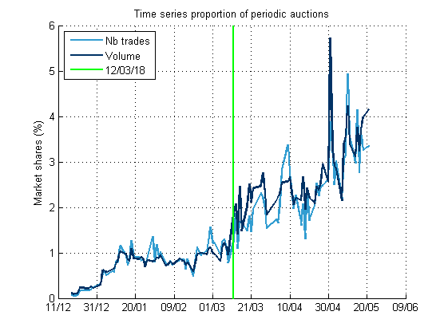

Figure – Periodic Auctions market shares (BATS & Turquoise) on the period 2017-12-18 to 2018-05-21 on the STOXX 600.

Table – Average market shares of Periodic Auctions on STOXX 600.

|  |  |  |  |
| --- | --- | --- | --- |
| From | To | Average market shares in number of trades (%) | Average market shares in volume (%) |
| 2017-12-18 | 2018-05-21 | 1.54 | 1.64 |
| 2017-12-18 | 2018-03-09 | 0.79 | 0.75 |
| 2018-03-12 | 2018-05-21 | 2.43 | 2.68 |

After the double volume cap introduction the 2018-03-12 a raise in the market shares seems to appear.

Below we represented , i.e. the market share of periodic auctions (of BATS and Turquoise) compared to the volume only on BATS and Turquoise (and not all listed markets as previously).

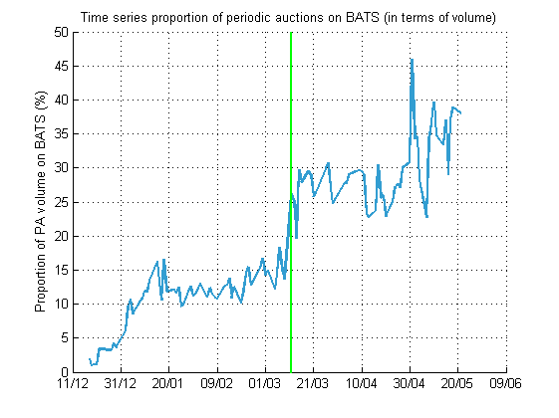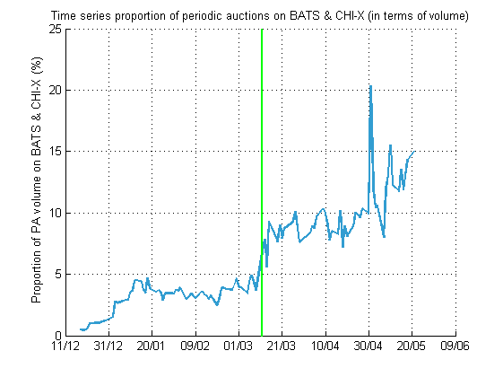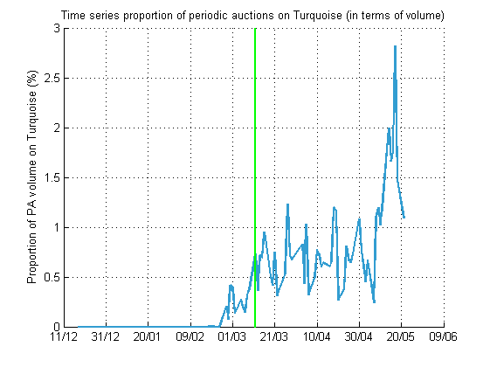

Figure – Proportion of Periodic Auctions on BATS (left), CHI-X & BATS (right) and Turquoise (bottom) over the total volume on its own venue, on the period 2017-12-18 to 2018-05-21, on the STOXX 600.

Table - BATS PA statistics, on the period 2018-06-01 to 2018-06-15, amounts in EUR.

|  |  |  |  |  |  |  |  |
| --- | --- | --- | --- | --- | --- | --- | --- |
| **Data** | **Name** | **MTD BATS total notional value traded** | **MTD BATS average daily total notional value traded** | **BATS average matched auctions per day** | **BATS average auction trade size** | **Listing Exchange lit average trade size** | **Maximum auction trade size** |
| BATS | Orange SA | 23,303,311 | 2,118,483 | 323 | 5,504 | 14,042 | 7,619 |
| KC | 23,301,180 | 2,118,289 | 330 | 5,505 | 6,984 | 7,619 |
| BATS | Publicis Groupe SA | 22,684,540 | 2,062,231 | 214 | 7,825 | 9,772 | 6,952 |
| KC | 22,684,540 | 2,062,231 | 221 | 7,825 | 5,353 | 6,952 |
| BATS | Danone SA | 19,478,178 | 1,770,743 | 282 | 5,005 | 13,594 | 3,204 |
| KC | 19,474,520 | 1,770,411 | 292 | 5,005 | 6,942 | 3,204 |
| BATS | Bayerische Motoren Werke AG | 18,977,542 | 1,725,231 | 256 | 5,466 | 21,233 | 1,030 |
| KC | 18,973,940 | 1,724,903 | 265 | 5,466 | 8,410 | 1,030 |
| BATS | Royal Dutch Shell PLC | 37,456,077 | 3,405,098 | 280 | 10,590 | 11,534 | 31,038 |
| KC | 37,551,240 | 3,413,749 | 285 | 10,620 | 7,131 | 31,038 |

#### Distinction between capped and uncapped stocks on the Darks

The label capped/uncapped on these stocks was taken from the parameter Workbook of BATS[4]. As of today there are 347 stocks labeled as capped and 250 as uncapped on BATS. Below is a Table that summarizes the capped/uncapped stocks

Table – Number of capped and uncapped stocks on BATS after each suspension date on STOXX 600.

|  |  |  |  |
| --- | --- | --- | --- |
| **As of** | **Nb capped stocks** | **Nb uncapped stocks** | **Nb capped stocks added** |
| 2018-03-12 | 316 | 281 | 316 |
| 2018-04-13 | 328 | 269 | 12 |
| 2018-05-15 | 347 | 250 | 19 |

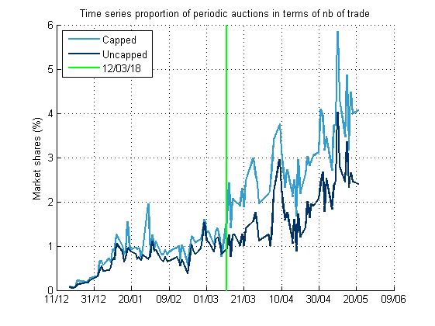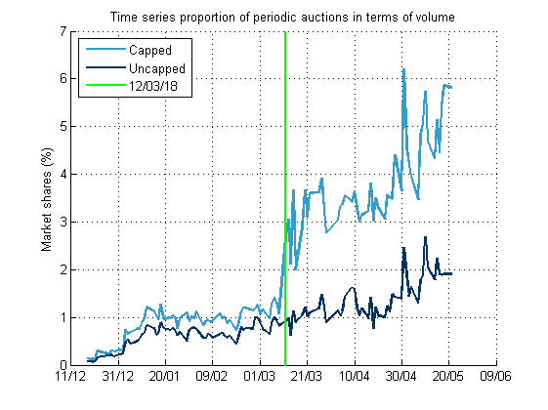

Figure – Periodic Auctions market share (BATS & Turquoise) on the period 2017-12-18 to 2018-05-21 in terms of number of trades (left) and volume (right).

At first sight it could seem odd that the market share in term of volume on uncapped stocks is not growing as fast as on the one in term of number of trades. Below we show that the ATS on Periodic Auction (BATS & Turquoise) relatively to the ATS on overall markets is pretty constant for uncapped stocks. While for capped ones there is a jump at the capped introduction date.

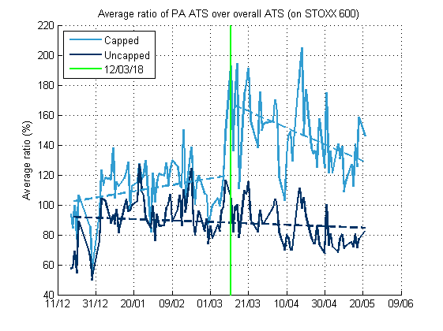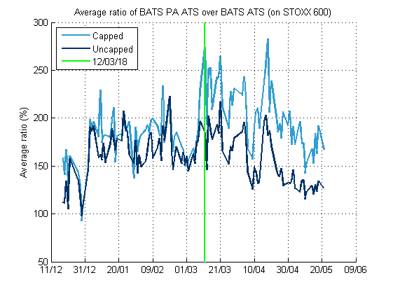

Figure – Ratio of Periodic Auction (BATS & Turquoise) ATS over overall (all listed markets of our data) ATS on the left ; and BATS PA ATS over BATS ATS on the right. On STOXX 600, on the period 2017-12-18 to 2018-05-21.

Table – Average market shares of Periodic Auctions (BATS & Turquoise), distinction being made between capped and uncapped stocks of STOXX 600.

|  |  |  |  |  |  |
| --- | --- | --- | --- | --- | --- |
| **From** | **To** | **Average market shares in number of trades (%)** | | **Average market shares in volume (%)** | |
| **Capped** | **Uncapped** | **Capped** | **Uncapped** |
| 2017-12-18 | 2018-05-21 | 1.82 | 1.22 | 2.22 | 0.97 |
| 2017-12-18 | 2018-03-09 | 0.87 | 0.70 | 0.88 | 0.61 |
| 2018-03-12 | 2018-05-21 | 2.94 | 1.84 | 3.80 | 1.40 |

#### Ratio between Turquoise and BATS on periodic auctions

The two leading companies that offer to their clients to trade on a periodic auction are Turquoise (LSE) and BATS (Cboe). The name of their periodic auction market is respectively Turquoise Lit Auctions and Cboe Periodic Auctions Book.

The goal of the following study is to see the evolution of the ratio (in number of trades or volume) between Turquoise and BATS on periodic auctions. Hence we can define as previously, where stands for Turquoise, and for Periodic Auctions

By the term Periodic Auction, we mean either Turquoise Lit Auction or Cboe Periodic Auctions Book (BATS). As in our data we have only trades on Turquoise or BATS periodic auctions, we have for Cboe Periodic Auctions Book, , and . So from now on we will only display and study the results on Turquoise Lit Auctions.

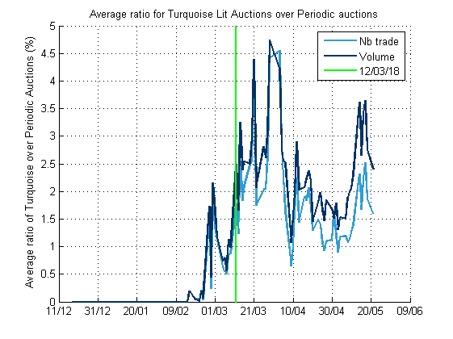

Figure – Ratio of Turquoise Lit Auctions over Periodic Auctions (BATS and Turquoise) on the period 2017-12-18 to 2018-05-21.

Table – Average market shares for Periodic Auctions of BATS and Turquoise over all our Periodic Auctions (BATS and Turquoise).

|  |  |  |  |  |
| --- | --- | --- | --- | --- |
| **Period** | **Average MS in nb of trades (%)** | | **Average MS in volume (%)** | |
| **Turquoise** | **BATS** | **Turquoise** | **BATS** |
| 2017-12-18 to 2018-05-21 | 0.94 | 99.06 | 1.20 | 98.80 |
| 2017-12-18 to 2018-03-09 | 0.17 | 99.83 | 0.21 | 99.79 |
| 2018-03-12 to 2018-05-21 | 1.85 | 98.16 | 2.38 | 97.62 |

As previously we will investigate by distinguishing between capped and uncapped stocks on the Darks. The following Figures show these time series for capped and uncapped stocks on STOXX 600.

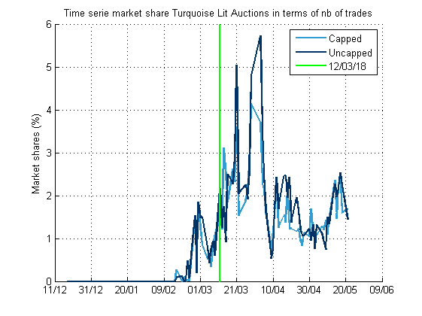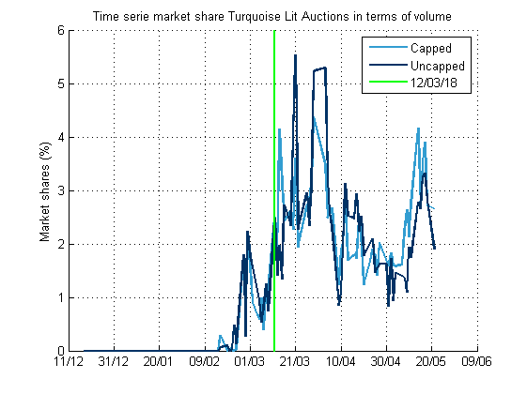

Figure – Turquoise Lit Auctions market shares on the period 2017-12-18 to 2018-05-21 in terms of number of trades (left) and volume (right).

### Possible correlations

Here we will investigate if the market shares on periodic auctions are correlated with one or many structural characteristics of the stock. To conduct this study we chose to look at the average daily market shares (in volume) on periodic auctions for stocks in STOXX 600 against the factor of interest.

Note that the average daily market shares on (in volume) on the period , noted , is different from the market shares (full period) on , on the period , noted :

However, over our period, on STOXX 600 empirical observations show that it’s almost the same measure.

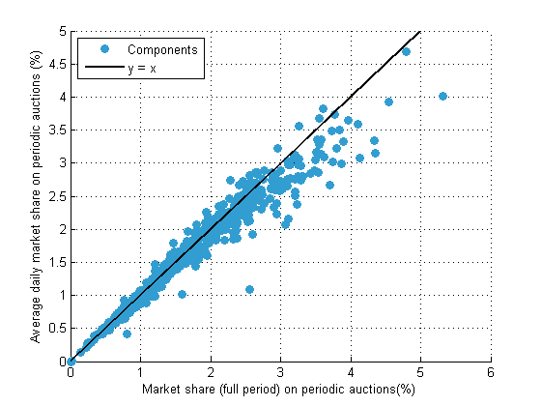

Figure – Average daily market shares of periodic auctions (BATS & Turquoise) against the market share (full period) on periodic auctions on the period 2017-12-18 to 2018-05-21, on STOXX 600 (one dot per share).

#### Market Capitalization

The market capitalization of a stock is defined as

We will use an equivalent, which is the free float methodology: instead of taking the total number of shares issued we are only taking the number of shares not locked-in by insiders, governments, *etc*. The source used is Bloomberg.

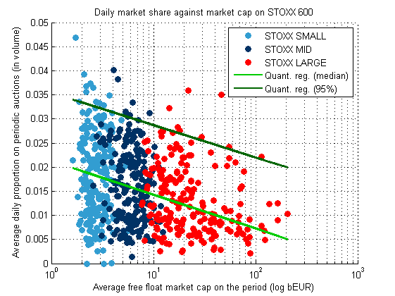

Figure – Average daily market shares on periodic auctions (BATS & Turquoise) against free float market cap on the period 2017-12-18 to 2018-05-21 on the STOXX 600 (one dot per stock).Logarithm scale for the x axis.

Results are displayed at Figure 8, and the average market shares are printed below in Table 6. When we look at first at the scatter plot it is not very clear but it seems that market shares is negatively correlated with market capitalization. This correlation (if verified) is weak.

Table – Average market shares of Periodic Auctions on the period 2018-02-21 to 2018-04-16.

|  |  |  |
| --- | --- | --- |
| Index | Average Market shares in volume (%) | Average Free Float Market Capitalization (bEUR) |
| STOXX 600 | 1.59 | 13.6 |
| STOXX SMALL | 1.81 | 2.8 |
| STOXX MID | 1.66 | 6.3 |
| STOXX LARGE | 1.31 | 31.5 |

We can also add the distinction between capped and uncapped stocks. As showed earlier, the market shares on capped stocks are significantly higher than on uncapped ones.

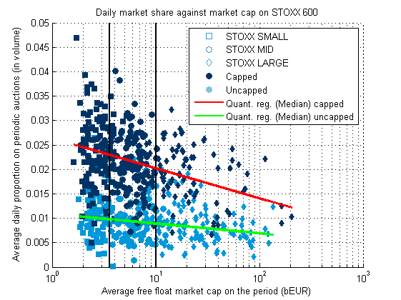

Figure – Average daily market shares against free float market cap, distinction being made between capped and uncapped stocks, on the period 2017-12-18 to 2018-05-21 on the STOXX 600 (one dot per stock).Logarithm scale for the x axis.

Table – Summary on capped and uncapped stocks on Bats dark market for different indexes, as of the date of this document.

|  |  |  |  |
| --- | --- | --- | --- |
| Index | Capped | Uncapped | Total |
| STOXX 600 | 347 | 250 | 597 |
| STOXX SMALL | 125 | 73 | 198 |
| STOXX MID | 123 | 76 | 199 |
| STOXX LARGE | 99 | 101 | 200 |

#### Volatility

Here we estimated the daily volatility of a stock by

where is the daily yield of the stock at time , i.e.

The period of estimation is the same as our observations, *i.e.* from 2017-12-18 to 2018-05-21. On the following graph which printed the results, we exclude five extreme values (volatility between 6.8% and 11%):

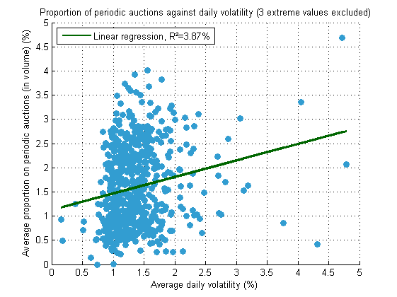

Figure – Average daily market shares on periodic auctions (BATS & Turquoise) against average daily volatility, both computed on the period 2017-12-18 to 2018-05-21 on the STOXX 600 (one dot per share, three extreme values excluded).

#### Number of trades

For each stock we computed the average number of trades (overall markets and on darks) over the period.

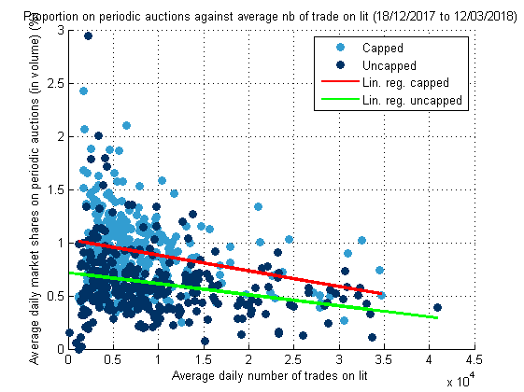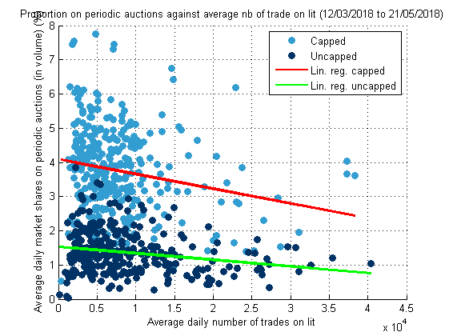

Figure – Average daily market shares against average number of trades on lit (all listed markets of our IDC), on the period 2017-12-18 to 2018-03-12 (left) and 2018-03-12 to 2018-05-21 (right), on STOXX 600 (one dot per stock). Non-aggregated trades.

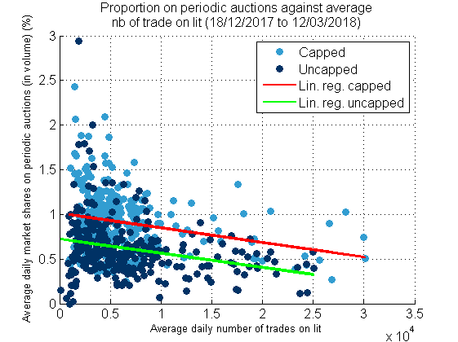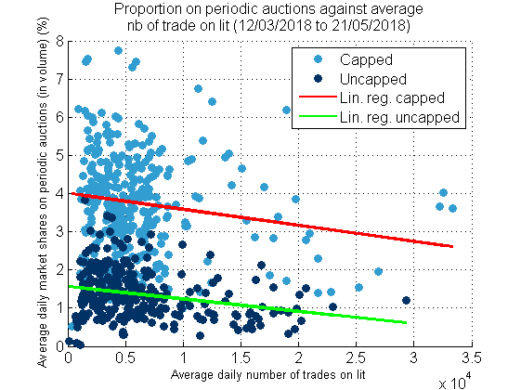

Figure – Average daily market shares against average number of trades on lit (all listed markets of our IDC), on the period 2017-12-18 to 2018-03-12 (left) and 2018-03-12 to 2018-05-21 (right), on STOXX 600 (one dot per stock). Aggregated trades.

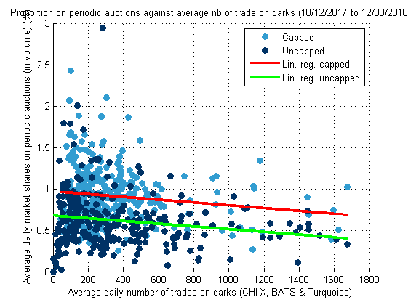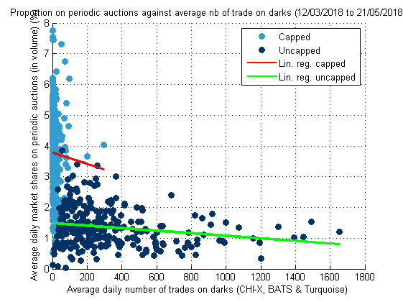

Figure – Average daily market shares against average number of trades on darks (CHI-X, BATS & Turquoise), on the period 2017-12-18 to 2018-03-12 (left) and 2018-03-12 to 2018-05-21 (right), on STOXX 600 (one dot per stock). Non-aggregated trades.

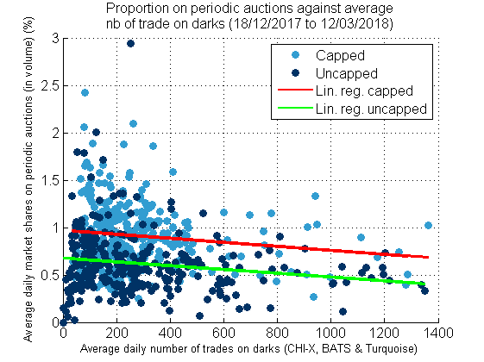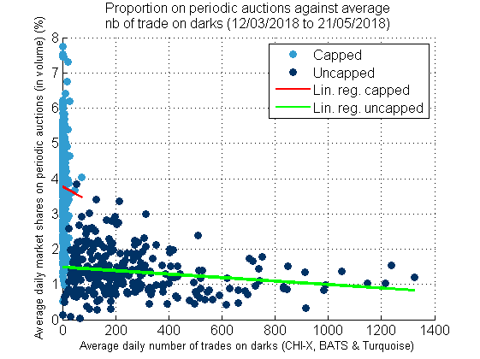

Figure – Average daily market shares against average number of trades on darks (CHI-X, BATS & Turquoise), on the period 2017-12-18 to 2018-03-12 (left) and 2018-03-12 to 2018-05-21 (right), on STOXX 600 (one dot per stock). Aggregated trades.

#### Market shares on Darks

Two different shapes appear on the scatter plot, if stocks are either capped or uncapped. For two different periods (before and after the cap introduction) results are printed in the Figure below.

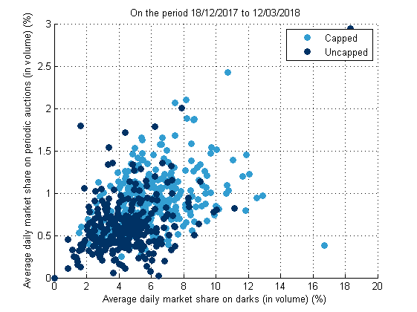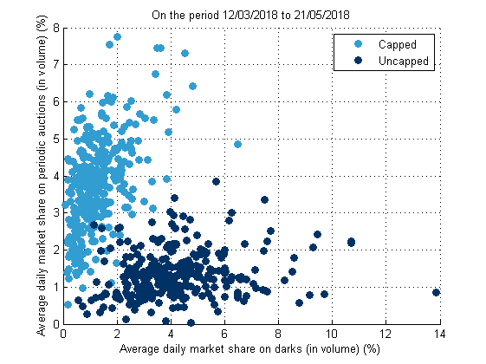

Figure – Average daily market shares on periodic auctions (in volume) against average daily market shares on Darks (in volume), on the period 2017-12-18 to 2018-03-12 (left) and 2018-03-12 to 2018-05-21 (right), on STOXX 600 (one dot per share).

It is strange that the market share on darks after the cap is not in our data.

Table – Average daily market shares on periodic auctions over capped/uncapped stocks of the STOXX 600 on different periods.

|  |  |  |
| --- | --- | --- |
| **Period** | **Average on capped stocks (%)** | **Average on uncapped stocks (%)** |
| 2017-12-18 to 2018-05-21 | 2.17 | 0.95 |
| 2017-12-18 to 2018-03-12 | 0.91 | 0.62 |
| 2018-03-12 to 2018-05-21 | 3.76 | 1.36 |

### Volume densities

#### Overall trading venues (BATS & Turquoise)

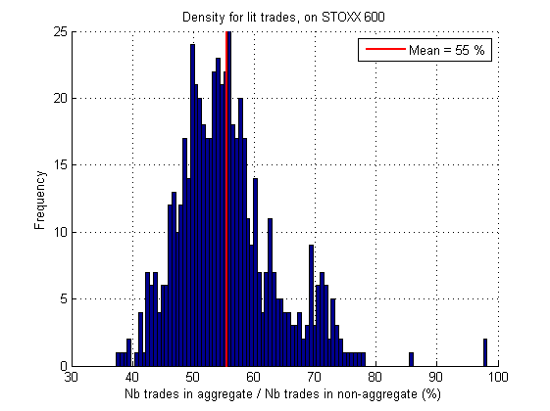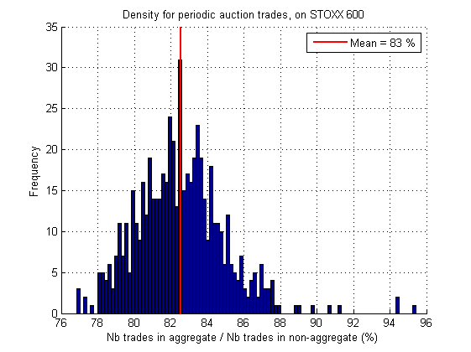

Figure - Density of the proportion of number of aggregated trades over number of non-aggregated trades, on STOXX 600. Over the period 2017-12-18 to 2018-07-31.

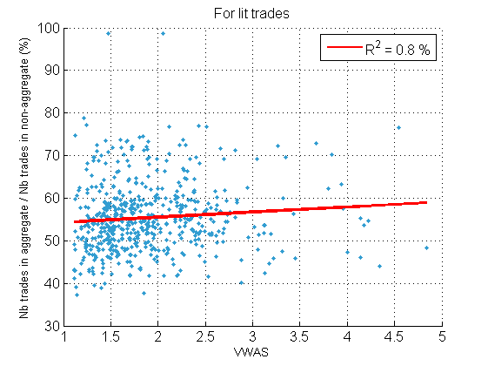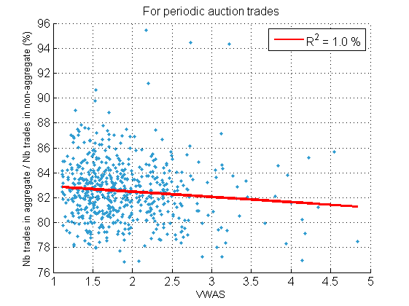

Figure - Number of aggregated trades over number of non-aggregated trades against the VWAS, on STOXX 600. On the period 2017-12-18 to 2018-07-31.

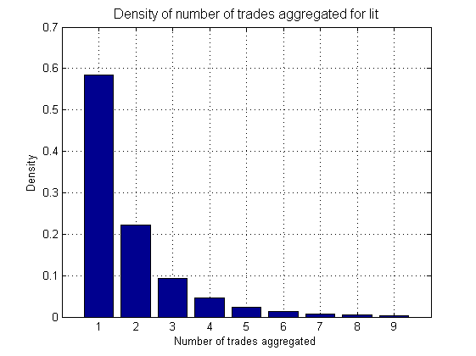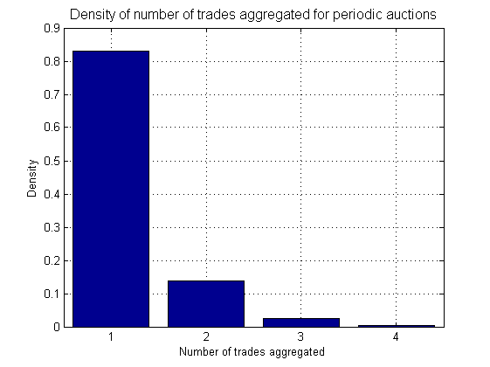

Figure - Densities of number of trades aggregated on lit (left) and periodic auctions (right). On STOXX 600, on the period 2017-12-18 to 2018-07-31.

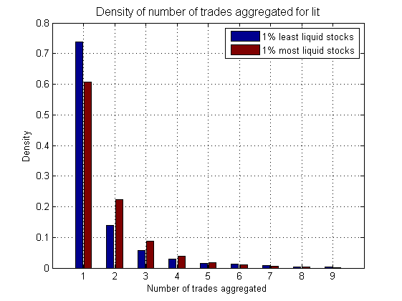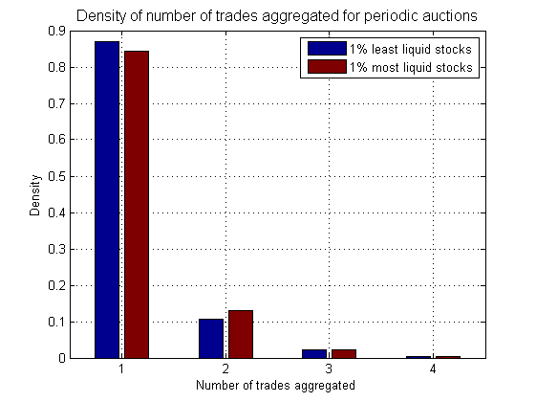

Figure - Density of the number of aggregated stocks for the 1% most and least liquid stocks of the STOXX 600. On the period 2017-12-18 to 2018-07-31.

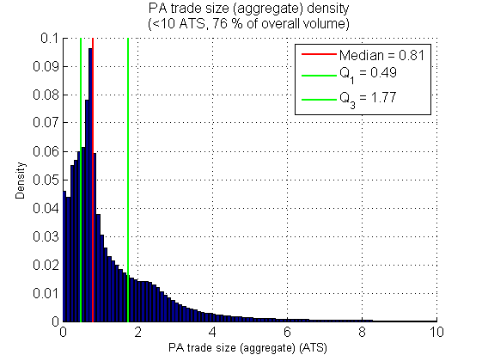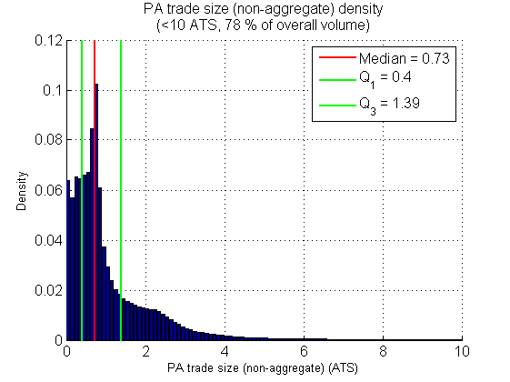

Figure - Trade size density of aggregated (left) and non-aggregated periodic auction trades. On STOXX 600, on the period 2017-12-18 to 2018-07-31.

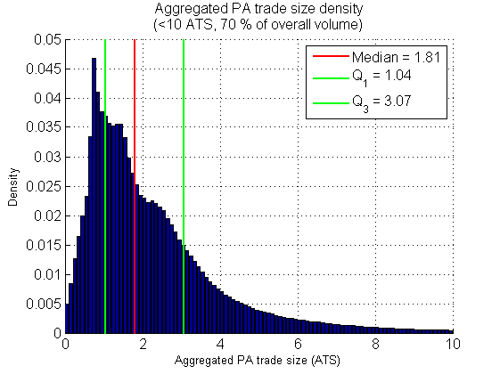

Figure - Trade size density of aggregated periodic auction trades. On STOXX 600, on the period 2017-12-18 to 2018-07-31.

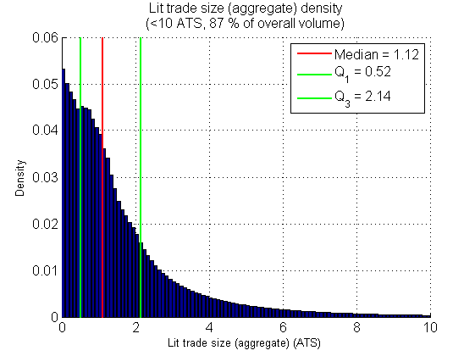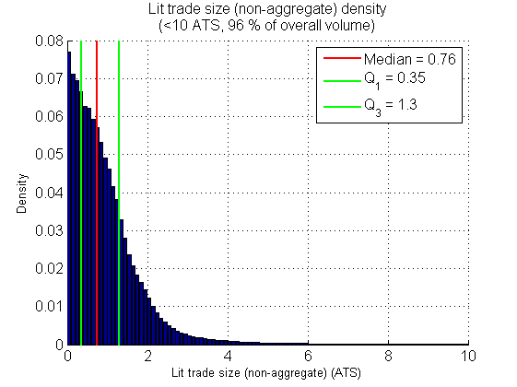

Figure - Trade size density of aggregated (left) and non-aggregated lit trades. On STOXX 600, on the period 2017-12-18 to 2018-07-31.

#### Distinction capped and uncapped stocks

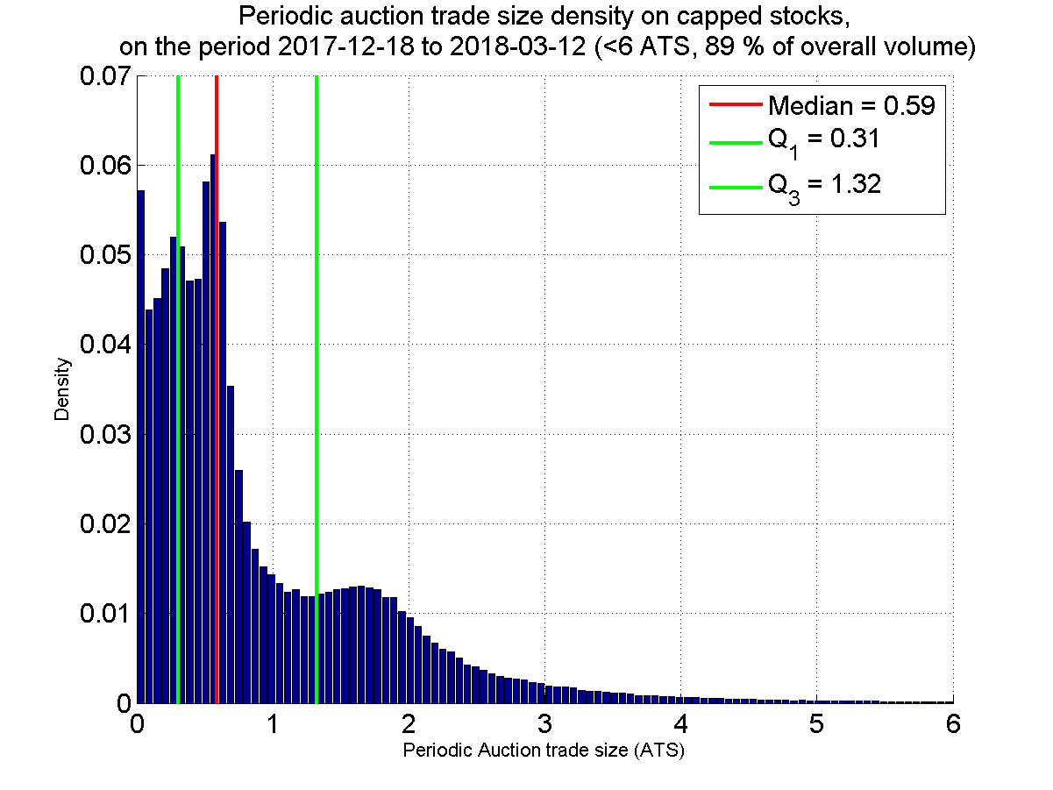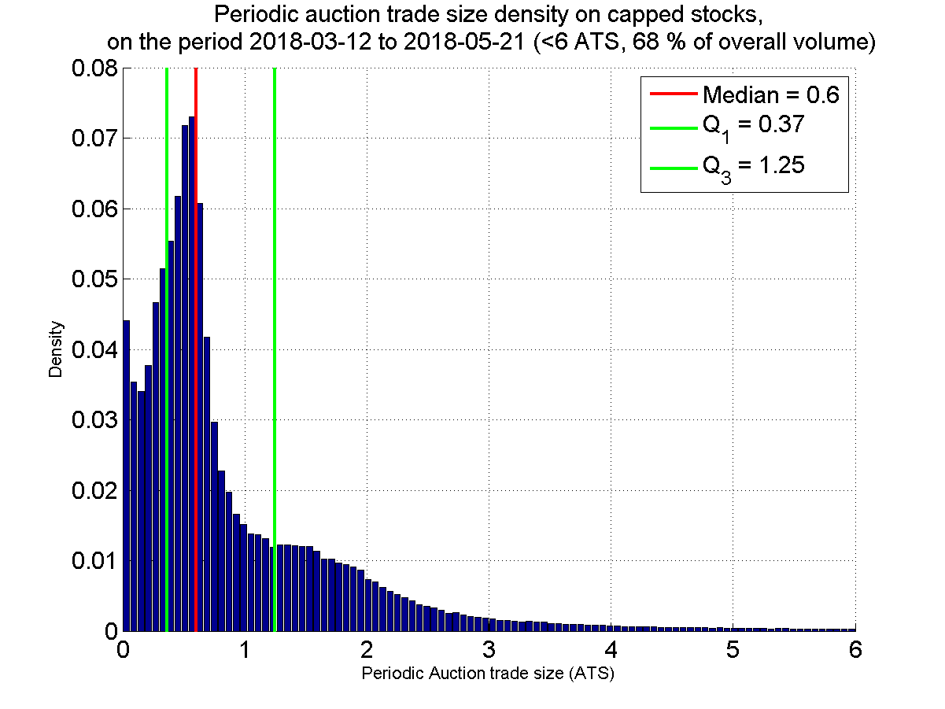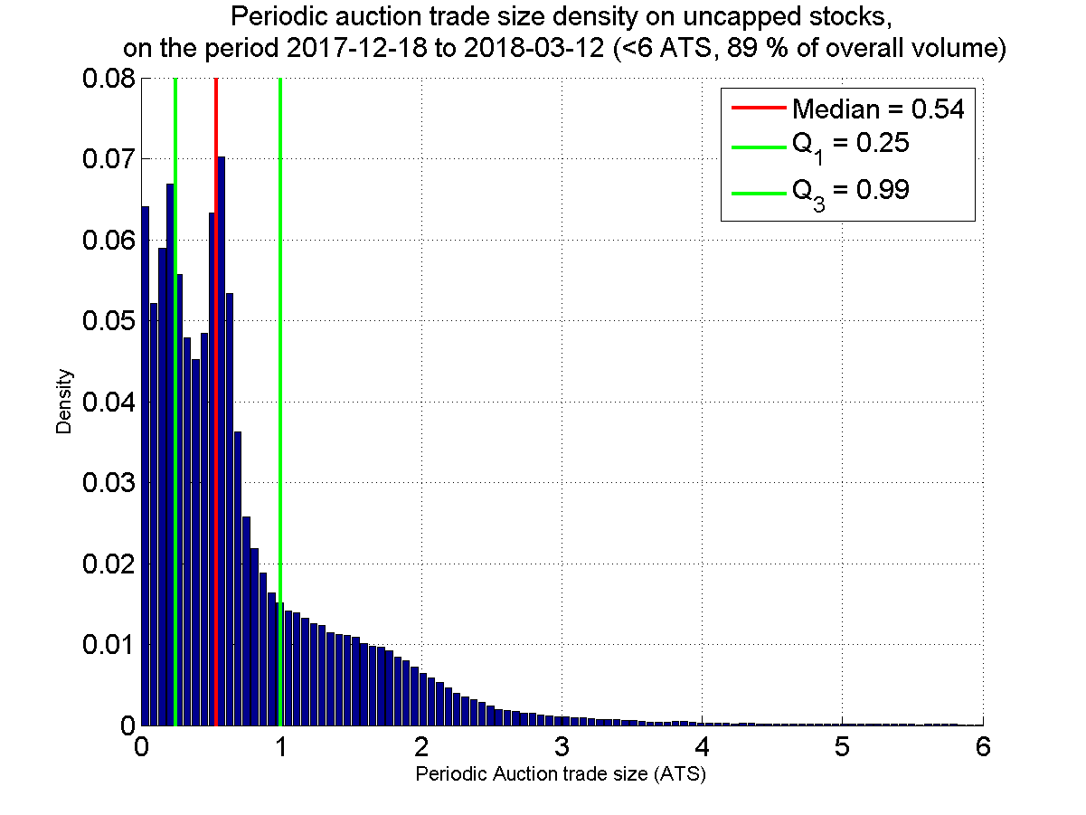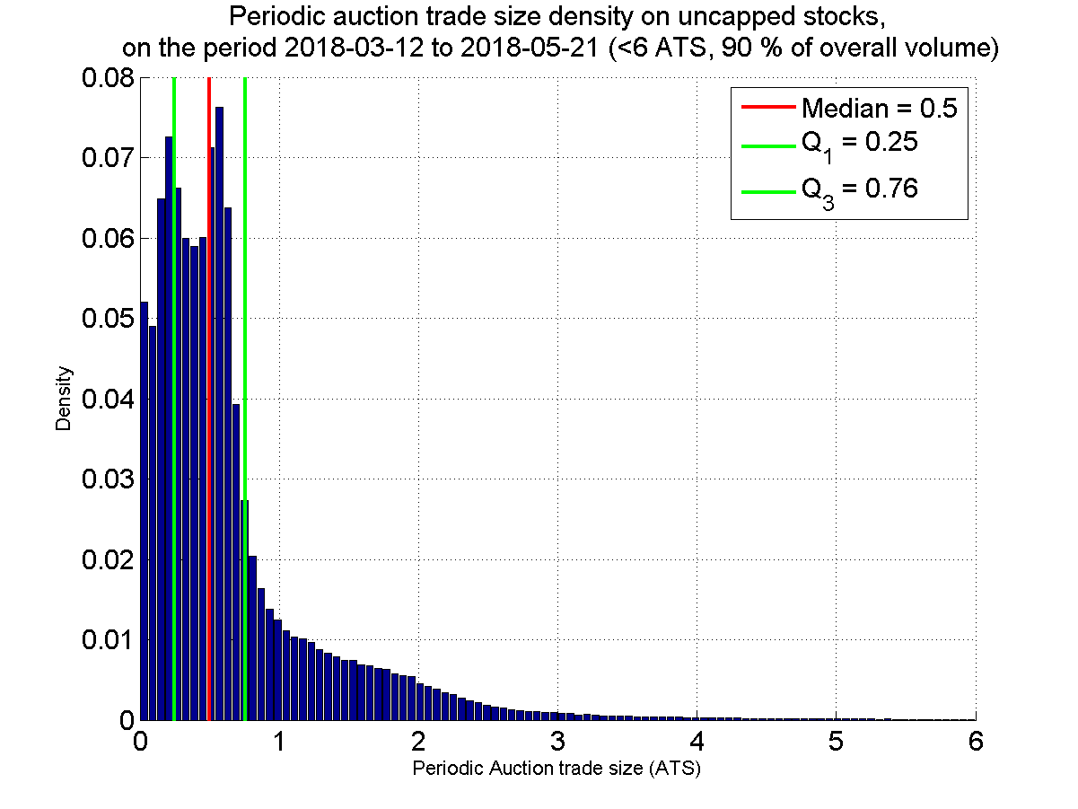

Figure – Periodic Auction trade size density for capped (top) and uncapped (bottom) stocks, before (left) and after (right) the double cap introduction. On STOXX 600, on the period 2017-12-18 to 2018-07-31. Non-aggregated trades.

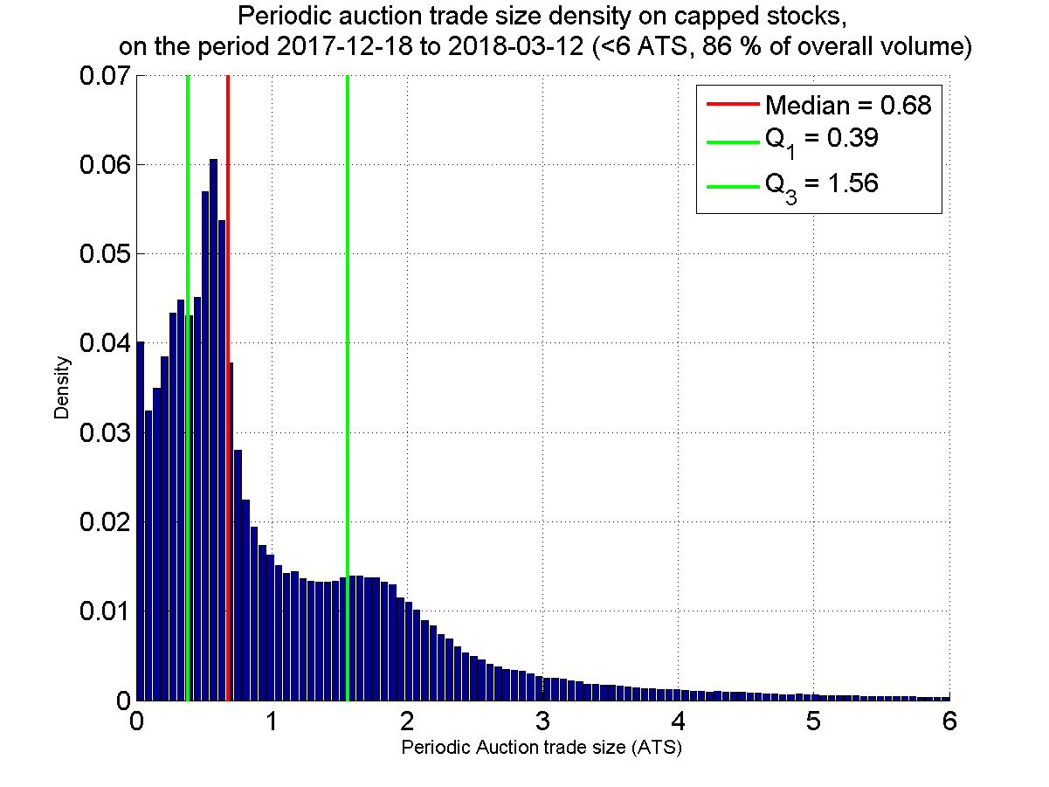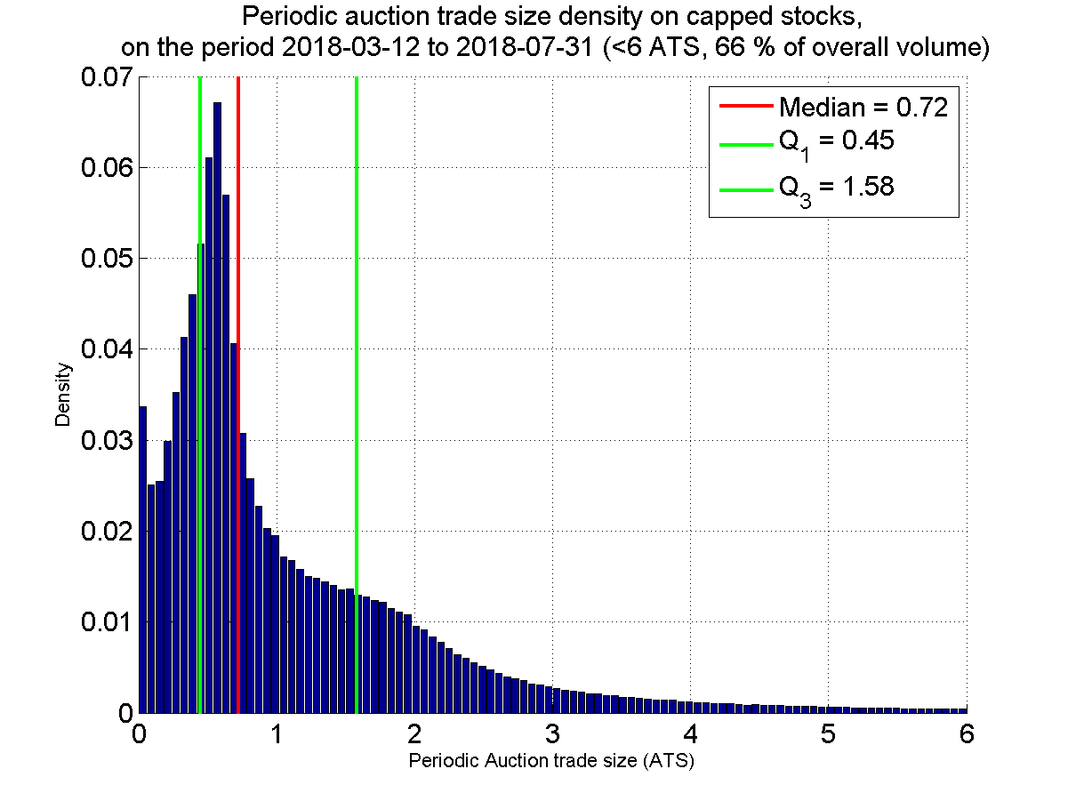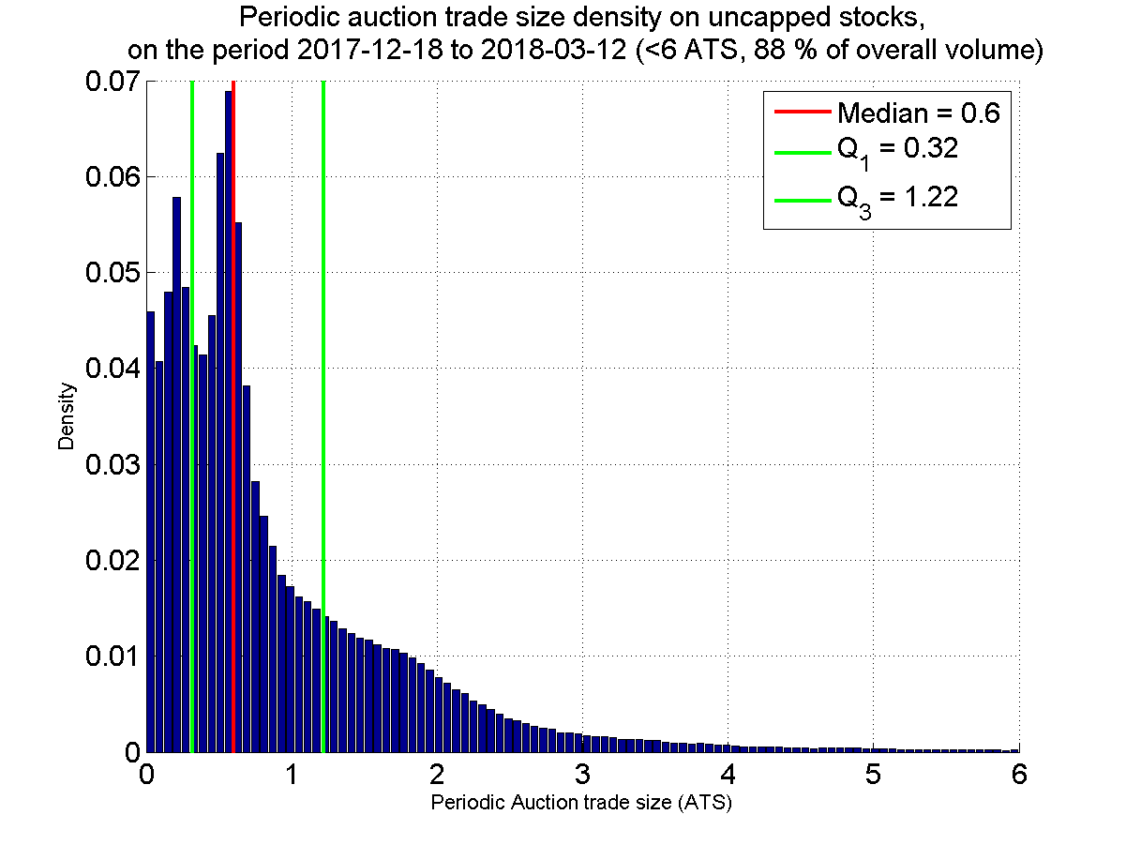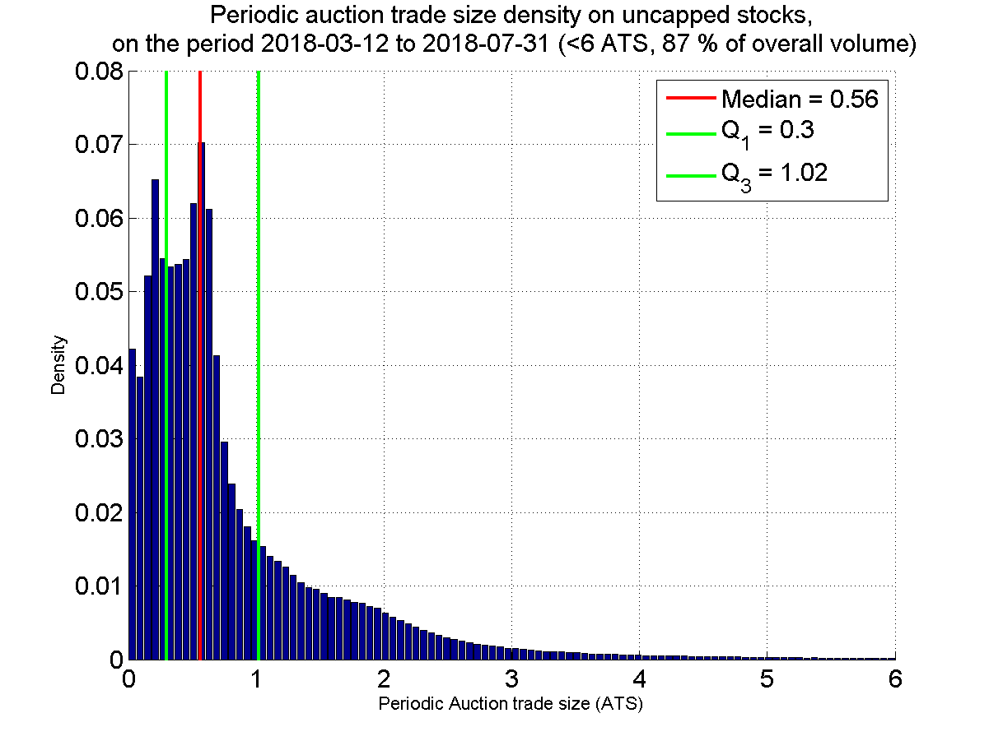

Figure – Periodic Auction trade size density for capped (top) and uncapped (bottom) stocks, before (left) and after (right) the double cap introduction. On STOXX 600, on the period 2017-12-18 to 2018-05-21. Aggregated trades.

The lit trade size density is identical for the two periods and for capped/uncapped stocks.

#### Distinction Bats & Turquoise

We will now see if there are significant changes in the pdf according to the trading venue (BATS or Turquoise). The ATS is always computed with respect to the TV, hence there is a BATS ATS and a Turquoise ATS for each stock at each date.

On average over the STOXX 600 and on the period 2017-12-18 to 2018-05-21, Turquoise ATS represents 57% of the Primary ATS, while BATS ATS represents 46% of Primary ATS.

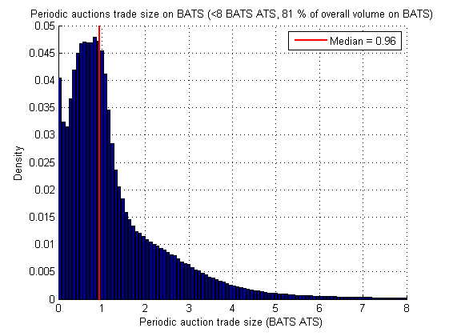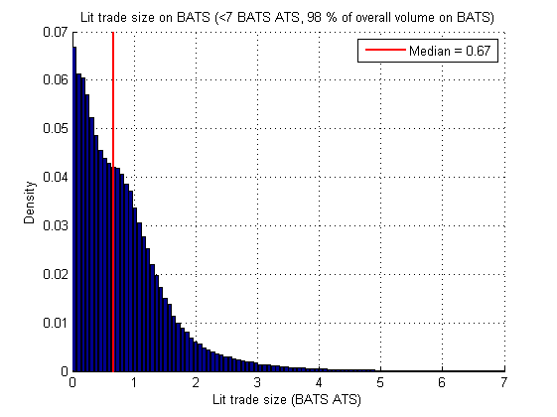

Figure – Empirical pdf of the periodic auction (left) and lit market (right) trade size on BATS, expressed in BATS ATS (on the period 2017-12-18 to 2018-05-21, on STOXX 600). Non-aggregated trades.

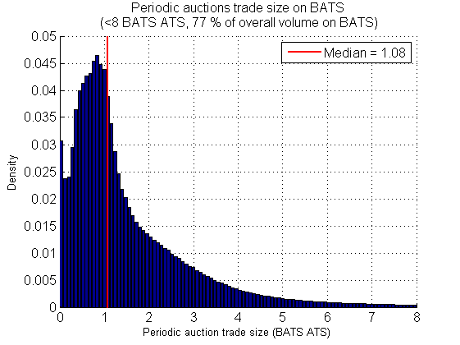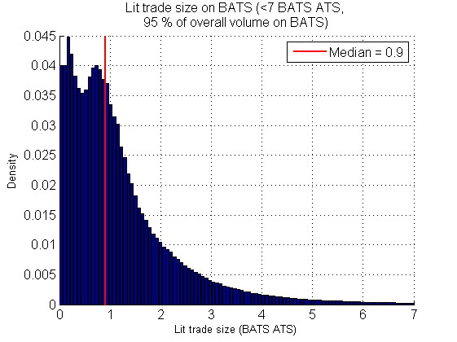

Figure – Empirical pdf of the periodic auction (left) and lit market (right) trade size on BATS, expressed in BATS ATS (on the period 2017-12-18 to 2018-07-31, on STOXX 600). Aggregated trades.

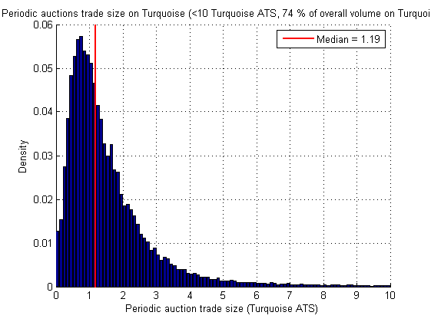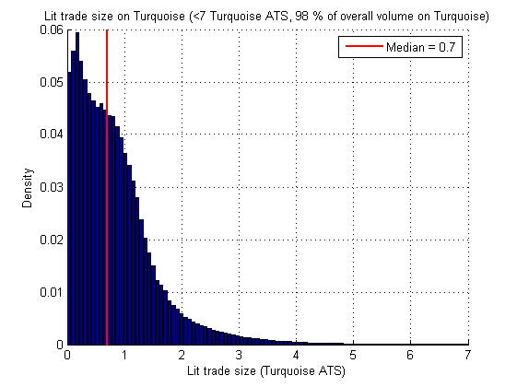

Figure – Empirical pdf of the periodic auction (left) and lit market (right) trade size on Turquoise, expressed in Turquoise ATS (on the period 2017-12-18 to 2018-05-21, on STOXX 600). Non-aggregated trades.

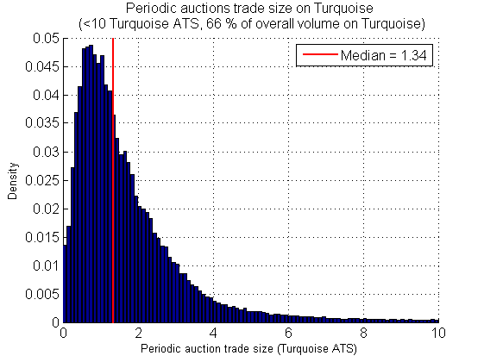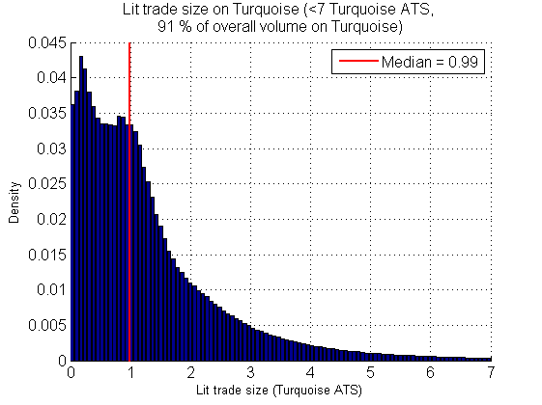

Figure – Empirical pdf of the periodic auction (left) and lit market (right) trade size on Turquoise, expressed in Turquoise ATS (on the period 2017-12-18 to 2018-07-31, on STOXX 600). Aggregated trades.

Note that the mode is not located near zero as for lit trades. This is probably due to the minimum size execution option, offered by both BATS and Turquoise (see Section 1.1.3).

## Settlement price analysis

### Deviation between settlement price and mid-point at auction settlement

We computed for each stock of STOXX 600 the difference between the auction settlement price (only on BATS Periodic Auction) and the mid-point of Cboe EBBO of the last quote update received before the settlement, on the period 2018-02-21 to 2018-04-16. We also displayed the difference between the settlement price and the best ask.

A1

A2

Q2

End of the call

Beginning of the call

Q1

Figure – Example of Periodic Auction messages during a call.

Where Qi are quote updates from the EBBO and Ai are Auction update messages[5] (see Section 1.1.2). At the end of the call the price and volume executable will be the same as in A2, and we will look at the difference between this price and the midpoint of Q2.

A quick computation over STOXX 600 on the period 2018-05-21 to 2018-05-25 showed that 10% of the time there is a quote update after the last auction update message of the call. Meaning that 10% of the time we have access to a mid-point that is after the last auction order that lead in a change in execution volume and/or price.

This gives us a distribution of this measure for each 599 stocks. Except for six stocks where there is no Periodic Auction trades on BATS.

Recall the distribution of the VWAS on STOXX 600

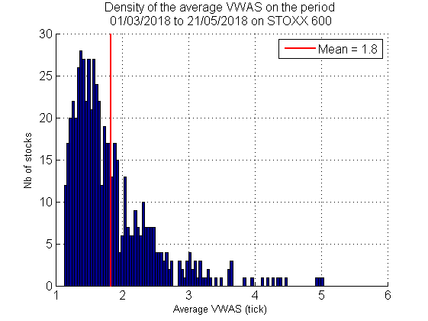

Figure - Density of the average VWAS (on the period 01/03/2018 to 21/05/2018), on STOXX 600.

#### Halma

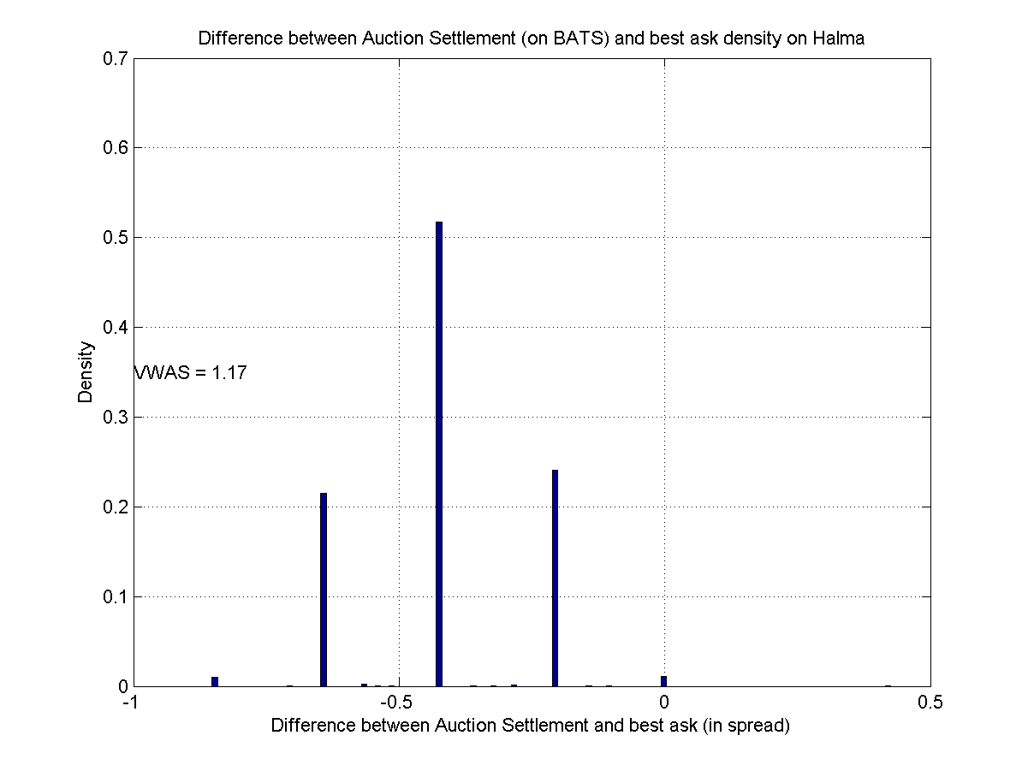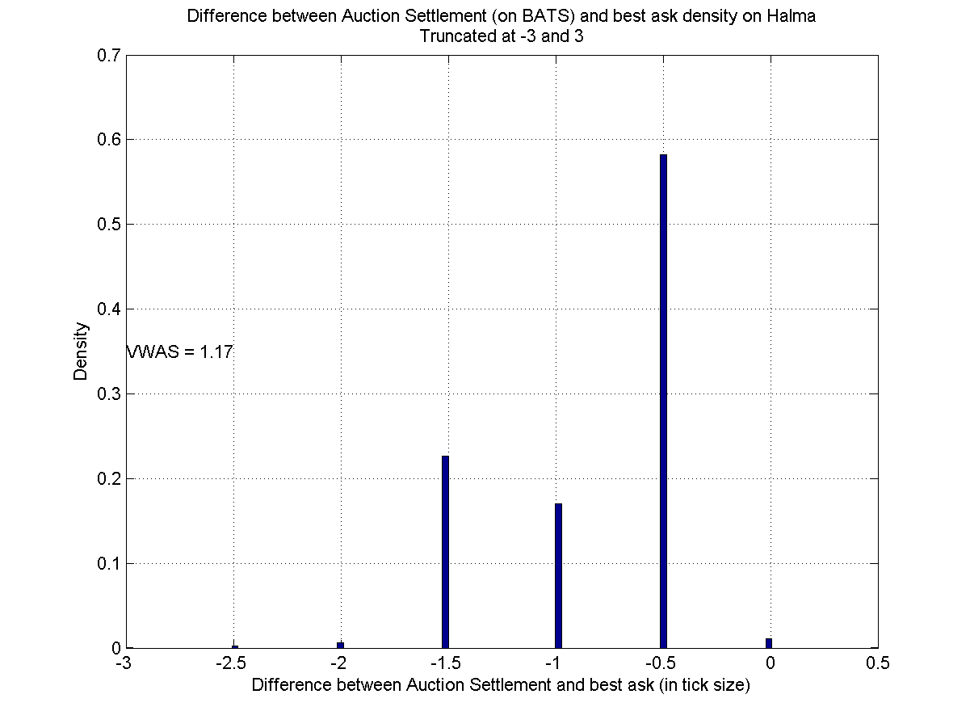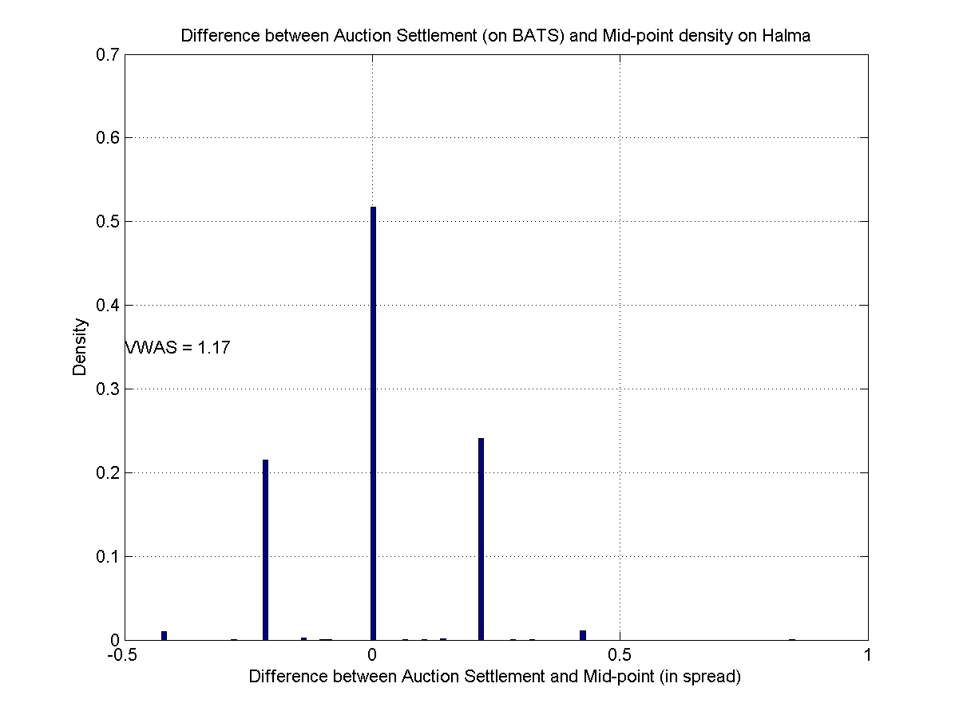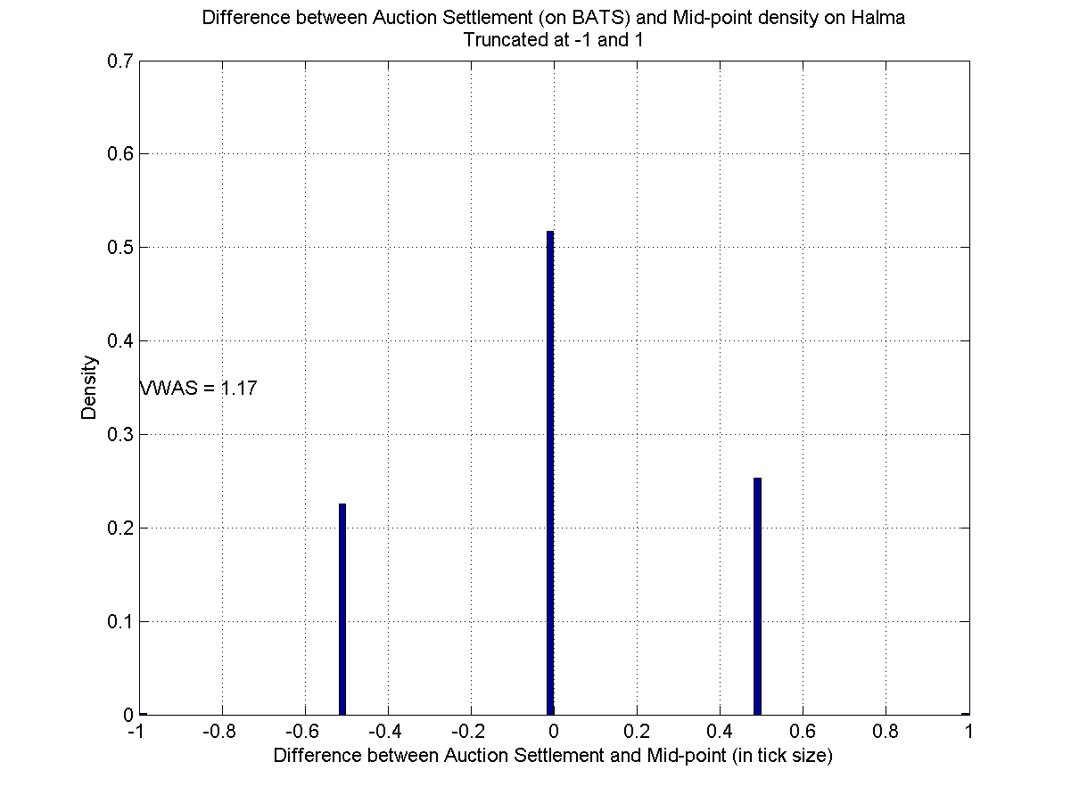

Figure – Difference between Periodic Auction (BATS) price settlement and last observed mid-point (bottom) or best ask (top), in spread (left) or tick (right), on the period 2017-12-18 to 2018-05-21.

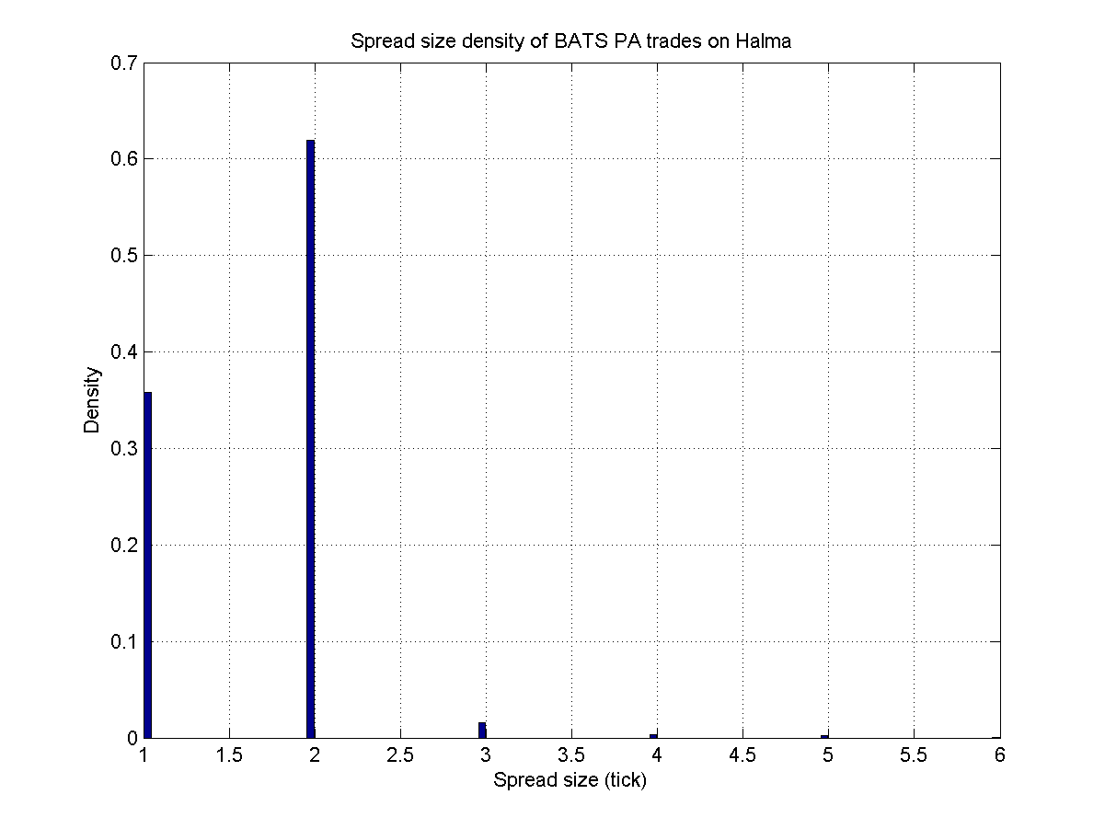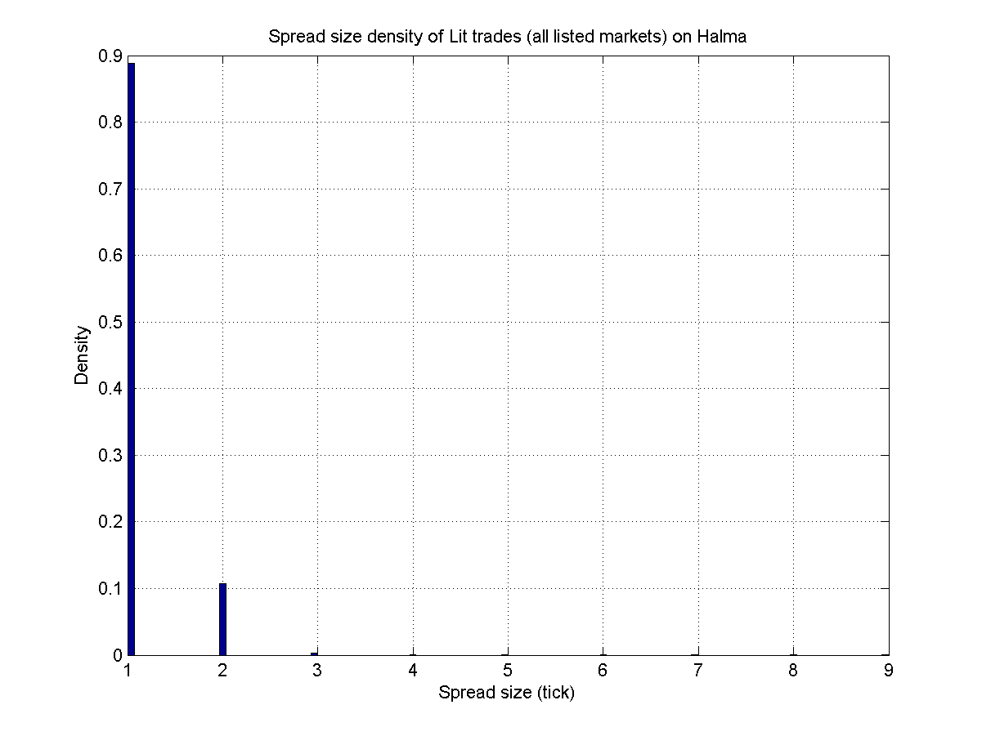

Figure – Spread size density (in tick) on Periodic Auctions (BATS) (left) and lit (all listed markets) (right), on the period 2017-12-18 to 2018-05-21.

#### AkzoNobel

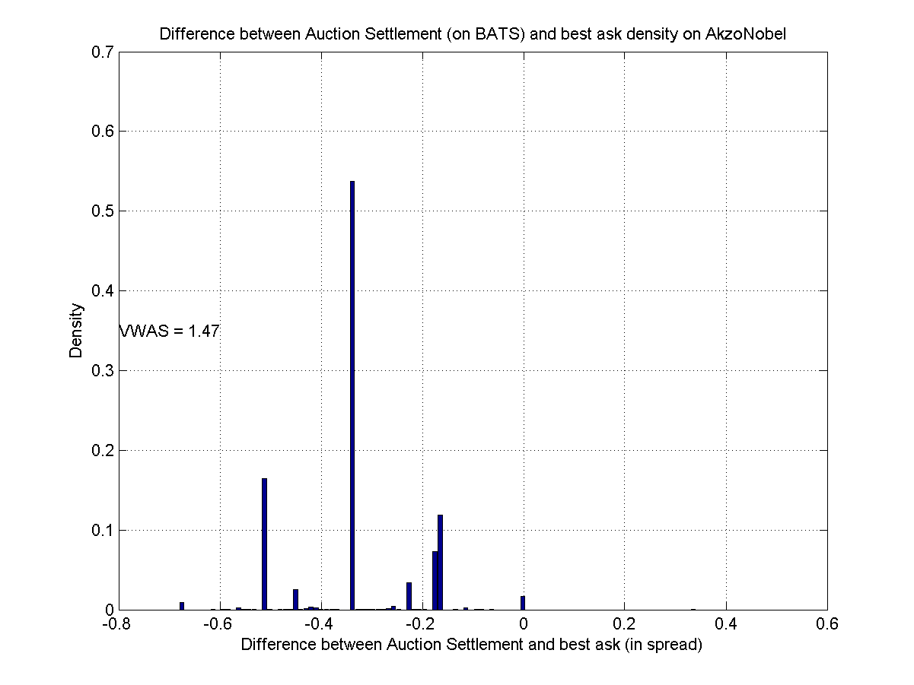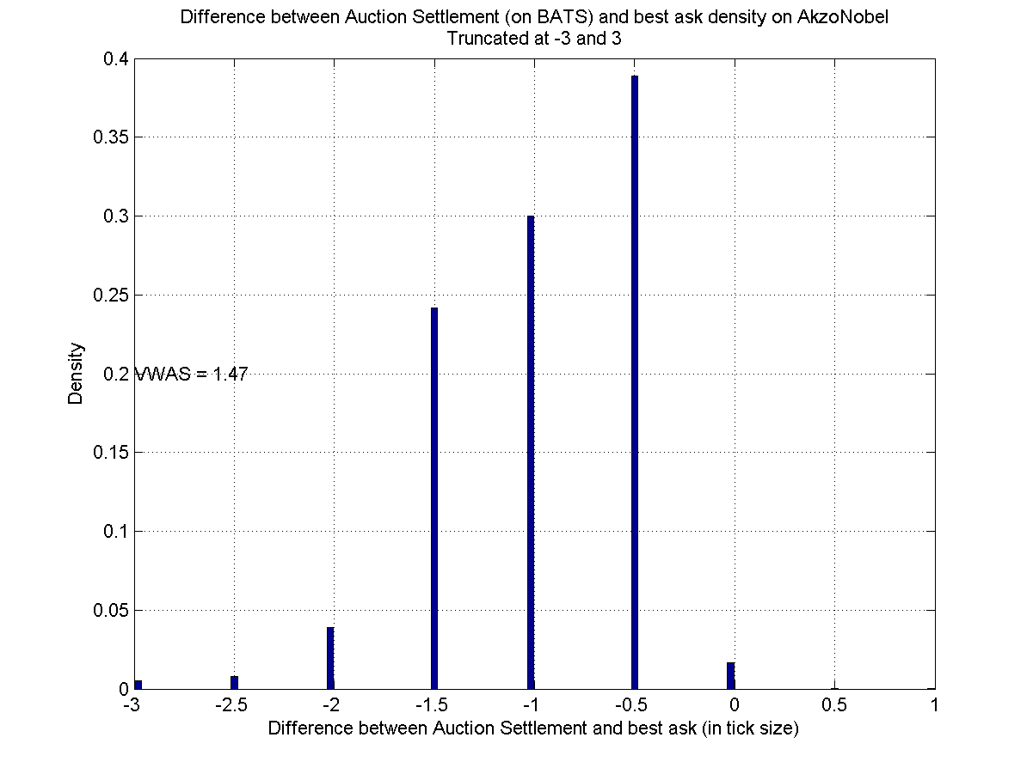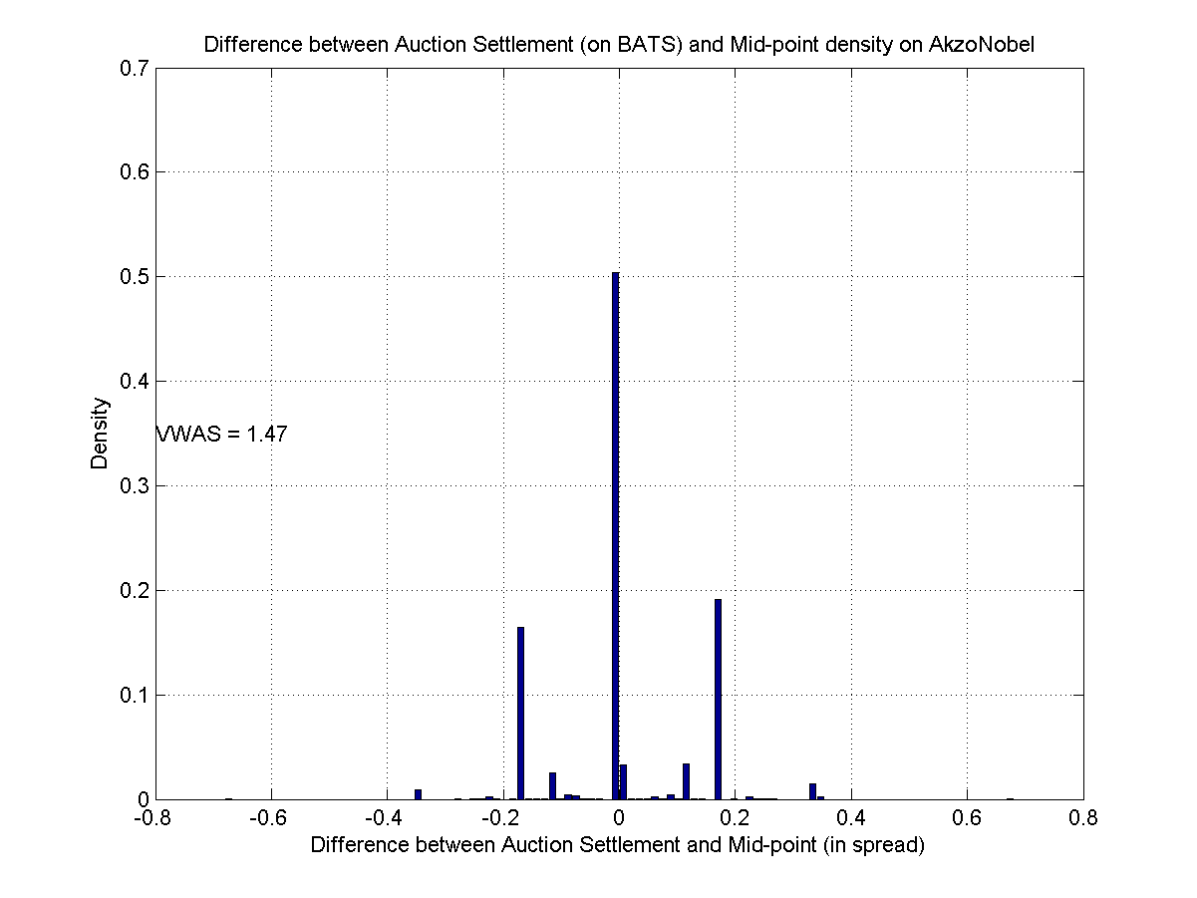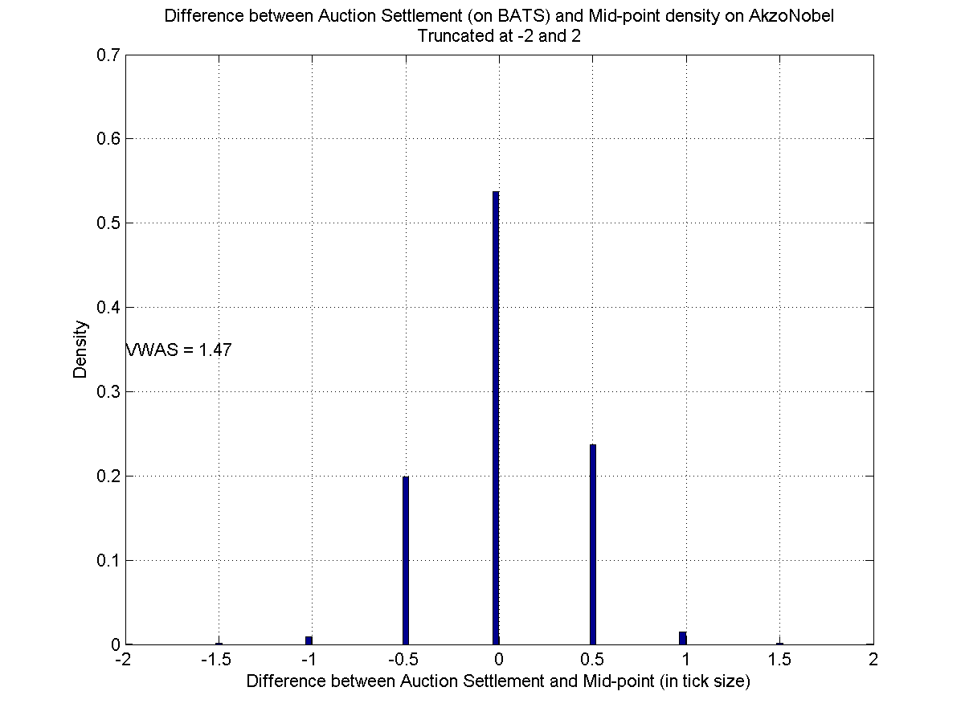

Figure – Difference between Periodic Auction (BATS) price settlement and last observed mid-point (bottom) or best ask (top), in spread (left) or tick (right), on the period 2017-12-18 to 2018-05-21.

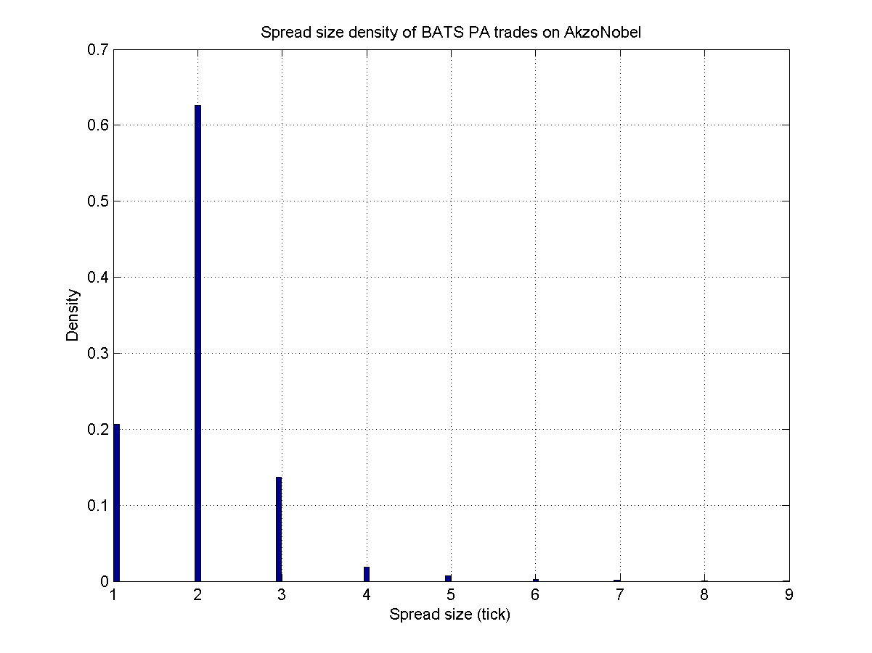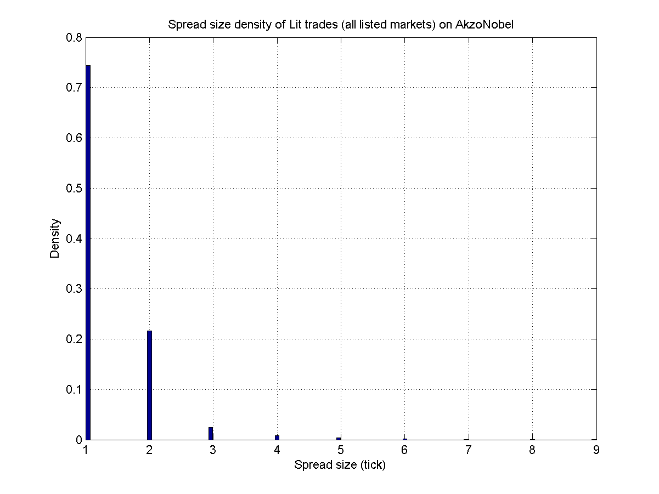

Figure – Spread size density (in tick) on Periodic Auctions (BATS) (left) and lit (all listed markets) (right), on the period 2017-12-18 to 2018-05-21.

#### TP ICAP

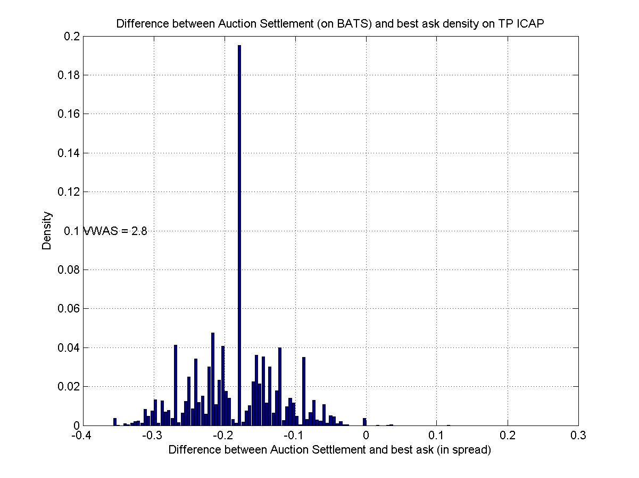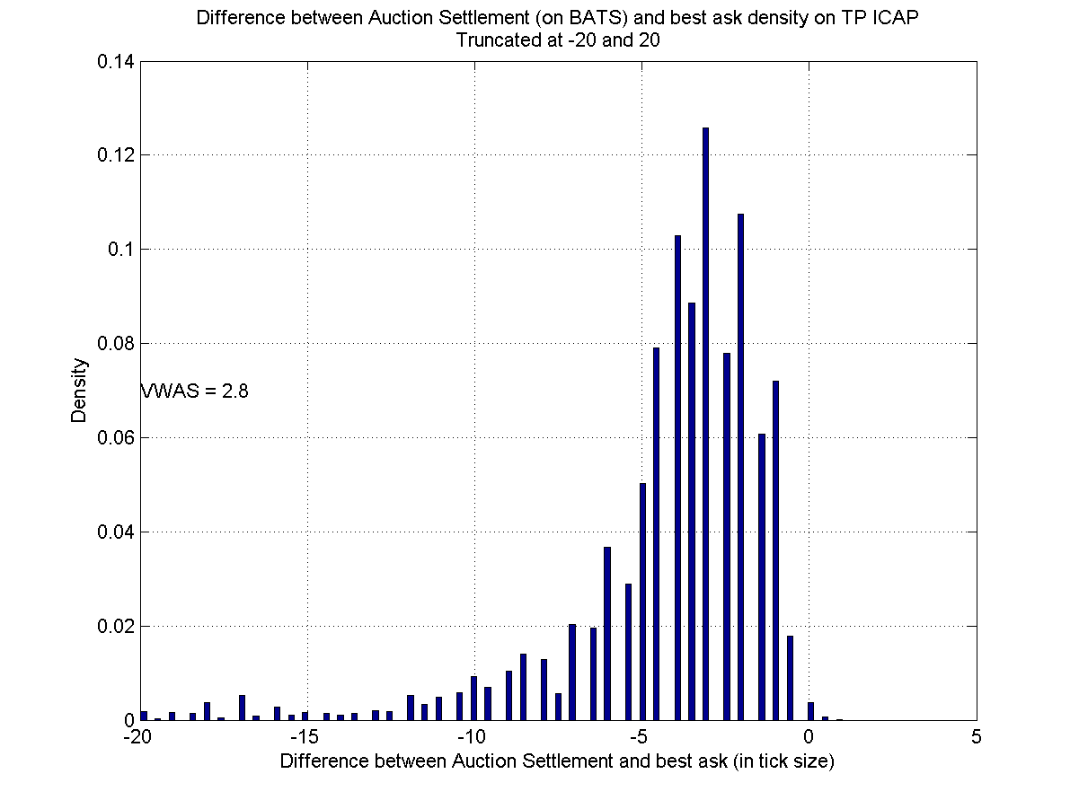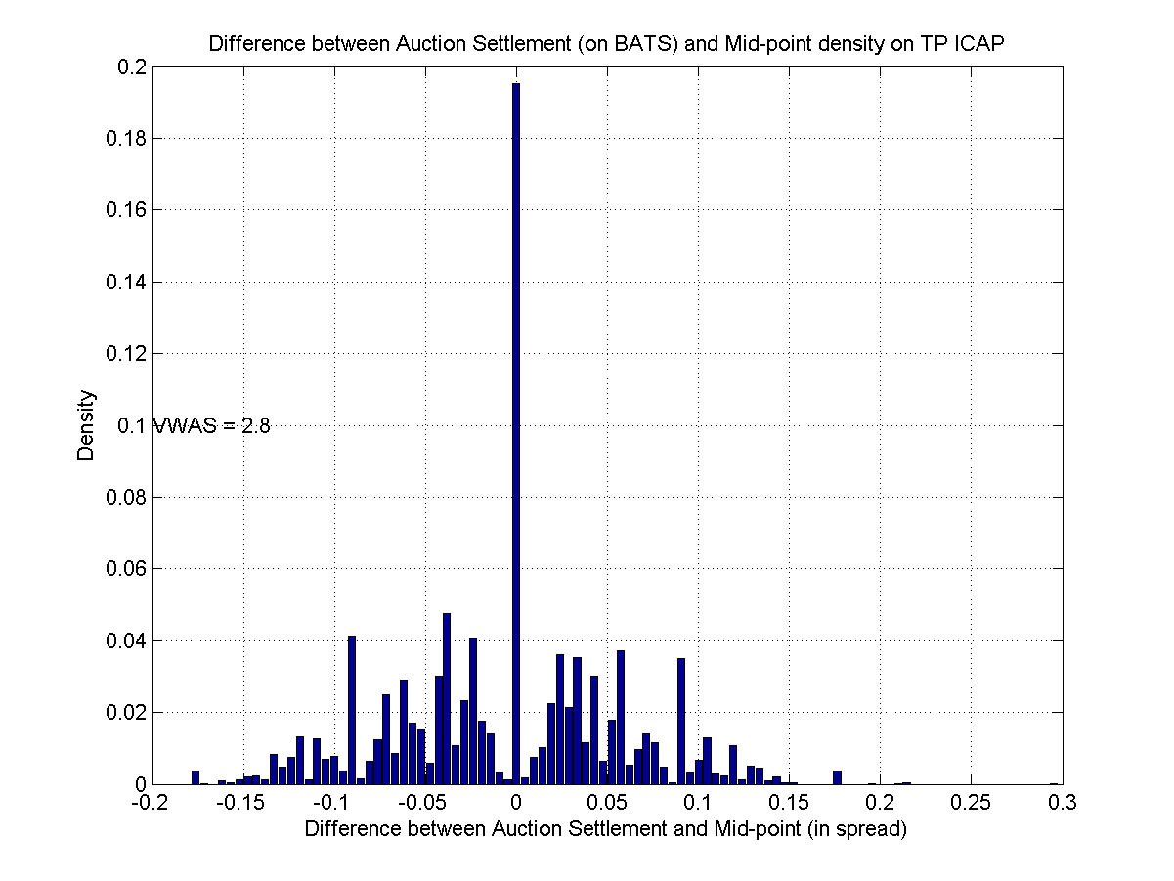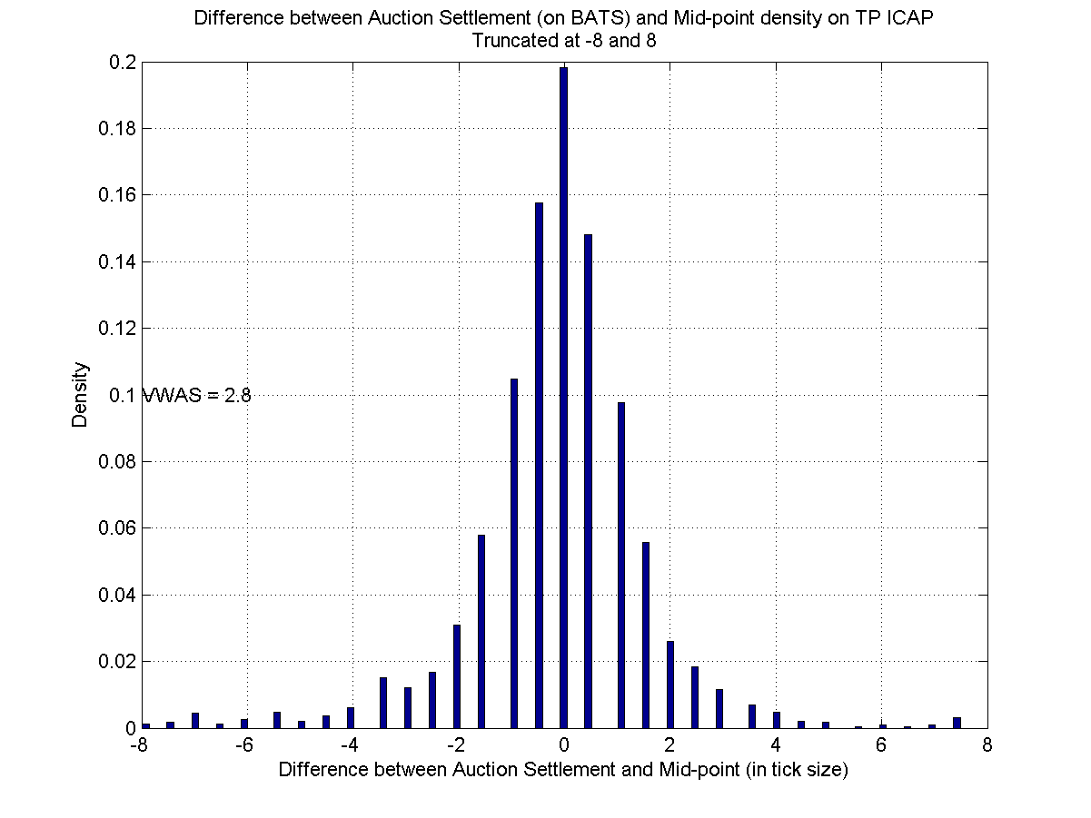

Figure – Difference between Periodic Auction (BATS) price settlement and last observed mid-point (bottom) or best ask (top), in spread (left) or tick (right), on the period 2017-12-18 to 2018-05-21.

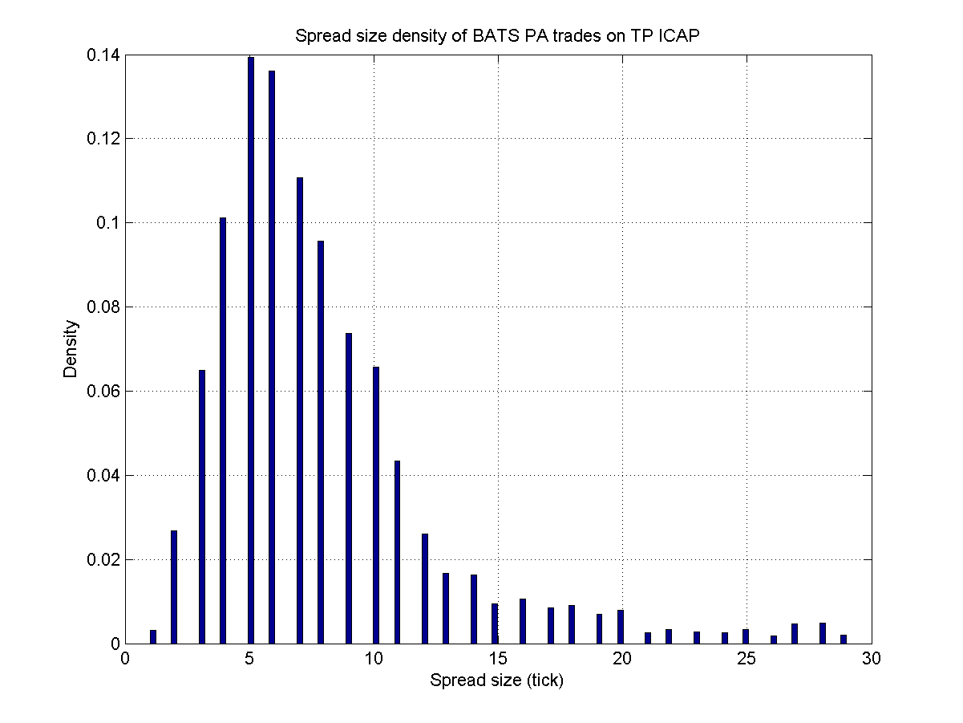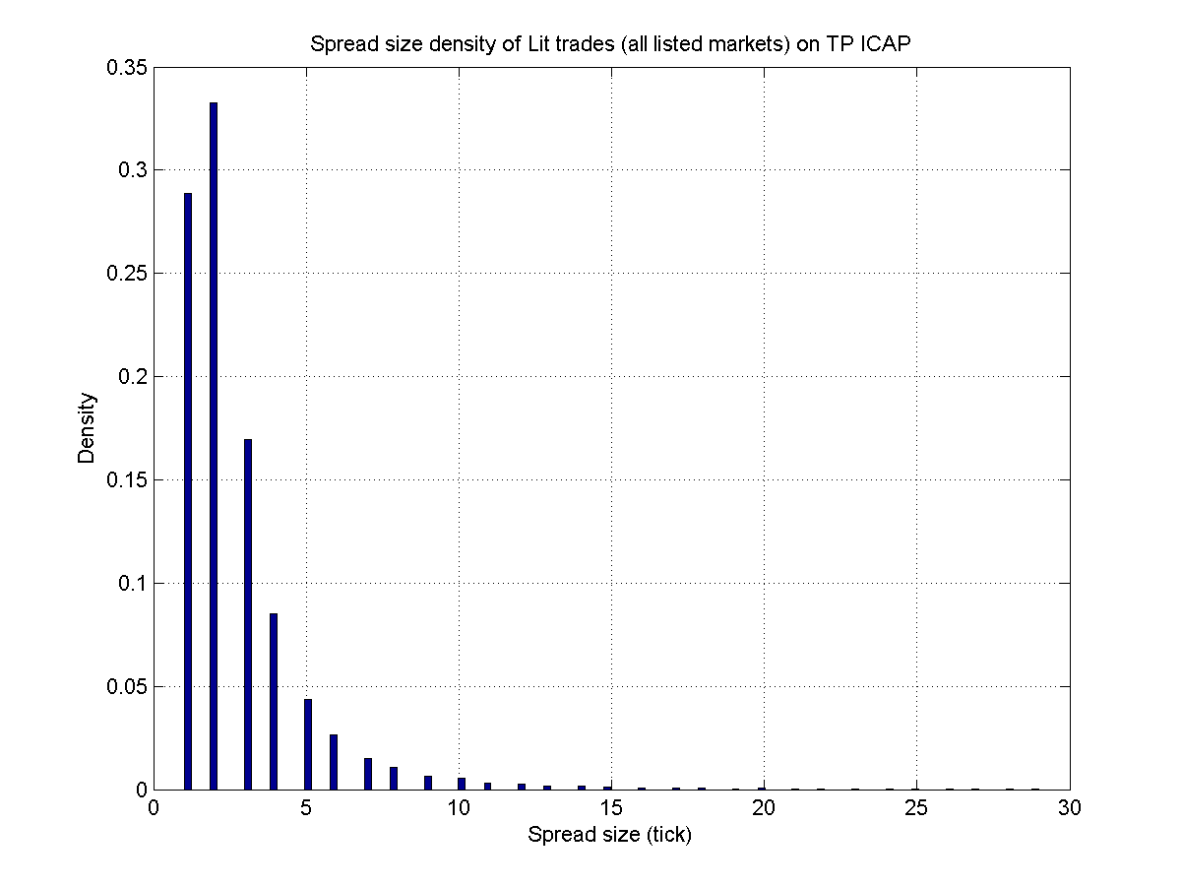

Figure – Spread size density (in tick) on Periodic Auctions (BATS) (left) and lit (all listed markets) (right), on the period 2017-12-18 to 2018-05-21.

Note that the difference with the best ask is almost never (strictly) positive, confirming that an order outside the collar will not be executed.

#### Characteristics

##### Settlement

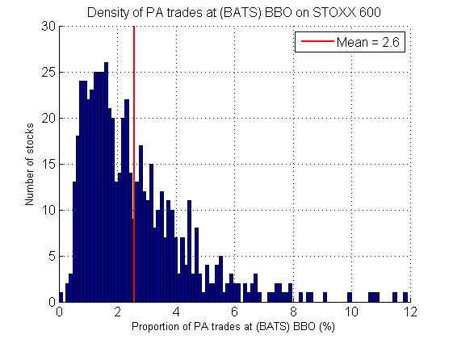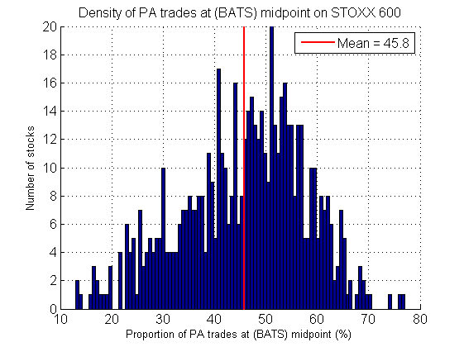

Figure - Proportion of settlement at BBO (left) and midpoint (right) (BATS quote) density, on STOXX 600, on the period 2017-12-18 to 2018-05-21.

##### Proportion of settlement at midpoint

###### For each stock

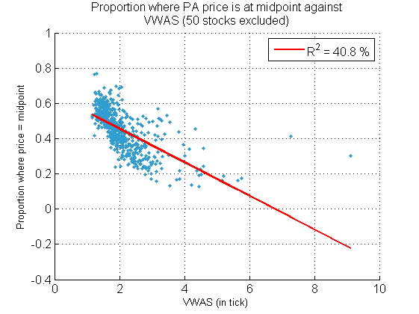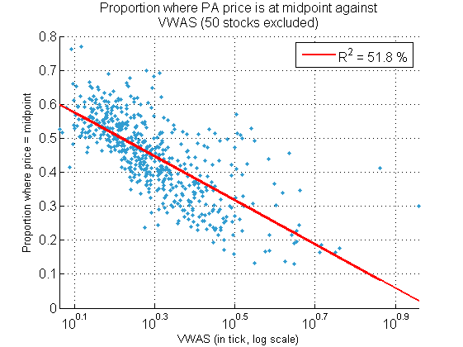

Figure – Proportion of price at midpoint against VWAS, on STOXX600, on the period 2017-12-18 to 2018-05-21. One dot per stock.

The two stocks that have a high VWAS are AMBU (7.3) and AIB Group PLC (9.1).

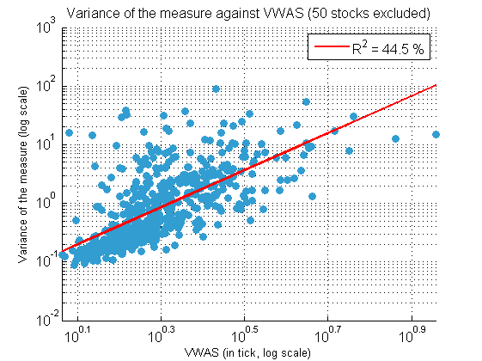

Figure – Variance of the measure (right) against VWAS, on STOXX600, on the period 2017-12-18 to 2018-05-21. One dot per stock.

###### For different spread

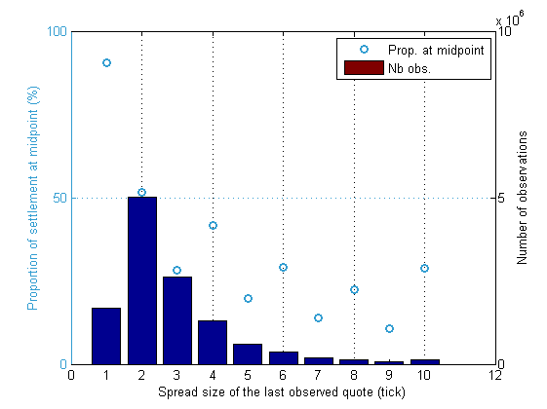

Figure - Proportion of PA settlement price at midpoint of the last observed quote against the spread of the last observed quote. On STOXX 600, on the period 2017-12-18 to 2018-07-31.

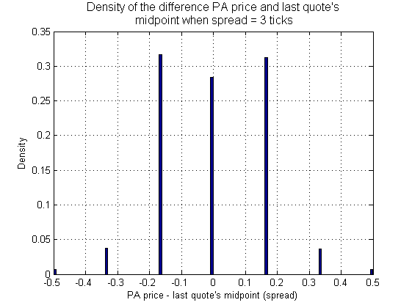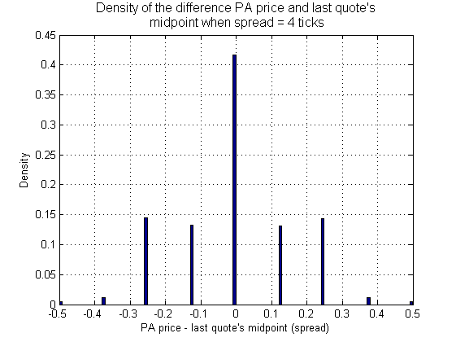

Figure - Density of the difference PA price and last observed quote's midpoint, when the spread is equal to 3 (left) and 4 (right) ticks. On STOXX 600, on the period 2017-12-18 to 2018-07-31.

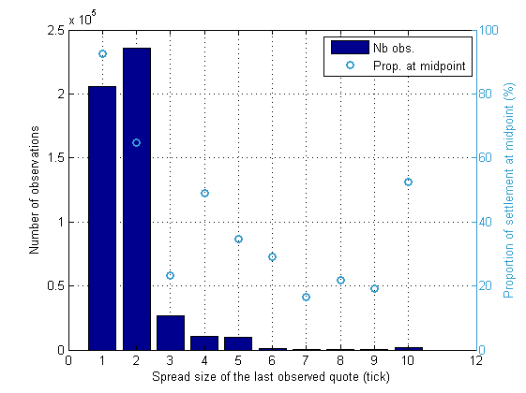

Figure – Proportion of PA price settlement at midpoint against spread, when the spread of the last observed quote is equal to the spread of the last observed trade (4 % of the time). On STOXX 600, on the period 2017-12-18 to 2018-07-31.

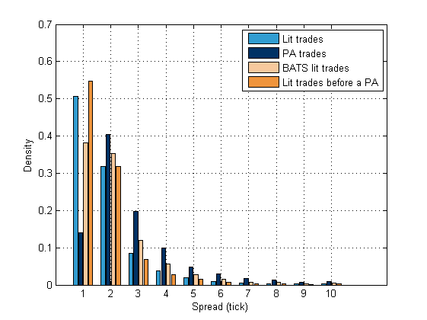

Figure - Spread density for lit, PA, BATS lit and lit trades before a PA. On STOXX 600, on the period 2017-12-18 to 2018-07-31.

##### Proportion of settlement at BBO

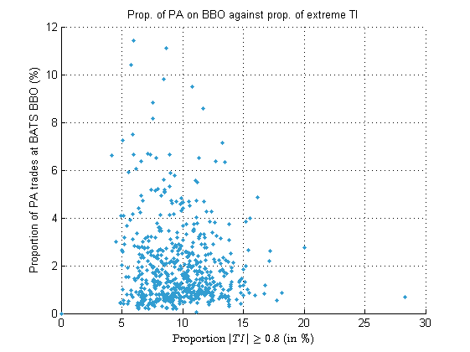

Figure - Proportion of PA trades on BATS BBO against "extreme" trading imbalance, on the period 2017-12-18 to 2018-05-21, on the STOXX 600, one dot per stock.

##### Link with spread

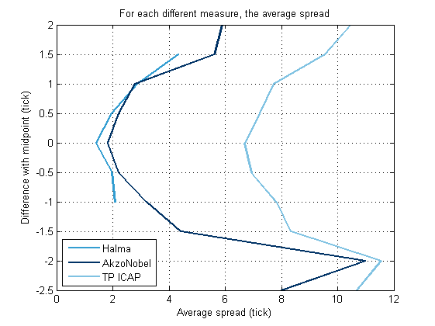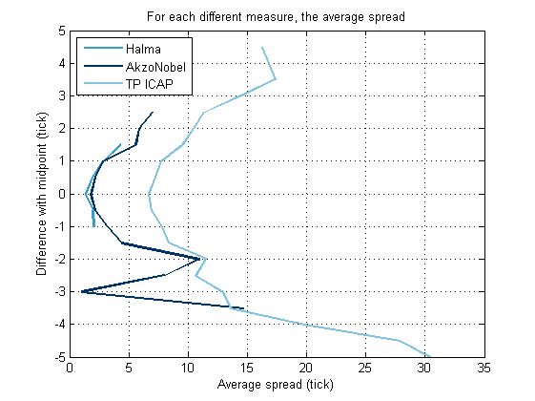

Figure - Average spread for each different value of the deviation with midpoint (in tick), on three stocks, on the period 2017-12-18 to 2018-05-21.

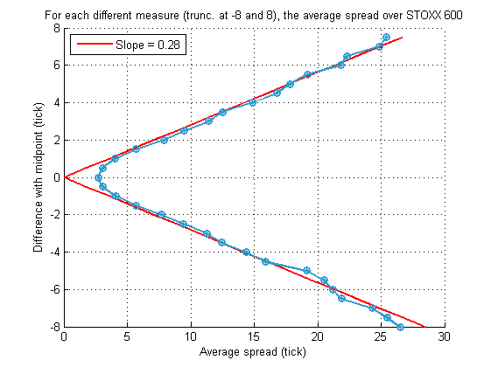

Figure - Average spread for each different value of the deviation with midpoint (in tick), over STOXX 600, on the period 2017-12-18 to 2018-05-21.

Hence we have on average, away from min spread,

Spread

Average auction price

Figure – Drawing of a tick and auction settlement price.

##### Link with Trading Imbalance

Here we compute the trading imbalance of the last 25 trades, for each PA trade observed.

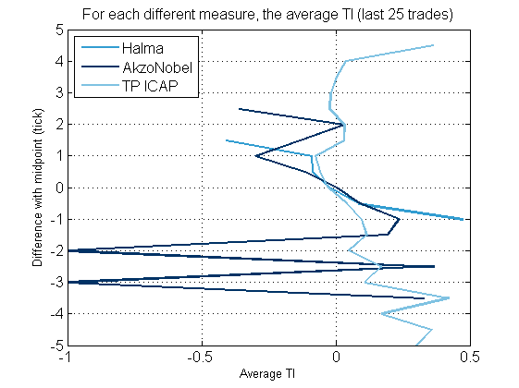

Figure - Average TI (last 25 trades) for each different value of the deviation with midpoint (in tick), on three stocks, on the period 2017-12-18 to 2018-05-21.

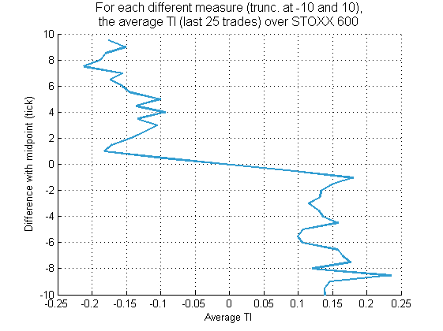

Figure - Average spread for each different value of the deviation with midpoint (in tick), over STOXX 600, on the period 2017-12-18 to 2018-05-21.

##### Link with time between auction settlement and last observed quote

To get a deeper view on the repartition of the time difference between the auction settlement and last observed quote, see this last density on Orange below.

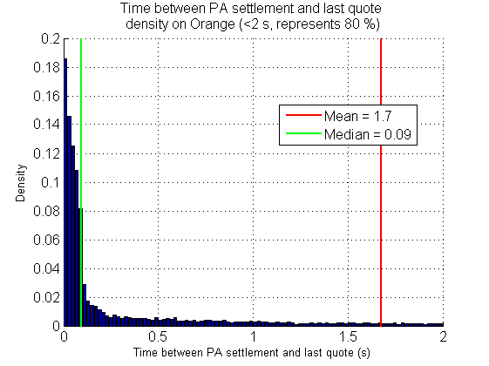

Figure - Time difference between auction settlement and last observed (BATS) quote density, on Orange, on the period 2017-12-18 to 2018-05-21.

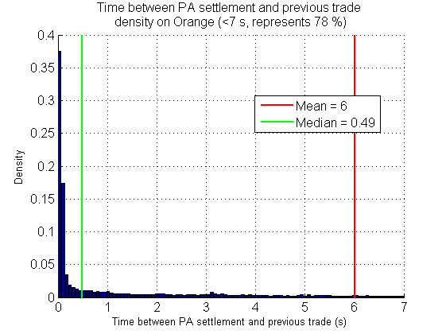

Figure - Time difference between auction settlement and last trade density, on Orange, on the period 2017-12-18 to 2018-05-21.

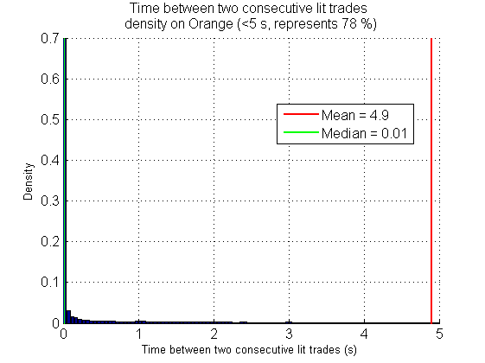

Figure - Time difference between two consecutive lit trades density on Orange, on the period 2017-12-18 to 2018-05-21.

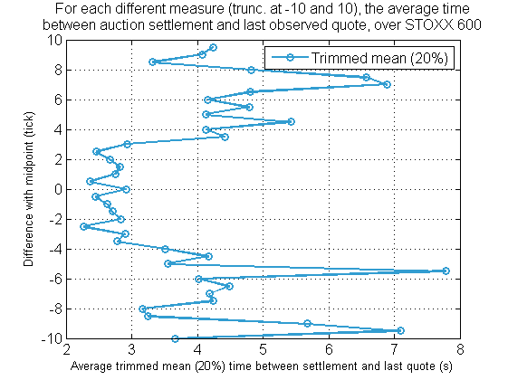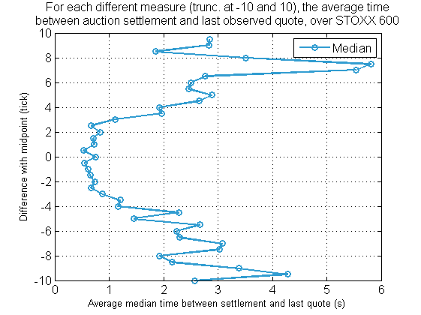

Figure - Average trimmed mean at 20% level (left) and median (right) of the time difference between auction settlement and last observed quote, for each different value of the deviation with midpoint, over STOXX 600, on the period 2017-12-18 to 2018-05-21.

##### Link with volume

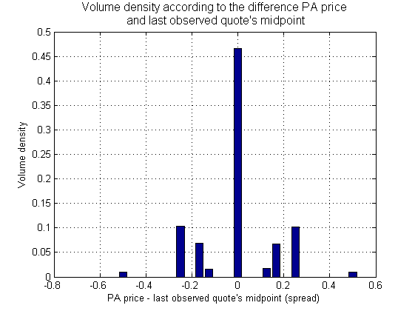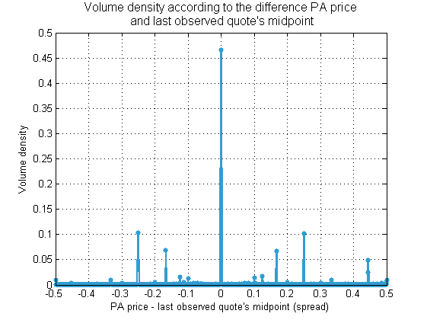

Figure – Proportion of volume traded on periodic auctions against the difference PA price and last quote’s midpoint (in spread). Over STOXX 600, on the period 2017-12-18 to 2018-07-31.

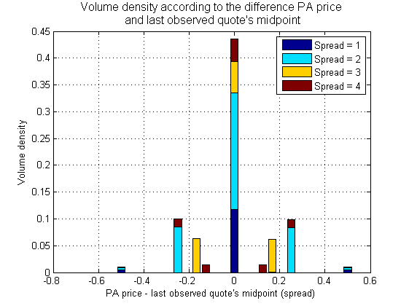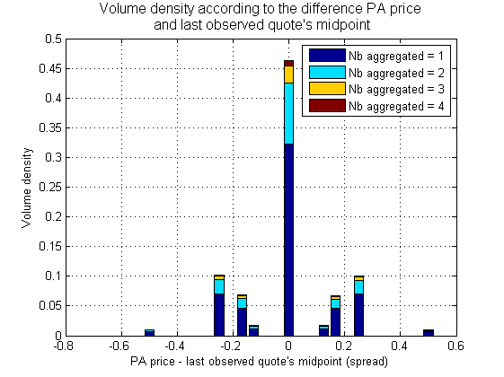

Figure

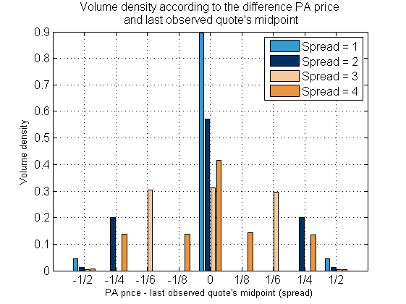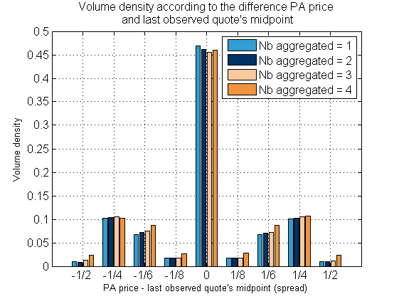

Figure

The plot on the left shows only the density at frequent positions of the difference PA price and last observed quote’s midpoint, *i.e.*

### Difference with weighted price

One defines the weighted price as

For the previous three examples we have the densities

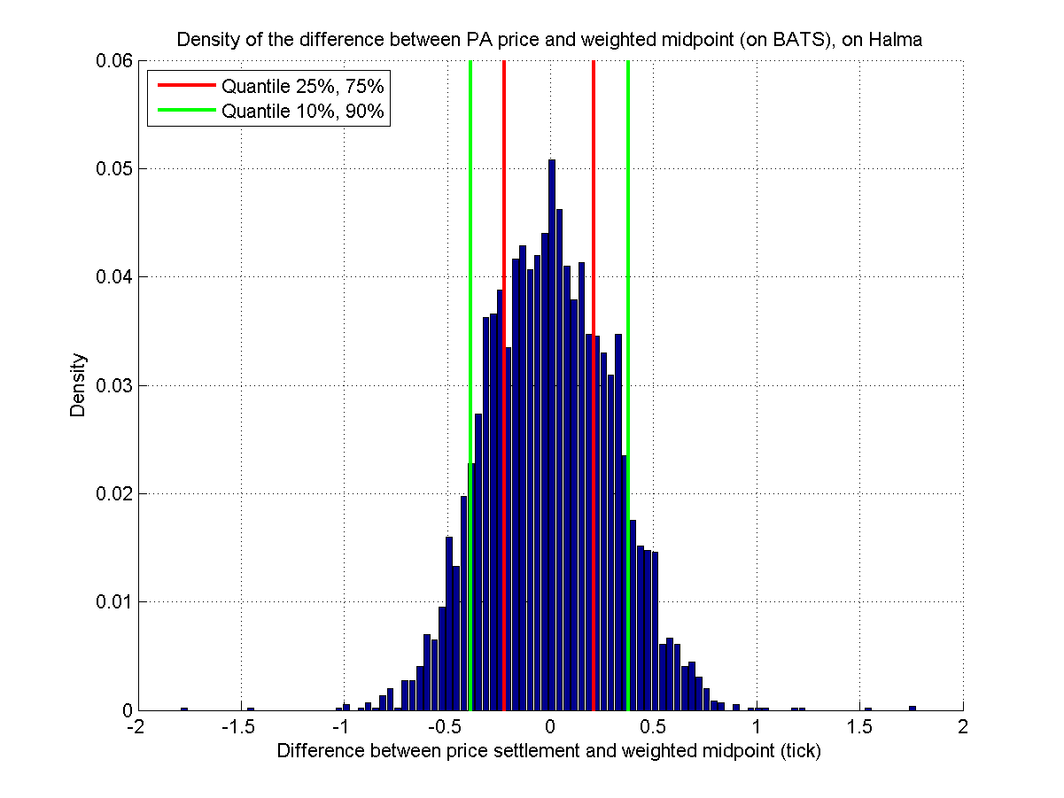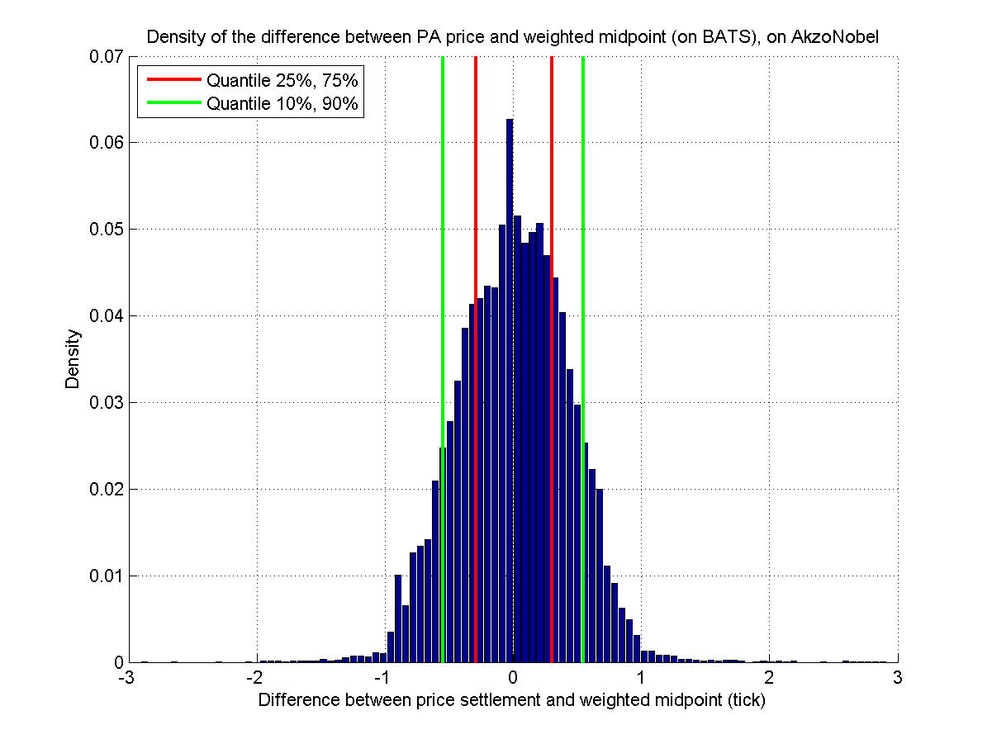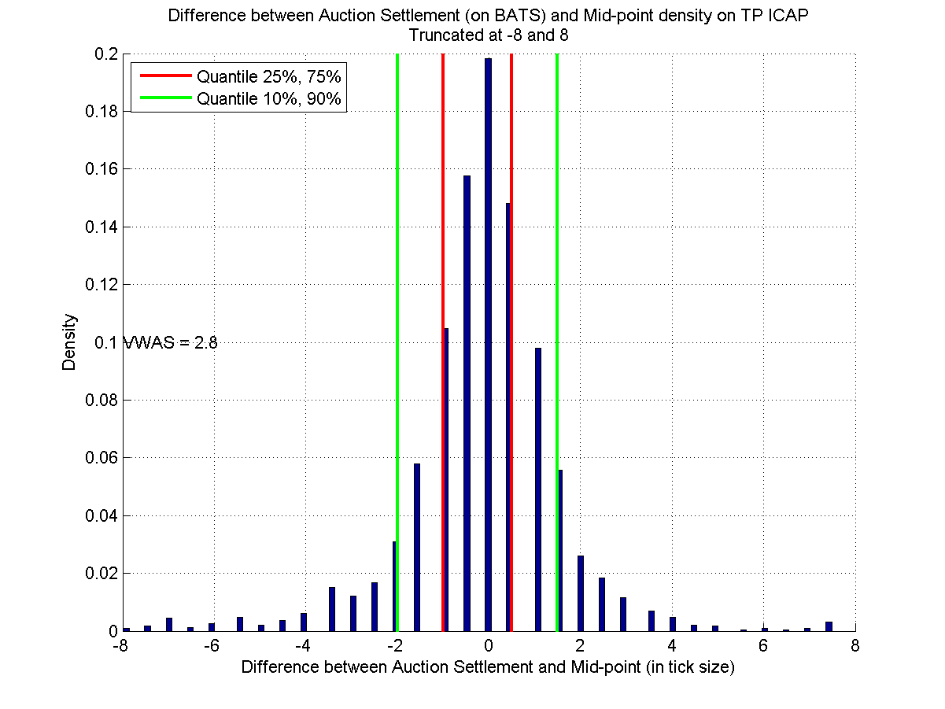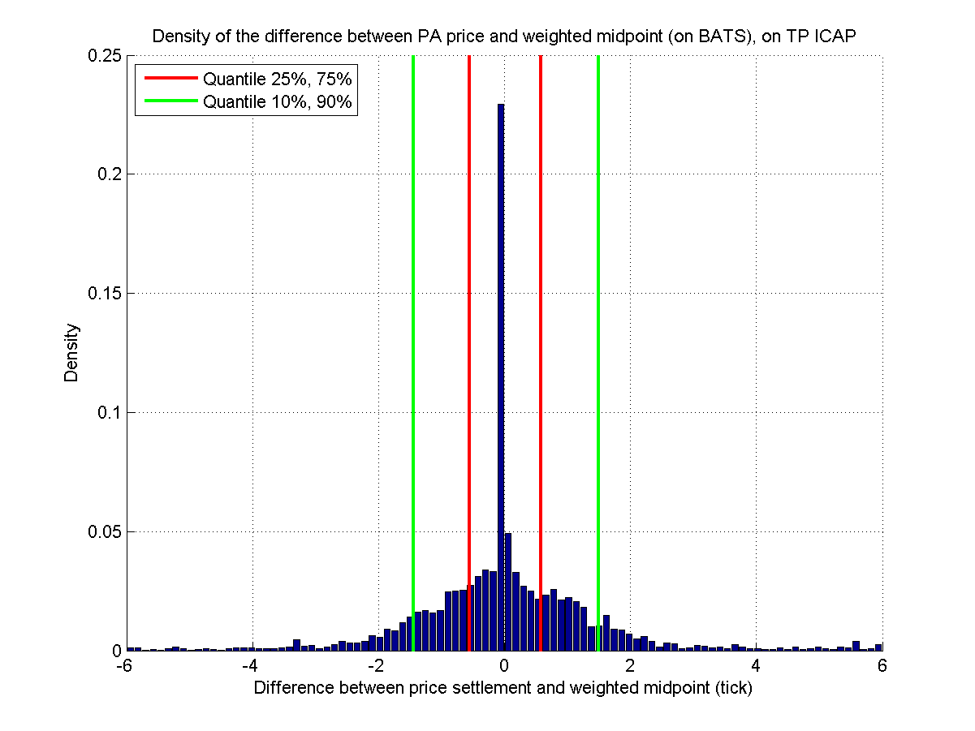

Figure – Density of the difference between PA price settlement (on BATS) and midpoint (left) or weighted price (right), on the period 2017-12-18 to 2018-05-21.

### Example of trade

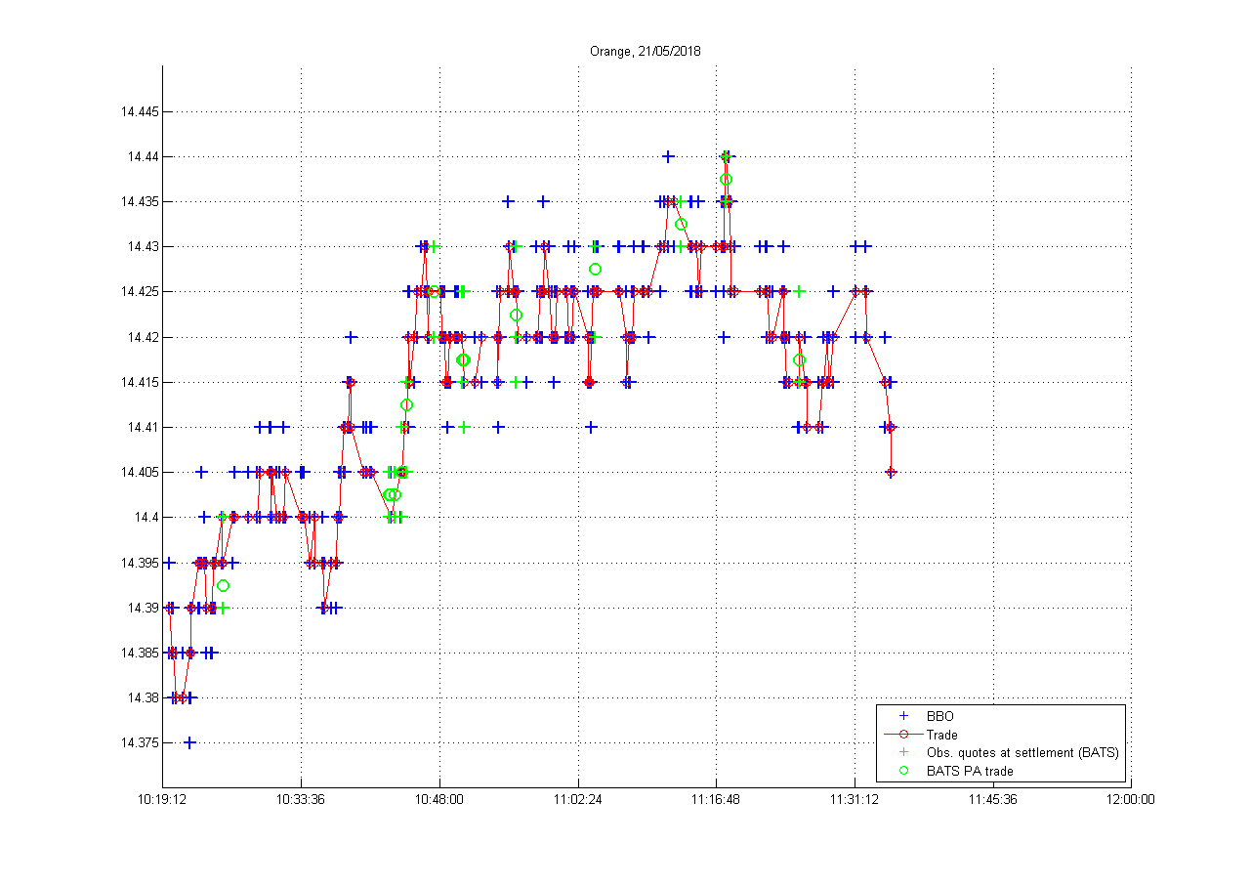

### Link with the market pressure

Here we cut the trading day in intervals of 5 min. For each interval we compute the mean of the measure (if one or more PA execution on BATS) over this interval, and the Trading Imbalance (or Order Book Imbalance) on the primary market. We compute this for each stock of the STOXX 600 and each day on the period 2017-12-18 to 2018-05-21.

On average over STOXX 600 and over this period we have 1.3 Periodic Auction execution per 5 min range. To have a better idea of how much PA are executed per 5 min see below.

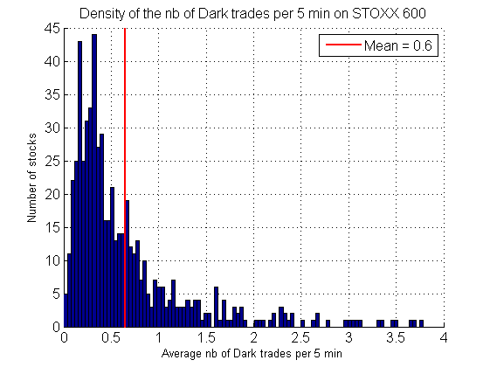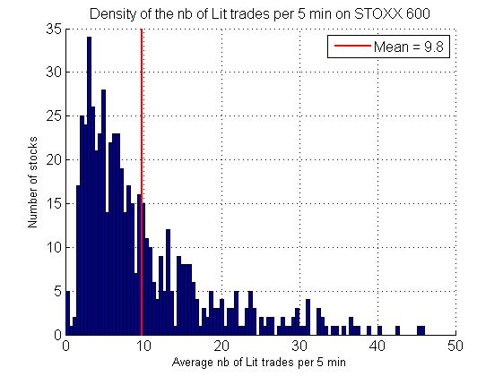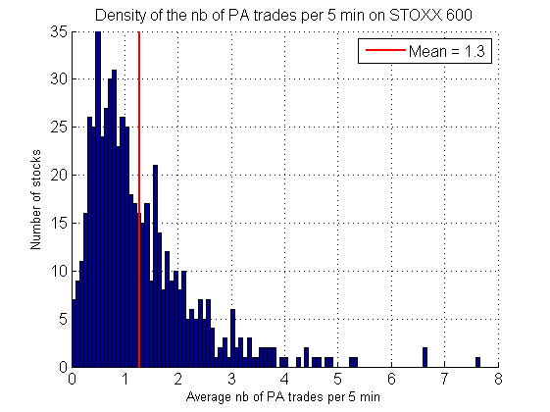

Figure - Density of the average (on the period 2017-12-18 to 2018-05-21) number of Dark (left), Lit (right) and PA (bottom) trades per 5 min, on STOXX 600.

#### Summary

|  |  |  |  |  |
| --- | --- | --- | --- | --- |
|  | **Order Book Imbalance** | | | |
|  | 5 min | Before last trade | After last trade | Last quote |
| Difference with last quote’s midpoint | -  Figure 59, page 47 | -  Figure 60, page 48 | -  Figure 60, page 48 | +  Figure 61, page 48 |
| Difference with last lit trade’s midpoint | +  Figure 66, page 51 |  |  |  |
| Undrifted difference with last lit trade’s midpoint | 0  Figure 67, page 51 |  |  |  |

|  |  |
| --- | --- |
|  | **Trading Imbalance 5 min** |
| Difference with last quote’s midpoint | -  Figure 57, page 46 |
| Difference with last lit trade’s midpoint | +  Figure 64, page 50 |

#### Trading imbalance

We define the trading imbalance as

where MO stands for Market Order.

The trading imbalance is calculated on the primary and over 5 minutes. Let us plot for each 5 min period where we have a PA execution the previous measure (difference with mid-point) against the trading imbalance on the same period. Below are given the examples of BMW and Orange.

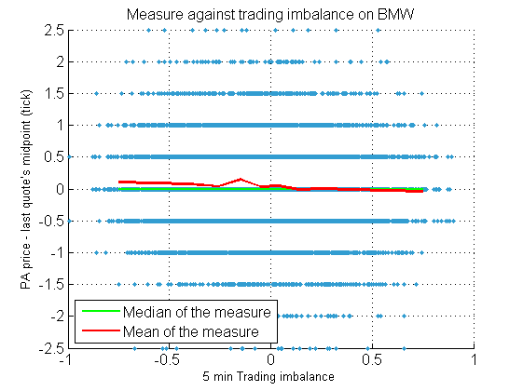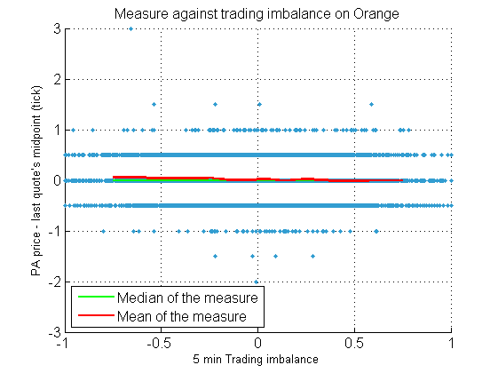

Figure – 5 min trading imbalance against the measure (on BATS), for BMW (left) and Orange (right), on the period 2017-12-18 to 2018-05-21 (one dot per period of 5 min where there is at least a PA execution on BATS).

For each quantile range of size 0.1 we computed the mean and median of the measure. There is no apparent tendency in the examples of Orange and BMW. Let us average these two measures (median and mean of the difference) over the STOXX 600.

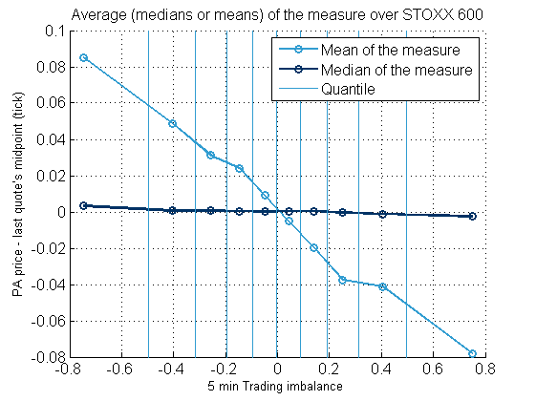

Figure – Average median and mean of the measure for each quantile range of TI, on STOXX 600, on the period 2017-12-18 to 2018-05-21 (one dot per quantile range).

Both slopes are negative. One has to keep in mind that by averaging the measure we are comparing things of different orders (see previous section, 2.2.1.4, the variance of the measure grows with spread).

#### Order book imbalance

Let us define the order book imbalance as

Again, the order book imbalance is computed on the primary and on 5 min ranges. Below are the examples of BMW and Orange.

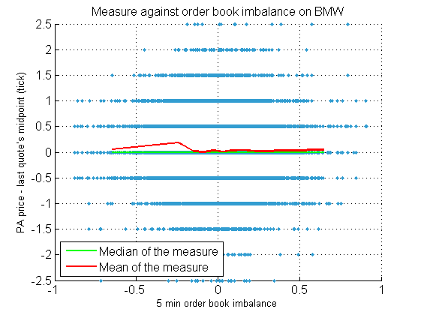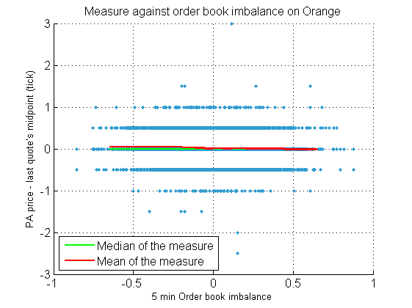

Figure – 5 min order book imbalance against the measure (on BATS), for BMW (left) and Orange (right), on the period 2017-12-18 to 2018-05-21 (one dot per period of 5 min where there is at least a PA execution on BATS).

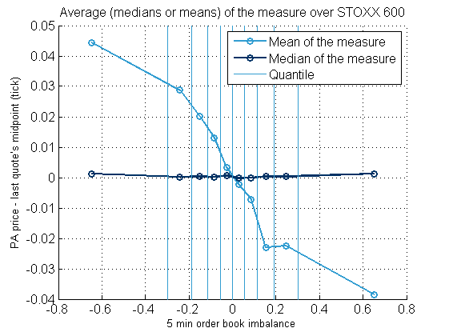

Figure – Average median and mean of the measure for each quantile range of OBI, on STOXX 600, on the period 2017-12-18 to 2018-05-21 (one dot per quantile range in the OBI).

Instead of the OBI on 5 min, one can look at the OBI before and after the last observed (lit) trade before the auction.

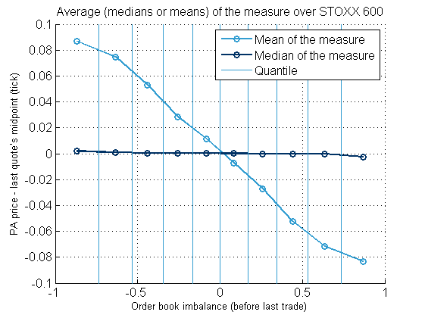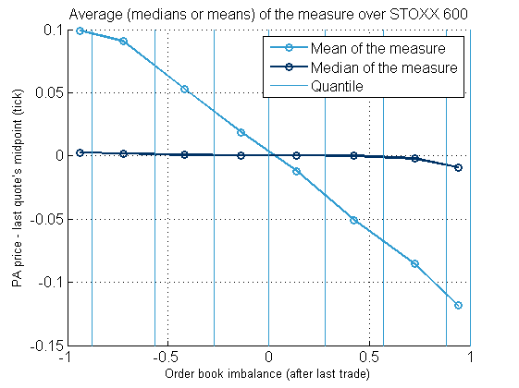

Figure – Average median and mean of the measure for each quantile range of OBI before (left) and after (right) the last observed (lit) trade before the auction, on STOXX 600, on the period 2017-12-18 to 2018-05-21 (one dot per quantile range in the OBI).

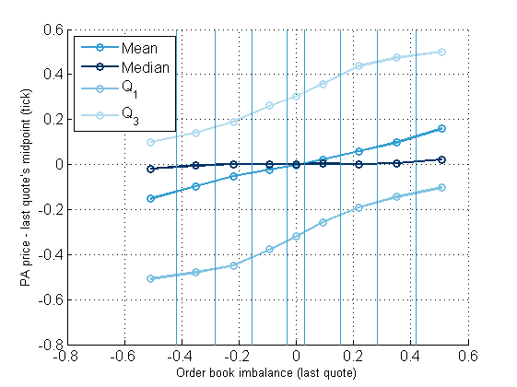

Figure – Mean, median, first and last quartile of the measure for each quantile range of the OBI of the last quote (of BATS) observed before the auction settlement, on STOXX 600, on the period 2017-12-18 to 2018-07-31 (one dot per quantile range of the OBI).

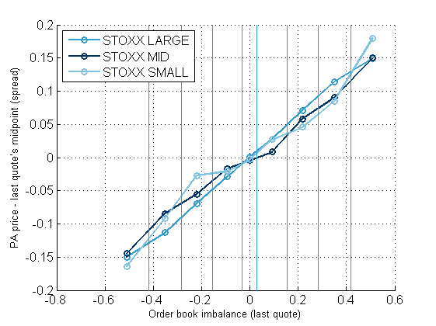

Figure - Mean of the difference PA price and last observed quote's midpoint for each OBI quantile. On the period 2017-12-18 to 2018-07-31.

### Change in the measure: difference with the mid-point of the previous trade

Now instead of looking at the difference with the mid-point at the end of the auction call, we will look at the mid-point of the previous (lit) trade. So now the mid-point will be behind the auction price, hence we expect a positive slope.

#### Trading imbalance

The examples of Orange and BMW below

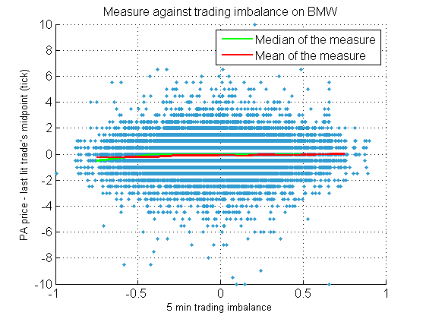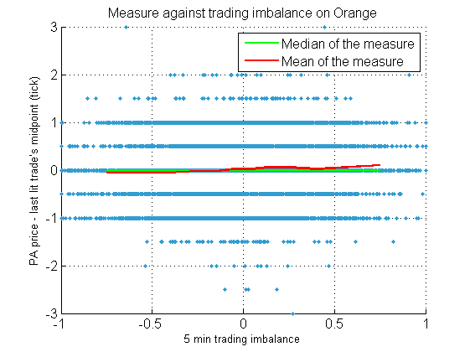

Figure – 5 min trading imbalance against the new measure (on BATS), for BMW (left) and Orange (right), on the period 2017-12-18 to 2018-05-21 (one dot per period of 5 min where there is at least a PA execution on BATS).

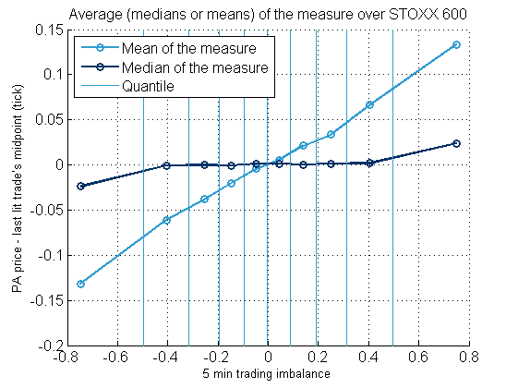

Figure – Average median and mean of the measure for each quantile range of TI, on STOXX 600, on the period 2017-12-18 to 2018-05-21 (one dot per quantile range).

We observe a positive slope for both mean and medians. As the mid-point of the previous trade is before the auction settlement, this tends to confirm in the previous analysis that the mid-point observed of the last quote update is after the “decision”[6] of the auction price.

#### Order book imbalance

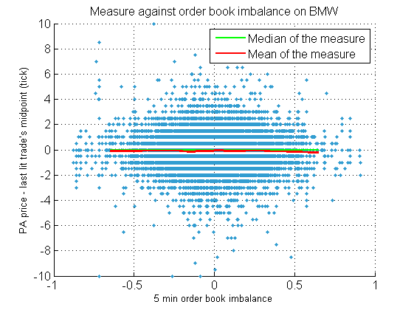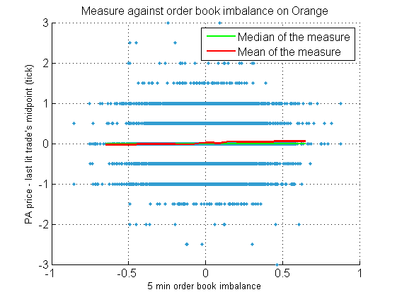

Figure – 5 min order book imbalance against the new measure (on BATS), for BMW (left) and Orange (right), on the period 2017-12-18 to 2018-05-21 (one dot per period of 5 min where there is at least a PA execution on BATS).

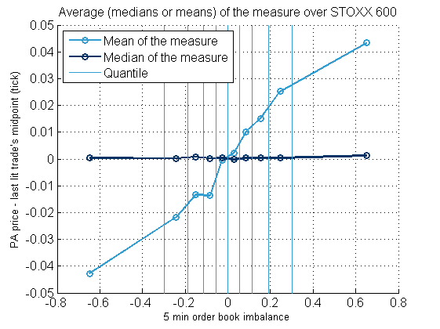

Figure – Average median and mean of the measure for each quantile range of OBI, on STOXX 600, on the period 2017-12-18 to 2018-05-21 (one dot per quantile range).

##### Without the drift

Here, for each computation of the difference between the auction settlement price and previous mid-point, we subtract the (scaled) drift observed on the 5 min period.

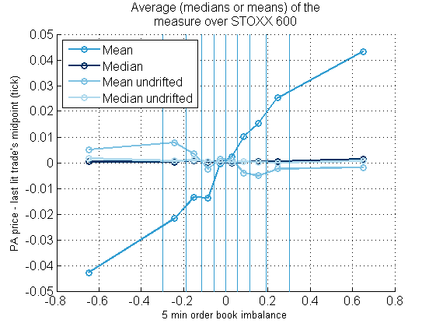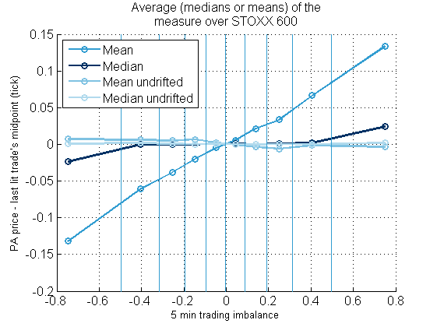

Figure – Average median and mean of the drifted and undrifted measure for each quantile range of OBI (left) and TI (right), on STOXX 600, on the period 2017-12-18 to 2018-05-21 (one dot per quantile range).

#### Conditionally to the last observed trade’s market order type

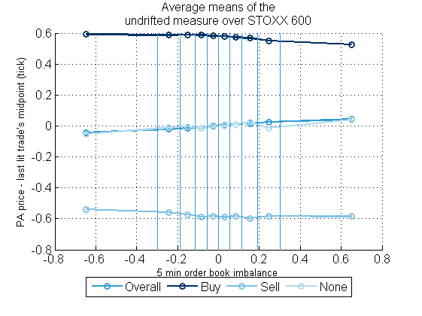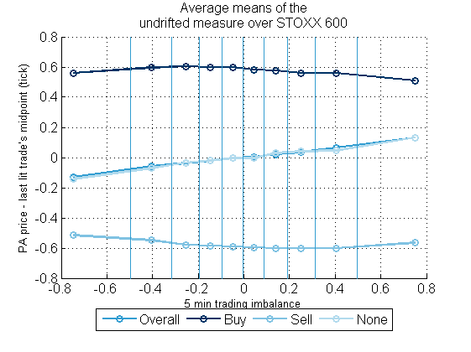

Figure – Average mean of the measure conditionally to the last observed trade’s MO type for each quantile range of OBI (left) and TI (right), on STOXX 600, on the period 2017-12-18 to 2018-05-21 (one dot per quantile range).

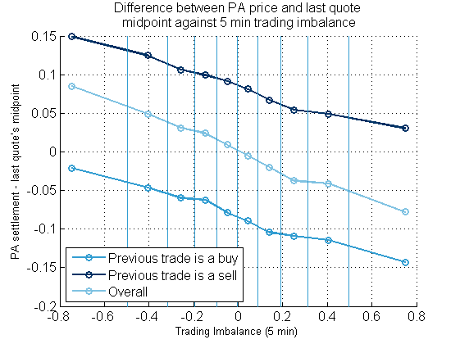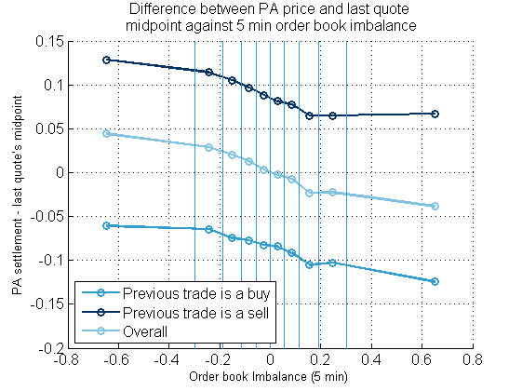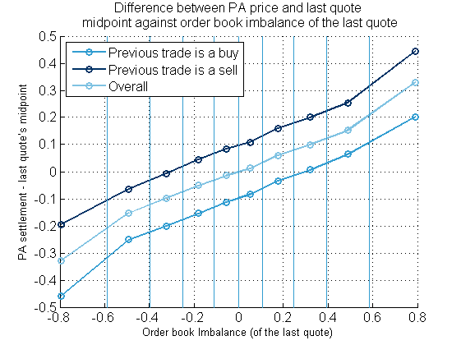

Figure - Average mean of the difference with last quote’s midpoint conditionally to the last observed trade’s MO type, for each quantile range of TI (left) and OBI(right, bottom), on STOXX 600, on the period 2017-12-18 to 2018-05-21 (one dot per quantile range).

### Link with the trend

We understand by trend the move of the midpoint. Here we will look at the trend just before the periodic auction, *i.e.* the difference between the midpoint of the last quote observed before a periodic auction and the last trade before a periodic auction.

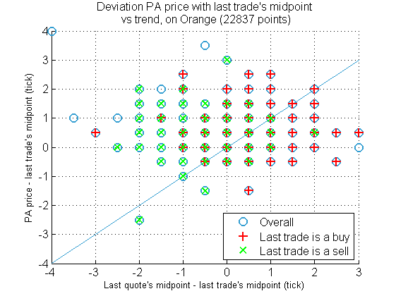

Figure - Difference of PA price and last trade's midpoint versus trend, on Orange, on the period 2017-12-18 to 2018-05-21.

Table – Proportions of PA trades based on the position of the difference PA price with last trade compared to the trend (rows sum to 1).

|  |  |  |  |
| --- | --- | --- | --- |
| **Last trade type** | **Diff PA last trade > trend** | **Diff PA last trade = trend** | **Diff PA last trade < trend** |
| Overall | 0.45 | 0.16 | 0.39 |
| Buy | 0.26 | 0.31 | 0.43 |
| Sell | 0.64 | 0.01 | 0.35 |

### Link with the liquidity and trade size (intraday)

Let us look at the number of transactions and volume on each 5 min ranges, on Total, on the period 2017-12-18 to 2018-05-21.

#### Liquidity (number of trades per 5 min ranges)

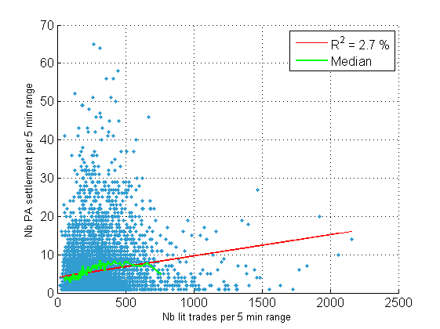

Figure - Number of Periodic Auctions settlement per period of 5 min against number of lit trades. On Total, on the period 2017-12-18 to 2018-05-21. One dot per 5 min range. Aggregated trades.

#### Trade size

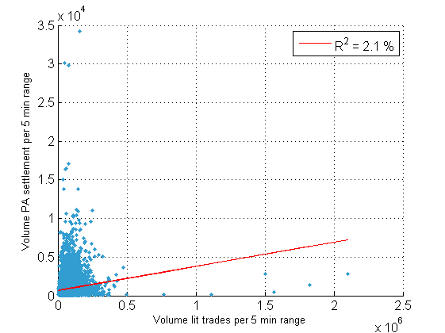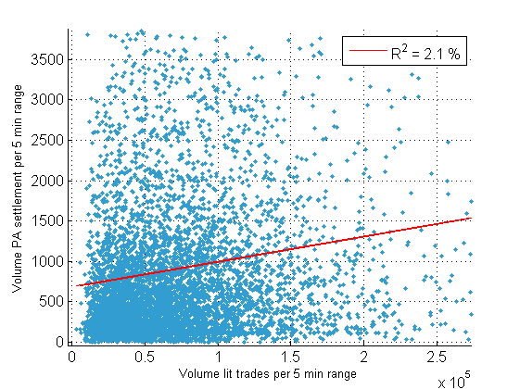

Figure – Volume of Periodic Auctions’ executions per period of 5 min against volume of lit trades. On Total, on the period 2017-12-18 to 2018-05-21. One dot per 5 min range. Aggregated trades.

#### Volume compared to moving average

We calculated the moving average on a T=60 days basis.

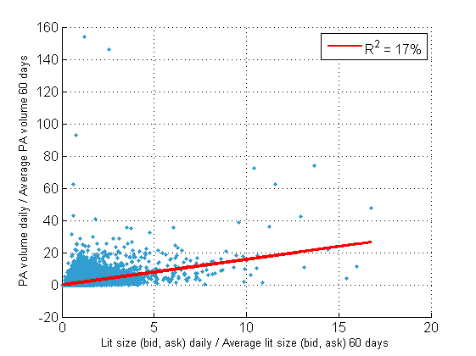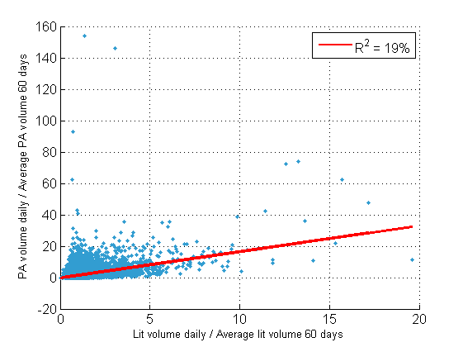

Figure – One dot for each stock * number of 60 days period. On STOXX 600, on the period 2017-12-18 to 2018-07-31.

#### Intraday volume curve

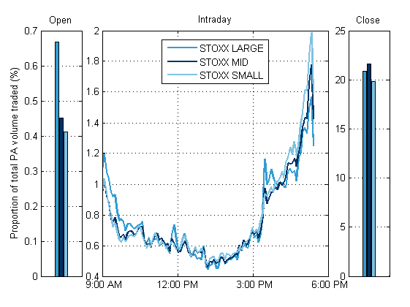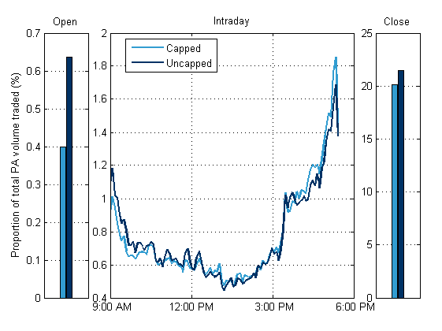

Figure - Excluding dark and periodic auction. On STOXX 600, on the period 2017-12-18 to 2018-07-31.

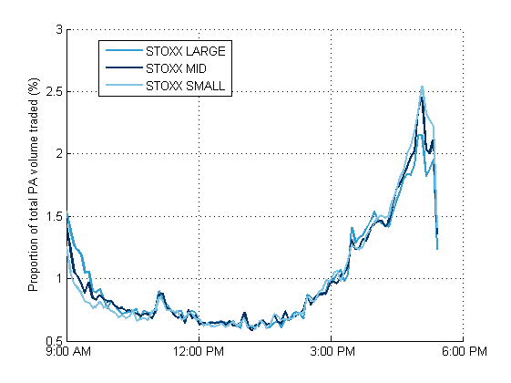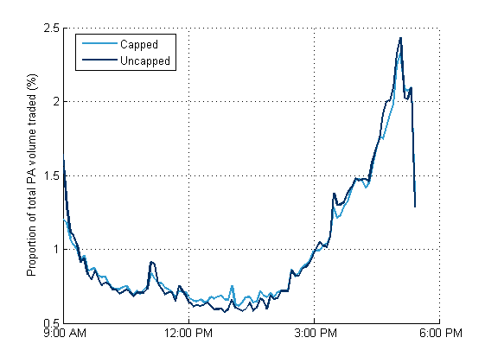

Figure - Only on periodic auctions. On STOXX 600, on the period 2017-12-18 to 2018-07-31.

## Price reversion based on our executions

### Description

### Market share

The first time we connected to the Periodic Auction was the 2018-03-06.

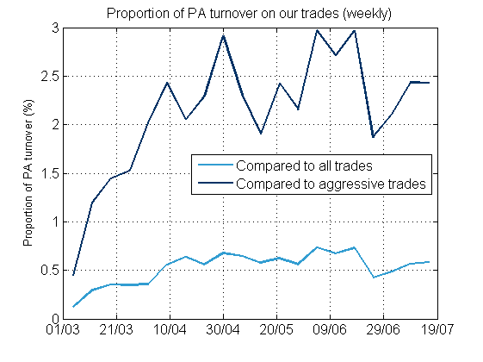

Figure - Proportion of turnover on Periodic Auction compared to overall turnover or on aggressive trades, on a weekly basis. On Kepler Cheuvreux's trades.

### Price reversion

On the following figures, for the dot at time the statistic is computed on the interval .

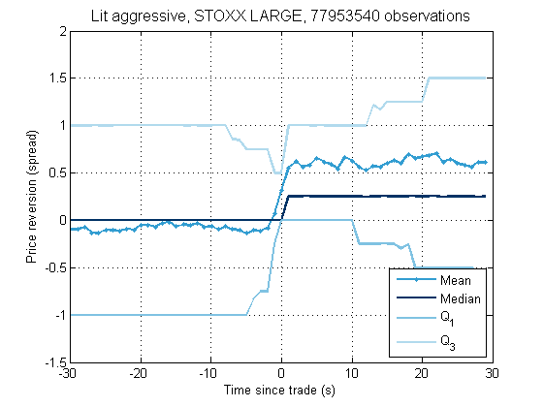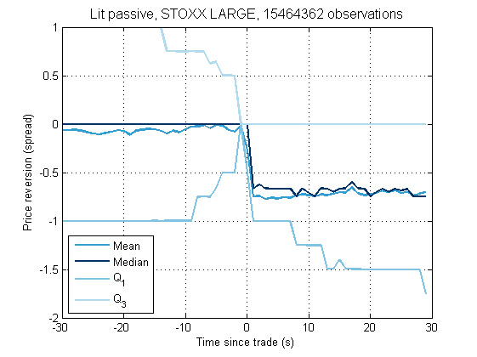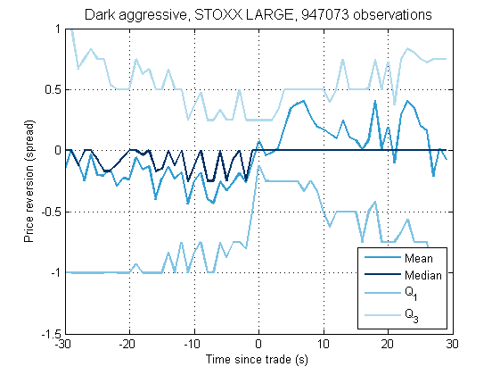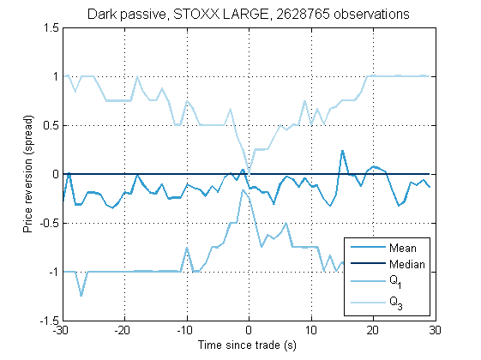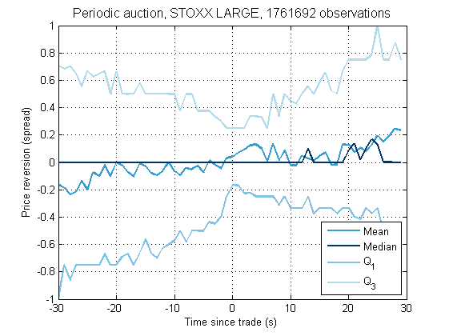

Figure - Price reversion of our trades. On STOXX LARGE, on the period 2018-03-06 to 2018-07-31.

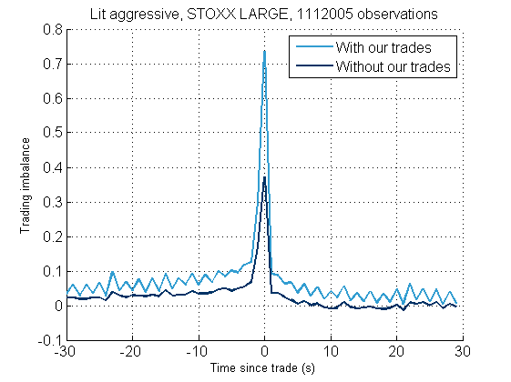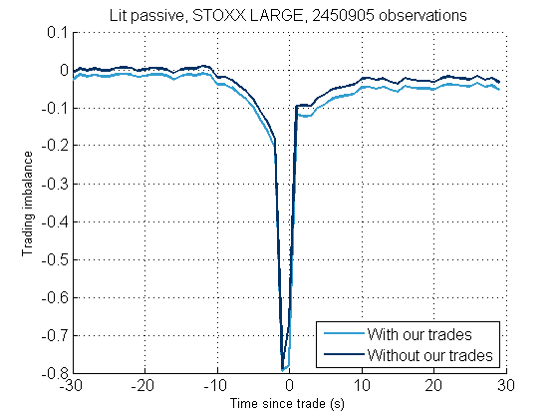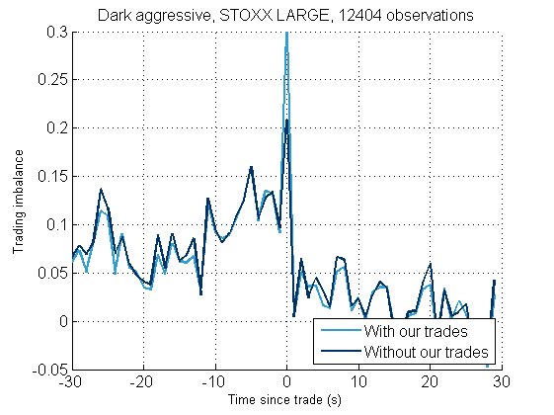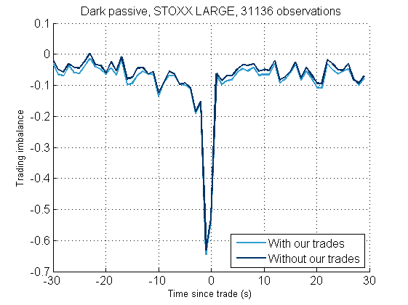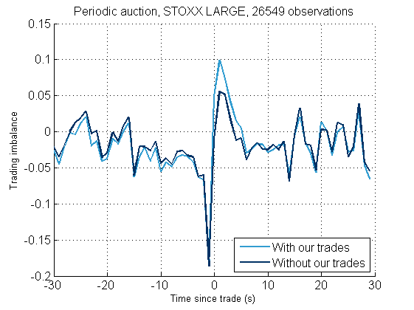

Figure - Trading imbalance on KC's lit aggressive, passive and periodic auction trades. On Orange, on the period 2017-12-18 to 2018-07-31.

# Appendix

## OBIs correlations

### Non-aggregated trades

=

PA Settlement

Last lit trade

Last (BATS) quote

Last BATS lit trade

Lit trade before BATS

Table - Correlation matrix, on Total, on the period 2017-12-18 to 2018-05-21.

|  |  |  |  |  |
| --- | --- | --- | --- | --- |
| **OBI** |  |  |  |  |
| Last (BATS) quote | 1 | 0.1 | 0.16 | 0.11 |
| Last lit trade | 0.1 | 1 | 0.2 | 0.15 |
| Last BATS lit trade | 0.16 | 0.2 | 1 | 0.51 |
| Lit trade before BATS | 0.11 | 0.15 | 0.51 | 1 |
|  |  |  |  |  |
| See scatter plot below |  |  |  |  |

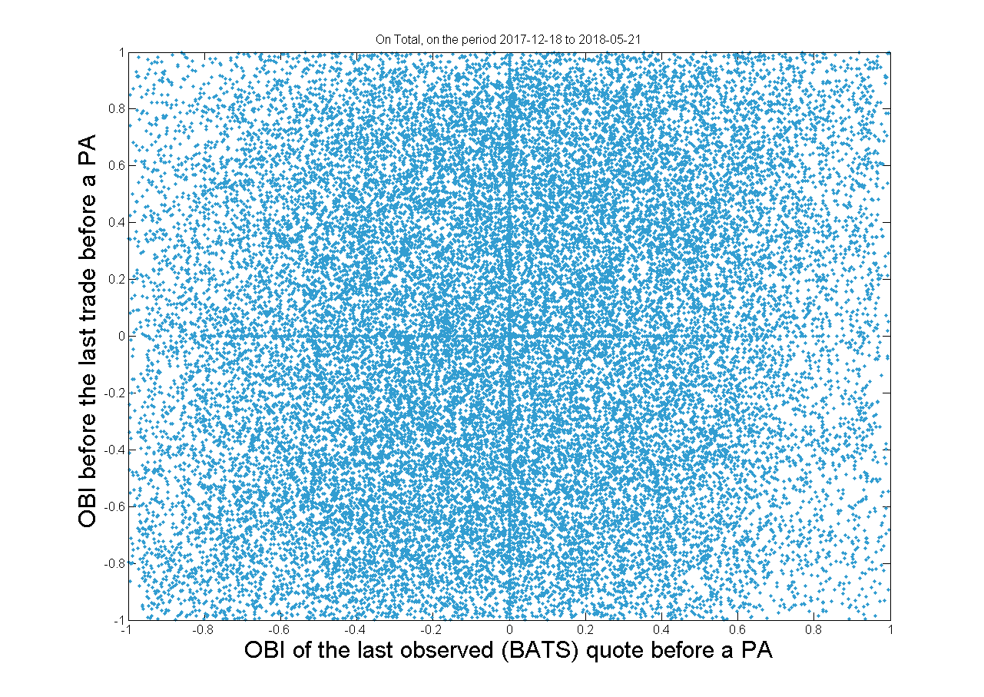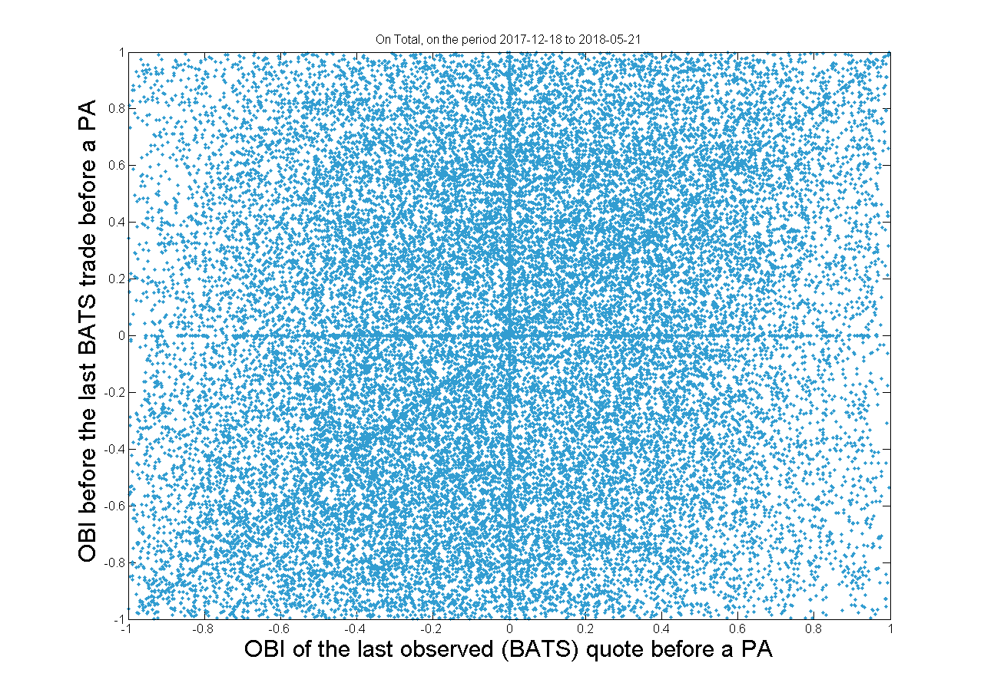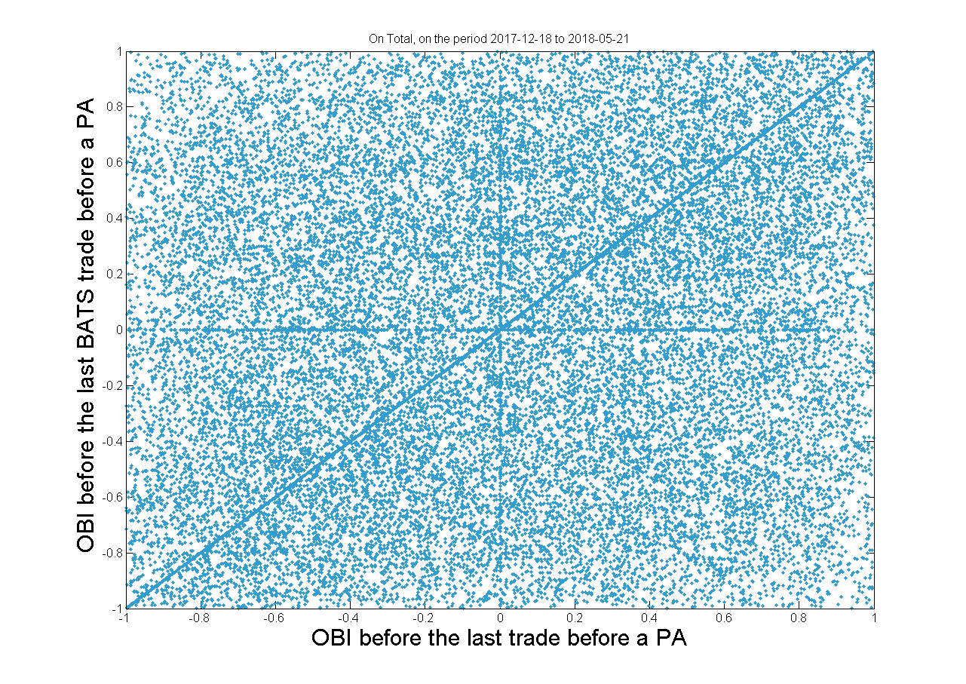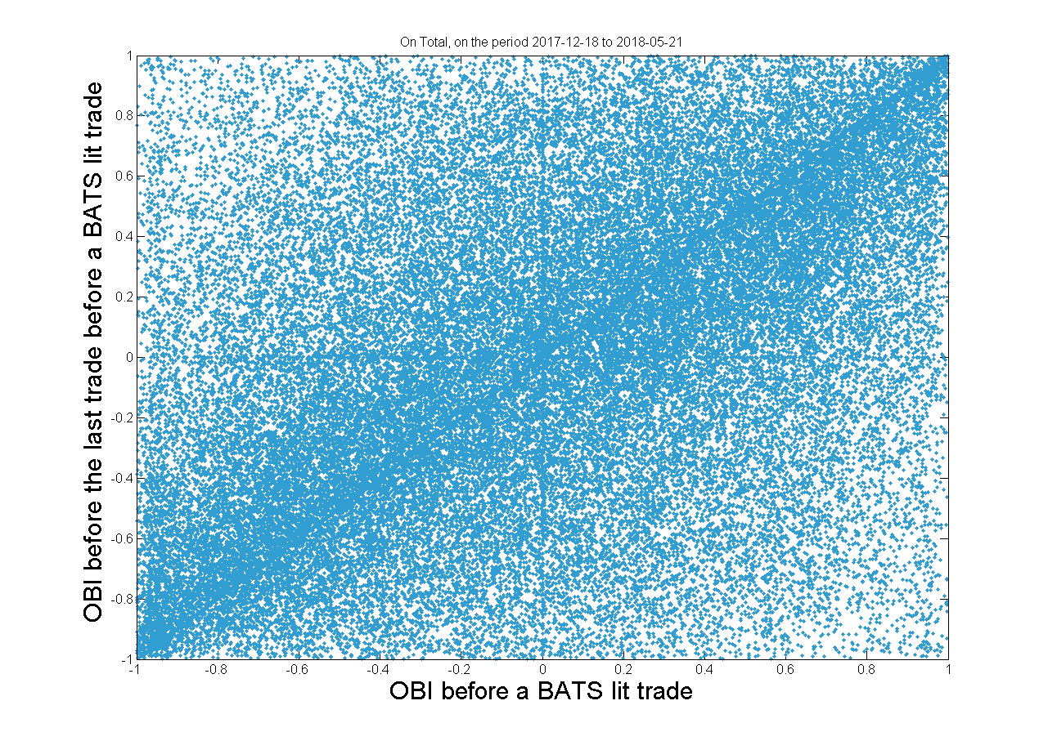

Figure - Scatter plot of the different OBIs.

### Aggregated trades

Table - Correlation matrix on aggregated trades, on Total, on the period 2017-12-18 to 2018-05-21.

|  |  |  |  |  |
| --- | --- | --- | --- | --- |
| **OBI** |  |  |  |  |
| Last (BATS) quote | 1.00 | 0.10 | 0.16 | 0.10 |
| Last lit trade | 0.10 | 1.00 | 0.20 | 0.13 |
| Last BATS lit trade | 0.16 | 0.20 | 1.00 | 0.37 |
| Lit trade before BATS | 0.10 | 0.13 | 0.37 | 1.00 |

## Trade size on BATS periodic auction

Let us for example plot the density of trade size on AC FP and ORA FP for two different dates, only for BATS periodic auction trades.

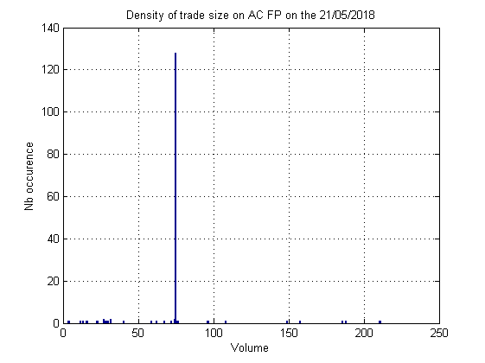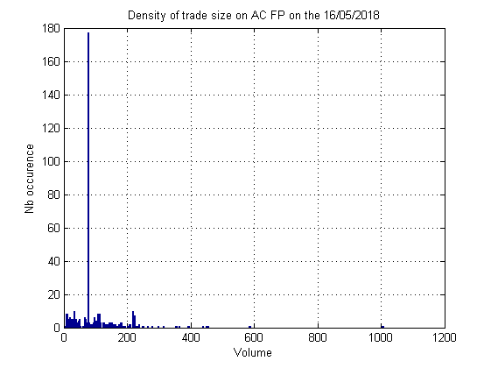

Figure – BATS periodic auction trade size density on AC FP the 2018-05-21 (left) and 2018-05-16 (right).

The 2018-05-21 there were 156 periodic auction’s trades on BATS, 128 of them had a volume of 75. Same pattern for the 2018-05-16, also a peak on the 75 volume.

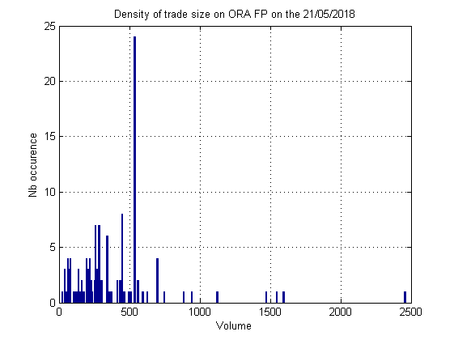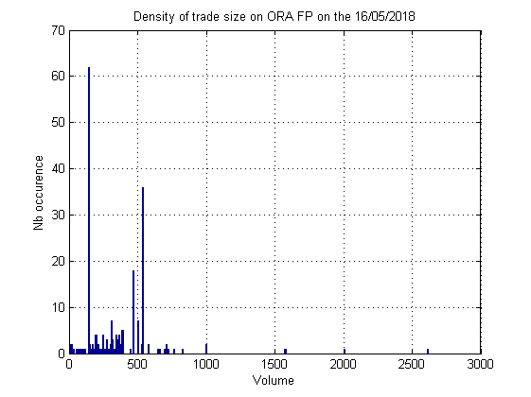

Figure – BATS periodic auction trade size density on ORA FP the 2018-05-21 (left) and 2018-05-16 (right).

Here again, on the 2018-05-21, out of 135 trades, 24 had a volume of 540 and 8 a volume of 449 ; all the other volumes had an occurrence of 1 or 2.

We found similar patterns on every random stocks of STOXX600 studied (9 stocks), on almost every date (in the period 2018-03-12 to 2018-05-21) there is one (sometimes 2-3) volume that has a very high occurrence compared to other volumes.

## Dark trade size

Here we plot the trade size density on darks (CHI-X, BATS and Turquoise) after the double cap introduction, on several stocks of the STOXX 600.

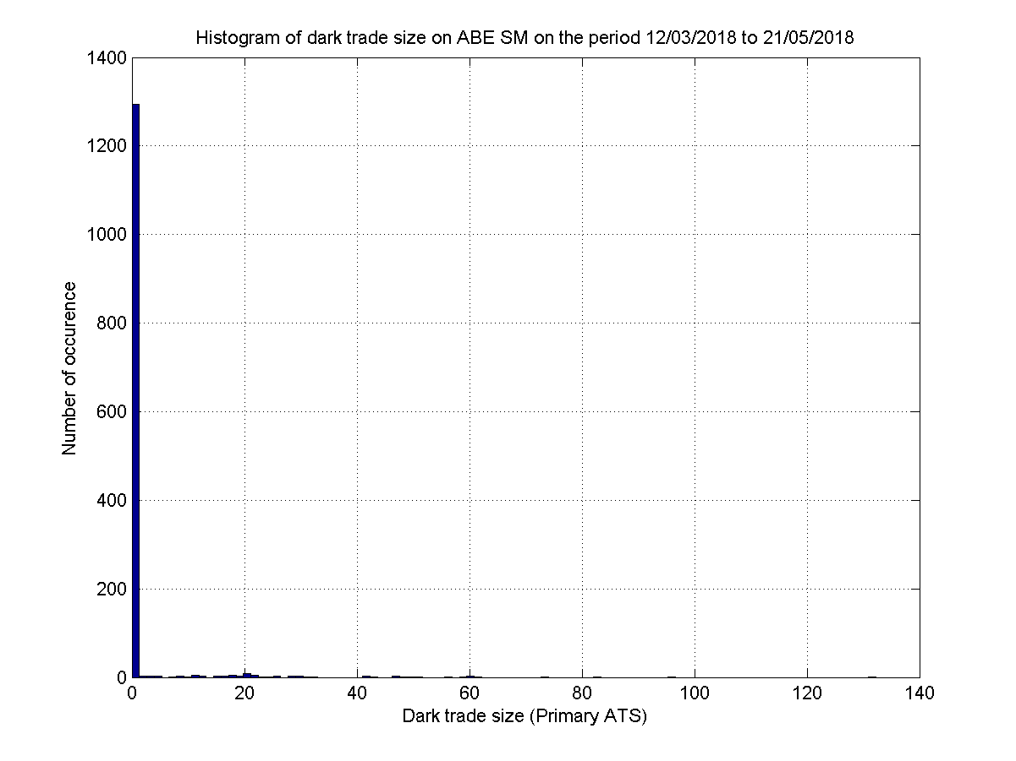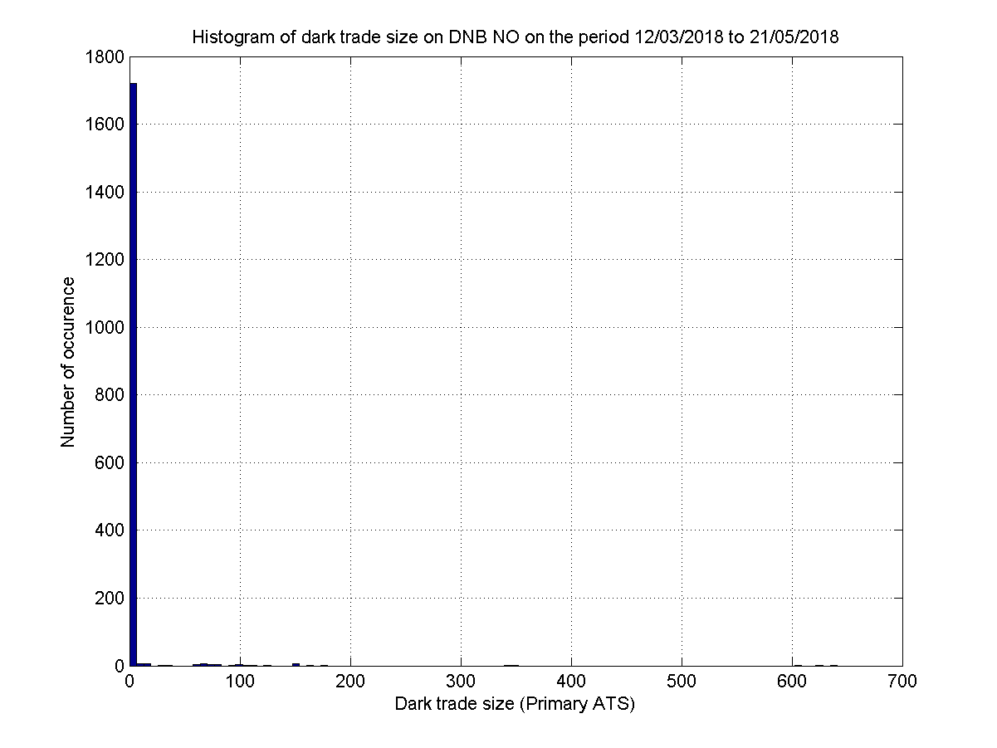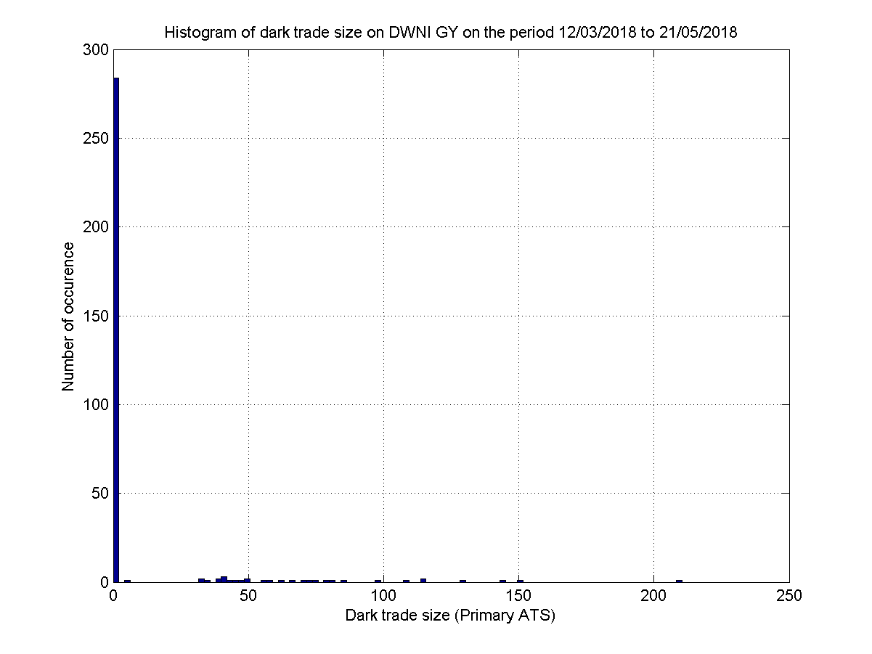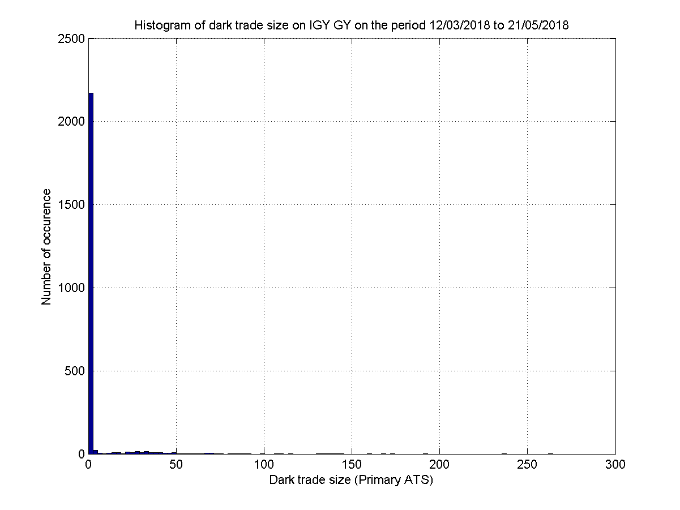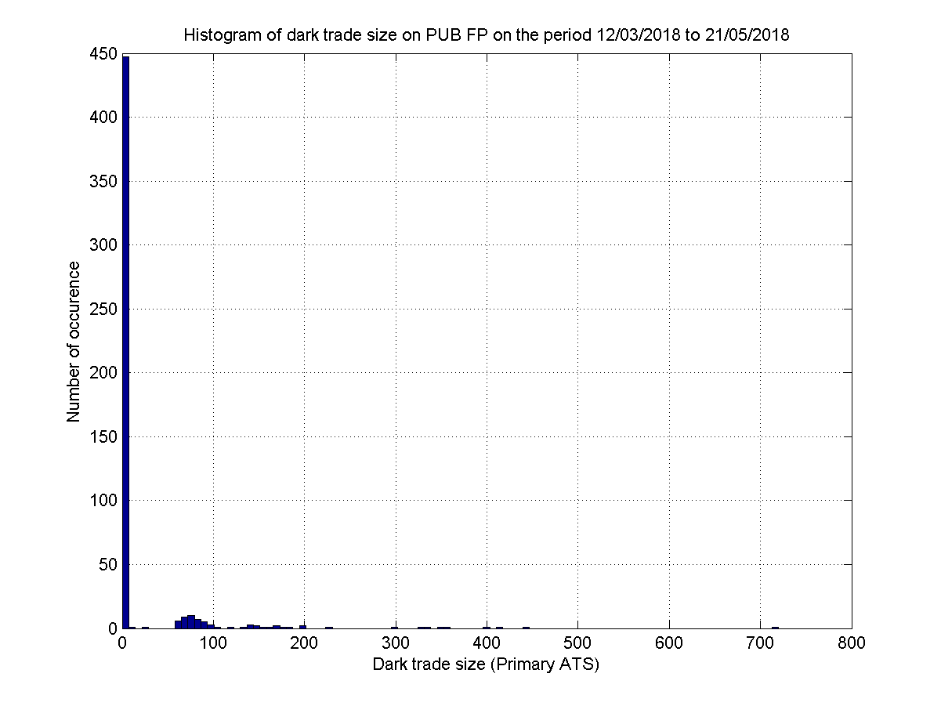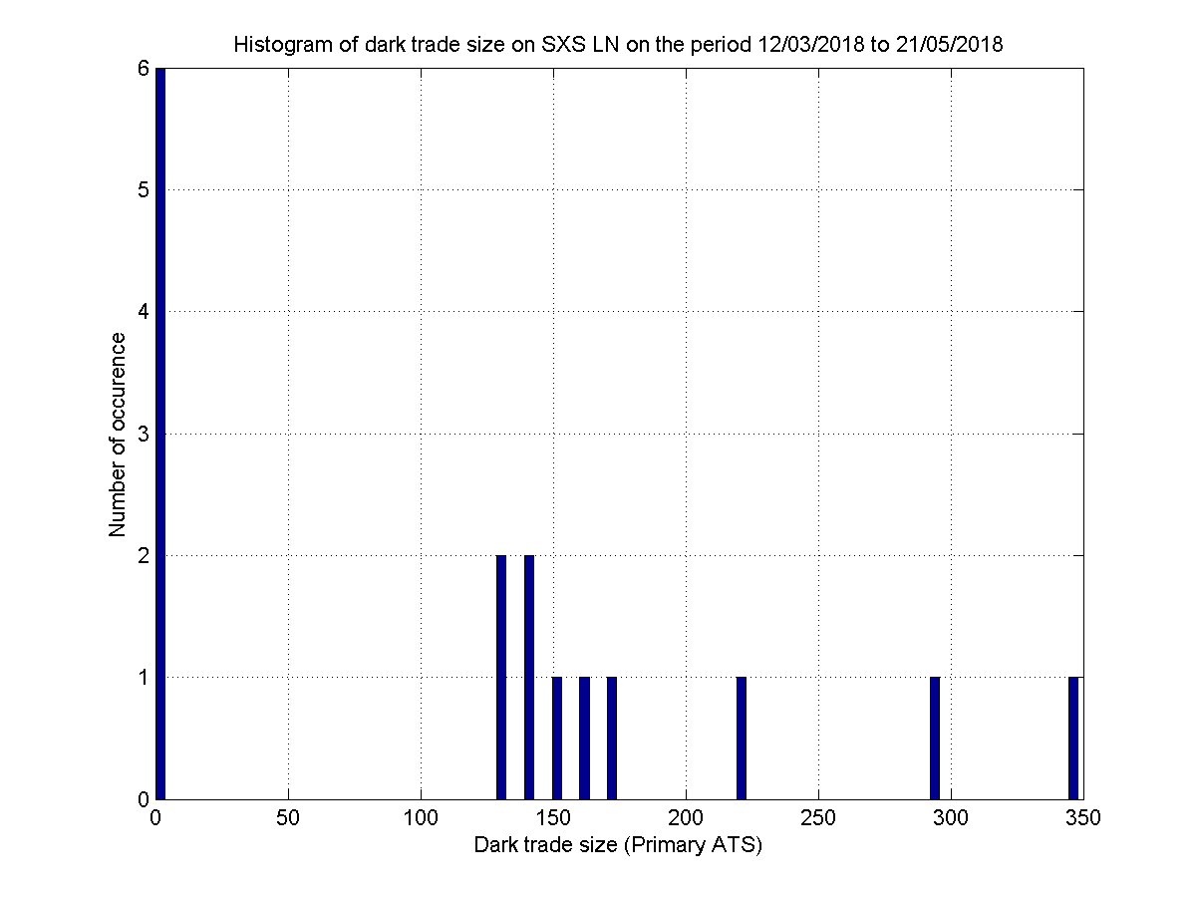

Figure – Trade size density on darks (CHI-X, BATS and Turquoise), on the period 2018-03-12 to 2018-05-21 on 6 different stocks of the STOXX 600.

## Correlation of average daily markets shares and market shares on darks

See Section 2.1.3 for the difference between these two factors. As showed in this last section (on periodic auctions), here also on darks they are almost the same.

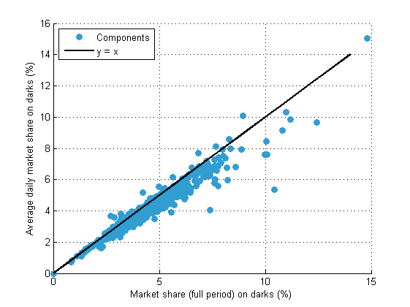

Figure – Average daily market shares (in volume) on darks (BATS & Turquoise) against market share (full period, in volume), on the period 2017-12-18 to 2018-05-21 on STOXX 600 (one dot per stock).

## Trade size pdf on Darks

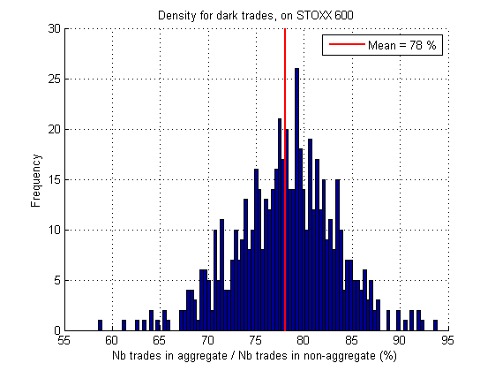

Figure - Density of the proportion of number of aggregated trades over the number of non-aggregated trades, over STOXX 600. On the period 2017-12-18 to 2018-07-31.

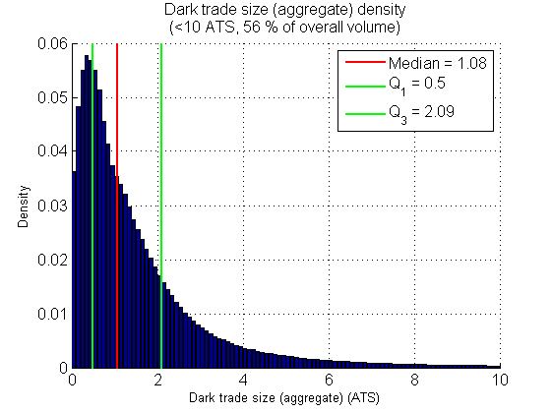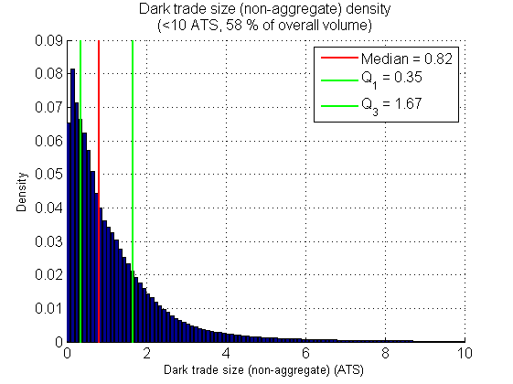

Figure - Density of trade size on aggregated (left) and non-aggregated (right) dark trades. On STOXX 600, on the period 2017-12-18 to 2018-07-31.

## Difference with last trade conditionally with MO type is market impact

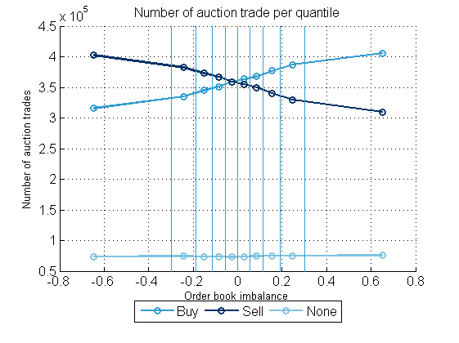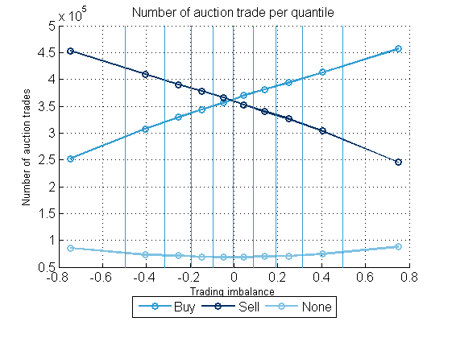

Figure – Number of auction trade per quantile range of OBI (left) and TI (right), over STOXX 600, on the period 2017-12-18 to 2018-05-21.

Let us focus on the buy case. We assume that the price settlement is at the midpoint of the last observed (BATS) quote. For all ,

Hence let us define the natural estimator

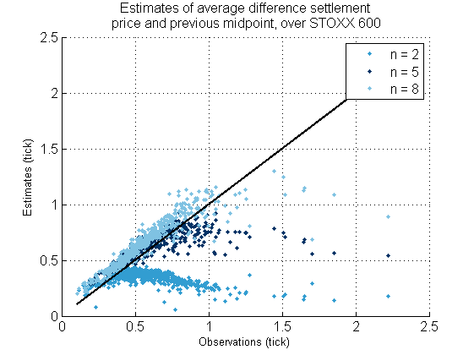

Figure - Estimates of the average difference between auction settlement and previous midpoint, where the previous trade is on the buy side. Over STOXX 600, on the period 2017-12-18 to 2018-05-21, one dot per stock.

By setting we can compute for all .

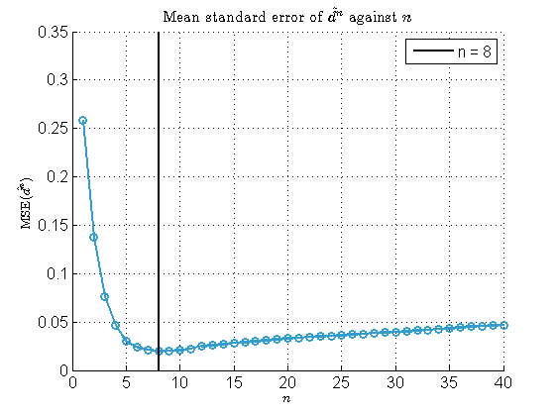

Figure - Mean standard error of against .

For the MSE is minimal, i.e. for a difference with the previous and current midpoint of maximum 4 ticks.

Table - Estimates for Accor, Orange and BMW.

|  |  |  |  |  |  |
| --- | --- | --- | --- | --- | --- |
|  |  |  |  |  |  |
| Accor | 0.31 | 0.18 | 0 | 0.41 | 0.47 |
| Orange | 0.45 | 0.13 | 0 | 0.36 | 0.40 |
| BMW | 0.27 | 0.24 | 0.0035 | 0.69 | 0.82 |

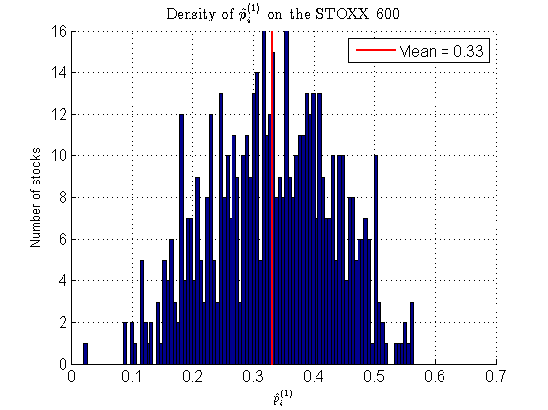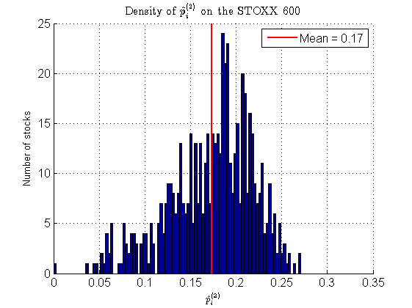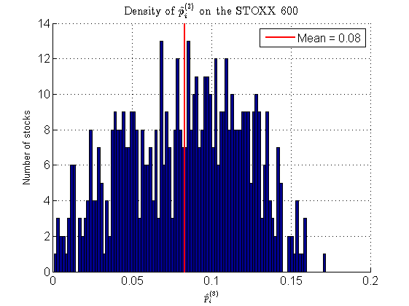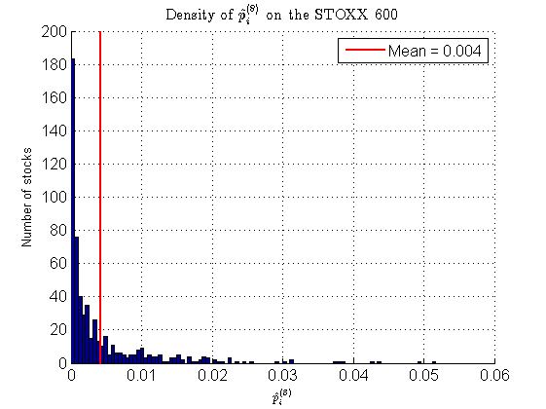

Figure - Density of the estimator for on STOXX 600, on the period 2017-12-18 to 2018-05-21.

1. Trading Venue.
2. Primary market : trading venue where the product was first admitted to trading ; sometimes Turquoise uses the most relevant market (liquidity)
3. i.e. when there is an ask order below a bid order.
4. <https://www.bats.com/europe/equities/market_statistics/symbols_traded/csv/?mkt=bxe>
5. Indicative price and executable volume.
6. By decision we understand orders and hence auction update messages.