Plasma for the space exploration:
On the Hall Effect Thruster modeling and performances
Antoine TAVANT,,*

Vivien Croes¹,², T. Lafleur,¹ Anne Bourdon¹, Pascal Chabert¹
29/01/2018
Despite electric propulsion (EP) having its beginning in the 1960’s, its full potential has only been realized in the last few years, with all-electric communication satellites and large small-satellite constellation projects [Villain15]. Since Hall effect thrusters (HETs) are one of the most successful EP technologies, there is an increased need for improved predictive models.
Typical HETs consist of three main components:
(1) An external cathode, providing electrons to sustain the plasma discharge and to neutralize the ion beam.
(2) An annular ceramic channel where the propellant gas is injected through an anode, ionized, and accelerated (due to a potential difference applied between the anode and cathode).
(3) An external magnetic circuit used to produce a radial magnetic field to trap electrons in the channel region.

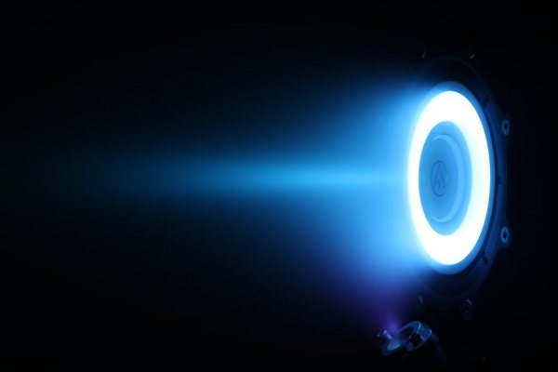
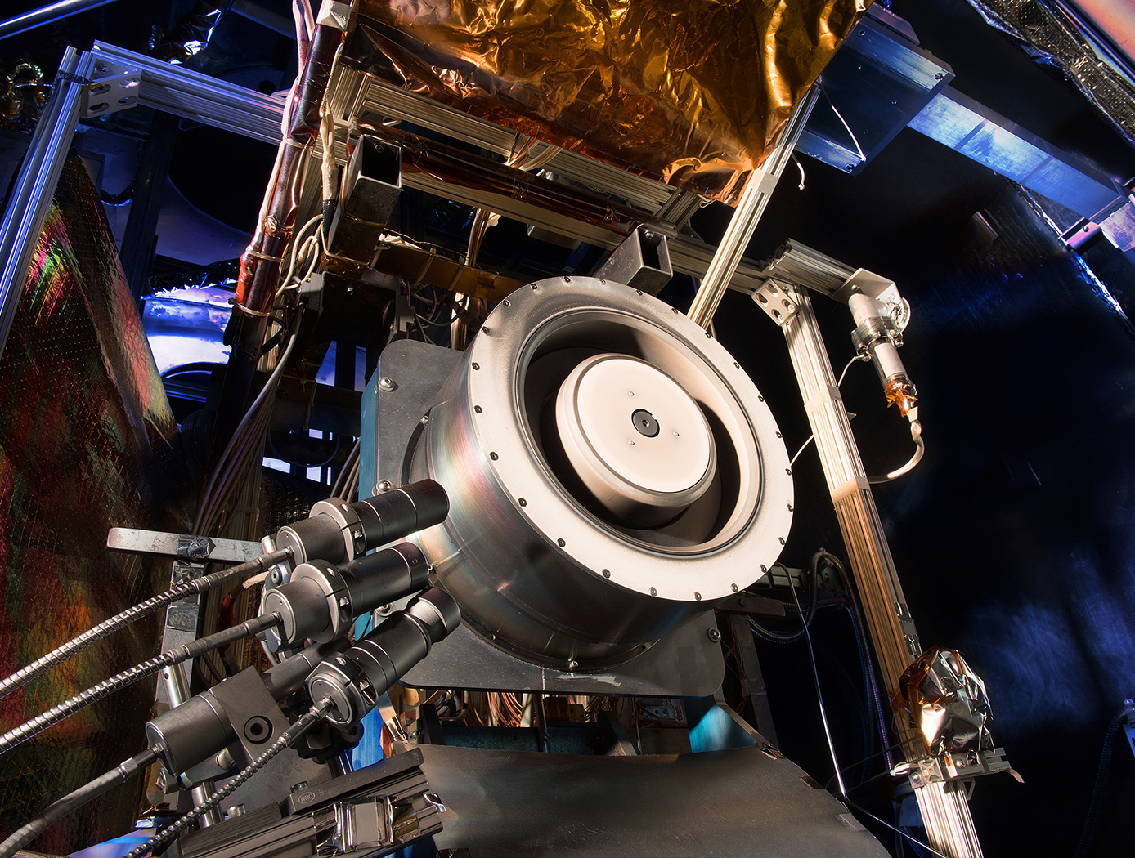
(a) An HET, Glenn Research Center, NASA (b) An HET firing, Sitael
Fig. 1 Two pictures of an Hall Effect Thruster (HET)

Numerous studies have shown that the electron mobility across this imposed magnetic field tends to be anomalously high in comparison to the predictions from classical diffusion theories [Goebel08]. Historically, multiple mechanisms have been proposed to explain this anomaly: Intense secondary electron emission, sheath instabilities, gradient driven instabilities, or electron cyclotron drift instabilities (ECDI). The latter mechanism has been deeply investigated theoretically [Lafleur16] and numerical [Croes17]. A 2D Particle-In-Cell simulation tool has been developed at the Laboratoire de Physique des Plasmas (LPP) in order to investigate the ECDI coupled with the wall effects. In addition, experiments are currently being designed in order to confront the simulation results to the real discharge. An overview of these results and the future work will be given.
References
- [Croes17]: V. Croes, T. Lafleur, Z. Bonaventura, A. Bourdon, and P. Chabert, Plasma Sources Sci. Technol., 2017
- [Goebel08]: D. M. Goebel and I. Katz, Fundamentals of Electric Propulsion: Ion and Hall Thrusters, 2008
- [Lafleur16]: T. Lafleur, S. D. Baalrud, and P. Chabert, Phys. Plasmas, 23(053503), 2016
- [Villain15]: R. Villain, Euroconsult Research Report, volume 18, 2015

LPP, CNRS, Ecole polytechnique, Univ. Paris-Sud, Observatoire de Paris, Université Paris-Saclay, Sorbonne Universités, 91128 Palaiseau, France
Safran Aircraft Engines. 27208 Vernon, France * antoine.tavant@lpp.polytechnique.fr.

