**- Project report -**

**An application for mobile devices – Thief and Policemen**

*Université Cergy Pontoise*

|  |  |
| --- | --- |
| **Authors** : | Bah Amadou Madjou |
|  | Phetramphand Antoine |

Contents

[I. Presentation of project 3](#_Toc439755810)

[1. Description 3](#_Toc439755811)

[2. Characters in the game 3](#_Toc439755812)

[3. Software used 3](#_Toc439755813)

[II. Team members 4](#_Toc439755814)

[III. Activities 5](#_Toc439755815)

[1. Acitivity “MainMenu” 5](#_Toc439755816)

[2. Acitivity “GameService” 5](#_Toc439755817)

[3. Acitivity “MySensor” 5](#_Toc439755818)

[IV. Intents 6](#_Toc439755819)

[V. Background Services / Threads 7](#_Toc439755820)

[VI. Sensors Used 8](#_Toc439755821)

[VII. User guide 9](#_Toc439755822)

# I. Presentation of project

## 1. Description

The application that we created called “***Thief and Policemen***”. It’s a simple video game which involves guiding an avatar to jump in order to avoid enemies to advance the game. Here, we can control the ***Thief***as the main character. The enemies are the ***Policemen***.

## 2. Characters in the game

The characters are:

- C:\Users\Antoine\AndroidStudioProjects\Project_ThiefAndPolicemen\app\src\main\res\drawable-nodpi\thief1.png The main character (the thief)

- C:\Users\Antoine\AndroidStudioProjects\Project_ThiefAndPolicemen\app\src\main\res\drawable-nodpi\enemy1.pngThe IA (the policemen)

## 3. Software used

We used **Android Studio** to develop this game.

To emulate this application, we used **Nexus S API 10**.

# II. Team members

Our team :

* **Bah Amadou Madjou**(e-mail : amsbert1@gmail.com)
* **Phetramphand Antoine**(e-mail : Antoine.phetramphand@gmail.com)

# III. Activities

## 1. Acitivity “MainMenu”

It’s the main Activity which contains the others activities and permits to execute them thanks to the method ***launch()***.

It displays also a menu which allows to choose a mode.

## 2. Acitivity “GameService”

It’s the Activity which allows to start the main game by using the class ***GamePanel***.

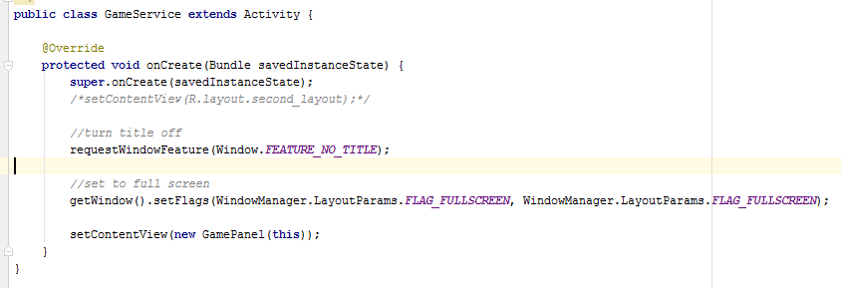

## 3. Acitivity “MySensor”

It’s the Activity which triggers the Sensor with type ***Accelerometer***.

# IV. Intents

The intents are used in the Activity “***MainMenu***”

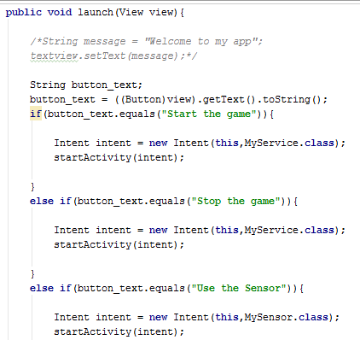

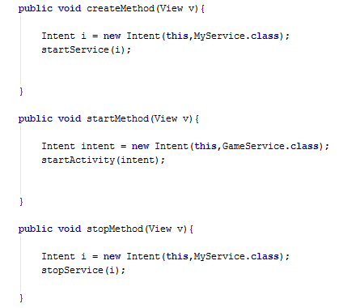

# V. Background Services / Threads

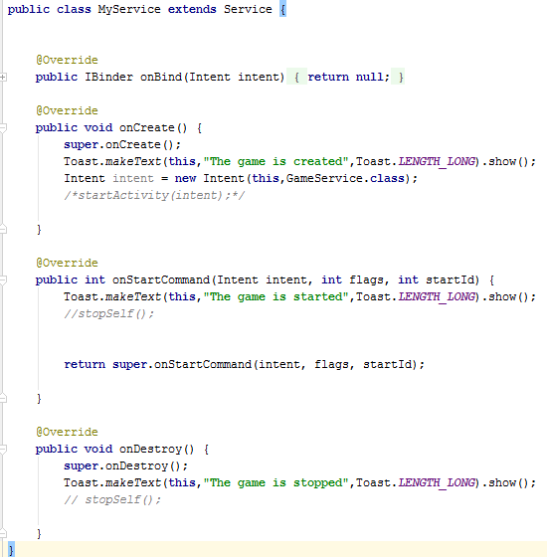

Here, this class enables to create or stop the game and sends messages to user if it succeeds.

# VI. Sensors Used

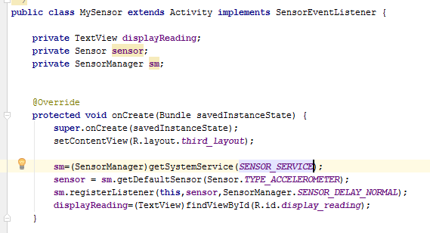

It uses the type ***Accelerometer***.

# VII. User guide

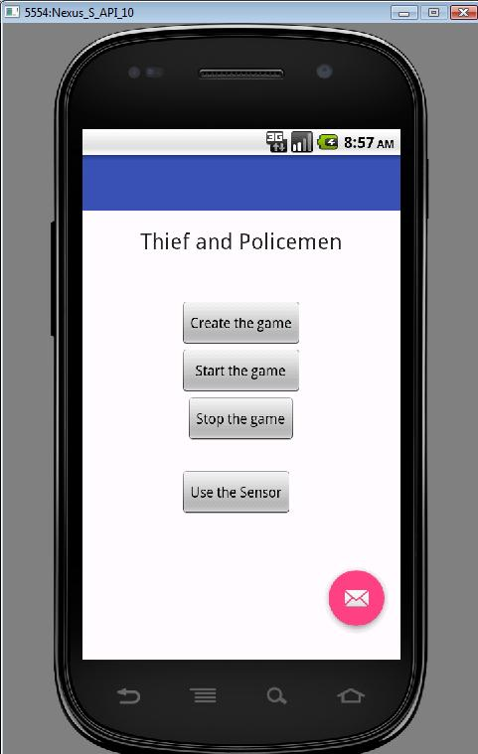

Here, this is the main menu when we execute the program.

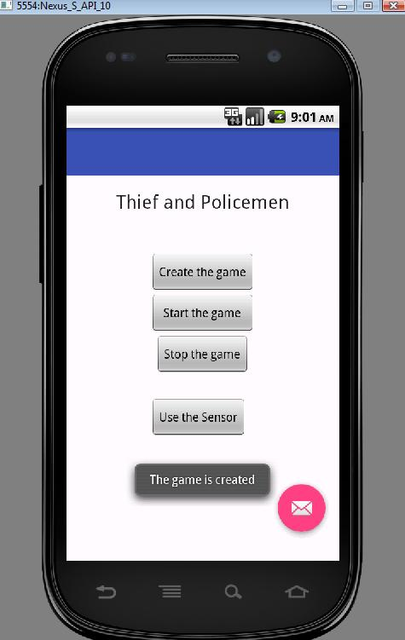

To call the service, you press the button « ***Create the game*** » and show this message “***The game is created***”.

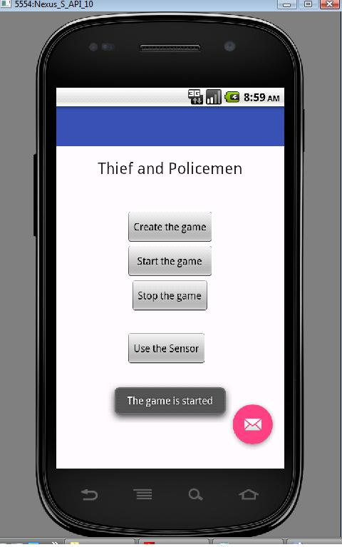

It starts the game and click on “***Start the game”*** to begin.

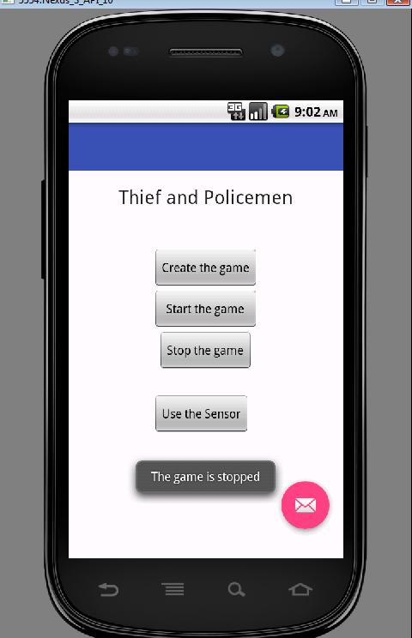

If you want to stop the service, click on « ***Stop the game*** ».

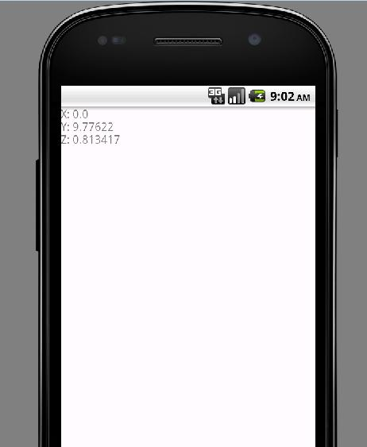

When you clik on « ***Use the sensor*** », it displays an other window.

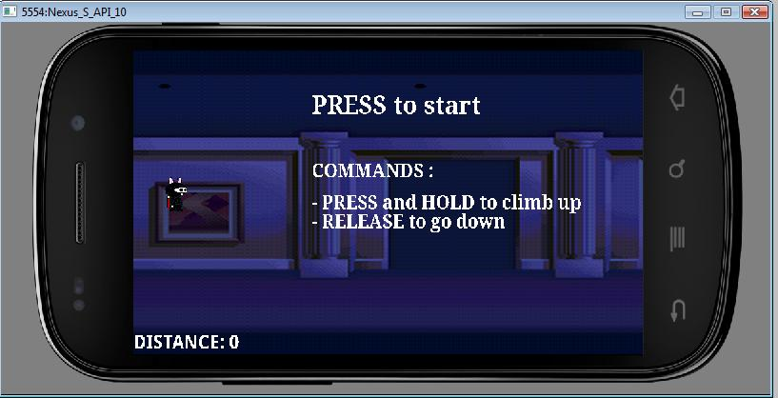

This is main game. Before to start, it’s much pleasant to see the application by using **Ctrl+F11**. It enables the mode ***Landscape***.

This window displays the commands of the game. For going up with the character, you need to press once or twice left button of the mouse and then hold the button. If you want to go down, you just release the button. The word “***distance***” means the distance you covered during the game.

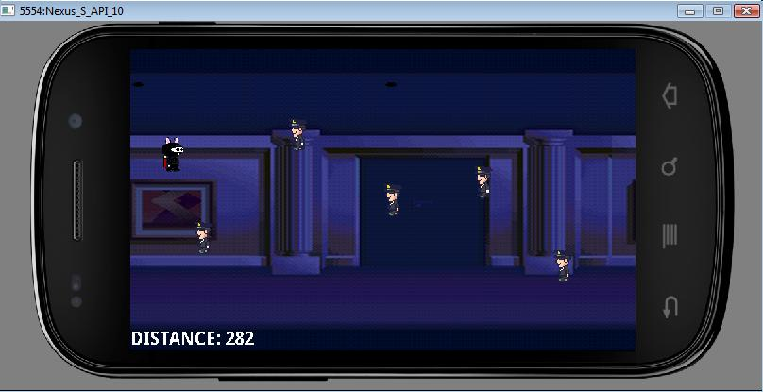

When the game starts, enemies (policemen) appear on the screen and they go towards the left. You have to avoid them. If one of them hit you, the game is over.