How to Submit Playlists by Platform- After copying the link just paste the link into the proper location onto the submission page (NO EDITS) and your done.

Spotify: […] -> Share -> Copy Embed Code

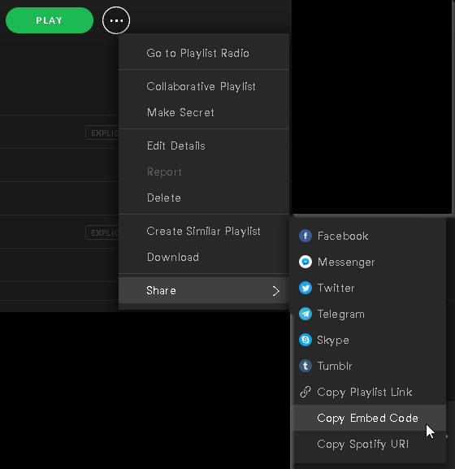

SoundCloud:

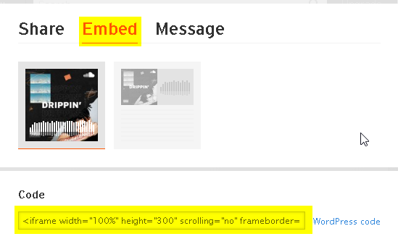

Tidal:

