**PLAYING THE GAME**

You are a Galactic Commando deep in enemy territory. Power hungry leaders of the repressive Bungeling Empire have stolen a fortune in gold from the people by means of excessive fast food taxes. Your task? To infiltrate each of 150 different treasury rooms, evade the deadly Bungeling guards, and recover every chest of Bungeling booty.

TO START:

After booting, the program automatically begins a self-playing demo of three different levels of play. Watch them to get a sense of game play. To begin play, press any key (except "return') or push a joystick button. Your player will start to flash. Move your player or push a joystick button to begin game action.

You will notice that gold chests carried by enemy guards cease to be visible. If you have picked up all the visible gold on the screen and the ladder leading to the next level has not yet appeared or you cannot reach the next level by climbing to the highest part of the screen, one or more of the guards is still carrying gold. You must trap the guards in a pit and pick up their gold. If an enemy carrying gold falls into a "dead end" that he and you are unable to leave, you will not be able to get that gold chest safely. If stuck in a "dead end," press CTRL-A to continue (see below).

SCORING:

Completing a level................1500 points

Picking up a gold chest. ............250

Trapping an enemy .................. 75

Enemy dying in a hole ...............75

KEYBOARD COMMANDS: I = move up

K = move down

J = move left

L = move right

u = dig left

0 = dig right

GAME PLAY:

JOYSTICK COMMANDS:

Up/Down/Left/Right

Button 0 = dig left

Button 1 = dig right

HIGH SCORES:

If you achieve a new high score, a high score list will appear on the screen at game's end. Type in your initials then press RETURN. Note:

You can use the left and right arrow keys to make corrections before pressing RETURN.

SPECIAL KEYS:

To complete a level, you must collect all the gold chests in a scene. When you succeed, you may then climb a ladder to the top of the screen and enter the next level. You will also gain bonus points and earn an extra life for each level you complete. You start with 5 lives.

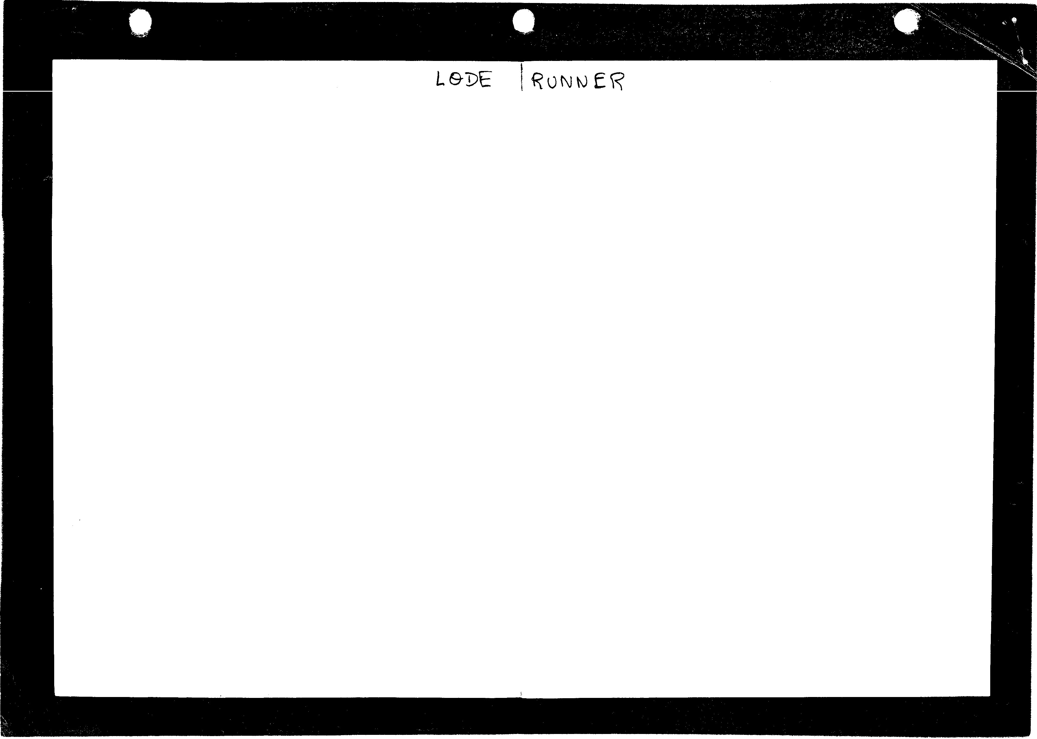

You will use your laser drill pistol to drill pits and passageways through brick floors. You may dig through fissured bricks only, not through solid surfaces, and holes must be drilled all the way through to be effective. If a Bungeling guard falls into a pit and gets stuck, it will become safe (for a moment) for you to run over him; also, he will release any gold he is carrying. Any holes that you've drilled will fill in again after a period of time, and guards caught in them when they refill will die and be replenished by new guards at the top of the screen. Be careful: Guards can climb out of pits that do not close up around them. Your player, however, cannot climb out of pits and will die if trapped in a pit that is only a single brick wide.

2

CTRL·A

CTRL-J CTRL-K RETURN CTRL-R

C..T.R.L.-.8

CTRL·X CTRL·Y ESC

aborts man if stuck without means of death or escape

sets game to joystick control

sets game to keyboard control

displays current high score list terminates current game (enter demo mode)

toggles sound ON/OFF

slows down overall game speed (press repeatedly)

speeds up overall game speed (press repeatedly)

flips x-axis on joystick flips y-axis on joystick

freezes action until ESC hit again

3

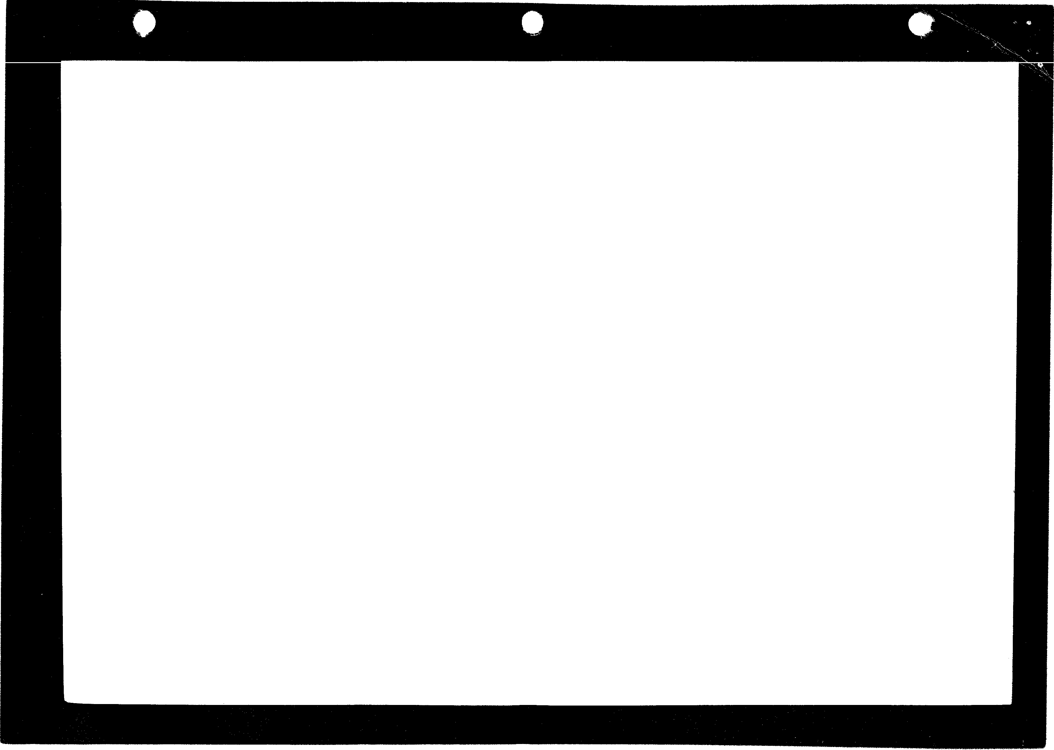

Cheet keys:

CTRL-sHIFT-N advances a level (CTRL-SHIFT-6 on lie) CTRL-sHIFT.P adds additional lives/players (CTRL·

SHIFT-2 on lie)

Using either of the two "cheat keys" forfeits your high score attempt for that game. So does beginning a session at any level other than the first (level 001).

MAKING YOUR OWN GAMES

The Game Generator ("Edit mode',lets you design, move, erase, playtest, and save to disk your own unique Lode Runner games­ with no programming knowledge required! You may also use this editor to access directly (then play) any of Lode Runner's 150 dlf· ferent game screens, as well as to erase high scores and prepare new data disks for use in saving your own game creations. Don't panic. It's all remarkably euy.

The following chart summarizes the steps Involved In making your own games. Detailed Instructions are given In the sections that follow.

HOW TO MAKE YOUR OWN GAMES: SUMMARY

|  |  |  |
| --- | --- | --- |
|  | WHAT TO DO | HOW TO DO IT |
| 1. | Enter "Edit Mode" | Press CTRL-E from demo mode (or CTRL-R then CTRL-E from game In progress) |
| 2. | Put "Initialized" data disk into disk drive | (See "Initializing Your Data Disk *j* |
| 3. | Design Your Game | Use 1-J·K·M keys to move cursor; Use9 to make shapes |
| 4. | Save Your Game | Press CTRL-S |
| 5. | Play Your Game | Press CTRL..Q to "Quit" game generator;  Press P (and RETURN) to "Play" |

4

*II*

f\l

Jl

ENTERING EDIT MODE:

First you must enter Edit mode. If you are playing a game, press CTRL·R to end the game, then press CTRL-E (for "Edit',.If you are starting from the self-playing demo mode, simply press CTRL·E.The Lode Runner Board Editor screen will appear, allowing you to enter the following single-key editing commands:

E (for "Edit', P (for "Play',

I (for "Initialize', C (for "Clear',

M (for "Move', S (for "Score',

These commands are explained in the instructions below.

INITIALIZING YOUR DATA DISK:

Before designing your first game board, you must prepare a Lode Runner data disk on which to save your creations. Enter the Edit mode (If you haven't done so already) and press I for "Initialize." Remove your Lode Runner disk and Insert a blank disk of your own into the drive. Press Y (for ''Yes'i,n response to the screen question ("Are you sure?',When the disk drive stops whirring, your data disk is ready to use, and you can use It to create and save 150 different boards without reinitlallzing. Note: Use this I command with cau­ tion as it erases the entire data disk! By the way, the program will prevent you from initializing (and erasing) your Lode Runner master disk.

DESIGNING YOUR OWN GAME BOARDS:

Now that you have an initialized data disk, you are ready to create your own games. From the Lode Runner Board Editor screen, press E (for "Edit',.You will be asked to type in the number of the game board you want to work on (001-150). For your first board, use 001. Type In the number, then press RETURN. The selected screen will appear.

NOTE:Whenever you type in board numbers in response to prompts In the Board Editor, you must type the entire three digit number before pressing RETURN (I.e. 3 must be entered as 003, 47 as 047, etc.) You may use the forward and back arrow keys to skip over digits or to make corrections before pressing RETURN.

*s*

The process of designing your own boards is simple. There are nine basic shapes that make up all Lode Runner game boards. Each of these shapes is controlled by one of nine number keys (1-9). Zero (0) makes a blank. To design a game screen, you simply move the cursor around the screen with the cursor movement keys and place the shapes where you want them by pressing the appropriate number keys.

Remember: You MUST have an initialized data disk on hand if you are going to save your creations to disk; you cannot use the Lode Runner master disk for this purpose.

IMPORTANT: SEE TIPS ON SAVING YOUR CREATIONS BELOW. YOU MUST SAVE YOUR GAME EACH TIME YOU QUIT THE GAME GENERATOR, EVEN TO PLAYTEST.

CURSOR MOVEMENT CONTROLS: I = up a line

M = down a line

J = left a character

K = right a character

LODE RUNNER SHAPES:

There are a few practical limitations regarding the number of ob­

jects you can use:

YOU MUST HAVE ONE "PLAYER" ON YOUR GAME BOARD FOR YOUR GAME TO BE PLAYABLE-i.e. NO MORE, NO LESS THAN ONE LODE RUNNER COMMANDO (SHAPE #9) MUST BE INCLUD­ ED IN YOUR GAME BOARD DESIGN. OTHERWISE, WHEN YOU TRY PLAYING YOUR GAME, YOU WILL BE RETURNED TO DEMO MODE.

You may have 1, 2, 3, 4 or 5 enemy guards (shape #8) on a board. No more than five, no less than one.

The other shapes (1-7) also have numerical limits, though you are not likely to exceed them. If you do, the program will simply Ignore the excess.

From within the game generator, you may also view adjacent Lode

Runner boards by pressing the forward or back arrow keys.

SAVING YOUR CREATIONS:

When you finish designing a screen or when you want to play test it or take a break ...

YOU MUST SAVE THE BOARD ON YOUR INITIAL­ IZED DATA DISK BY TYPING CTRL-S (for "Save''). IF

YOU DO NOT SAVE THE GAME ON A DATA DISK,

D 0 = blank

•• 1 = diggable floor

II 2 = undiggable floor

3 = ladder

:-1: 5 = trap door

:J 6 = ladder that appears after getting all gold

II 7 = gold chest

8 =enemy

THE BOARD WILL BE LOST WHEN YOU EXIT THE GAME GENERATOR!

PLAYING YOUR GAME:

After you have saved a board (using CTRL-5), type CTRL-Q (for "Quit''). CTRL-Q returns you to the Board Editor screen. From there simply type P (for "Play'') and RETURN to play the game board you've created.

,,

OTHER EDIT MODE COMMANDS:

The other single-key commands available from the Board Editor

(CTRL-E screen) are as follows:

4 = hand over hand bar J;- 9 = player

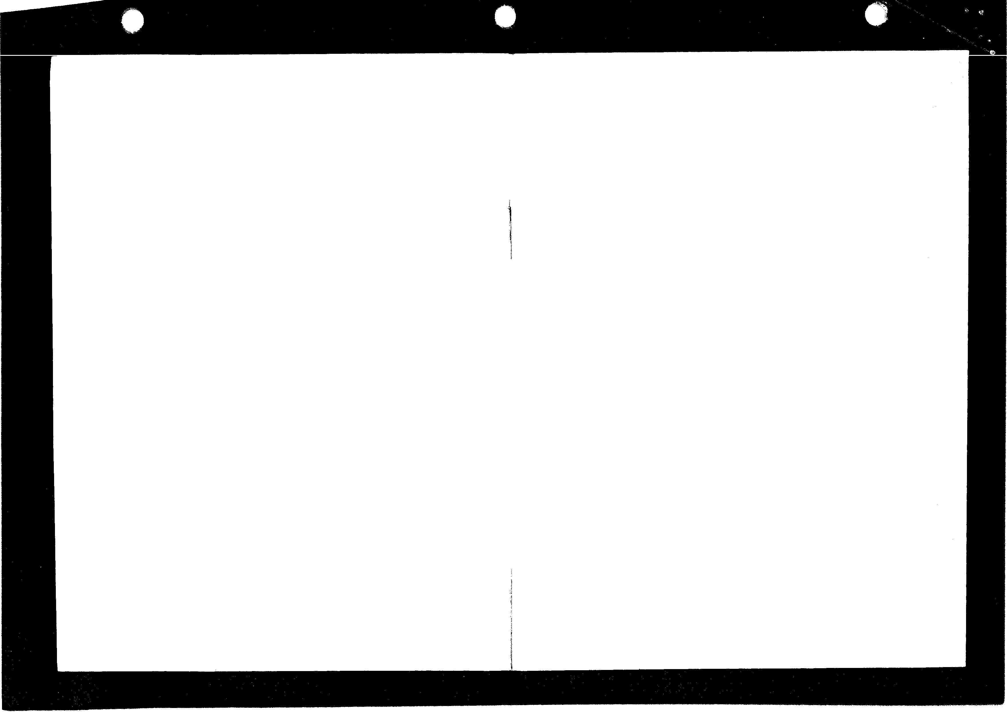

6

P (Play)-Lets you select any game board you desire. After press­ ing P, you will be asked to enter the three digit number of the level you wish to play (001-150). Type in the number and press RETURN. Note: If you attempt to enter Play mode using a disk that has no

7

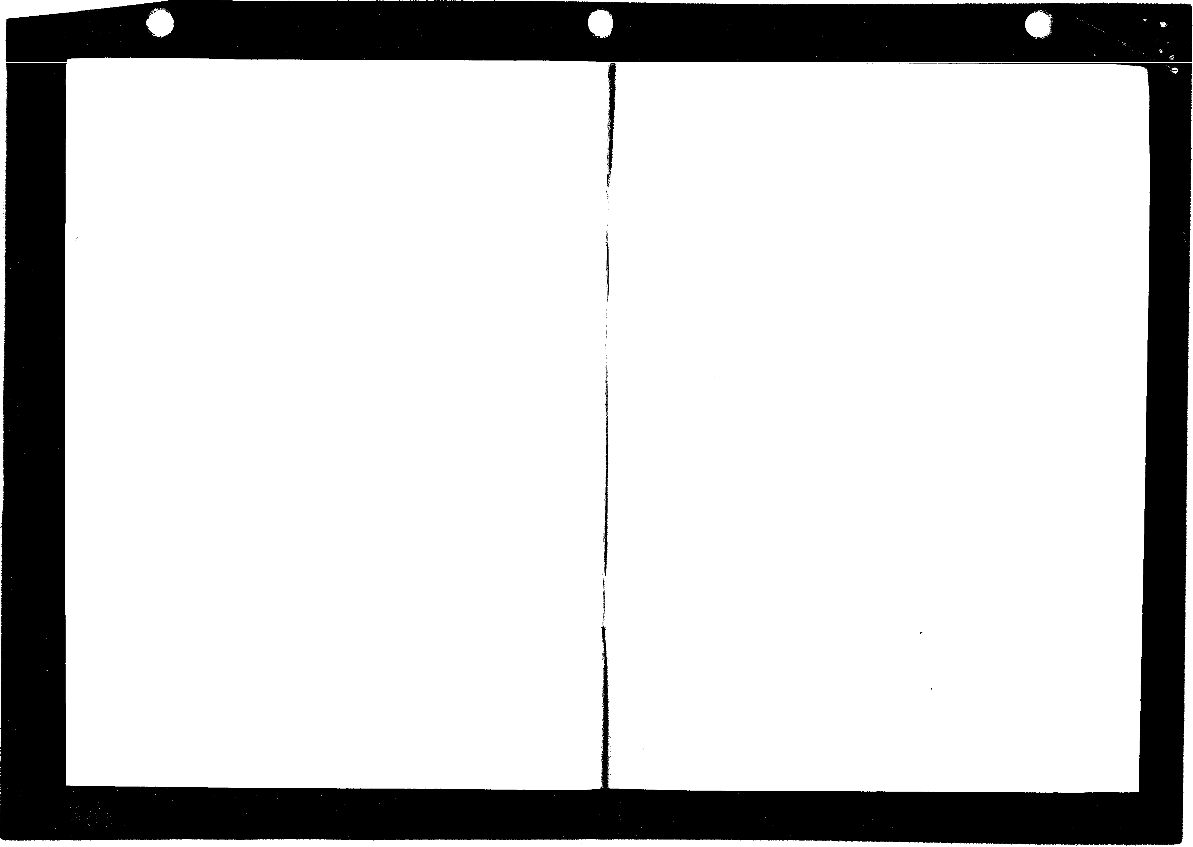

level 001, control is returned to demo mode. To resolve this, enter

Edit mode and create a first level.

S (Score)-Clears high scores from the disk; you start high scores over again with a clean slate.

C (Clear)-Erases a game board from the disk (blanks the board).

**M** (Move)-Copies a board to another level number.

· ,, -Note: You cannot Clear, Move, or Edit the game boards on the master disk. These functions are available for use with a data disk only.

**TROUBLESHOOTING:**

Whenever there is a disk error, the game will return to demo mode. If this happens, check to see if the Lode Runner master disk is in

the disk drive and if the drive door is shut. If this doesn't resolve the problem, check to see if you have a level 001 on your game disk. If not, create one.

Playtest your own board creations to make sure they are beatable. If you want to refine or improve them, simply return to the editor.

Remember, as mentioned in "Game Play," if a player becomes stuck in a "dead end" with no way out, press CTRL-A to Sacrifice that "life" and to resume play.

8