CareBridge: Diabetes Readmission and Cardiometabolic Comorbidity
Antoine Ward | B.S. Data Science capstone | 2026-09-24

Contents
Abstract
Executive summary
1. Introduction
2. Research questions
3. Data preparation
4. Methodology
5. Analysis
6. Recommendations
7. Challenges and limitations
8. References
Appendix

Abstract
This study examined readmission prediction in 70,423 patients with diabetes and cardiometabolic associations in 253,680 BRFSS respondents. Patient-grouped cross-validation yielded XGBoost average precision (AP) 0.1805 (95% interval 0.1721–0.1889) at 8.93% event prevalence. Adding a deliberately unavailable future encounter count increased AP by 0.1204, illustrating the impact of information leakage. SHAP described the fitted model; threshold audits quantified demographic differences. Three parallel survey models, nested likelihood tests, and adjusted comorbidity models characterized cross-sectional associations. An MLP and outcome-blind clustering extended the analysis. Results support further validation, with substantial limits from historical data, sample selection, missing survey-design fields, and observational measurement.

Executive summary
XGBoost exceeded the utilization-history rule (AP 0.1116) and logistic regression (0.1643). Its lift over prevalence was 2.02. The raw probabilities were audited for calibration but were not recalibrated. Group error rates vary at a shared cutoff, so aggregate accuracy cannot establish equitable performance. The future-count model is retained solely as a diagnostic. The BRFSS outcomes measure existing diagnosed conditions, and cardiac disease is a combined heart disease/angina/heart attack indicator. All survey percentages are unweighted sample statistics. The deliverable includes code, tables, figures, this report, and a reproducible runner.

1. Introduction
CareBridge connects two analytic questions: identifying patterns associated with early readmission after a diabetes hospitalization, and comparing correlates of diabetes, stroke, and cardiac disease in a community survey. The sources differ in time, population, and unit of observation, so they are analyzed separately. The hospital dataset covers 1999–2008 [1]; the survey extract derives from 2015 BRFSS [2, 3]. Neither analysis estimates intervention effects.

2. Research questions
RQ1: Which patient, encounter, utilization, and medication-management factors predict 30-day readmission, and how do discrimination, calibration, and subgroup error rates compare? The proposal's intent concerns unplanned readmission, but the supplied target does not distinguish planned readmissions. The available predictors support scoring at discharge.
RQ2: Which behavioral, clinical, and socioeconomic indicators predict each survey condition, how do their rankings differ, and which existing diagnoses are most strongly associated with another condition? This is concurrent disease classification, not a prospective incidence model.
The original verbatim H2a–H2d statements were unavailable in the repository. This report uses the working definitions in analysis_specification.md: H2a tests the clinical/behavioral block; H2b tests the socioeconomic/access block; H2c describes ranking differences; H2d examines adjusted comorbidity. These are exploratory operational definitions, not a claim of preregistration. H1d has no supplied parity margin, so the audit cannot declare equivalence or certify fairness.

3. Data preparation
Bronze preserves raw strings and lineage. Silver casts types, resolves sentinels, and applies eligibility rules. Gold groups primary diagnoses, derives encounter order, and selects each patient's first retained encounter. Encounter ID is an ordering proxy because admission dates are unavailable. Expired discharges are outside the population at risk for subsequent readmission; hospice is retained. Patients with apparent post-expired encounters are excluded as unresolved records. These are eligibility and data-quality decisions; the deliberate future-count feature is a separate temporal-leakage experiment. Stable patient/encounter sorting makes CV input order repeatable.
Medication adjustment is defined as any individual drug marked Up or Down. The original change flag also occurs with No/Steady drug entries and therefore does not isolate this dose-adjustment construct. This finding does not establish that no medication initiation or other treatment change occurred. Features include medication counts, service counts per day, prior utilization, and an Isolation Forest anomaly score. Race is reserved for audit; age and recorded gender remain predictors.
BRFSS uses the unrebalanced 253,680-row binary extract, not the 50/50 variant. All three outcome columns are excluded from the shared predictive feature set. Other diagnosis indicators enter only the separate, explicitly cross-sectional comorbidity models. Survey weights, strata, and primary sampling units are absent from this mirror, which limits population inference [2, 3].

4. Methodology

4.1 Readmission prediction and uncertainty
The utilization rule, logistic regression, linear SVM, and XGBoost were compared on five StratifiedGroupKFold partitions (seed 42). Anomaly detection, scaling, and categorical encoding were fitted inside each training fold. One patient contributes one primary row. AP is the reported PR-AUC convention, with ROC-AUC secondary. Paired percentile intervals use 1,000 patient bootstrap resamples of fixed OOF scores. They do not include model-refit or selection uncertainty. No cutoff was optimized on these outcomes.

4.2 Calibration, explanation, and sensitivity
Raw OOF probability calibration uses Brier score, a joint logistic intercept/slope fit, and ten quantile bins. The scikit-learn return order is observed fraction followed by mean prediction [4]. SHAP explains the full-cohort XGBoost refit using 5,000 sampled observations, an explicit 100-row background, and interventional probability output [5]. Base value plus contributions must reconstruct each prediction within numerical tolerance. Source-level importance sums signed one-hot contributions per patient before taking absolute magnitudes. This is descriptive model attribution, not causal inference or a new performance estimate. Correlated and derived features complicate individual attribution.
The sensitivity experiment adds patient_encounter_count to an otherwise identical pipeline on identical materialized folds. This count includes later retained encounters and is unavailable at the index discharge. The primary feature allowlist continues to exclude it. Subgroup audits report TPR and FPR at 0.05, 0.10, 0.15, 0.20, and 0.25 with pointwise Wilson 95% intervals. Zero denominators produce undefined rates. Descriptive max–min gaps exclude denominators below 20; all group counts remain available. The displayed 0.10 cutoff is illustrative.

4.3 Survey models and hypothesis tests
Three common logistic specifications use five shared folds stratified by the joint outcome pattern. Age, general health, education, and income bands are one-hot encoded; continuous predictors are standardized inside folds. AP intervals use 300 respondent-row resamples. Held-out permutation importance uses 5,000 validation rows per fold and three repeats; the reported standard deviation is repeat/fold variability, not a confidence interval. Separate unpenalized logistic association models estimate odds ratios and nested likelihood-ratio tests on identical rows. Benjamini–Hochberg correction is applied separately to nested tests, comorbidity terms, and the coefficient table. Standard errors assume independent records and do not account for the unavailable survey design.

4.4 Neural benchmark and phenotyping
The Keras benchmark uses 64 and 32 ReLU units, dropout 0.2, a sigmoid output, Adam at 0.001, batch size 512, and exactly 20 training epochs per fold. Test patients never influence preprocessing or stopping. It is compared with XGBoost using paired OOF AP. Exploratory K-means phenotypes use 12 utilization inputs after log1p and standardization; outcomes are excluded. The cluster count (2–6) is selected by silhouette on a fixed sample, then refitted on the full cohort. A second seed provides an adjusted Rand agreement check. Post-fit event rates describe the clusters and do not independently validate them.

5. Analysis

5.1 Model discrimination and existing hypotheses
Table 1. RQ1 OOF discrimination; PR-AUC denotes average precision.
model | pr_auc | ci_low | ci_high | roc_auc
prevalence | 0.0893 | — | — | 0.5000
rule_baseline | 0.1116 | 0.1075 | 0.1159 | 0.5479
logistic | 0.1643 | 0.1575 | 0.1716 | 0.6465
linear_svm | 0.1622 | 0.1557 | 0.1695 | 0.6477
gradient_boosting | 0.1805 | 0.1721 | 0.1889 | 0.6572
H1c: the paired XGBoost-minus-logistic bootstrap mean AP difference was 0.0161 (0.0115 to 0.0208). The difference is positive in the reported interval. This comparison remains conditional on the chosen feature set, models, and cohort.
H1b: the dose-adjustment interaction OR was 0.914 (0.790–1.057); p=0.2237. An interaction coefficient modifies the product of main-effect odds ratios; it is not the combined group's standalone odds ratio. These observational estimates do not identify a treatment benefit. H1e: length-of-stay variance/mean was 2.0175; the boundary-corrected Poisson-versus-negative-binomial LR statistic was 19004.6. The fitted negative binomial improves likelihood, but the observed stay range is restricted to 1–14 days and untruncated distribution fits remain approximations.

5.2 Calibration and SHAP
Table 2. Raw OOF calibration.
model | brier_score | calibration_intercept | calibration_slope
logistic | 0.0790 | -0.0882 | 0.9601
gradient_boosting | 0.0784 | -0.0677 | 0.9680
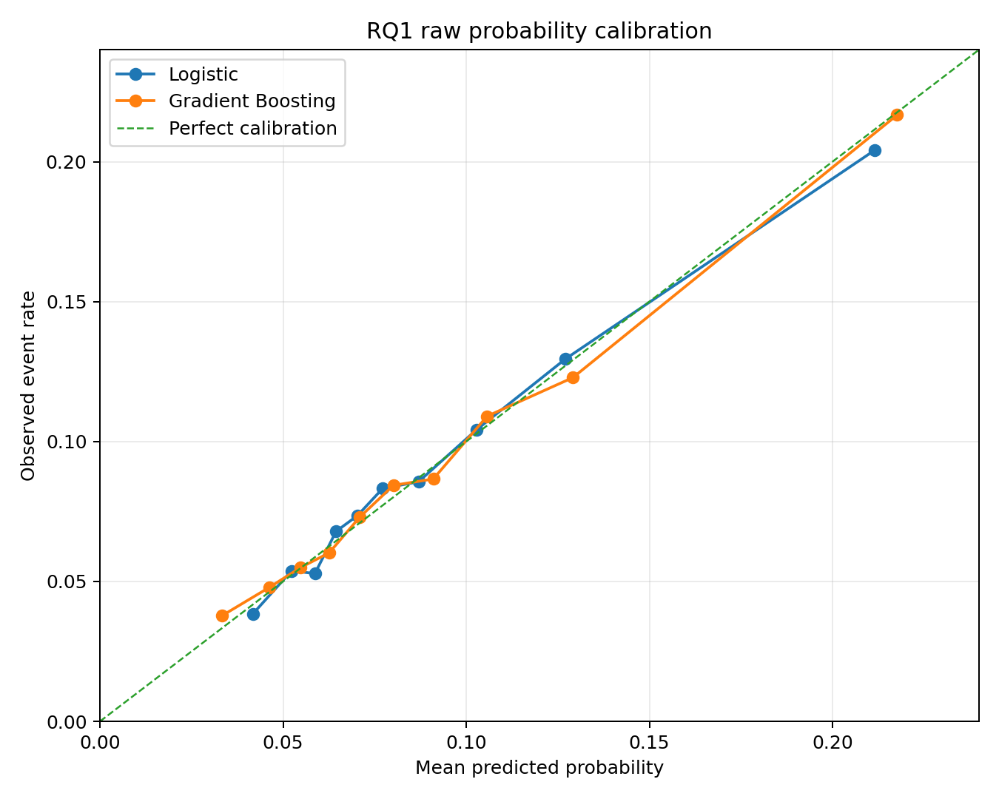
Figure 1. Correctly oriented predicted versus observed risk.
Table 3. Ten highest source-level SHAP magnitudes; units are probability contributions.
source_feature | mean_abs_shap | importance_pct
discharge_disposition_id | 0.0273 | 26.2217
number_inpatient | 0.0121 | 11.6205
diag_1_group | 0.0078 | 7.4917
n_active_diabetes_meds | 0.0052 | 5.0458
age_midpoint | 0.0051 | 4.9225
time_in_hospital | 0.0044 | 4.2633
num_lab_procedures | 0.0044 | 4.1920
anomaly_score | 0.0037 | 3.5508
number_diagnoses | 0.0034 | 3.3054
procedures_per_day | 0.0030 | 2.8947
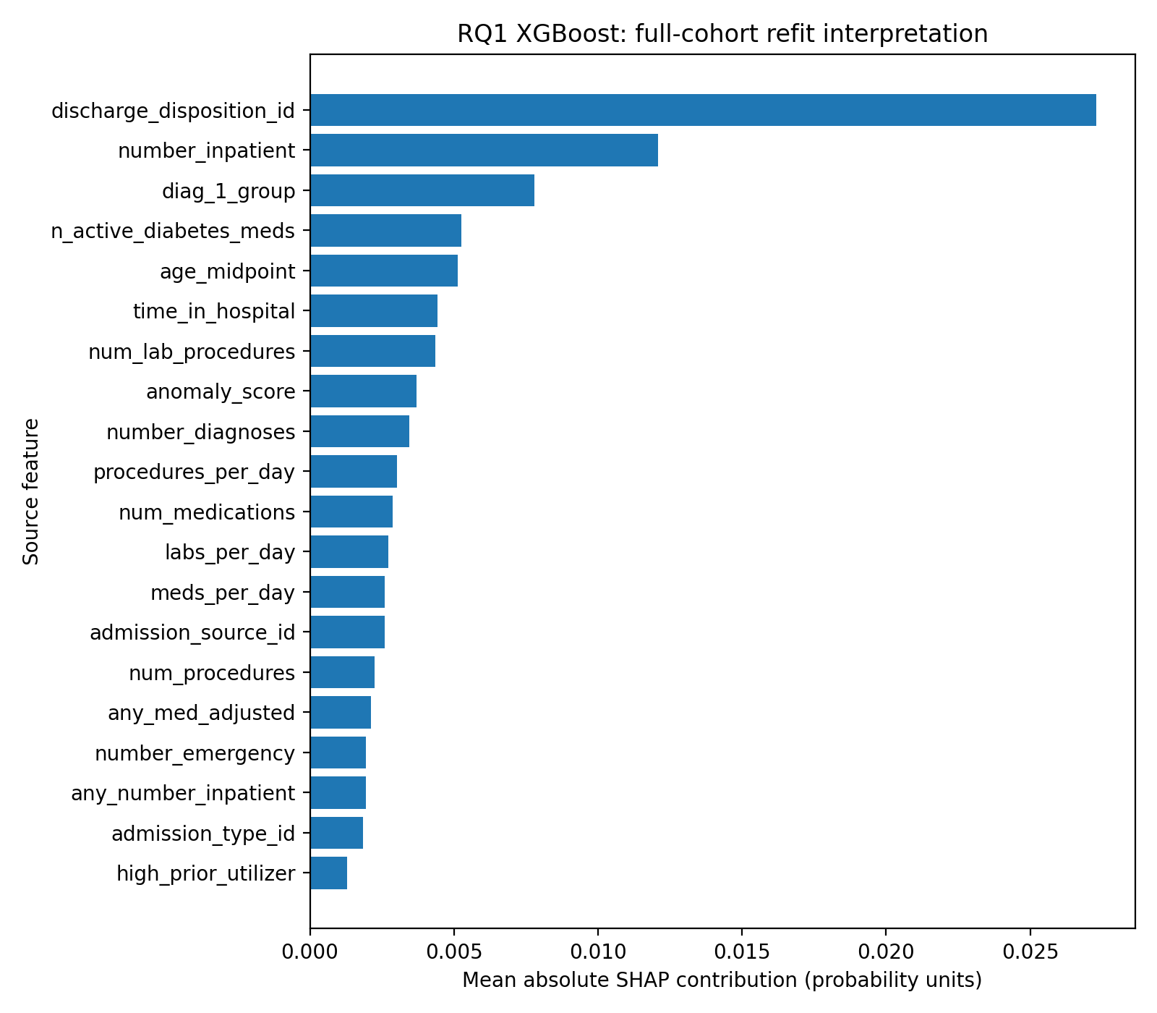
Figure 2. Source-level SHAP importance.
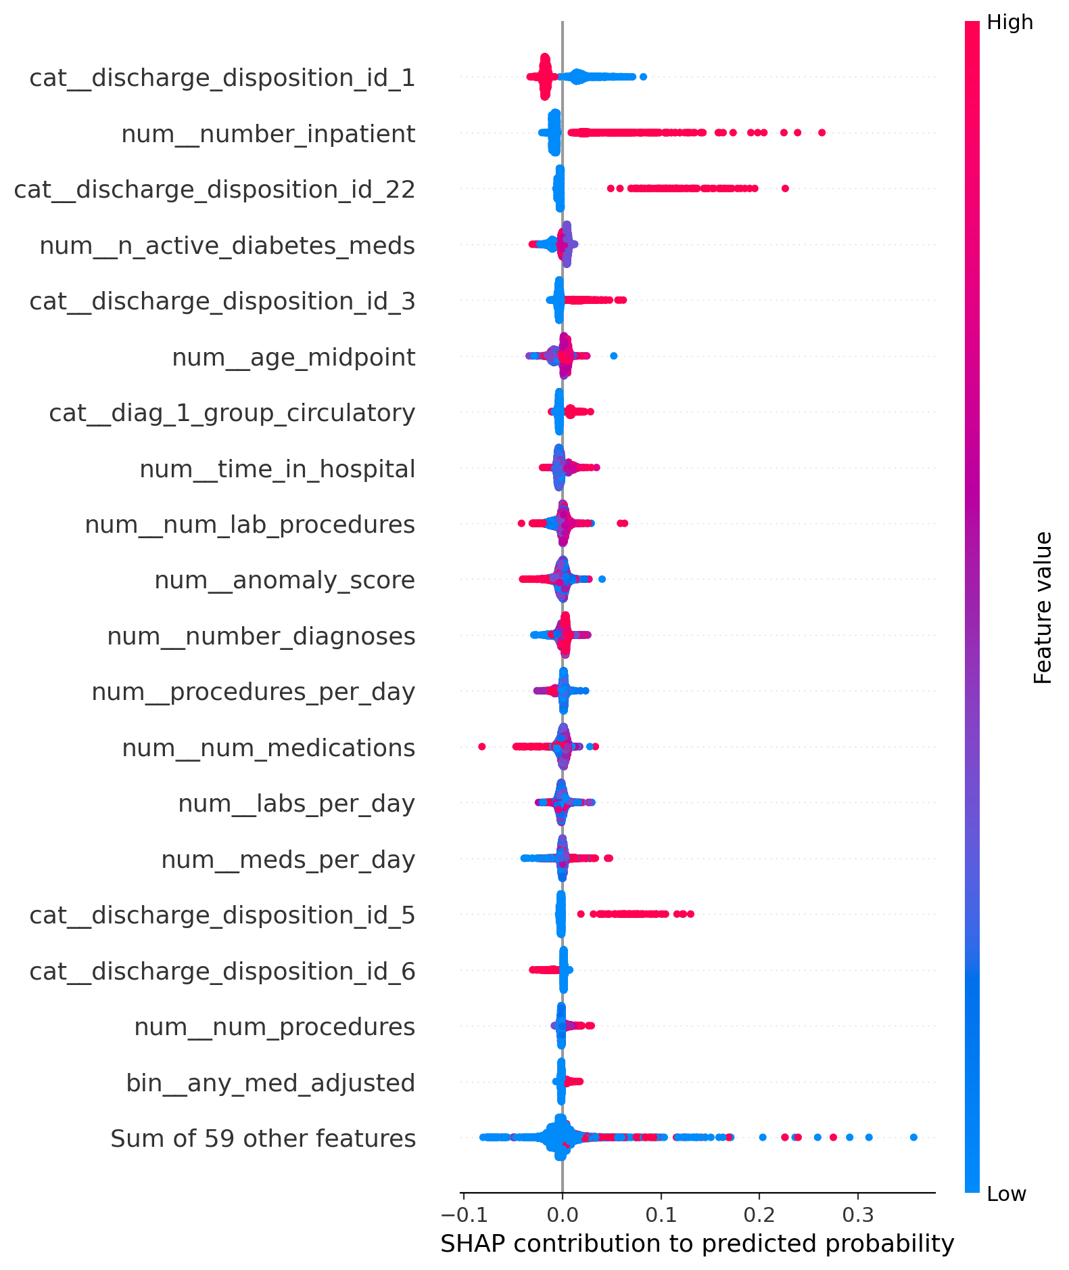
Figure 3. Encoded-feature SHAP contributions in the sampled cohort.

5.3 Leakage sensitivity
Table 4. Identical-fold comparison with and without future encounter count.
scenario | pr_auc | ci_low | ci_high | roc_auc
safe_model | 0.1805 | 0.1721 | 0.1889 | 0.6572
with_future_count | 0.3009 | 0.2901 | 0.3117 | 0.8089
The observed AP increase was 0.1204, with paired 95% interval 0.1119–0.1291. This is apparent performance obtained using unavailable information; it must not be reported as a valid model improvement.
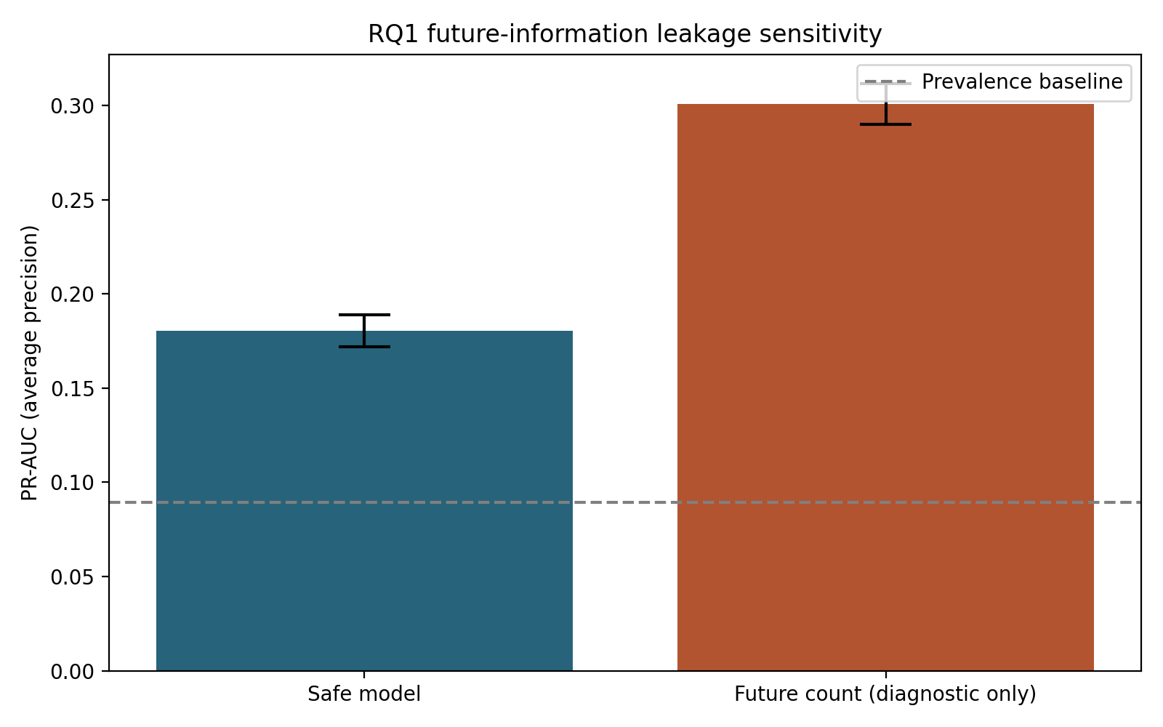
Figure 4. Performance inflation from future information.

5.4 H1d subgroup audit
Table 5. Descriptive subgroup ranges at the illustrative 0.10 threshold.
attribute | metric | eligible_groups | max_minus_min
age_band | tpr | 9 | 0.3279
age_band | fpr | 10 | 0.3965
gender | tpr | 2 | 0.0346
gender | fpr | 2 | 0.0225
race | tpr | 6 | 0.1332
race | fpr | 6 | 0.0788
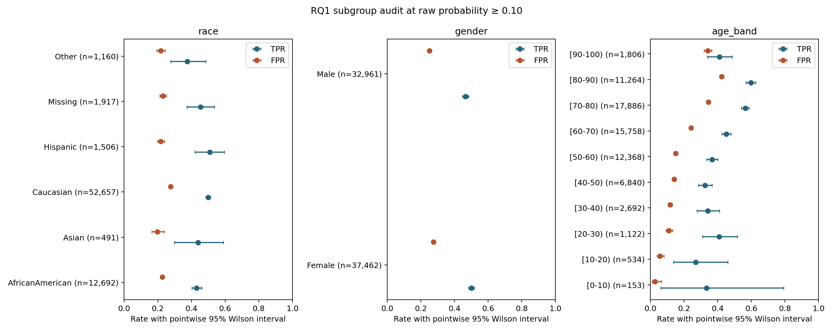
Figure 5. Subgroup TPR/FPR and pointwise Wilson intervals.
Differences in observed error rates require investigation and cannot be dismissed because race was excluded from predictors. Small groups have wider uncertainty. Marginal intervals and max–min ranges do not constitute a simultaneous test or an equivalence assessment. H1d is addressed descriptively; a binary fairness conclusion is not identified without a prespecified tolerance, deployment context, and independent validation.

5.5 RQ2 and working H2a–H2d
Table 6. Three survey outcome models; sample-level OOF performance.
outcome | prevalence | pr_auc | ci_low | ci_high | roc_auc
has_diabetes | 0.1393 | 0.4111 | 0.4055 | 0.4160 | 0.8232
has_stroke | 0.0406 | 0.1529 | 0.1474 | 0.1583 | 0.8127
has_cardiac | 0.0942 | 0.3471 | 0.3407 | 0.3533 | 0.8406
Table 7. Working H2a/H2b nested likelihood tests.
outcome | comparison | lr_statistic | df | p_adj_bh
has_diabetes | H2a_clinical_behavior | 32656.4874 | 16 | <1e-300
has_diabetes | H2b_socioeconomic | 502.6902 | 14 | 3.74e-98
has_stroke | H2a_clinical_behavior | 8406.1140 | 16 | <1e-300
has_stroke | H2b_socioeconomic | 448.1408 | 14 | 1.06e-86
has_cardiac | H2a_clinical_behavior | 18649.9969 | 16 | <1e-300
has_cardiac | H2b_socioeconomic | 347.0745 | 14 | 1.69e-65
At BH-adjusted alpha 0.05, 6 of 6 block-addition tests reject their reduced specifications. Large samples can detect small incremental effects; these p-values do not measure predictive or practical value. H2c is described by held-out permutation rankings and their Spearman agreement below, without a formal equality claim.
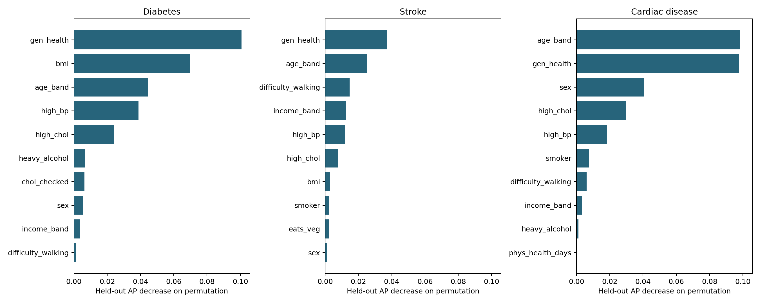
Figure 6. Outcome-specific held-out permutation AP losses.
The three largest held-out permutation AP losses for has_cardiac were age_band, gen_health, sex. These ranks reflect the fitted specification and predictor dependence.
The three largest held-out permutation AP losses for has_diabetes were gen_health, bmi, age_band. These ranks reflect the fitted specification and predictor dependence.
The three largest held-out permutation AP losses for has_stroke were gen_health, age_band, difficulty_walking. These ranks reflect the fitted specification and predictor dependence.
Table 8. Descriptive agreement between outcome predictor rankings.
outcome_a | outcome_b | spearman_rank_correlation
has_diabetes | has_stroke | 0.7193
has_diabetes | has_cardiac | 0.6930
has_stroke | has_cardiac | 0.7649
Table 9. Working H2d: directed comorbidity associations adjusted for shared covariates and the third diagnosis.
outcome | existing_condition | conditional_prevalence | adjusted_odds_ratio | or_ci_low | or_ci_high
has_diabetes | has_stroke | 0.3175 | 1.1748 | 1.1187 | 1.2338
has_diabetes | has_cardiac | 0.3297 | 1.2894 | 1.2453 | 1.3351
has_stroke | has_diabetes | 0.0925 | 1.2011 | 1.1436 | 1.2615
has_stroke | has_cardiac | 0.1648 | 2.6168 | 2.4952 | 2.7443
has_cardiac | has_diabetes | 0.2229 | 1.3325 | 1.2867 | 1.3800
has_cardiac | has_stroke | 0.3825 | 2.6584 | 2.5342 | 2.7888
For has_cardiac, has_stroke had the largest adjusted odds-ratio point estimate (2.658; 2.534–2.789). Ranking point estimates does not establish that competing associations differ significantly.
For has_diabetes, has_cardiac had the largest adjusted odds-ratio point estimate (1.289; 1.245–1.335). Ranking point estimates does not establish that competing associations differ significantly.
For has_stroke, has_cardiac had the largest adjusted odds-ratio point estimate (2.617; 2.495–2.744). Ranking point estimates does not establish that competing associations differ significantly.

5.6 MLP and exploratory phenotypes
Table 10. Exploratory neural-network benchmark.
model | n | pr_auc | ci_low | ci_high | roc_auc
keras_mlp | 70423 | 0.1706 | 0.1632 | 0.1787 | 0.6538
gradient_boosting | 70423 | 0.1805 | 0.1721 | 0.1889 | 0.6572
MLP minus XGBoost AP was -0.0099, with paired interval -0.0136–-0.0062. No neural hyperparameter search was performed. Model selection on this cohort requires a separate external evaluation.
Table 11. Phenotype size, post-fit event rate, and agreement across two seeds.
cluster | n | event_rate | ci_low | ci_high | seed_stability_ari
0 | 5171 | 0.1019 | 0.0940 | 0.1105 | 0.7584
1 | 5366 | 0.0703 | 0.0637 | 0.0774 | 0.7584
2 | 23389 | 0.1071 | 0.1032 | 0.1111 | 0.7584
3 | 10343 | 0.0652 | 0.0606 | 0.0701 | 0.7584
4 | 4434 | 0.1227 | 0.1134 | 0.1327 | 0.7584
5 | 21720 | 0.0767 | 0.0732 | 0.0803 | 0.7584
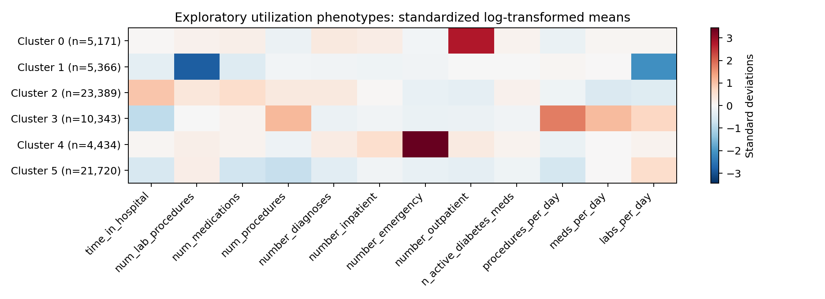
Figure 7. Utilization phenotype profiles; cluster numbers are arbitrary.

6. Recommendations
Retain the leakage-safe feature contract and validate predictor availability at discharge. Evaluate the frozen pipeline on newer data from independent institutions before considering operational use. Fit any probability recalibration within training folds or on a separate calibration set. Select operating points using a stated workload and error-cost objective, then assess uncertainty on independent patients. Reassess subgroup errors with adequate event counts and prespecified disparity tolerances. Obtain the original weighted BRFSS design variables for population inference. Treat comorbidity and phenotype results as hypothesis-generating associations, not individual care recommendations.

7. Challenges and limitations
The principal challenges were temporal leakage, ambiguous medication coding, sparse prior utilization counts, and unequal subgroup precision. Calibration plotting originally swapped observed and predicted outputs; a regression test now verifies the exported columns. SHAP aggregation now preserves signed dummy contributions before calculating magnitudes. Stable cohort ordering and pinned dependencies reduce reproducibility drift. Patient-level predictions and explanations stay in the ignored local data directory; published outputs are aggregate.
Residual limits include historical and selected hospital data, absent admission dates and planned-readmission flags, possible missed care outside participating hospitals, use of encounter ID as chronology, observational confounding, and selection of the first retained encounter. Goodness-of-fit rejection is expected with large samples; continuous fits to integer length of stay are descriptive comparisons rather than proof of an underlying continuous distribution. BRFSS is self-reported, cross-sectional, and unweighted here. Symptoms, general health, and diagnoses can be jointly determined. Survey-response patterns cannot identify unique people or households in this extract. Bootstrap uncertainty is conditional on existing OOF predictions. SHAP background choice, correlated predictors, permutation dependence, and cluster selection can change rankings. The original formal H2 statements and institutional submission template must be reconciled with the separate course materials before submission.

8. References
[1] Clore, Cios, DeShazo, and Strack (2014). Diabetes 130-US Hospitals for Years 1999–2008. UCI Machine Learning Repository. https://doi.org/10.24432/C5230J
[2] CDC. 2015 BRFSS Survey Data and Documentation. https://www.cdc.gov/brfss/annual_data/annual_2015.html
[3] CDC. BRFSS 2015 Codebook. https://www.cdc.gov/brfss/annual_data/2015/pdf/codebook15_llcp.pdf
[4] Scikit-learn 1.5. calibration_curve API documentation. https://scikit-learn.org/1.5/modules/generated/sklearn.calibration.calibration_curve.html
[5] SHAP. TreeExplainer API documentation. https://shap.readthedocs.io/en/stable/generated/shap.TreeExplainer.html
[6] Strack et al. (2014). Impact of HbA1c Measurement on Hospital Readmission Rates: Analysis of 70,000 Clinical Database Patient Records. BioMed Research International, 781670. https://doi.org/10.1155/2014/781670
[7] Dataset mirrors: https://www.kaggle.com/datasets/brandao/diabetes and https://www.kaggle.com/datasets/alexteboul/diabetes-health-indicators-dataset. Original source documentation takes precedence over mirror descriptions.

Appendix

A. Reproduction and artifact provenance
Install Python 3.12 and requirements.txt, install the local package, configure Kaggle credentials, run python -m carebridge.ingest.download, and run python -m carebridge.run_analysis. The runner executes sequentially with bounded thread counts. Each analysis also runs as its own module. analysis_manifest.json records package versions and SHA-256 hashes of input files and result tables. analysis_specification.md records feature, uncertainty, and hypothesis-label conventions. The table of contents is assembled from this report's fixed section list; it contains section titles rather than renderer-dependent page numbers.
Appendix table A1: rq1_model_comparisons.csv
comparison | mean_diff | ci_low | ci_high | excludes_zero
gradient_boosting - logistic | 0.0161 | 0.0115 | 0.0208 | True
linear_svm - logistic | -0.0022 | -0.0031 | -0.0013 | True
gradient_boosting - rule_baseline | 0.0689 | 0.0623 | 0.0756 | True
logistic - rule_baseline | 0.0528 | 0.0479 | 0.0581 | True
Appendix table A2: rq1_threshold_analysis.csv
rule | threshold | flagged_n | sensitivity_recall | ppv_precision | f1
probability | 0.0500 | 56911 | 0.9084 | 0.1004 | 0.1808
probability | 0.1000 | 19947 | 0.4845 | 0.1528 | 0.2323
probability | 0.1500 | 6763 | 0.2345 | 0.2181 | 0.2260
probability | 0.2000 | 3155 | 0.1369 | 0.2729 | 0.1823
probability | 0.2500 | 1673 | 0.0871 | 0.3276 | 0.1376
top_5pct_risk | 0.1915 | 3522 | 0.1470 | 0.2626 | 0.1885
top_10pct_risk | 0.1479 | 7043 | 0.2426 | 0.2167 | 0.2289
top_20pct_risk | 0.1151 | 14085 | 0.3801 | 0.1698 | 0.2347
Appendix table A3: rq1_calibration.csv
model | bin | mean_predicted_probability | observed_event_rate
logistic | 1 | 0.0418 | 0.0385
logistic | 2 | 0.0523 | 0.0538
logistic | 3 | 0.0587 | 0.0528
logistic | 4 | 0.0645 | 0.0679
logistic | 5 | 0.0703 | 0.0735
logistic | 6 | 0.0772 | 0.0832
logistic | 7 | 0.0870 | 0.0856
logistic | 8 | 0.1028 | 0.1042
logistic | 9 | 0.1271 | 0.1295
logistic | 10 | 0.2116 | 0.2042
gradient_boosting | 1 | 0.0333 | 0.0378
gradient_boosting | 2 | 0.0462 | 0.0479
gradient_boosting | 3 | 0.0547 | 0.0550
gradient_boosting | 4 | 0.0626 | 0.0602
gradient_boosting | 5 | 0.0709 | 0.0730
gradient_boosting | 6 | 0.0801 | 0.0844
gradient_boosting | 7 | 0.0910 | 0.0866
gradient_boosting | 8 | 0.1057 | 0.1091
gradient_boosting | 9 | 0.1291 | 0.1228
gradient_boosting | 10 | 0.2176 | 0.2167
Appendix table A4: h1b_adjusted_odds.csv
term | odds_ratio | ci_low | ci_high | p_value
const | 0.0296 | 0.0254 | 0.0345 | <1e-300
HbA1c measured | 0.9724 | 0.8916 | 1.0605 | 0.5265
Medication adjusted | 1.1504 | 1.0731 | 1.2333 | 7.93e-05
Both (interaction) | 0.9139 | 0.7905 | 1.0565 | 0.2237
Diagnoses recorded | 1.0369 | 1.0217 | 1.0524 | 1.50e-06
Active diabetes agents | 1.0085 | 0.9791 | 1.0388 | 0.5756
Length of stay | 1.0415 | 1.0316 | 1.0516 | 8.77e-17
Medications administered | 1.0042 | 1.0002 | 1.0081 | 0.0371
Procedures | 0.9804 | 0.9642 | 0.9969 | 0.0198
Any prior inpatient | 1.8855 | 1.7612 | 2.0186 | 3.10e-74
Any prior emergency | 1.2440 | 1.1349 | 1.3635 | 3.12e-06
Any prior outpatient | 1.0403 | 0.9646 | 1.1219 | 0.3054
Age (band midpoint) | 1.0084 | 1.0066 | 1.0102 | 4.59e-20
Hospice discharge | 0.2855 | 0.1729 | 0.4712 | 9.48e-07
Appendix table A5: rq1_hypothesis_tests.csv
test | effect_size | p_adj | n
mannwhitneyu: time_in_hospital | 0.1177 | 3.97e-54 | 70423
mannwhitneyu: number_inpatient | 0.0958 | 6.54e-111 | 70423
mannwhitneyu: num_medications | 0.0853 | 1.05e-28 | 70423
chi2: high_prior_utilizer | 0.0830 | 3.33e-106 | 70423
chi2: any_number_inpatient | 0.0819 | 5.91e-104 | 70423
mannwhitneyu: number_diagnoses | 0.0803 | 4.35e-28 | 70423
mannwhitneyu: num_lab_procedures | 0.0648 | 3.00e-17 | 70423
chi2: age_band | 0.0508 | 5.38e-34 | 70423
chi2: diag_1_group | 0.0429 | 1.46e-20 | 70423
chi2: any_med_adjusted | 0.0235 | 7.24e-10 | 70423
chi2: race | 0.0159 | 0.0039 | 70423
chi2: is_hospice | 0.0155 | 6.70e-05 | 70423
chi2: a1c_tested | 0.0091 | 0.0182 | 70423
chi2: a1c_tested_and_changed | 0.0008 | 0.8539 | 70423
Appendix table A6: rq2_importance.csv
outcome | feature | mean_ap_decrease | repeat_sd | rank
has_diabetes | age_band | 0.0448 | 0.0092 | 3
has_diabetes | sex | 0.0054 | 0.0037 | 8
has_diabetes | bmi | 0.0700 | 0.0180 | 2
has_diabetes | high_bp | 0.0387 | 0.0101 | 4
has_diabetes | high_chol | 0.0242 | 0.0102 | 5
has_diabetes | chol_checked | 0.0064 | 0.0038 | 7
has_diabetes | smoker | 0.0004 | 0.0005 | 12
has_diabetes | phys_activity | -7.97e-05 | 0.0005 | 17
has_diabetes | eats_fruit | 4.79e-05 | 0.0004 | 15
has_diabetes | eats_veg | -0.0001 | 0.0003 | 18
has_diabetes | heavy_alcohol | 0.0067 | 0.0023 | 6
has_diabetes | gen_health | 0.1007 | 0.0096 | 1
has_diabetes | mental_health_days | 0.0003 | 0.0004 | 13
has_diabetes | phys_health_days | 0.0007 | 0.0009 | 11
has_diabetes | difficulty_walking | 0.0013 | 0.0016 | 10
has_diabetes | education | -0.0004 | 0.0014 | 19
has_diabetes | income_band | 0.0038 | 0.0032 | 9
has_diabetes | has_coverage | 1.10e-05 | 0.0004 | 16
has_diabetes | skipped_care_cost | 7.64e-05 | 0.0003 | 14
has_stroke | age_band | 0.0251 | 0.0148 | 2
has_stroke | sex | 0.0009 | 0.0044 | 10
has_stroke | bmi | 0.0031 | 0.0029 | 7
has_stroke | high_bp | 0.0118 | 0.0102 | 5
has_stroke | high_chol | 0.0077 | 0.0058 | 6
has_stroke | chol_checked | 0.0008 | 0.0014 | 11
has_stroke | smoker | 0.0021 | 0.0064 | 8
has_stroke | phys_activity | -0.0002 | 0.0005 | 15
has_stroke | eats_fruit | -0.0016 | 0.0013 | 18
has_stroke | eats_veg | 0.0021 | 0.0026 | 9
has_stroke | heavy_alcohol | -3.15e-05 | 0.0013 | 14
has_stroke | gen_health | 0.0369 | 0.0095 | 1
has_stroke | mental_health_days | -0.0015 | 0.0037 | 17
has_stroke | phys_health_days | 6.61e-05 | 0.0035 | 13
has_stroke | difficulty_walking | 0.0146 | 0.0102 | 3
has_stroke | education | -0.0027 | 0.0026 | 19
has_stroke | income_band | 0.0127 | 0.0115 | 4
has_stroke | has_coverage | -0.0005 | 0.0007 | 16
has_stroke | skipped_care_cost | 0.0002 | 0.0038 | 12
has_cardiac | age_band | 0.0985 | 0.0130 | 1
has_cardiac | sex | 0.0405 | 0.0106 | 3
has_cardiac | bmi | -3.73e-05 | 0.0006 | 14
has_cardiac | high_bp | 0.0182 | 0.0078 | 5
has_cardiac | high_chol | 0.0299 | 0.0069 | 4
has_cardiac | chol_checked | 0.0002 | 0.0023 | 12
has_cardiac | smoker | 0.0076 | 0.0073 | 6
has_cardiac | phys_activity | -0.0003 | 0.0011 | 18
has_cardiac | eats_fruit | 0.0001 | 0.0003 | 13
has_cardiac | eats_veg | 0.0003 | 0.0004 | 11
has_cardiac | heavy_alcohol | 0.0012 | 0.0014 | 9
has_cardiac | gen_health | 0.0977 | 0.0153 | 2
has_cardiac | mental_health_days | -7.31e-05 | 0.0012 | 16
has_cardiac | phys_health_days | 0.0003 | 0.0006 | 10
has_cardiac | difficulty_walking | 0.0061 | 0.0036 | 7
has_cardiac | education | -0.0003 | 0.0016 | 17
has_cardiac | income_band | 0.0035 | 0.0039 | 8
has_cardiac | has_coverage | -7.10e-05 | 0.0003 | 15
has_cardiac | skipped_care_cost | -0.0009 | 0.0034 | 19
Appendix table A7: rq2_adjusted_odds.csv
outcome | term | odds_ratio | ci_low | ci_high | p_adj_bh
has_diabetes | const | 0.0003 | 0.0002 | 0.0005 | 1.80e-247
has_diabetes | sex | 1.3379 | 1.3032 | 1.3735 | 5.92e-104
has_diabetes | bmi | 1.0590 | 1.0571 | 1.0609 | <1e-300
has_diabetes | high_bp | 2.0825 | 2.0234 | 2.1434 | <1e-300
has_diabetes | high_chol | 1.7436 | 1.6979 | 1.7906 | <1e-300
has_diabetes | chol_checked | 3.4766 | 3.0397 | 3.9764 | 3.86e-73
has_diabetes | smoker | 0.9730 | 0.9481 | 0.9986 | 0.0528
has_diabetes | phys_activity | 0.9452 | 0.9189 | 0.9723 | 0.0001
has_diabetes | eats_fruit | 0.9776 | 0.9517 | 1.0042 | 0.1262
has_diabetes | eats_veg | 0.9711 | 0.9413 | 1.0019 | 0.0862
has_diabetes | heavy_alcohol | 0.4553 | 0.4222 | 0.4911 | 8.51e-92
has_diabetes | mental_health_days | 0.9971 | 0.9955 | 0.9988 | 0.0011
has_diabetes | phys_health_days | 0.9967 | 0.9951 | 0.9982 | 5.17e-05
has_diabetes | difficulty_walking | 1.1794 | 1.1411 | 1.2190 | 3.25e-22
has_diabetes | has_coverage | 1.0820 | 1.0131 | 1.1555 | 0.0261
has_diabetes | skipped_care_cost | 1.0150 | 0.9704 | 1.0618 | 0.5801
has_diabetes | age_band_2 | 1.1451 | 0.8601 | 1.5247 | 0.4166
has_diabetes | age_band_3 | 1.5749 | 1.2185 | 2.0355 | 0.0008
has_diabetes | age_band_4 | 2.3964 | 1.8783 | 3.0574 | 4.21e-12
has_diabetes | age_band_5 | 3.0680 | 2.4175 | 3.8935 | 7.33e-20
has_diabetes | age_band_6 | 3.7464 | 2.9621 | 4.7384 | 9.37e-28
has_diabetes | age_band_7 | 4.7087 | 3.7317 | 5.9417 | 2.00e-38
has_diabetes | age_band_8 | 5.1540 | 4.0876 | 6.4986 | 3.86e-43
has_diabetes | age_band_9 | 6.4276 | 5.1000 | 8.1007 | 2.40e-55
has_diabetes | age_band_10 | 7.6431 | 6.0642 | 9.6330 | 8.48e-66
has_diabetes | age_band_11 | 8.0974 | 6.4200 | 10.2130 | 4.50e-69
has_diabetes | age_band_12 | 7.4742 | 5.9183 | 9.4392 | 2.59e-63
has_diabetes | age_band_13 | 6.2965 | 4.9843 | 7.9541 | 4.12e-53
has_diabetes | gen_health_2 | 2.0694 | 1.9378 | 2.2099 | 1.47e-103
has_diabetes | gen_health_3 | 4.2185 | 3.9563 | 4.4981 | <1e-300
has_diabetes | gen_health_4 | 6.6370 | 6.1927 | 7.1132 | <1e-300
has_diabetes | gen_health_5 | 8.1775 | 7.5304 | 8.8803 | <1e-300
has_diabetes | education_2 | 0.9634 | 0.6579 | 1.4107 | 0.8814
has_diabetes | education_3 | 0.8606 | 0.5900 | 1.2555 | 0.5004
has_diabetes | education_4 | 0.8104 | 0.5570 | 1.1789 | 0.3289
has_diabetes | education_5 | 0.8481 | 0.5829 | 1.2339 | 0.4505
has_diabetes | education_6 | 0.7731 | 0.5312 | 1.1251 | 0.2228
has_diabetes | income_band_2 | 0.9869 | 0.9207 | 1.0578 | 0.7733
has_diabetes | income_band_3 | 0.9562 | 0.8942 | 1.0225 | 0.2329
has_diabetes | income_band_4 | 0.9346 | 0.8751 | 0.9981 | 0.0583
has_diabetes | income_band_5 | 0.8575 | 0.8036 | 0.9151 | 5.84e-06
has_diabetes | income_band_6 | 0.7880 | 0.7391 | 0.8401 | 6.41e-13
has_diabetes | income_band_7 | 0.7716 | 0.7232 | 0.8232 | 9.13e-15
has_diabetes | income_band_8 | 0.6692 | 0.6276 | 0.7136 | 5.35e-34
has_stroke | const | 0.0023 | 0.0011 | 0.0048 | 4.40e-56
has_stroke | sex | 1.1981 | 1.1474 | 1.2510 | 5.45e-16
has_stroke | bmi | 0.9839 | 0.9806 | 0.9871 | 1.19e-21
has_stroke | high_bp | 1.7857 | 1.6988 | 1.8770 | 4.54e-114
has_stroke | high_chol | 1.3517 | 1.2930 | 1.4131 | 8.45e-40
has_stroke | chol_checked | 1.4109 | 1.1955 | 1.6650 | 7.37e-05
has_stroke | smoker | 1.2260 | 1.1740 | 1.2802 | 7.25e-20
has_stroke | phys_activity | 1.0215 | 0.9760 | 1.0692 | 0.4206
has_stroke | eats_fruit | 1.0306 | 0.9857 | 1.0775 | 0.2286
has_stroke | eats_veg | 0.8659 | 0.8242 | 0.9097 | 1.95e-08
has_stroke | heavy_alcohol | 0.8364 | 0.7511 | 0.9314 | 0.0017
has_stroke | mental_health_days | 1.0061 | 1.0037 | 1.0085 | 1.34e-06
has_stroke | phys_health_days | 1.0069 | 1.0046 | 1.0093 | 1.05e-08
has_stroke | difficulty_walking | 1.7715 | 1.6830 | 1.8646 | 3.08e-105
has_stroke | has_coverage | 1.0906 | 0.9778 | 1.2163 | 0.1500
has_stroke | skipped_care_cost | 1.2231 | 1.1437 | 1.3080 | 7.46e-09
has_stroke | age_band_2 | 0.9996 | 0.5688 | 1.7566 | 0.9988
has_stroke | age_band_3 | 1.8541 | 1.1458 | 3.0001 | 0.0169
has_stroke | age_band_4 | 2.2261 | 1.4023 | 3.5337 | 0.0011
has_stroke | age_band_5 | 2.8589 | 1.8231 | 4.4830 | 7.71e-06
has_stroke | age_band_6 | 3.1654 | 2.0329 | 4.9288 | 5.98e-07
has_stroke | age_band_7 | 3.9221 | 2.5333 | 6.0721 | 1.70e-09
has_stroke | age_band_8 | 4.5753 | 2.9609 | 7.0697 | 1.49e-11
has_stroke | age_band_9 | 5.2695 | 3.4131 | 8.1356 | 1.36e-13
has_stroke | age_band_10 | 6.2092 | 4.0221 | 9.5855 | 3.79e-16
has_stroke | age_band_11 | 7.8380 | 5.0751 | 12.1049 | 4.18e-20
has_stroke | age_band_12 | 9.0274 | 5.8406 | 13.9533 | 1.15e-22
has_stroke | age_band_13 | 10.3852 | 6.7237 | 16.0406 | 1.50e-25
has_stroke | gen_health_2 | 1.4405 | 1.2950 | 1.6024 | 3.64e-11
has_stroke | gen_health_3 | 2.3146 | 2.0871 | 2.5669 | 2.92e-56
has_stroke | gen_health_4 | 3.4049 | 3.0496 | 3.8016 | 2.09e-104
has_stroke | gen_health_5 | 4.5709 | 4.0375 | 5.1747 | 2.27e-126
has_stroke | education_2 | 0.8493 | 0.4722 | 1.5276 | 0.6494
has_stroke | education_3 | 1.0852 | 0.6072 | 1.9398 | 0.8467
has_stroke | education_4 | 0.9855 | 0.5532 | 1.7557 | 0.9754
has_stroke | education_5 | 1.0740 | 0.6027 | 1.9139 | 0.8539
has_stroke | education_6 | 1.0606 | 0.5948 | 1.8911 | 0.8814
has_stroke | income_band_2 | 0.9535 | 0.8663 | 1.0494 | 0.3927
has_stroke | income_band_3 | 0.8895 | 0.8093 | 0.9775 | 0.0210
has_stroke | income_band_4 | 0.7949 | 0.7231 | 0.8737 | 3.33e-06
has_stroke | income_band_5 | 0.7484 | 0.6809 | 0.8225 | 3.36e-09
has_stroke | income_band_6 | 0.6503 | 0.5913 | 0.7153 | 1.93e-18
has_stroke | income_band_7 | 0.5943 | 0.5385 | 0.6560 | 1.50e-24
has_stroke | income_band_8 | 0.4827 | 0.4371 | 0.5329 | 1.74e-46
has_cardiac | const | 0.0007 | 0.0004 | 0.0013 | 4.73e-123
has_cardiac | sex | 2.1825 | 2.1155 | 2.2517 | <1e-300
has_cardiac | bmi | 1.0022 | 0.9998 | 1.0045 | 0.0900
has_cardiac | high_bp | 1.7794 | 1.7193 | 1.8417 | 2.01e-235
has_cardiac | high_chol | 1.9078 | 1.8478 | 1.9698 | <1e-300
has_cardiac | chol_checked | 1.7680 | 1.5538 | 2.0118 | 1.23e-17
has_cardiac | smoker | 1.4282 | 1.3849 | 1.4728 | 3.31e-113
has_cardiac | phys_activity | 1.0405 | 1.0063 | 1.0758 | 0.0272
has_cardiac | eats_fruit | 1.0105 | 0.9789 | 1.0431 | 0.5801
has_cardiac | eats_veg | 1.0297 | 0.9926 | 1.0682 | 0.1496
has_cardiac | heavy_alcohol | 0.7133 | 0.6607 | 0.7700 | 1.23e-17
has_cardiac | mental_health_days | 1.0030 | 1.0011 | 1.0049 | 0.0031
has_cardiac | phys_health_days | 1.0019 | 1.0001 | 1.0036 | 0.0528
has_cardiac | difficulty_walking | 1.4171 | 1.3649 | 1.4713 | 2.92e-73
has_cardiac | has_coverage | 1.0008 | 0.9235 | 1.0845 | 0.9928
has_cardiac | skipped_care_cost | 1.2984 | 1.2325 | 1.3678 | 2.50e-22
has_cardiac | age_band_2 | 1.2784 | 0.8113 | 2.0143 | 0.3477
has_cardiac | age_band_3 | 1.8131 | 1.2066 | 2.7243 | 0.0060
has_cardiac | age_band_4 | 1.9422 | 1.3097 | 2.8801 | 0.0014
has_cardiac | age_band_5 | 2.6972 | 1.8401 | 3.9534 | 6.36e-07
has_cardiac | age_band_6 | 3.8270 | 2.6305 | 5.5678 | 4.63e-12
has_cardiac | age_band_7 | 5.0494 | 3.4838 | 7.3187 | 2.78e-17
has_cardiac | age_band_8 | 6.2782 | 4.3374 | 9.0875 | 5.69e-22
has_cardiac | age_band_9 | 8.5779 | 5.9306 | 12.4069 | 1.12e-29
has_cardiac | age_band_10 | 11.4326 | 7.9052 | 16.5338 | 8.65e-38
has_cardiac | age_band_11 | 15.1439 | 10.4683 | 21.9079 | 1.40e-46
has_cardiac | age_band_12 | 17.8700 | 12.3451 | 25.8677 | 4.29e-52
has_cardiac | age_band_13 | 23.6829 | 16.3667 | 34.2695 | 1.43e-62
has_cardiac | gen_health_2 | 1.5395 | 1.4331 | 1.6538 | 1.20e-31
has_cardiac | gen_health_3 | 2.7618 | 2.5758 | 2.9613 | 2.37e-178
has_cardiac | gen_health_4 | 4.7786 | 4.4319 | 5.1524 | <1e-300
has_cardiac | gen_health_5 | 7.5449 | 6.9053 | 8.2438 | <1e-300
has_cardiac | education_2 | 0.8544 | 0.5446 | 1.3403 | 0.5613
has_cardiac | education_3 | 0.9663 | 0.6186 | 1.5093 | 0.9006
has_cardiac | education_4 | 0.9448 | 0.6066 | 1.4715 | 0.8539
has_cardiac | education_5 | 1.0369 | 0.6657 | 1.6153 | 0.8998
has_cardiac | education_6 | 0.9455 | 0.6068 | 1.4733 | 0.8539
has_cardiac | income_band_2 | 0.9831 | 0.9085 | 1.0639 | 0.7405
has_cardiac | income_band_3 | 0.9344 | 0.8652 | 1.0091 | 0.1085
has_cardiac | income_band_4 | 0.8903 | 0.8253 | 0.9605 | 0.0039
has_cardiac | income_band_5 | 0.8350 | 0.7746 | 0.9002 | 4.31e-06
has_cardiac | income_band_6 | 0.7945 | 0.7375 | 0.8558 | 2.54e-09
has_cardiac | income_band_7 | 0.7721 | 0.7157 | 0.8329 | 4.37e-11
has_cardiac | income_band_8 | 0.7054 | 0.6543 | 0.7606 | 2.52e-19
Appendix table A8: rq1_phenotype_selection.csv
k | silhouette | selection_sample_n
2 | 0.1383 | 10000
3 | 0.1428 | 10000
4 | 0.1590 | 10000
5 | 0.1682 | 10000
6 | 0.1708 | 10000
Appendix table A9: rq1_shap_global_importance.csv
source_feature | mean_abs_shap | importance_pct | rank
discharge_disposition_id | 0.0273 | 26.2217 | 1
number_inpatient | 0.0121 | 11.6205 | 2
diag_1_group | 0.0078 | 7.4917 | 3
n_active_diabetes_meds | 0.0052 | 5.0458 | 4
age_midpoint | 0.0051 | 4.9225 | 5
time_in_hospital | 0.0044 | 4.2633 | 6
num_lab_procedures | 0.0044 | 4.1920 | 7
anomaly_score | 0.0037 | 3.5508 | 8
number_diagnoses | 0.0034 | 3.3054 | 9
procedures_per_day | 0.0030 | 2.8947 | 10
num_medications | 0.0029 | 2.7505 | 11
labs_per_day | 0.0027 | 2.6205 | 12
meds_per_day | 0.0026 | 2.5036 | 13
admission_source_id | 0.0026 | 2.4873 | 14
num_procedures | 0.0022 | 2.1601 | 15
any_med_adjusted | 0.0021 | 2.0357 | 16
number_emergency | 0.0019 | 1.8690 | 17
any_number_inpatient | 0.0019 | 1.8668 | 18
admission_type_id | 0.0018 | 1.7668 | 19
high_prior_utilizer | 0.0013 | 1.2398 | 20
number_outpatient | 0.0012 | 1.1380 | 21
a1c_tested | 0.0011 | 1.0626 | 22
gender | 0.0011 | 1.0324 | 23
max_glu_serum | 0.0007 | 0.6346 | 24
a1c_result | 0.0006 | 0.5373 | 25
is_hospice | 0.0003 | 0.3081 | 26
any_number_emergency | 0.0003 | 0.2411 | 27
any_number_outpatient | 0.0001 | 0.1208 | 28
a1c_tested_and_changed | 0.0001 | 0.1168 | 29
Appendix table A10: rq1_shap_encoded_importance.csv
encoded_feature | source_feature | mean_abs_shap | rank
cat__discharge_disposition_id_1 | discharge_disposition_id | 0.0182 | 1
num__number_inpatient | number_inpatient | 0.0121 | 2
cat__discharge_disposition_id_22 | discharge_disposition_id | 0.0053 | 3
num__n_active_diabetes_meds | n_active_diabetes_meds | 0.0052 | 4
cat__discharge_disposition_id_3 | discharge_disposition_id | 0.0052 | 5
num__age_midpoint | age_midpoint | 0.0051 | 6
cat__diag_1_group_circulatory | diag_1_group | 0.0050 | 7
num__time_in_hospital | time_in_hospital | 0.0044 | 8
num__num_lab_procedures | num_lab_procedures | 0.0044 | 9
num__anomaly_score | anomaly_score | 0.0037 | 10
num__number_diagnoses | number_diagnoses | 0.0034 | 11
num__procedures_per_day | procedures_per_day | 0.0030 | 12
num__num_medications | num_medications | 0.0029 | 13
num__labs_per_day | labs_per_day | 0.0027 | 14
num__meds_per_day | meds_per_day | 0.0026 | 15
cat__discharge_disposition_id_5 | discharge_disposition_id | 0.0026 | 16
cat__discharge_disposition_id_6 | discharge_disposition_id | 0.0025 | 17
num__num_procedures | num_procedures | 0.0022 | 18
bin__any_med_adjusted | any_med_adjusted | 0.0021 | 19
num__number_emergency | number_emergency | 0.0019 | 20
bin__any_number_inpatient | any_number_inpatient | 0.0019 | 21
cat__admission_source_id_1 | admission_source_id | 0.0016 | 22
cat__diag_1_group_other | diag_1_group | 0.0014 | 23
cat__diag_1_group_respiratory | diag_1_group | 0.0014 | 24
bin__high_prior_utilizer | high_prior_utilizer | 0.0013 | 25
num__number_outpatient | number_outpatient | 0.0012 | 26
cat__diag_1_group_diabetes | diag_1_group | 0.0011 | 27
bin__a1c_tested | a1c_tested | 0.0011 | 28
cat__gender_Female | gender | 0.0010 | 29
cat__diag_1_group_musculoskeletal | diag_1_group | 0.0010 | 30
cat__discharge_disposition_id_2 | discharge_disposition_id | 0.0008 | 31
cat__admission_type_id_3 | admission_type_id | 0.0008 | 32
cat__admission_source_id_17 | admission_source_id | 0.0007 | 33
cat__diag_1_group_mental | diag_1_group | 0.0007 | 34
cat__admission_type_id_1 | admission_type_id | 0.0007 | 35
cat__diag_1_group_genitourinary | diag_1_group | 0.0006 | 36
cat__discharge_disposition_id_25 | discharge_disposition_id | 0.0006 | 37
cat__admission_source_id_5 | admission_source_id | 0.0005 | 38
cat__diag_1_group_nervous_sensory | diag_1_group | 0.0005 | 39
cat__admission_source_id_4 | admission_source_id | 0.0005 | 40
cat__discharge_disposition_id_18 | discharge_disposition_id | 0.0004 | 41
cat__discharge_disposition_id_infrequent_sklearn | discharge_disposition_id | 0.0004 | 42
cat__diag_1_group_supplementary | diag_1_group | 0.0004 | 43
cat__max_glu_serum_Missing | max_glu_serum | 0.0004 | 44
cat__admission_type_id_5 | admission_type_id | 0.0004 | 45
cat__admission_source_id_7 | admission_source_id | 0.0004 | 46
cat__admission_type_id_6 | admission_type_id | 0.0004 | 47
cat__admission_type_id_2 | admission_type_id | 0.0004 | 48
cat__diag_1_group_neoplasms | diag_1_group | 0.0003 | 49
bin__is_hospice | is_hospice | 0.0003 | 50
cat__a1c_result_Norm | a1c_result | 0.0003 | 51
cat__a1c_result_>8 | a1c_result | 0.0003 | 52
cat__discharge_disposition_id_23 | discharge_disposition_id | 0.0003 | 53
cat__diag_1_group_endocrine_other | diag_1_group | 0.0003 | 54
cat__diag_1_group_injury | diag_1_group | 0.0003 | 55
cat__admission_source_id_20 | admission_source_id | 0.0003 | 56
bin__any_number_emergency | any_number_emergency | 0.0003 | 57
cat__admission_source_id_2 | admission_source_id | 0.0002 | 58
cat__a1c_result_Missing | a1c_result | 0.0002 | 59
cat__diag_1_group_digestive | diag_1_group | 0.0002 | 60
cat__max_glu_serum_Norm | max_glu_serum | 0.0001 | 61
cat__gender_Male | gender | 0.0001 | 62
bin__any_number_outpatient | any_number_outpatient | 0.0001 | 63
bin__a1c_tested_and_changed | a1c_tested_and_changed | 0.0001 | 64
cat__admission_source_id_6 | admission_source_id | 0.0001 | 65
cat__a1c_result_>7 | a1c_result | 0.0001 | 66
cat__discharge_disposition_id_13 | discharge_disposition_id | 0.0001 | 67
cat__admission_type_id_8 | admission_type_id | 9.98e-05 | 68
cat__max_glu_serum_>200 | max_glu_serum | 8.39e-05 | 69
cat__admission_source_id_3 | admission_source_id | 4.60e-05 | 70
cat__diag_1_group_infectious | diag_1_group | 3.99e-05 | 71
cat__discharge_disposition_id_4 | discharge_disposition_id | 2.58e-05 | 72
cat__max_glu_serum_>300 | max_glu_serum | 2.57e-05 | 73
cat__discharge_disposition_id_7 | discharge_disposition_id | 1.31e-05 | 74
cat__admission_type_id_infrequent_sklearn | admission_type_id | 0.0000 | 75
cat__diag_1_group_infrequent_sklearn | diag_1_group | 0.0000 | 76
cat__discharge_disposition_id_14 | discharge_disposition_id | 0.0000 | 77
cat__admission_source_id_infrequent_sklearn | admission_source_id | 0.0000 | 78
Appendix table A11: rq2_comorbidity.csv
outcome | existing_condition | exposed_n | cooccurring_n | conditional_prevalence | prevalence_ci_low | prevalence_ci_high
has_diabetes | has_stroke | 10292 | 3268 | 0.3175 | 0.3086 | 0.3266
has_diabetes | has_cardiac | 23893 | 7878 | 0.3297 | 0.3238 | 0.3357
has_stroke | has_diabetes | 35346 | 3268 | 0.0925 | 0.0895 | 0.0955
has_stroke | has_cardiac | 23893 | 3937 | 0.1648 | 0.1601 | 0.1695
has_cardiac | has_diabetes | 35346 | 7878 | 0.2229 | 0.2186 | 0.2273
has_cardiac | has_stroke | 10292 | 3937 | 0.3825 | 0.3732 | 0.3920
Appendix table A12: rq2_comorbidity.csv
outcome | existing_condition | prevalence_lift | p_adj_bh
has_diabetes | has_stroke | 2.2789 | 1.13e-10
has_diabetes | has_cardiac | 2.3664 | 3.08e-46
has_stroke | has_diabetes | 2.2789 | 2.97e-13
has_stroke | has_cardiac | 4.0615 | <1e-300
has_cardiac | has_diabetes | 2.3664 | 6.56e-58
has_cardiac | has_stroke | 4.0615 | <1e-300
Appendix table A13: rq2_discrimination.csv
outcome | n | events | brier_score
has_diabetes | 253680 | 35346 | 0.0983
has_stroke | 253680 | 10292 | 0.0364
has_cardiac | 253680 | 23893 | 0.0715
Subgroup TPR at every prespecified threshold (rq1_fairness.csv).
attribute | group | threshold | events | tpr | tpr_ci_low | tpr_ci_high
race | AfricanAmerican | 0.0500 | 1093 | 0.8838 | 0.8634 | 0.9015
race | AfricanAmerican | 0.1000 | 1093 | 0.4309 | 0.4019 | 0.4605
race | AfricanAmerican | 0.1500 | 1093 | 0.2132 | 0.1899 | 0.2384
race | AfricanAmerican | 0.2000 | 1093 | 0.1153 | 0.0977 | 0.1356
race | AfricanAmerican | 0.2500 | 1093 | 0.0714 | 0.0576 | 0.0882
race | Asian | 0.0500 | 41 | 0.9024 | 0.7745 | 0.9614
race | Asian | 0.1000 | 41 | 0.4390 | 0.2989 | 0.5896
race | Asian | 0.1500 | 41 | 0.2683 | 0.1569 | 0.4193
race | Asian | 0.2000 | 41 | 0.1463 | 0.0688 | 0.2844
race | Asian | 0.2500 | 41 | 0.1220 | 0.0532 | 0.2554
race | Caucasian | 0.0500 | 4814 | 0.9148 | 0.9066 | 0.9224
race | Caucasian | 0.1000 | 4814 | 0.4992 | 0.4851 | 0.5133
race | Caucasian | 0.1500 | 4814 | 0.2416 | 0.2297 | 0.2539
race | Caucasian | 0.2000 | 4814 | 0.1435 | 0.1339 | 0.1537
race | Caucasian | 0.2500 | 4814 | 0.0912 | 0.0834 | 0.0997
race | Hispanic | 0.0500 | 122 | 0.9262 | 0.8657 | 0.9607
race | Hispanic | 0.1000 | 122 | 0.5082 | 0.4206 | 0.5953
race | Hispanic | 0.1500 | 122 | 0.2541 | 0.1852 | 0.3380
race | Hispanic | 0.2000 | 122 | 0.1721 | 0.1154 | 0.2488
race | Hispanic | 0.2500 | 122 | 0.1311 | 0.0824 | 0.2025
race | Missing | 0.0500 | 141 | 0.8865 | 0.8236 | 0.9289
race | Missing | 0.1000 | 141 | 0.4539 | 0.3740 | 0.5362
race | Missing | 0.1500 | 141 | 0.1773 | 0.1231 | 0.2486
race | Missing | 0.2000 | 141 | 0.0638 | 0.0339 | 0.1169
race | Missing | 0.2500 | 141 | 0.0355 | 0.0152 | 0.0803
race | Other | 0.0500 | 80 | 0.8750 | 0.7850 | 0.9307
race | Other | 0.1000 | 80 | 0.3750 | 0.2769 | 0.4845
race | Other | 0.1500 | 80 | 0.1500 | 0.0879 | 0.2441
race | Other | 0.2000 | 80 | 0.1000 | 0.0515 | 0.1851
race | Other | 0.2500 | 80 | 0.0625 | 0.0270 | 0.1381
gender | Female | 0.0500 | 3368 | 0.9103 | 0.9002 | 0.9195
gender | Female | 0.1000 | 3368 | 0.5006 | 0.4837 | 0.5175
gender | Female | 0.1500 | 3368 | 0.2384 | 0.2243 | 0.2531
gender | Female | 0.2000 | 3368 | 0.1393 | 0.1280 | 0.1514
gender | Female | 0.2500 | 3368 | 0.0867 | 0.0777 | 0.0967
gender | Male | 0.0500 | 2923 | 0.9063 | 0.8952 | 0.9163
gender | Male | 0.1000 | 2923 | 0.4660 | 0.4479 | 0.4841
gender | Male | 0.1500 | 2923 | 0.2299 | 0.2150 | 0.2455
gender | Male | 0.2000 | 2923 | 0.1341 | 0.1222 | 0.1469
gender | Male | 0.2500 | 2923 | 0.0876 | 0.0779 | 0.0984
age_band | [0-10) | 0.0500 | 3 | 0.3333 | 0.0615 | 0.7923
age_band | [0-10) | 0.1000 | 3 | 0.3333 | 0.0615 | 0.7923
age_band | [0-10) | 0.1500 | 3 | 0.3333 | 0.0615 | 0.7923
age_band | [0-10) | 0.2000 | 3 | 0.3333 | 0.0615 | 0.7923
age_band | [0-10) | 0.2500 | 3 | 0.0000 | 0.0000 | 0.5615
age_band | [10-20) | 0.0500 | 26 | 0.4231 | 0.2554 | 0.6105
age_band | [10-20) | 0.1000 | 26 | 0.2692 | 0.1370 | 0.4608
age_band | [10-20) | 0.1500 | 26 | 0.1538 | 0.0615 | 0.3353
age_band | [10-20) | 0.2000 | 26 | 0.0769 | 0.0214 | 0.2414
age_band | [10-20) | 0.2500 | 26 | 0.0385 | 0.0068 | 0.1889
age_band | [20-30) | 0.0500 | 83 | 0.6988 | 0.5931 | 0.7869
age_band | [20-30) | 0.1000 | 83 | 0.4096 | 0.3101 | 0.5171
age_band | [20-30) | 0.1500 | 83 | 0.2771 | 0.1923 | 0.3816
age_band | [20-30) | 0.2000 | 83 | 0.1807 | 0.1127 | 0.2770
age_band | [20-30) | 0.2500 | 83 | 0.1084 | 0.0581 | 0.1934
age_band | [30-40) | 0.0500 | 188 | 0.8138 | 0.7521 | 0.8630
age_band | [30-40) | 0.1000 | 188 | 0.3404 | 0.2765 | 0.4108
age_band | [30-40) | 0.1500 | 188 | 0.2021 | 0.1510 | 0.2652
age_band | [30-40) | 0.2000 | 188 | 0.1489 | 0.1051 | 0.2068
age_band | [30-40) | 0.2500 | 188 | 0.0957 | 0.0614 | 0.1463
age_band | [40-50) | 0.0500 | 507 | 0.7751 | 0.7368 | 0.8093
age_band | [40-50) | 0.1000 | 507 | 0.3254 | 0.2861 | 0.3674
age_band | [40-50) | 0.1500 | 507 | 0.1519 | 0.1233 | 0.1857
age_band | [40-50) | 0.2000 | 507 | 0.0789 | 0.0585 | 0.1057
age_band | [40-50) | 0.2500 | 507 | 0.0592 | 0.0418 | 0.0832
age_band | [50-60) | 0.0500 | 879 | 0.8248 | 0.7983 | 0.8485
age_band | [50-60) | 0.1000 | 879 | 0.3675 | 0.3362 | 0.3998
age_band | [50-60) | 0.1500 | 879 | 0.1866 | 0.1622 | 0.2137
age_band | [50-60) | 0.2000 | 879 | 0.1081 | 0.0892 | 0.1303
age_band | [50-60) | 0.2500 | 879 | 0.0717 | 0.0564 | 0.0907
age_band | [60-70) | 0.0500 | 1414 | 0.9335 | 0.9193 | 0.9454
age_band | [60-70) | 0.1000 | 1414 | 0.4519 | 0.4261 | 0.4779
age_band | [60-70) | 0.1500 | 1414 | 0.2228 | 0.2019 | 0.2452
age_band | [60-70) | 0.2000 | 1414 | 0.1358 | 0.1189 | 0.1546
age_band | [60-70) | 0.2500 | 1414 | 0.0905 | 0.0767 | 0.1066
age_band | [70-80) | 0.0500 | 1824 | 0.9485 | 0.9373 | 0.9577
age_band | [70-80) | 0.1000 | 1824 | 0.5647 | 0.5418 | 0.5873
age_band | [70-80) | 0.1500 | 1824 | 0.2752 | 0.2552 | 0.2962
age_band | [70-80) | 0.2000 | 1824 | 0.1480 | 0.1325 | 0.1651
age_band | [70-80) | 0.2500 | 1824 | 0.0927 | 0.0802 | 0.1068
age_band | [80-90) | 0.0500 | 1199 | 0.9716 | 0.9606 | 0.9796
age_band | [80-90) | 0.1000 | 1199 | 0.5972 | 0.5691 | 0.6246
age_band | [80-90) | 0.1500 | 1199 | 0.2711 | 0.2467 | 0.2969
age_band | [80-90) | 0.2000 | 1199 | 0.1651 | 0.1452 | 0.1872
age_band | [80-90) | 0.2500 | 1199 | 0.0959 | 0.0805 | 0.1139
age_band | [90-100) | 0.0500 | 168 | 0.9464 | 0.9013 | 0.9716
age_band | [90-100) | 0.1000 | 168 | 0.4107 | 0.3391 | 0.4863
age_band | [90-100) | 0.1500 | 168 | 0.1548 | 0.1079 | 0.2171
age_band | [90-100) | 0.2000 | 168 | 0.1190 | 0.0784 | 0.1767
age_band | [90-100) | 0.2500 | 168 | 0.0893 | 0.0549 | 0.1421
Subgroup FPR at every prespecified threshold (rq1_fairness.csv).
attribute | group | threshold | non_events | fpr | fpr_ci_low | fpr_ci_high
race | AfricanAmerican | 0.0500 | 11599 | 0.7584 | 0.7506 | 0.7661
race | AfricanAmerican | 0.1000 | 11599 | 0.2271 | 0.2196 | 0.2348
race | AfricanAmerican | 0.1500 | 11599 | 0.0747 | 0.0701 | 0.0797
race | AfricanAmerican | 0.2000 | 11599 | 0.0346 | 0.0314 | 0.0381
race | AfricanAmerican | 0.2500 | 11599 | 0.0176 | 0.0154 | 0.0201
race | Asian | 0.0500 | 450 | 0.7422 | 0.6999 | 0.7805
race | Asian | 0.1000 | 450 | 0.1978 | 0.1636 | 0.2371
race | Asian | 0.1500 | 450 | 0.0556 | 0.0379 | 0.0807
race | Asian | 0.2000 | 450 | 0.0222 | 0.0121 | 0.0404
race | Asian | 0.2500 | 450 | 0.0133 | 0.0061 | 0.0288
race | Caucasian | 0.0500 | 47843 | 0.8126 | 0.8090 | 0.8160
race | Caucasian | 0.1000 | 47843 | 0.2766 | 0.2726 | 0.2806
race | Caucasian | 0.1500 | 47843 | 0.0857 | 0.0832 | 0.0883
race | Caucasian | 0.2000 | 47843 | 0.0372 | 0.0355 | 0.0389
race | Caucasian | 0.2500 | 47843 | 0.0180 | 0.0168 | 0.0192
race | Hispanic | 0.0500 | 1384 | 0.7254 | 0.7013 | 0.7483
race | Hispanic | 0.1000 | 1384 | 0.2175 | 0.1965 | 0.2400
race | Hispanic | 0.1500 | 1384 | 0.0780 | 0.0650 | 0.0934
race | Hispanic | 0.2000 | 1384 | 0.0311 | 0.0231 | 0.0416
race | Hispanic | 0.2500 | 1384 | 0.0181 | 0.0123 | 0.0265
race | Missing | 0.0500 | 1776 | 0.7736 | 0.7536 | 0.7925
race | Missing | 0.1000 | 1776 | 0.2303 | 0.2113 | 0.2504
race | Missing | 0.1500 | 1776 | 0.0653 | 0.0547 | 0.0778
race | Missing | 0.2000 | 1776 | 0.0175 | 0.0123 | 0.0247
race | Missing | 0.2500 | 1776 | 0.0090 | 0.0056 | 0.0146
race | Other | 0.0500 | 1080 | 0.7519 | 0.7252 | 0.7767
race | Other | 0.1000 | 1080 | 0.2176 | 0.1940 | 0.2432
race | Other | 0.1500 | 1080 | 0.0657 | 0.0524 | 0.0821
race | Other | 0.2000 | 1080 | 0.0269 | 0.0188 | 0.0383
race | Other | 0.2500 | 1080 | 0.0130 | 0.0077 | 0.0216
gender | Female | 0.0500 | 34094 | 0.7932 | 0.7889 | 0.7975
gender | Female | 0.1000 | 34094 | 0.2740 | 0.2693 | 0.2788
gender | Female | 0.1500 | 34094 | 0.0862 | 0.0833 | 0.0893
gender | Female | 0.2000 | 34094 | 0.0370 | 0.0351 | 0.0391
gender | Female | 0.2500 | 34094 | 0.0189 | 0.0176 | 0.0204
gender | Male | 0.0500 | 30038 | 0.8040 | 0.7995 | 0.8085
gender | Male | 0.1000 | 30038 | 0.2515 | 0.2467 | 0.2565
gender | Male | 0.1500 | 30038 | 0.0782 | 0.0752 | 0.0813
gender | Male | 0.2000 | 30038 | 0.0343 | 0.0323 | 0.0364
gender | Male | 0.2500 | 30038 | 0.0159 | 0.0146 | 0.0174
age_band | [0-10) | 0.0500 | 150 | 0.1533 | 0.1044 | 0.2196
age_band | [0-10) | 0.1000 | 150 | 0.0267 | 0.0104 | 0.0666
age_band | [0-10) | 0.1500 | 150 | 0.0067 | 0.0012 | 0.0368
age_band | [0-10) | 0.2000 | 150 | 0.0000 | 0.0000 | 0.0250
age_band | [0-10) | 0.2500 | 150 | 0.0000 | 0.0000 | 0.0250
age_band | [10-20) | 0.0500 | 508 | 0.2598 | 0.2236 | 0.2997
age_band | [10-20) | 0.1000 | 508 | 0.0571 | 0.0400 | 0.0808
age_band | [10-20) | 0.1500 | 508 | 0.0256 | 0.0150 | 0.0433
age_band | [10-20) | 0.2000 | 508 | 0.0118 | 0.0054 | 0.0255
age_band | [10-20) | 0.2500 | 508 | 0.0098 | 0.0042 | 0.0228
age_band | [20-30) | 0.0500 | 1039 | 0.5111 | 0.4807 | 0.5414
age_band | [20-30) | 0.1000 | 1039 | 0.1107 | 0.0930 | 0.1312
age_band | [20-30) | 0.1500 | 1039 | 0.0452 | 0.0342 | 0.0596
age_band | [20-30) | 0.2000 | 1039 | 0.0260 | 0.0179 | 0.0375
age_band | [20-30) | 0.2500 | 1039 | 0.0115 | 0.0066 | 0.0201
age_band | [30-40) | 0.0500 | 2504 | 0.5667 | 0.5472 | 0.5860
age_band | [30-40) | 0.1000 | 2504 | 0.1166 | 0.1046 | 0.1298
age_band | [30-40) | 0.1500 | 2504 | 0.0475 | 0.0399 | 0.0566
age_band | [30-40) | 0.2000 | 2504 | 0.0276 | 0.0218 | 0.0347
age_band | [30-40) | 0.2500 | 2504 | 0.0112 | 0.0077 | 0.0161
age_band | [40-50) | 0.0500 | 6333 | 0.6521 | 0.6403 | 0.6638
age_band | [40-50) | 0.1000 | 6333 | 0.1416 | 0.1333 | 0.1504
age_band | [40-50) | 0.1500 | 6333 | 0.0497 | 0.0447 | 0.0554
age_band | [40-50) | 0.2000 | 6333 | 0.0234 | 0.0199 | 0.0274
age_band | [40-50) | 0.2500 | 6333 | 0.0115 | 0.0092 | 0.0145
age_band | [50-60) | 0.0500 | 11489 | 0.6520 | 0.6433 | 0.6607
age_band | [50-60) | 0.1000 | 11489 | 0.1498 | 0.1434 | 0.1564
age_band | [50-60) | 0.1500 | 11489 | 0.0512 | 0.0473 | 0.0554
age_band | [50-60) | 0.2000 | 11489 | 0.0241 | 0.0215 | 0.0271
age_band | [50-60) | 0.2500 | 11489 | 0.0124 | 0.0105 | 0.0145
age_band | [60-70) | 0.0500 | 14344 | 0.8472 | 0.8412 | 0.8530
age_band | [60-70) | 0.1000 | 14344 | 0.2425 | 0.2356 | 0.2496
age_band | [60-70) | 0.1500 | 14344 | 0.0764 | 0.0722 | 0.0809
age_band | [60-70) | 0.2000 | 14344 | 0.0331 | 0.0303 | 0.0362
age_band | [60-70) | 0.2500 | 14344 | 0.0158 | 0.0139 | 0.0180
age_band | [70-80) | 0.0500 | 16062 | 0.9013 | 0.8966 | 0.9058
age_band | [70-80) | 0.1000 | 16062 | 0.3451 | 0.3378 | 0.3525
age_band | [70-80) | 0.1500 | 16062 | 0.1118 | 0.1070 | 0.1168
age_band | [70-80) | 0.2000 | 16062 | 0.0478 | 0.0446 | 0.0512
age_band | [70-80) | 0.2500 | 16062 | 0.0232 | 0.0210 | 0.0257
age_band | [80-90) | 0.0500 | 10065 | 0.9284 | 0.9232 | 0.9332
age_band | [80-90) | 0.1000 | 10065 | 0.4231 | 0.4135 | 0.4328
age_band | [80-90) | 0.1500 | 10065 | 0.1196 | 0.1134 | 0.1261
age_band | [80-90) | 0.2000 | 10065 | 0.0471 | 0.0431 | 0.0514
age_band | [80-90) | 0.2500 | 10065 | 0.0245 | 0.0217 | 0.0277
age_band | [90-100) | 0.0500 | 1638 | 0.9139 | 0.8993 | 0.9266
age_band | [90-100) | 0.1000 | 1638 | 0.3419 | 0.3193 | 0.3652
age_band | [90-100) | 0.1500 | 1638 | 0.0665 | 0.0555 | 0.0797
age_band | [90-100) | 0.2000 | 1638 | 0.0305 | 0.0232 | 0.0400
age_band | [90-100) | 0.2500 | 1638 | 0.0110 | 0.0070 | 0.0173
Raw-scale utilization means by phenotype (rq1_phenotype_profiles.csv).
cluster | feature | mean
0 | mean_time_in_hospital | 4.1857
1 | mean_time_in_hospital | 3.2879
2 | mean_time_in_hospital | 7.0329
3 | mean_time_in_hospital | 2.0213
4 | mean_time_in_hospital | 4.4233
5 | mean_time_in_hospital | 2.6413
0 | mean_num_lab_procedures | 44.8188
1 | mean_num_lab_procedures | 3.8489
2 | mean_num_lab_procedures | 50.8848
3 | mean_num_lab_procedures | 38.4915
4 | mean_num_lab_procedures | 46.4175
5 | mean_num_lab_procedures | 44.9248
0 | mean_num_medications | 16.7418
1 | mean_num_medications | 12.1933
2 | mean_num_medications | 20.5864
3 | mean_num_medications | 16.2064
4 | mean_num_medications | 16.3121
5 | mean_num_medications | 10.5816
0 | mean_num_procedures | 1.0132
1 | mean_num_procedures | 1.1843
2 | mean_num_procedures | 1.9182
3 | mean_num_procedures | 3.3465
4 | mean_num_procedures | 1.1186
5 | mean_num_procedures | 0.1895
0 | mean_number_diagnoses | 7.9362
1 | mean_number_diagnoses | 6.9622
2 | mean_number_diagnoses | 7.9032
3 | mean_number_diagnoses | 6.7817
4 | mean_number_diagnoses | 7.8092
5 | mean_number_diagnoses | 6.5017
0 | mean_number_inpatient | 0.3119
1 | mean_number_inpatient | 0.0876
2 | mean_number_inpatient | 0.1900
3 | mean_number_inpatient | 0.1105
4 | mean_number_inpatient | 0.5232
5 | mean_number_inpatient | 0.1136
0 | mean_number_emergency | 0.0534
1 | mean_number_emergency | 0.0470
2 | mean_number_emergency | 0.0002
3 | mean_number_emergency | 0.0148
4 | mean_number_emergency | 1.4849
5 | mean_number_emergency | 0.0021
0 | mean_number_outpatient | 2.7356
1 | mean_number_outpatient | 0.2277
2 | mean_number_outpatient | 0.0299
3 | mean_number_outpatient | 0.0958
4 | mean_number_outpatient | 0.4562
5 | mean_number_outpatient | 0.0298
0 | mean_n_active_diabetes_meds | 1.2984
1 | mean_n_active_diabetes_meds | 1.1785
2 | mean_n_active_diabetes_meds | 1.3232
3 | mean_n_active_diabetes_meds | 1.0713
4 | mean_n_active_diabetes_meds | 1.2751
5 | mean_n_active_diabetes_meds | 1.0576
0 | mean_procedures_per_day | 0.2750
1 | mean_procedures_per_day | 0.5201
2 | mean_procedures_per_day | 0.2977
3 | mean_procedures_per_day | 2.0133
4 | mean_procedures_per_day | 0.2929
5 | mean_procedures_per_day | 0.0746
0 | mean_meds_per_day | 5.0570
1 | mean_meds_per_day | 5.2950
2 | mean_meds_per_day | 3.2537
3 | mean_meds_per_day | 9.4571
4 | mean_meds_per_day | 4.9318
5 | mean_meds_per_day | 4.9445
0 | mean_labs_per_day | 13.9582
1 | mean_labs_per_day | 1.4989
2 | mean_labs_per_day | 8.0246
3 | mean_labs_per_day | 22.9768
4 | mean_labs_per_day | 15.2608
5 | mean_labs_per_day | 21.1770

B. Artifact inventory
tables/dq_anomalies.csv
tables/dq_anomaly_profile.csv
tables/dq_illegal_transitions.csv
tables/dq_transition_matrix.csv
tables/eda_numeric_summary.csv
tables/eda_univariate_spread.csv
tables/eda_vif.csv
tables/h1b_adjusted_odds.csv
tables/h1e_los_continuous_fits.csv
tables/h1e_poisson_vs_negbin.csv
tables/rq1_calibration.csv
tables/rq1_fairness.csv
tables/rq1_fairness_gaps.csv
tables/rq1_hypothesis_tests.csv
tables/rq1_leakage_comparison.csv
tables/rq1_leakage_sensitivity.csv
tables/rq1_mlp_comparison.csv
tables/rq1_mlp_difference.csv
tables/rq1_model_comparisons.csv
tables/rq1_model_discrimination.csv
tables/rq1_phenotype_profiles.csv
tables/rq1_phenotype_selection.csv
tables/rq1_shap_encoded_importance.csv
tables/rq1_shap_global_importance.csv
tables/rq1_threshold_analysis.csv
tables/rq2_adjusted_odds.csv
tables/rq2_comorbidity.csv
tables/rq2_discrimination.csv
tables/rq2_importance.csv
tables/rq2_nested_lrt.csv
tables/rq2_rank_agreement.csv

