Data Visualizations
CareBridge — Diabetes Readmission Risk and Cardiometabolic Comorbidity
Team Lead: Antoine Ward · B.S. Data Science Capstone

1. Purpose and Conventions
Each entry below states what question the figure serves, why that chart type was chosen over the alternatives, which design decisions make it readable or honest, and what it shows. Every figure is generated by the analysis pipeline and rebuilt on each run.
- Colour carries meaning. Navy for primary series, mid-blue for secondary, slate for annotation. One warm accent is reserved for things that mean *attention* — a threshold crossed, a value excluded, an anomaly.
- Confidence intervals wherever a rate appears. Group sizes span two orders of magnitude here (491 to 52,666). Bare point estimates would imply uniform precision that does not exist.
- Baselines and sample sizes are shown. A rate is only interpretable against the cohort rate, and 0% on n = 1,642 means something different from 0% on n = 2. Levels below 100 observations are suppressed.
- Discrete data is drawn as discrete. Variables taking few integer values are plotted as exact counts, not binned into histograms that would impose arbitrary boundaries on already-separated values.
- No frame, gridlines behind the data. Top and right spines removed. Neither carries information; both compete with the data for attention.

2. Data Quality Visualizations
These figures support cleaning decisions. Each one changed a choice in the pipeline.

Figure 1 — Missingness by Column
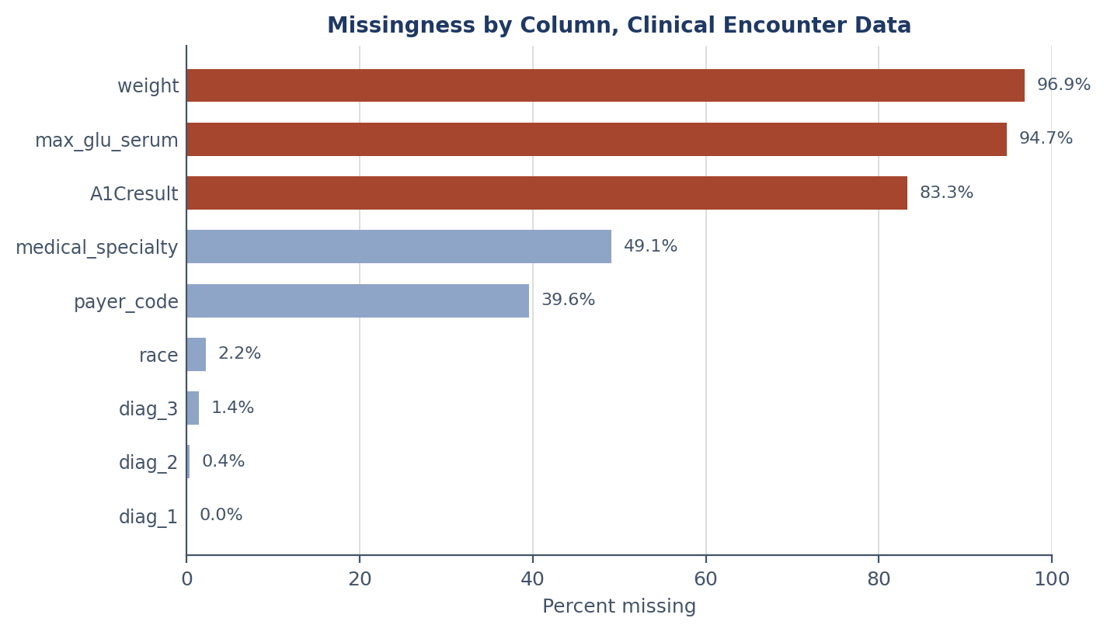
dq_encounters_missingness.png
Purpose. Decide which columns to use, which need missingness encoded as a category, and which to drop. A decision figure, not a descriptive one.
Why this chart type. Ranked horizontal bars. Horizontal because the labels are column names — words, not numbers — and vertical bars would force rotated labels.
Design decisions. The x-axis is fixed 0 to 100 rather than scaled to the data: without that anchor, a chart topping out at 12% looks identical to one topping out at 97%. Bars above 50% take the accent colour because that threshold separates *encode as category* from *drop the column*, so colour carries a decision rather than decoration.
What it shows. Weight is ~97% missing and is dropped; imputation at that rate would be model output presented as observation. Medical specialty (49.1%) and payer code (39.5%) are retained with missingness encoded explicitly, since which fields go unrecorded may itself carry signal.

Figure 2 — Readmission Rate by Discharge Disposition
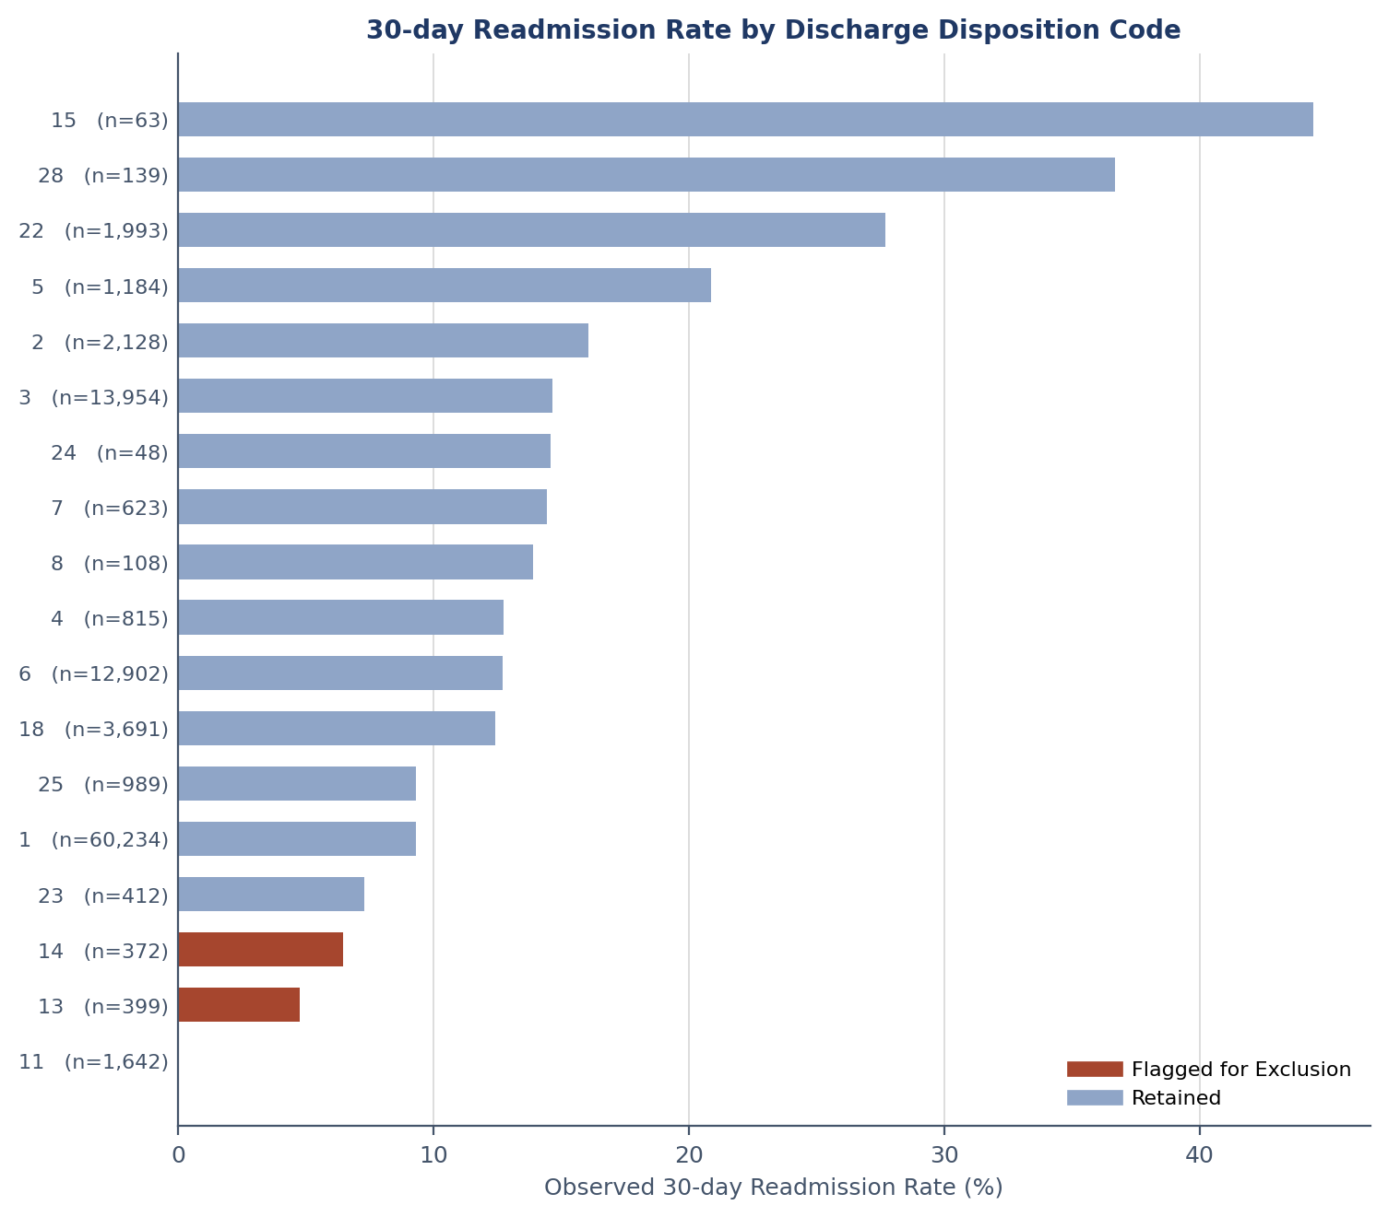
dq_disposition_audit.png
Purpose. Validate the leakage exclusion list empirically. The Kaggle mirror ships a description PDF instead of the ID lookup, so code meanings had to be tested rather than read. A code meaning *expired* predicts a rate of exactly zero.
Why this chart type. Vertical bars against a horizontal reference line. The line because each bar is meaningful only relative to the 11.16% baseline, which a reader cannot hold in mind while scanning five bars.
Design decisions. Colour encodes the decision, not the value — accent for excluded, blue for retained. Sample size prints under each bar, because 0% on 1,642 encounters is evidence and 0% on 2 is not. Rates show three decimals so *exactly* zero is distinguishable from *approximately* zero; that precision is the claim.
What it shows. Codes 11, 19, 20 return exactly 0.000% across 1,652 encounters. Codes 13 and 14 return 4.762% and 6.452% — half the baseline, but unambiguously nonzero. The six codes conventionally excluded as one group do not behave as one.

3. Distribution Visualizations
These characterize variable shape, which determines whether a linear specification is appropriate and which transforms are required.

Figure 3 — Distribution of Numeric Features
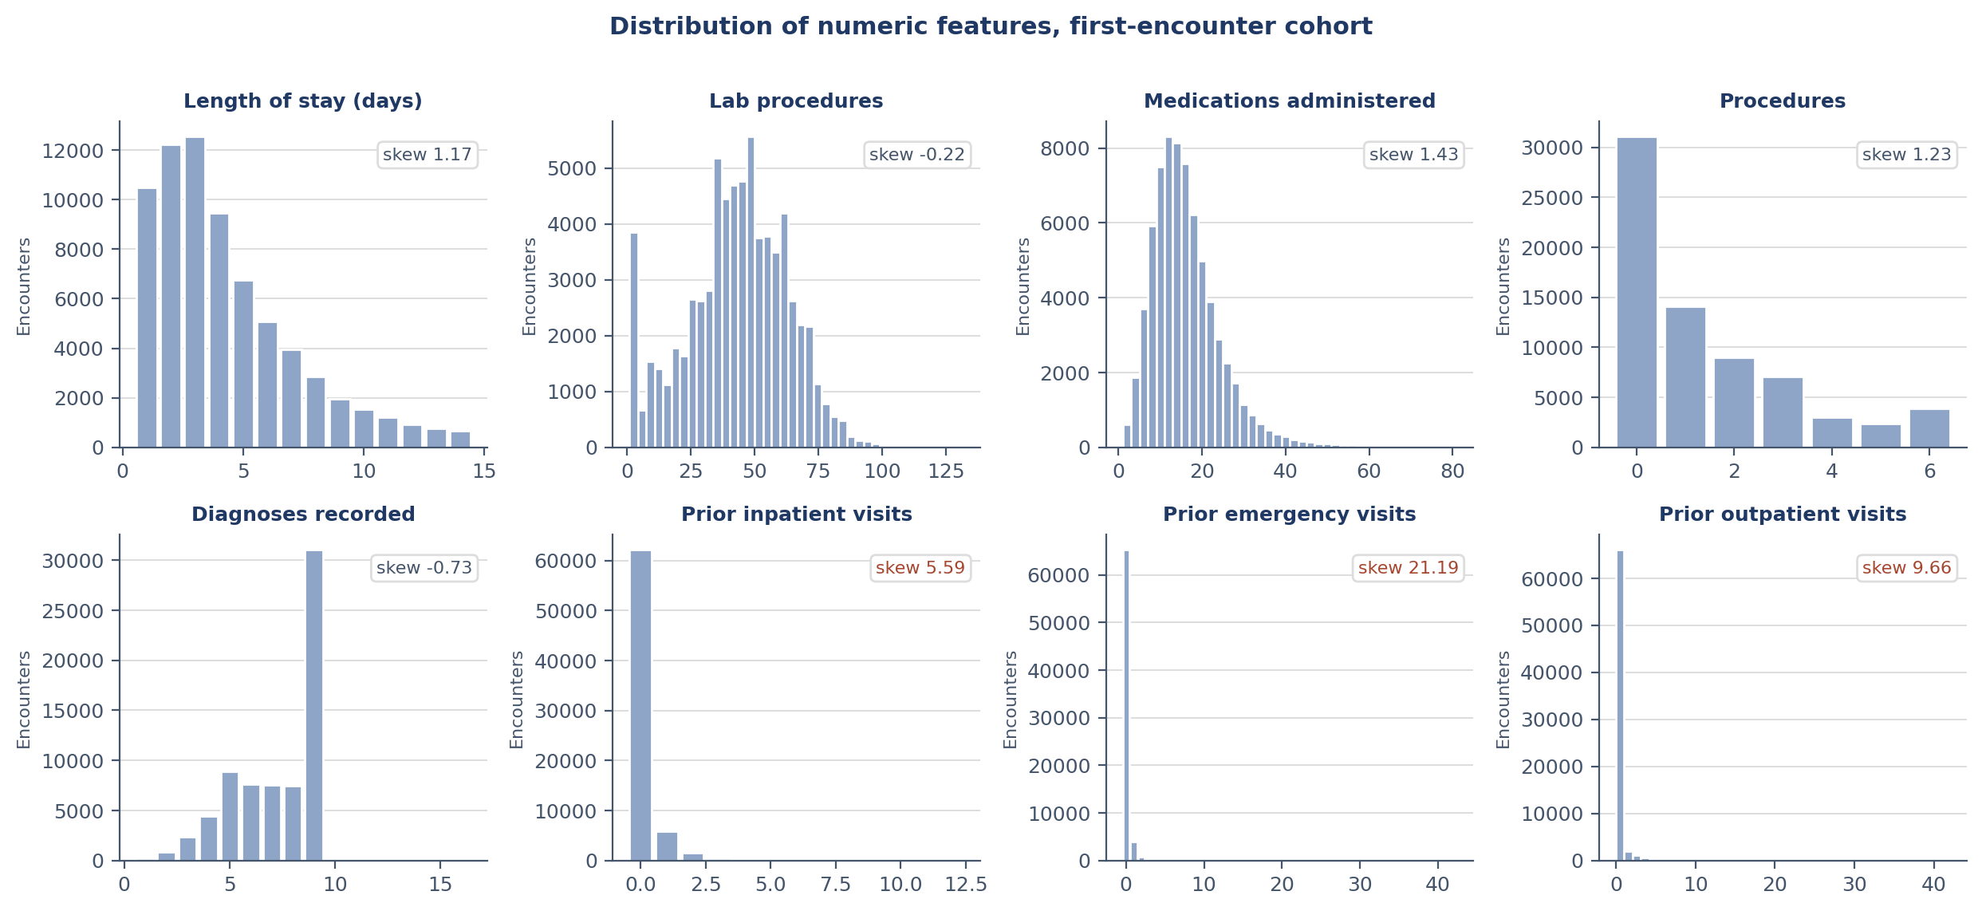
eda_numeric_distributions.png
Purpose. Establish the shape of every numeric predictor before a model assumes anything about it.
Why this chart type. Small multiples — eight panels sharing a layout. Separate figures would let a reader compare each variable to itself but not to the others; the grid makes relative shape immediately legible.
Design decisions. Each panel picks its own renderer: 25 or fewer distinct values are drawn as exact counts, everything else as a histogram. Length of stay takes integers 1–14, and binning it would create gaps and doubled bars that do not exist in the data. Skewness is annotated per panel and printed in accent beyond |2|, so the figure flags its own outliers.
What it shows. Three prior-utilization variables are severely skewed. Lab procedures and diagnoses recorded are mildly *left*-skewed and need no transformation — describing the feature set as uniformly right-skewed would be inaccurate.

Figure 4 — Length of Stay, Linear and Logarithmic
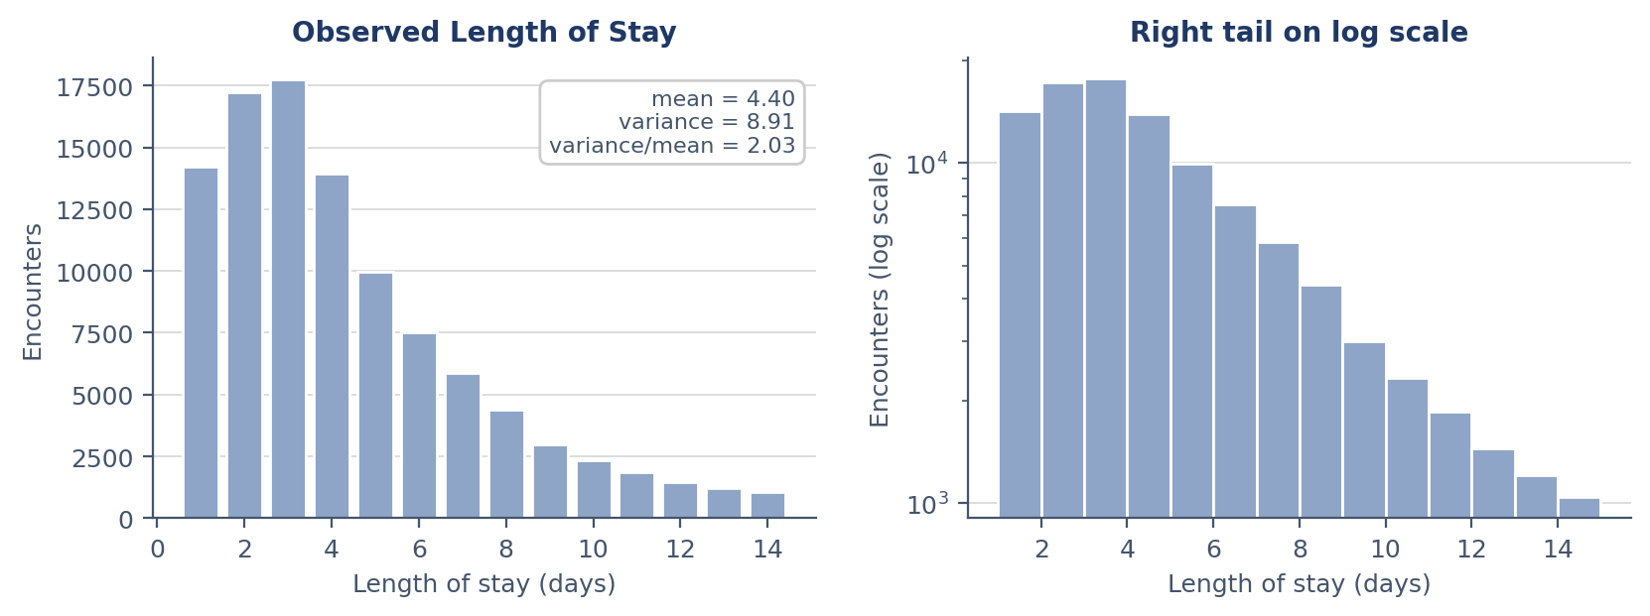
eda_los_distribution.png
Purpose. Motivate the distributional choice for H1e. Poisson and negative binomial make different assumptions about spread, and this is the outcome of the count-regression component.
Why this chart type. Two panels, same data, different scales. Left is a bar chart of exact counts, because plotting a discrete count as continuous would undercut the argument the figure exists to make. Right is log-scaled, because a long thin right tail is invisible on a linear axis.
Design decisions. The left panel carries an annotation box reporting mean, variance, and their ratio — Poisson requires variance to equal the mean exactly, so the ratio is the direct test. Printing it on the chart means the figure argues its own case rather than deferring to surrounding prose. Placed in axes coordinates so it stays in the corner regardless of data scaling.
What it shows. A variance-to-mean ratio near 2 — double what Poisson permits. Descriptive evidence for H1e that precedes the formal test, which later confirms it.

4. Outcome Relationship Visualizations
These establish which features carry univariate signal before modelling, and give a prior for what the multivariable model should find.

Figure 5 — Readmission Rate by Feature Decile
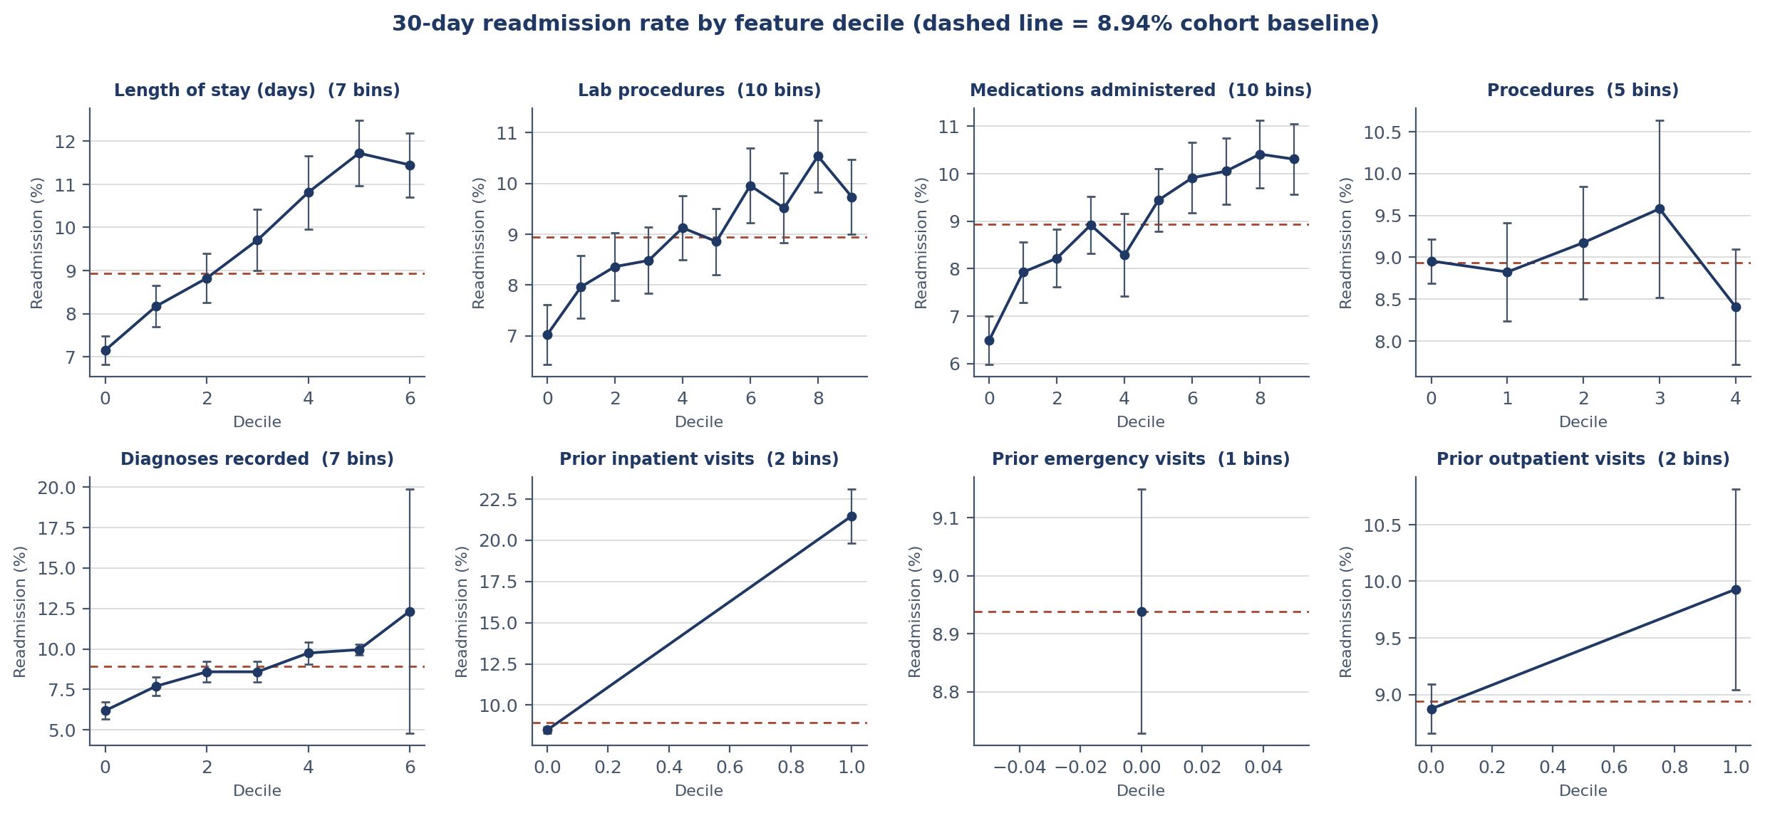
eda_readmission_by_decile.png
Purpose. Identify which numeric features separate readmitted patients, and whether the relationship is monotone. A flat line means no univariate signal.
Why this chart type. Small multiples as line-with-error-bar plots rather than bars. Deciles are ordered, so a line encodes the shape of the relationship in a way categorical bars cannot. Slope is the finding; a line renders slope.
Design decisions. Binomial confidence intervals at every point — quantile boundaries collapse on mostly-zero variables, so bins are unequal and precision genuinely varies. The number of bins actually formed prints in each panel title, an honesty measure: a reader seeing '2 bins' knows not to read that panel as a decile curve.
What it shows. Prior inpatient visits produces the steepest relationship by a wide margin. Prior emergency collapses to a single bin at 92.71% zeros, making its spread exactly zero and the variable appear uninformative — which the binary encoding contradicts.

Figure 6 — Readmission Rate by Categorical Level
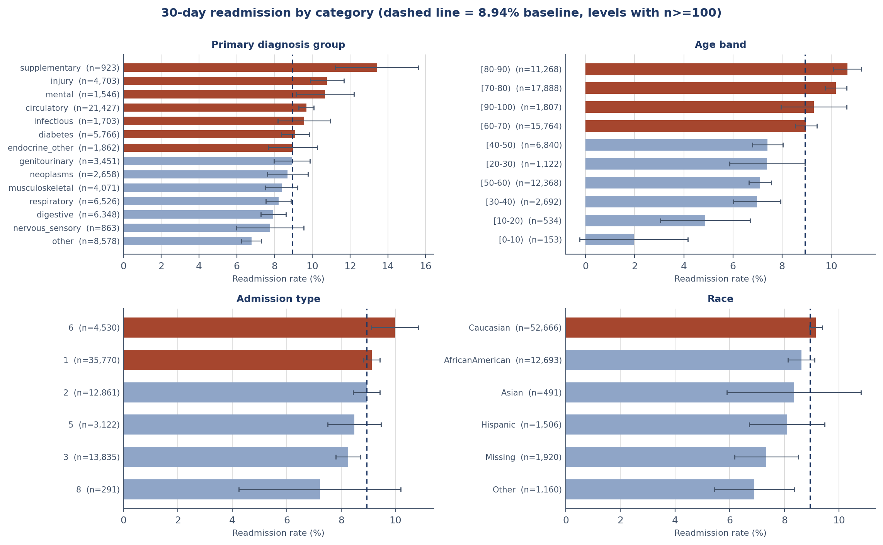
eda_readmission_by_category.png
Purpose. Identify which categorical levels carry elevated risk, and provide the baseline picture for the later fairness audit.
Why this chart type. Horizontal bars with error bars, sorted by rate rather than by level, because the ordering is itself the finding — the reader wants to know which categories rank highest, not to read them alphabetically.
Design decisions. Levels below 100 observations are suppressed, and sample size prints in each remaining label. Bars above baseline take the accent colour, so elevated-risk categories are identifiable without reading values. Error bars matter here because category sizes span two orders of magnitude.
What it shows. Supplementary diagnosis codes — aftercare and complications of prior treatment — rank highest, then injury and mental disorders. Clinically coherent: all three describe elevated care-transition risk. Unadjusted race rates span 2.25 points with substantially overlapping intervals.

Figure 7 — Correlation Among Numeric Predictors
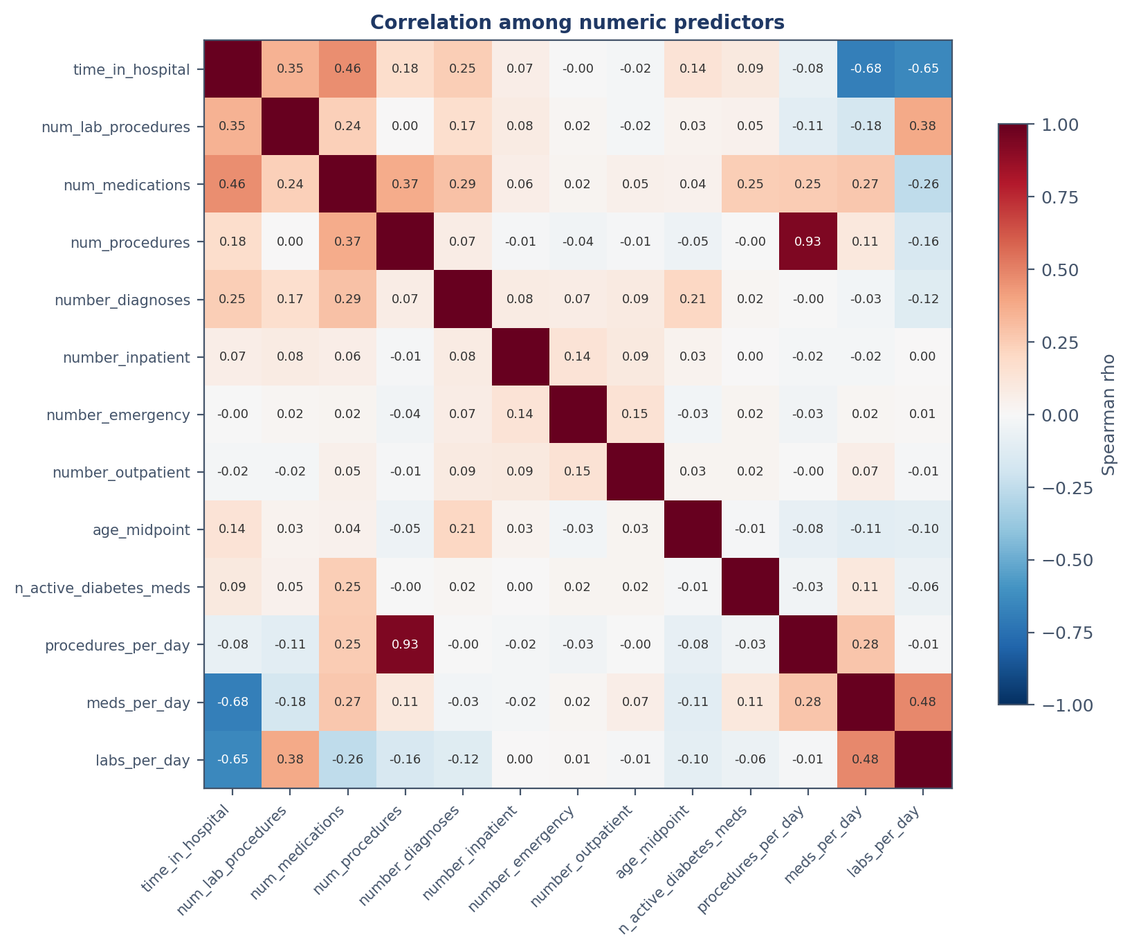
eda_correlation_matrix.png
Purpose. Detect multicollinearity before fitting a regression. Three features divide a count by length of stay, and length of stay is itself a predictor — a structural risk that would destabilize coefficients.
Why this chart type. A heatmap. Thirteen predictors produce 169 pairwise correlations; a table that size is unreadable, while colour intensity locates the strong relationships in one pass.
Design decisions. Spearman, not Pearson — several features are heavily skewed counts, where a linear coefficient is dominated by extreme values. The colormap is diverging and anchored at ±1, because correlation has a meaningful midpoint and sign that a sequential map would obscure. Diagonals omitted; text colour flips on saturated cells so every annotation stays legible.
What it shows. No correlation strong enough to threaten estimation. Rate features and their underlying counts are mildly related but not redundant, confirmed by variance inflation factors below 5. All thirteen predictors retained.

5. Population Survey Visualizations
These support RQ2 — predictors of diabetes, stroke, and cardiac disease at population level, and how strongly those conditions co-occur.

Figure 8 — Class Balance Across All Four Outcomes
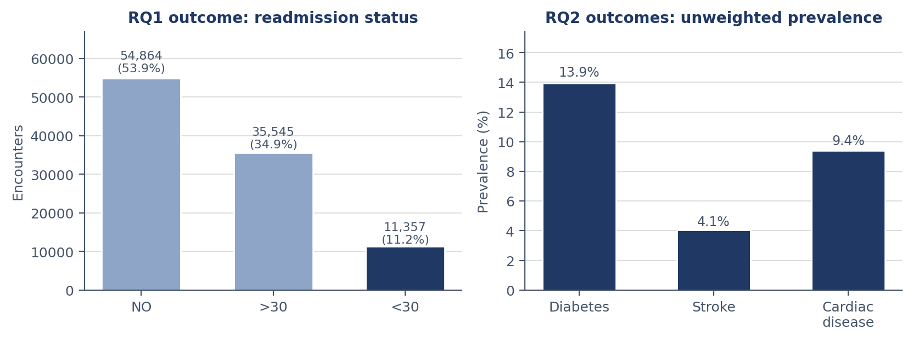
eda_outcome_balance.png
Purpose. Establish prevalence, which determines the evaluation metric. Precision-recall is required at low prevalence; ROC-based measures flatter models on imbalanced data.
Why this chart type. Paired bar charts, one panel per source. Separate panels because the two sources differ in scale and grain — shared axes would misrepresent both.
Design decisions. The left panel prints both count and percentage: the count establishes scale, the percentage establishes prevalence, and prevalence drives the metric choice. Only the target class takes the primary colour. Axis limits are extended so labels do not collide with the title.
What it shows. Prevalence runs 4.1% (stroke) to 13.9% (diabetes). Stroke is rarest and will be hardest to model, with the widest intervals on any predictor ranking.

Figure 9 — Co-occurrence of the Three Survey Conditions
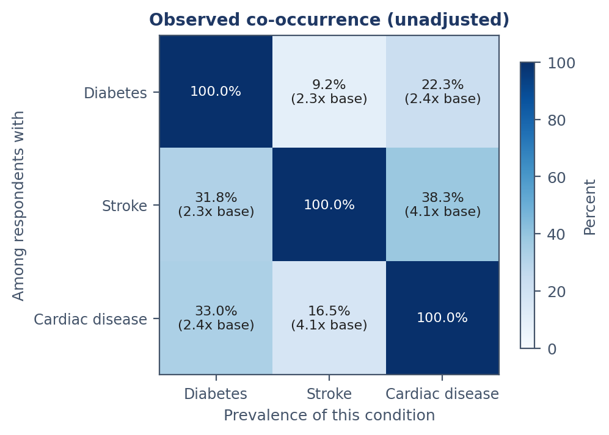
eda_condition_cooccurrence.png
Purpose. Quantify how strongly the three conditions appear together — the basis for the comorbidity component of RQ2, and for whether one diagnosis should trigger screening for the others.
Why this chart type. A heatmap of conditional prevalences. The matrix is deliberately asymmetric — the share of diabetics who have had a stroke is not the share of stroke patients with diabetes, since base rates differ threefold — and a heatmap preserves what a symmetric plot would destroy.
Design decisions. Each off-diagonal cell reports the conditional percentage and the lift over base rate. Lift is essential: 22% co-occurrence means nothing without knowing whether 22% of everyone has the condition. The colormap is sequential, not diverging, because values run from none to a lot with no meaningful midpoint, and is anchored at zero so contrast is stable across runs.
What it shows. All three pairs co-occur well above independence. Stroke and cardiac disease link at ~4.1× base rate, roughly twice either one's association with diabetes. The conditions do not cluster uniformly, suggesting any shared predictor core may prove cardiovascular rather than common to all three.

Figure 10 — Body Mass Index by Diabetes Status
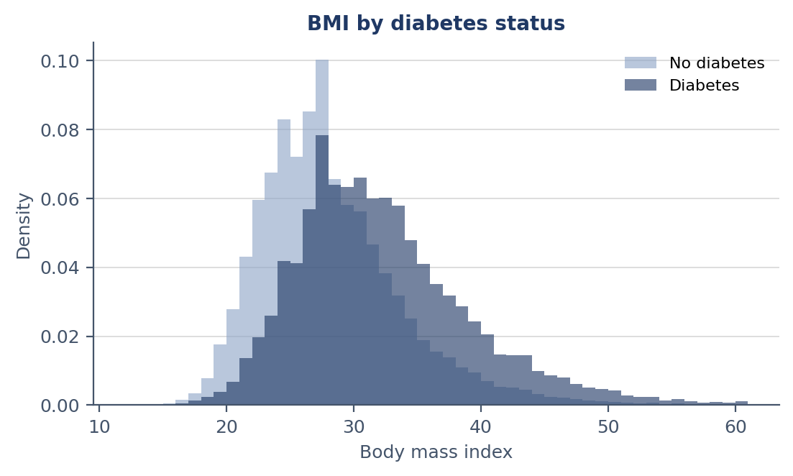
eda_bmi_by_diabetes_status.png
Purpose. Assess whether BMI discriminates diabetes status, and by how much — the descriptive form of the hypothesis that predictor importance differs across the three outcomes.
Why this chart type. Overlapping density histograms rather than side-by-side, because the question is about distributional overlap and adjacent panels make that comparison much harder to make visually.
Design decisions. Density, not counts — mandatory rather than stylistic at an 86/14 split, where raw counts would render the diabetes distribution as an invisible sliver. Shared bin edges are equally mandatory: independently binned histograms would not align and the comparison would be invalid. Partial transparency keeps the overlap readable.
What it shows. Clear separation, with group means on opposite sides of the obesity threshold. Standardized mean difference 0.641, against 0.181 for cardiac disease and 0.102 for stroke — BMI discriminates diabetes several times more strongly than the cardiovascular outcomes.

Figure 11 — Diabetes Prevalence by Income Band
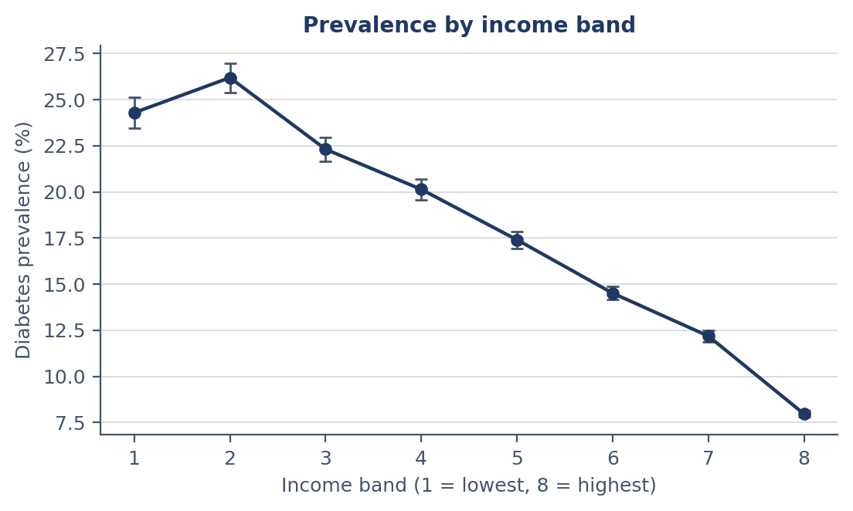
eda_income_gradient.png
Purpose. Determine whether income relates to prevalence as a continuous gradient or a threshold. The distinction has policy consequences: a threshold justifies cutoff-based eligibility, a gradient argues against it.
Why this chart type. A line plot with error bars across ordered categories. A line because the *shape* is the finding — bars would render the same values while discarding the continuity that distinguishes gradient from threshold.
Design decisions. Binomial intervals at every point, and they matter more than usual: band sizes run 9,811 to 90,385, so precision visibly varies along the curve. Every band gets an explicit tick, since these are ordered categories and automatic selection would label only some. The anomalous band is marked in accent and annotated, so the irregularity is encountered in the figure rather than discovered in the text. The axis label states the coding direction, because a reader assuming the opposite would read the chart backwards.
What it shows. A 3.05-fold decline from the second-lowest to the highest band, monotonic across bands 2–8 — consistent with a graded relationship. The lowest band departs, with an interval that does not overlap the band above it. Since the outcome measures *diagnosed* diabetes, reduced healthcare contact may lower detection rather than disease.

6. Summary of Design Rationale
The encoding must match the data type. Discrete counts are drawn as counts, ordered categories as lines, asymmetric relationships in asymmetric matrices. Each alternative would render the same numbers while discarding a property the figure exists to communicate — and for length of stay, would actively undercut the argument being made about it.
Uncertainty is shown, not implied. Group sizes span two orders of magnitude. Every rate carries binomial intervals, every categorical label carries its sample size, and categories too small to estimate are suppressed rather than plotted.
Colour carries meaning or is not used. One warm accent appears throughout, and only to mark something requiring attention: a missingness rate above the drop threshold, a code excluded for leakage, a skewness beyond the conventional bound, a band breaking a monotonic pattern. Using it decoratively anywhere would weaken it everywhere.
The figure should argue its own case. Where one statistic is the point, it is printed on the figure: the variance-to-mean ratio, the lift multiple, the bin count, the standardized difference. A figure depending on surrounding prose will be misread the moment it is extracted into a slide.

