VAJZ
Assessment & Placement Preparation Platform
Technical Requirements Document
Architecture, Data Model, APIs & App Flow
Document type: TRD
Version 1.0 | August 9, 2026
Status: Draft for Review

1. Architecture Overview
VAJZ is a two-front web application (Admin Console + Candidate Portal) backed by a set of REST/GraphQL services behind a single API gateway. Coding-question execution runs in an isolated sandbox service; proctoring artifacts (webcam snapshots, tab-switch events) are stored in object storage and referenced from the reporting service.
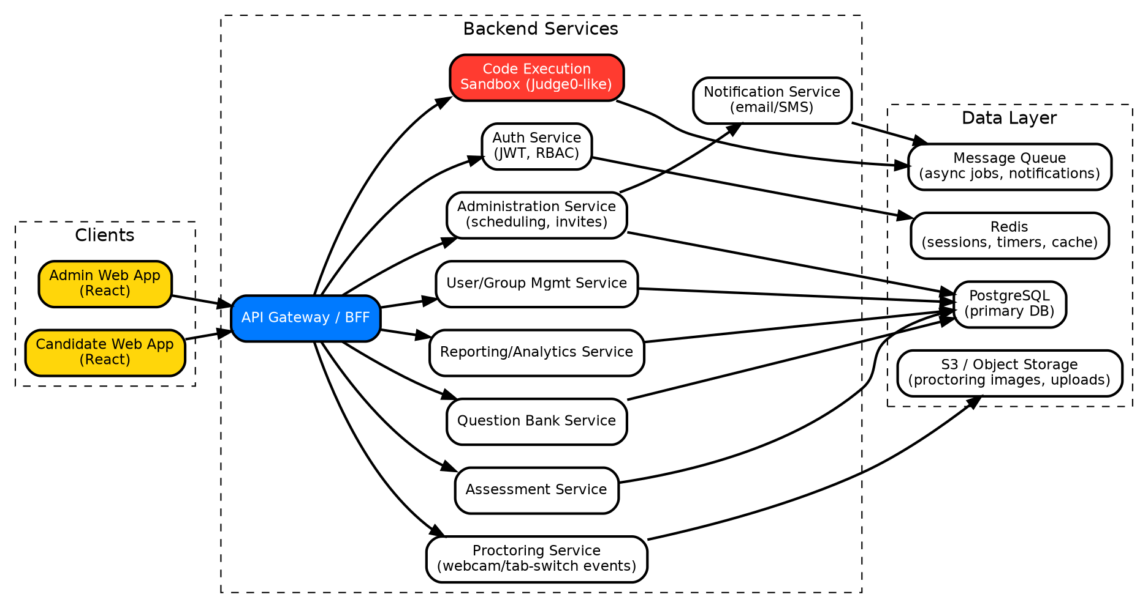
Figure 1 — High-level system architecture

1.1 Recommended Tech Stack
Layer | Choice | Notes
Frontend (Admin + User) | React + TypeScript, React Query, Tailwind/CSS-in-JS | Two apps or one app with role-based routing; shared design-token package
API layer | Node.js (NestJS) or equivalent, REST + WebSocket | WebSocket/SSE for live timer sync and proctoring events
Auth | JWT access + refresh tokens, RBAC (Admin, Super Admin, Candidate) | Short-lived access token, rotating refresh token
Primary database | PostgreSQL | Relational data: users, groups, questions, assessments, administrations, submissions
Cache / sessions | Redis | Active test session state, timers, rate limiting
Code execution | Sandboxed runner (Judge0-style, containerized, resource-limited) | Queued via message broker, isolated network, CPU/time limits per submission
Object storage | S3-compatible bucket | Proctoring snapshots, bulk-upload files, exported reports
Notifications | Email provider (transactional) + queue worker | Triggered on Publish & Invite; SMS is a future channel
Infra | Containerized services on Kubernetes or managed PaaS | Autoscale API and code-execution pools independently

2. App Flow

2.1 Admin Flow — Author → Assemble → Schedule → Publish by Group → Report
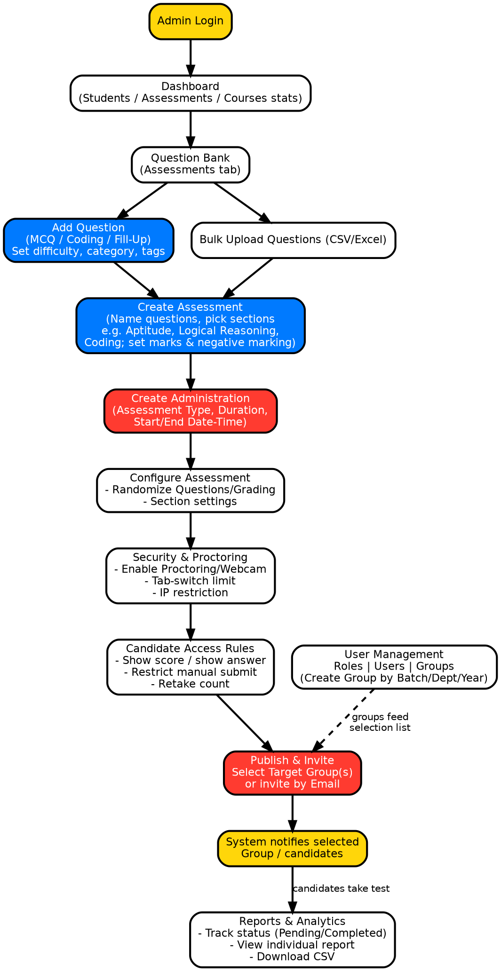
Figure 2 — Admin flow, ending in Publish & Invite by selecting a target Group
Key step: Publish & Invite. After Create Administration → Assessment Configuration → Security & Proctoring → Candidate Access rules are all saved, the Admin reaches the Publish & Invite screen, selects one or more Groups (sourced from User Management), optionally adds ad-hoc email invitees, and confirms. The system then fans out notifications to every candidate in the selected groups and flips the administration's status to Scheduled/Live.

2.2 Candidate (User) Flow — Login → View Assigned Tests → Take Assessment
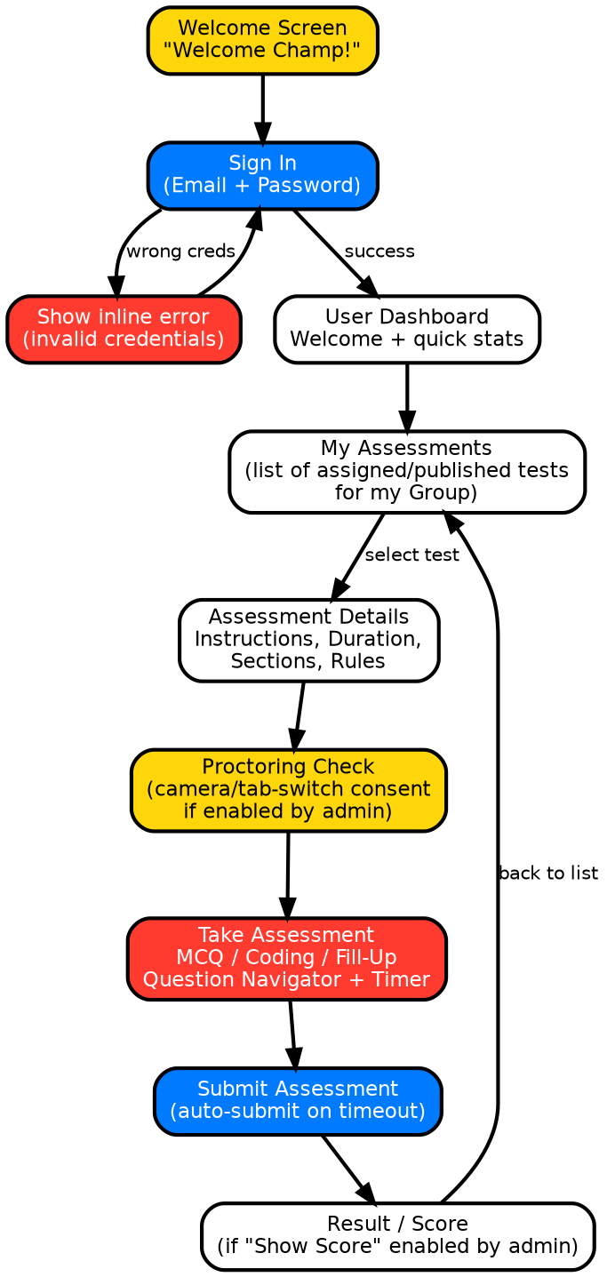
Figure 3 — Candidate flow from login to result
Key step: after a successful login, the candidate's “My Assessments” list is populated only with administrations whose selected Group(s) include the candidate — this is a server-side filter (“administration_group” join to “user_group”), not a client-side filter, so a candidate can never see a test outside their assigned group(s).

3. Data Model (Core Entities)
Entity | Key Fields | Relationships
User | id, name, email, password_hash, role_id, group_ids[] | belongs to Role; many-to-many with Group
Role | id, name (Admin/Super Admin/Student), category, permissions[] | has many Users
Group | id, name, batch, department, placement_year, status | has many Users; referenced by Administration
Question | id, type (MCQ/Coding/FillUp), title, description, difficulty, category, tags[], marks, test_cases[] (coding), options[] (MCQ) | referenced by Section
Assessment | id, title, sort_by, status | has many Sections
Section | id, assessment_id, name, question_ids[], marks_per_question, negative_marking | belongs to Assessment; references Questions
Administration | id, assessment_id, name, category, assessment_type, duration_min, start_at, end_at, status | belongs to Assessment; has Config/Security/Access sub-objects
AdministrationConfig | administration_id, randomize_questions, randomize_grading | belongs to Administration
SecuritySettings | administration_id, proctoring_enabled, image_capture_enabled, tab_switch_limit, ip_restriction_cidr[] | belongs to Administration
AccessSettings | administration_id, show_score, show_answers, restrict_manual_submit, retake_count | belongs to Administration
AdministrationGroup | administration_id, group_id | join table: which groups an administration is published to
Invite | id, administration_id, email, source (group/manual), status | tracks ad-hoc invites outside groups
Submission | id, administration_id, user_id, started_at, submitted_at, status, score, proctoring_flag_count | belongs to Administration + User
Answer | id, submission_id, question_id, response, is_correct, marks_awarded | belongs to Submission
ProctoringEvent | id, submission_id, type (tab_switch/snapshot), timestamp, asset_url | belongs to Submission

4. Key API Endpoints (representative)
Method & Path | Purpose
POST /auth/login | Candidate or Admin login, returns JWT pair
GET /admin/questions?type=&category=&difficulty= | List/filter question bank
POST /admin/questions | Create a question (MCQ/Coding/FillUp)
POST /admin/questions/bulk-upload | Bulk import questions from spreadsheet
POST /admin/assessments | Create assessment with sections
POST /admin/assessments/:id/administrations | Create administration (schedule) for an assessment
PATCH /admin/administrations/:id/config | Save configuration / security / access settings
POST /admin/administrations/:id/publish | Publish & invite — body includes group_ids[] and/or emails[]
GET /admin/administrations/:id/report | Candidate-level report for an administration
GET /admin/administrations/:id/report/export | CSV export of results
GET /admin/groups, POST /admin/groups | List / create candidate groups
GET /user/assessments | Candidate's assigned assessments, filtered server-side by group membership
GET /user/assessments/:administrationId | Assessment detail / instructions before starting
POST /user/assessments/:administrationId/start | Start attempt, create Submission, start server-side timer
PUT /user/submissions/:id/answers/:questionId | Save an answer (auto-save on Save & Next)
POST /user/submissions/:id/submit | Manual or auto submit
POST /user/submissions/:id/proctoring-event | Log tab-switch / webcam snapshot event
POST /code-execution/run | Run/test a coding submission against test cases (internal, called by submission flow)

5. Security & Integrity Requirements
- RBAC enforced server-side on every endpoint; Admin and Candidate tokens are scoped to different permission sets.
- Group-based visibility is enforced in the query layer (never trust a client-supplied group filter).
- Proctoring: webcam snapshots and tab-switch events are timestamped, hashed, and stored with the submission for audit; configurable tab-switch limit auto-flags or auto-submits per admin configuration.
- IP restriction, when enabled, is validated on both session start and each answer-save call.
- All test-taking traffic over TLS; snapshots and code submissions encrypted at rest.
- Code execution sandbox runs untrusted candidate code in a network-isolated, resource- and time-limited container per submission.

6. Non-Functional / Operational Requirements
- Horizontal autoscaling on the API and code-execution pools ahead of scheduled administration start times.
- Redis-backed server-side timer is the source of truth for auto-submit, not the client clock.
- Structured audit log for all publish actions (who published, which groups, when).
- Nightly backups of PostgreSQL with point-in-time recovery; object storage versioning enabled.
- Centralized logging/metrics (e.g. OpenTelemetry) with alerting on submission-save error rate and code-execution queue depth.

7. Design System Tokens (for implementation)
The comic-book visual direction (see UI/UX deliverable) should be implemented as design tokens shared by both frontends:
Token | Value | Usage
color.primary.red | #FF3B30 | Primary actions, live/urgent states
color.primary.yellow | #FFD60A | Highlights, current-state markers, backgrounds
color.primary.blue | #007AFF | Secondary actions, navigation chrome
color.surface | #FFFFFF | Card/panel surfaces
color.ink | #000000 | Outlines, text, shadows
border.outline | 3–5px solid #000000 | All cards, buttons, inputs
shadow.hard | offset 4–10px, 0 blur, #000000 | Comic “pop” shadow, no blur
pattern.halftone | radial-gradient dot repeat | Background/accent fill, 10–16px grid
radius.card | 10–14px | Rounded-square, never fully circular except radios

