**DeltaX Assignment**

PFB the General Details,

* Tools: Visual Studio 2019 , Microsoft SQL Server
* 3 APIs were designed as Part of this Assignment.
* All Database Connections are Made using **Entity Framework Core**
* Cross Orgin Resource Sharing enabled for the API’s which needs to Communicated.
* **Swagger** is Enabled for all the APIs for checking the Output.

PFB the Details of APIs,

* Add Producer API

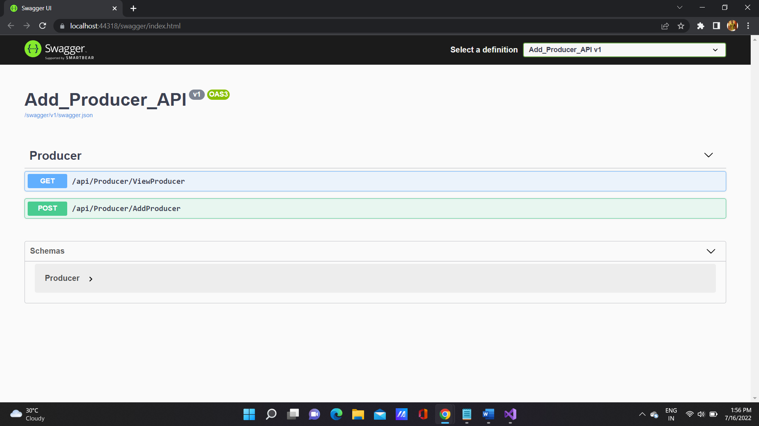

ViewProducer (GET) – To View all the Producer Details from the Database.

AddProducer (POST) – To Add a new Producer Details.

* Add Actor API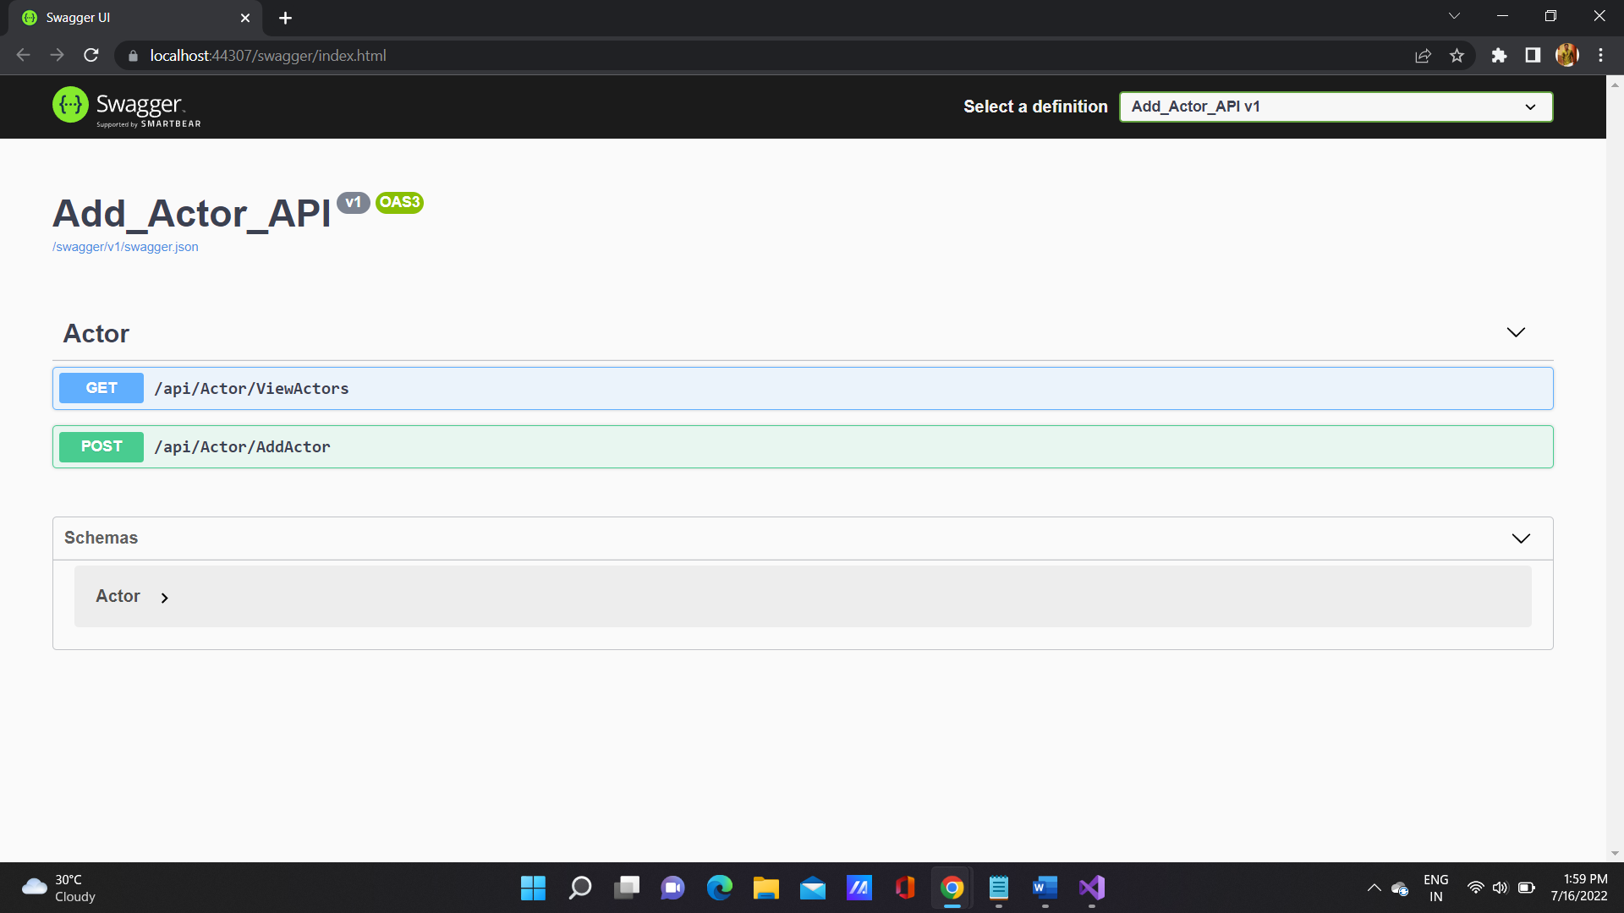

ViewActor (GET) – To View all the Actor Details from the Database.

AddActor (POST) – To Add a new Actor Details.

* Add-Edit-Delete Movie API

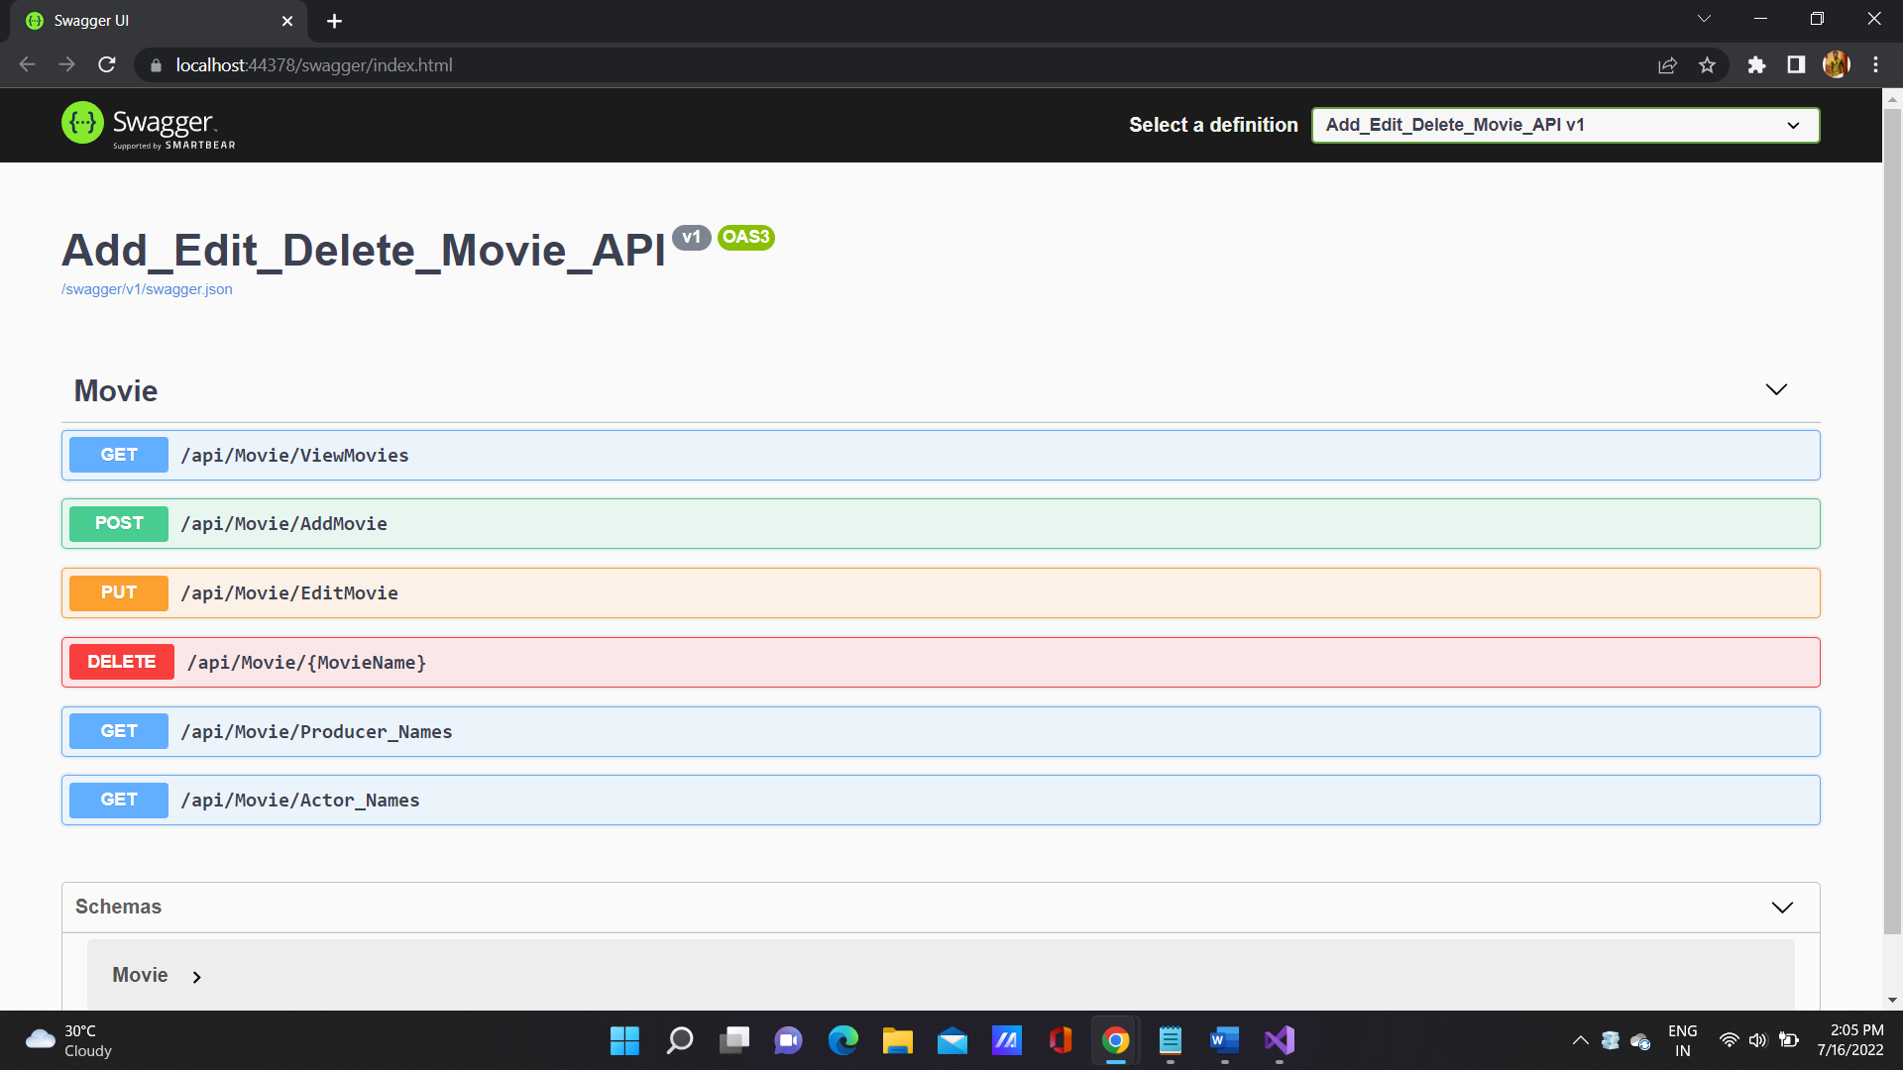

ViewMovie (GET) – To View all the Movies Details from the Database.

AddMovie (POST) – To Add a new Movie Details.

EditMovie (PUT) – To Edit/Update the Movie Details.

DeleteMovie (DELETE) – TO Delete a Movie from Database.

ProducerNames (GET) – Gets the list of Producer Names from Add Producer API .

ActorNames (GET) – Gets the list of Actor Names from Add Actor API .