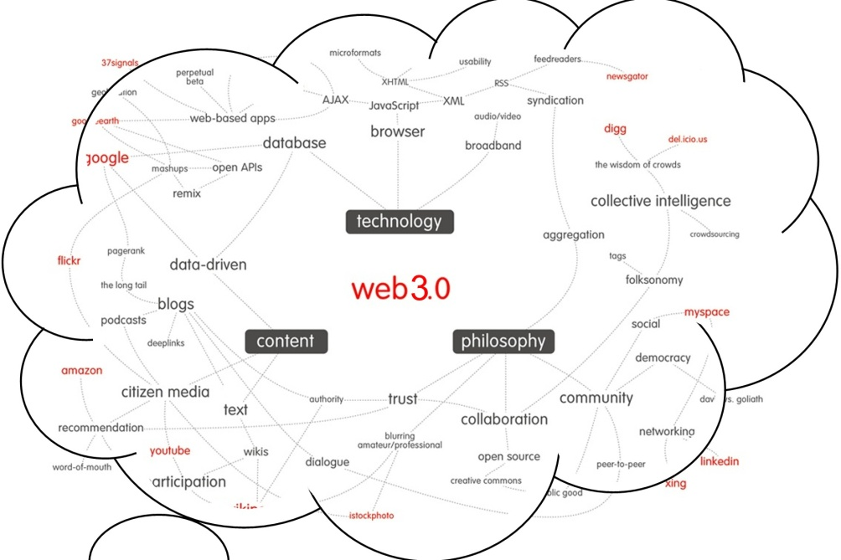

A tag cloud is a way of jotting down key points in a cloud and using those points for reference to study. Our project aims at a way to automate the information retrieval process of a tag cloud with smart searching and a different look at the way the information is searched over the internet. We will use ontology’s to represent our word database in a more creative and intelligent way. The student logs into his/her page and enters the tag words and in the background server all the information is retrieved and stored for future viewing by the student and his/her peers.