Section 1: Week 1 - Build Your First LLM Product: Exploring Top Models & Transformers

1. Day 1 - LLM Engineering Roadmap: From Beginner to Master in 8 Weeks

This kind of experimenting with different models and finding the one that works best for your problem. That is a critical skill for an LLM engineer. So this is valuable time spent.

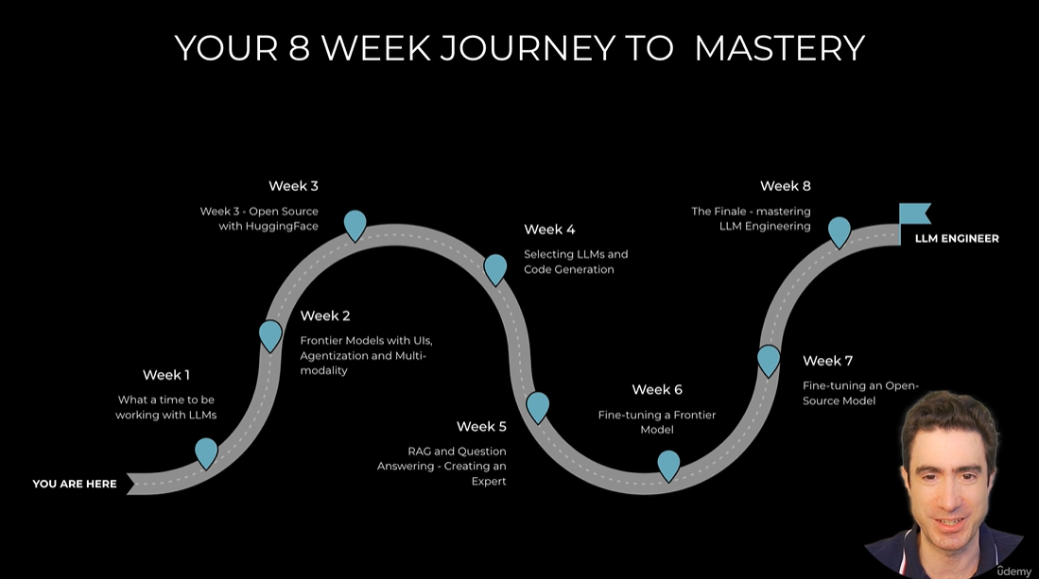

7. Day 1 - Setting Up Your LLM Development Environment: Tools and Best Practices

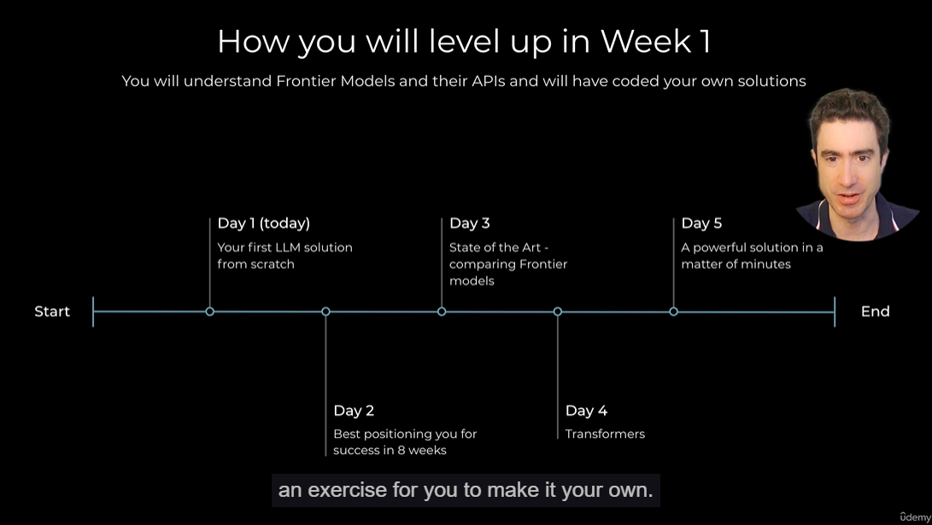

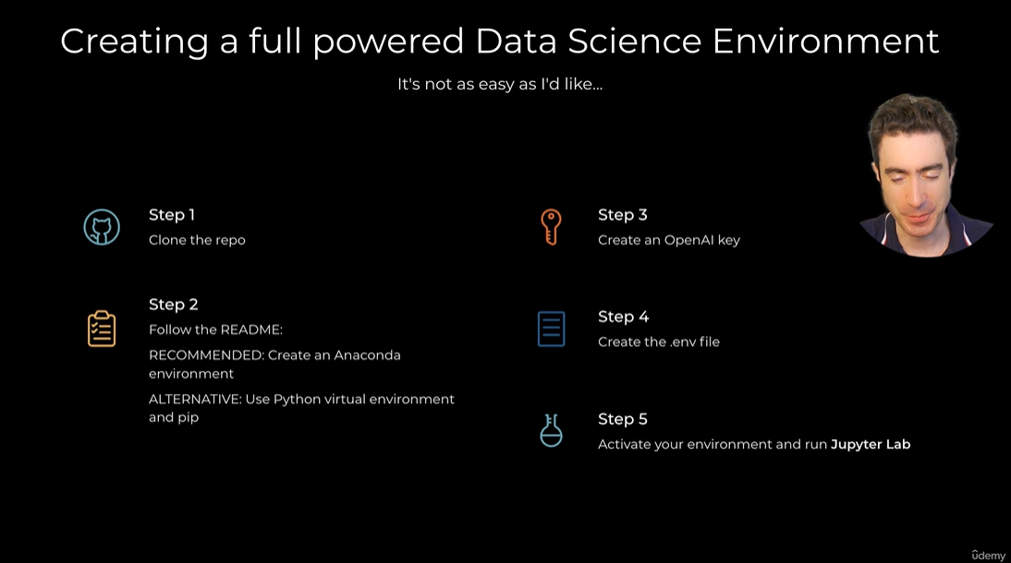

15. Day 1 - Wrapping Up Day 1: Key Takeaways and Next Steps in LLM Engineering

