14.03.2018, 22:53
FastQC Raw Read Quality Check via cmd interface:
fastqc amp_res_1.fastq amp_res_1.fastq -O ~/Bio_projects/Project_1\
fastqc amp_res_1.fastq amp_res_2.fastq -O ~/Bio_projects/Project_1\
-/-, 23:10
Nextera Transposase Sequences encountered in FastQC report trimmed with CutAdapt (sequences in questions obtained from Illumina Adapter Sequences Manual: https://support.illumina.com/content/dam/illumina-support/documents/documentation/chemistry_documentation/experiment-design/illumina-adapter-sequences-1000000002694-06.pdf ):
cutadapt -a TCGTCGGCAGCGTCAGATGTGTATAAGAGACAG -A GTCTCGTGGGCTCGGAGATGTGTATAAGAGACAG -o amp_res_cut_1.fastq -p amp_res_cut_2.fastq amp_res_1.fastq amp_res_2.fastq
Output statistic were redirected in error stream and saved as report2.txt file and displayed in FastQC:
fastqc amp_res_cut_1.fastq amp_res_cut_2.fastq -O ~/Bio_projects/Project_1
Result: no obvious effect except for slight length distribution distortion
15.03.2018, 0:16
Reads were trimmed with Trimmomatic; adapter sequences were taken from Trimmomatic default Nextera Transposase Sequences fasta file. Two attempts were performed with MINLEN parameter equal to 50 and 30, respectively.
java -jar ~/Trimmomatic-0.36/trimmomatic-0.36.jar PE -threads 4 -phred33 -trimlog trimlog.txt amp_res_1.fastq amp_res_2.fastq amp_res_trimmed_1.fastq amp_res_trimmed_2.fastq amp_res_trimmed_3.fastq amp_res_trimmed_4.fastq ILLUMINACLIP:NexteraPE-PE.fa:3:30:7:2 MINLEN:50
Since FastQC reports did not show any significant increase in read quality, we decided to perform HEADCROP trimming clipping all nucleotides after pos. 80, which led to complete Per Tile Sequence Quality attribute remedy:
java -jar ~/Trimmomatic-0.36/trimmomatic-0.36.jar PE -threads 4 -phred33 -trimlog trimlog.txt amp_res_1.fastq amp_res_2.fastq amp_res_trimmed3_1.fastq amp_res_trimmed32.fastq amp_res_trimmed3_3.fastq amp_res_trimmed3_4.fastq ILLUMINACLIP:NexteraPE-PE.fa:3:30:7:2 MINLEN:50 CROP:80
All fastqc report are presented in FASQC_reports folder. Final result:
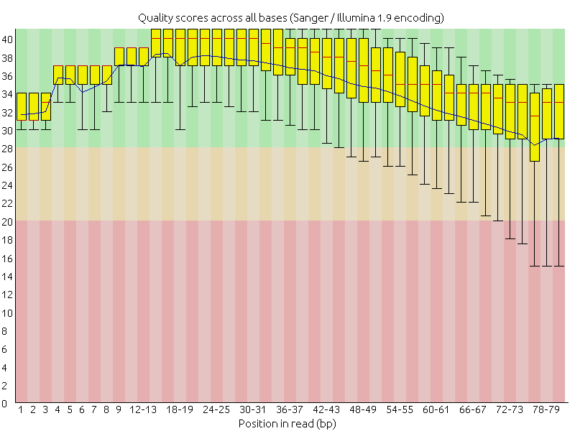
-/-, 049
Reference genome was indexed via bowtie2-builder command:
bowtie2-build GCA_000005845.2_ASM584v2_genomic.fna ref_index
-/- 0:55
Alignment\
bowtie2-build GCA_000005845.2_ASM584v2_genomic.fna ref_index
-/-, 1:00
Read alignment against indexed reference:
bowtie2 -x ref_index -1 amp_res_trimmed3_1.fastq -2 amp_res_trimmed3_3.fastq -p 2 > ref_align.sam
-/-, 1:10
SAM to BAM output file conversion
samtools view -S -b ref_align.sam > ref_align.bam
-/-, 1:14
Conversion statistics called and written in the summary file
samtools flagstat ref_align.bam > stat.txt
-/-, 1:17
Binary file sorting:
samtools sort ref_align.bam -o ref_align_sorted.bam
-/-, 1:25
Indexing ali
samtools index ref_align_sorted.bam
.-/-, 1:35
creating mpileup file
samtools mpileup -f GCF_000005845.2_ASM584v2_genomic.fna ref_align_sorted.bam > my.mpileup
.-/-, 1:39
Trying to obtain SNP from mpileup file with VarScan (with diverse frequency thresholds — 0.5 and 0.9) with the following command:
java -jar VarScan.v2.3.9.jar mpileup2snp my.mpileup --min-var-freq 0.5--variants --output-vcf 1 > Variants10.vcf
As a result, no differences were noiticed between different frequencies, thus, proper trimming is more crutial for desirable output. 6 SNP`s were detected

.-/-, 1:45
Vizualizing result with IGV genomic browser. Adding genome from fna reference file and subsequent adding sorted SAM and vcf files was executed.

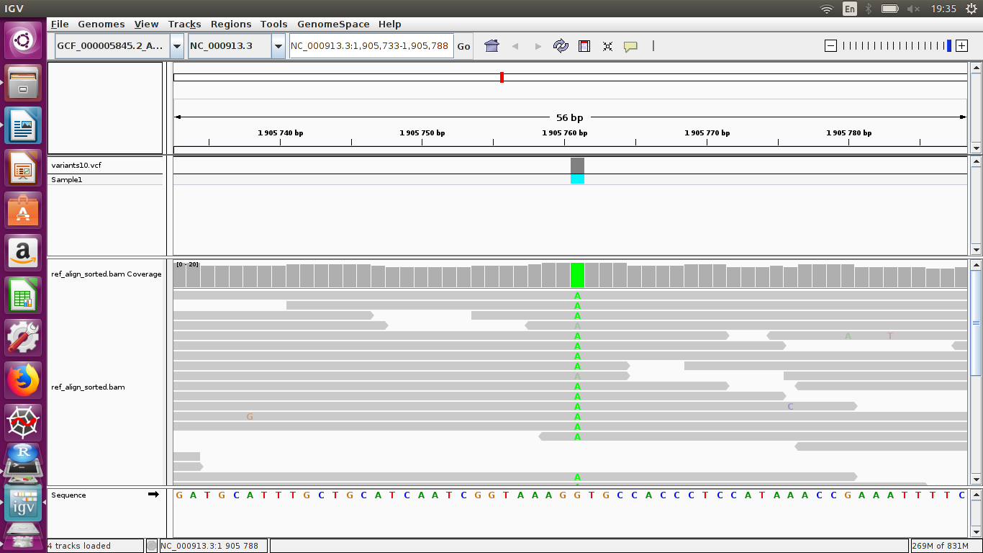
18.03.2018, 22:20
Creating database for snpFF to annotate previous output.
-Entering snpEff folder
-changing config-file with vim: vi snpEff.сonfiq
#Eco_K12.genome: Escherichia coli
-creating new directory — mkdir /data/E_coli_K12
-copying gff and fna files into this folder
-building database:
java -jar snpEff.jar -gff3 -v data/Eco_K12/GCA_000005845.2_ASM584v2_genomic.fna
.-/-, 22:50
Final SNP anotation
java -jar snpEff.jar -v CA_000005845.2_ASM584v2_genomic.fna Variants10.vcf > var_ann.vcf
.-/-, 23:00
annotated SNP analyzing (presentetd in final report)

Supplementary data (programmes versions):
samtools-1.7
IGV_2.4.9
Trimmomatic-0.36
VarScan.v2.3.9
bowtie2-2.3.4.1-linux-x86_64
snpEff 4.3T (2017-11-24)

