22.03.17, 19:15
Reads downloaded and gunzipped in /home/username/Downloads/Project2 directory

-/-, 19:46
KF848938.1 fasta sequence downloaded with Python script

20:39
FastQC inspection of fastq reads

20:42
Most frequent overabundant k-mer BLASTed against global database and recognized as IVA hemagglutinine part. No trimming suggested.

21:00
bowtie2-build KF848938.1.fasta ref_index

21:02
bowtie2 -x ref_index -U SRR1705851.fastq > ref_align.sam

21:10
samtools view -S -b ref_align.sam

21:12
samtools view -S -b ref_align.sam > ref_align.bam

21:15
samtools sort ref_align.bam ref_align_sorted

21:20
samtools flagstat ref_align_sorted.bam > stat.txt


21:42
pipe

21:50
samtools depth ref_align_sorted.bam > sortlist.txt

21:57
cat sortlist.txt | cut -f3 | sort | uniq | sort -nr

22:10
samtools mpileup -BQ0 -d10000000 ref_align_sorted.bam > my.mpileup

22:25
VarScan.v2.3.9.jar mpileup2snp my.mpileup --min-var-freq 0.99 --variants --output-vcf 1 > Variants10.vcf

22:29
Sorted bam visualized with IGV together with variant caller output
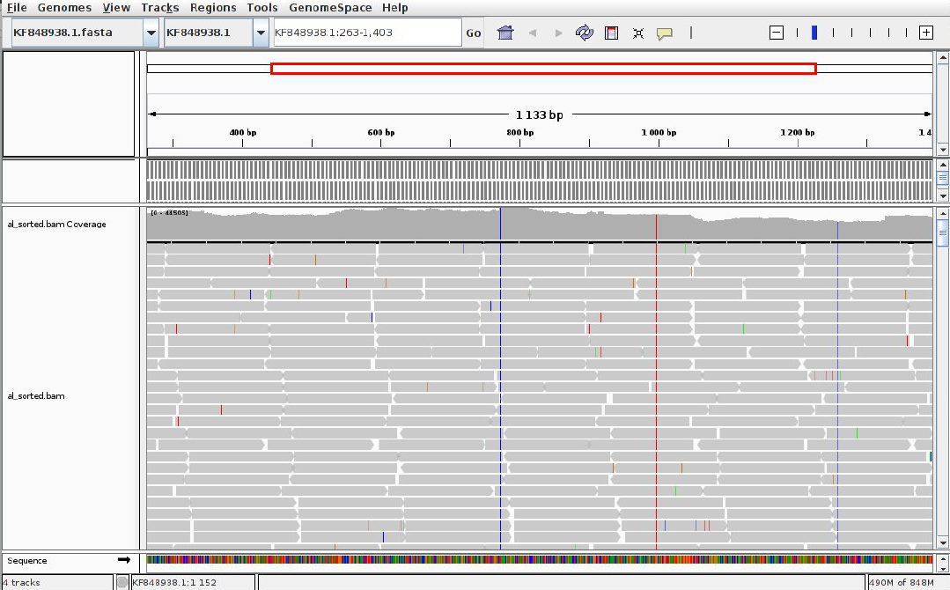

22:30 – 23:10

23:11
Critical error revealed:
samtools mpileup -BQ0 -d10000000 -f KF848938.1.fasta ref_align_sorted.bam > my.mpileup
java -jar VarScan.v2.3.9.jar mpileup2snp my.mpileup --min-var-freq 0.001 --variants --output-vcf 1 > Variants10.vcf

23:27
BAM file visualized in IGV with a new VCF variant caller output
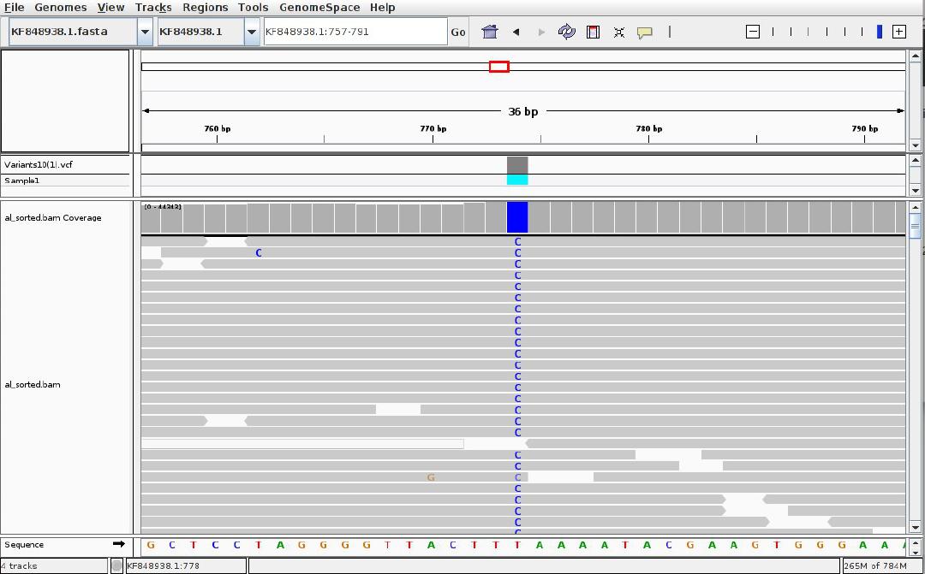

23:44
cat Variants10.vcf | awk 'NR > 24 {print $0}' | awk '($10 ~ /0.001/) {print $0}'

23:46
improved: cat Variants10.vcf | awk '($10 ~ /0.1/) {print $0}'

23.03.18, 00:05
gunzip SRR1705858.fastq.gz
gunzip SRR1705859.fastq.gz
gunzip SRR1705860.fastq.gz

00:10
cat KF848938.1.fasta | awk 'NR > 1' | wc -m
Result: 1693

00:11
cat SRR1705858.fastq | awk 'END {print NR/(4*1693)}'
Result: 151.557
cat SRR1705859.fastq | awk 'END {print NR/(4*1693)}'
Result: 137.819
cat SRR1705860.fastq | awk 'END {print NR/(4*1693)}'
Result: 147.646

00:20-00:40
bowtie2 -x ref_index -U SRR1705859.fastq > ref_align_58.sam
samtools view -S -b ref_align_58.sam > ref_align_58.bam
samtools sort ref_align_58.bam ref_align_sorted_58
samtools flagstat ref_align_sorted_58.bam > stat_58.txt
samtools mpileup -BQ0 -d10000000 -f KF848938.1.fasta ref_align_sorted_58.bam > my_58.mpileup
java -jar VarScan.v2.3.9.jar mpileup2snp my_58.mpileup --min-var-freq 0.001 --variants --output-vcf 1 > Variants58.vcf

00:40-01:05
Same worklow performed over SRR1705859 and SRR1705860

01:20
cat Variants58.vcf | awk 'NR > 23 {print $1, $2, $4, $5, $10}' | awk '{gsub(/ /,",");print}' > 58_filt.csv

01:21
cat Variants59.vcf | awk 'NR > 23 {print $1, $2, $4, $5, $10}' | awk '{gsub(/ /,",");print}' > 59_filt.csv

01:22
cat Variants60.vcf | awk 'NR > 23 {print $1, $2, $4, $5, $10}' | awk '{gsub(/ /,",");print}' > 60_filt.csv

02:40
awk -F \, '{print $5}' 58_filt.csv | grep -o -P '.{0,5}%' | sed 's/.*://' | sed 's/%//' > percents_58.csv
awk -F \, '{print $5}' 59_filt.csv | grep -o -P '.{0,5}%' | sed 's/.*://' | sed 's/%//' > percents_59.csv
awk -F \, '{print $5}' 60_filt.csv | grep -o -P '.{0,5}%' | sed 's/.*://' | sed 's/%//' > percents_60.csv

03:00
R mean and sd evaluation:

Ultramean: 3.2437066666666667
UltraSD: 10.1689936666666667

03:30

cat Variants10.vcf | awk 'NR > 23 {print $1, $2, $4, $5, $10}' | awk '{gsub(/ /,"\t");print}' > Variants10.csv
awk -F \, '{print $5}' Variants10 | grep -o -P '.{0,5}%' | sed 's/.*://' | sed 's/%//' > Variants_20.csv
Merging files in libre office
03:50

IGV SNP visualization and screening for amino acids substitutions

