Российский университет транспорта (МИИТ)
Институт транспортной техники и систем управления
Кафедра «Управление и защита информации»
Отчет
по практическому заданию
по теме «Структуры данных»
по дисциплине «Системы управления базами данных»
Выполнил:
Студент группы ТКИ-442
Жижин А.Д.
Проверил:
Доцент кафедры УиЗИ к.т.н., с.н.с
Васильева М. А.
Москва 2024
Оглавление
1. Условие задачи 3
2. Текст программы на языке С++ 3
2.1. ../src/Node.hpp 3
2.2. ../src/BST.hpp 5
2.3. ../src/main.cpp 8
2.4. ../src/CmakeLists.txt 8
2.5. ../test/NodeTest.cpp 8
2.6. ../test/BSTTest.cpp 9
2.7. ../test/CmakeLists.txt 10
2.8. CmakeLists.txt 10
3. Результат работы программы 11

- Условие задачи
Бинарное дерево поиска
Определить класс «Node», включающий следующую информацию:
- Данные любого типа;
- Указатели на поддеревья и родителя;
Определить класс «BST», включающий следующую информацию:
- Указатель на корень дерева;
В программе предусмотреть:
- создание БДП;
- вывод на экран;
- удаление элемента по ключу;
- вставка элемента по ключу;
- поиск данных элемента по ключу;
- поиск минимального и максимального элемента.

- Текст программы на языке С++

  - ../src/Node.hpp
#pragma once
#include <iostream>
#include <sstream>
#include "BST.hpp"
template<typename T>
class Node {
template<typename U>
friend class BST;
private:
T data;
Node<T> *left, *right, *parent;
public:
Node(const Node<T>& other) = delete;
explicit Node(T data): left(nullptr), right(nullptr), parent(nullptr), data(data){}
~Node(){
this->left = nullptr;
this->right = nullptr;
if (this->parent != nullptr)
{
if (this == this->parent->left)
this->parent->left = nullptr;
else if (this == this->parent->right)
this->parent->right = nullptr;
}
}
T getData(){ return data; }
Node<T>* getLeft(){ return left; }
Node<T>* getRight(){ return right; }
/**
* @brief swap data between nodes
* @param other - node to swap
*/
void dataSwap(Node<T>* other){
auto tmp = this->data;
this->data = other->data;
other->data = tmp;
}
/**
* @brief Operator left shift
* @param node - node to output
* @return output stream
*/
friend std::ostream& operator<<(std::ostream& out, const Node<T>& node){
out << node.data << " ";
return out;
}
/**
* @brief Operator equal
* @param other - node to compare
* @return result of comparison
*/
bool operator==(Node<T> const& other) const { return data == other.data; }
/**
* @brief Operator not equal
* @param other - node to compare
* @return result of comparison
*/
bool operator!=(Node<T> const& other) const { return data != other.data; }
/**
* @brief Operator greater
* @param other - node to compare
* @return result of comparison
*/
bool operator>(Node<T> const& other) const { return data > other.data; }
/**
* @brief Operator lower
* @param other - node to compare
* @return result of comparison
*/
bool operator<(Node<T> const& other) const { return data < other.data; }
};

  - ../src/BST.hpp
#pragma once
#include "Node.hpp"
template<typename T>
class Node;
template<typename T>
class BST {
private:
Node<T>* root = nullptr;
/**
* @brief func to insert node in tree
* @param node - node to insert
* @param current - buffer for recursion (default = root)
* @param parent - revers link in hierarchy (default = nullptr)
* @return pointer on current obj
*/
Node<T>* inserter(Node<T>* node, Node<T>* current, Node<T>* parent) {
if (current == nullptr){
current = node;
current->parent = parent;
return current;
}
if (*node < *current)
current->left = inserter(node, current->left, current);
else if (*node > *current)
current->right = inserter(node, current->right, current);
return current;
}
/**
* @brief func to find node in tree
* @param node - node to find
* @param current - buffer for recursion (default = root)
* @return pointer on current obj
*/
bool contains(Node<T> *node, Node<T> *current) {
if (current == nullptr)
return false;
else if (*node == *current)
return true;
else if (*node < *current)
contains(node,current->left);
else
contains(node,current->right);
}
/**
* @brief func to find minimum node in (sub)tree
* @param node - root node of (sub)tree (default = root)
* @return pointer on minimum node
*/
Node<T>* findMin(Node<T>* node) {
if (node == nullptr || node->left == nullptr)
return node;
return findMin(node->left);
}
/**
* @brief func to find maximum node in (sub)tree
* @param node - root node of (sub)tree (default = root)
* @return pointer on maximum node
*/
Node<T>* findMax(Node<T>* node) {
if (node == nullptr || node->right == nullptr)
return node;
return findMax(node->right);
}
/**
* @brief output in increasing order
* @param node - root node of (sub)tree (default = root)
* @param out - output stream
* @return string of nodes in increasing order
*/
std::string inOrderTraversal(Node<T>* node, std::ostringstream& out) {
if (node != nullptr) {
inOrderTraversal(node->left, out);
out << *node;
inOrderTraversal(node->right, out);
}
return out.str();
}
/**
* @brief output in post order
* @param node - root node of (sub)tree (default = root)
* @param out - output stream
* @return string of nodes in post order
*/
std::string postOrderTraversal(Node<T>* node, std::ostringstream& out) {
if (node != nullptr) {
postOrderTraversal(node->left, out);
postOrderTraversal(node->right, out);
out << *node;
}
return out.str();
}
/**
* @brief func to convert subtree root into leaf
* @param current - root of subtree
* @return pointer on leaf
*/
Node<T>* subtreeToLeaf(Node<T>* current){
if (current->left == nullptr || current->right == nullptr)
return current;
else if (current->left != nullptr) {
current->dataSwap(current->left);
subtreeToLeaf(current->left);
} else if (current->right != nullptr) {
current->dataSwap(current->right);
subtreeToLeaf(current->right);
}
}
/**
* @brief func to delete node from tree
* @param data - key to delete
* @param root - root node of (sub)tree (default = root)
*/
void nodeRemover(Node<T>* node, Node<T>* current) {
if (contains(node, current) == false)
return;
else{
if (node->data > current->data)
nodeRemover(node, current->right);
else if (node->data < current->data)
nodeRemover(node, current->left);
else{
delete subtreeToLeaf(current);
}
}
}
/**
* @brief func to delete tree
* @param root - root node of (sub)tree (default = root)
*/
void treeRemover(Node<T>* node){
if (node) {
treeRemover(node->left);
treeRemover(node->right);
delete node;
}
}
public:
BST() { this->root = nullptr; }
Node<T>* getRoot(){ return this->root; }
Node<T>* getMin() { return findMin(this->root); }
Node<T>* getMax() { return findMax(this->root); }
/**
* @brief interface for inserter
* @param newData - key to insert
*/
void insertNode(const T& newData) {
this->root = inserter(new Node<T>(newData), this->root, nullptr);
}
/**
* @brief interface for contains
* @param dataToFind - key to search
* @return bool - flag - is tree contains it or not
*/
bool isContains (T dataToFind) {
Node<T>* tmp = new Node<T>(dataToFind);
bool is = contains(tmp, this->root);
delete tmp;
return is;
}
/**
* @brief interface for in increase order output
* @return string of nodes in increasing order
*/
std::string inOrderPrint() {
std::ostringstream buffer{};
inOrderTraversal(this->root, buffer);
return buffer.str();
}
/**
* @brief interface for in decrease order output
* @return string of nodes in increasing order
*/
std::string postOrderPrint() {
std::ostringstream buffer{};
postOrderTraversal(this->root, buffer);
return buffer.str();
}
/**
* @brief interface for deleting node from tree
*/
void deleteNode(const T& data) {
Node<T>* tmp = new Node<T>(data);
nodeRemover(tmp, this->root);
delete tmp;
}
/**
* @brief tree destructor
*/
~BST() { treeRemover(this->root); }
};

  - ../src/main.cpp
#include "BST.hpp"
int main(){
return 0;
}

  - ../src/CmakeLists.txt
cmake_minimum_required(VERSION 3.0)
project("BinarySearchTree")
set(CMAKE_CXX_STANDARD 20)
add_executable(7th_semester
Node.hpp
BST.hpp
main.cpp
)

  - ../test/NodeTest.cpp
#include <gtest/gtest.h>
#include "../src/Node.hpp"
TEST(NodeTest, dataConstructorTest) {
Node<int>* node = new Node<int>(0);
ASSERT_EQ(0, node->getData());
ASSERT_EQ(nullptr, node->getLeft());
ASSERT_EQ(nullptr, node->getRight());
}
TEST(NodeTest, intCompareOperatorTest) {
Node<int>* otherNode = new Node<int>(15);
Node<int>* node = new Node<int>(10);
ASSERT_EQ(false, *node == *otherNode);
ASSERT_EQ(true, *node != *otherNode);
ASSERT_EQ(false, *node > *otherNode);
ASSERT_EQ(true, *node < *otherNode);
}
TEST(NodeTest, stringCompareOperatorTest) {
Node<std::string>* node = new Node<std::string>("ozob");
Node<std::string>* otherNode = new Node<std::string>("bozo");
ASSERT_EQ(false, *node == *otherNode);
ASSERT_EQ(true, *node != *otherNode);
ASSERT_EQ(true, *node > *otherNode);
ASSERT_EQ(false, *node < *otherNode);
}
TEST(NodeTest, dataSwapTest) {
Node<int>* otherNode = new Node<int>(15);
Node<int>* node = new Node<int>(10);
node->dataSwap(otherNode);
ASSERT_EQ(15, node->getData());
ASSERT_EQ(10, otherNode->getData());
}
int main(int argc, char **argv) {
::testing::InitGoogleTest(&argc, argv);
return RUN_ALL_TESTS();
}

  - ../test/BSTTest.cpp
#include <gtest/gtest.h>
#include "../src/BST.hpp"
TEST(BSTTest, insertTest) {
BST<int>* tree = new BST<int>();
tree->insertNode(10);
tree->insertNode(15);
tree->insertNode(5);
ASSERT_EQ(10, tree->getRoot()->getData());
ASSERT_EQ(5, tree->getRoot()->getLeft()->getData());
ASSERT_EQ(15, tree->getRoot()->getRight()->getData());
}
TEST(BSTTest, isContainsTest) {
BST<int>* tree = new BST<int>();
tree->insertNode(10);
tree->insertNode(15);
tree->insertNode(5);
ASSERT_EQ(true, tree->isContains(5));
ASSERT_EQ(false, tree->isContains(55));
}
TEST(BSTTest, findMinTest) {
BST<int>* tree = new BST<int>();
tree->insertNode(10);
tree->insertNode(15);
tree->insertNode(5);
ASSERT_EQ(5, tree->getMin()->getData());
}
TEST(BSTTest, findMaxTest) {
BST<int>* tree = new BST<int>();
tree->insertNode(10);
tree->insertNode(15);
tree->insertNode(5);
ASSERT_EQ(15, tree->getMax()->getData());
}
TEST(BSTTest, removeTest) {
BST<int>* tree = new BST<int>();
tree->insertNode(10);
tree->insertNode(15);
tree->insertNode(5);
tree->insertNode(7);
tree->insertNode(12);
tree->insertNode(3);
tree->insertNode(17);
ASSERT_EQ(true, tree->isContains(15));
tree->deleteNode(15);
ASSERT_EQ(false, tree->isContains(15));
}

  - ../test/CmakeLists.txt
cmake_minimum_required(VERSION 3.0)
set(CMAKE_CXX_STANDARD 20)
project("BSTTest")
enable_testing()
add_executable(test
NodeTest.cpp
BSTTest.cpp)
target_link_libraries(test gtest gmock)

  - CmakeLists.txt
cmake_minimum_required(VERSION 3.0)
project("BinarySearchTreeWithTests")
set(CMAKE_CXX_STANDARD 20)
add_subdirectory(test)
add_subdirectory(src)
- Результат работы программы
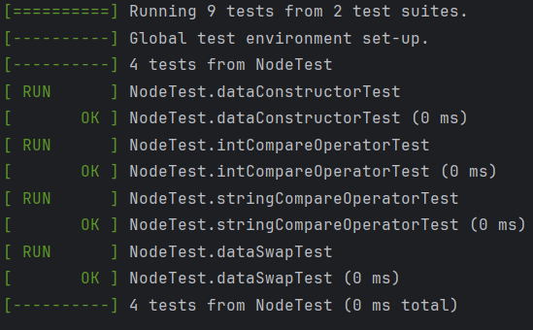
- Результат работы тестов для узла дерева
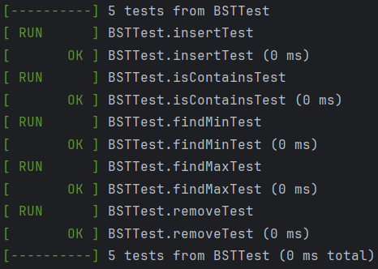
- Результат работы тестов для бинарного дерева поиска
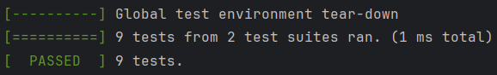
- Сводка по работе всех тестов

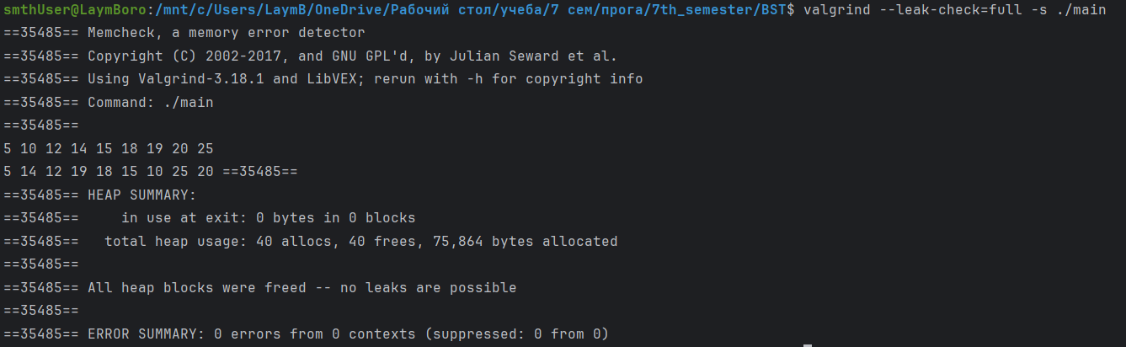
- Анализ памяти с помощью valgrind
- UML диаграмма классов
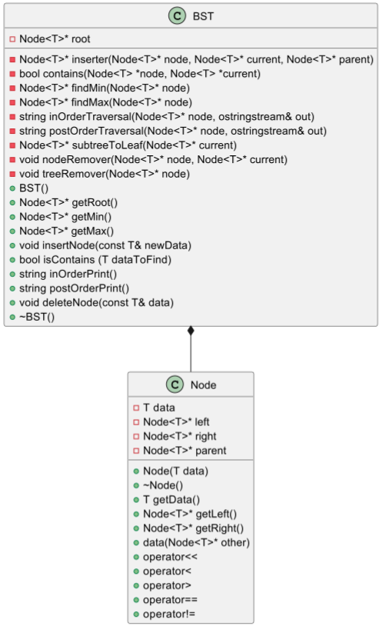
- Uml диаграмма классов

