1. Set JVM parameter: 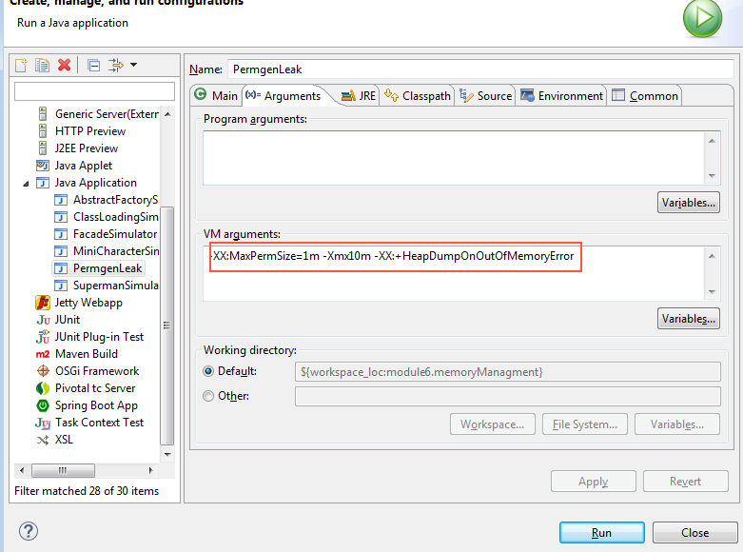
2. Run HeapLeak class from Task3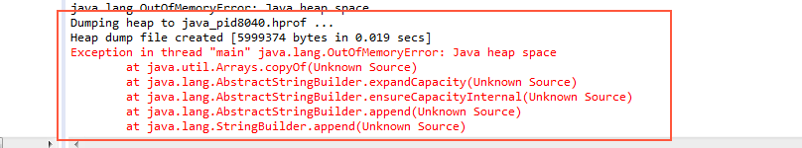
3. Opened created heap dump with memory analyzer tool. It showed the “Leak Suspects” info

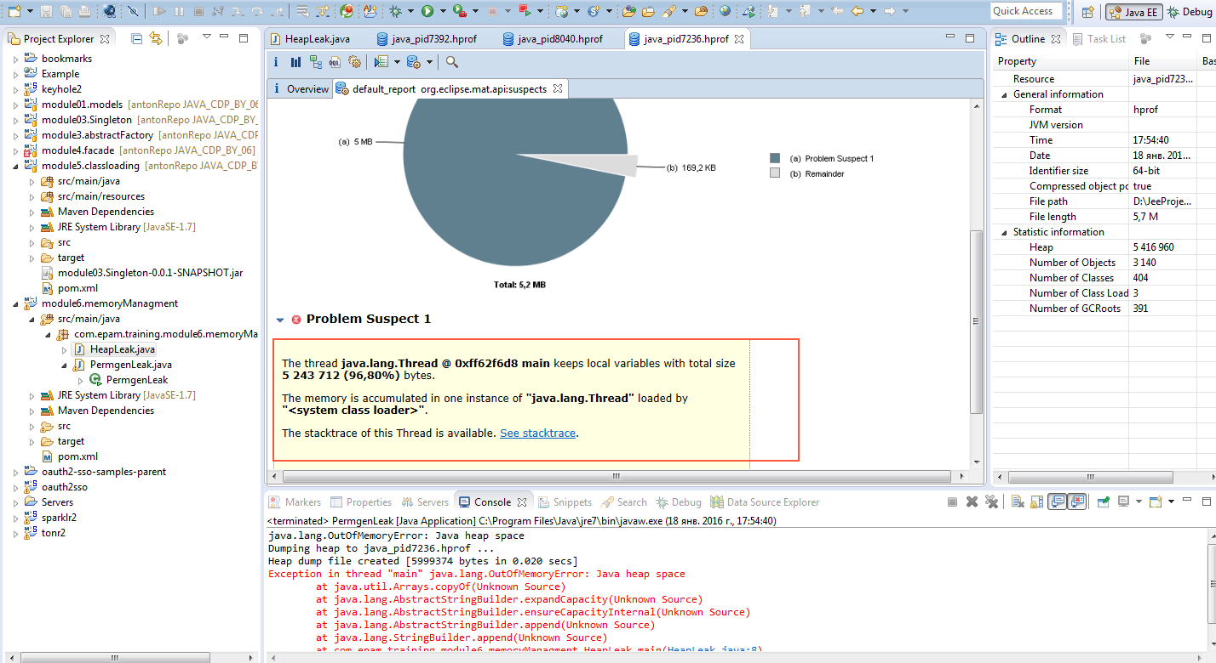

1. There is possibility to see dominator tree where possible see problem with Thread main

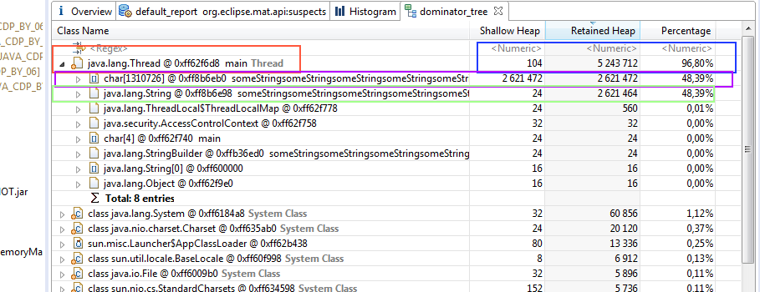

1. Is possible to see how this objects reference to each other

