1. Set VM parameters: 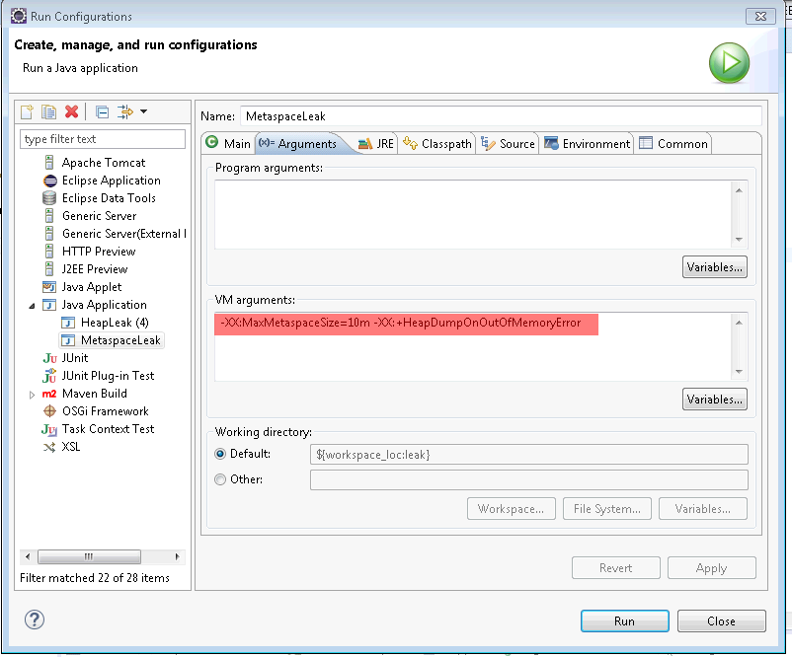
2. Run a PermgenLeak class from Task3 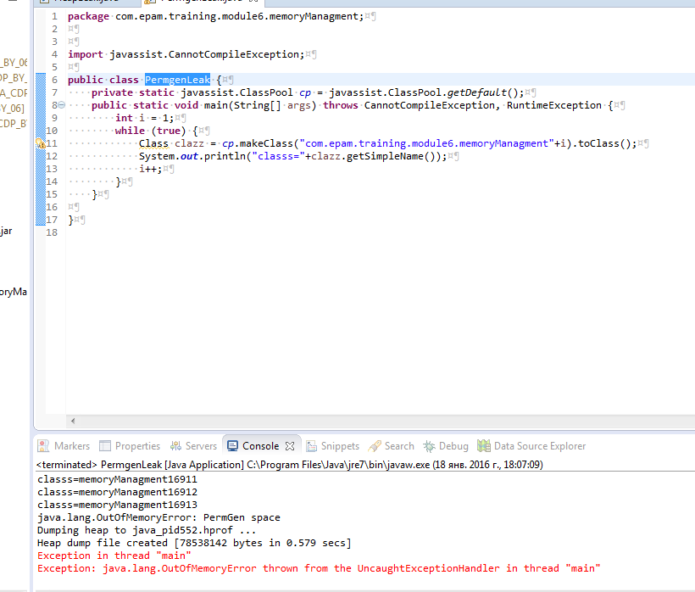
3. Opened the created heap dump with the memory analyzer tool. It showed the “Leak Suspects” info. 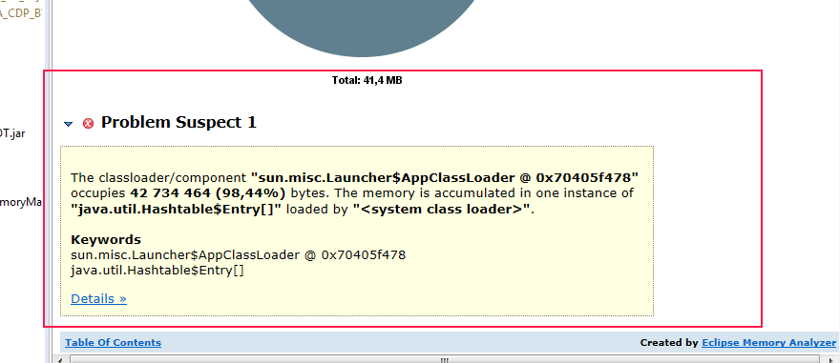
4. See ClassPool details (4. See ClassPool details (This object only storage for Class object))

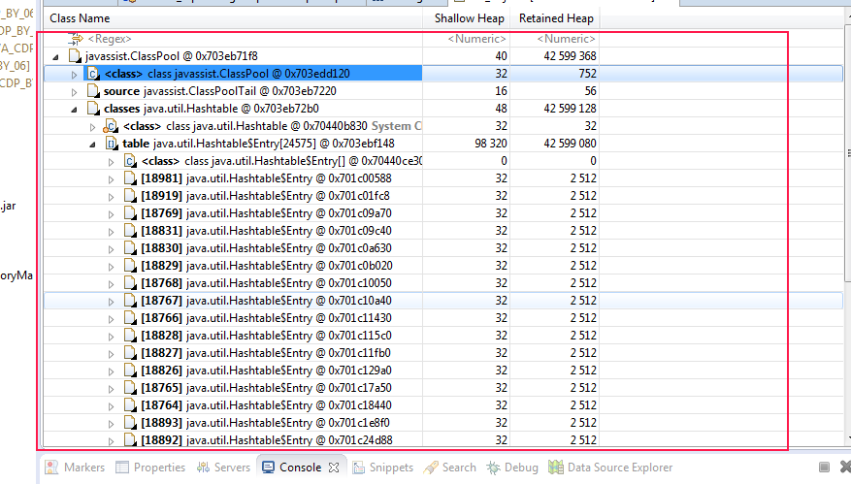

1. The reason of the issue is a large number of created classes.

