**ExcellenTrip**

Disadventages

App, not web

Not at local

**A**

**inspirock**

<https://www.inspirock.com/trip/3-days-in-tel-aviv-itinerary-with-culture-relaxing-romantic-beaches-museums-and-shopping-b3b182c5-ecb1-4ff3-bf35-a0fc0d03c507/itinerary/list>

**Disadvantages**

1. Shows places in different areas, not as asked – wrong city

2. Chooses middle level locations

3. Not flexible

4. One simple route

5. Not adjustable for users history

**Advantages**

TimeLine + Calendar + Maps

**B**

Google Trips

<https://get.google.com/trips/>

Phone application

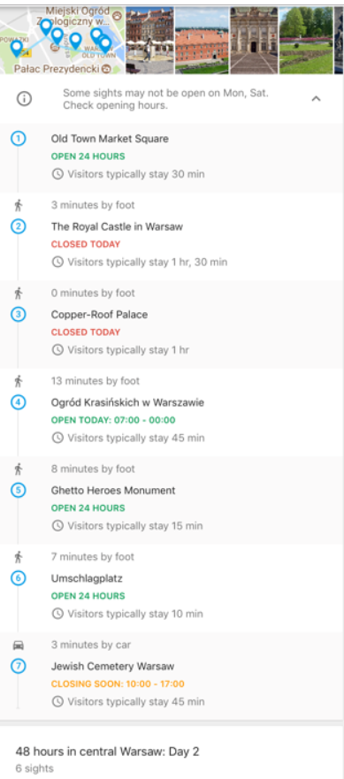

**Find and save places to see in Google Trips**

## Day Plans

One nice feature of Google Trips is the ability to create Day Plans from your saved places. Google jumps ahead and created some suggestions for you. Here’s an example of such a day plan that Google thinks is great for me.

## places and map view

Once I've saved all the things I want to see, I check the map view of saved places. Here Google Trip displays all then lists I've created.

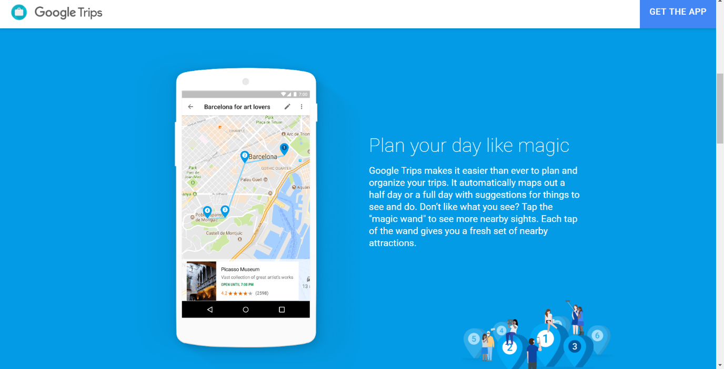

**VisitACity**

<https://www.visitacity.com/en/london/activities/day-trips--excursions?activitiesCategoryId=351>

Disadvantages

Show only paid daily trips

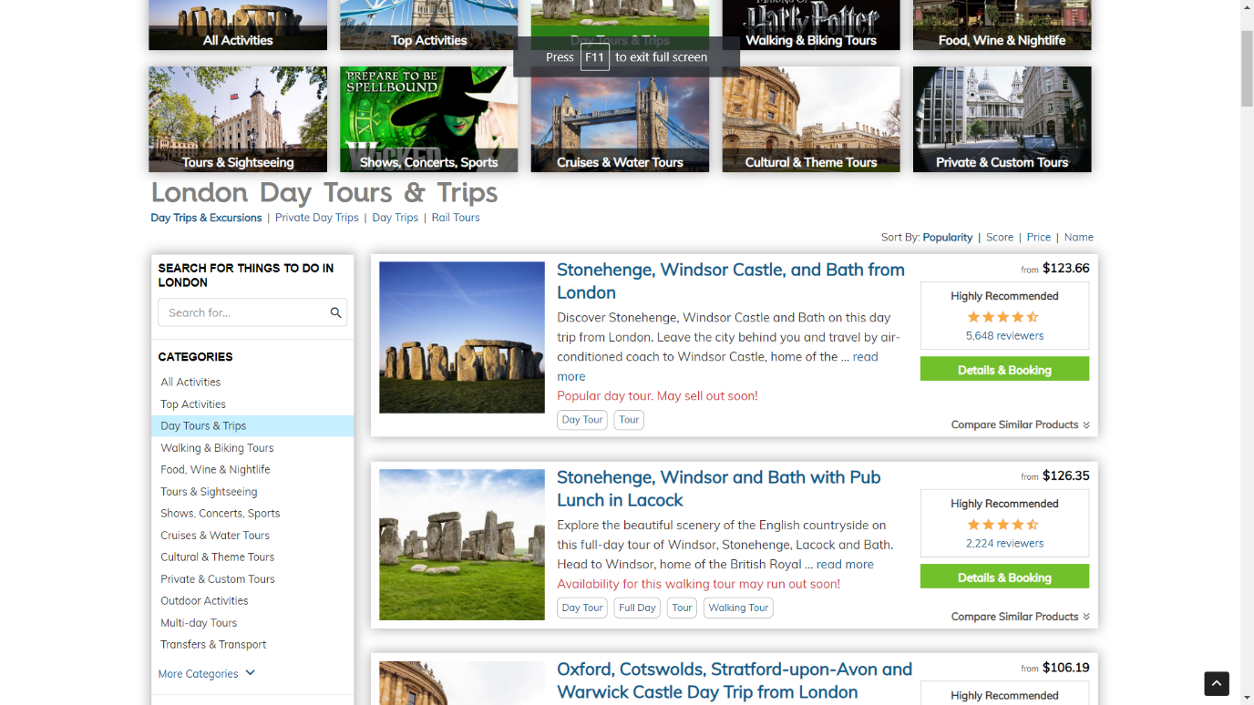

Sygic

<https://maps.sygic.com/#/?map=13,32.081193,34.746323&item=city:370>

advantages

Add place to created trip

Marks all best places

Dis

Paid daily trip only

Not automated

**Travefy**

<https://travefy.com/plan#/trip/2166467/days/day/10994036?i=21694594>

