PostgreSQL Exam Preparation I

Submit your solutions to the SoftUni Judge Contest.

Zoo
As an employee of the local Zoo, you have been given the opportunity to design a management system to track the animals and the people involved in the Zoo. This system will help streamline operations and ensure efficient management of the Zoo's resources.

Section 1. Data Definition Language (DDL) - (30 pts)
You have been provided with the E/R Diagram of the Zoo. This diagram represents the relationships between various entities within the Zoo and serves as a visual representation of the database structure.
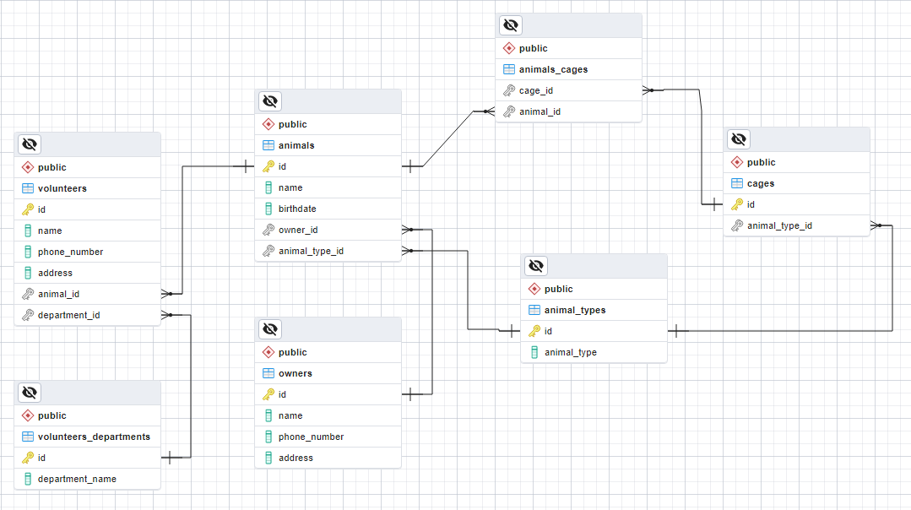
Create a PostgreSQL database named "zoo_db" that consists of seven tables:
- "owners" - stores information about the owners of the animals;
- "animal_types" - hold data about the different types of animals in the zoo;
- "cages" - stores information about the animal cages;
- "animals" - contain information about the animals;
- "volunteers_departments" - hold data about the departments of the volunteers;
- "volunteers" - contain information about the volunteers in the zoo;
- "animals_cages" - serves as a many-to-many mapping table between animals and cages.
NOTE: Please ensure that you use the exact data types specified in the model tables when working with dates. For instance, if a column is of type "DATE," make sure to use the "DATE" type. Similarly, if a column is of type "TIMESTAMP" use the "TIMESTAMP" data type. Failure to use the correct data types may result in the Judge system rejecting your submission as incorrect.
Your first assignment is to create the database tables based on the provided models. Follow the given specifications to create the tables.

owners
Column Name | Data Type | Constraints
id | Integer from 0 to 2,147,483,647 | Primary Key, Unique table identification, Auto-increment
name | String up to 50 symbols | NULL is not allowed
phone_number | String up to 15 symbols | NULL is not allowed
address | String up to 50 symbols | NULL is permitted

animal_types
Column Name | Data Type | Constraints
id | Integer from 0 to 2,147,483,647 | Primary Key, Unique table identification, Auto-increment
animal_type | String up to 30 symbols | NULL is not allowed

cages
Column Name | Data Type | Constraints
id | Integer from 0 to 2,147,483,647 | Primary Key, Unique table identification, Auto-increment
animal_type_id | Integer from 0 to 2,147,483,647 | Relationship with table animal_types, Cascade Operations, NULL is not allowed

animals
Column Name | Data Type | Constraints
id | Integer from 0 to 2,147,483,647 | Primary Key, Unique table identification, Auto-increment
name | String up to 30 symbols | NULL is not allowed
birthdate | DATE | NULL is not allowed
owner_id | Integer from 0 to 2,147,483,647 | Relationship with table owners, Cascade Operations, NULL is permitted
animal_type_id | Integer from 0 to 2,147,483,647 | Relationship with table animal_types, Cascade Operations, NULL is not allowed

volunteers_departments
Column Name | Data Type | Constraints
id | Integer from 0 to 2,147,483,647 | Primary Key, Unique table identification, Auto-increment
department_name | String up to 30 symbols | NULL is not allowed

volunteers
Column Name | Data Type | Constraints
id | Integer from 0 to 2,147,483,647 | Primary Key, Unique table identification, Auto-increment
name | String up to 50 symbols | NULL is not allowed
phone_number | String up to 15 symbols | NULL is not allowed
address | String up to 50 symbols | NULL is permitted
animal_id | Integer from 0 to 2,147,483,647 | Relationship with table animals, Cascade Operations, NULL is permitted
department_id | Integer from 0 to 2,147,483,647 | Relationship with table volunteers_departments, Cascade Operations, NULL is not allowed

animals_cages
Column Name | Data Type | Constraints
cage_id | Integer from 0 to 2,147,483,647 | Relationship with table cages, Cascade Operations, NULL is not allowed
animal_id | Integer from 0 to 2,147,483,647 | Relationship with table animals, Cascade Operations, NULL is not allowed

Database Design
Submit only your CREATE statements for all tables to the Judge.

Section 2. Data Manipulation Language (DML) - (10 pts)
Before beginning, it is necessary to import "dataset.sql". If the structure has been properly created, the data should be inserted successfully.
In this particular situation, various tasks require making changes to the database, including data modifications and the addition of new records.

Insert
Let's insert sample data into the database by writing a query that adds the provided records into their respective tables, with all "id" values generated automatically.

volunteers
name | phone_number | address | animal_id | department_id
Anita Kostova | 0896365412 | Sofia, 5 Rosa str. | 15 | 1
Dimitur Stoev | 0877564223 | NULL | 42 | 4
Kalina Evtimova | 0896321112 | Silistra, 21 Breza str. | 9 | 7
Stoyan Tomov | 0898564100 | Montana, 1 Bor str. | 18 | 8
Boryana Mileva | 0888112233 | NULL | 31 | 5

animals
name | birthdate | owner_id | animal_type_id
Giraffe | 2018-09-21 | 21 | 1
Harpy Eagle | 2015-04-17 | 15 | 3
Hamadryas Baboon | 2017-11-02 | NULL | 1
Tuatara | 2021-06-30 | 2 | 4

Update
Kaloqn Stoqnov, an existing owner in the database, visited the zoo to adopt all animals that currently do not have an owner assigned to them. Please update the records by correctly assigning the "owner_id" to these animals.

Example
Before update
id | name | birthdate | owner_id | animal_type_id
1 | Brown bear | 2017-07-17 | 3 | 1
2 | Chimpanzee | 2010-01-21 | 6 | 1
… | … | … | … | …
11 | Hippo | 2017-09-07 | [null] | 1
12 | Koala | 2018-06-30 | 24 | 1
… | … | … | … | …
14 | Banded Archer Fish | 2022-01-15 | [null] | 2
15 | Cichlid | 2021-01-21 | 5 | 2
16 | Koi | 2021-07-05 | [null] | 2
… | … | … | … | …
20 | Saddlebill Stork | 2019-08-21 | [null] | 3
… | … | … | … | …
44 | Desert Hairy Scorpion | 2020-05-13 | [null] | 6
… | … | … | … | …
50 | Tuatara | 2021-06-30 | 2 | 4

After update
id | name | birthdate | owner_id | animal_type_id
1 | Brown bear | 2017-07-17 | 3 | 1
2 | Chimpanzee | 2010-01-21 | 6 | 1
… | … | … | … | …
11 | Hippo | 2017-09-07 | 4 | 1
12 | Koala | 2018-06-30 | 24 | 1
… | … | … | … | …
14 | Banded Archer Fish | 2022-01-15 | 4 | 2
15 | Cichlid | 2021-01-21 | 5 | 2
16 | Koi | 2021-07-05 | 4 | 2
… | … | … | … | …
20 | Saddlebill Stork | 2019-08-21 | 4 | 3
… | … | … | … | …
44 | Desert Hairy Scorpion | 2020-05-13 | 4 | 6
… | … | … | … | …
50 | Tuatara | 2021-06-30 | 2 | 4

Delete
The Zoo has decided to close down the 'Education program assistant' department. Your task is to remove this department from the database. Please note that there might be foreign key constraint conflicts that need to be considered during the deletion process.

Example
Before delete
id | name | phone_number | address | animal_id | department_id
1 | Kiril Kostadinov | 0896541233 | Sofia , 213 Tsarigradsko shose str. | 7 | 2
2 | Boyan Boyanov | 0896321546 | Plovdiv, 15 Arda str. | 14 | 1
3 | Mariya Petkova | 0874563201 | Kalofer, 2 Tsar Simeon str. | 4 | 3
… | … | … | … | … | …
6 | Anton Antonov | 0877456123 | Varna, 2 Dobrotitsa str. | 11 | 3
7 | Yanko Totev | 0896369258 | Sofia, 54 Hristo Botev str. | 1 | 2
8 | Katerina Dimitrova | 0874589665 | [null] | 5 | 6
… | … | … | … | … | …
29 | Boryana Mileva | 0888112233 | [null] | 31 | 5

id | department_name
1 | Guest engagement
2 | Education program assistant
3 | Zoo events
… | …

After delete
id | name | phone_number | address | animal_id | department_id
2 | Boyan Boyanov | 0896321546 | Plovdiv, 15 Arda str. | 14 | 1
3 | Mariya Petkova | 0874563201 | Kalofer, 2 Tsar Simeon str. | 4 | 3
… | … | … | … | … | …
6 | Anton Antonov | 0877456123 | Varna, 2 Dobrotitsa str. | 11 | 3
8 | Katerina Dimitrova | 0874589665 | [null] | 5 | 6
… | … | … | … | … | …
29 | Boryana Mileva | 0888112233 | [null] | 31 | 5

id | department_name
1 | Guest engagement
3 | Zoo events
… | …

Section 3. Querying - (40 pts)
In the upcoming assignment, the Zoo management has requested you to retrieve specific data. It is crucial to mention that the sample results provided are based on a fresh database. To ensure a clean dataset, you need to recreate the database and import the sample data again using the provided "dataset.sql" file. It is important not to make any modifications or include any data from the INSERT, UPDATE, and DELETE tasks.

Volunteers
Retrieve details about all the "volunteers", including their "name", "phone_number", "address", the animal they are responsible for ("animal_id"), and the department they are involved in ("department_id"). Sort the results by the volunteer's "name" in ascending order. If a volunteer is responsible for multiple animals, the results should be further sorted by the "animal_id" in ascending order. Additionally, sort the results by the "department_id" in ascending order.

Example
name | phone_number | address | animal_id | department_id
Anton Antonov | 0877456123 | Varna, 2 Dobrotitsa str. | 11 | 3
Boyan Boyanov | 0896321546 | Plovdiv, 15 Arda str. | 14 | 1
Darina Petrova | 0889654236 | Sofia, 39 Bratya Buxton str. | 31 | 3
Dilyana Stoeva | 0889412025 | Sofia, 15 Lyulyak str. | [null] | 2
… | … | … | … | …
Zdravko Asenov | 0889652365 | Sofia, 6 Neven str. | 19 | 2

Animals Data
The goal of this task is to retrieve a list of all animals and their corresponding types. Extract the "name" of the animal, "animal_type", and the "birthdate" formatted as 'DD.MM.YYYY'. Sort the results in ascending order based on the animal's "name".

Example
name | animal_type | birthdate
African Penguin | Birds | 17.07.2017
African Spurred Tortoise | Reptiles | 26.09.2009
American Kestrel | Birds | 27.04.2019
… | … | …
Bald Eagle | Birds | 29.06.2014
… | … | …
California Condor | Birds | 19.12.2014
… | … | …
Woma Python | Reptiles | 26.04.2019

Owners and Their Animals
Write an SQL query that retrieves the animals for each owner. Find the top 5 owners who have the highest count of animals. Select the owner's "name" and the "count_of_animals" they own. Order the result by the count of animals owned in descending order. If there are multiple owners with the same count of animals, order them by the owner's "name" in ascending order.

Example
owner | count_of_animals
Kaloqn Stoqnov | 4
Kiril Peshev | 4
Kamelia Yancheva | 3
Martin Genchev | 3
Metodi Dimitrov | 3

Owners, Animals and Cages
As part of your responsibilities, you are required to retrieve information about the owners of 'Mammals', including the name of their animal and the cage in which these animals are located. The query should select the owner's "name" and the animal's "name" in the format "owner - animal", along with the owner's "phone_number" and the cage "id". The results should be ordered by the "name" of the owner in ascending order. If an owner has more than one animal, the results should be ordered by their animal`s "name" in descending order.

Example
owners - animals | phone_number | cage_id
Anelia Mihova - Koala | 0897856147 | 16
Borislava Kamenova - Fennec Fox | 0877477112 | 21
Gergana Mancheva - Brown bear | 0897412123 | 26
Kaloqn Stoqnov - Leopard | 0878325642 | 32
Kaloqn Stoqnov - Elephant | 0878325642 | 37
… | … | …
Petya Dobreva - Giant Panda | 0874547896 | 27

Volunteers in Sofia
Create a SQL query that retrieves information about the "volunteers" who are involved in the 'Education program assistant' department and live in Sofia. The query should select their "name", "phone_number", and "address" in Sofia (excluding the city's name). The results should be ordered by the "name" of the volunteers in ascending order.

Example
volunteers | phone_number | address
Dilyana Stoeva | 0889412025 | 15 Lyulyak str.
Kiril Kostadinov | 0896541233 | 213 Tsarigradsko shose str.
Yanko Totev | 0896369258 | 54 Hristo Botev str.
Zdravko Asenov | 0889652365 | 6 Neven str.

Animals for Adoption
Retrieve all animals that are not owned, and are younger than 5 years (as of '01/01/2022'), excluding Birds. Select their "name", year of birth, and "animal_type". Order the results by the "name" of the animal in ascending order.

Example
animal | birth_year | animal_type
Banded Archer Fish | 2022 | Fish
Chameleon | 2018 | Reptiles
Desert Hairy Scorpion | 2020 | Invertebrates
Goliath Frog | 2020 | Amphibians
Hippo | 2017 | Mammals
Koi | 2021 | Fish
Poison Frog | 2020 | Amphibians

Section 4. Programmability - (20 pts)

All Volunteers in a Department
Your task is to create a user-defined function called fn_get_volunteers_count_from_department(). This function should accept a parameter named "searched_volunteers_department" with a maximum length of 30, which represents a specific department. The function should return the count of volunteers who are involved in that department.
For this task, please only submit your user-defined function in the Judge system.

Examples
Query | Output
SELECT fn_get_volunteers_count_from_department('Education program assistant') | 6
SELECT fn_get_volunteers_count_from_department('Guest engagement') | 4
SELECT fn_get_volunteers_count_from_department('Zoo events') | 5

12. Animals with Owner or Not
To address the task, you should create a stored procedure named sp_animals_with_owners_or_not(). This procedure accepts a parameter called "animal_name" of type VARCHAR(30) and retrieves the name of the owner associated with the specified animal. If the animal does not have an owner, the procedure will return the value 'For adoption'.
For this task, please only submit your stored procedure in the Judge system.

Example
Query | Output
CALL sp_animals_with_owners_or_not('Pumpkinseed Sunfish') | Kamelia Yancheva
CALL sp_animals_with_owners_or_not('Hippo') | For adoption
CALL sp_animals_with_owners_or_not('Brown bear') | Gergana Mancheva

