Peer-to-peer network

Peer-to-peer network is when multiple computers are connected together with a universal serial bus and share resources between each other without a server. 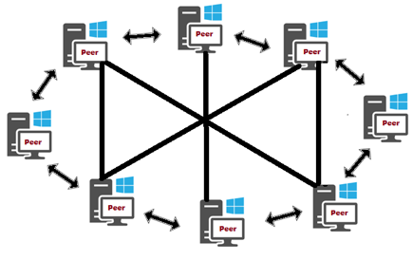

It is very simple to set up a peer-to-peer network and not a lot of knowledge is needed for that which means that it is also quicker to set it up. If it requires a third party, it still will be cheaper than a client server network.

Peer-to-peer doesn’t have any redundancy features which means that failures can result in the network’s downtime and the increased possibility of data loss and file corruption.

The peer-to-peer network is not scalable because both connections are connected to the system and, therefore, no more systems can be connected to the network because no more ports are available.

The data sharing across the connected devices within the network using the peer-to-peer network is less secure than in client server network because it doesn’t implement any security which helps both systems to access directories of each other.

The peer-to-peer network has a lower level of security than a client server network because everyone who is connected to it can access all resources on the computers in the network but user permissions can be set on the network which is unpopular but makes it secure.

In the peer-to-peer network no product licencing is needed because the installed operating system on the computer already includes the client software which results in network being much cheaper than the client server network.

Peer-to-peer network is more basic than client server network and, therefore, its cost is lower because it has only two computer systems and one ethernet cable.

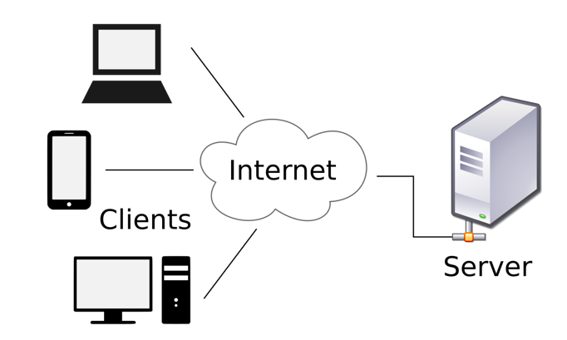Client server network

Client server network is a computer network

where the main computer (the server) acts as a

hub to which all clients and their individual PCs

are connected. They can access data and run programs on the server. Servers are located in closed rooms or special server rooms where the business keeps all of its important information

which the company’s operators don’t always

need to access. The rest of the computers on the

network is the clients.

In the client server network, the expertise who has skills should set it up and usually they also require one more staff or a third party. It requires more time and costs more money because it is more secure and has more complicate dynamic or static routing tables.

The redundancy features of the client server network give an opportunity to duplicate power supplies and to hot swap redundant servers and drive arrays because commonly the backups are used to prevent the network’s downtime in case of a failure.

The client server network is much more scalable because it can be extended by unplugging one of the connections from the switch’s port and plugging a RJ45 crossover ethernet cable there and into another switch to extend the network further.

The client server network can share data between the network’s servers and devices in the same way as peer-to-peer network but transfers information and data more securely.

The client server has a higher security level because of setting the different permissions which gives users an opportunity to access the network without accessing other computer systems. The access levels can depend on the user.

The cost of the client server network is increased because of the software and you need to pay the licencing fees for it for each user in the network and the server operating system (MDS) itself which results in this network being much more expensive.

The software and hardware in the client server network is more expensive than in peer-to-peer network because it uses the router, switches, computer systems, server and cables which all adds up to its cost, making it more expensive than peer-to-peer network.