Design Example Report

Title | XXXXX
Specification | Input: XXX VAC – XXX VAC  Output: XX V / XX A
Application | XXXXX
Product family | XXXXX
Document No. | DER-XXXX
Date | XX/XXXX
Revision | XXXXX

Summary and Features
- XXXX

PATENT INFORMATION
The products and applications illustrated herein (including transformer construction and circuits external to the products) may be covered by one or more U.S. and foreign patents, or potentially by pending U.S. and foreign patent applications assigned to Power Integrations. A complete list of Power Integrations' patents may be found at www.power.com. Power Integrations grants its customers a license under certain patent rights as set forth at https://www.power.com/company/intellectual-property-licensing/.
Table of Contents
1 Introduction 3
2 Power Supply Specification 4
3 Schematic 5
4 Circuit Description 7
4.1 Key Circuit Features 7
5 PCB Layout 8
6 Bill of Materials 9
7 Flyback Transformer Design Spreadsheet 10
8 Flyback Transformer Specification 11
8.1 Electrical Connection Diagram 11
8.2 Electrical Specifications 11
8.3 Materials 11
8.4 Transformer Build Diagram 12
8.5 Winding Information 12
9 Performance Data 13
10 Waveforms 13
11 Constant Voltage PWM Dimming 13
11.1 PWM Dimming Waveforms 14
12 Conducted EMI 14
12.1 Test Set-up 14
12.2 Floating Output-Load Resistor 14
13 Line Surge 16
13.1 Combination Wave Differential Mode Test 16
13.2 Ring Wave Surge 16
14 Electrostatic Discharge Test (ESD) 16
14.1 Air Discharge 16
15 Revision History 17

Important Note:
Although this board is designed to satisfy safety isolation requirements, the engineering prototype has not been agency approved. Therefore, all testing should be performed using an isolation transformer to provide the AC input to the prototype board.

Introduction

Power Supply Specification
The table below represents the minimum acceptable performance of the design. Actual performance is listed in the results section.

Description | Symbol | Min. | Typical | Max. | Units | Comment
Input  Voltage | V_{IN}
Low Voltage Withstand | V_{IN}
Frequency | f_{LINE}

Schematic

Circuit Description

Key Circuit Features

PCB Layout

Bill of Materials
Electrical Components
Item | Qty | Ref  Des | Description | Manufacturer Part Number | Manufacturer

Miscellaneous Parts
Item | Qty | Ref  Des | Description | Manufacturer Part Number | Manufacturer

Flyback Transformer Design Spreadsheet
1 |  | INPUT | INFO | OUTPUT | UNITS

Flyback Transformer Specification

Electrical Connection Diagram

Electrical Specifications
Parameter | Condition | Specification

Materials
Item | Description

Transformer Build Diagram

Winding Information

Performance Data

Waveforms

Constant Voltage PWM Dimming

PWM Dimming

Conducted EMI

Test Set-up

Floating Output-Load Resistor

Line Surge

Combination Wave Differential Mode Test
Pass criterion is no output interruption.
AC Input Voltage  (VAC) | Surge Voltage  (kV) | Phase Angle  (º) | Generator Impedance  () | Number of Strikes | Test Result

Ring Wave Surge
ESD was tested at 24V output. Pass criterion: no permanent interruption of output.
AC Input Voltage  (VAC) | Surge Voltage  (kV) | Phase Angle  (º) | Generator Impedance  () | Number of Strikes | Test Result

Electrostatic Discharge Test (ESD)

Air Discharge
AC Input Voltage  (VAC) | Discharge Voltage  (kV) | Discharge Point | Number of Strikes | Test Result

Revision History
Date | Author | Revision | Description & Changes | Reviewed By

Bill of Materials
Item | Quantity | Designator | Value | Description | Manufacturer Part Number | Manufacturer
1 | 2 | C1  C2 | 6.8 µF | 6.8 µF, 400 V, High Voltage Al Electrolytic, (16 mm x 10 mm) | EKXG401ELL6R8MJ16S | United Chemi-Con
2 | 1 | C3 | 10 µF | 10 µF, 16 V, Ceramic, X7R | C1206C106K4RACTU | Kemet
3 | 1 | C4 | 0.068 nF | 0.068 nF, 250 VAC, Ceramic, Y Class | 2211JA250680KCRSP | Knowles Syfer
4 | 1 | C5 | 560 pF | 560 pF, 100 V, Ceramic, C0G | 08051A561JAT2A | AVX Corp
5 | 1 | C6 | 1500 µF | 1500 µF, 10.0 V, Electrolytic, Super Low ESR, 22 mΩ, (25 mm x 10 mm) | EKZE100ELL152MJ25S | United Chemi-Con
6 | 1 | C7 | 100 µF | 100 µF, 10.0 V, Electrolytic, Low ESR, 500 mΩ, (3.5 mm x 2.8 mm) | T495B107M010ATE500 | Kemet
7 | 4 | D1  D2  D3  D4 | CRG05  (TE85L,Q,M) | 800 V, 1 A, Standard Recovery, TO-220-3F | CRG05(TE85L,Q,M) | Toshiba
8 | 1 | D5 | RS07K-GS08 | 800 V, 1.4 A, Fast Recovery, 300 ns, DO-219AB | RS07K-GS08 | Vishay
9 | 1 | D6 | DFLS240-7 | 40 V, 2 A, Schottky, POWERDI123 | DFLS240-7 | Diodes Inc.
10 | 2 | L1  L2 | 1 mH | 1 mH, 0.33 A | B82464A4105K000 | Bourns Inc.
11 | 1 | L3 | 3.3 µH | 3.3 µH, 2.6 A | LQH66SN3R3M03L | Murata
12 | 1 | R1 | 4.7 kΩ | 4.7 kΩ, 5 %, 0.25 W, Thick Film |  | Generic
13 | 2 | R2  R3 | 1.96 MΩ | 1.96 MΩ, 1 %, 0.25 W, Thick Film |  | Generic
14 | 1 | R4 | 18 Ω | 18 Ω, 5 %, 0.25 W, Thick Film |  | Generic
15 | 1 | R5 | 100 Ω | 100 Ω, 5 %, 0.125 W, Thick Film |  | Generic
16 | 1 | RF1 | 10 Ω | 10 Ω, 2 W, Flameproof Wire-Wound Resistor | FW20A10R0JA | Bourns Inc.
17 | 1 | T1 | EPC17 (PC95EPC17-Z) | 3F3 Core Material_x000D_  Refer to ManµFacturer datasheet for a number of parts to purchase | PC95EPC17-Z | TDK
18 | 1 | T1 Bobbin | EPC17 - 1 (P5-S5) | Bobbin Material : Phenolic | EPC17/8/6 5+5 | Guanzhou Tongyang Electronics
19 | 1 | U1 | TNY275PN | TinySwitch-III, TNY275PN, DIP-8 | TNY275PN | Power Integrations
20 | 1 | U2 | FOD817A3SD | Optocoupler FOD817A3SD , 70 V, CTR 80 - 160 %, 4-SMD | FOD817A3SD | ON Semiconductor
21 | 1 | VR1 | P6SMB160A-E3/52 | 160 V, 5 W, 5 %, DO-214AA, TVS | P6SMB160A-E3/52 | Vishay
22 | 1 | VR2 | BZT55B3V9-GS08 | 3.9 V, 500 mW, 2 %, SOD-80, General Purpose | BZT55B3V9-GS08 | Vishay
23 | 1 |  |  | 52 mm² area on Copper PCB. 2 oz (70 µm) thickness. Heatsink for use with Device U1. |  | Custom
24 | 1 |  |  | 52 mm² area on Copper PCB. 2 oz (70 µm) thickness. Heatsink for use with Rectifier D6. |  | Custom

Load Transient Response
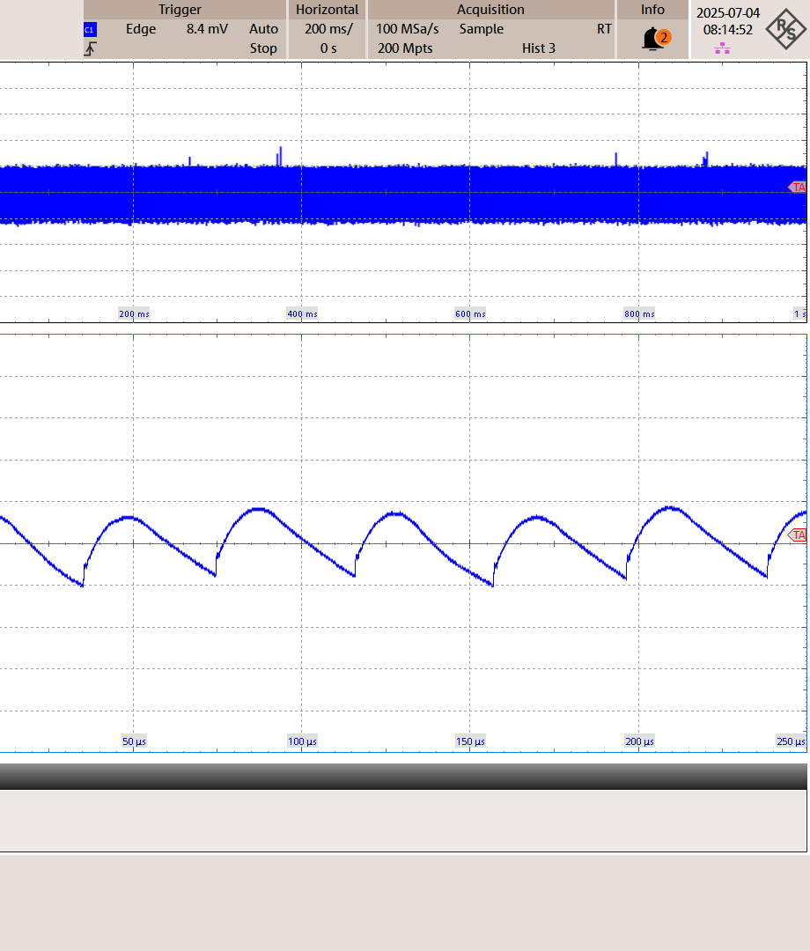  Figure – adasdasd  asd  asd  ads | 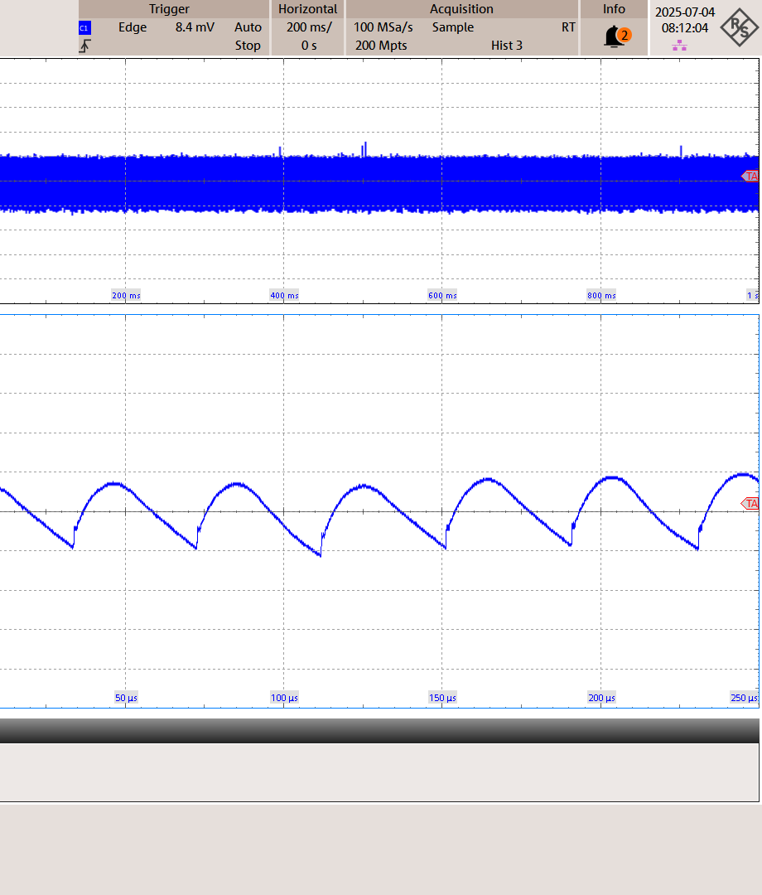  Figure – Load transient 90 VAC, 5 V, 2.4 A
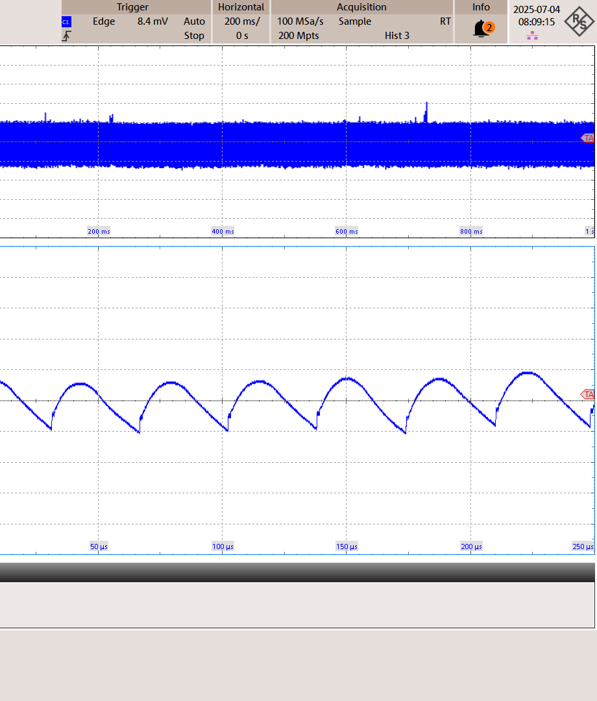  Figure – Load transient 90 VAC, 5 V, 2.7 A | 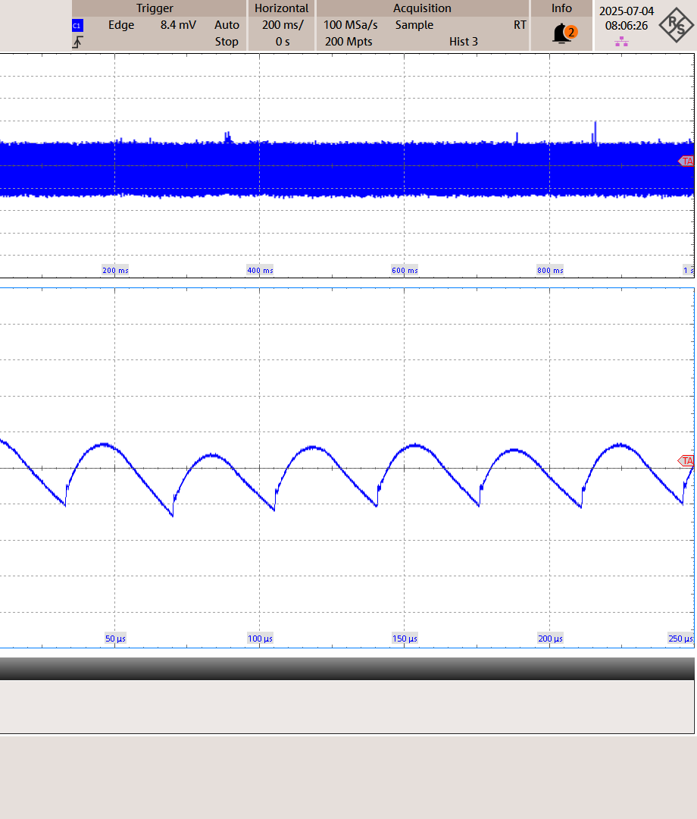  Figure – Load transient 90 VAC, 5 V, 3 A
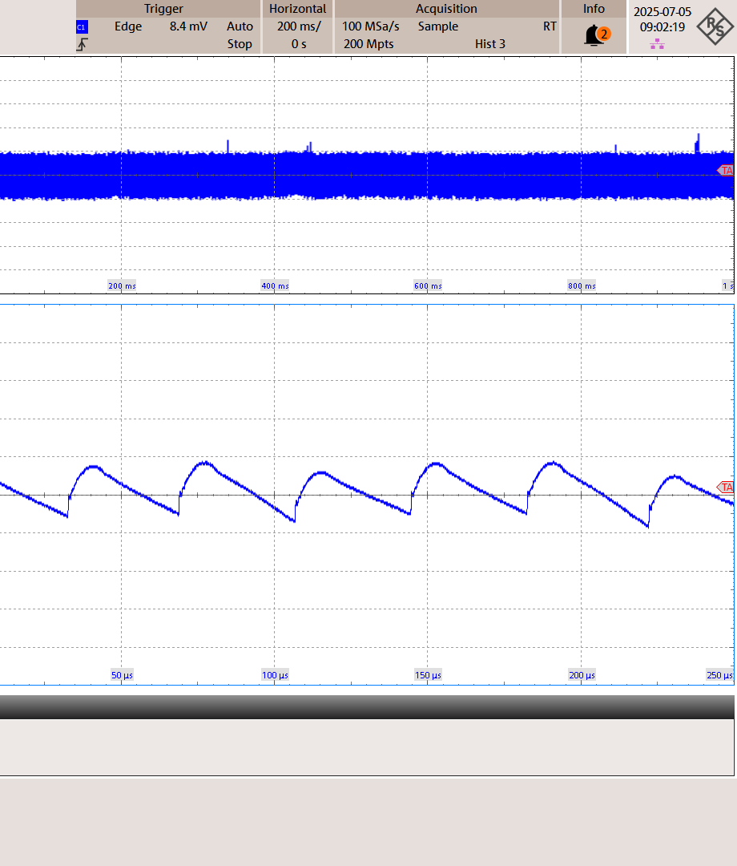  Figure – Load transient 90 VAC, 9 V, 1.5 A | 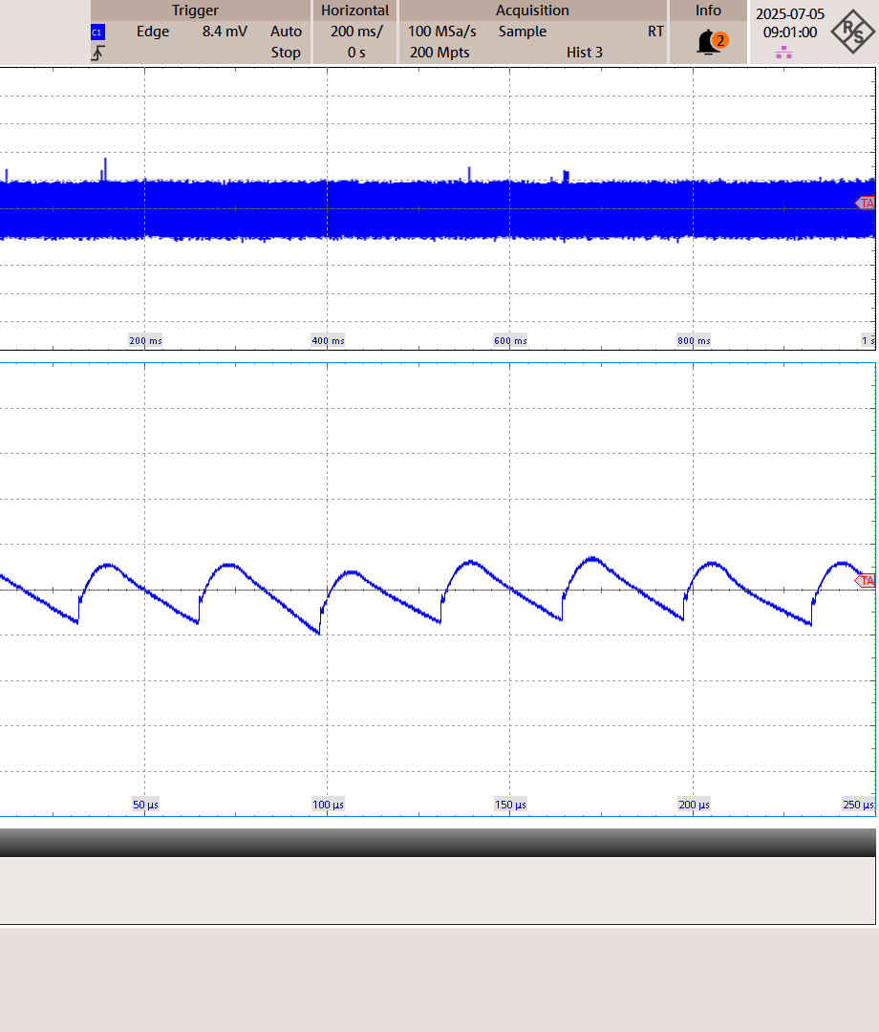  Figure – Load transient 90 VAC, 9 V, 1.8 A
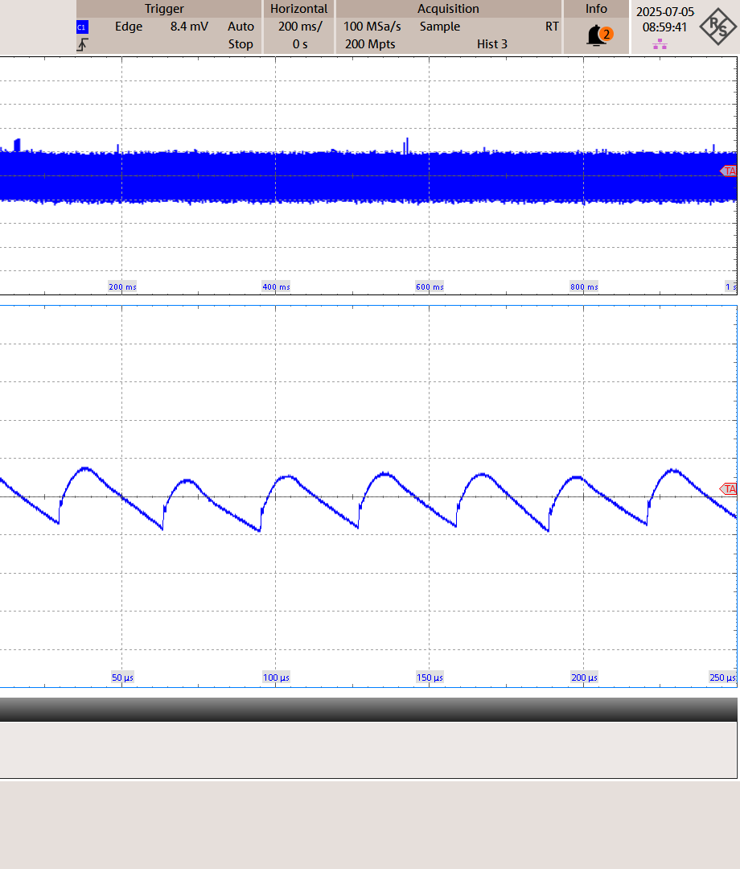  Figure – Load transient 90 VAC, 9 V, 2.1 A |   Figure – Load transient_90 VAC_5 V_2.1 A
  Figure – Load transient_90 VAC_5 V_2.4 A |   Figure – Load transient_90 VAC_5 V_2.7 A
  Figure – Load transient_90 VAC_5 V_3 A |   Figure – Load transient_90 VAC_9 V_1.5 A
  Figure – Load transient_90 VAC_9 V_1.8 A |   Figure – Load transient_90 VAC_9 V_2.1 A

Output Ripple Measurements
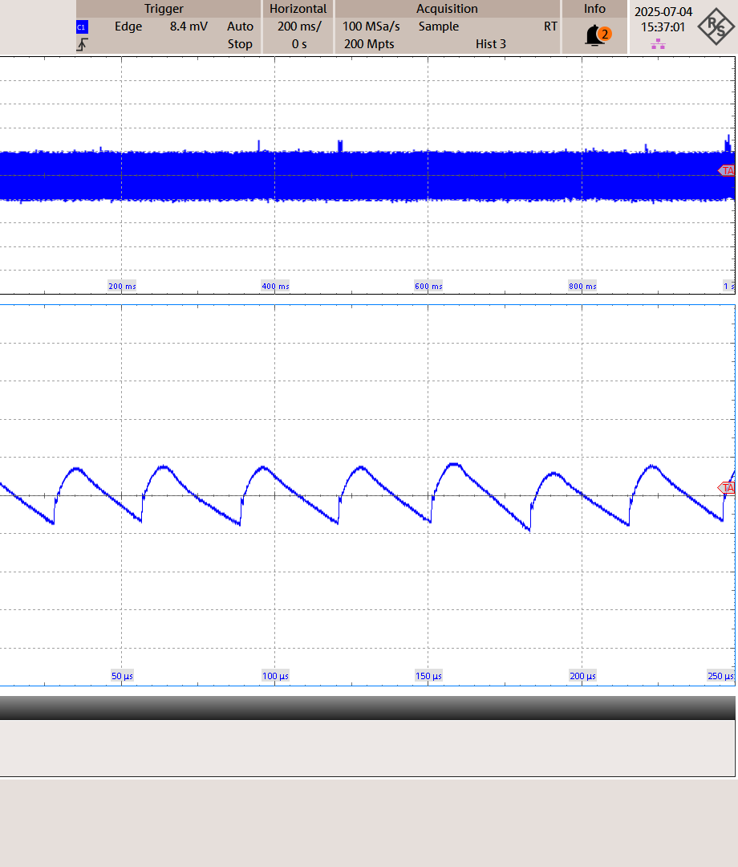  Figure – Output ripple 265 VAC, 12 V, 2.1 A | 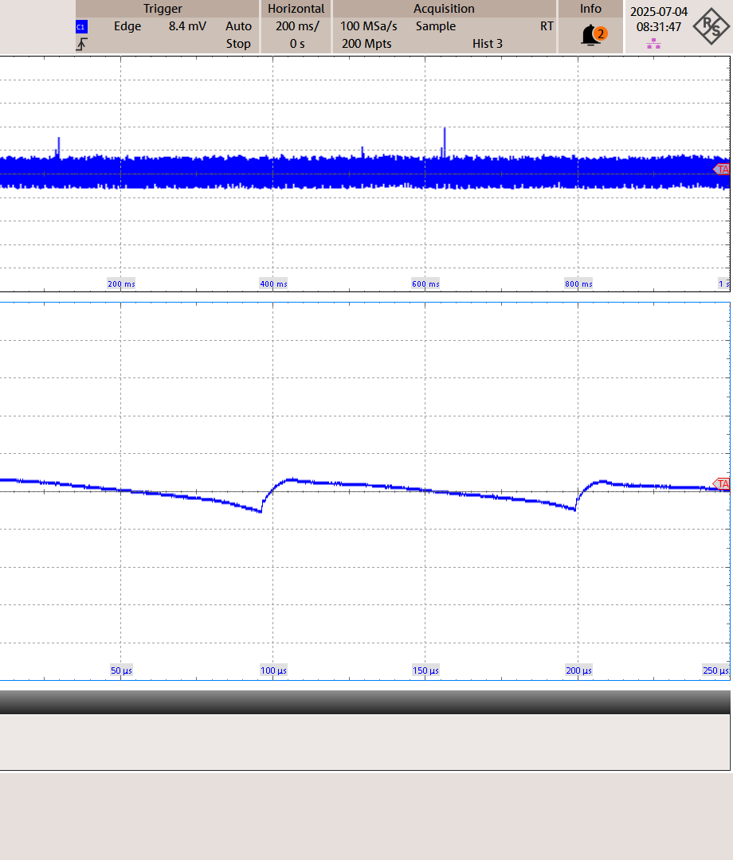  Figure – Output ripple 90 VAC, 5 V, 0.3 A
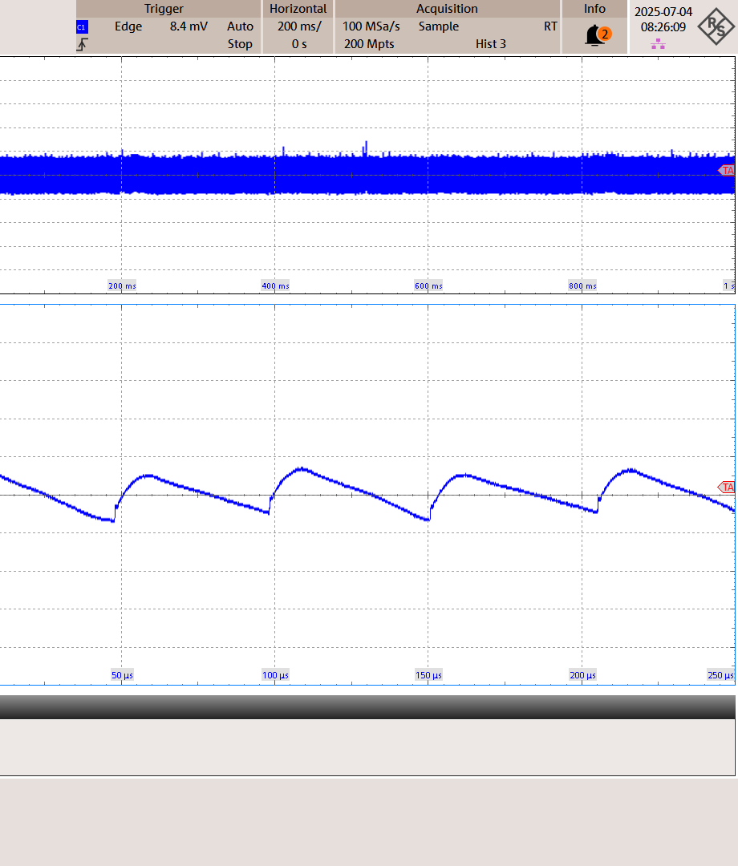  Figure – Output ripple 90 VAC, 5 V, 0.9 A | 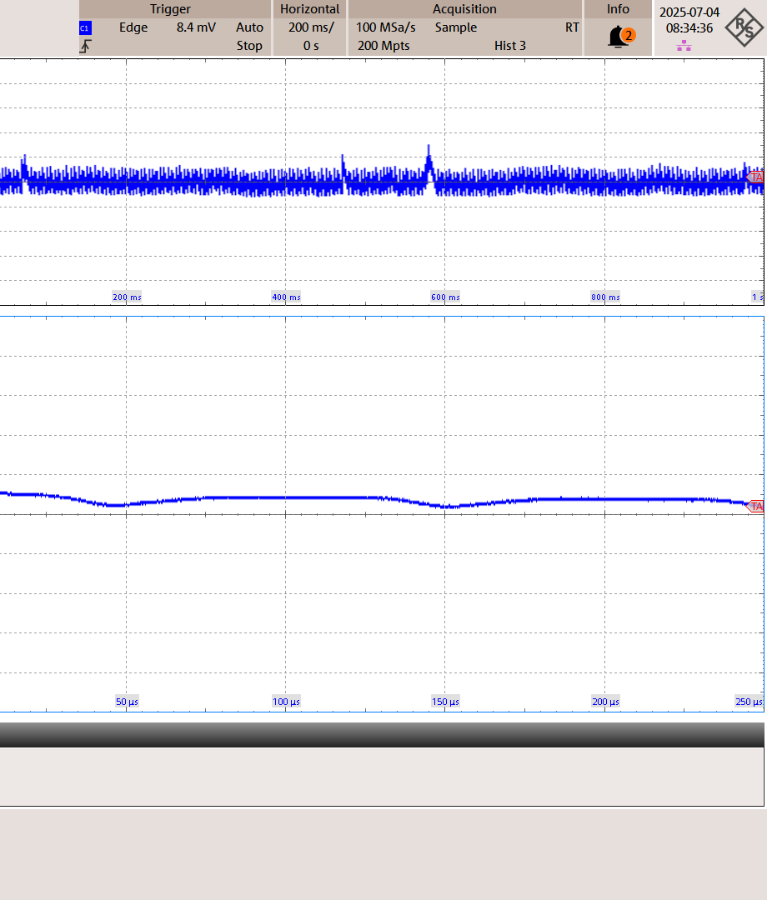  Figure – Output ripple 90 VAC, 5 V, 0 A
  Figure – Output ripple_265 VAC_12 V_2.1 A |   Figure – Output ripple_90 VAC_5 V_0.3 A
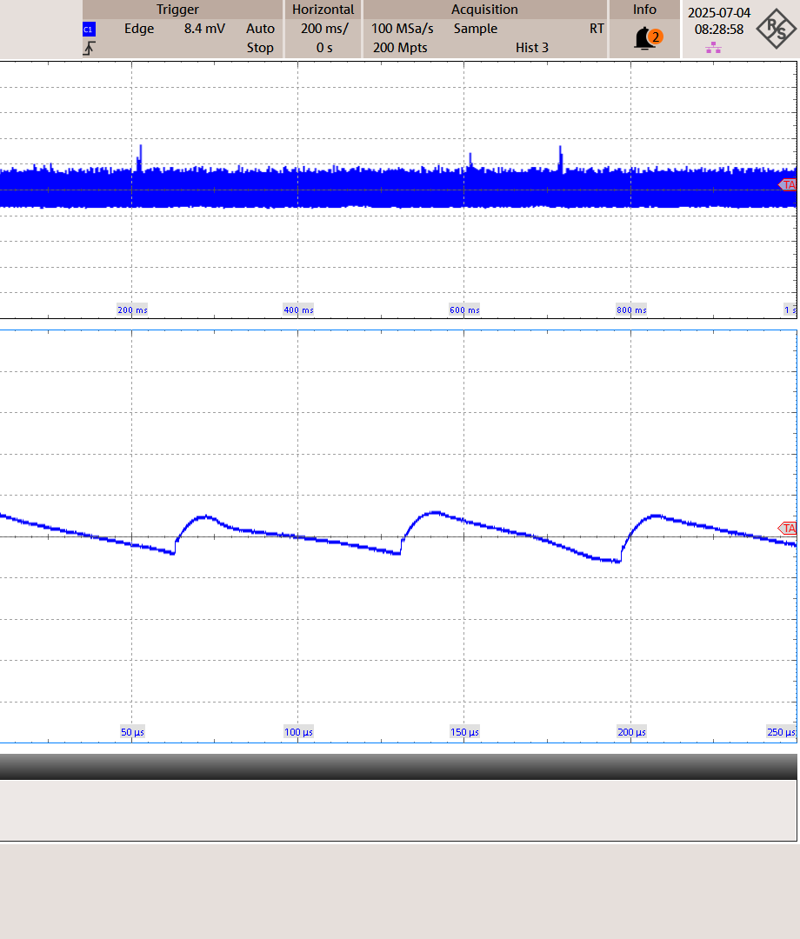  Figure – Output ripple_90 VAC_5 V_0.6 A |   Figure – Output ripple_90 VAC_5 V_0.9 A

Figure – Output ripple_90 VAC_5 V_0 A

