Item Kafka Producer / Consumer / Flink POC
System Architecture Document
End-to-end data flow: MS SQL Server → REST API → Apache Kafka → Apache Flink → MySQL
Repository: ConfluentCloud_Kafka-Producer-Consumer-POC
Package namespace: com.antontech.itemkafka_poc
Generated: August 2026

Architecture
End-to-end view of how data moves through this proof-of-concept application, from the source Item table through Apache Kafka and Apache Flink to the MySQL sink table, plus how the REST layer ties it all together. This document expands on the project's ARCHITECTURE.md with full-resolution rendered diagrams suitable for presentations, interviews, and offline reading.

1. High-Level Component Diagram
The diagram below shows every major building block in the system: the source and sink databases, the Spring Boot REST layer (producer, consumer, gateway and Flink control-plane controllers), the three Apache Flink jobs, the shared Kafka topic, and the downstream gateway used for the JWT/mTLS demonstration flow.
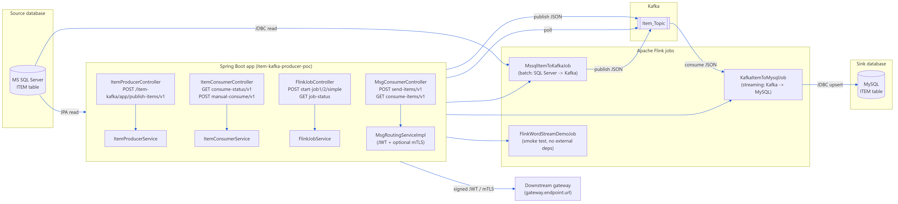
Figure 1 – High-level component diagram of the full system

2. End-to-End Sequence: Flink Pipeline (the "real" replication path)
This is the production-style replication pipeline. Job 1 performs a one-shot batch read from SQL Server and publishes the rows to Kafka as JSON. Job 2 is an unbounded streaming job that continuously reads from the same Kafka topic and upserts every record into MySQL using a batched JDBC sink. Both jobs are triggered on demand through FlinkJobController and tracked via FlinkJobService.
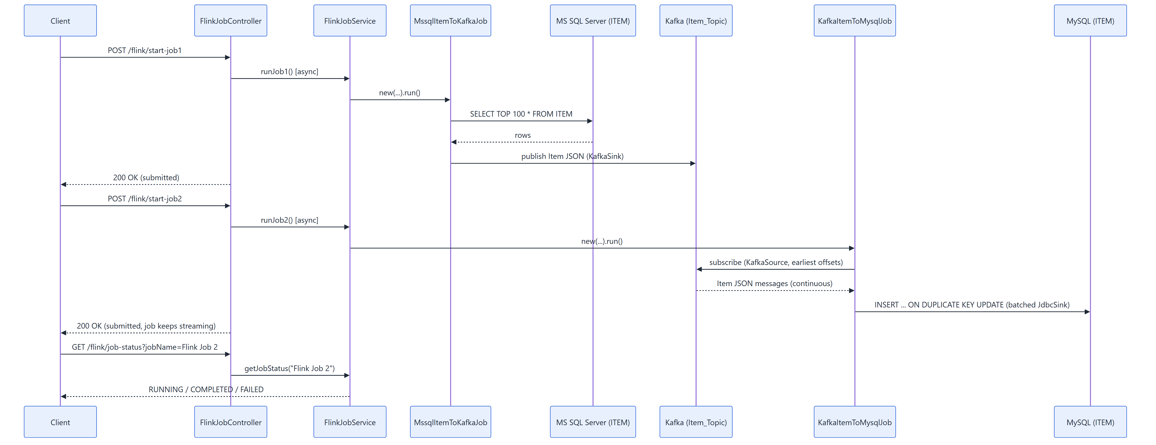
Figure 2 – Flink batch-source (Job 1) and streaming-sink (Job 2) sequence

3. End-to-End Sequence: Spring Kafka Producer/Consumer Path (lighter demo)
This lighter-weight path demonstrates plain Spring Kafka usage without Flink: a producer controller reads Item rows via JPA and publishes them to Kafka, and a separate consumer controller performs a manual, time-boxed poll of the same topic. It exists to contrast a simple polling consumer against the resilient Flink streaming approach described in Section 6.
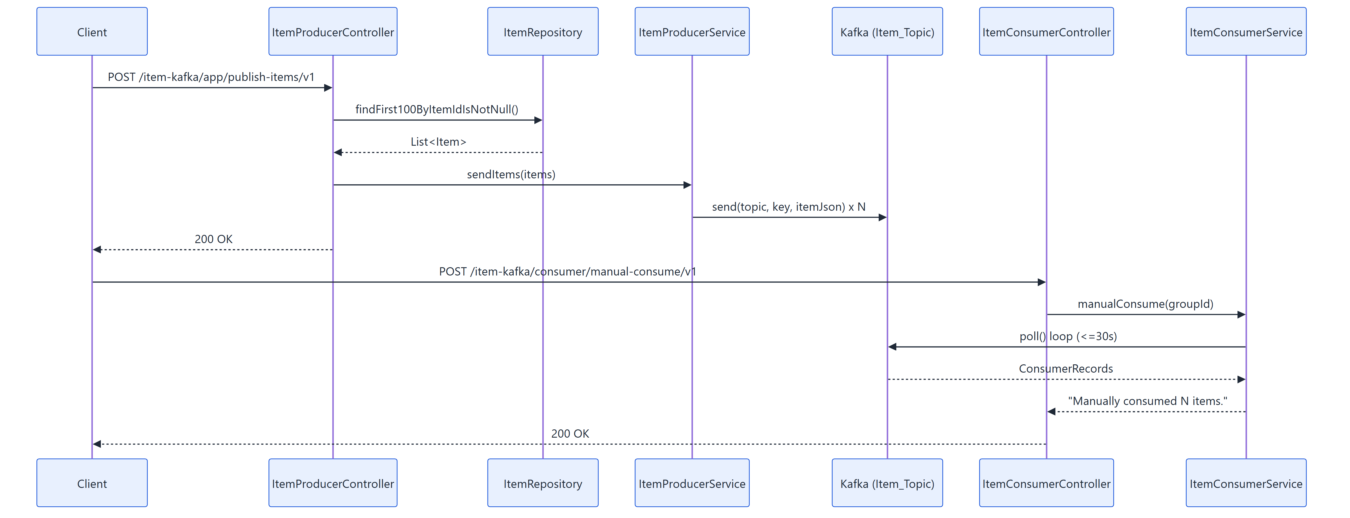
Figure 3 – Spring Kafka producer and manual-consumer sequence

4. Component Responsibilities
Layer | Class(es) | Responsibility
REST – producer | ItemProducerController, ItemProducerService | Read Item rows via JPA, publish to Kafka
REST – consumer | ItemConsumerController, ItemConsumerService | On-demand poll of the shared Kafka topic
REST – gateway test | MsgConsumerController, MsgRoutingServiceImpl, JwtTokenUtil | Demonstrates JWT-signed / optionally mTLS-secured calls to an external gateway
REST – Flink control plane | FlinkJobController, FlinkJobService, JobStatus | Starts/tracks the Flink jobs on demand instead of requiring a separate cluster submission
Flink – batch source | MssqlItemToKafkaJob | One-shot read of up to 100 rows from SQL Server, publish as JSON to Kafka
Flink – streaming sink | KafkaItemToMysqlJob | Unbounded consumption from Kafka, batched upsert into MySQL
Flink – smoke test | FlinkWordStreamDemoJob | Dependency-free job to validate the Flink runtime independent of Kafka/JDBC
Config | KafkaProperties, MySqlProperties, MSSQLDataSourceProperties, SSLProperties | Type-safe, environment-variable-driven configuration – no hardcoded secrets or connection strings
Domain model | Item, ManualConsumeRequest, ServiceRequest, JwtResponse | JPA entity + REST request/response DTOs

5. Data Model
Item (src/main/java/com/antontech/itemkafka_poc/model/Item.java) is a JPA entity mapped to the ITEM table on both sides of the pipeline (SQL Server source, MySQL sink) and is also the JSON payload shape published to and consumed from Kafka (serialized with Gson using a custom LocalDateTimeAdapter for LocalDateTime fields). See DATABASE_SETUP.md in the repository for the full column list and both the SQL Server and MySQL DDL scripts.

6. Why Apache Flink Is Used Here
The Spring Kafka path (ItemConsumerService) is intentionally simple: it opens a short-lived KafkaConsumer, polls for up to ~30 seconds and stops. That is fine for a demo/manual-trigger scenario, but it does not scale and has no fault tolerance built in. Apache Flink is used for the “real” replication path (KafkaItemToMysqlJob) because it provides, largely for free:
- True unbounded streaming, not polling – Flink's KafkaSource maintains a long-lived, continuously-running dataflow that reacts to new Kafka records as they arrive, instead of a client repeatedly opening/closing connections and possibly missing records between polls.
- Backpressure handling – if MySQL momentarily can't keep up with the batch upsert rate, Flink automatically slows down how fast it reads from Kafka rather than buffering unboundedly in memory or dropping records.
- Built-in batching and retries at the sink – JdbcSink is configured with withBatchSize(1000) / withBatchIntervalMs(200) / withMaxRetries(3), batching many small upserts into fewer, larger round trips to MySQL and automatically retrying a failed batch instead of losing it.
- Horizontal scalability – the same job definition can be resubmitted to a real Flink cluster with higher parallelism (flink.parallelism.default) to consume multiple Kafka partitions in parallel with no code changes.
- Exactly-once/at-least-once semantics options – Flink's checkpointing model (available, not fully wired up in this POC) is what lets production deployments guarantee no data is lost or duplicated across restarts.
- Decoupling of runtime lifecycle from the calling HTTP request – because KafkaItemToMysqlJob is an unbounded stream, it is deliberately triggered asynchronously so the triggering REST call can return immediately while replication keeps running in the background.
In short: the Spring consumer path exists to demonstrate the “manual poll” mental model simply; the Flink path exists to demonstrate how you would actually build a resilient, scalable, continuously-running Kafka-to-database replication pipeline in production.

7. Synchronous vs. Asynchronous Endpoints
This matters a lot for a future front end: some endpoints return only once all work is done (safe to await directly and update the UI from the response), while others return immediately and the real work continues in the background (the UI must poll or otherwise check back later).
Endpoint | Controller Method | Sync/Async | Why
POST /item-kafka/app/publish-items/v1 | ItemProducerController.createItemKafkaTopic() | Synchronous | Reads up to 100 rows and calls kafkaTemplate.send(...).get() (blocking) for each one before returning
GET /item-kafka/consumer/consume-status/v1 | ItemConsumerController.checkConsumerStatus() | Synchronous | In-memory boolean check, no I/O
POST /item-kafka/consumer/manual-consume/v1 | ItemConsumerController.manualConsumeItem() | Synchronous (slow, up to ~30s) | Blocks the HTTP request thread for the whole poll loop before responding
POST /item-kafka/app/send-items/v1 | MsgConsumerController.sendItemsToKafka() | Synchronous | Builds the JWT and prepares the request inline; no background thread involved
GET /item-kafka/app/consume-items/v1 | MsgConsumerController.consumeItemsFromKafka() | Synchronous | Just logs and returns
POST /flink/start-job1 | FlinkJobController.triggerFlinkJob1() | Asynchronous | Wrapped in CompletableFuture.runAsync(...); returns 200 OK immediately while the job runs on a background thread
POST /flink/start-job2 | FlinkJobController.triggerFlinkJob2() | Asynchronous (never self-completes) | KafkaItemToMysqlJob is an unbounded stream; the HTTP call only confirms it was submitted, not completed
POST /flink/start-simple-job | FlinkJobController.triggerFlinkSimpleJob() | Synchronous | Deliberately not wrapped in CompletableFuture – the demo job is short, so the controller waits for an immediate pass/fail result
GET /flink/job-status?jobName= | FlinkJobController.getJobStatus() | Synchronous | Simple in-memory map lookup – the endpoint a front end polls to find out when an async job has finished

7.1 How a Front End Should Trigger and Observe the Async Jobs
Since /flink/start-job1 and /flink/start-job2 return before the work is done, there is no webhook, callback, or WebSocket built into this POC to push completion events to a client. The supported pattern is client-side polling of /flink/job-status:
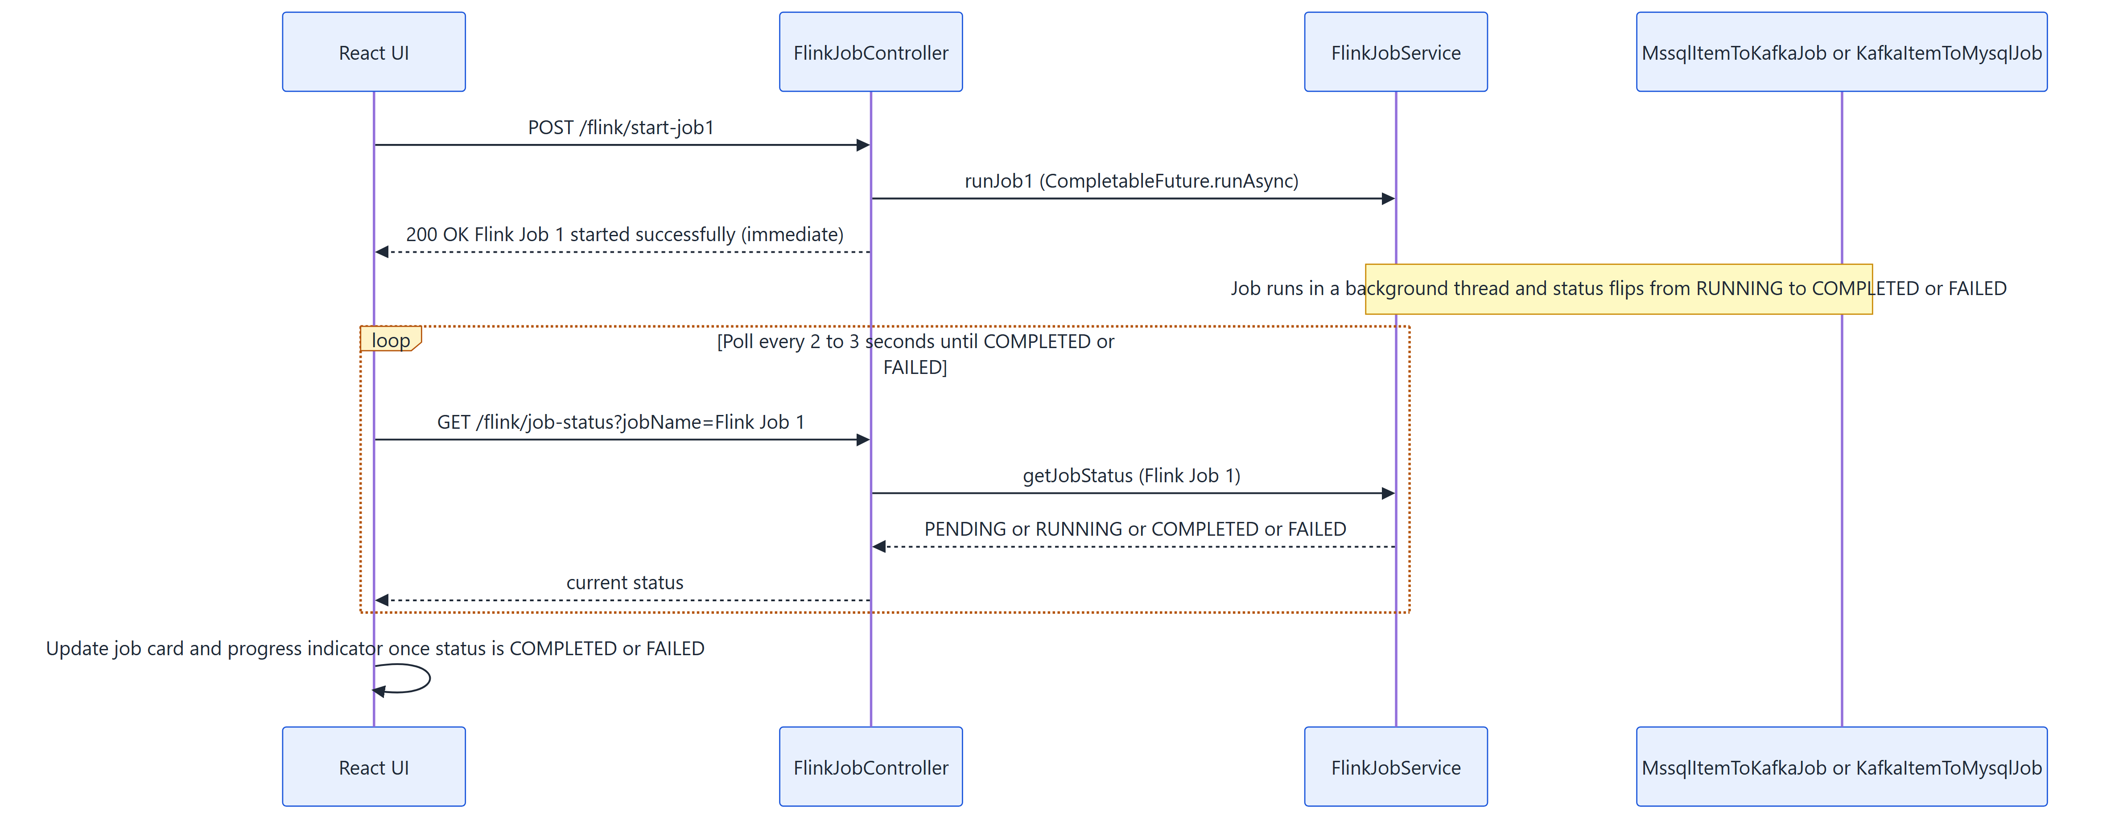
Figure 4 – Recommended fire-then-poll pattern for the React front end

Practical guidance for the upcoming React client:
- Treat start-job1/start-job2 calls like “fire, then poll” – disable the trigger button and show a spinner/“Running...” badge immediately on submit, independent of the (fast) HTTP response.
- Poll GET /flink/job-status?jobName=Flink Job 1 (or Flink Job 2 / Flink Simple Job) on an interval (e.g. every 2–3 seconds) and stop polling once the status is COMPLETED or FAILED.
- Remember Flink Job 2 is an unbounded stream – once RUNNING, it is expected to stay RUNNING indefinitely. Message this clearly in the UI, e.g. “Streaming replication is active” rather than a progress bar implying an end state.
- start-simple-job and every non-Flink endpoint can simply be awaited directly (standard fetch/axios request/response), no polling needed.

8. Configuration and Secrets Flow
No credential, connection string, keystore password, or private key is ever committed to source control. Values flow from environment variables through Spring's YAML placeholders into strongly-typed configuration classes and finally into the beans that need them, as shown below. See SETUP_GUIDE.md for how to supply your own values for a local demo.
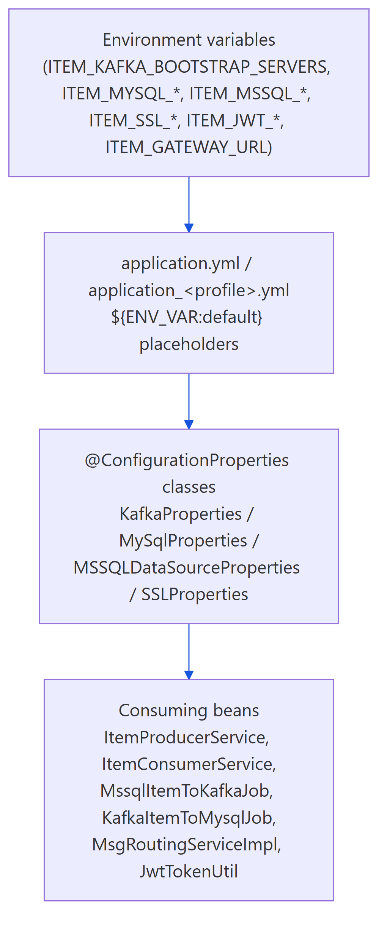
Figure 5 – Environment variables to configuration beans

9. CORS: How the React Front End Is Allowed to Call This API
The companion React UI (ReactJS-UI-For-Item-Kafka-Producer-POC, typically served by Vite on http://localhost:5173) runs on a different origin (scheme + host + port combination) than this API (http://localhost:8082). Browsers enforce the Same-Origin Policy: by default, JavaScript running on one origin is not allowed to read the response of an HTTP request made to a different origin, even if the server processed the request successfully. CORS (Cross-Origin Resource Sharing) is the mechanism browsers use to relax that restriction, driven entirely by response headers the server sends back.
For a “simple” GET/POST with a non-trivial Content-Type (such as the JSON bodies this API uses), the browser first sends an automatic OPTIONS “pre-flight” request carrying an Origin header. The server must respond with an Access-Control-Allow-Origin header matching that origin (plus the allowed methods) before the browser will send the real GET/POST request at all. If the headers are missing or don't match, the browser blocks the call client-side and the request never reaches application code in a usable way from the page's point of view.
How it is wired up in this repository:
- CorsConfig (src/main/java/com/antontech/itemkafka_poc/configuration/CorsConfig.java) registers a WebMvcConfigurer.addCorsMappings(...) rule – plus a CorsConfigurationSource bean for defence-in-depth if a security filter chain is ever added – that allows GET/POST/PUT/DELETE/PATCH/OPTIONS, any request header, and exposes the Authorization header, for a configured list of origins.
- Allowed origins are externalised, not hardcoded: cors.allowed-origins in application.yml (environment variable ITEM_CORS_ALLOWED_ORIGINS, comma-separated), defaulting to http://localhost:5173,http://localhost:3000 to cover both Vite's and Create-React-App-style dev servers out of the box.
- No cookies/HTTP-session credentials are used by this API (it is stateless, JWT-signed where auth is relevant), so allowCredentials is left false and the broad allowedHeaders("*") is safe here – if this were extended to use cookie-based sessions, allowCredentials(true) would require an explicit origin list instead of a wildcard.
- For a production deployment, set ITEM_CORS_ALLOWED_ORIGINS to the real front-end domain(s) only (e.g. https://items.antontech.co.za) to avoid leaving local dev ports open on the public API.

End of document – see README.md, SETUP_GUIDE.md, API_DOCUMENTATION.md, KAFKA_SETUP.md and DATABASE_SETUP.md in the repository for full setup details.

