Виконав: Чабан Антон ІТ-03

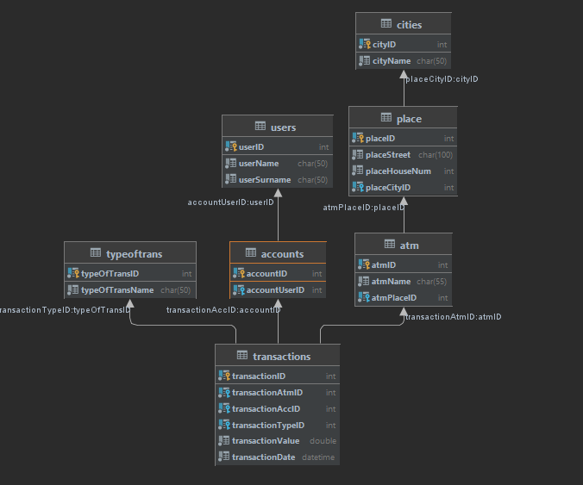

Запити:

**create** **database** **if** **not** **exists** bankDb;

**create** **table** **users**

(

userID **int** **auto_increment**,

userName **char**(**50**) **not** **null**,

userSurname **char**(**50**) **not** **null**,

**constraint** users_userID_uindex

**unique** (userID)

);

**alter** **table** users

**add** **primary** **key** (userID);

**create** **table** **cities**

(

cityID **int** **auto_increment**,

cityName **char**(**50**) **not** **null**,

**constraint** cities_cityID_uindex

**unique** (cityID)

);

**alter** **table** cities

**add** **primary** **key** (cityID);

**create** **table** **place**

(

placeID **int** **auto_increment**,

placeStreet **char**(**100**) **not** **null**,

placeHouseNum **int** **not** **null**,

placeCityID **int** **not** **null**,

**constraint** place_placeID_uindex

**unique** (placeID),

**constraint** place_fk

**foreign** **key** (placeCityID) **references** **cities** (cityID)

);

**alter** **table** place

**add** **primary** **key** (placeID);

**create** **table** **accounts**

(

accountID **int** **auto_increment**,

accountUserID **int** **not** **null**,

**constraint** accounts_accountID_uindex

**unique** (accountID),

**constraint** accounts_fk

**foreign** **key** (accountUserID) **references** **users** (userID)

);

**alter** **table** accounts

**add** **primary** **key** (accountID);

**create** **table** **atm**

(

atmID **int** **auto_increment**,

atmName **char**(**55**) **not** **null**,

atmPlaceID **int** **not** **null**,

**constraint** atm_atmID_uindex

**unique** (atmID),

**constraint** atm_fk

**foreign** **key** (atmPlaceID) **references** **place** (placeID)

);

**alter** **table** atm

**add** **primary** **key** (atmID);

**create** **table** **typeoftrans**

(

typeOfTransID **int** **auto_increment**,

typeOfTransName **int** **not** **null**,

**constraint** typeOfTrans_typeOfTransID_uindex

**unique** (typeOfTransID)

);

**alter** **table** typeoftrans

**add** **primary** **key** (typeOfTransID);

**alter** **table** typeoftrans modify typeOfTransName **char**(**50**) **not** **null**;

**create** **table** **transactions**

(

transactionID **int** **auto_increment**,

transactionAtmID **int** **not** **null**,

transactionAccID **int** **not** **null**,

transactionTypeID **int** **not** **null**,

transactionValue **double** **not** **null**,

transactionDate **datetime** **not** **null**,

**constraint** transactions_transactionID_uindex

**unique** (transactionID),

**constraint** transactions_ATMfk

**foreign** **key** (transactionAtmID) **references** **atm** (atmID),

**constraint** transactions_Accfk

**foreign** **key** (transactionAccID) **references** **accounts** (accountID),

**constraint** transactions_Typefk

**foreign** **key** (transactionTypeID) **references** **typeoftrans** (typeOfTransID)

);

**alter** **table** transactions

**add** **primary** **key** (transactionID);

--------------------------

a)

**select** u.userID, **sum**(transactionValue)

**from** bankdb.transactions

**inner** **join** bankdb.atm a **on** transactions.transactionAtmID = a.atmID

**inner** **join** bankdb.accounts a2 **on** transactions.transactionAccID = a2.accountID

**inner** **join** bankdb.users u **on** a2.accountUserID = u.userID

**where**

(transactionDate **between** '2020-12-01 00:00:00' **AND** '2021-12-01 00:00:00')

**and** (a.atmPlaceID = **1**)

**and** (transactionTypeID = **1**)

**group** **by** u.userID

**order** **by** **sum**(transactionValue);

b)

**select** pl.placeID

**from** bankdb.transactions tr

**inner** **join** bankdb.atm at **on** tr.transactionAtmID = at.atmID

**inner** **join** bankdb.place pl **on** at.atmPlaceID = pl.placeID

**where** tr.transactionValue > (

**select** **avg**(t.transactionValue) **from** bankdb.transactions t

**inner** **join** bankdb.atm a **on** t.transactionAtmID = a.atmID

**inner** **join** bankdb.place p **on** a.atmPlaceID = p.placeID

**inner** **join** bankdb.cities c **on** p.placeCityID = c.cityID

**where** (c.cityID = **2**));

c)

d)

select a.atmPlaceID, count(t.transactionID) as count  
from bankdb.transactions as t  
inner join atm a on t.transactionAtmID = a.atmID  
group by transactionAtmID  
order by count desc  
limit 1;

e)

**select** u.userID, u.userName, u.userSurname

**from** bankdb.accounts a

**inner** **join** bankdb.users u **on** a.accountUserID = u.userID

**where** **not** **exists**(**select** **1**

**from** bankdb.transactions t

**where** (t.transactionDate **between** '2021-11-01 00:00:00' **AND** '2021-12-01 00:00:00')

**and** t.transactionAccID = a.accountID)