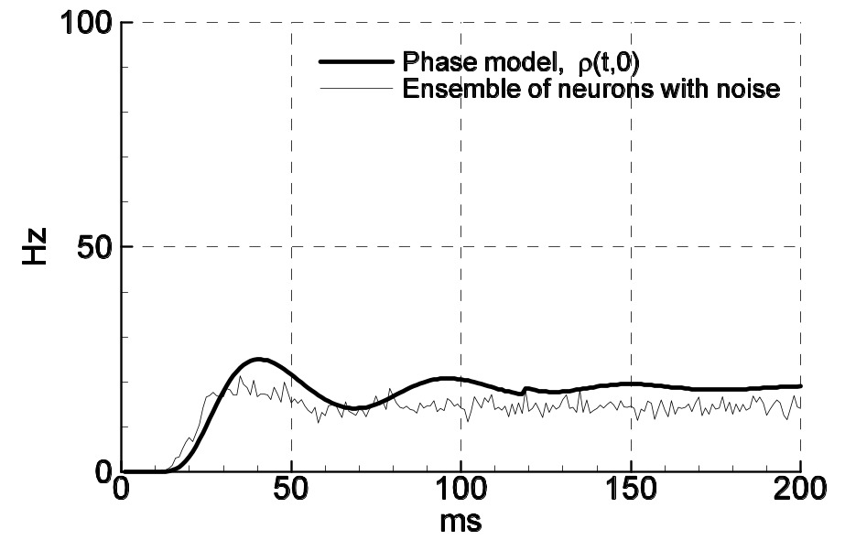
Pop_Single_noAd_200pA.eps
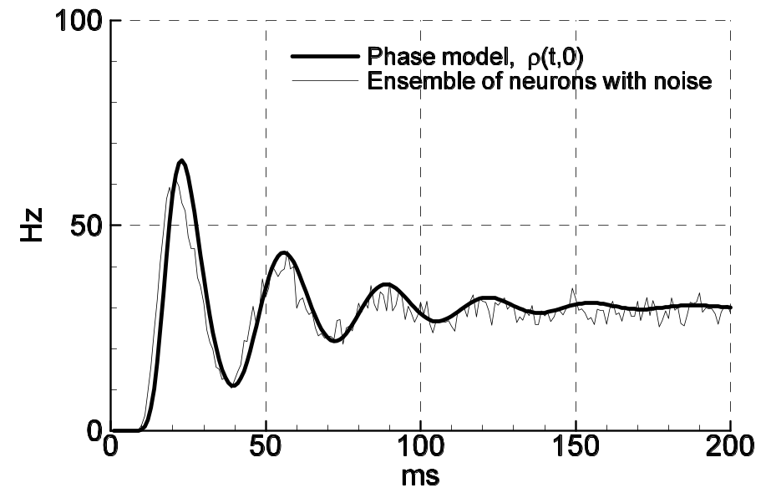 Pop_Single_noAd_300pA.eps
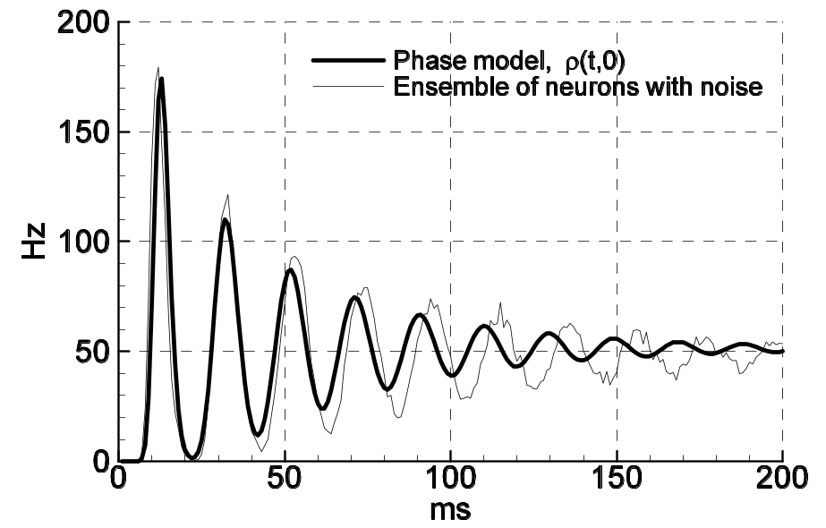
Pop_Single_noAd_500pA.eps

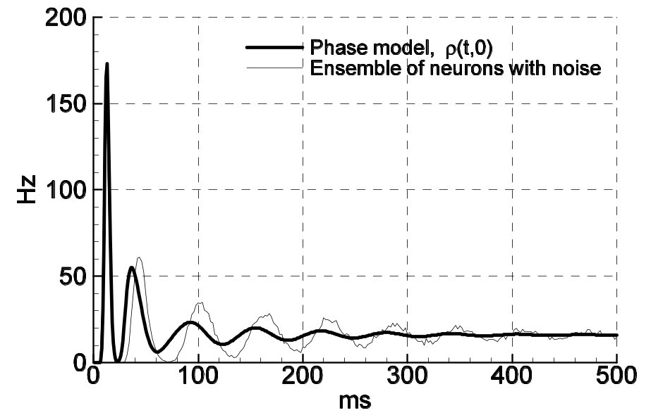
Pop_Single_noAHP_500pA.eps

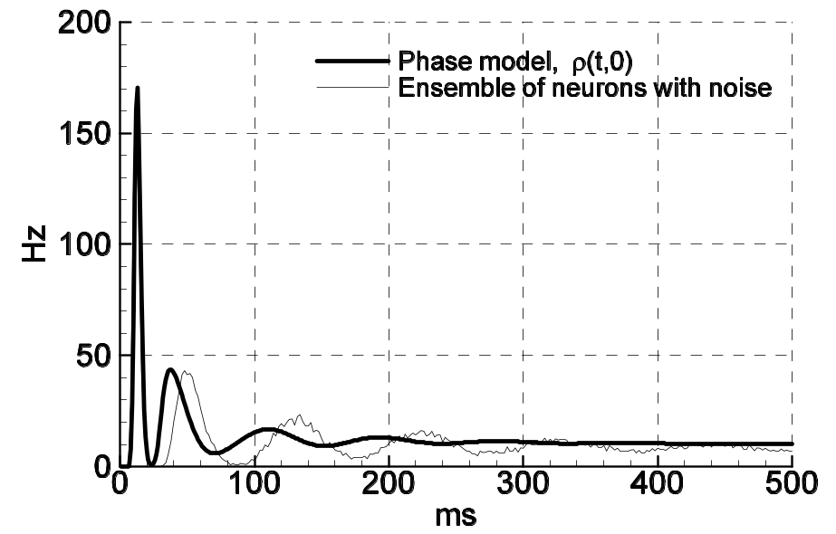
Pop_Single_Ad_500pA.eps

