g_{NMDA}=0
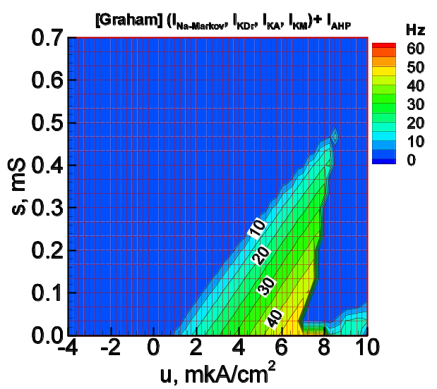
s
u
g_{NMDA}
g_{AMPA}
g_{GABA}

g_{NMDA}=1.6 g_{L}
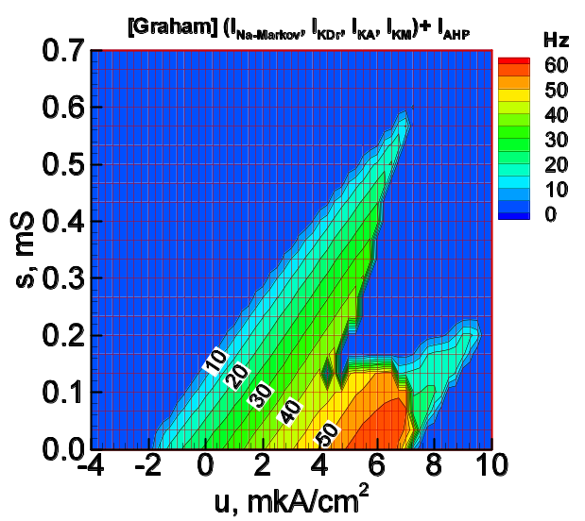

g_{NMDA}=3.2 g_{L}
