Why Has Fear Of Surveillance Of Ordinary People For Law Enforcement Become More Prominent Among Some Americans?
PSC 3500W: Fear and Politics September 9, 2026
Anton Chung Frantisak

Introduction
With more than 120,000 cameras across more than 6,000 communities that record 20 billion license-plate scans per month, Flock Safety, or Flock, had marketed its system as an ideal tool for fighting crime like finding a stolen car carrying a 14-month-old child (Flock Safety, n.d.; Harwell et al., n.d.). But by using automated license plate readers (ALPRs) like Flock’s massive camera network, at least 50 law-enforcement officers were able to track their subjects’ daily lives, such as to stalk women without their knowledge or consent (Harwell et al., n.d.). Such a polarizing tool—both used for very good and very bad—has faced overwhelming recent scrutiny from the populace, media, and politicians because it enables law enforcement to monitor ordinary people. This essay argues that the (1) media theory of fear, (2) political elite theory of fear, and (3) political culture theory of fear may help explain why fear of surveillance of ordinary people for law enforcement appears to have become more prominent among some Americans.
This essay first introduces how interest in Flock has increased using Google Search data. It then explores polling data on Flock and ALPRs, the amount of news articles on Flock, and examples of political elites across the U.S. and political spectrum taking negative stances toward Flock. Last, it proposes three explanations for why this fear has become more prominent: (1) the media theory of fear; (2) the political elite theory of fear; and (3) the political culture theory of fear.
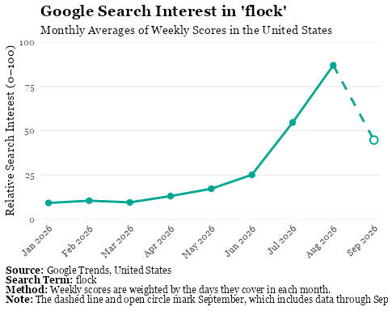

The Fear of Surveillance of Ordinary People for Law Enforcement
Fear about surveillance of ordinary people for law enforcement gained renewed attention in Summer 2026 amid the debate over Flock Safety cameras (See Figure 1), but such concerns had already been expressed as early as 2012 by the ACLU (American Civil Liberties Union 2012). The general concern is that law enforcement has misused and may continue to misuse surveillance of ordinary people for personal reasons or to monitor their lawful activities without a legitimate reason (Harwell et al., n.d.). As of late, (1) public opinion toward Flock has grown more negative, (2) news coverage about Flock has increased, and (3) political elites have criticized Flock.

Opinion Polls about Flock and ALPRs
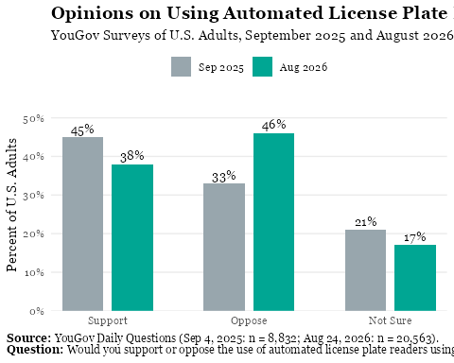
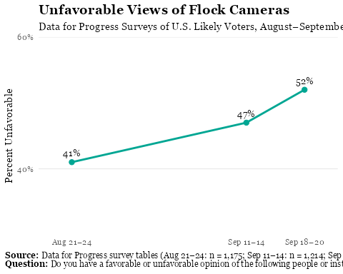
The first piece of evidence is that negative public opinion toward Flock has increased recently (See Figure 3). Polling data shows that the percentage of surveyed Americans who viewed Flock unfavorably rose from 41 to 52 percent between late August and late September (Springs 2026). These descriptive data show that views of Flock cameras became more negative at the same time that search interest in Flock increased (See Figures 1 and 3). This pattern thus warrants a further investigation of the broader category to which Flock cameras belong—namely, ALPRs for law enforcement.
The descriptive data on Americans’ views of law enforcement’s use of ALPRs like Flock cameras mirror the same shift in the negative direction observed in public opinion toward Flock (See Figure 2). Across two polls that asked an identical question in 2025 and 2026, opposition to law enforcement using ALPRs rose from 33 to 46 percent, whereas support for it fell from 45 to 38 percent (YouGov 2026, 2025). These data expand the descriptive trend established previously to law enforcement using ALPRs in general. Therefore, it seems that public opinion toward ALPRs became more negative in the second survey, in whose time frame Flock also became an important issue. Although these data cannot establish a causal link between Flock’s salience and increasing opposition toward law enforcement’s use of ALPRs, they indicate that the shift in opinion was not limited to Flock.

Mentions of Flock in the Media
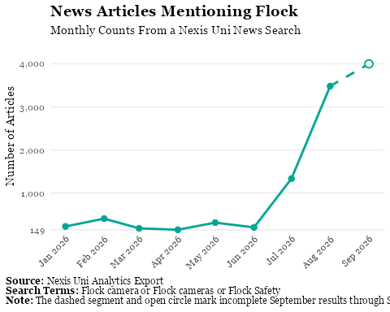
The second piece of evidence is that the amount of news coverage that mentions Flock has increased (See Figure 4). Starting during July 2026 in the Nexis Uni database, similar to the Google Search metrics, news articles began to mention Flock much more frequently, rising from under 500 articles per month from January through June to over 1,000 in July, over 3,000 in August, and around 4,000 articles from September 1 through September 27, 2026 (NexusUni 2026). Thus, the increase in news articles that mentioned Flock occurred in a similar time frame to the rise in unfavorable views of Flock and opposition to law enforcement’s use of ALPRs (See Figures 2–4).

Flock in Politics
The last piece of evidence involves political elites. Texas State Senator Lois Kolkhorst (R) released an op-ed in August, in which she argued that “the use of Flock cameras aims to be a frightening new web of warrantless mass surveillance… One could reasonably think that we are only a pandemic away from ushering in a ‘social credit score’ similar to the Chinese government, which can limit its citizens’ movements based on government approval” and reported that “My colleagues in the Texas Senate are discussing an outright ban on ALPRs, and I am right there with them” (Lois Kolkhorst, n.d.). While Kolkhorst was one of the most direct political elites to warn that Flock could curtail individual liberty, concerns about Flock were bipartisan and across the U.S., with Senators Ron Wyden (D) of Oregon, Adam Schiff (D) of California, Josh Hawley (R) of Missouri, and Governor Ron DeSantis (R) of Florida criticizing its current use or investigating its safeguards in recent months (Office of Adam Schiff, n.d.; Talcott 2026; Office of Josh Hawley 2026). Therefore, political elites took stances against Flock in a similar window to the rise in unfavorable views of Flock and increase in media coverage (See Figures 2 and 4).

Three Pathways: Why Has This Fear Become More Prominent?
This section describes three explanations for why this fear has become more prominent among some Americans. First is the media theory of fear, which argues that the media may make surveillance seem more threatening because it has an incentive to repeatedly report stories about surveillance that can generate profit and be inexpensive to cover. Second is the political elite theory of fear, which claims that political elites may make surveillance appear more threatening when they set the media agenda by investigating how law enforcement uses it, issuing public statements about its risks, and proposing laws to restrict it. Third is the political culture theory of fear, which posits that U.S. political culture about the right to privacy as an individual liberty may be influential in making surveillance seem more threatening. ## The Media Theory of Fear
Media is one possible explanation for why the fear became more prominent. As shown in Figure 4, the amount of news articles that mentioned Flock increased in July and August 2026 and remained high through September 27. Some articles within this sample have either outright argued against Flock cameras or reported opposition to them in headings such as “Flock cameras are un-American. I’m glad folks are fighting back” or “Texas privacy fight grows as Flock cameras spark Fourth of July protest” (Russell 2026; Humble 2026). Coverage of Flock has also highlighted alleged misuse, such as a police officer making more than 700 inquiries to allegedly stalk his estranged wife or a police officer allegedly using more than 2,000 Flock searches to track his ex-girlfriend (Russell 2026). Therefore, some media outlets have presented Flock in ways that could invoke fear.
This coverage could increase fear of surveillance of ordinary people for law enforcement. Romer et al. (romerTelevisionNewsCultivation2003?) find that watching local news was associated with a greater fear of crime after controlling for crime rates. This finding aligns with the media theory of fear, in which (1) people rely on and tend to trust news in terms of information and (2) news organizations have incentives to cover subjects that individuals might fear, since such coverage can be attention-grabbing and generate profit while often being inexpensive to report (MediaFear?). One can thus apply this model to the topic at hand, such that repeated reports in the media of officers allegedly misusing Flock may lead people who trust the news to fear that law enforcement could misuse surveillance of ordinary people.
Hypothesis 1: If Americans are exposed to sensational media coverage of officers allegedly misusing Flock, then they will be more likely to fear surveillance of ordinary people for law enforcement than Americans who are not exposed to such coverage.

The Political Elite Theory of Fear
Another possible explanation for why the fear became more prominent is the action of political elites. From the East Coast to the West Coast, Democrats and Republicans have made statements, opened investigations, and proposed policies aimed at controlling or removing Flock cameras (Lois Kolkhorst, n.d.; Office of Adam Schiff, n.d.; Talcott 2026; Office of Josh Hawley 2026). These negative positions about Flock have had various justifications, ranging from fear of misuse by individual law enforcement officers to warning that surveillance by the government could limit individual liberty (Lois Kolkhorst, n.d.; Office of Josh Hawley 2026). In so doing, politicians may have connected Flock cameras to fears that law enforcement might misuse surveillance of ordinary people or limit individual liberty.
This binding of the threat of misuse or a loss of liberty to Flock cameras could increase fear of surveillance of ordinary people for law enforcement. Kaufmann (kaufmannThreatInflationFailure?), in describing how the Bush administration sold the Iraq war to the American public, identifies that the administration inflated the threat that Saddam Hussein posed by (1) setting the media agenda by focusing on the threat Saddam Hussein posed to Americans in public speeches and statements, (2) publicizing pieces of evidence that did favor their views while withholding evidence that did not, and (3) leveraging the White House’s credibility on foreign policy (PoliticiansFear?). When applied to this topic, U.S. politicians could make surveillance of ordinary people for law enforcement seem more threatening if news outlets report their statements and actions against Flock to Americans who regard the politicians as credible.
Hypothesis 2: If Americans are exposed to news coverage of Flock that quotes politicians warning about its risks, then they will be more likely to fear surveillance of ordinary people for law enforcement than Americans who are exposed to similar coverage without politicians’ warnings.

The Political Culture Theory of Fear
Political culture is the last possible explanation for why the fear might have become more prominent. In surveys from earlier decades, Westin (2003) finds that Americans’ concern about threats to personal privacy was high, rising from 64 percent in 1978 to 84 percent in 1995, in which 51 percent of Americans identified the government as the greatest potential threat to privacy. More recently, about 70 percent of Americans who responded to the World Values Survey Wave 7 in 2017 said the government probably or definitely should not have a right to collect information about people without their knowledge (EVS/WVS 2024). Therefore, many Americans were concerned about government intrusions on privacy both decades ago and in 2017, before the current debate about Flock.
This ingrained belief in privacy could thus influence the attitudes of some Americans toward Flock. The political culture theory of fear suggests that politicians and news outlets may share and express fears already held by a great number of the population (PoliticalCultureFear?). For example, Gibson and Howard (gibsonRussianAntiSemitismScapegoating2007?) found that attitudes toward Jews changed little during the turmoil in Russia in the 1990s, even though some politicians blamed Jews for the country’s problems. On this basis, they argued that politicians’ appeals depend on beliefs the public already holds, since prejudice against Jews was not widespread enough in Russia for those appeals to succeed. Using this model, an existing concern about government intrusions on privacy may make some Americans more likely to fear surveillance of ordinary people for law enforcement when Flock receives more attention.

References
American Civil Liberties Union. 2012. “What We Know About License Plate Tracking, What We Don’t, And Our Plan to Find Out More ACLU.” In American Civil Liberties Union.
EVS/WVS. 2024. Joint EVS/WVS 2017-2022 Dataset (Joint EVS/WVS)Joint EVS/WVS 2017-2022 Dataset (Joint EVS/WVS). GESIS. https://doi.org/10.4232/1.14320.
Flock Safety. n.d. 6 Abducted Children Recovered in Colorado in 5 Months. Https://www.flocksafety.com/blog/six-abducted-children-recovered-in-five-months-in-colorado-with-flock-lpr-technology.
Harwell, Drew, Douglas MacMillan, and Aaron Schaffer. n.d. How Rogue Officers Turned a Nationwide Camera Network into a Tool for Stalking. Https://www.washingtonpost.com/technology/2026/08/02/how-police-officers-used-vast-network-cameras-spy-their-exes/.
Humble, Ahmed. 2026. “Texas Privacy Fight Grows as Flock Cameras Spark Fourth of July Protest.” Chron (Houston, TX), July.
Lois Kolkhorst. n.d. Lois Kolkhorst.
NexusUni. 2026. 10,000+ Results for "Flock Camera" OR "Flock Cameras" OR "Flock Safety" (Narrowed). Https://advance.lexis.com/search/index?crid=a33e7950-1f62-456f-84a6-29d94c8d7c23&pdpermalink=5784e124-50f4-4a2f-9d2a-8a1e395eb6ca&pdmfid=1519360&pdisurlapi=true.
Office of Adam Schiff. n.d. “NEWS: Sens. Schiff, Wyden Press Flock CEO for Answers on Troubling Abuse of Technology Amid Surveillance Network Concerns, Push to Protect American’s Privacy.” In Senator Schiff.
Office of Josh Hawley. 2026. “Chairman Hawley Investigates AI-Powered Flock Cameras Amidst Privacy Concerns.” In Josh Hawley.
Russell, Nicole. 2026. “Flock Cameras Are Un-American. I’m Glad Folks Are Fighting Back. Opinion.” USA Today Online, August.
Springs, Abby. 2026. Unfavorable Views of Flock Surveillance Cameras Have Grown Since August. Data for Progress.
Talcott, Anthony. 2026. “‘Out of Control:’ Florida Gov. DeSantis Says Lawmakers Should Tackle Flock Cameras.” Local News in WKMG. Https://www.clickorlando.com/news/local/2026/08/28/out-of-control-florida-gov-desantis-says-lawmakers-should-tackle-flock-cameras/.
Westin, Alan F. 2003. “Social and Political Dimensions of Privacy.” Journal of Social Issues 59 (2): 431–53. https://doi.org/10.1111/1540-4560.00072.
YouGov. 2025. Would You Support or Oppose the Use of Automated License Plate Readers Using Computer-Controlled Cameras for Law Enforcement Purposes in Your Community? Daily Question. Https://yougov.com/daily-results/20250904-67d37-1.
YouGov. 2026. Would You Support or Oppose the Use of Automated License Plate Readers Using Computer-Controlled Cameras for Law Enforcement Purposes in Your Community? Daily Question. Https://yougov.com/daily-results/20260824-a9b53-1.

