Account

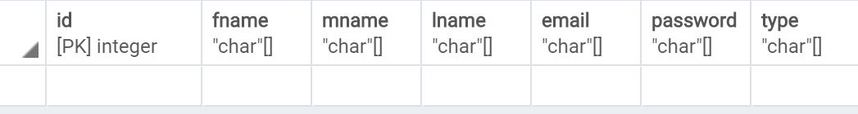

Listing

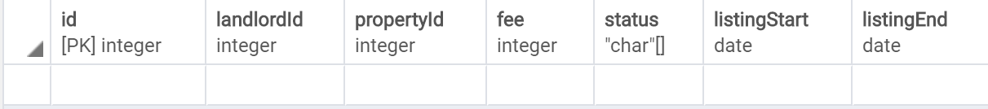

Notification

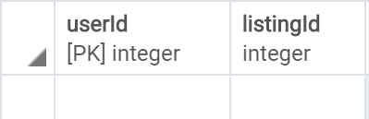

Property



SearchCriteria

