Name: Antonio Santos

Lab Section: B03

Course: ENCM 369

Lab Assignment: Lab 1

Exercise G

// exG.c

// ENCM 369 Winter 2019 Lab 1 Exercise G

#include <stdio.h>

#include <stdlib.h>

#include <math.h>

#define MAX_ABS_F (5.0e-12)

#define POLY_DEGREE 4

*double* polyval(const *double* *a, *int* n, *double* x);

// Return a[0] + a[1] * x + ... + a[n] * pow(x, n).

*int* main(*void*)

{

*double* f[ ] = {1.5, 0.7, -3.1, -1.2, 1.0};

*double* dfdx[POLY_DEGREE];

*double* guess;

*int* max_updates;

*int* update_count;

*int* scan_count;

*int* i;

*int* close_enough = 0;

*double* current_x, current_f, current_dfdx;

printf("This program demonstrates use of Newton's Method to find\n"

"approximate roots of the polynomial\nf(x) = ");

printf("%.2f", f[0]);

i = 1;

first_for_start:

if(i > POLY_DEGREE) goto first_for_end;

if(f[i] < 0) goto first_else_code;

printf(" + %.2f*pow(x,%d)", f[i], i);

i++;

goto first_for_start;

first_else_code:

printf(" - %.2f*pow(x,%d)", -f[i], i);

i++;

goto first_for_start;

first_for_end: ;

printf("\nPlease enter a guess at a root, and a maximum number of\n"

"updates to do, separated by a space.\n");

scan_count = scanf("%lf%d", &guess, &max_updates);

if(scan_count == 2) goto correct_count;

printf("Sorry, I couldn't understand the input.\n");

exit(1);

correct_count: ;

if(max_updates >= 0) goto valid_input;

printf("Sorry, a negative limit on updates does not make sense.\n");

exit(1);

valid_input: ;

printf("Running with initial guess %f.\n", guess);

i = POLY_DEGREE - 1;

second_for_start:

if(i < 0) goto second_for_end;

dfdx[i] = (i + 1) * f[i + 1];

i--;

goto second_for_start;

second_for_end: ;

current_x = guess;

update_count = 0;

while_loop_start:

if(!1) goto while_loop_end;

current_f = polyval(f, POLY_DEGREE, current_x);

printf("%d update(s) done; x is %.15f; f(x) is %.15e\n",

update_count, current_x, current_f);

if(fabs(current_f) > MAX_ABS_F) goto end_first_if;

close_enough = 1;

goto while_loop_end;

end_first_if: ;

if(update_count != max_updates) goto end_second_if;

goto while_loop_end;

end_second_if: ;

current_dfdx = polyval(dfdx, POLY_DEGREE - 1, current_x);

current_x -= current_f / current_dfdx;

update_count++;

goto while_loop_start;

while_loop_end: ;

if(!close_enough) goto second_else_code;

printf("Stopped with approximate solution of %.12f.\n",

current_x);

goto end_if;

second_else_code:

printf("%d updates performed, |f(x)| still >= %g.\n",

update_count, MAX_ABS_F);

goto end_if;

end_if: ;

return 0;

}

*double* polyval(const *double* *a, *int* n, *double* x)

{

*double* result = a[n];

*int* i;

i = n - 1;

for_loop_start:

if(i < 0) goto for_loop_end;

result = x * result + a[i];

i--;

goto for_loop_start;

for_loop_end: ;

return result;

}

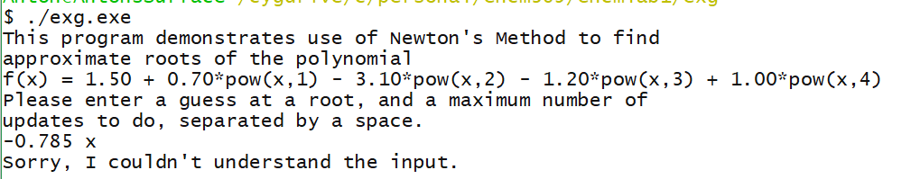

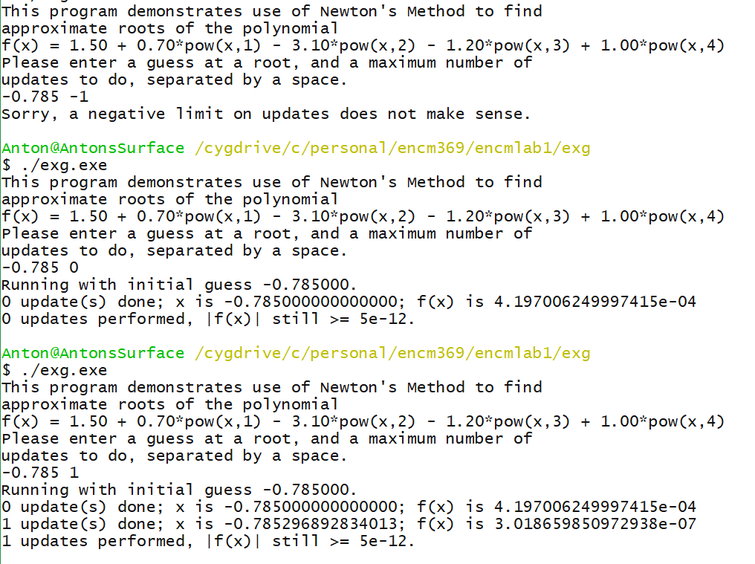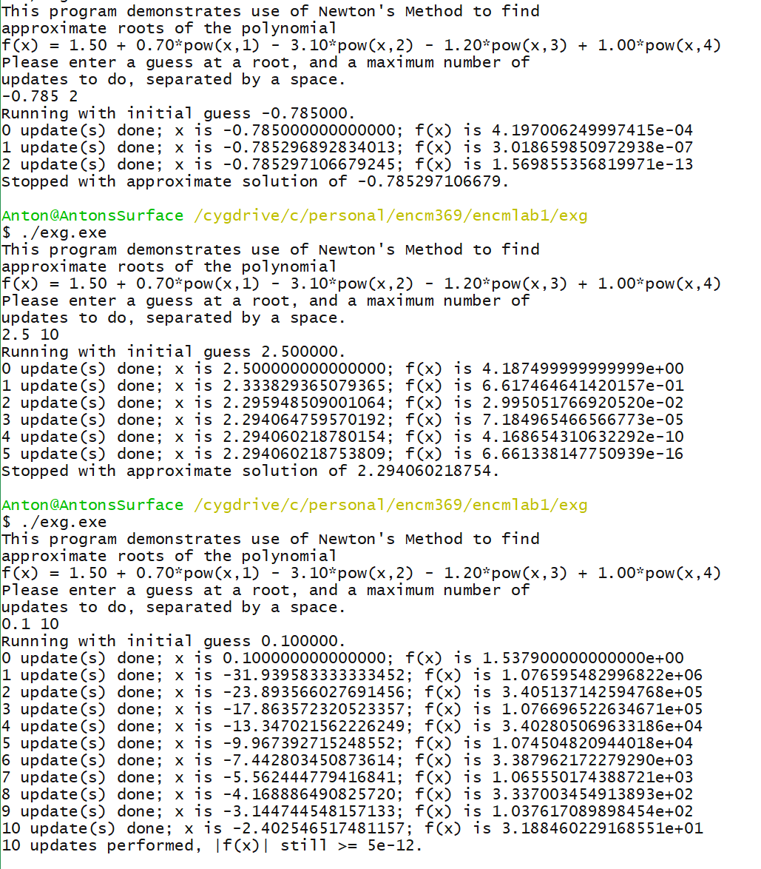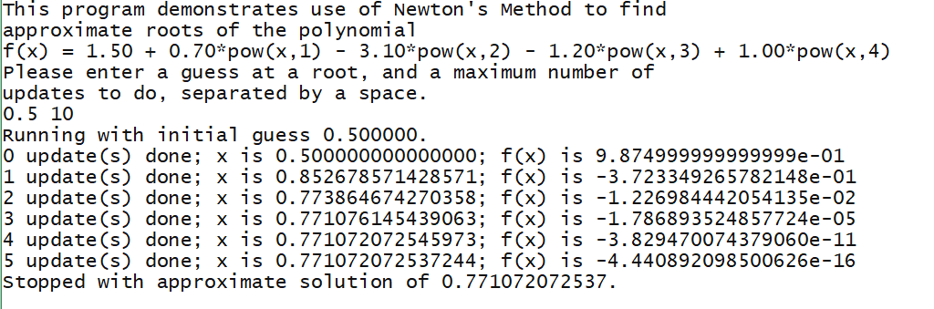



Exercise H

// exH.c

// ENCM 369 Winter 2019 Lab 1 Exercise H

#include <stdio.h>

*void* print_array(const *char* *str, const *int* *a, *int* n);

// Prints the string given by str on stdout, then

// prints a[0], a[1], ..., a[n - 1] on stdout on a single line.

*void* sort_array(*int* *a, *int* n);

// Sorts a[0], a[1], ..., a[n - 1] from smallest to largest.

*int* main(*void*)

{

*int* test_array[] = {440, 220, 330, 550, 330, 660, 110, 330, 440};

print_array("before sorting ...", test_array, 9);

sort_array(test_array, 9);

print_array("after sorting ...", test_array, 9);

return 0;

}

*void* print_array(const *char* *str, const *int* *a, *int* n)

{

*int* i;

puts(str);

i = 0;

for_loop_start:

if(i >= n) goto for_loop_end;

printf(" %d", a[i]);

i++;

goto for_loop_start;

for_loop_end: ;

printf("\n");

}

*void* sort_array(*int* *a, *int* n)

{

// This is an implementation of an algorithm called selection sort.

*int* i, j, min, j_of_min;

i = 0;

outer_for_start:

if(i >= n-1) goto outer_for_end;

min = a[i];

j_of_min = i;

j = i + 1;

inner_for_start:

if(j >= n) goto inner_for_end;

if(a[j] >= min) goto end_if;

min = a[j];

j_of_min = j;

end_if: ;

j++;

goto inner_for_start;

inner_for_end: ;

a[j_of_min] = a[i];

a[i] = min;

i++;

goto outer_for_start;

outer_for_end: ;

}

