Course: ENSF 409

Student Name: Antonio Santos

Lab number: Lab 2

Exercise 3  
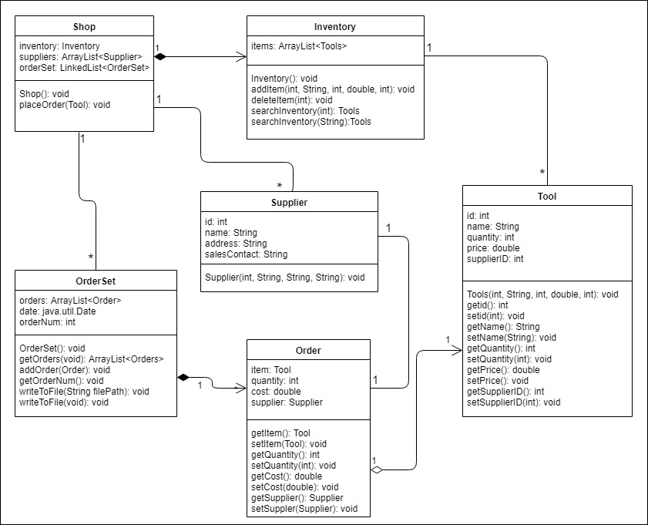

Exercise 4

import java.io.*;

//STUDENTS SHOULD ADD CLASS COMMENTS, METHOD COMMENTS, FIELD COMMENTS

/**

* Provides data fields and methods to create a tic-tac-toe game

* in a Java application

* This class is the starting point of the program

*

* @author Antonio Santos

* @version 1.0

* @since January 31, 2019

*/

public class Game implements *Constants* {

    /**

     * The board that will be used in the game

     */

    private *Board* theBoard;

    /**

     * The moderator that will be in charge of watching the game

     */

    private *Referee* theRef;

    /**

     * Creates a new Board object to play on

     */

public Game( ) {

theBoard = new Board();

    }

    /**

     * Sets the referee and tells it to start the game

     * @param *r* sets the referee that will be running the game

     * @throws IOException

     */

public *void* appointReferee(*Referee* *r*) throws *IOException* {

theRef = r;

    theRef.runTheGame();

}

    public static *void* main(*String*[] *args*) throws *IOException* {

*Referee* theRef;

*Player* xPlayer, oPlayer;

*BufferedReader* stdin;

*Game* theGame = new Game();

        stdin = new BufferedReader(new InputStreamReader(System.in));

        System.out.print("\nPlease enter the name of the \'X\' player: ");

*String* name= stdin.readLine();

        while (name == null) {

            System.out.print("Please try again: ");

            name = stdin.readLine();

        }

        xPlayer = new Player(name, LETTER_X);

        xPlayer.setBoard(theGame.theBoard);

        System.out.print("\nPlease enter the name of the \'O\' player: ");

        name = stdin.readLine();

        while (name == null) {

            System.out.print("Please try again: ");

            name = stdin.readLine();

        }

        oPlayer = new Player(name, LETTER_O);

        oPlayer.setBoard(theGame.theBoard);

        theRef = new Referee();

        theRef.setBoard(theGame.theBoard);

        theRef.setoPlayer(oPlayer);

        theRef.setxPlayer(xPlayer);

theGame.appointReferee(theRef);

    }

}

public interface Constants {

    static final *char* SPACE_CHAR = ' ';

    static final *char* LETTER_O = 'O';

    static final *char* LETTER_X = 'X';

}

//STUDENTS SHOULD ADD CLASS COMMENTS, METHOD COMMENTS, FIELD COMMENTS

/**

* This class is in charge of displaying the board on the console

* and adding the marks that the players put on the board.

* It will also be in charge of checking for a winner or if the

* board is full.

*

* @author Antonio Santos

* @version 1.0

* @since January 31, 2019

*/

public class Board implements *Constants* {

    /**

     * The board that will be displayed on the console

     */

    private *char* theBoard[][];

    /**

     * the number of marks on the board

     */

    private *int* markCount;

    /**

     * creates the the board matrix.

     */

    public Board() {

        markCount = 0;

        theBoard = new *char*[3][];

        for (*int* i = 0; i < 3; i++) {

            theBoard[i] = new *char*[3];

            for (*int* j = 0; j < 3; j++)

                theBoard[i][j] = SPACE_CHAR;

        }

    }

    /**

     * Returns the mark placed in the wanted element

     * @param *row*   index of row

     * @param *col*   index of column

     * @return  the character within the wanted element

     */

    public *char* getMark(*int* *row*, *int* *col*) {

        return theBoard[row][col];

    }

    /**

     * checks if the board is full

     * @return  the markCount = to 9;

     */

    public *boolean* isFull() {

        return markCount == 9;

    }

    /**

     * will constantly check the board to see if xPlayer has won the game

     * @return returns whether the player has won or not

     */

    public *boolean* xWins() {

        if (checkWinner(LETTER_X) == 1)

            return true;

        else

            return false;

    }

    /**

     * will constantly check the board to see if xPlayer has won the game

     * @return returns whether the player has won or not

     */

    public *boolean* oWins() {

        if (checkWinner(LETTER_O) == 1)

            return true;

        else

            return false;

    }

    /**

     * displays the board on the console.

     */

    public *void* display() {

        displayColumnHeaders();

        addHyphens();

        for (*int* row = 0; row < 3; row++) {

            addSpaces();

            System.out.print(" row " + row + ' ');

            for (*int* col = 0; col < 3; col++)

                System.out.print("| " + getMark(row, col) + " ");

            System.out.println("|");

            addSpaces();

            addHyphens();

        }

    }

    /**

     * Sets the element with the mark given by the player and

     * increases the mark count

     * @param *row*   index of row

     * @param *col*   index of col

     * @param *mark*  mark that will be placed in the element

     */

    public *void* addMark(*int* *row*, *int* *col*, *char* *mark*) {

        theBoard[row][col] = mark;

        markCount++;

    }

    /**

     * clears the board and resets the mark count

     */

    public *void* clear() {

        for (*int* i = 0; i < 3; i++)

            for (*int* j = 0; j < 3; j++)

                theBoard[i][j] = SPACE_CHAR;

        markCount = 0;

    }

    /**

     * checks if a player has won the game

     * @param *mark*  the mark that will be used to check for winner

     * @return returns result. will return 1 if there is a winner else 0

     */

*int* checkWinner(*char* *mark*) {

*int* row, col;

*int* result = 0;

        for (row = 0; result == 0 && row < 3; row++) {

*int* row_result = 1;

            for (col = 0; row_result == 1 && col < 3; col++)

                if (theBoard[row][col] != mark)

                    row_result = 0;

            if (row_result != 0)

                result = 1;

        }

        for (col = 0; result == 0 && col < 3; col++) {

*int* col_result = 1;

            for (row = 0; col_result != 0 && row < 3; row++)

                if (theBoard[row][col] != mark)

                    col_result = 0;

            if (col_result != 0)

                result = 1;

        }

        if (result == 0) {

*int* diag1Result = 1;

            for (row = 0; diag1Result != 0 && row < 3; row++)

                if (theBoard[row][row] != mark)

                    diag1Result = 0;

            if (diag1Result != 0)

                result = 1;

        }

        if (result == 0) {

*int* diag2Result = 1;

            for (row = 0; diag2Result != 0 && row < 3; row++)

                if (theBoard[row][3 - 1 - row] != mark)

                    diag2Result = 0;

            if (diag2Result != 0)

                result = 1;

        }

        return result;

    }

    /**

     * displays the column header

     */

*void* displayColumnHeaders() {

        System.out.print(" ");

        for (*int* j = 0; j < 3; j++)

            System.out.print("|col " + j);

        System.out.println();

    }

    /**

     * displays the hyphens

     */

*void* addHyphens() {

        System.out.print(" ");

        for (*int* j = 0; j < 3; j++)

            System.out.print("+-----");

        System.out.println("+");

    }

    /**

     * adds white space

     */

*void* addSpaces() {

        System.out.print(" ");

        for (*int* j = 0; j < 3; j++)

            System.out.print("| ");

        System.out.println("|");

    }

}

/**

* This class will be in charge of setting the board and setting the players.

*

* @author Antonio Santos

* @version 1.0

* @since January 31, 2019

*/

public class Referee{

/**

* Player that uses the X mark

*/

private *Player* xPlayer;

/**

* Player that uses the O mark

*/

private *Player* oPlayer;

/**

* The board that will be used in the game.

*/

private *Board* board;

/**

* Constructor for referee

*/

public Referee(){}

/**

* Begins the game and sets the players as opponents

* of one another

*/

public *void* runTheGame(){

xPlayer.setOpponent(oPlayer);

oPlayer.setOpponent(xPlayer);

board.display();

xPlayer.play();

}

/**

* sets the game board

* @param *board* the game board

*/

public *void* setBoard(*Board* *board*){

this.board = board;

}

/**

* sets the player that will use the O mark

* @param *oPlayer* Player that will use the O mark

*/

public *void* setoPlayer(*Player* *oPlayer*){

this.oPlayer = oPlayer;

}

/**

* sets the player that will use the X mark

* @param *xPlayer* Player that will use the X mark

*/

public *void* setxPlayer(*Player* *xPlayer*){

this.xPlayer = xPlayer;

}

}

import java.util.Scanner;

/**

* This class takes care of all of the information about the player

* and also where the game moves are executed.

*

* @author Antonio Santos

* @version 1.0

* @since January 31, 2019

*/

public class Player implements *Constants*{

/**

* name of the player

*/

private *String* name;

/**

* the game board that will be used in the game

*/

private *Board* board;

/**

* the opponent of the current player

*/

private *Player* opponent;

/**

* the mark of the player

*/

private *char* mark;

/**

* Player constructor sets the name and mark

* @param *name* name of the player

* @param *mark* mark to be used by the player

*/

public Player(*String* *name*, *char* *mark*){

this.name = name;

this.mark = mark;

}

/**

* Where the game starts. Prompts players to make moves and checks

* every turn if a player has won.

*/

public *void* play(){

while(true){

makeMove();

if(board.xWins() == true){

board.display();

System.out.println("GAME OVER: " + name + " is the winner.");

break;

}else if(board.oWins() == true){

board.display();

System.out.println("GAME OVER: " + name + " is the winner.");

break;

}else if(board.isFull() == true){

board.display();

System.out.println("GAME OVER: game ended in a tie");

break;

}

board.display();

opponent.play();

}

System.out.println("Game ended...");

System.exit(1);

}

/**

* Where the players make their moves.

*/

public *void* makeMove(){

System.out.print("\n" + name + ", what row would you like your next " + mark + " be placed in?");

*Scanner* scan = new Scanner(System.in);

*int* row = scan.nextInt();

System.out.print("\n" + name + ", what column would you like your next " + mark + " be placed in?");

*int* col = scan.nextInt();

if(board.getMark(row, col) == LETTER_O || board.getMark(row, col) == LETTER_X){

System.out.println("\nSpot already taken, please choose an open space.");

makeMove();

}

board.addMark(row, col, mark);

}

/**

* sets the opponent of a player

* @param *player* opponent of current player

*/

public *void* setOpponent(*Player* *player*){

opponent = player;

}

/**

* sets board of the game

* @param *board* board to be used by the game

*/

public *void* setBoard(*Board* *board*){

this.board = board;

}

}

