9.26.2020

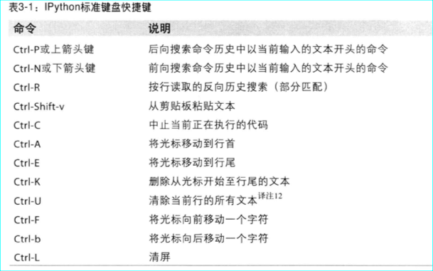

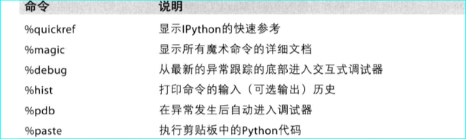

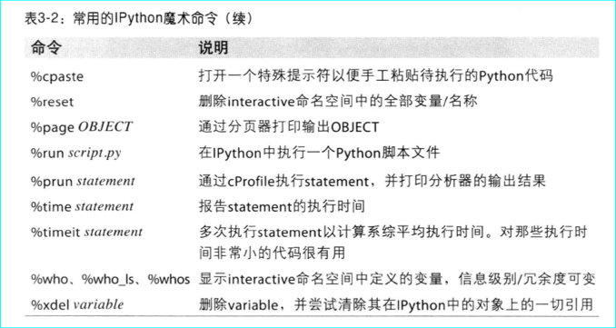

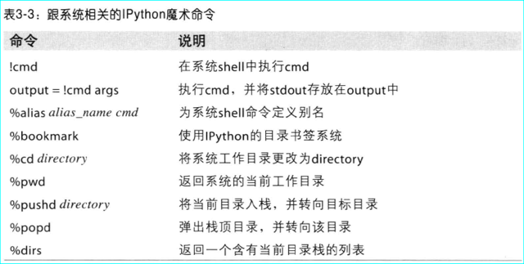



sudo /Applications/Install\ macOS\ Catalina.app/Contents/Resources/createinstallmedia --volume /Volumes,macOS --applicationpath /Applications/Install\ macOS\ Catalina.app --nointeraction