The Website will be only accessed as Administrator by one person. Everyone else who accesses the websites will have no access/authority to have privileges to change or modify data that is on the website.

The main sections of the pages that we felt that was required in this website was; Home[index], Amy, Services and Contact as following:

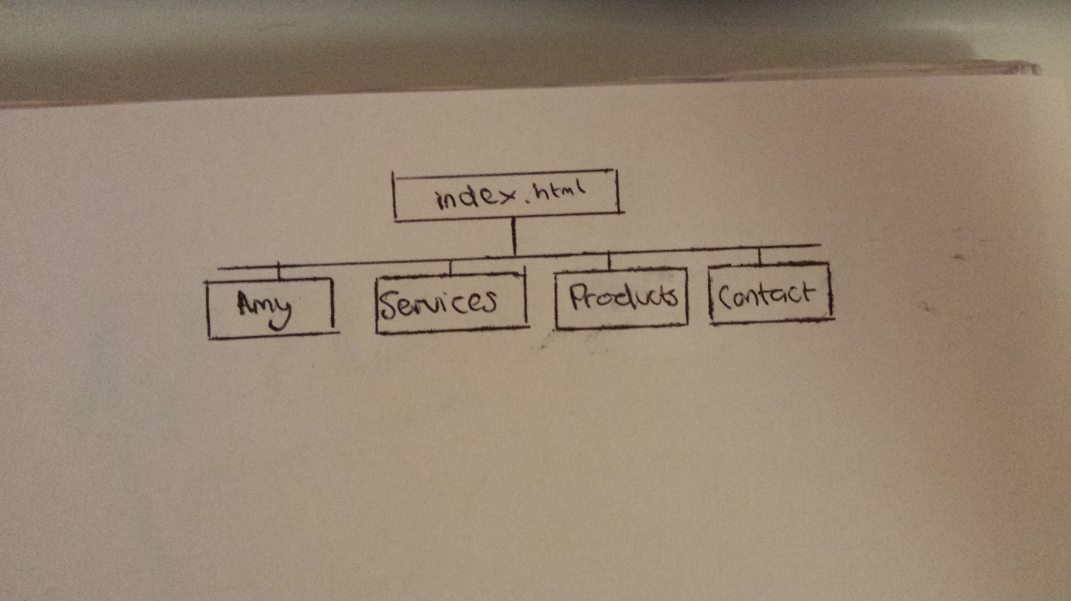

These work well as our main heading as they give the key data to the user. This was a good starting point for our website. We then expanded the page by branching other pages off these. Eventually we form a website as follows:

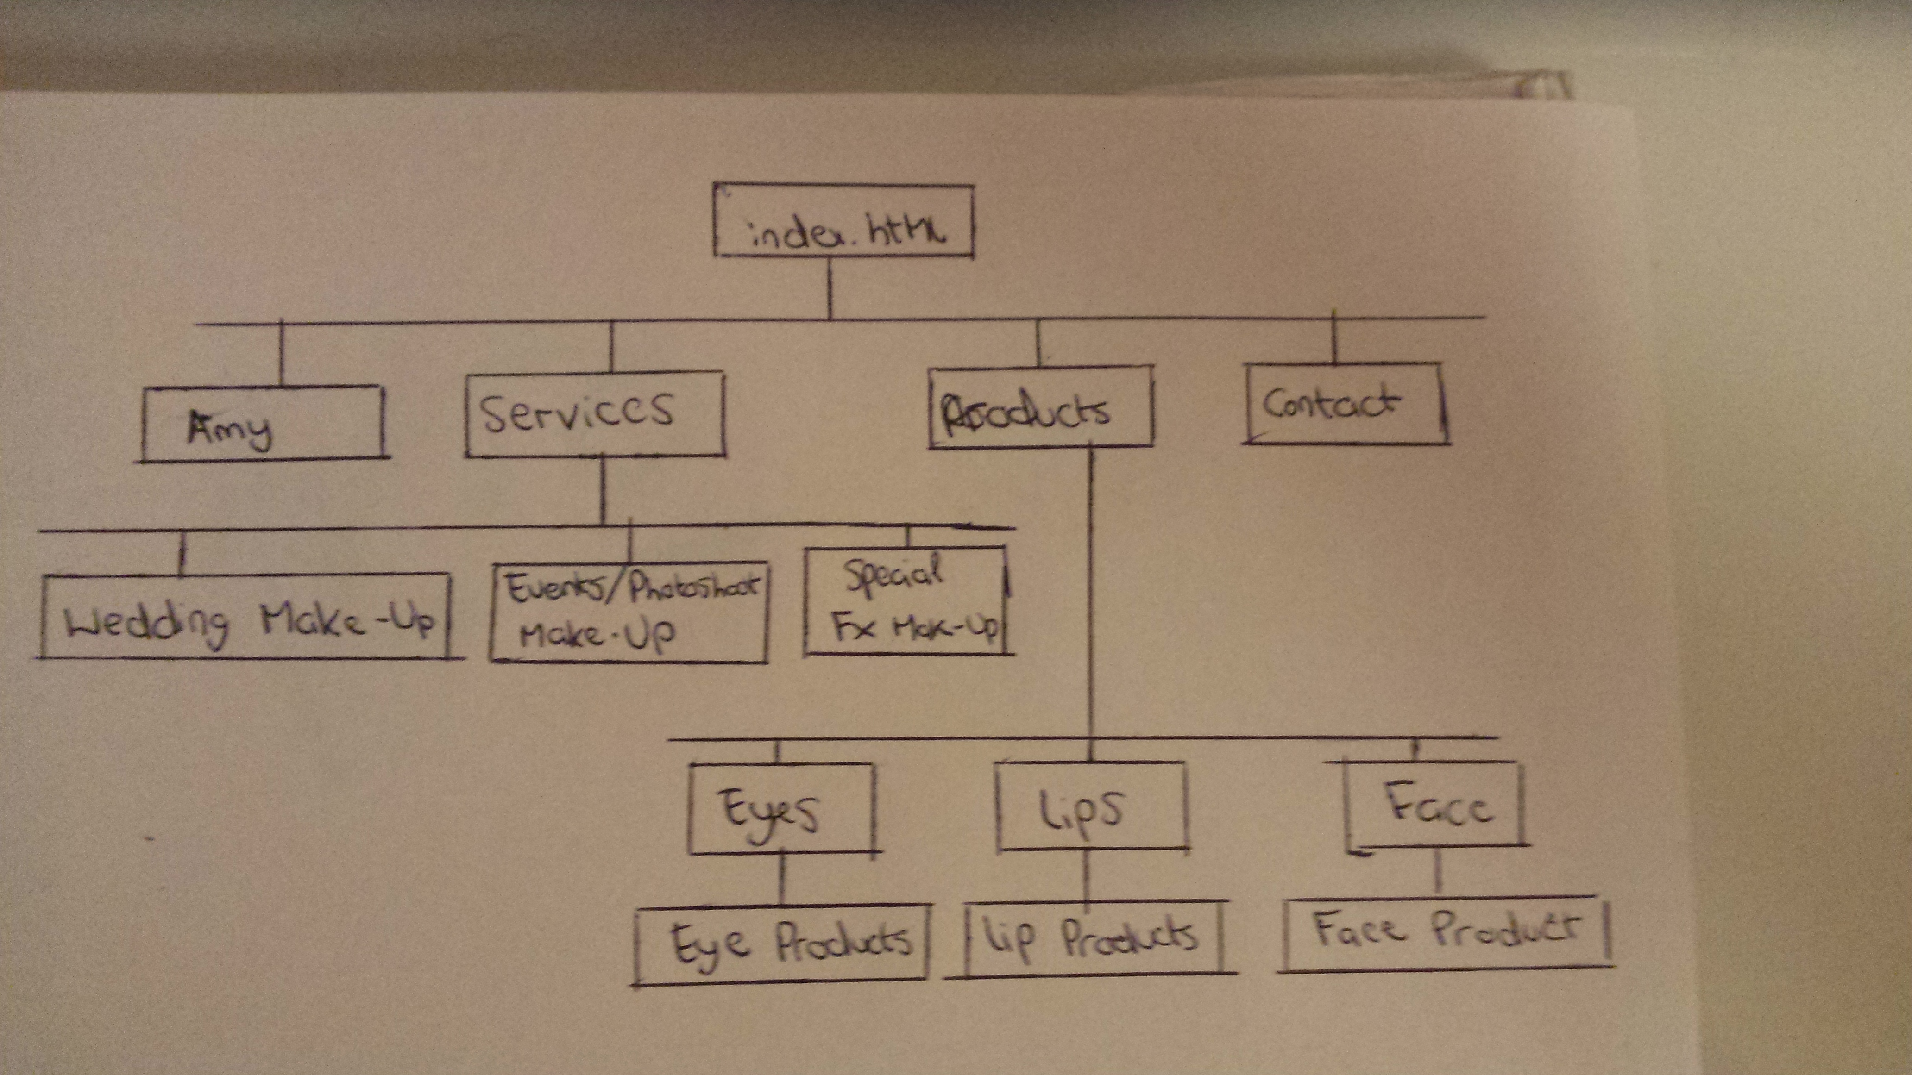

From the index page, the “Amy”, “Services”, “Products” and “Contacts” are accessible. Inside of “Services” we have place subpages “Wedding”, “Events” and “SpecialFX” pages within it which is relevant to “Services” page and they link nicely. This also works the same as the “Products” page with “Eyes”, “Lips” and “Face”. With each of these subpages are products, which over time will grow. As of right now we have inserted one product for sale within each of these page, which we are aiming to make dynamic so the content will be updateable.

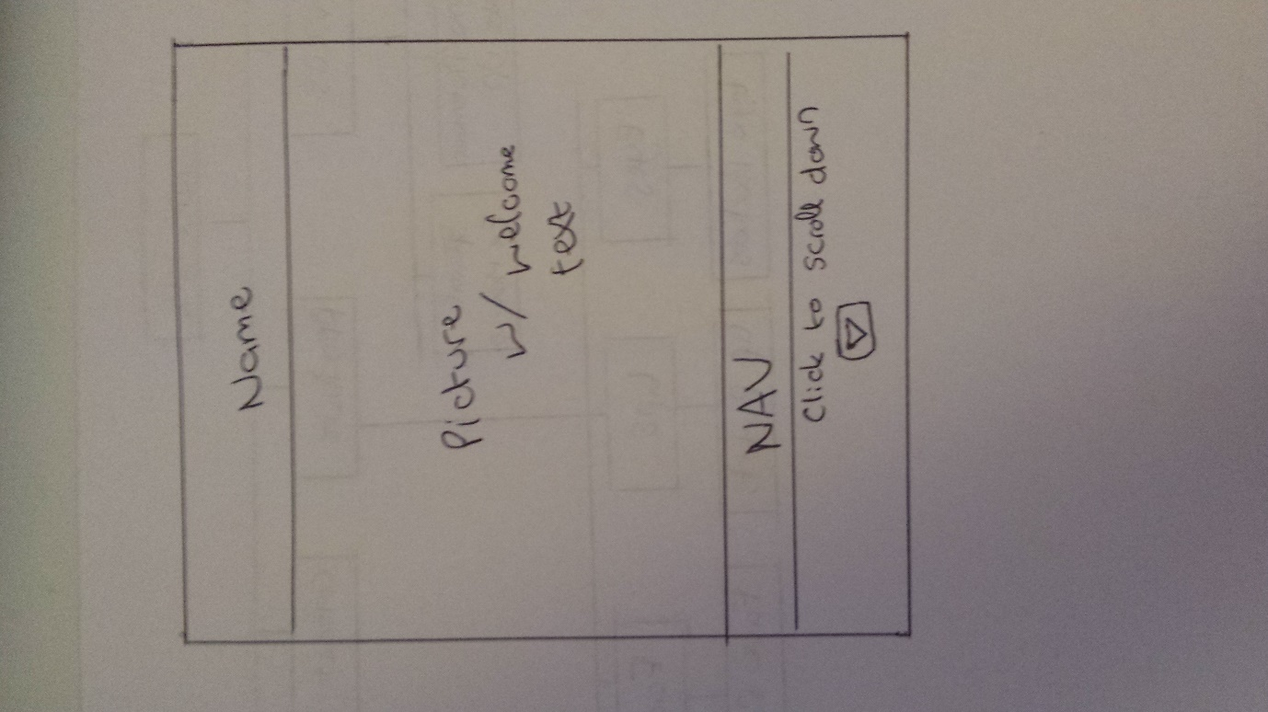

Our first sketch was a one-page layout, having all the content on one page. We quickly decided against that and chose not to go with a one-page layout, even though it was a nice feature we had far too much content for that. Plus, that sort of layout works best with a more static kind of website.

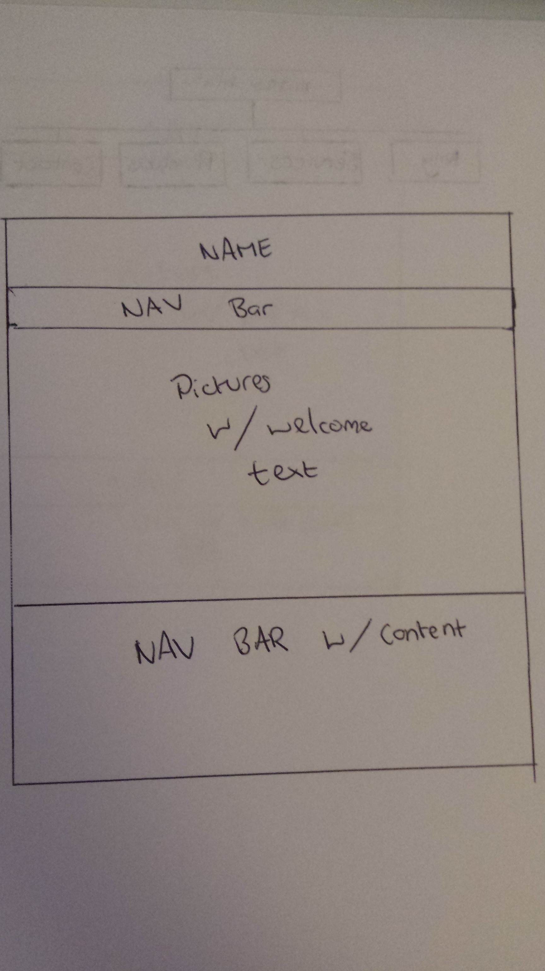

The home page will have a navigation bar on the home page, and indeed all the webpages to allow for easy access for the end user to navigate around the website. When we done our research of websites that served similar purpose, it seemed that most websites of its kind was organised in this kind of manner. As we did not want to branch too much from similar websites such as Tara Make-Up, Retro Flame, Callanberry, we wanted to give them a product that they were expecting to get.

In our design stage we had a rough idea what we wanted to achieve, most website of this kind has a similar page design which we would not like to stray from too much in case it interfered with the customer’s time on the website. We had a look around for themes that may fit our websites needs, and we managed to find a bootstrap theme that fit the purpose. The theme is <https://startbootstrap.com/template-overviews/business-casual/> . We modified the page to look exactly what we wanted to from the start. Before we started the process we felt that the background should be white to fit in with similar websites, but during creating the page we changed our minds and believed the best solution was to take a picture of the customers actually Make-Up room wallpaper, and make that act as a background picture for the website. This worked well and we decided to keep it in our final draft. We also added a carousel on the homepage to give the user a chance to view some work done by the MUA in the past. We felt this was a good to interact with the user on their first visit. As this is a static draft, our carousel won’t be fully functional until the final upload. Most images are from the customer’s previous make-up jobs, others were found on google-images. The aim is to have all original images before the final upload.

UPDATE:

We Started off with huge error with setting up the database. We both spend hours comparing other projects to this one and there didn’t seem to be any difference in the code at all. We decided to cut out losses and start a new play project, copying in our existing work. This worked, and eventually we got the database up and running.

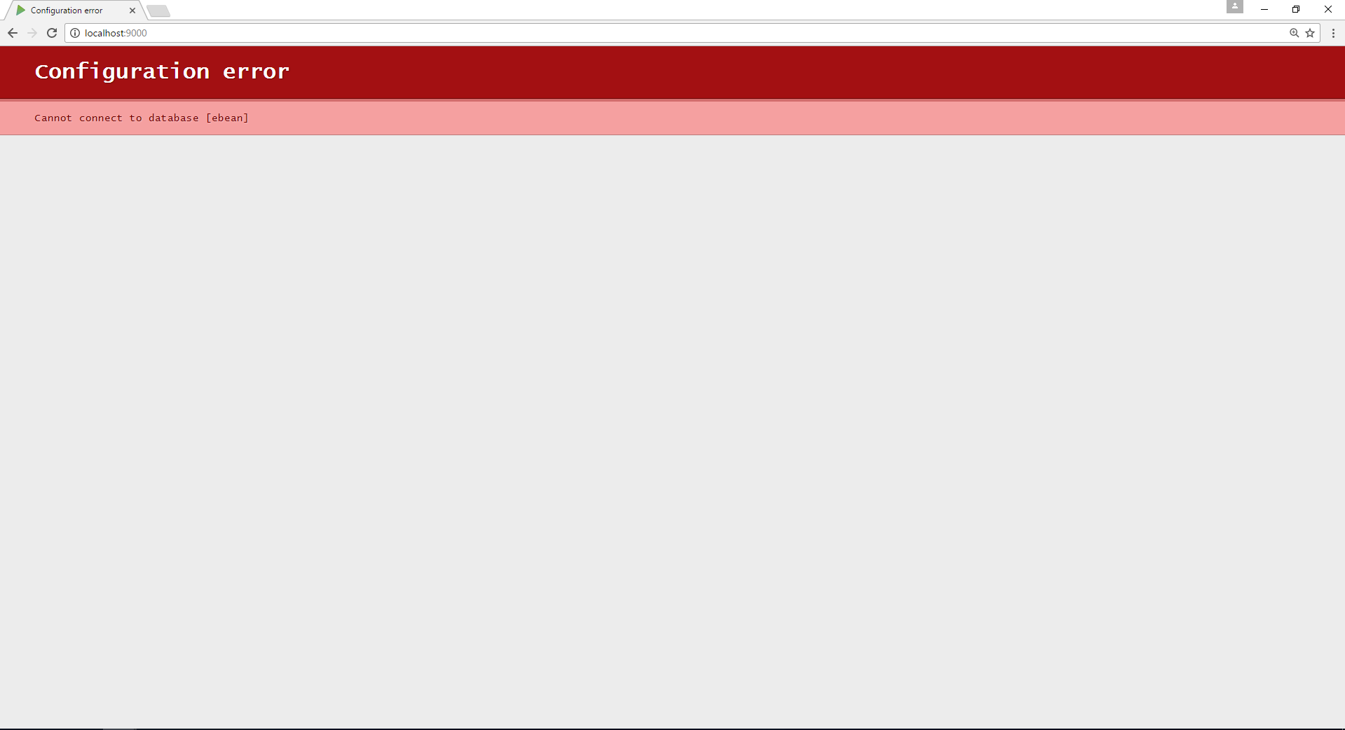

We found it difficult to apply the configuration to the original design so we had to alter it to make it work. We were initially a three-person group, put one of our members dropped out and this made the workload very demanding for us, however, the two of us contributed equally putting in a lot of work each. But as there was only two of us, we both feel we learned more from this project than if there was three in our group.