# Exercises: HTML and CSS Overview, HTML Structure - Exercises

Problems for exercises and homework for the ["HTML and CSS" course @ SoftUni](https://softuni.bg/courses/web-fundamentals-html5). Submit your solutions in the SoftUni judge system at <https://judge.softuni.bg/Contests/394/HTML-and-CSS-Overview> .

## My First Page

Create a Web Page like the following.

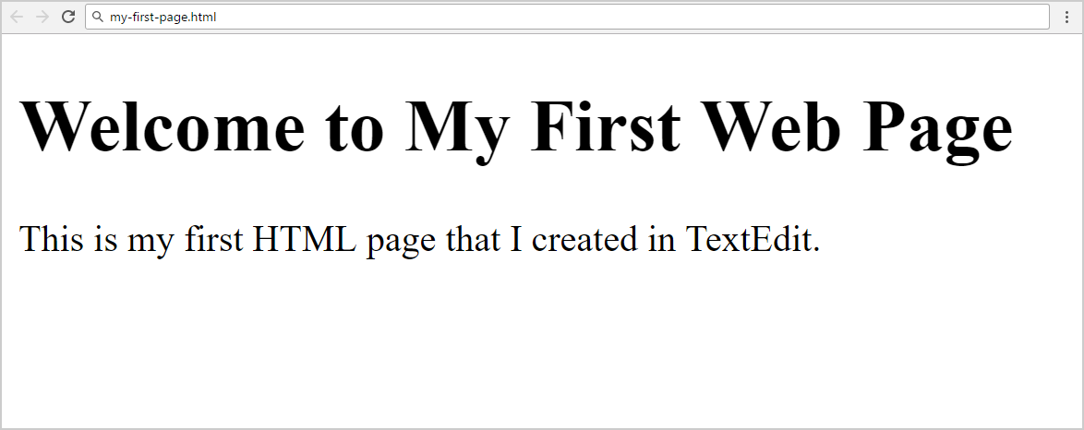

Create “**my-first-page.html**”

### Constraints

* <h1> tag for heading
* <p>tag for paragraph

## Definition Lists

Create a Web Page like the following.

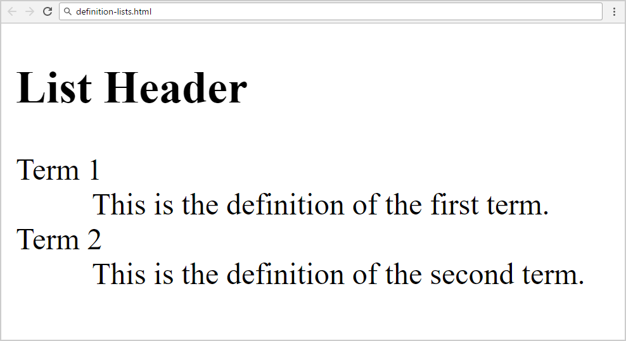

Create “**definition-lists.html**”

### Constraints

* <h2> tag for heading
* <dl>tag for definition list

## Reversed List

Create a Web Page like the following.

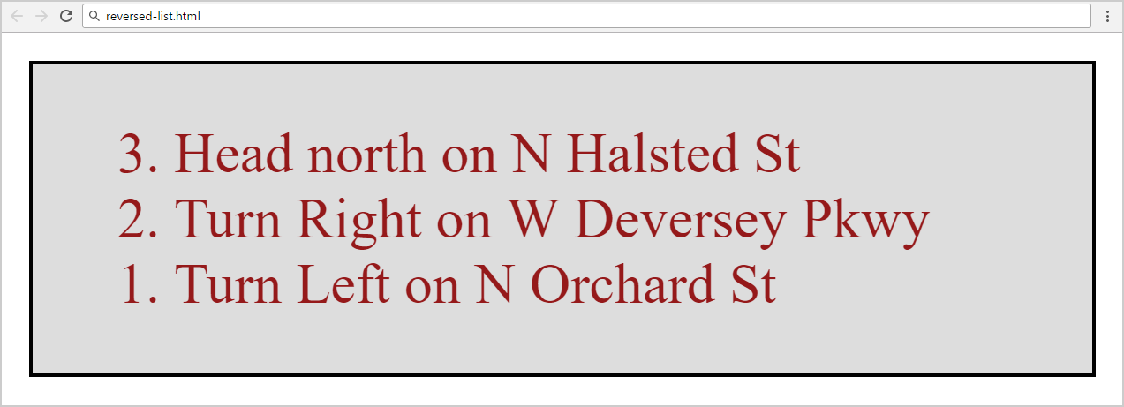

Create two files: “**reversed-list.html**”and“**reversed-list.css**”

### Constraints

* <div>with **id=wrapper** as a **container**
  + Background color: #dddddd;
  + Text color: #95191a;
  + Width container: 300px;
  + Border: 1px solid #000000;

### Hints

Use:

* <ol> with **reversed** attribute
  + <ol reversed="reversed">
* Submit **only** **reversed-list.html** + **reversed-list.css** in **ZIP** file

## The Runners Home

Create a Web Page like the following using **Runners-Home.txt**.

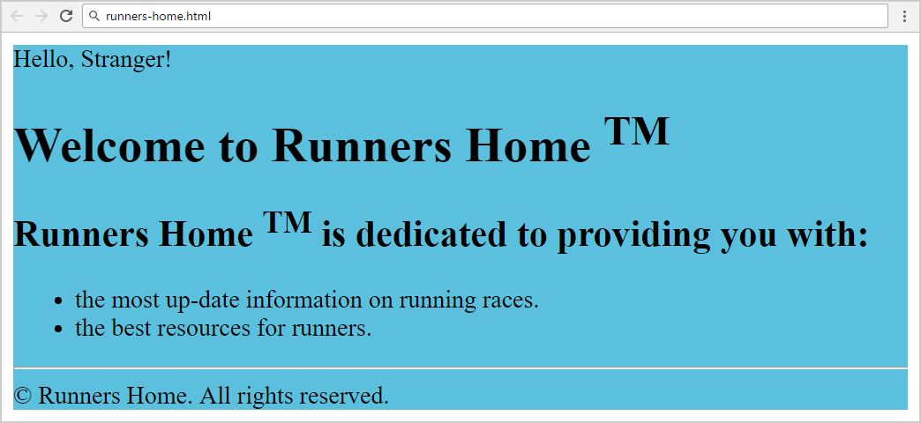

Create two files: “**runners-home.html**” and “**runners-home.css**”

### Constraints

* **<div>** with **id=wrapper** as a **container**
  + Background color: **#5bc0de;**

**Hints**

Use:

* <h1> and <h2>tags for headings
* <sup>tag for **superscript text**
* <p> tag for paragraphs and <span> for Hello, Stranger!
* <ul>tag for list items
* <hr />for horizontal line
* <footer>tag for copyright part + **&copy;** for copy right symbol

### Constraints

* **<div>** with **id=wrapper** as a **container**
  + Width container: **400px;**
  + Background color: **#dddddd;**
  + Border: **1px solid #000000;**
  + Margin Left**: 20px;**
  + Padding**: 10px;**
* **<p>** tag for paragraph + **font-size: 18px;**
* **<em>** tag for italic text

### Hints

Use:

* **<h1>** tagfor heading + **center the text**
* **<q>** tag for quotation text
  + **q::before {  
     content: open-quote;  
    }**
  + **q::after {   
     content: close-quote;  
    }**

## Simple Navigation Bar

Create a Web Page like the following:

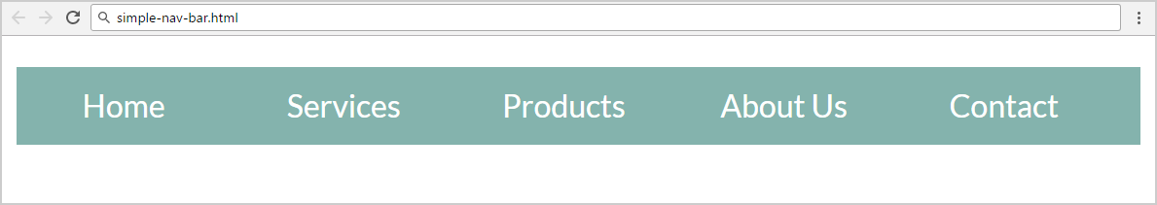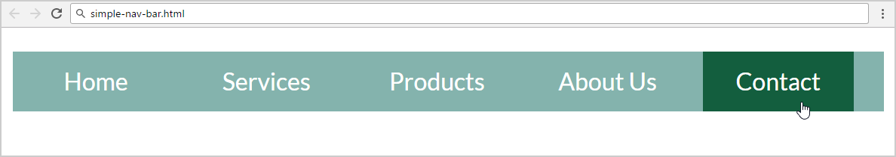

Create two files: "**simple-nav-bar.html**" and "**simple-nav-bar.css**".

### Constraints

* <body>
  + **font-family: "Lato", sans-serif;**
* <nav>tag as container
* Use unordered list in the navigation section
  + Padding: 0;
  + Heigth: 40px;
  + Line Heigth: 30px;
  + Background Color: #84b3ad;
* <li> tag for list item
  + Width: 100px;
  + Margin: 0 5px;
  + Padding: 5px 0;
  + Cursor: **pointer;**
  + Text color: #ffffff;
  + Center the text
* <li>on hover
  + Background Color: #135e3e;
  + Padding: 5px 0;
* Put a **hyperlink** in each list item in the navigation bar.
* Remove the text decoration and fix its color:
  + Put “text-decoration: none;” for the “li a” CSS selector.
  + Change the color for the “li a” CSS selector.

### Hints

* <li> with display:inline-block;in the CSS file
* Put in your CSS all @font-face definitions from <https://fonts.googleapis.com/css?family=Lato:300,400,900>

Your **HTML** file might look like this:

|  |
| --- |
| **simple-nav-bar.html** |
| <!DOCTYPE html> <**html**> <**head**>  <**title**>Simple Navigation Bar</**title**>  <**link rel="stylesheet" href="simple-nav-bar.css"**> </**head**> <**body**>  **<nav>  <ul>**  **<li><a href="#">**Home**</a></li>  *<--TODO: put the rest of list item here -->***  **</ul>  </nav>** **</body> </html>** |

Your **CSS** file might look like this:

|  |
| --- |
| **simple-nav-bar.css** |
| **@font-face** … *(include the code from* [*https://fonts.googleapis.com/css?family=Lato:300,400,900*](https://fonts.googleapis.com/css?family=Lato:300,400,900)*)*  **body** { // TODO }  **ul** { // TODO }  **li** { // TODO }  **li a** { // TODO }  **li:hover** { // TODO } |

## Simple Article

Create a Web Page like the screenshot below.

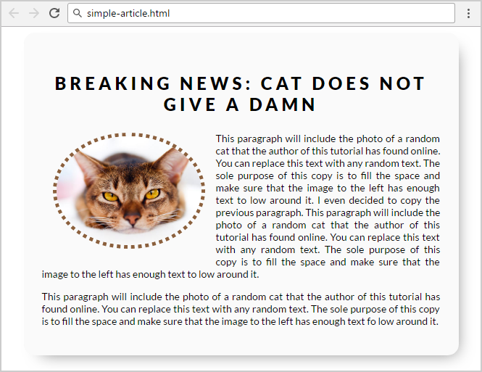

Create two files: "**simple-article.html"** and **"simple-article.css"**

Use **semantic HTML** to create HTML the page.

### Constraints

* <body>
  + font-family:"Lato", sans-serif;[**"https://fonts.googleapis.com/css?family=Lato:300,400,900"**](https://fonts.googleapis.com/css?family=Lato:300,400,900)
* Content
  + Width: 550px;
  + Border radius:15px;
  + Center the content
  + Padding: 25px;
  + Background color: #fafafa;
  + box-shadow: 10px 11px 35px -14px rgba(0,0,0,0.54);
* <h1> tag for heading
  + Margin bottom: 0;
  + Padding: 10px;
  + Text center
  + Letter spacing: 5px;
* **Image**
  + Width: 200px;
  + Border radius: 50%;
  + Margin: 15px;
  + Border: 5px dotted #8b603d;
  + Use “**left floating**” for the image: <https://css-tricks.com/almanac/properties/f/float/>
* **Paragraphs**
  + Text size: 14px;
  + Use “text-align: justify” to align the text left and right (learn more at <http://www.w3schools.com/css/css_text.asp>).

## Table

Create a Web Page like the following.

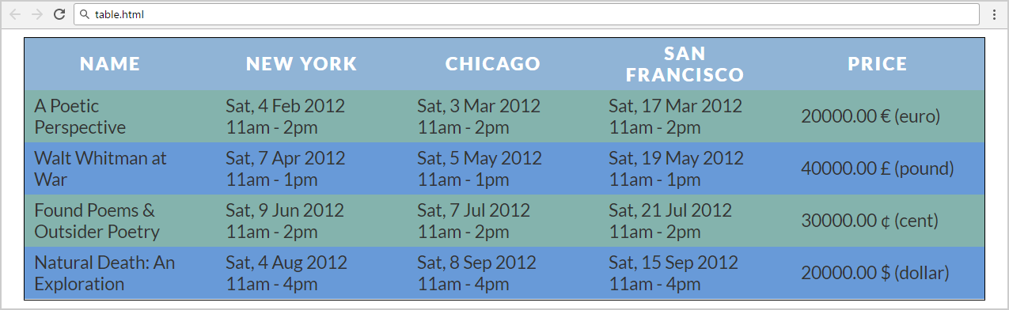

Create two files: "**table.html**" and "**table.css**".

Use **semantic HTML** to create the page.

### Constraints

* Font-family: "Lato", sans-serif;
* Table
  + Text color: #333333;
  + Border spacing: none;
  + Center the **table**
* Table headings
  + Text color: #ffffff;
  + Background color: #90b4d6;
  + Center the text
  + Letter spacing: 2px;
* Table headingfor bold text
  + Padding: 5px 30px 5px 10px;
  + Text size: 18px;
  + Margin: 0;
  + Text align: **left;**
  + Background color: #84b3ad;
* Table data
  + Padding: 5px 30px 5px 10px;
  + Text size: 18px;
  + Margin: 0;
  + Text align **left**
  + Background color: #84b3ad;
  + Width: 150px;

### Hints

Use:

* **tr:nth-child(even) td, tr:nth-child(even) th** { Background color: **#689ad8;**

}

* Search search in Internet for the **HTML entities** representing the currency symbols: <https://www.google.bg/search?q=html+entities+currency+symbols>.