# Lab: Introduction To Bootstrap - Exercises

## Simple Design

Create a Web Page like the following:

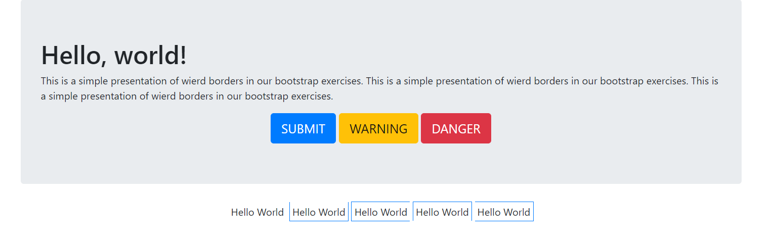

### Constraints

* Search for bootstrap classes to make this type of styles(try to use Bootstrap only)

## Form

Create a Web Page like the following.

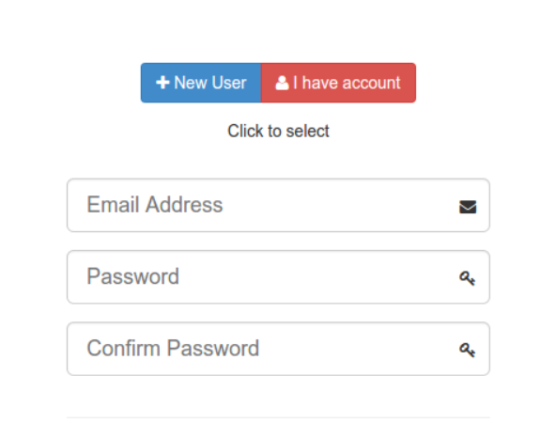

Create one file: **"form.html"**.

### Constraints

Search for: [Bootstrap Glyphicons](https://www.w3schools.com/icons/bootstrap_icons_glyphicons.asp)

## Clean Blog

Create a Web Page like the following:

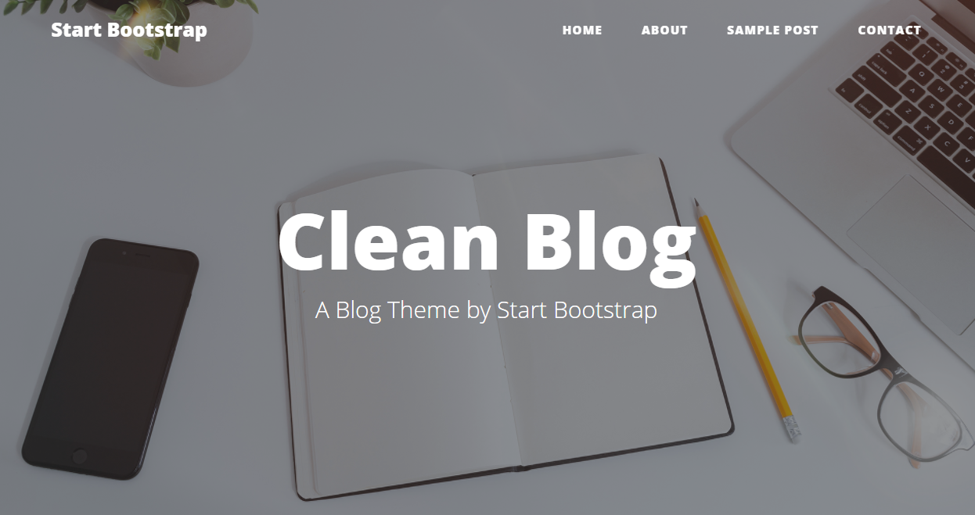

Create one file: **"blog.html"**

### Constraints

Use random picture for background

Search in:

<https://hackerthemes.com/bootstrap-cheatsheet/>

and

<https://getbootstrap.com/docs/4.0/getting-started/introduction/>