# Lab: Introduction to AJAX

Problems for in-class lab for the [“JavaScript for Front-End” course @ SoftUni](https://softuni.bg/courses/javascript-for-front-end).

## AJAX Load

Use **jQuery** to **write** a JS function that loads an online resource into a div with **id "text".** Make a request to "**text.html**" and replace the target div’s content with the returned **HTML**. Create the files ajax-load.html and text.html and place them in the same folder, so that your script can find the latter.

Submit your loadTitle function.

### Skeleton

|  |
| --- |
| **ajax-load.html** |
| <!DOCTYPE html>  <html lang="en">  <head>  <meta charset="UTF-8">  <title>AJAX Load Example</title>  <script src="https://code.jquery.com/jquery-3.1.1.min.js"></script>  </head>  <body>  <div id="text">  <h1>AJAX jQuery.load()</h1>  <button onclick="loadTitle()">Load Title</button>  </div>  </body>  </html> |

|  |
| --- |
| **text.html** |
| <h1>Voilla!</h1>  <p>I am a text loaded with AJAX request</p> |

|  |
| --- |
| **ajax-load.js** |
| function loadTitle() {  *// TODO*  } |

### Examples

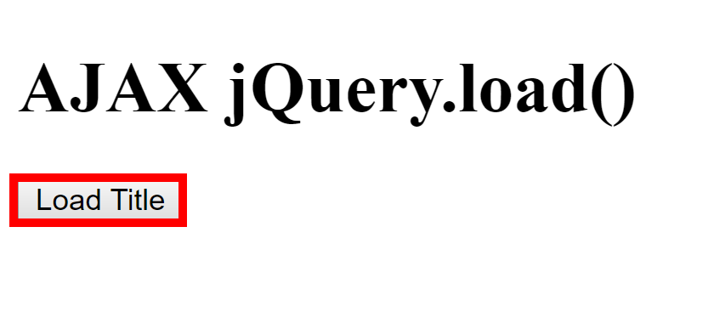 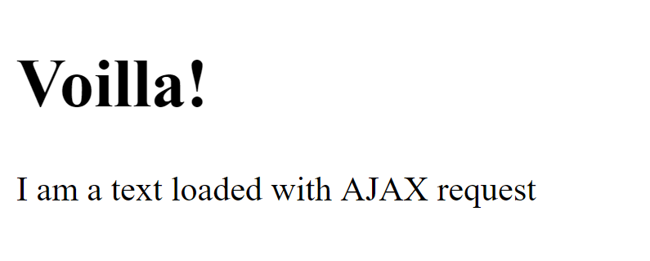

## Github Repos

Your task is to **write** a JS function that **executes** an **AJAX** request with **jQuery** and loads all user **github repositories** by a given username (taken from input field with **id "username"**) into a **list** (each repository as a **list-item**) with **id** "**repos**". Use the properties full_name and html_url of the returned objects to create a link to each repo’s GitHub page. If an **error** occurs (like 404 “Not Found”), **append** to the list a list-item with **text** "Error" instead. Clear the contents of the list before any new content is appended. See the **highlighted lines** of the skeleton for formatting details of each list item. Submit your loadRepos function.

### Skeleton

|  |
| --- |
| **github-repos.html** |
| <!DOCTYPE html>  <html lang="en">  <head>  <meta charset="UTF-8">  <title>GitHub Repos</title>  <script src="https://code.jquery.com/jquery-3.1.1.min.js"></script>  </head>  <body>  GitHub username:  <input type="text" id="username" value="k1r1L" />  <button onclick="loadRepos()">Load Repos</button>  <ul id="repos">  <li>  <a href="*{repo.html_url}*">  *{repo.full_name}*  </a>  </li>  </ul>  <script>  function loadRepos() {  *// AJAX call …*  }  </script>  </body>  </html> |

### Examples

