## Problem 1 – Art Gallery

Create a Web page (HTML5 + CSS3 + images) that looks and behaves like the screenshots below:

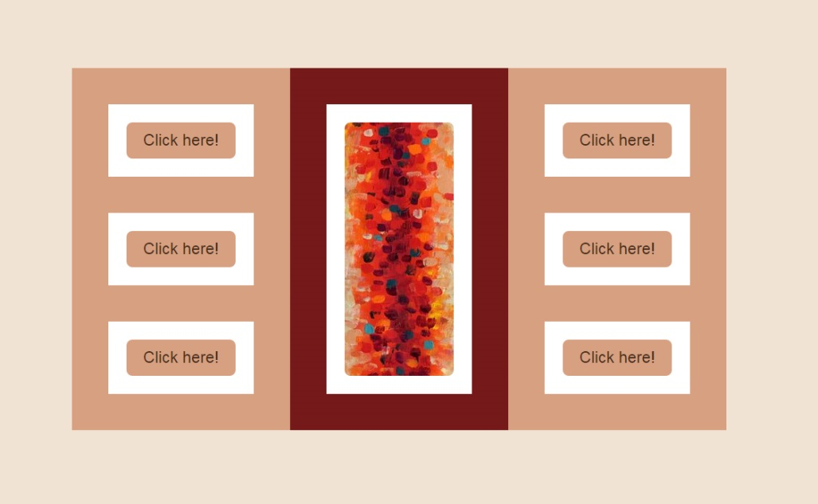

* The hand cursors in the screenshots show what happens when the mouse moves over certain elements.

### Input

You are given the above screenshots + all required images + the texts on the site.

### Output

The output should be valid HTML5 + CSS3 + images that implement the above Web page.

### Constraints

* Font: Arial, Helvetica, sans-serif
* Font size: **22px**
* Container width: 900px, height: 500px
* The site should open correctly in Chrome 35.
* Responsive design is not required.
* Pixel-perfect implementation is not required.