## Problem 2 – Blues Page

Create a Web site (HTML5 + CSS3 + images) that looks and behaves like the screenshots below:

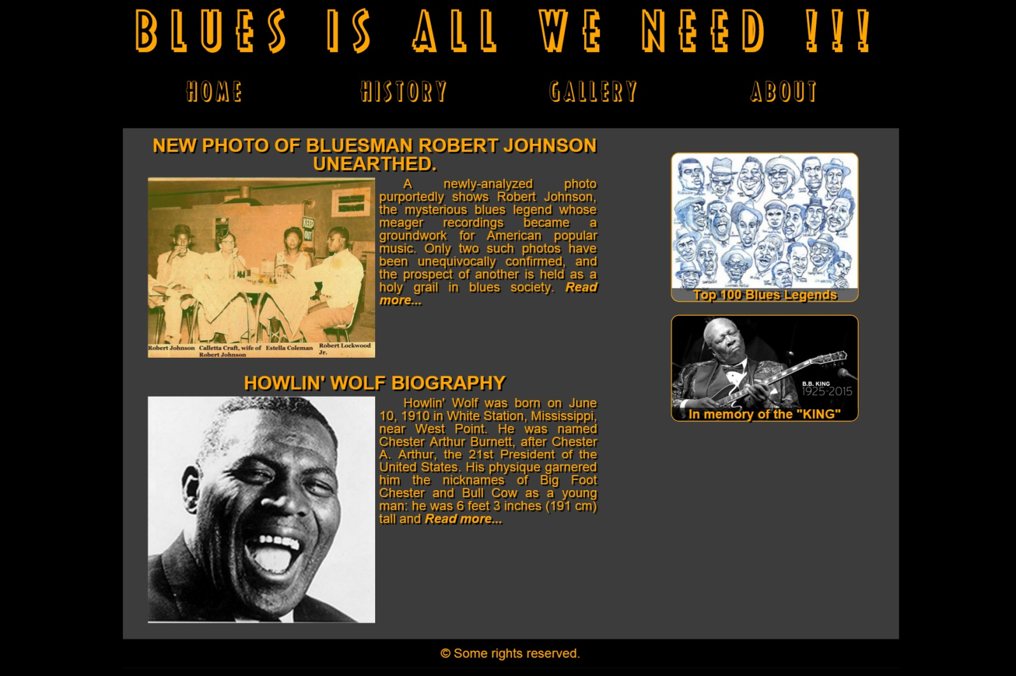

* The hand cursors in the screenshots show what happens when the mouse moves over certain elements.

### Input

You are given two screenshots + font (RicksAmericanNF.ttf) + the texts + the images on the site.

### Output

The output should be valid HTML5 + CSS3 + images that implement the above Web site.

### Constraints

* Fonts:
  + Site content: Arial, Helvetica, sans-serif; 16px.
  + Header title: 60px.
  + Navigation font size: 30px;
  + Article title: 23px;
* Site content: fixed width 960px.
* The site should open correctly in Chrome 45+.
* Responsive design is not required.
* Pixel-perfect implementation is not required.
* Take the colors from the pictures with color picker.