Hello to all. This is a quick introduction on how to use this plugin. In this tutorial you will learn how this works, what limitiations are present and most importantly how to setup all of this. So let’s start!

First of all, I will list all things that you need to have or know before you can proceed with installation.

- Your Xbox must be softmodded or hardmodded
- You have installed XBMC4Xbox on your Xbox as application or default dashboard
- Know how to use FTP to transfer files between your PC and Xbox (or some other way to do this, but FTP is most preferred and easiest method)

Now, I will list some limitations that will be bypassed in some future (I hope):

- video length – on Xboxes with 64MB RAM don’t play videos which are longer than 1h. On Xboxes with 128MB RAM you can play videos of 3h length. I currently don’t understand how adaptive streams works, neither I know how to implement them on Xbox, so I’m using formated streams which must be loaded in RAM memory. I hope I will fix this in some future.

I hope this limitations will be fixed in the next release of this plugin. :) Now we are ready to introduce this plugin and explain how to setup everything.
This plugin is using Invidious APIs for fetching data from YouTube. Unfortunately for us, XBMC4Xbox is using OpenSSL 0.9.8 which doesn’t support newer versions of TLS encryption. To bypass this, I have created simple backend in Node.js that acts as a gateway between our Xbox and Invidious API. First, Xbox send request to this gateway which passes that request to Invidious API. When Invidious API return some response, gateway passes that to the Xbox. Hovever, if some day, someone host Invidious Instance (API) that doesn’t require TLS1.2, changing only one line of code in this plugin will make it completely independent of PC API (gateway). So when we understand how this works, let’s show how to setup this.

First, go to this link and download latest release. When downloading is finished, extract downloaded archive. After extracting, you will find two folders:

- PC – inside this folder you are going to find another folder called “xbox-backend”. This is actually a gateway. It’s simple PC application that can run on any operating system and can run on any device (Desktop, Laptop, Raspberry Pie).

- Xbox – inside this folder you are going to find another folder called “YouTube”. This is plugin for XBMC4Xbox.

Let’s now explain how to use this. First of all, head to the xbox-backend folder, and open executable file that corresponds to your operating system. If you are on windows after opening bin-win.exe, cmd window should pop up like it’s shown on picture below. If you get “Windows Security Alert” just click on “Allow access”. In red box, you can notice two imporatnt thigs. First is IP ADDRESS of gateway (actually ip address of device on which this gateway is running; 10.0.2.15) and PORT on which gateway is running (9007). Remember or write somewhere this two informations, because we will need them later.
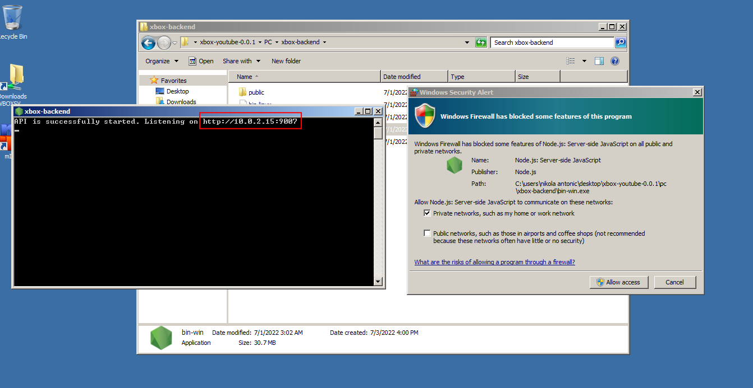
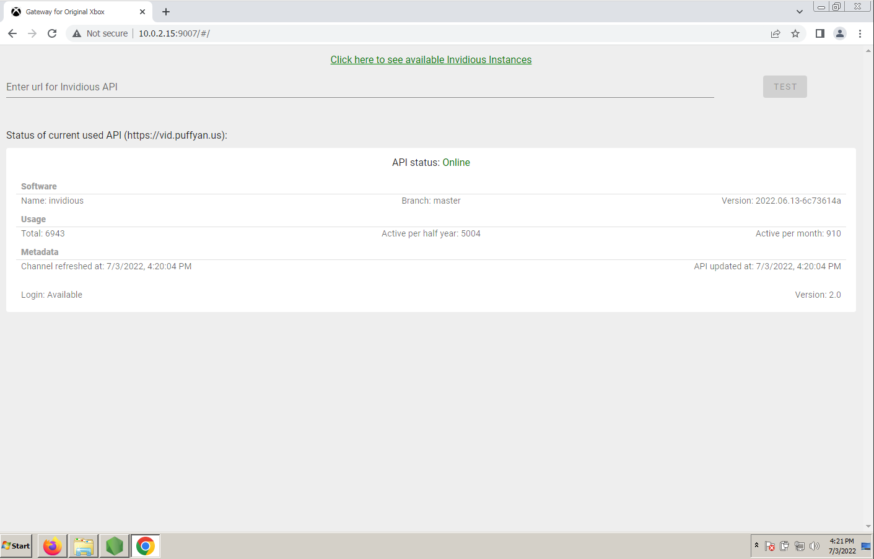
Now I will explain how you can use GUI of this Gateway to check status of current used API and also how to change to another API. In your prefered browser go to web address on which gateway is listening/running. In my case it’s “http://10.0.2.15:9007”. After that, you should see GUI of gateway as shown on picture below.

If current used API is online, you will get status informations. If it’s not you will get notification that informs you about that. If you click on green text that says “Click here to see available Invidious instances” you will be promted to https://api.invidious.io/. On this web site you will find all official available Invidious instances (APIs) that you can use. If there is instance from your country, use that. Now I will explain how to update to the new Invidious instance (API). Copy name of Invidious instance that you want to use (ex. yewtu.be), head to the GUI of gateway, and in text field enter url of that instance in format “https://name” (in my case it’s https://yewtu.be). After that clik on Test button, and if everything is alright you will get status of that instance. After clicking on Update API button, instance will be updated and saved, and you will be informed via notification.

This is basically tutorial how to setup PC Gateway and how to use it. One important thing to keep in mind is that PC Gateway and Xbox must be in the same network. For example, your local home network. Now let’s explain how to setup plugin for XBMC4Xbox.
First, head to the Xbox folder and copy YouTube to Q:/plugins/video on your Xbox. plugins/video is located at XBMC4Xbox installation folder, and if you are using FTP to transfer files it’s Q:/plugins/video. After that, head to the Videos → Plugins and if everything is alright you will se YouTube plugin installed. Click white button on your controller and go to Plugin settings. Inside Gateway (PC) Ip Address enter Ip Address of gateway (in my case 10.0.2.15) and below that PORT of gateway (in my case 9007). After that click on OK button, and you should be ready to use YouTube on Original Xbox!
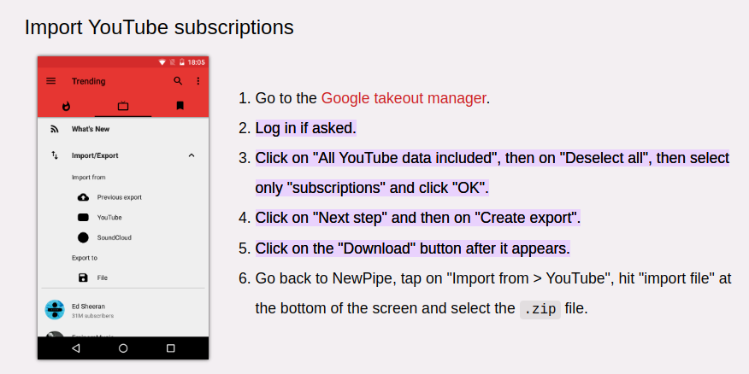
Now we are ready to use this plugin. You can also import Subscriptions from your YouTube account. First of all, you need to export Subscriptions from your account. You can follow tutorial on picture below which is taken from NewPipe website.

When you done this, after extracting downloaded archive, inside Takeout → YouTube and YouTube Music → Subscriptions you will find file called “subscriptions.csv”. Copy this file to root of E:\ partition of your Xbox. Then go to plugin, press white button on joypad, go to Plugin settings, and when settings window popup, go down below and press “Import subscriptions from YouTube”. If everything is alright, you will get notification about successful import.

That’s it. If you have any problems or find some bugs please open Issues at github page or ask on OG Xbox topic. Here is video: https://www.youtube.com/watch?v=At9XPKZNprM

