Stream Movies & TV Shows
Original Xbox

Hello guys, I’m proud to release my first ever project for my favourite gaming system, Original Xbox. Everything started with my desire to learn skinning for Kodi, and because Kodi originated on Xbox, then known as XBMC (XBox Media Center), I decided to make this thing (Xbox :D) play and stream movies from internet and to show all haters and PS2 fanboys why this console was ahead of it’s time and why there is a huge homebrew scene 20 years later. Also, I’m impresed of what console with Pentium 3 processor and 64MB of RAM is capable of. Enough intro, let’s dig in.

Structure of app
This app is actually consistent od two main APPs. One is for Xbox (Xbox App further in text), and other is for your PC/Laptop (PC API further in text).

App for Xbox is actually python script for XBMC4Xbox with custom GUI created with custom XBMC skinning engine based on Xbmc Origins, Embuary skin fo Kodi and UI of Xbox Series X/S. This app communicate with TMDB API and shows all results which that API returns. When you want to watch something, Xbox App request from PC API available streams for that movie/tv show, then you pick one stream and after that PC API start streaming that movie/tv show on Local IP Address from which Xbox play video.

PC API is actually javascript app that offers torrent search engine and downloading and streaming torrents. Because Xbox is not powerful to handle 720p/H.264/5 or anything above that I used ffmpeg to real-time convert movie to 720p/H.263. Frontend of this app is done in Vue.js framework with Vuetify and it’s inspired by VueTorrent UI.

So, now when you know how this app actually work, I think it’s time to see how to setup everything.

Setup guide
First of all , let’s see what you need to have in order to use this app:
- Softmodded or hardmodded Xbox
- Installed XBMC4Xbox as default dashboard
- [OPTIONAL] 128MB RAM upgraded Xbox
- PC with decent x64 CPU and 4GB or more RAM
- PC with Windows (7+) or Linux

As you can see, you don’t need anything special. I won’t take you through steps how to softmod your Xbox or how to install XBMC4Xbox. There is plenty of tutorials which covers that on YT and OGXbox forums. For YouTube I recommend Mr.Mario.

Let’s begin tutorial how to setup this app on your Xbox and PC. First we will setup PC API and after that we will setup Xbox app. If you ever softmodded Xbox, installed custom dashboards or any other homebrew app this tutorial will be easy for you.
First of all head to the GITHUB and download latest version of app (at time of writing is v0.0.1-alpha.1) for your PC depending on which OS you are using. I recommend using portable version but there is also .deb, .rpm and setup file for Windows. Everything I wrote will be for Windows for two reasons:

- windows is the most popular system
- if you are using Linux you know how to setup this without any tutorial

When you open GITHUB link under “Assets” you will find releases. Download “xbox-streaming-win32-x64-0.0.1-portable.zip” and downloaded it. You can also download “xbox-addon.zip” which we will user later in tutorial when we will be setting up Xbox. When downloaded unzip “xbox-streaming-win32-x64-0.0.1-portable.zip” and in folder “xbox-streaming-win32-x64” you will find “xbox-streaming.exe” which you can run.
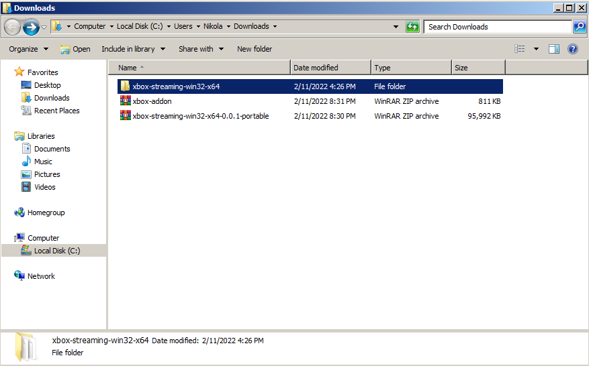
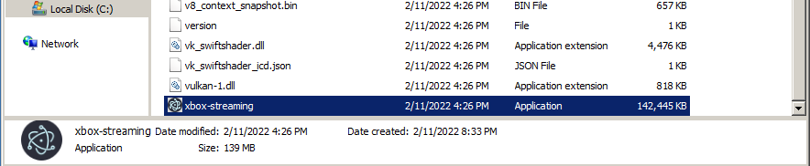
Picture 1.1 When extracted

Picture 1.2 Location of .exe file

When you open app if everything is alright in front of you will pop up window like on picture above. If you get Window Security Alert press “Allow Access”.
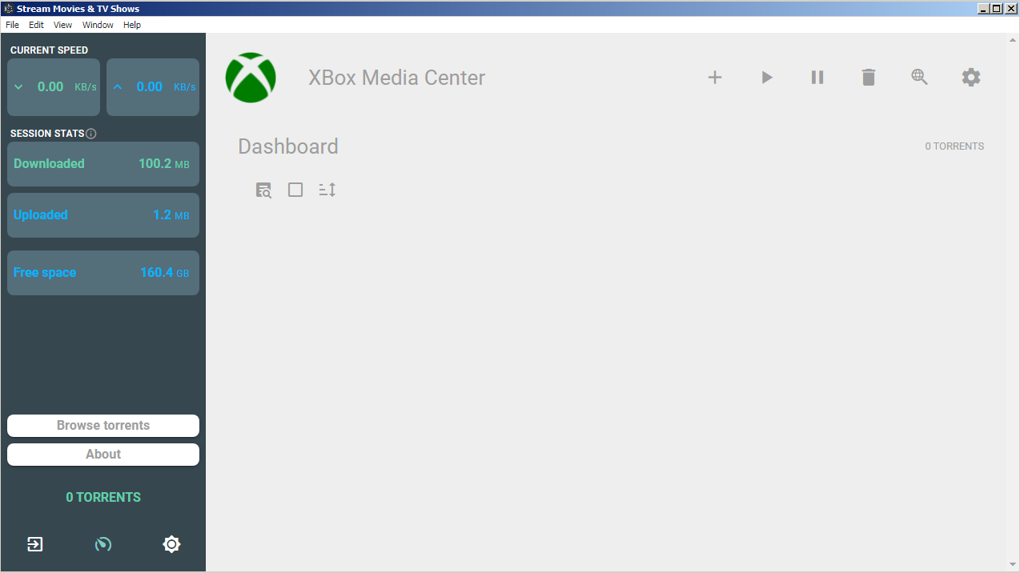
Picture 1.3 PC API Dashboard

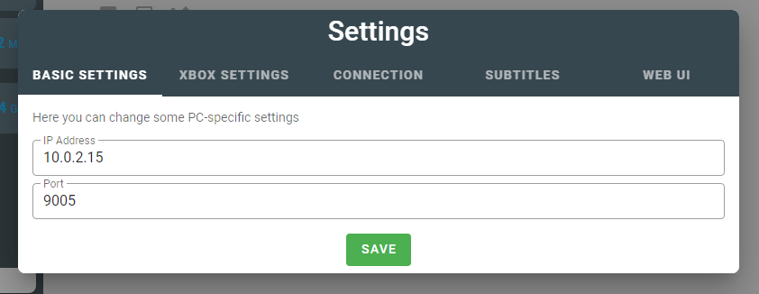
Next thing to do is setup IP ADDRESS and Port (by default 80 in XBMC4Xbox) of your Xbox in Settings. Open Settings located in right top corner and you will get this window:
Picture 1.4 Settings

First of all in Basic Settings remember or write on some paper IP Address and Port. This is IP ADDRESS of your PC on Local Are Network and Port is port on which PC API is running. This is needed for Xbox App because when Xbox wants to send some request to PC API it needs to know on which address and port PC API is running. After that open Xbox Settings and enter IP Address of your Xbox. This is used when you want to remote start playing video on your Xbox (when you right click on torrent and press Play on Xbox). You can get IP Address of Xbox by going to: System → System Info → Network. When you did all this, your PC API is ready to be used. Now we will setup Xbox App.

If you didn’t already downloaded, download from GITHUB “xbox-addon.zip” and extract it. Inside of it you will find “Stream Movies & TV Shows” folder. This is script for XBMC4Xbox. To install it copy “Stream Movies & TV Shows” to scripts folder of XBMC4Xbox installation folder. In most cases it is “E:\Apps\XBMC\scripts”. Again I suppose you know how to transfer files on Xbox using FTP and FileZilla. If you don’t there is a plenty of tutorials.

When you did this, now is time to configure some things in XBMC4Xbox. Head to the System → Settings → Network → Services and enable “Allow control of XBMC via HTTP”. Port should be 80 by default (like in our PC API settings for Xbox). Username should be “xbmc” and password should be blank. To set password blank open it, delete all and press DONE. There should be seven stars, that means that password is blank. This allows us to control XBMC4Xbox via HTTP (option to remote start playing video in PC API app).

Okey, know it’s time to open our Xbox App. Head to the Programs → Scripts → Scripts and hear you should find “Stream Movies & TV Shows” with PopCorn Time icon. When you first time open script you need to enter HOST ADDRESS and Port. Remeber when I say to you to remember or write on papir? Well, this is it. In Host Address type IP ADDRESS of your PC and in Port port on which PC API is working. Here is example.
Picture 2.1 First time setup

Then press “Save Settings” and if everything went well you should see home page for movies like on picture below:

Picture 2.2 Home page

One thing you need to keep in mind. IP Address of yours PC is dynamicaly calculated by Internet Router. In some future IP ADDRESS can change and because of that you need to update HOST ADDRESSS in Xbox App. You can do that by pressing “Start” button when you are one home page which will open Settings dialog exactly same as on picture 2.1. Port will be almost all time same, but if you try to run two instances of PC API on same PC port can change. If port is somehow taken by another process PC API will find first available and used that.

In the end, thanks to all who use my app I hope you enyoy watching movies on 21 year old console. Cheers!

