Task 1 report

Human-computer interaction

Antoni Forzpańczyk a2019156557  
Jędrzej Szor a2019156734

Introduction

Through the world’s technology development along humanity’s history most of devices, equipment or everyday tools are made especially to be used by people. Thus those inventions should be made to be most user friendly as well as easy to cope with. Nowadays, people are overwhelmed by technologies and solutions to entertain, teach or simply to make life much easier. However, sometimes inventors does not take users’ usability of their products at the very first place. Below we will present some particular badly designed devices in user’s perspective in addition we will provide one example of well-developed and designed product to be used by common people.

Two taps

Everyone uses tap in the bathroom to wash hands. Warm water feels good as well as helps to provide soap well. This simple activity made many times per day should be automatic and as easy as it is possible.

Nevertheless, there are situations when washing hands can frustrate person. Especially when you have two taps instead of one. One is for really cold water and other one is for very hot. With that solution there is no option to wash hands in convenient temperature. You need to choose whether freeze your hands or burn them.

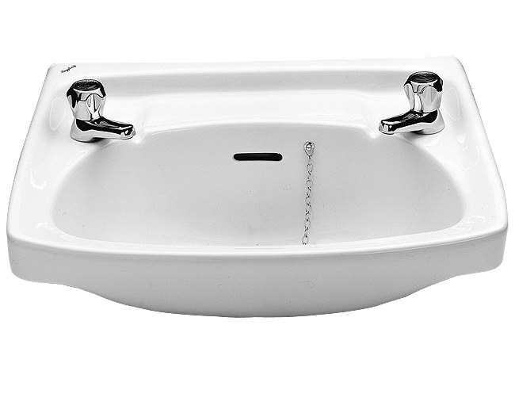

That solution is common in United Kingdom and was described in BBC’s article: <https://www.bbc.com/news/uk-england-42948046> It shed a light on historical issues when water was provided to citizens’ households. Taps were separated to eventually avoid contamination between two sources of water. In addition there was a significant imbalance in pressure in pipes. In addition cold one came from local supply and was fit to drink.

Along technology development, when cold and hot water come from one supply source it can be mixed. Cities provide hydraulics which ensure us with clear water to be mixed through one tap.

Warm oven using timer

Kitchen is the specific place in household where there is plenty of advanced devices which are supposed to be as user-friendly as possible. However, there are some inappropriate solutions developed in kitchen devices. In our apartment in Coimbra, we have oven which needs to have timer set at any time to warm itself to previously set temperature. In that case when we set timer to not enough, oven will switch off with too low temperature inside or to too much over will work and heat itself for too long time with results in waste of electrical energy.

Obviously, oven has temperature detector and will notify when temperature is reached, but it requires standing next to it and watching the notification diode.

The best solution would be to develop the system which shuts down the oven and notifies owner loudly. This will provide user some spare time to cope with other things in household.

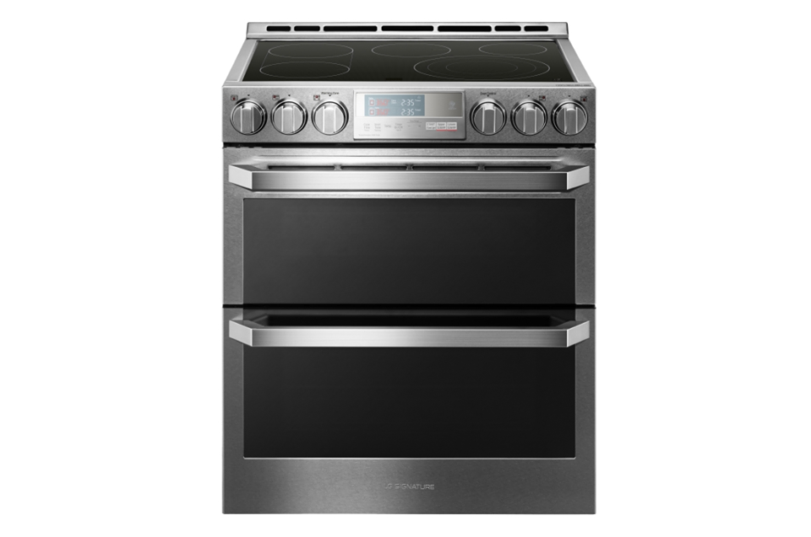

Windows 8.1

Windows 8 was created as a successor of Windows 7, however it was not only a PC operating system. It was aimed to be an OS for computers and mobile devices as well. It ended up in being completely unusable on both. Using system which is created for touchscreens on a computer without touchscreen is really uncomfortable. One of the issues were the infamous “tiles”. When user logged in he did not see his desktop as in all of the previous systems, but a screen filled with tiles. One of them was desktop but in order to proceed to the home screen user had to find the right tile and click it. It was really confusing, pointless and it completely destroyed the habits created while using all of the previous versions of Windows. A simple way to incorporate tiles and keep the intuitive design would be to proceed right to the desktop after login but leave a possibility to go to the tile screen.

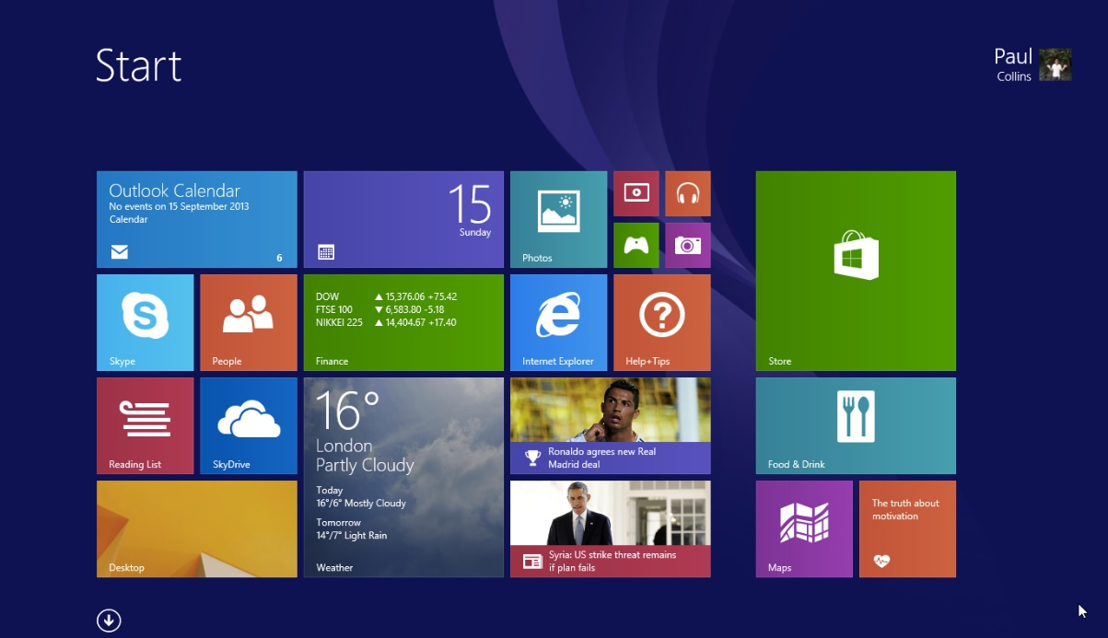

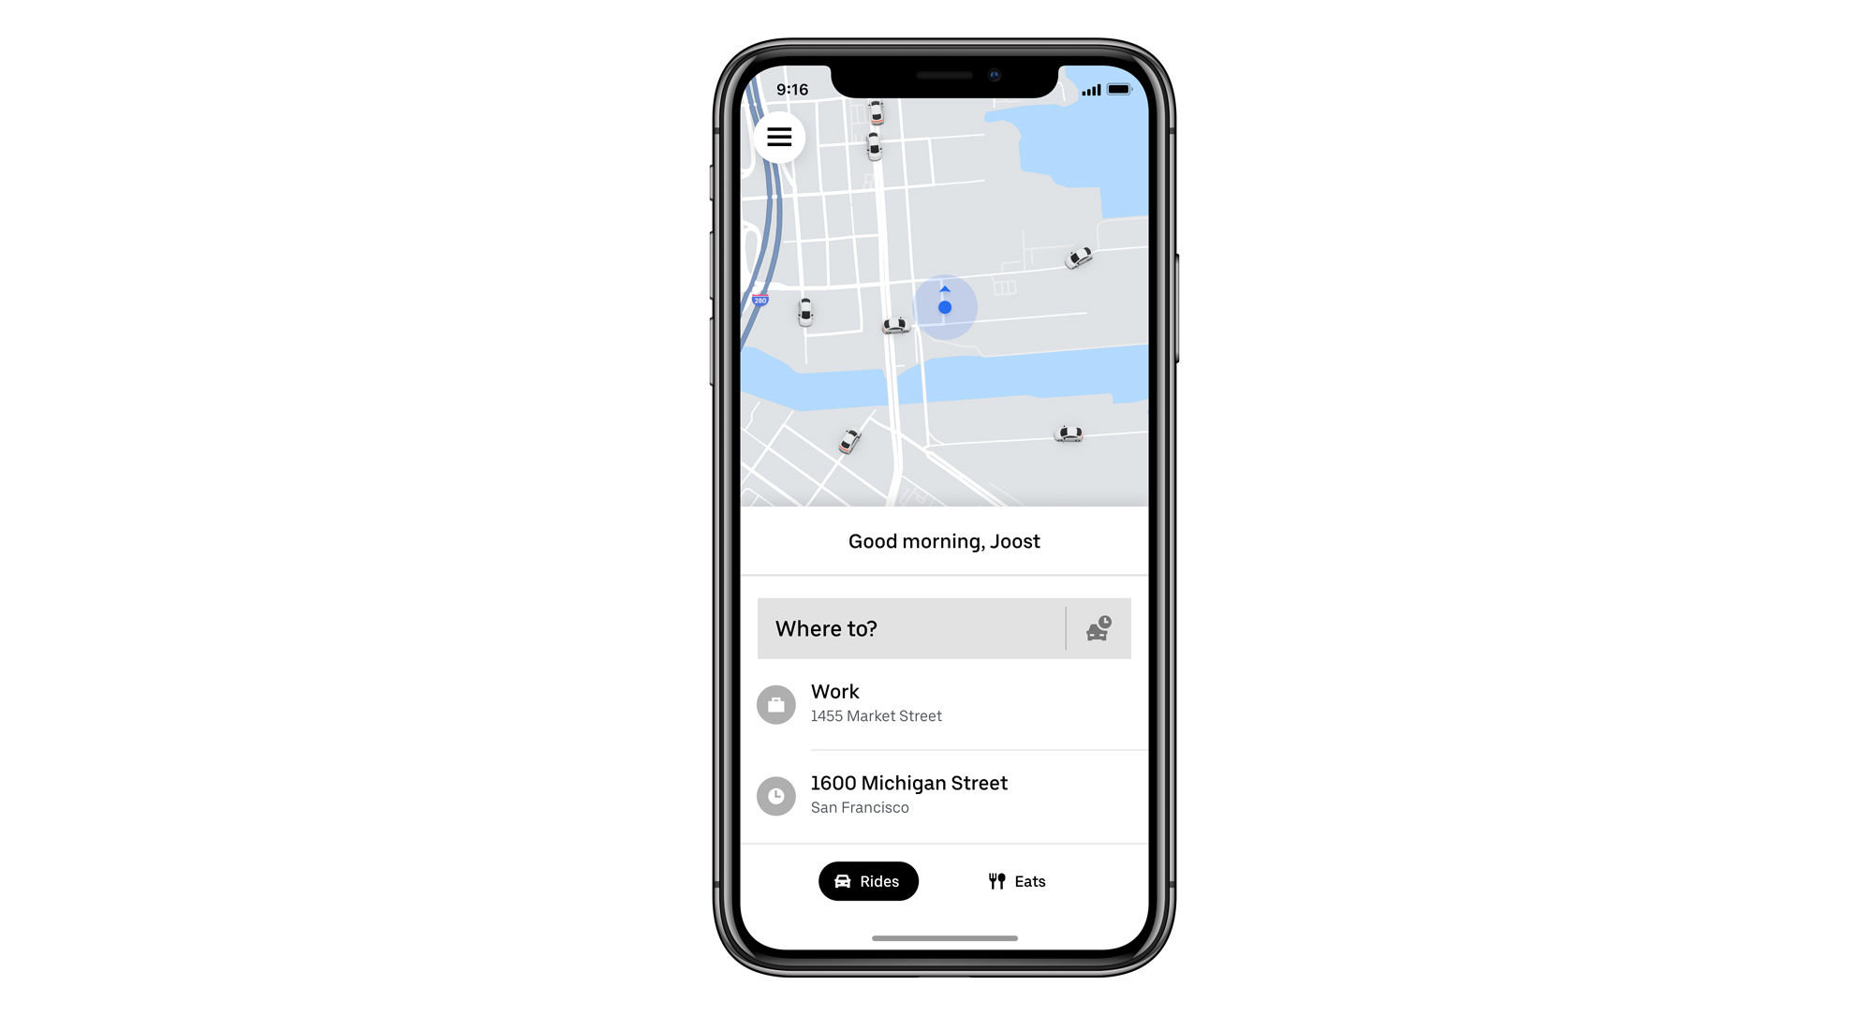Uber

Uber was a pioneer of transport applications. At the launch time it was completely unique to the extent that it was unregulated by law. Uber has made its reputation on being extremely cheap and extremely convenient. Once the user created an account all he has to do is click one button. The application sends the closest car to the current location of the user. When the car arrives at the spot chosen by the user, driver also clicks a button and the payment is automatic. What makes Uber more unique is that the driver is also a client and uses an application as well.

Summary

In conclusion, creating a user-friendly design is not an easy task to do, however if it’s a go-to goal it can be achieved. Additionally, user-friendly design gives the device a lot. Even great inventions can be unused and forgotten if they are simply inconvenient to use. Examples provided by us prove that bad design can make devices unusable and good design can make great inventions even greater.