Group 6:

Antoni Forzpańczyk a2019156557  
Jędrzej Szor a2019156557

Antoni Forzpańczyk a2019156557  
Jędrzej Szor a2019156557

Task 4 report

**Human-computer interaction**

Task 4 report

**Human-computer interaction**

List of contents

List of contents 1

Introduction 1

User analysis 2

Disabilities target 5

Task analysis 6

Metaphors 8

Low fidelity prototype 9

Implementation 12

Potential hardware idea 16

Introduction

This report is the conclusion of the work done in order to design and implement the Memory game enabling inclusion of the colour blind people as well as people with Parkinson’s disease. In this document we describe the conducted user analysis, description of the above mentioned disabilities, performed task analysis, the affiliated metaphors, description of prepared low fidelity prototype, details of implementation and proposed hardware idea.

User analysis

To explore and characterize our average users who would potentially interact with the game, we used Persona Analysis. We tried to find and describe most common person profile matching our assumptions and describe them to have much greater insight into our target. Personas are not real people but only representation of user archetype which might you our application.

Product vision

To formulate and group our personas we used Product Vision Analysis which provides mechanisms to see on the product from different perspectives and what is much important, in objective manner. The product vision is a statement that encapsulates what we are trying to achieve and sort them to have clear point of view on our product.

**Vision:**

The aim of our product is to deliver simple gameplay for everyday users. The purpose of the game is to be available for people suffering from colour-blindness or Parkinson’s disease. The positive impact provided by the application will be the adjustment of functionality for people with beforehand mentioned disorders.

**Target:**

* People wanted to kill the time for example in public transport.
* People seeking logical puzzles willing to improve their mind.
* People who like setting new records.



**Needs:**

* Easy to use
* Simple and aesthetic design.
* Adjusted to people with colour blindness and Parkinson’s disease.

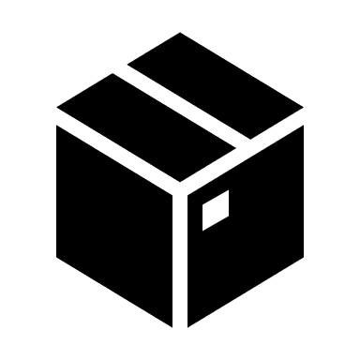

**Product**

* Mobile game for Android operating system.
* Endless gameplay with scoring system.

Source: <https://sophilabs.co/blog/product-inception-product-vision-board>

User profiles

After obtaining wide insight into the characteristics of our product we can focus on our target more specifically. We gathered our potential users characteristics, needs and product description and proposed three personas. All of them represents people which might encounter our product. Following profiles describe only common and average archetypes of personas, we should mind that those are not personal characteristics.

Zak Driscoll - IT student

|  |  |  |
| --- | --- | --- |
| About | Key goals and needs: | Photo: |
| Spends a lot of time in front of documentations and code constantly staring at the same spot.  He lives in the suburbs, so he is forced to use public transportation.  He need to do the brakes while working to reset his mind and come back to activity he was doing.  He plays video games in spare time, especially on lectures.  Zak is very competitive person and loves reaching new scores especially those which impress others. | To have something to easily unwind and ease during breaks.  To have something to kill the time on the way to university. |  |

Karen Osborne - Full-time mum

|  |  |  |
| --- | --- | --- |
| About | Key goals and needs: | Photo: |
| Full-time mum living in small flat in Washington D.C which 3 young children  She likes challenges but having the young children requires a lot of time of devotion.  She is intelligent and well-read thus she seeks the tools to enhance her mind and memory.  Karen is fond of listening sophisticated music such as jazz. While listening she can ease and relax.  Karen suffers from colour-blindness which does not allow her to distinguish most contrasting taints. | To have mind development application  To have source of relaxation |  |

Harold Stock - Retired car mechanic

|  |  |  |
| --- | --- | --- |
| About | Key goals and needs: | Photo: |
| He is retired car mechanic conserving trucks for big transportation company.  Due to harsh work conditions he his body became weak and Harold suffered from two strokes which made his brain frail.   Harold was diagnosed with Parkinson’s disease which handicaps everyday activities.   He is still young in his spirits and seeks for the solution to train memory and hands’ coordination.  He often surfs the internet but only on his computer with special mouse tracker to facilitate his disorder. | To improve his coordination  To still train his mind and develop short-term memory. |  |

Conclusion

Using this technique we have extracted a general idea of our client base. Considering features and strengths of our product we believe that it will be successful among people with brief moments of time to pass or people who would like to train their memory using our product. Concerning the disability modes implemented in the game we can also add to that group people suffering from colour blindness or Parkinson’s disease.

Disabilities target

Colour blindness

Colour blindness occurs when you are unable to see colours in a normal way. It is also known as colour deficiency. Colour blindness often happens when someone cannot distinguish between certain colour. This usually happens between greens and reds, and occasionally blues. In the retina, there are two types of cells that detect light. They are called rods and cones. Rods detect only light and dark and are very sensitive to low light levels. Cone cells detect colour and are concentrated near the centre of your vision. There are three types of cones that see colour: red, green and blue. The brain uses input from these cone cells to determine our colour perception.

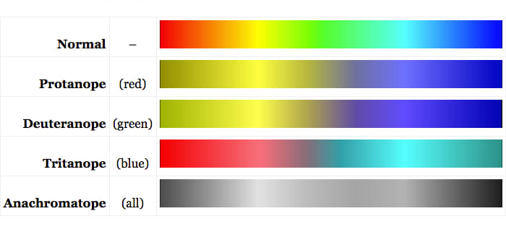

Figure 1Types of colour blindness

source:  
<https://www.aao.org/eye-health/diseases/what-is-color-blindness>  
<https://iristech.co/vision-introduction/>

Parkinson's disease

Parkinson's disease is a progressive nervous system disorder that affects movement. Symptoms start gradually, sometimes starting with a barely noticeable tremor in just one hand. Tremors are common, but the disorder also commonly causes stiffness or slowing of movement.

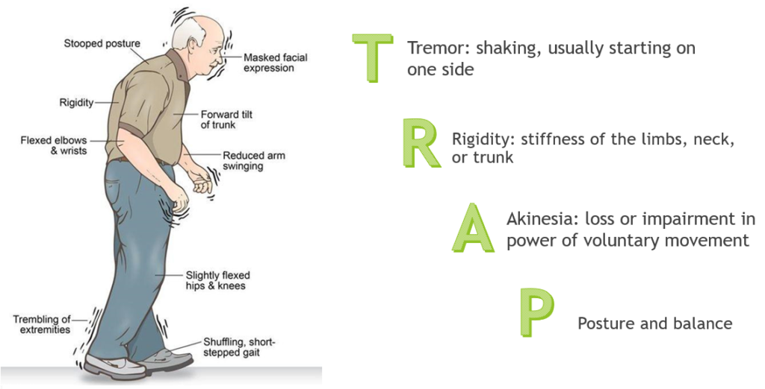

Figure 2: Syndromes of Parkinson's

source:   
<https://www.mayoclinic.org/diseases-conditions/parkinsons-disease/symptoms-causes/syc-20376055>

<https://parkinsonsnebraska.org/understanding-parkinsons-disease/>

Task analysis

The main task of our application is to deliver simple yet challenging gameplay for users with colour blindness or Parkinson’s disease. It is carried out by providing special modes which enable people with above mentioned disabilities to play our game more comfortable.

The colour blind mode changes the colours of the in-game buttons to colours easier distinguished by colour blind people. It eases the more stimuli help memorizing the sequence better, hence helping achieve higher score.

The Parkinson’s mode increases the size of the in-game buttons making it easier for the people with Parkinson’s disease to hit.

Use case diagram

While thinking about functionalities and possible actions performed in our application we created use case diagram which is a part of Unified Modelling Language (UML). Following diagram depicts actions which can be done by the user with taking into account extensions and inclusion of some sub activities.

As the diagram presents user can switch some accessibility modes on for colour blind people as well as those suffering from Parkinson’s. In addition sound can be muted in settings view. Player, obviously, can play the game and exit playing whenever he wants by pressing certain button on the screen. Finally user can exit whole application from menu view by pressing exit button.

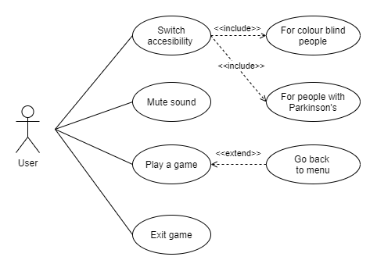

Figure 3: Use case of the game

Task diagram

Here we describe an exemplary task, which is playing the game with the Parkinson’s mode enabled.

Task: **Play the game with support for people with Parkinson’s disease enabled.**

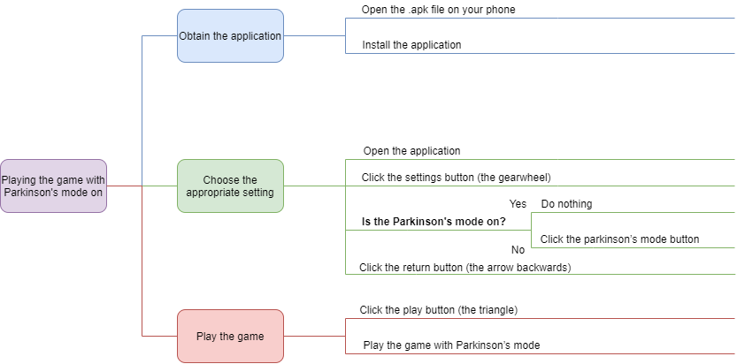

Figure 4: Task diagram of playing the game in Parkinson's accessibility mode

1. Get the application
   1. Open the .apk file on your phone
   2. Install the application
2. Choose the appropriate setting
   1. Open the application
   2. Click the settings button (the gearwheel)

|  |  |
| --- | --- |
| **If the Parkinson’s mode has tick next to it** | **Else** |
| c. Click the return button (the arrow backwards) | c. Click the Parkinson’s mode button |
|  | d. Click the return button (the arrow backwards) |

1. Play the game
   1. Click the play button (the triangle)
   2. Play the game with support for Parkinson’s mode

source:

<https://creately.com/diagram/example/hmppe9is1/New%20Hierarchical%20Task%20Analysis>

<https://xd.adobe.com/ideas/process/user-research/task-analysis-ux-with-example/>

Metaphors

*“One common approach that designers have exploited for controlling complexity is to ground user interface actions, tasks, and goals in a familiar framework of concepts that are already understood. Such a framework is called a user interface metaphor (…)”*

Handbook of Human-Computer Interaction (Second Edition) Dennis C.NealeJohn M.Carroll

<https://www.sciencedirect.com/science/article/pii/B9780444818621500868>

Metaphors help user to operate with UI and eliminate text information displayed on the screen. We can easily exchange text information “Delete” with trash bin icon because this image is strongly associated with removing. In our application we minimalized text on the screen and replaced them with icons representing metaphors that are easily recognizable. However, our product might be used by disabled people and there is possibility that some of them can have cognitive disorders, especially elder people. That is why we below most important controls we provided descriptions for example “Play”, “Exit”.

Usages in project

Below we present icons representing metaphors in our game:

Menu screen

|  |  |  |
| --- | --- | --- |
|  |  |  |
| Play button | Go to settings button | Exit button |

Settings screen

|  |  |  |  |  |
| --- | --- | --- | --- | --- |
|  |  |  |  |  |
| Close button | Go back button | Mute sound button | More detail button | Tick box |

Game screen

|  |  |
| --- | --- |
|  |  |
| Go to home button | New high score icon |

Low fidelity prototype

*Low-fidelity (lo-fi) prototyping is a quick and easy way to translate high-level design concepts into tangible and testable artefacts. The first and most important role of lo-fi prototypes is to check and test functionality rather than the visual appearance of the product.*

<https://theblog.adobe.com/prototyping-difference-low-fidelity-high-fidelity-prototypes-use/>

As far as prototyping is concerned we focused on low fidelity prototyping (lo-fi) to have greater experience our UI physically. We wanted to adjust buttons to be accessible for finger range and test designed controls. We did not use any of suggested prototyping programs because we focused on physical design. We created our prototypes by the use of paper sheets, pen and scissors. We created all controls we want to have in UI and placed them adequately. Since our components were made of paper we could easily adjust the layout and test one again whether that position is suitable for us.

Paper prototyping benefits:

* **Leverage common design skills** – Everyone is able to sketch prototype regardless the manual skills. Paper prototyping focuses on functionalities and layouts rather than design.
* **Allow early testing –** Testing paper prototype let us to find layout issues when information is unclearly displayed.
* **Support rapid experimentation***.* Different UI components are easily moveable without any necessity to cope with code or graphical software. When we discovered the problem, we could just try redesign whole layout and examine it instantly.

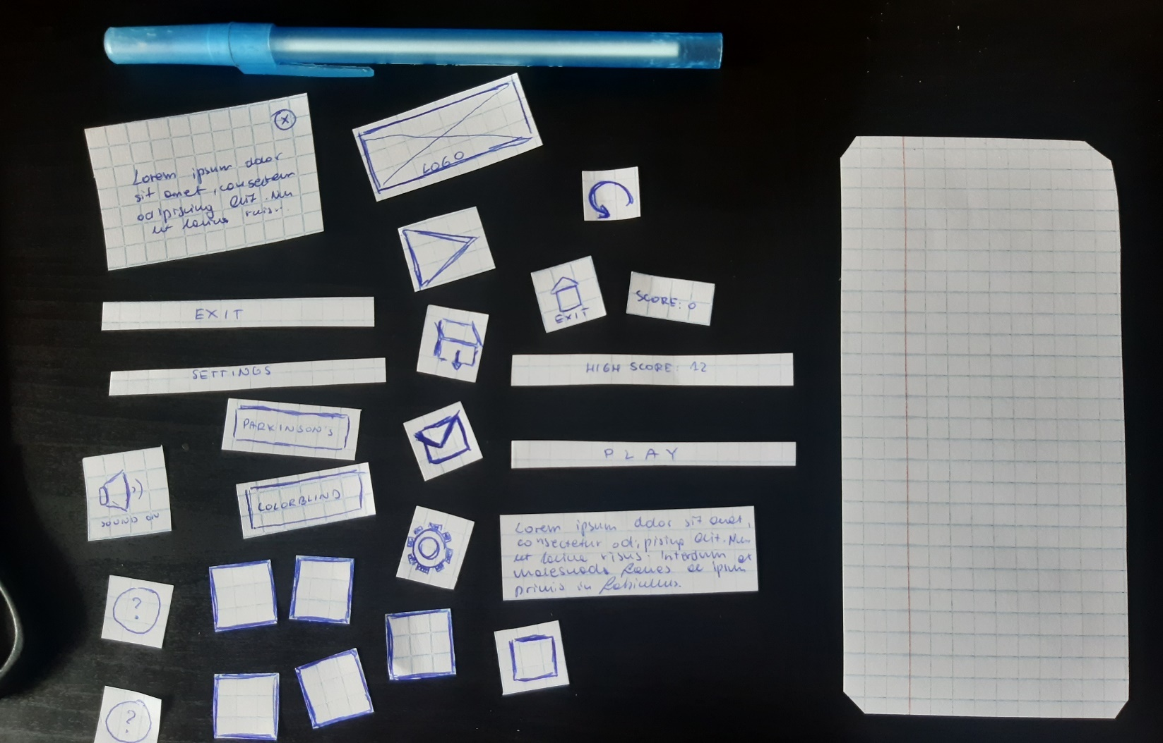

Mockups

Below we present mockups for our application. We focused on most important views in users’ perspective.

|  |  |
| --- | --- |
| Figure 5: Prototype of menu screen | Figure 6: Prototype of game screen |

|  |  |
| --- | --- |
| Figure 7: Prototype of settings screen | Figure 8: Prototype of settings screen with description of the accessibility |

Implementation

Development tools

For the implementation of our idea we have used **Unity** as development platform and **C#** as the programming language. Unity offers a wide variety of libraries as well as tools necessary for easy implementation of the desired user interface and the game features. The target operating system is **Android** for mobile devices.

Graphics

To design and produce quickly graphics we focused on pixel art style. To design icons and logos we used **Piskel** online tool which provides limited functionalities while creating new project however this solution was suitable for us.

Presentation

Rules

The general aim of the game is to repeat the sequence of lighting up buttons. If the sequence is correct, a next button is added to the sequence, so that every next iteration is more difficult. The goal is to achieve the highest score possible. After loss the user can see amount of points he gained and he can compare it to his previous highs core. This mechanism is widely known and valued for its simplicity, increasing difficulty and memory training.

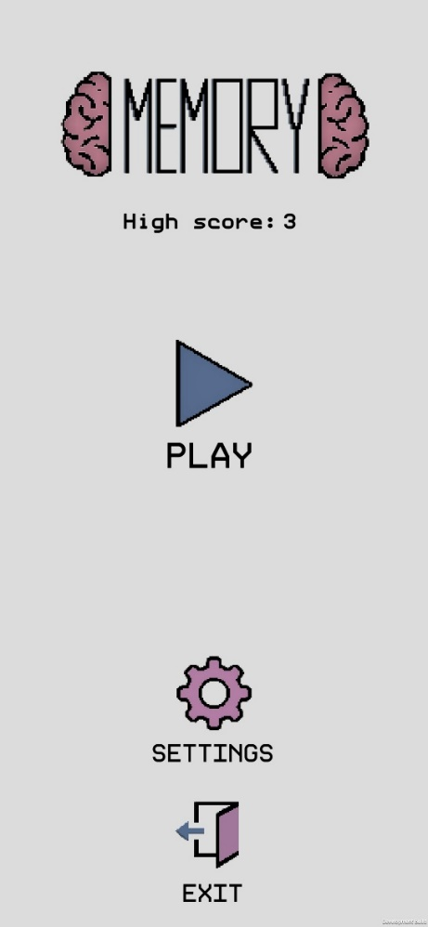Main menu

Figure 9: Menu screen

**Design:**

Our main menu view consists of game logo below we can notice the high score. We provided three buttons to operate on the application. Every button has its description below.

**Functionality:**

High score is stored locally and updated when player breaks his record. Every button has its separate functionality. Play button switches current view to game view. Settings button opens settings view and Exit button just exits the application.

Settings

|  |  |
| --- | --- |
| Figure 10: Settings | Figure 11: Settings with description of accessibility mode |

**Design:**

Setting view is composed of following controls. At the top right corner of the screen we can notice Return button. The below is description of the application accessibility required in project’s description. Then we have choice section where we are able tick the checkbox by clicking on the button. In addition in the right side of the screen there are See More buttons. At the very bottom of the view we can notice Mute/Unmute toggle button.

**Functionalities:**

Return button switches view back to main menu by clicking on it. Two buttons with described disorders we want to facilitate switches relevant accessibilities and toggle tick box visible on the right site. Button See More on the left site displays the description of the particular accessibility. We can close that pop-up by clicking the X icon in the top left corner.

Game view

|  |  |  |
| --- | --- | --- |
| Figure 12: Game view in pressing phase | Figure 13: Game in observing phase | Figure 14: Game over screen |

**Design:**

Layout of the graphical user interface in game view is minimalistic. In top left corner we have current score. In contrary on the right side of the screen we can notice Go Home button. In the centre of the view there are placed five buttons responsible for all gameplay. They have relevant colours assigned. After failing the game dialogue screen pops up with information of the scored points. If player breaks the record, relevant information is displayed on the screen. To provide soothing and calming experience, the pastel and soft colours, jazz music and minimalist design is included into gameplay.

**Functionalities:**

The purpose of the game is to repeat pattern of colours displayed on the screen by clicking relevant buttons. When pattern is shown background darkens and buttons are blocked. After that, background changes its colour back to light grey. Every button when is clicked changes its colour and makes its unique sound. As far as other controls are concerned, home button switches the view back to main menu cancelling the whole game. In pop-up window after loosing the game we have home button which moves user back to main menu and button to play again the game.

Accessibility for disabled people

According to project requirements we have implemented modes that are supposed to facilitate the usage of our application.

Colour blindness

First one is mode devoted to people suffering from colour blindness which might have significant impact on the gameplay. Sequence in the game is displayed by various blinking colours. Lack of ability to distinguish colours properly would definitely handicap the gameplay. Hence, we added the mode that changes the colours which are much more easy do distinguish by people with that disability.

|  |  |
| --- | --- |
| Regular colours | Adjusted colours |
| StopStopStopStopStop | StopStopStopStopStop |

Parkinson’s disease

Second accessibility facilitates using people suffering from motor inconveniences. Users with Parkinson’s disease have shaky and limited range of movement that is why we provided mode which enlarges the size of the buttons to make them much more easy to press.

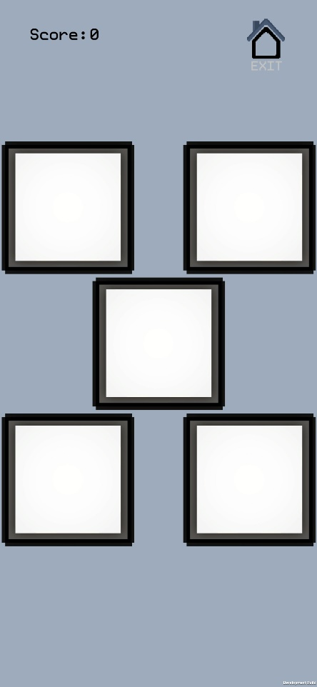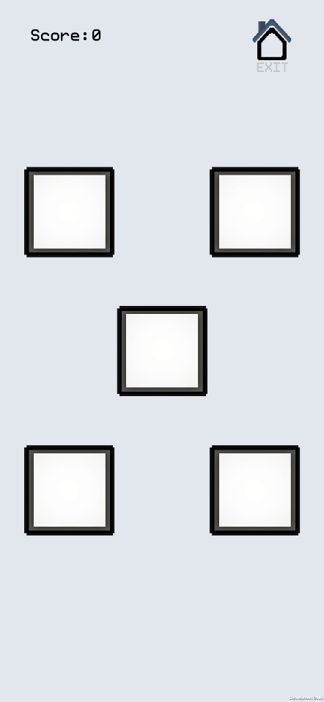

Figure 15: Game view with enlarged buttons

Figure 16: Game view with regular buttons

Potential hardware idea

A possible hardware to incorporate in our project would be a board with physical buttons. Similarly to our current solution, the buttons would light up and make a sound both when the sequence appears as well as when it is recreated. The board would be connected to the brain carrying out all the necessary calculations and actually running the program.

However in our opinion such a solution would make our product less useful and more rigid. If the buttons were physical, they could not change size and it would be difficult for them to change the colour. It would be also impossible to show any kind of feedback concerning the correctness of performed sequence, hence making the system less intuitive.