Visoka škola strukovnih studija za informacione
i komunikacione tehnologije



Dokumentacija

Predmet: Web programiranje PHP 2

Student: Antonije Pavlovic 47/16

1. Opis funckionalnosti

Sajt je namenjen kupovini knjiga. Na pocetnoj strani se nalaze najnovije knjige koje su u ponudi,kao I mogucnost pretrage po imenu autora. Na vrhu stranice sa desne strane se nalaze dva linka, za logovanje I registraciju. Korisnici koji se nisu ulogovali nemaju nikakve mogucnosti osim gledanja sajta. Korisnici koji su ulogovani I pritom nisu admini mogu da kupuju knjige. Admin ima pravo pristupa admin panelu gde upravalja celokupnim sadrzajem sajta. Admin moze da dodaje,brise,azurira podatke o korisnicima, knjigama, autorima I kategorijama knjiga.Takodje admin moze pratiti aktivnosti korisnika,kao greske koje se dogadjaju prilikom rada aplikacije I preuzeti izvestaj u .cvs formatu,kako za pojedinacnog korisnika,tako I celokupan izvestaj.Skoro celokupan sadrzaj je uradjen pomocu ajax-a.
Korisceni jezici | - CSS3  - HTML5  - JavaScript  - PHP (OOP)
Korisceni HTML sabloni(framework-ci) | Bootstrap 4
Koriscene biblioteke | Jquery
Koriscene biblioteke iz framework-a | Laravel
Koriscene php biblioteke van frameworka | /
Funkcionalnosti realizovane putem AJAXA | - Logovanje  - Registracija  - Pretraga po autoru  - Paginacija  - Filtritanje po kategoriji  - Dodavanje u korpu  - Brisanje iz korpe  - Konacna kupovina  - Slanje mejla administratoru  - Celokupan admin panel(insert,update,delete) korisnika,knjiga,autora,kategorija
Lokacije gde je napisan AJAX kod | /public/js/script.js  /public/js/admin.js

2. Skica struktura stranica

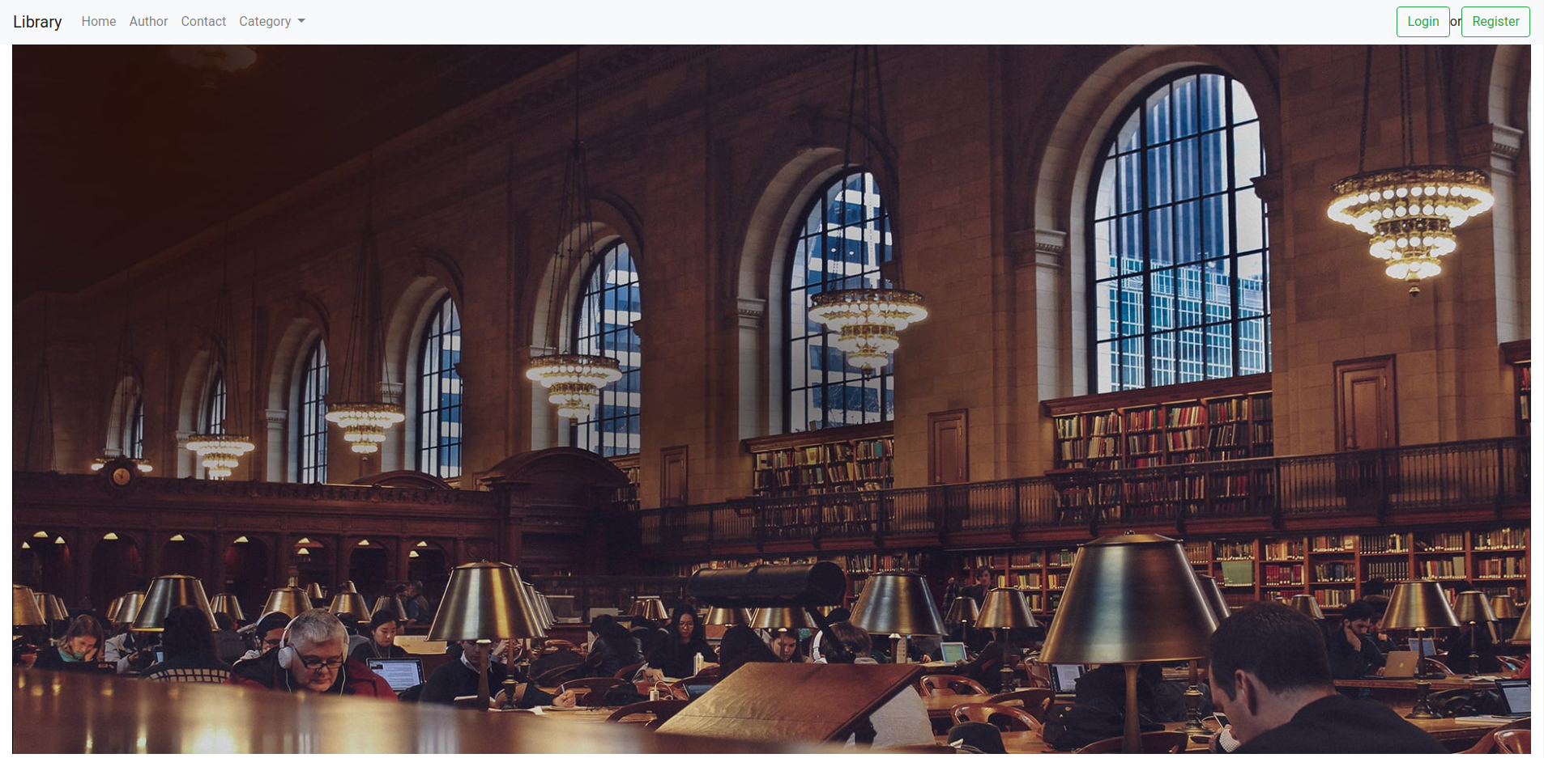
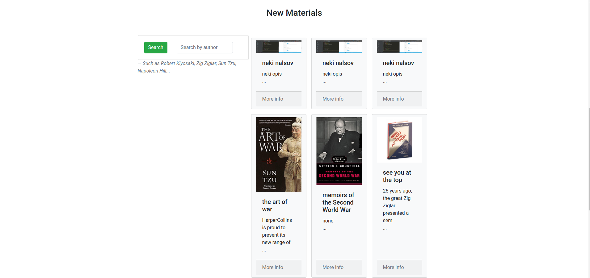
2.1 Home

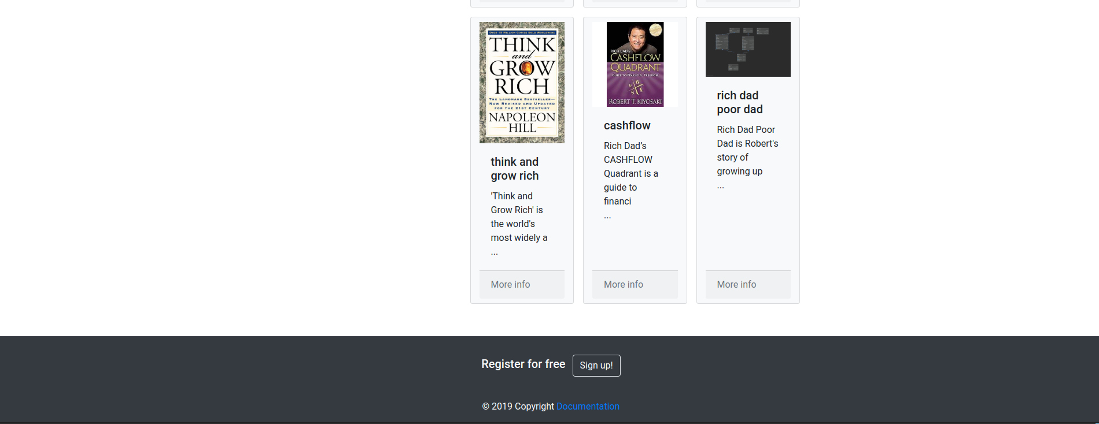

2.2 Author
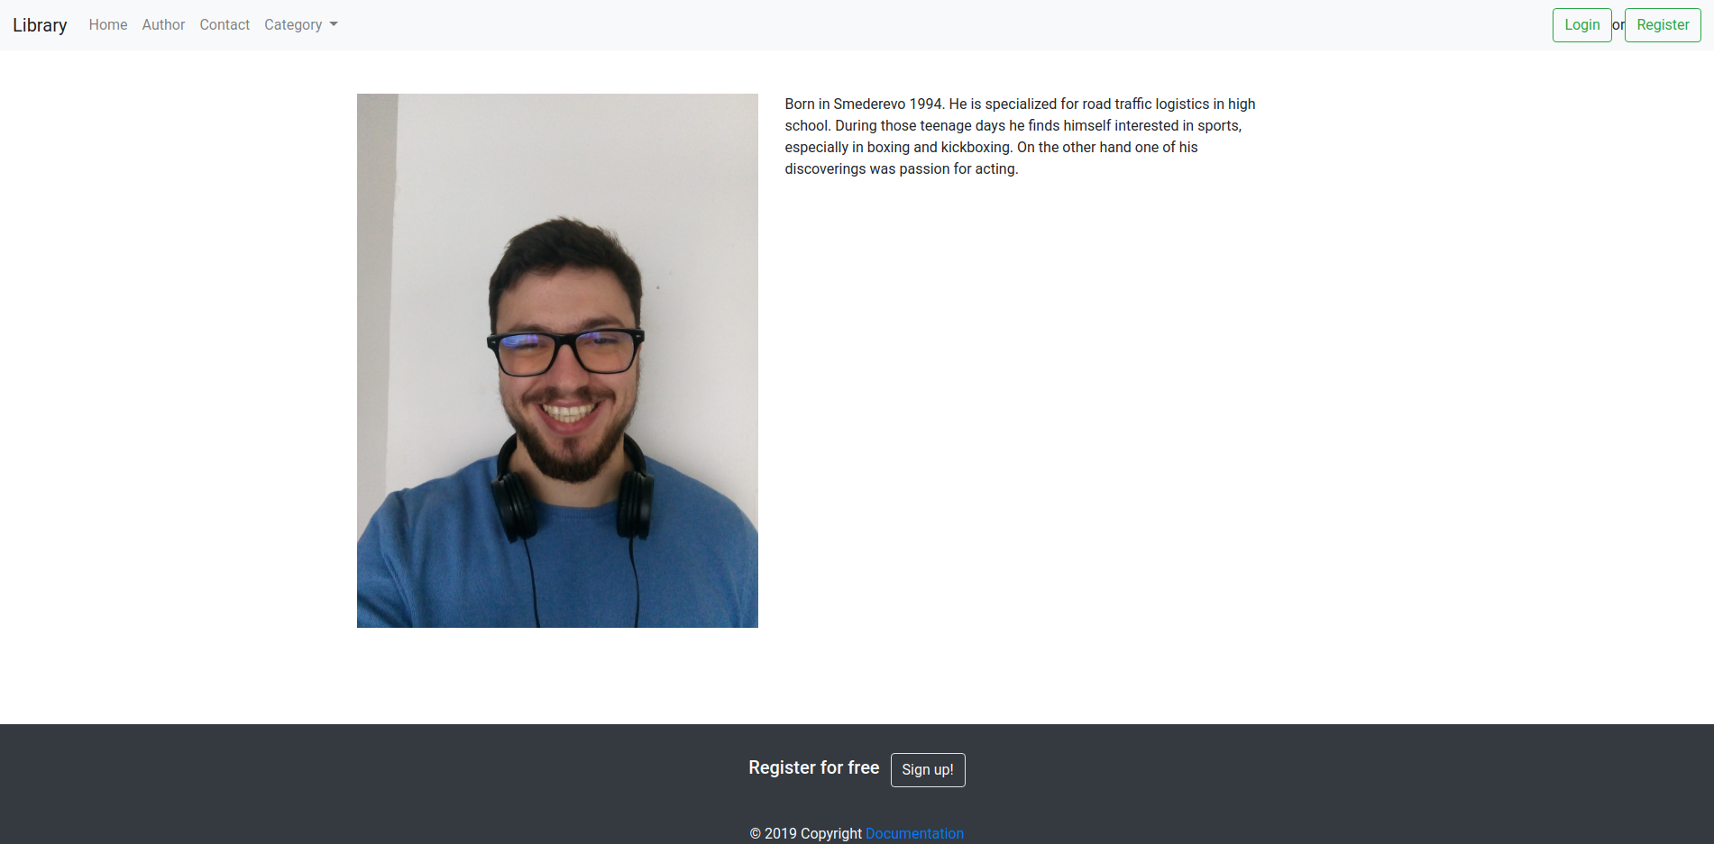

2.3 Contact

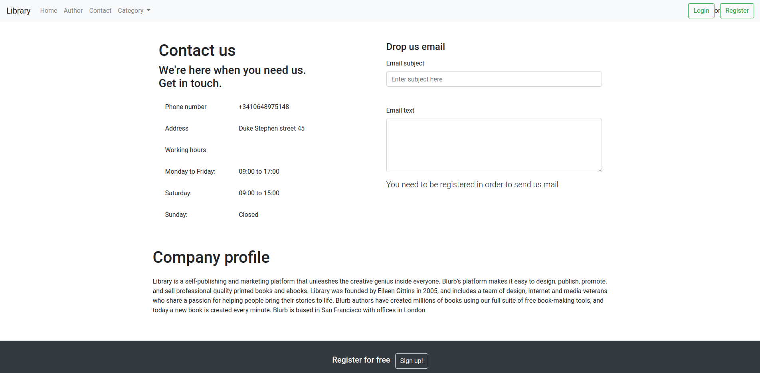

2.4 Login

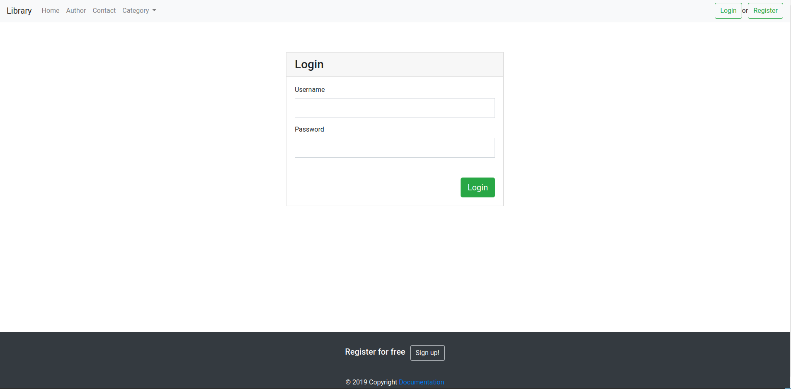

2.5 Register
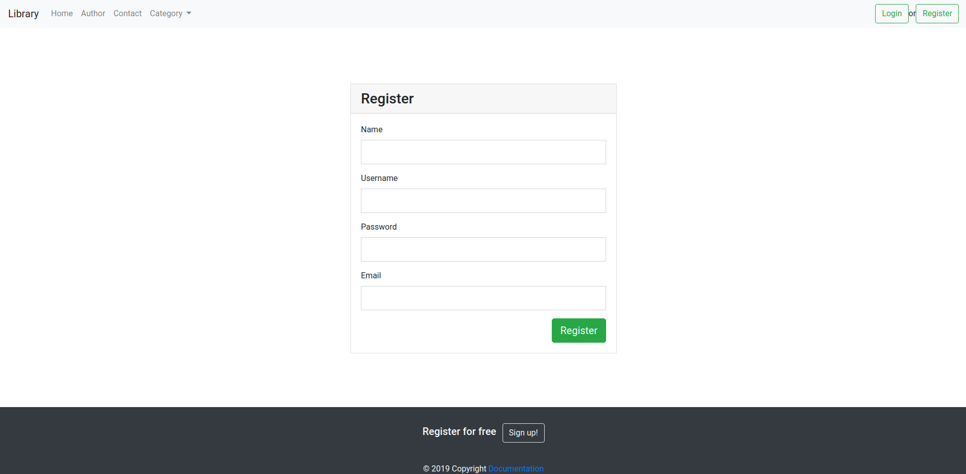

2.6 Admin

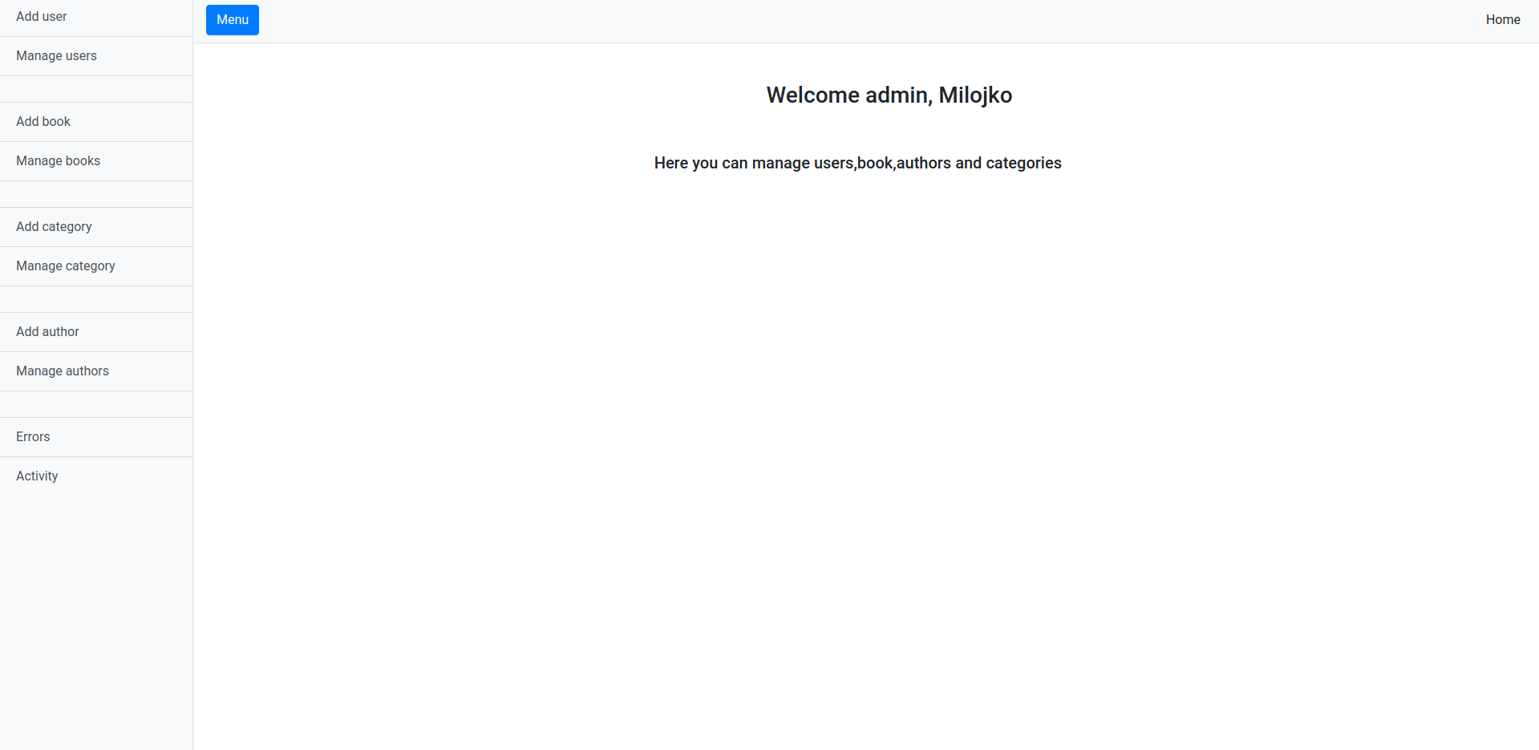

2.7 Cart

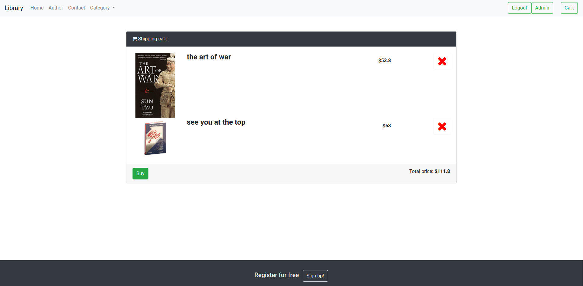

2.8 More info
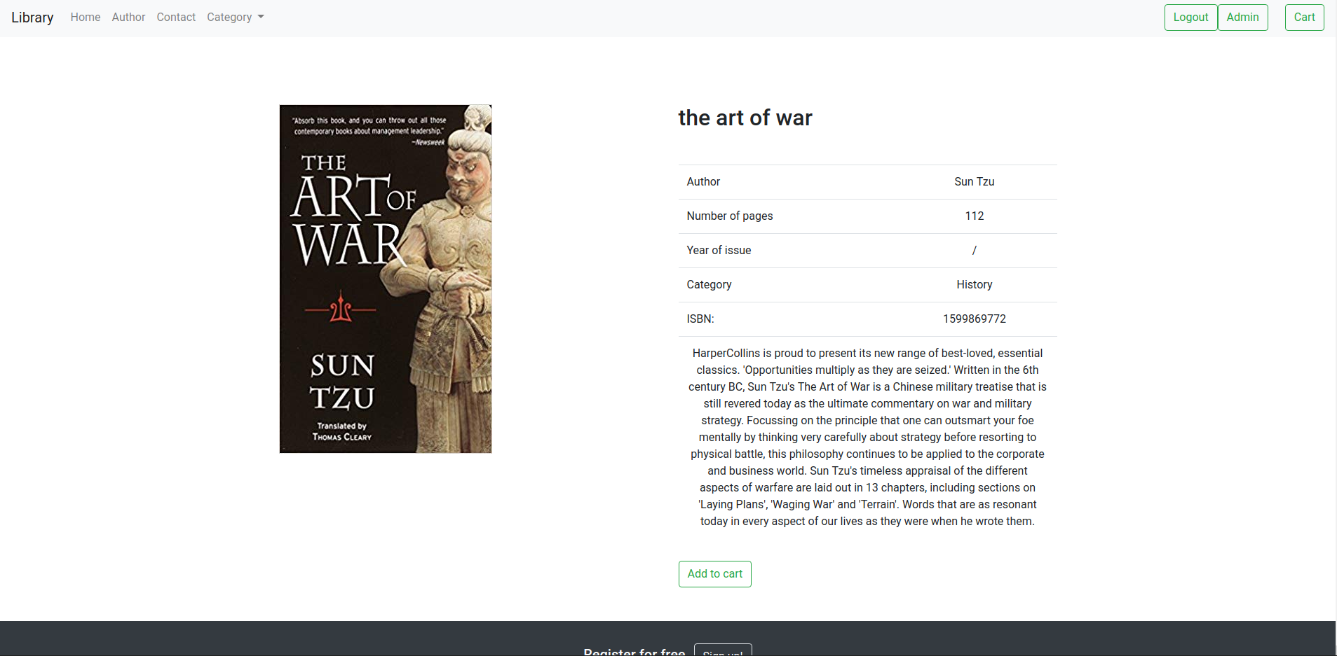

3.Dijagram baze podataka
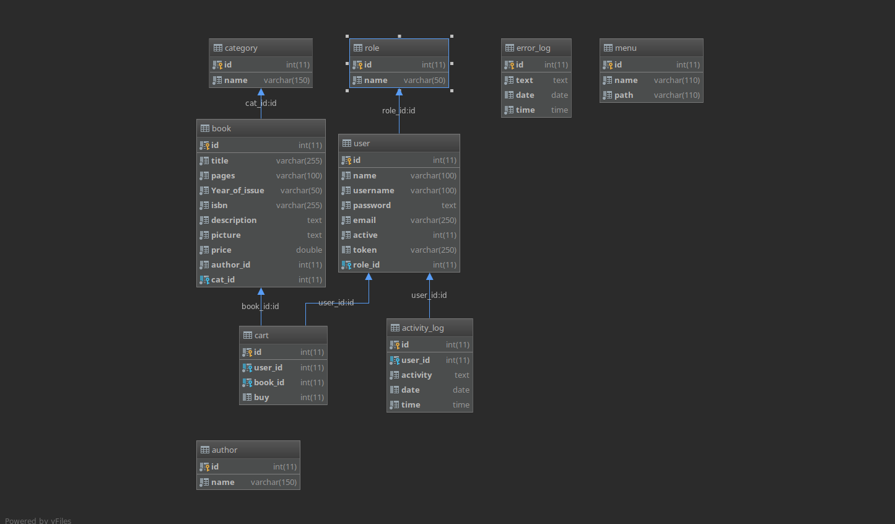

4. MVC organizacija

4.1 Kontroleri

ActivityController
__construct()
renderActivity()
exportCSV()
userActivityCSV($id)
activityDate(Request $request)

AdminController
renderAdmin()
unauthorized()

AuthController
renderLogin()
renderRegister()
login(LoginRequest $request)
logout(Request $request)
register(Request $request)
verification(Request $request)

AuthorController
__construct()
index()
create()
store(Request $id)
show($id)
edit($id)
update(Request $request)
destroy($id)

BookController
__construct()
index()
create()
store(Request $id)
show($id)
edit($id)
update(Request $request)
destroy($id)

CartController
__construct()
renderCart()
addToCart(Request $request)
remove(Request $request)
buy(Request $request)

CategoryController
__construct()
index()
create()
store(Request $id)
show($id)
edit($id)
update(Request $request)
destroy($id)

ErrorController
__construct()
renderExport()
exportCSV()

FrontController
__construct()
renderHome()
author()
contact()
support()
search(Request $request)
paginationSearch(Request $request)
categoryFilter(Request $request)
paginationCategory(Request $request)
showBook($id)

UserController
__construct()
index()
create()
store(Request $id)
show($id)
edit($id)
update(Request $request)
destroy($id)

4.2 Modeli
Activity
insertActivity($userID,$activity)
getActivity()
activityDate()

Author
getAuthors()
insertAuthor($name)
daleteAuthor($id)
getAuthor($id)
update($id,$name)

Book
getBook($id)
getBooks()
insertBook($title,$pages,$year,$isbn,$picture,$author,$category,$description,$price)
updateBook($title,$pages,$year,$isbn,$picture,$author,$category,$description,$price,$id)
deleteBoo($id)
getNewBooks()
search($text)
paginationSearch($authorID,$from,$perPage)
categoryFilter($catID)
paginatinCategory($catID,$from,$perPage)

Cart
getBooks()
addToCart($uid,$pid)
remove($bookID,$userID)
getOrderedBooks($userID)
buy($userID)

Category
getCategories()
insertCategory($name)
deleteCategory($id)
getCategory($id)
update($id,$name)

Error
insertError($text)
getErrors()

Menu
getLinks()

User
login($username,$password)
register($name,$username,$password,$email,$token)
activateUser($token)
getUser($id)
insert($name,$username,$password,$email,$active,$token,$role)

delete($id)
update($name,$username,$email,$active,$role,$id)
userActivity($id
getAllUsers()

4.3 View
Layouts
admin.blade
main.blade

Pages
admin.blade
home.blade
cart.blade
author.blade
contact.blade
login.blade
registeg.blade
more_info.blade

Partials
bg_image.blade
contenct.blade
foote.blade
nav.blade
head.blade

5.JavaScript

5.1 admin.js
const main = () => {
$.ajaxSetup({
headers: {
'X-CSRF-TOKEN': $('meta[name="csrf-token"]').attr('content')
}
});
/********R E G I S T E R N E W U S E R*********/
$('.registerNewUser').on('click',() => {
let name = $('#name').val();
let username = $('#username').val();
let email = $('#email').val();
let password = $('#password').val();
let active = $('#active').val();
let role = $('#role').val();
//console.log({name,username,email,password,active,role})
//regExr
$.ajax({
url : '/addUser',
method : 'post',
dataType : 'json',
data : {
name,
username,
email,
password,
active,
role
},
success(data) {
if(data){
jQuery('#addUser').modal('show');
$("#form").trigger('reset');
}
},
error(err) {
let elem = '';
let errors = $.parseJSON(err.responseText);
$.each(errors['errors'], function(index, value) {
elem += `<p style="color: red;"> ${value[0]} </p>`;
// console.log(value[0]);
});
$('.addUserErrors').html(elem);
}
})
});
/********D E L E T E U S E R*******/
$('.deleteUser').on('click', function () {
let id = $(this).data('uid');
$.ajax({
url : `/deleteUser/${id}`,
method : 'get',
dataType : 'json',
data : {},
success(data) {
if(data){
$(`button.deleteUser[data-uid=${id}]`).fadeOut(300, function() { $(`button.deleteUser[data-uid=${id}]`).parents()[1].remove();});
}
},
error(err) {
console.log(err);
}
})
});
/*********U P D A T E U S E R**************/
$('.updateUser').on('click',function () {
let userID = $(this).data('uid');
let name = $('#name').val();
let username = $('#username').val();
let email = $('#email').val();
let active = $('#active').val();
let role = $('#role').val();
$.ajax({
url : `/updateUser/${userID}`,
method : 'post',
dataType : 'json',
data : {
name,
username,
email,
active,
role
},
success(data) {
if(data == 200)
jQuery('#updateSuccesfull').modal('show');
},
error(err) {
console.log(err);
}
})
});
/********SEARCH BY DATE ACTIVITY*******/
$('.activityDate').on('click',() => {
let from = $('.from').val();
let to = $('.to').val();
if(from && to){
$.ajax({
url : '/activityDate',
method : 'post',
dataType : 'json',
data : {
from,
to
},
success(data) {
console.log(data);
if(data){
let elem = '';
elem += `<h5>All activities in between ${from} and ${to} / <a href="/renderActivity">Load all activity</a></h5>`;
elem += ` <div class="table-wrapper-scroll-y my-custom-scrollbar">
<table class="table mt-3">
<thead class="thead-dark">
<tr>
<th scope="col">#</th>
<th scope="col">User</th>
<th scope="col">Activity</th>
<th scope="col">Date</th>
<th scope="col">Time</th>
</tr>
</thead>
<tbody>`;
for(let i = 0 ; i < data.length ; i++){
elem += `<tr>
<th scope="row">${ i + 1}</th>
<td>${data[i].user_id}</td>
<td>${data[i].activity}</td>
<td>${data[i].date}</td>
<td>${data[i].time}</td>
</tr>`
}
elem += ` </tbody>
</table>
</div>
<span class="mt-3">Get export in <a href="/activityCSV">CSV (all data from database)</a></span>`;
$('.activityContainer').html(elem);
}else{
alert(data)
}
},
error(err){
console.log(err);
}
})
}else{
alert('Choose the start and end date')
}
});
/***********D E L E T E B O O K************/
$('.deleteBook').on('click',function () {
let bookID = $(this).data('pid');
$.ajax({
url : '/deleteBook/' + bookID,
method : 'post',
dataType : 'json',
data : {},
success(data){
if(data)
$(`button.deleteBook[data-pid=${bookID}]`).fadeOut(300, () => $(`button.deleteBook[data-pid=${bookID}]`).parents()[1].remove());
},
error(err){
console.log(err);
}
})
});
/*************A D D C A T E G O R Y*************/
$('.addCategory').on('click',function () {
let name = $('.categoryName').val();
$.ajax({
url : '/addCategory',
method : 'post',
dataType : 'json',
data : {
name
},
success(data){
if(data){
alert('Successfully added')
window.location.href = "/admin";
}
},
error(err){
console.log(err);
}
})
});
/************D E L E T E C A T E G O R Y*******/
$('.deleteCategory').on('click',function () {
let catID = $(this).data('pid');
$.ajax({
url : '/deleteCategory/'+ catID,
method : 'get',
dataType : 'json',
data : {},
success(data) {
if(data)
$(`button.deleteCategory[data-pid=${catID}]`).fadeOut(300, () => $(`button.deleteCategory[data-pid=${catID}]`).parents()[1].remove());
},error(err){
console.log(err);
}
})
});
/*****U P D A T E C A T E G O R Y*******/
$('.updateCategory').on('click',function () {
let catID = $(this).data('pid');
let name = $('.categoryUpdateName').val();
//console.log(name);
$.ajax({
url : '/updateCategory',
method : 'post',
dataType: 'json',
data :{
name,
catID
},success(data) {
if(data){
alert('Successfully updated');
window.location.href = "/admin";
}
},
error(err){
console.log(err);
}
})
})
/*******A D D AU T H O R*******/
$('.addAuthor').on('click',function () {
let name = $('.authorName').val();
$.ajax({
url : '/addAuthor',
method : 'post',
dataType : 'json',
data : {
name
},
success(data){
if(data){
alert('Successfully added')
window.location.href = "/admin";
}
},
error(err){
console.log(err);
}
})
});
/************D E L E T E A U T H O R*******/
$('.deleteAuthor').on('click',function () {
let authorID = $(this).data('pid');
$.ajax({
url : '/deleteAuthor/'+ authorID,
method : 'get',
dataType : 'json',
data : {},
success(data) {
if(data)
$(`button.deleteAuthor[data-pid=${authorID}]`).fadeOut(300, () => $(`button.deleteAuthor[data-pid=${authorID}]`).parents()[1].remove());
},error(err){
console.log(err);
}
})
});
/*****U P D A T E A U T H O R*******/
$('.updateAuthor').on('click',function () {
let authorID = $(this).data('pid');
let name = $('.authorName').val();
//console.log(name);
$.ajax({
url : '/updateAuthor',
method : 'post',
dataType: 'json',
data :{
name,
authorID
},success(data) {
if(data){
alert('Successfully updated');
window.location.href = "/admin";
}
},
error(err){
console.log(err);
}
})
})
};
document.addEventListener('DOMCoalertntentLoaded',main());

5.2 script.js
const main = () => {
$.ajaxSetup({
headers: {
'X-CSRF-TOKEN': $('meta[name="csrf-token"]').attr('content')
}
});
//mesage on login and register page
$('.unregistered').hide();
//sort description on home page
$("p.card-text").text(function(index, currentText) {
return currentText.substr(0, 50);
});
//cart
(function(){
$("#cart").on("click", function() {
$(".shopping-cart").fadeToggle( "fast");
});
})();
/*********L O G I N***************/
$('.login').on('click',() => {
let username = $('.username').val();
let password = $('.password').val();
//regular expression
$.ajax({
url : '/login',
method : 'post',
dataType : 'json',
data : {
username,
password
},
success(data){
if(data.code === 200)
window.location.href = 'http://127.0.0.1:8000/';
if(data.code === 422){
$('.unregistered').html('Sory, username or password is not ok');
$('.unregistered').show();
}else
$('.unregistered').hide();
},
error(e){
//console.log(e.status);
if (e.status === 422){
$('.unregistered').html('Please fill in all fields');
$('.unregistered').show();
}else{
$('.unregistered').hide();
}
}
})
});
/********* R E G I S T E R *********/
$('.register').on('click',() => {
let name = $('.name').val();
let username = $('.username').val();
let password = $('.password').val();
let email = $('.email').val();
//regular expression
$.ajax({
url : '/register',
method: 'post',
dataType: 'json',
data : {
name,
username,
password,
email
},
success(data) {
console.log(data);
jQuery("#exampleModal").modal('show');
},
error(e) {
let elem = '';
let errors = $.parseJSON(e.responseText);
$.each(errors['errors'], function(index, value) {
elem += `<p style="color: red;"> ${value[0]} </p>`;
// console.log(value[0]);
});
$('.registerErrors').html(elem);
}
})
});
/**********S U P P O R T**************/
$('.sendMail').on('click', () => {
let subject = $('#emailSubject').val();
let text = $('#emailTxt').val();
let email = $('#email').val();
let username = $('#username').val();
let userID = $('#userID').val();
//regular expression
$.ajax({
url : '/support',
method : 'post',
dataType : 'json',
data : {
subject,
text,
email,
username,
userID
},
beforeSend: function() {
alert('just wait for a second')
},
success(data){
jQuery("#ignismyModal").modal('show');
console.log(data);
},
error(e){
console.log(e);
}
})
});
/**********S E A R C H B Y A U T H O R*********/
$('.searchBtn').on('click',() => {
let text = $('.searchTxt').val();
if(!text)
jQuery("#emptySearch").modal('show');
else{
$.ajax({
url: '/search',
method : 'get',
dataType : 'json',
data : {
text
},
success(data) {
//Pagination
let rows = data.data;
let numPerPage = 2;
let numOfPages =Math.ceil( rows.length / numPerPage);
let pagination = ' <ul class="pagination pagination-md">';
for(let i = 0 ; i < numOfPages ; i++) {
pagination += ` <li class="page-item paginationLink" data-page="${i+1}"
data-author="${rows[i].authorID}"
data-perpage="${numPerPage}">
<a class="page-link" >${i+1}</a></li>`
}
pagination += '</<ul>';
$('.paginationContainer').html(pagination);
//Render products
let elem = '';
for(let i = 0 ; i < rows.length ; i++) {
if(i > numPerPage)
break;
elem += `<div class="card col-lg-3 m-2 bg-light ">
<img src="${rows[i].picture}" class="card-img-top pt-2" alt="...">
<div class="card-body">
<h5 class="card-title">${rows[i].title}</h5>
<p class="card-text">${rows[i].description.substr(0, 50)}</p> ...
</div>
<div class="card-footer mb-2">
<a href="/moreInfo/${rows[i].bookID}" class="text-muted">More info</a>
</div>
</div>`;
}
$('.productContainer').html(elem);
},
error(err) {
console.log(err);
}
})
}
});
$(document).on('click','.paginationLink', function() {
let page = $(this).data('page');
let authorID = $(this).data('author');
let numPerPage = $(this).data('perpage');
$.ajax({
url : '/paginationSearch',
method : 'get',
dataType : 'json',
data : {
page,
authorID,
numPerPage
},
success(data){
//render books - pagination
let elem = '';
for(let i = 0 ; i < data.length ; i ++){
elem += `<div class="card col-lg-3 m-2 bg-light ">
<img src="${data[i].picture}" class="card-img-top pt-2" alt="...">
<div class="card-body">
<h5 class="card-title">${data[i].title}</h5>
<p class="card-text">${data[i].description.substr(0, 50)}</p> ...
</div>
<div class="card-footer mb-2">
<a href="/moreInfo/${data[i].bookID}" class="text-muted">More info</a>
</div>
</div>`;
}
$('.productContainer').html(elem);
},
error(err){
console.log(err);
}
})
});
/**********F I L T E R B Y C A T E G O R Y*********/
$(document).on('click','.categoryFilter', function () {
let catID = $(this).data('id');
$.ajax({
url : '/categoryFilter',
method : 'get',
dataType : 'json',
data : {
catID
},
success(data) {
//pagination container
let numPerPage = 2;
let numOfPages =Math.ceil( data.length / numPerPage);
let pagination = ' <ul class="pagination pagination-md">';
for(let i = 0 ; i < numOfPages ; i++) {
pagination += ` <li class="page-item paginationCategory" data-page="${i+1}"
data-cat="${data[i].cat_id}"
data-perpage="${numPerPage}">
<a class="page-link" >${i+1}</a></li>`
}
pagination += '</<ul>';
$('.paginationContainer').html(pagination);
//render books
let elem = '';
for(let i = 0 ; i < data.length ; i++) {
if(i > numPerPage)
break;
elem += `<div class="card col-lg-3 m-2 bg-light ">
<img src="${data[i].picture}" class="card-img-top pt-2" alt="...">
<div class="card-body">
<h5 class="card-title">${data[i].title}</h5>
<p class="card-text">${data[i].description.substr(0, 50)}</p> ...
</div>
<div class="card-footer mb-2">
<a href="/moreInfo/${data[i].bookID}" class="text-muted">More info</a>
</div>
</div>`;
}
$('.productContainer').html(elem);
},
error(err){
console.log(err);
}
})
});
$(document).on('click','.paginationCategory',function () {
let page = $(this).data('page');
let catID = $(this).data('cat');
let numPerPage = $(this).data('perpage');
$.ajax({
url : '/paginatinCategory',
method : 'get',
dataType : 'json',
data : {
page,
catID,
numPerPage
},
success(data){
console.log(data);
let elem = '';
for(let i = 0 ; i < data.length ; i ++){
elem += `<div class="card col-lg-3 m-2 bg-light ">
<img src="${data[i].picture}" class="card-img-top pt-2" alt="...">
<div class="card-body">
<h5 class="card-title">${data[i].title}</h5>
<p class="card-text">${data[i].description.substr(0, 50)}</p> ...
</div>
<div class="card-footer mb-2">
<a href="/moreInfo/${data[i].bookID}" class="text-muted">More info</a>
</div>
</div>`;
}
$('.productContainer').html(elem);
},
error(err){
console.log(err);
}
})
});
/******** A D D T O C A R T *********/
$('.addToCart').on('click',function () {
let uid = $(this).data('uid');
let pid = $(this).data('pid');
$.ajax({
url : '/addToCart',
method : 'post',
dataType : 'json',
data : {
uid,
pid
},
success(data) {
if(data)
alert('uspesno ste ubacili prozivod'); //sad nesto da uradi redirect ili tako nesto
else
alert('greska')
},
error(err){
console.log(err);
}
})
});
/**********R E M O V E P R O D U C T F R O M C A R T **************/
$('.removeProduct').on('click',function() {
let bookID = $(this).data('id');
let userID = $(this).data('uid');
let sumPrice = $('b.sumPrice').text();
let bookPrice =$(this).data('price');
$.ajax({
url : '/removeFromCart',
method : 'post',
dataType : 'json',
data : {
bookID,
userID
},
success(data){
if(data){
$(`i.removeProduct[data-id=${bookID}]`).parents()[3].remove();
let newSum = (sumPrice - bookPrice).toFixed(2);
$('.sumPrice').html(newSum.toString()) }
else
alert('greska')
},
error(err){
console.log(err);
}
})
});
/********B U Y P R O D U C T S********/
$('.buyProducts').on('click', function () {
let userID = $(this).data('uid');
$.ajax({
url : '/buy',
method : 'post',
dataType : 'json',
data : {
userID
},
success(data) {
console.log(data);
if(data === 200)
alert('You order was successful,check your mail for details');
else
console.log('nesto nije ok');
},
error(err){
console.log(err);
}
})
})
};
document.addEventListener('DOMContentLoaded', main());

6.PHP kod

6.1 kontroleri

6.1.1 ActivityController
<?php
namespace App\Http\Controllers;
use App\Http\Requests\RegistrationRequest;
use App\models\Activity;
use App\models\User;
use Illuminate\Http\Request;
class ActivityController extends Controller
{
private $a;
function __construct()
{
$this->a = new Activity();
}
function renderActivity()
{
$res = $this->a->getActivity();
return view('pages.admin.activity', ["data" => $res]);
}
function exportCSV()
{
$headers = array(
'Content-Type' => 'application/vnd.ms-excel; charset=utf-8',
'Cache-Control' => 'must-revalidate, post-check=0, pre-check=0',
'Content-Disposition' => 'attachment; filename=abc.csv',
'Expires' => '0',
'Pragma' => 'public',
);
$filename = "download.csv";
$handle = fopen($filename, 'w');
fputcsv($handle, [
"id",
"user",
"activity",
"date",
"time"
]);
$data = $this->a->getActivity();
foreach ($data as $row) {
// Add a new row with data
fputcsv($handle, [
$row->id,
$row->user_id,
$row->activity,
$row->date,
$row->time
]);
}
fclose($handle);
return response()->download($filename, "activity.csv", $headers);
}
function userActivityCSV($id){
$headers = array(
'Content-Type' => 'aplication/vnd.ms-excel; charset=utf-8',
'Cache-Control' => 'must-revalidate, post-check=0, pre-check=0',
'Content-Disposition' => 'attachment; filename=abc.csv',
'Expires' => '0',
'Pragma' => 'public'
);
$filename = 'download.csv';
$handle = fopen($filename, 'w');
fputcsv($handle,[
'id',
'user',
'activity',
'date',
'time',
]);
$u = new User();
$data = $u->userActivity($id);
foreach ($data as $row) {
// Add a new row with data
fputcsv($handle, [
$row->id,
$row->name,
$row->activity,
$row->date,
$row->time
]);
}
fclose($handle);
return response()->download($filename, $data[0]->name . 'Activity.csv', $headers);
}
function activityDate(Request $request){
$from = $request->input('from');
$to = $request->input('to');
$res = $this->a->activityDate($from,$to);
if($res)
return response()->json($res);
}
}

6.1.2 AdminController
<?php
namespace App\Http\Controllers;
use Illuminate\Http\Request;
class AdminController extends Controller
{
function renderAdmin(){
return view('pages/admin/main');
}
function unauthorized() {
return view('pages/admin/unauthorized');
}
}

6.1.3 AuthController
<?php
namespace App\Http\Controllers;
use App\Http\Requests\LoginRequest;
use App\Http\Requests\RegistrationRequest;
use App\Mail;
use App\models\Activity;
use App\models\Error;
use App\models\User;
use http\Env\Response;
use Illuminate\Http\Request;
class AuthController extends Controller
{
function renderLogin() {
return view('pages.login');
}
function renderRegister() {
return view('pages.register');
}
function login(LoginRequest $req) {
$username = $req->input('username');
$password = $req->input('password');
$u = new User();
$res = $u->login($username,$password);
if($res) {
session()->push('user',$res);
Activity::insertActivity($res->id,'user logged in');
return response()->json(['code'=> 200]);
}else {
Error::insertError('Login failed - Unprocessable Entity');
return response()->json(['code'=>422]);
}
}
function logout(Request $req) {
$id = $req->session()->get('user')[0]->id;
$req->session()->forget('user');
$req->session()->flush();
Activity::insertActivity($id,'user logged out');
return redirect('/login');
}
function register(RegistrationRequest $req) {
$name = $req->input('name');
$username = $req->input('username');
$password = $req->input('password');
$email = $req->input('email');
$token = md5(time() . $password);
$u = new User();
try{
$res = $u->register($name,$username,$password,$email,$token);
if($res){
Activity::insertActivity($res,'the user has registered');
$mail = new Mail();
$code = $mail->register($token,$email);
return response()->json(['code'=> $code]);
}else {
Error::insertError('Register failed');
return response()->json(['code'=> 250]);
}
}catch (\Exception $e) {
Error::insertError($e);
return response()->json($e);
}
}
function verification($token) {
$u = new User();
$res = $u->activateUser($token);
if($res)
return redirect('/');
}
}

6.1.4 AuthorController
<?php
namespace App\Http\Controllers;
use App\models\Author;
use Illuminate\Http\Request;
class AuthorController extends Controller
{
private $a;
public function __construct()
{
$this->a = new Author();
}
/**
* Display a listing of the resource.
*
* @return \Illuminate\Http\Response
*/
public function index()
{
$res = $this->a->getAuthors();
if($res)
return view('pages.admin.author.manageAuthor',['authors'=> $res]);
}
/**
* Show the form for creating a new resource.
*
* @return \Illuminate\Http\Response
*/
public function create()
{
return view('pages.admin.author.addAuthor');
}
/**
* Store a newly created resource in storage.
*
* @param \Illuminate\Http\Request $request
* @return \Illuminate\Http\Response
*/
public function store(Request $request)
{
$name = $request->input('name');
$res = $this->a->insertAuthor($name);
if($res)
return response()->json($res);
}
/**
* Display the specified resource.
*
* @param int $id
* @return \Illuminate\Http\Response
*/
public function show($id)
{
//
}
/**
* Show the form for editing the specified resource.
*
* @param int $id
* @return \Illuminate\Http\Response
*/
public function edit($id)
{
$res = $this->a->getAuthor($id);
return view('pages.admin.author.updateAuthor',['author'=>$res]);
}
/**
* Update the specified resource in storage.
*
* @param \Illuminate\Http\Request $request
* @param int $id
* @return \Illuminate\Http\Response
*/
public function update(Request $request)
{
$name = $request->input('name');
$id = $request->input('authorID');
$res = $this->a->update($id,$name);
if($res)
return response()->json($res);
}
/**
* Remove the specified resource from storage.
*
* @param int $id
* @return \Illuminate\Http\Response
*/
public function destroy($id)
{
$res = $this->a->deleteAuthor($id);
if($res)
return response()->json($res);
}
}

6.1.5 BookController
<?php

namespace App\Http\Controllers;

use App\Http\Requests\AddBookRequest;
use App\models\Author;
use App\models\Book;
use App\models\Category;
use Illuminate\Http\Request;

class BookController extends Controller
{
private $b;
function __construct()
{
$this->b = new Book();
}

/**
* Display a listing of the resource.
*
* @return \Illuminate\Http\Response
*/
public function index()
{
$books = $this->b->getBooks();
return view('pages.admin.manageBooks',["books" => $books]);
}

/**
* Show the form for creating a new resource.
*
* @return \Illuminate\Http\Response
*/
public function create()
{
$c = new Category();
$a = new Author();
$cat = $c->getCategories();
$authors = $a->getAuthors();
return view('pages.admin.addBook',['categories'=> $cat,'authors'=>$authors]);
}

/**
* Store a newly created resource in storage.
*
* @param \Illuminate\Http\Request $request
* @return \Illuminate\Http\Response
*/
public function store(AddBookRequest $request) //ubaciti Request klasu za proveru
{
$title = $request->input('title');
$pages = $request->input('pages');
$year= $request->input('year');
$isbn= $request->input('isbn');
$picture = $request->file('picture');
$author = $request->input('author');
$category= $request->input('category');
$description = $request->input('description');
$price = $request->input('price');

$name = time() . '.' . $picture->getClientOriginalExtension();
$destinationPath = public_path('/images');

$b = new Book();
$res = $b->insertBook($title,$pages,$year,$isbn,'/images/'.$name,$author,$category,$description,$price);
if($res){
$picture->move($destinationPath, $name);
return redirect('/admin')->with(['message'=>'bravo sinovac']);
}
}

/**
* Display the specified resource.
*
* @param int $id
* @return \Illuminate\Http\Response
*/
public function show($id)
{
//
}

/**
* Show the form for editing the specified resource.
*
* @param int $id
* @return \Illuminate\Http\Response
*/
public function edit($id)
{
$c = new Category();
$a = new Author();
$cat = $c->getCategories();
$authors = $a->getAuthors();

$res = $this->b->getBook($id);
return view('pages.admin.updateBook',['book' => $res,'categories'=>$cat,'authors' => $authors]);
}

/**
* Update the specified resource in storage.
*
* @param \Illuminate\Http\Request $request
* @param int $id
* @return \Illuminate\Http\Response
*/
public function update(Request $request, $id)
{
$title = $request->input('title');
$pages = $request->input('pages');
$year= $request->input('year');
$isbn= $request->input('isbn');
$oldPicture = $request->input('oldPicture');
$newPicture = $request->file('newPicture');
$author = $request->input('author');
$category= $request->input('category');
$description = $request->input('description');
$price = $request->input('price');

if($newPicture){
unlink(public_path(). $oldPicture);
$name = time() . '.' . $newPicture->getClientOriginalExtension();
$destinationPath = public_path('/images');

$res = $this->b->updateBook($title,$pages,$year,$isbn,'/images/'.$name,$author,$category,$description,$price,$id);
if($res){
$newPicture->move($destinationPath, $name);
return redirect('/admin')->with(['message'=>'bravo sinovac']);
}
}else {
// dd($oldPicture);
$res = $this->b->updateBook($title,$pages,$year,$isbn,$oldPicture,$author,$category,$description,$price,$id);
if($res)
return redirect('/admin')->with(['message'=>'bravo sinovac']);
}

}

/**
* Remove the specified resource from storage.
*
* @param int $id
* @return \Illuminate\Http\Response
*/
public function destroy($id)
{
$res = $this->b->deleteBook($id);
if($res)
return response()->json($res);
}
}

6.1.6 CartController
<?php
namespace App\Http\Controllers;
use App\Mail;
use App\models\Activity;
use App\models\Cart;
use http\Env\Response;
use Illuminate\Http\Request;
class CartController extends Controller
{
private $c;
private $mail;
private $activity;
function __construct()
{
$this->c = new Cart();
$this->mail = new Mail();
$this->activity = new Activity();
}
function renderCart(){
$res = $this->c->getBooks();
if(count($res))
return view('pages.cart',["books" => $res]);
else
return view('pages.cart' ,["notice" => 'You did not yet buy anything']);
}
function addToCart(Request $req){
$uid = $req->input('uid');
$pid = $req->input('pid');
$res = $this->c->addToCart($uid,$pid);
if($res)
return response()->json($res);
else
return response()->json(false);
}
function remove(Request $req){
$bookID = $req->input('bookID');
$userID = $req->input('userID');
$res = $this->c->remove($bookID,$userID);
if($res)
return response()->json($res);
else
return response()->json(['status' => 409]);
}
function buy(Request $req){
$userID = $req->input('userID');
$orderedBooks = $this->c->getOrderedBooks($userID);
$emailText = '</<br><span>Order items:</span>';
$emailText .= '<ul>';
$priceSum = 0;
for($i = 0 ; $i < count($orderedBooks) ; $i++){
$emailText .= '<li>'. $orderedBooks[$i]->title .'</li>';
$priceSum += $orderedBooks[$i]->price;
}
$emailText .= '</ul>';
$emailText .= '<span> Order price: $'. $priceSum .' </span>';
$res = $this->c->buy($userID);
if($res){
$code = $this->mail->confirmationMail($userID,$emailText);
if($code == 200){
$this->activity->insertActivity($userID,'user has made purchase');
return response()->json($code);
}else{
$this->activity->insertActivity($userID,$code);
}
}
}
}

6.1.7 CategoryController
<?php
namespace App\Http\Controllers;
use App\models\Category;
use Illuminate\Http\Request;
class CategoryController extends Controller
{
private $c;
public function __construct()
{
$this->c = new Category();
}
/**
* Display a listing of the resource.
*
* @return \Illuminate\Http\Response
*/
public function index()
{
$res = $this->c->getCategories();
return view('pages.admin.category.manageCategory',['category'=>$res]);
}
/**
* Show the form for creating a new resource.
*
* @return \Illuminate\Http\Response
*/
public function create()
{
return view('pages.admin.category.addCategory');
}
/**
* Store a newly created resource in storage.
*
* @param \Illuminate\Http\Request $request
* @return \Illuminate\Http\Response
*/
public function store(Request $request)
{
$name = $request->input('name');
$res = $this->c->insertCategory($name);
return response()->json($res);
}
/**
* Display the specified resource.
*
* @param int $id
* @return \Illuminate\Http\Response
*/
public function show($id)
{
//
}
/**
* Show the form for editing the specified resource.
*
* @param int $id
* @return \Illuminate\Http\Response
*/
public function edit($id)
{
$res = $this->c->getCategory($id);
if($res)
return view('pages.admin.category.updateCategory',['cat'=>$res]);
}
/**
* Update the specified resource in storage.
*
* @param \Illuminate\Http\Request $request
* @param int $id
* @return \Illuminate\Http\Response
*/
public function update(Request $request)
{
$name = $request->input('name');
$catID = $request->input('catID');
$res = $this->c->update($catID,$name);
if($res)
return response()->json($res);
}
/**
* Remove the specified resource from storage.
*
* @param int $id
* @return \Illuminate\Http\Response
*/
public function destroy($id)
{
$res = $this->c->deleteCategory($id);
if($res)
return response()->json($res);
}
}

6.1.8 ErrorController
<?php
namespace App\Http\Controllers;
use App\models\Error;
use Illuminate\Http\Request;
class ErrorController extends Controller
{
private $e;
function __construct()
{
$this->e = new Error();
}
function renderError(){
$errors = $this->e->getErrors();
return view('pages.admin.errors',["errors" => $errors]);
}
function exportCSV(){
$headers = array(
'Content-Type' => 'application/vnd.ms-excel; charset=utf-8',
'Cache-Control' => 'must-revalidate, post-check=0, pre-check=0',
'Content-Disposition' => 'attachment; filename=abc.csv',
'Expires' => '0',
'Pragma' => 'public',
);
$filename = "download.csv";
$handle = fopen($filename, 'w');
fputcsv($handle, [
"id",
"text",
"date",
"time"
]);
$data= $this->e->getErrors();
foreach ($data as $row) {
// Add a new row with data
fputcsv($handle, [
$row->id,
$row->text,
$row->date,
$row->time
]);
}
fclose($handle);
return response()->download($filename, "errors.csv", $headers);
}
}

6.1.9 FrontController
<?php
namespace App\Http\Controllers;
use App\Mail;
use App\models\Activity;
use App\models\Book;
use App\models\Category;
use App\models\Error;
use App\models\Menu;
use Illuminate\Http\Request;
use test\Mockery\MagicParams;
class FrontController extends Controller
{
private $b;
private $m;
private $c;
private $mail;
public function __construct() {
$this->b = new Book();
$this->m = new Menu();
$this->c = new Category();
$this->mail = new Mail();
}
function renderHome() {
$res = $this->b->getNewBooks();
$links = $this->m->getLinks();
$cat = $this->c->getCategories();
if(!session()->has('links'))
session()->push('links',$links);
if(!session()->has('categories'))
session()->push('categories',$cat);
return view('pages.home',['books' => $res]);
}
function author(){
return view('pages.author');
}
function contact(){
return view('pages.contact');
}
function support(Request $request){
$email = $request->input('email');
$username= $request->input('username');
$text = $request->input('text');
$subject = $request->input('subject');
$userID = $request->input('userID');
try{
$res = $this->mail->support($email,$username,$subject,$text);
if($res) {
Activity::insertActivity($userID,'User was contact support');
return response()->json(['code'=>$res]);
}
else
return response()->json(['code'=>$res]);
}catch (\Exception $e) {
Error::insertError($e);
}
}
function search(Request $request) {
$text = strtolower($request->input('text'));
$res = $this->b->search($text);
return response()->json(["data"=>$res]);
}
function paginationSearch(Request $req) {
$page = $req->input('page');
$authorID = $req->input('authorID');
$perPage = $req->input('numPerPage');
$offset = ($page - 1) * $perPage;
$res = $this->b->paginationSearch($authorID,$offset,$perPage);
return response()->json($res);
}
function categoryFilter(Request $req) {
$catID = $req->input('catID');
$res = $this->b->categoryFilter($catID);
if($res)
return response()->json($res);
}
function paginatinCategory(Request $req) {
$page = $req->input('page');
$catID = $req->input('catID');
$perPage = $req->input('numPerPage');
$offset = ($page - 1) * $perPage;
$res = $this->b->paginatinCategory($catID,$offset,$perPage);
return response()->json($res);
}
function showBook($id){
$res = $this->b->getBook($id);
return view('pages.moreInfo',['book'=>$res]);
}
}

6.1.10 UserController
<?php
namespace App\Http\Controllers;
use App\Http\Requests\AddUserRequest;
use App\models\User;
use Illuminate\Database\QueryException;
use Illuminate\Http\Request;
class UserController extends Controller
{
private $u;
function __construct()
{
$this->u = new User();
}
/**
* Display a listing of the resource.
*
* @return \Illuminate\Http\Response
*/
public function index()
{
$res = $this->u->getAllUsers();
return view('pages.admin.manageUsers',['users' => $res]);
}
/**
* Show the form for creating a new resource.
*
* @return \Illuminate\Http\Response
*/
public function create()
{
return view('pages.admin.addUser');
}
/**
* Store a newly created resource in storage.
*
* @param \Illuminate\Http\Request $request
* @return \Illuminate\Http\Response
*
* name,
username,
email,
password,
active,
role
*/
public function store(AddUserRequest $request)
{
$name = $request->input('name');
$username = $request->input('username');
$email = $request->input('email');
$password = $request->input('password');
$active = $request->input('active');
$role = $request->input('role');
$token = md5(time() . $password);
try{
$res = $this->u->insert($name,$username,$password,$email,$active,$token,$role);
if($res)
return response()->json($res);
}catch (QueryException $e){
return response()->json($e);
}
}
/**
* Display the specified resource.
*
* @param int $id
* @return \Illuminate\Http\Response
*/
public function show($id)
{
$res = $this->u->userActivity($id);
return view('pages.admin.userActivity',['data' => $res]);
}
/**
* Show the form for editing the specified resource.
*
* @param int $id
* @return \Illuminate\Http\Response
*/
public function edit($id)
{
$res = $this->u->getUser($id);
return view('pages.admin.updateUser',['user' => $res]);
}
/**
* Update the specified resource in storage.
*
* @param \Illuminate\Http\Request $request
* @param int $id
* @return \Illuminate\Http\Response
*
* name,
username,
email,
password,
active,
role
*/
public function update(Request $request, $id)
{
//ubaci rikvest klasuuu
$name = $request->input('name');
$username = $request->input('username');
$email = $request->input('email');
$active = $request->input('active');
$role = $request->input('role');
$res = $this->u->update($name,$username,$email,$active,$role,$id);
if($res){
return response()->json(200);
}else
return response()->json(400);
}
/**
* Remove the specified resource from storage.
*
* @param int $id
* @return \Illuminate\Http\Response
*/
public function destroy($id)
{
$res = $this->u->delete($id);
return response()->json($res);
}
}

6.2 Middlewares

6.2.1 AdminCheck
<?php
namespace App\Http\Middleware;
use Closure;
class AdminCheck
{
/**
* Handle an incoming request.
*
* @param \Illuminate\Http\Request $request
* @param \Closure $next
* @return mixed
*/
public function handle($request, Closure $next)
{
if($request->session()->has('user')){
if($request->session()->get('user')[0]->role_id == 2)
return $next($request);
else
return redirect('/');
} //dd('aloooo');//return $next($request);
else
return redirect('/unauthorized');
}
}

6.2.2 LoginCheck
<?php
namespace App\Http\Middleware;
use Closure;
class LoginCheck
{
/**
* Handle an incoming request.
*
* @param \Illuminate\Http\Request $request
* @param \Closure $next
* @return mixed
*/
public function handle($request, Closure $next)
{
if($request->session()->has('user'))
return $next($request);
else
return redirect('/login');
}
}

6.3 Request

6.3.1 AddBookRequest
<?php
namespace App\Http\Requests;
use Illuminate\Foundation\Http\FormRequest;
class AddBookRequest extends FormRequest
{
/**
* Determine if the user is authorized to make this request.
*
* @return bool
*/
public function authorize()
{
return true;
}
/**
* Get the validation rules that apply to the request.
*
* @return array
*/
public function rules()
{
return [
"title" => "required",
"pages" => "required",
"year" => "required",
"isbn" => "required",
"description" => "required",
"picture" => "required",
"price" => "required",
"author" => "required",
"category" => "required",
];
}
public function messages()
{
return [
"required" => "Enter :attribute"
];
}
}

6.3.2 AddUserRequest
<?php
namespace App\Http\Requests;
use Illuminate\Foundation\Http\FormRequest;
class AddUserRequest extends FormRequest
{
/**
* Determine if the user is authorized to make this request.
*
* @return bool
*/
public function authorize()
{
return true;
}
/**
* Get the validation rules that apply to the request.
*
* @return array
*/
public function rules()
{
return [
'name' => 'required|regex:/^[A-Z][a-z]{2,12}$/',
'username' => 'required|regex:/^[A-z0-9]{2,15}$/',
'password' => 'required|regex:/^[A-Z]+[A-z0-9]{5,}$/',
'email' => 'required',
"active" => "required",
"role" => "required"
];
}
public function messages()
{
return [
'name.required' => 'Enter your name',
'name.regex' => 'Name: First letter need to be capital and name can not be less than 3 letters and only letters allowed',
'username.required' => 'Enter your username',
'username.regex' => 'Username: Only letters and numbers allowed minimum number of characters is 2 and maximum is 15',
'password.required' => 'Enter password',
'password.regex' => 'Password: First letter need to be capital,password must include digits and can not be less than 6 characters',
'email.required' => 'Enter your mail',
'active.required' => 'Choose status',
'role.required' => 'Choose user role'
];
}
}

6.3.3 LoginRequest
<?php
namespace App\Http\Requests;
use Illuminate\Foundation\Http\FormRequest;
class LoginRequest extends FormRequest
{
/**
* Determine if the user is authorized to make this request.
*
* @return bool
*/
public function authorize()
{
return true;
}
/**
* Get the validation rules that apply to the request.
*
* @return array
*/
public function rules()
{
return [
"username" => "required",
"password" => "required"
];
}
public function messages()
{
return [
"username" => "Enter your username",
"password" => "Enter your password",
];
}
}

6.3.4 RegistrationRequest
<?php
namespace App\Http\Requests;
use Illuminate\Foundation\Http\FormRequest;
class RegistrationRequest extends FormRequest
{
/**
* Determine if the user is authorized to make this request.
*
* @return bool
*/
public function authorize()
{
return true;
}
/**
* Get the validation rules that apply to the request.
*
* @return array
*
*/
public function rules()
{
return [
'name' => 'required|regex:/^[A-Z][a-z]{2,12}$/',
'username' => 'required|regex:/^[A-z0-9]{2,15}$/',
'password' => 'required|regex:/^[A-Z]+[A-z0-9]{5,}$/',
'email' => 'required',
];
}
public function messages()
{
return [
'name.required' => 'Enter your name',
'name.regex' => 'Name: First letter need to be capital and name can not be less than 3 letters and only letters allowed',
'username.required' => 'Enter your username',
'username.regex' => 'Username: Only letters and numbers allowed minimum number of characters is 2 and maximum is 15',
'password.required' => 'Enter password',
'password.regex' => 'Password: First letter need to be capital,password must include digits and can not be less than 6 characters',
'email.required' => 'Enter your mail',
];
}
}

6.4 PHPMail
<?php
/**
* Created by PhpStorm.
* User: antonije
* Date: 2/24/19
* Time: 5:43 PM
*/
namespace App;
use App\models\Error;
use PHPMailer\PHPMailer\PHPMailer;
use Prophecy\Exception\Exception;
use \App\models\User;
class Mail
{
private $mail;
private $code;
private $user;
public function __construct() {
$this->mail = new PHPMailer();
try {
$this->mail->SMTPOptions = array(
'ssl' => array(
'verify_peer' => false,
'verify_peer_name' => false,
'allow_self_signed' => true
)
);
$this->mail->isSMTP();
$this->mail->Host = 'smtp.gmail.com';
$this->mail->SMTPAuth = true;
$this->mail->Username = 'tokoricnickoimejezauzeto@gmail.com';
$this->mail->Password = '';
$this->mail->SMTPSecure = 'tls';
$this->mail->Port = 587;
} catch (Exception $e) {
echo http_response_code(500);
}
}
function register($token,$email){
try{
$this->mail->setFrom('tokoricnickoimejezauzeto@gmail.com', 'Antonije Pavlovic');
$this->mail->addAddress($email);
$this->mail->isHTML(true);
$this->mail->Subject = 'Registration';
$this->mail->Body = 'Click on the following link: <a href="http://127.0.0.1:8000/verification/'.$token.'">LINK</a> to activate your account';
$this->mail->send();
$this->code = 200;
return $this->code;
}catch (\PHPMailer\PHPMailer\Exception $e){
Error::insertError($this->mail->ErrorInfo);
return $e;
}
}
function support($email,$username,$subject,$text){
try{
$this->mail->setFrom('tokoricnickoimejezauzeto@gmail.com', $username);
$this->mail->addAddress('antonijepavlovic1@gmail.com');
$this->mail->addReplyTo($email, $username);
$this->mail->isHTML(true);
$this->mail->Subject = $subject;
$this->mail->Body = $text;
if($this->mail->send()){
$this->code = 200;
return $this->code;
}
else{
$this->code = 500;
return $this->code;
}
}catch (\PHPMailer\PHPMailer\Exception $e){
Error::insertError($this->mail->ErrorInfo);
return $e;
}
}
function confirmationMail($userID,$emailText){
$this->user = new User();
$res = $this->user->getUser($userID);
$email = $res->email;
try{
$this->mail->setFrom('tokoricnickoimejezauzeto@gmail.com', 'Library - online book shop');
$this->mail->addAddress($email);
$this->mail->isHTML(true);
$this->mail->Subject = 'Confirmation mail';
$this->mail->Body = 'Your order has been accepted'.$emailText;
if($this->mail->send()){
$this->code = 200;
return $this->code;
}else{
$this->code = 400;
return $this->code;
}
}catch (\PHPMailer\PHPMailer\Exception $e){
Error::insertError($this->mail->ErrorInfo);
return $e;
}
}
}

6.5 Models

6.5.1 Activity
<?php
/**
* Created by PhpStorm.
* User: antonije
* Date: 3/4/19
* Time: 10:01 PM
*/
namespace App\models;
use Illuminate\Support\Facades\DB;
class Activity
{
static function insertActivity($userID, $activity)
{
return DB::table('activity_log')
->insert([
"user_id" => $userID,
"activity" => $activity,
"date" => date('Y-m-d'),
"time" => date('H:i:s')
]);
}
function getActivity(){
return DB::table('activity_log')
->get();
}
function activityDate($from,$to){
return DB::table('activity_log')
->where('date','>=',$from)
->where('date','<=',$to)
->get();
}
}

6.5.2 Author
<?php
/**
* Created by PhpStorm.
* User: antonije
* Date: 3/10/19
* Time: 4:59 PM
*/
namespace App\models;
use Illuminate\Support\Facades\DB;
class Author
{
function getAuthors(){
return DB::table('author')
->get();
}
function insertAuthor($name){
return DB::table('author')
->insert([
"name"=>$name
]);
}
function deleteAuthor($id){
return DB::table('author')
->where('id','=',$id)
->delete();
}
function getAuthor($id){
return DB::table('author')
->where('id','=',$id)
->first();
}
function update($id,$name){
return DB::table('author')
->where('id','=',$id)
->update([
"name"=> $name
]);
}
}

6.5.3 Book
<?php
/**
* Created by PhpStorm.
* User: antonije
* Date: 2/23/19
* Time: 11:00 AM
*/
namespace App\models;
use Illuminate\Support\Facades\DB;
class Book
{
function getBook($id){
return DB::table('book as b')
->join('category as c','b.cat_id','=','c.id')
->join('author as a','b.author_id','=','a.id')
->where('b.id','=',$id)
->select('*','b.id as bookID','c.name as catName','a.name as authorName','c.id as catID','a.id as authorID')
->get();
}
function getBooks(){
return DB::table('book as b')
->join('author as a','b.author_id','=','a.id')
->join('category as c','b.cat_id','=','c.id')
->select('*','a.name as authorName','c.name as categoryName','b.id as bookID')
->get();
}
function insertBook($title,$pages,$year,$isbn,$picture,$author,$category,$description,$price){
return DB::table('book')
->insert([
"title" => $title,
"pages" => $pages,
"Year_of_issue" => $year,
"isbn" => $isbn,
"description" => $description,
"picture" => $picture,
"price" => $price,
"author_id" => $author,
"cat_id" => $category
]);
}
function updateBook($title,$pages,$year,$isbn,$picture,$author,$category,$description,$price,$id){
return DB::table('book')
->where('id' ,'=',$id)
->update([
"title" => $title,
"pages" => $pages,
"Year_of_issue" => $year,
"isbn" => $isbn,
"description" => $description,
"picture" => $picture,
"price" => $price,
"author_id" => $author,
"cat_id" => $category
]);
}
function deleteBook($id){
return DB::table('book')
->where('id','=',$id)
->delete();
}
function getNewBooks(){
return DB::table('book')
->orderBy('id','desc')
->offset(0)
->limit(9)
->select('*','book.id as bookID')
->get();
}
function search ($text){
return DB::table('book as b')
->join('author as a','b.author_id','=','a.id')
->where('name','like','%'.$text.'%')
->select('*','b.id as bookID','a.id as authorID')
->get();
}
function paginationSearch($authorID,$from,$perPage){
return DB::table('book as b')
->join('author as a','b.author_id','=','a.id')
->where('b.author_id','=',$authorID)
->offset($from)
->limit($perPage)
->select('*','b.id as bookID','a.id as authorID')
->get();
}
function categoryFilter($catID){
return DB::table('book as b')
->join('category as c','b.cat_id','=','c.id')
->where('c.id','=',$catID)
->select('*','b.id as bookID')
->get();
}
function paginatinCategory($catID,$from,$perPage){
return DB::table('book as b')
->join('category as c','b.cat_id','=','c.id')
->where('b.cat_id','=',$catID)
->offset($from)
->limit($perPage)
->select('*','b.id as bookID','c.id as catID')
->get();
}
}

6.5.4 Cart
<?php
/**
* Created by PhpStorm.
* User: antonije
* Date: 3/2/19
* Time: 5:06 PM
*/
namespace App\models;
use Illuminate\Support\Facades\DB;
class Cart
{
function getBooks(){
return DB::table('cart as c')
->join('book as b','c.book_id','=','b.id')
->where('buy','=',0)
->select('*','b.id as bookID')
->get();
}
function addToCart($uid,$pid){
return DB::table('cart')
->insert([
"user_id" => $uid,
"book_id" => $pid,
"buy" => 0
]);
}
function remove($bookID,$userID){
return DB::table('cart')
->where([
['book_id', '=',$bookID],
['user_id','=',$userID]
])
->delete();
}
function getOrderedBooks($userID){
return DB::table('cart as c')
->join('book as b','c.book_id','=','b.id')
->where('c.user_id','=',$userID)
->where('buy','=','0')
->get();
}
function buy($userID){
return DB::table('cart')
->where('user_id','=',$userID)
->update([
"buy" => 1
]);
}
}

6.5.5 Category
<?php
/**
* Created by PhpStorm.
* User: antonije
* Date: 2/23/19
* Time: 7:26 PM
*/
namespace App\models;
use Illuminate\Support\Facades\DB;
class Category
{
function getCategories(){
return DB::table('category')
->get();
}
function insertCategory($name){
return DB::table('category')
->insert([
"name" => $name
]);
}
function deleteCategory($id){
return DB::table('category')
->where('id','=',$id)
->delete();
}
function getCategory($id){
return DB::table('category')
->where('id','=',$id)
->get();
}
function update($id,$name){
return DB::table('category')
->where('id','=',$id)
->update([
"name"=> $name
]);
}
}

6.5.6 Error
<?php
/**
* Created by PhpStorm.
* User: antonije
* Date: 3/5/19
* Time: 6:50 AM
*/
namespace App\models;
use Illuminate\Support\Facades\DB;
class Error
{
public static function insertError($text){
DB::table('error_log')
->insert([
"text" => $text,
"date" => date('Y-m-d'),
"time" => date('H:i:s')
]);
}
public function getErrors(){
return DB::table('error_log')
->get();
}
}

6.5.7 Menu
<?php
/**
* Created by PhpStorm.
* User: antonije
* Date: 2/23/19
* Time: 7:26 PM
*/
namespace App\models;
use Illuminate\Support\Facades\DB;
class Menu
{
function getLinks() {
return DB::table('menu')
->get();
}
}

6.5.8 User
<?php
/**
* Created by PhpStorm.
* User: antonije
* Date: 2/24/19
* Time: 1:24 PM
*/

namespace App\models;

use App\Http\Middleware\Authenticate;
use Illuminate\Support\Facades\DB;

class User
{
function login($username,$password){
return DB::table('user')
->where([
'username' => $username,
'password' => md5($password)
])
->first();
}
function register($name,$username,$password,$email,$token) {
return DB::table('user')
->insertGetId([
"name" => $name,
"username" => $username,
"password" => md5($password),
"email" => $email,
"active" => 0,
"token" => $token,
"role_id" => 1
]);
}
function activateUser($token){
return DB::table('user')
->where('token',$token)
->update([
"active" => 1
]);
}

function getUser($id){
return DB::table('user')
->where('id','=',$id)
->first();
}

function insert($name,$username,$password,$email,$active,$token,$role) {
return DB::table('user')
->insert([
"name" => $name,
"username" => $username,
"password" => $password,
"email" => $email,
"active" => $active,
"token" => $token,
"role_id" => $role
]);
}

function getAllUsers(){
return DB::table('user')
->get();
}

function delete($id){
return DB::table('user')
->where('id','=',$id)
->delete();
}

function update($name,$username,$email,$active,$role,$id){
return DB::table('user')
->where('id','=',$id)
->update([
"name" => $name,
"username" => $username,
"email" => $email,
"active" => $active,
"role_id" => $role
]);
}

function userActivity($id){
return DB::table('user as u')
->join('activity_log as a','u.id','=','a.user_id')
->where('a.user_id','=',$id)
->get();
}

6.6 View

6.6.1 Author.blade
@extends('layouts.main')
@section('content')
<div class="row">
<div class="col-lg-5 mt-5">
<img src="{{asset('/')}}images/autor.jpg" class="img-fluid" >
</div>
<div class="col-lg-6">
<div id="str" class="mt-5"></div>
</div>
</div>
<script>
//Author biography text on autor page
let string = ` Born in Smederevo 1994. He is specialized for road traffic logistics in high school.
During those teenage days he finds himself interested in sports, especially in boxing and kickboxing.
On the other hand one of his discoverings was passion for acting.
Therefore he became core member of school theater at that time.
He also took place in numerous humanitarian actions.
Now he is on the final year of his bachelor studies on internet technologies.
Antonije is friendly and communicative person who loves challenges and competitions.`;
let str = string.split(``);
let el = document.getElementById('str');
(function animate() {
str.length > 0 ? el.innerHTML += str.shift() : clearTimeout(running);
let running = setTimeout(animate, 80);
})();
</script>
@endsection

6.6.2 Cart.blade
@extends('layouts.main')
@section('content')
<div class="modal fade" id="pera" tabindex="-1" role="dialog" aria-labelledby="exampleModalLabel" aria-hidden="true">
<div class="modal-dialog" role="document">
<div class="modal-content">
<div class="modal-header">
<h5 class="modal-title" id="exampleModalLabel">Modal title</h5>
<button type="button" class="close" data-dismiss="modal" aria-label="Close">
<span aria-hidden="true">&times;</span>
</button>
</div>
<div class="modal-body">
Please check your mail and click on link so you can verify account
</div>
<div class="modal-footer">
<button type="button" class="btn btn-primary" data-dismiss="modal">Close</button>
</div>
</div>
</div>
</div>
<div class="container mt-5">
@if(isset($books))
<div class="card shopping-cart">
<div class="card-header bg-dark text-light">
<i class="fa fa-shopping-cart" aria-hidden="true"></i>
Shipping cart
<div class="clearfix"></div>
</div>
<div class="card-body">
@php ($price = 0)
@foreach($books as $book)
@php ($price += $book->price)
<!-- PRODUCT -->
<div class="row sinleProduct" >
<div class="col-12 col-sm-12 col-md-2 text-center">
<img class="img-responsive" src="{{$book->picture}}" width="130px">
</div>
<div class="col-12 text-sm-center col-sm-12 text-md-left col-md-6">
<h4 class="product-name"><strong>{{$book->title}}</strong></h4>
</div>
<div class="col-12 col-sm-12 text-sm-center col-md-4 text-md-right row">
<div class="col-3 col-sm-3 col-md-6 text-md-right pt-3">
<h6><span>$</span><strong class="price">{{$book->price}}</strong></h6>
</div>
<div class="col-4 col-sm-4 col-md-4">
</div>
<div class="col-2 col-sm-2 col-md-2 text-right">
<button type="button" class="btn btn-outline-light btn-xs">
<i class="fa fa-remove removeProduct" data-uid="{{session()->get('user')[0]->id}}" data-price="{{$book->price}}" data-id="{{$book->bookID}}" style="font-size:40px;color:red"></i>
</button>
</div>
</div>
</div>
<!-- END PRODUCT -->
@endforeach
</div>
<div class="card-footer">
<div class="row">
<div class="col-lg-6">
<button class="btn btn-success buyProducts" data-uid="{{session()->get('user')[0]->id}}">Buy</button>
</div>
<div class="col-lg-6 " >
<span style="float:right"> Total price: <b>$</b><b class="sumPrice">{{$price}}</b></span>
</div>
</div>
</div>
</div>
@else
<p>{{$notice}}</p>
@endif
</div>
@endsection

6.6.3 Contact.blade
@extends('layouts.main')
@section('content')
<div class="row mt-5">
<div class="col-lg-6">
<h1>Contact us</h1>
<h3>We're here when you need us. </br>Get in touch.</h3>
<form class="mt-4 ml-3">
<div class="form-group row">
<label for="staticEmail" class="col-sm-4 col-form-label">Phone number</label>
<div class="col-sm-8">
<input type="text" readonly class="form-control-plaintext" id="staticEmail" value="+3410648975148">
</div>
</div>
<div class="form-group row">
<label for="staticEmail" class="col-sm-4 col-form-label">Address </label>
<div class="col-sm-8">
<input type="text" readonly class="form-control-plaintext" id="staticEmail" value="Duke Stephen street 45">
</div>
</div>
<div class="form-group row">
<label for="staticEmail" class="col-sm-4 col-form-label">Working hours</label>
<div class="col-sm-8">
<input type="text" readonly class="form-control-plaintext" id="staticEmail" value="">
</div>
</div>
<div class="form-group row">
<label for="staticEmail" class="col-sm-4 col-form-label">Monday to Friday:</label>
<div class="col-sm-8">
<input type="text" readonly class="form-control-plaintext" id="staticEmail" value="09:00 to 17:00">
</div>
</div>
<div class="form-group row">
<label for="staticEmail" class="col-sm-4 col-form-label">Saturday:</label>
<div class="col-sm-8">
<input type="text" readonly class="form-control-plaintext" id="staticEmail" value="09:00 to 15:00">
</div>
</div>
<div class="form-group row">
<label for="staticEmail" class="col-sm-4 col-form-label">Sunday:</label>
<div class="col-sm-8">
<input type="text" readonly class="form-control-plaintext" id="staticEmail" value="Closed">
</div>
</div>
</form>
</div>
<div class="col-lg-6">
<h4> Drop us email</h4>
<form class="mt-2">
<div class="form-group mt-3">
<label for="exampleFormControlInput1">Email subject</label>
<input type="text" class="form-control" id="emailSubject" placeholder="Enter subject here">
</div>
<div class="form-group mt-5">
<label for="exampleFormControlTextarea1">Email text</label>
<textarea class="form-control" id="emailTxt" rows="5"></textarea>
</div>
@if(session()->has('user'))
<button type="button" class="btn btn-primary mb-2 mt-3 sendMail">Send us email</button>
<input type="hidden" id="email" value="{{session()->get('user')[0]->email}}"/>
<input type="hidden" id="username" value="{{session()->get('user')[0]->name}}"/>
<input type="hidden" id="userID" value="{{session()->get('user')[0]->id}}"/>
@else
<p class="lead">
You need to be registered in order to send us mail
</p>
@endif
</form>
</div>
</div>
<!--Model Popup starts-->
<div class="container">
<div class="row">
<div class="modal fade" id="ignismyModal" role="dialog">
<div class="modal-dialog">
<div class="modal-content">
<div class="modal-header">
<button type="button" class="close" data-dismiss="modal" aria-label=""><span>×</span></button>
</div>
<div class="modal-body">
<div class="thank-you-pop">
<img src="http://goactionstations.co.uk/wp-content/uploads/2017/03/Green-Round-Tick.png" alt="">
<h1>Thank You!</h1>
<p>Your email is received and we will contact you soon</p>
<a href="/" class="rd_more btn btn-default">Go to Home</a>
</div>
</div>
</div>
</div>
</div>
</div>
</div>
<!--Model Popup ends-->
<div class="row mt-5">
<h1>Company profile</h1>
<p class="mt-3">
Library is a self-publishing and marketing platform that unleashes the creative genius inside everyone. Blurb’s platform makes it easy to design, publish, promote, and sell professional-quality printed books and ebooks.
Library was founded by Eileen Gittins in 2005, and includes a team of design, Internet and media veterans who share a passion for helping people bring their stories to life. Blurb authors have created millions of books using our full suite of free book-making tools, and today a new book is created every minute. Blurb is based in San Francisco with offices in London
</p>
</div>
@endsection

6.6.4 Home.blade
@extends('layouts.main')

@section('bg_image')
<div class="container-fluid">
<img src="{{asset('/')}}images/library.jpg" class="img-fluid">
</div>
@endsection

@section('content')
<div class="row justify-content-center mt-5">
<h3>New Materials</h3>

</div>
<div class="row mt-5 ml-5">
<div class="col-lg-4">
<div class="row">
<form class="card ">
<div class="card-body row align-items-center">
<div class="col-auto">
<button class="btn btn-success searchBtn" type="button">Search</button>
</div>
<!--end of col-->
<div class="col">
<input class="form-control form-control-borderless searchTxt" type="search" placeholder="Search by author">
</div>
<!--end of col-->
<div class="col-auto">
</div>
<!--end of col-->
</div>

</form>
<blockquote class="blockquote">
<footer class="blockquote-footer"><cite title="Source Title">Such as Robert Kiyosaki, Zig Ziglar, Sun Tzu, Napoleon Hill...</cite></footer>
</blockquote>
</div>
</div>
<div class="col-lg-8">
<div class="row productContainer">
@foreach($books as $book)
<div class="card col-lg-3 m-2 bg-light ">
<img src="{{$book->picture}}" class="card-img-top pt-2" alt="...">
<div class="card-body">
<h5 class="card-title">{{$book->title}}</h5>
<p class="card-text">{{$book->description}}</p> ...
</div>
<div class="card-footer mb-2">
<a href="/moreInfo/{{$book->bookID}}" class="text-muted">More info</a>
</div>
</div>
@endforeach
</div>
<div class="row justify-content-center">
<nav class="paginationContainer">

</nav>
</div>
</div>

</div>
<div class="modal fade" tabindex="-1" id="emptySearch" role="dialog" aria-labelledby="exampleModalLabel" aria-hidden="true">
<div class="modal-dialog" role="document">
<div class="modal-content">
<div class="modal-header">
<h5 class="modal-title" id="exampleModalLabel">Notice</h5>
<button type="button" class="close" data-dismiss="modal" aria-label="Close">
<span aria-hidden="true">&times;</span>
</button>
</div>
<div class="modal-body">
Please insert the name of author or search by category in menu
</div>
<div class="modal-footer">
<button type="button" class="btn btn-primary" data-dismiss="modal">Close</button>
</div>
</div>
</div>
</div>

@endsection

6.6.5 login.blade
@extends('layouts.main')
@section('content')
<div class="container py-5">
<div class="row">
<div class="col-md-12">
<h2 class="text-center text-white mb-4"></h2>
<div class="row">
<div class="col-md-6 mx-auto">
<div class="card rounded-0">
<div class="card-header">
<h3 class="mb-0">Login <p class="unregistered" style="color: red"> </p></h3>
</div>
<div class="card-body">
<form class="form" role="form" id="formLogin">
<div class="form-group">
<label for="uname1">Username</label>
<input type="text" class="form-control form-control-lg rounded-0 username" name="uname1">
</div>
<div class="form-group">
<label>Password</label>
<input type="password" class="form-control form-control-lg rounded-0 password" >
</div>
<div>
<label class="custom-control custom-checkbox">
<input type="checkbox" class="custom-control-input">
<span class="custom-control-indicator"></span> </label>
</div>
<button type="button" class="btn btn-success btn-lg float-right login">Login</button>
</form>
</div>
</div>
</div>
</div>
</div>
</div>
</div>
@endsection

6.6.6 More info
@extends('layouts.main')
@section('content')
<div class="row justify-content-center mt-5">
<div class="col-lg-6 mt-5">
<img class="img-fluid" src="{{$book[0]->picture}}"/>
</div>
<div class="col-lg-6 mt-5">
<h2 class="mb-5">{{$book[0]->title}}</h2>
<table class="table ">
<tbody>
<tr>
<td>Author</td>
<td align="center"> {{$book[0]->authorName}}</td>
</tr>
<tr>
<td>Number of pages</td>
<td align="center">{{$book[0]->pages}}</td>
</tr>
<tr>
<td >Year of issue</td>
<td align="center">{{$book[0]->Year_of_issue}}</td>
</tr>
<tr>
<td >Category</td>
<td align="center">{{$book[0]->catName}}</td>
</tr>
<tr>
<td >ISBN:</td>
<td align="center">{{$book[0]->isbn}}</td>
</tr>
<tr>
<td colspan="2" align="center">
<p>
{{$book[0]->description}}
</p>
</td>
</tr>
</tbody>
</table>
@if(session()->has('user'))
<button class="btn btn-outline-success my-3 my-sm-0 addToCart" data-uid="{{session()->get('user')[0]->id}}" data-pid="{{$book[0]->bookID}}">Add to cart</button>
@endif
</div>
</div>
@endsection

6.6.7 Register.blade
@extends('layouts.main')
@section('content')
<div class="container py-5">
<div class="row">
<div class="col-md-12">
<h2 class="text-center text-white mb-4">Bootstrap 4 Login Form</h2>
<div class="row">
<div class="col-md-6 mx-auto">
<div class="card rounded-0">
<div class="card-header">
<h3 class="mb-0">Register</h3>
</div>
<div class="card-body">
<form class="form" role="form">
<div class="form-group">
<label for="uname1">Name</label>
<input type="text" class="form-control form-control-lg rounded-0 name"/>
</div>
<div class="form-group">
<label for="uname1">Username</label>
<input type="text" class="form-control form-control-lg rounded-0 username">

</div>
<div class="form-group">
<label>Password</label>
<input type="password" class="form-control form-control-lg rounded-0 password">
</div>
<div class="form-group">
<label>Email</label>
<input type="email" class="form-control form-control-lg rounded-0 email">
</div>
<button type="button" class="btn btn-success btn-lg float-right register">Register</button>
</form>
</div>
</div>
</div>
</div>
<div class="row">
<div class="col-lg-6 mx-auto registerErrors">

</div>
</div>
</div>
</div>
<div class="row">
<!-- Modal -->
<div class="modal fade" id="exampleModal" tabindex="-1" role="dialog" aria-labelledby="exampleModalLabel" aria-hidden="true">
<div class="modal-dialog" role="document">
<div class="modal-content">
<div class="modal-header">
<h5 class="modal-title" id="exampleModalLabel">Modal title</h5>
<button type="button" class="close" data-dismiss="modal" aria-label="Close">
<span aria-hidden="true">&times;</span>
</button>
</div>
<div class="modal-body">
Please check your mail and click on link so you can verify account
</div>
<div class="modal-footer">
<button type="button" class="btn btn-primary" data-dismiss="modal">Close</button>
</div>
</div>
</div>
</div>
</div>
</div>
@endsection

6.6.8 footer.blade
<footer class="page-footer font-small bg-dark pt-4 mt-5">
<div class="container">
<ul class="list-unstyled list-inline text-center py-2">
<li class="list-inline-item text-light">
<h5 class="mb-1 ">Register for free</h5>
</li>
<li class="list-inline-item">
<a href="/register" class="btn border rounded text-light">Sign up!</a>
</li>
</ul>
</div>
<div class="footer-copyright text-center py-3 text-light">© 2019 Copyright
<a href=""> Documentation</a>
</div>
<script src="{{asset('/')}}js/script.js"></script>
</footer>
</body>
</html>

6.6.9 head.blade
<!DOCTYPE html>
<html lang="en">
<head>
<meta name="csrf-token" content="{{ csrf_token() }}" />
<meta charset="utf-8">
<meta name="viewport" content="width=device-width, initial-scale=1">
<link rel="stylesheet" href="https://stackpath.bootstrapcdn.com/bootstrap/4.2.1/css/bootstrap.min.css" integrity="sha384-GJzZqFGwb1QTTN6wy59ffF1BuGJpLSa9DkKMp0DgiMDm4iYMj70gZWKYbI706tWS" crossorigin="anonymous">
<link rel="stylesheet" type="text/scss" href="{{asset('/')}}css/main.css">
<script src="https://code.jquery.com/jquery-3.3.1.slim.min.js" integrity="sha384-q8i/X+965DzO0rT7abK41JStQIAqVgRVzpbzo5smXKp4YfRvH+8abtTE1Pi6jizo" crossorigin="anonymous"></script>
<script src="https://ajax.googleapis.com/ajax/libs/jquery/3.3.1/jquery.min.js"></script>
<script src="https://stackpath.bootstrapcdn.com/bootstrap/4.2.1/js/bootstrap.min.js" integrity="sha384-B0UglyR+jN6CkvvICOB2joaf5I4l3gm9GU6Hc1og6Ls7i6U/mkkaduKaBhlAXv9k" crossorigin="anonymous"></script>
<link rel="stylesheet" href="https://cdnjs.cloudflare.com/ajax/libs/font-awesome/4.7.0/css/font-awesome.min.css">
</head>

6.6.10 nav.blade
<body>
<nav class="navbar navbar-expand-lg navbar-light bg-light">
<a class="navbar-brand" href="#">Library</a>
<button class="navbar-toggler" type="button" data-toggle="collapse" data-target="#navbarSupportedContent" aria-controls="navbarSupportedContent" aria-expanded="false" aria-label="Toggle navigation">
<span class="navbar-toggler-icon"></span>
</button>
<div class="collapse navbar-collapse" id="navbarSupportedContent">
<ul class="navbar-nav mr-auto">
@if(session()->has('links') && session()->has('categories'))
@foreach(session()->get('links')[0] as $link)
@if($link->name == "Category")
<li class="nav-item dropdown">
<a class="nav-link dropdown-toggle" href="#" id="navbarDropdown" role="button" data-toggle="dropdown" aria-haspopup="true" aria-expanded="false">
{{$link->name}}
</a>
<div class="dropdown-menu" aria-labelledby="navbarDropdown">
@foreach(session()->get('categories')[0] as $cat)
<a class="dropdown-item categoryFilter" data-id = "{{$cat->id}}">{{$cat->name}}</a>
@endforeach
</div>
</li>
@else
<li class="nav-item">
<a class="nav-link" href="{{$link->path}}">{{$link->name}}</a>
</li>
@endif
@endforeach
@endif
</ul>
<form class="form-inline my-2 my-lg-0">
@if(!session()->has('user'))
<a href="/login" class="btn btn-outline-success my-2 my-sm-0 ">Login</a>
<span>or</span>
<a href="/register" class="btn btn-outline-success my-2 my-sm-0" >Register</a>
@else
<a href="/logout" class="btn btn-outline-success my-2 my-sm-0 ">Logout</a>
@if(session()->get('user')[0]->role_id == 2)
<a href="/admin" class="btn btn-outline-success my-2 my-sm-0 ">Admin</a>
@endif
<a href="/cart" class="btn btn-outline-success ml-4 my-2 my-sm-0">
Cart
</a>
@endif
</form>
</div>
</nav>

6.6.11 Activity.blade
@extends('layouts.admin')
@section('content')
<div class="container mt-5">
<h5>Search by date</h5>
<div class="row">
<div class="col-lg-5">
<div class="form-group">
<label > From: </label>
<input type="date" name="bday" max="3000-12-31"
min="1000-01-01" class="form-control from">
</div>
</div>
<div class="col-lg-5">
<div class="form-group">
<label > To: </label>
<input type="date" name="bday" min="1000-01-01"
max="3000-12-31" class="form-control to">
</div>
</div>
<div class="col-lg-2">
<div class="form-group">
<button class="btn btn-outline-secondary mt-4 activityDate" type="button" id="button-addon1"> Submit </button>
</div>
</div>
</div>
</div>
<div class="container mt-5 activityContainer">
<h5>All activities in app </h5>
<div class="table-wrapper-scroll-y my-custom-scrollbar">
<table class="table mt-3">
<thead class="thead-dark">
<tr>
<th scope="col">#</th>
<th scope="col">User</th>
<th scope="col">Activity</th>
<th scope="col">Date</th>
<th scope="col">Time</th>
</tr>
</thead>
<tbody>
@php ($counter =0)
@foreach($data as $activity)
<tr>
<th scope="row">{{++$counter}}</th>
<td>{{$activity->user_id}}</td>
<td>{{$activity->activity}}</td>
<td>{{$activity->date}}</td>
<td>{{$activity->time}}</td>
</tr>
@endforeach
</tbody>
</table>
</div>
<span class="mt-3">Get export in <a href="/activityCSV">CSV (all data from database)</a></span>
</div>
@endsection

6.6.12 Error.blade
@extends('layouts.admin')
@section('content')
<div class="container mt-3">
<h5>Errors occured in app </h5>
<div class="table-wrapper-scroll-y my-custom-scrollbar">
<table class="table mt-3">
<thead class="thead-dark">
<tr>
<th scope="col">#</th>
<th scope="col">Text</th>
<th scope="col">Date</th>
<th scope="col">Time</th>
</tr>
</thead>
<tbody>
@php ($counter =0)
@foreach($errors as $err)
<tr>
<th scope="row">{{++$counter}}</th>
<td>{{$err->text}}</td>
<td>{{$err->date}}</td>
<td>{{$err->time}}</td>
</tr>
@endforeach
</tbody>
</table>
</div>
<span>Get export in <a href="/errorCSV">CSV</a></span>
</div>
@endsection

6.6.13 main.blade
@extends('layouts.admin')
@section('content')
{{session('message')}}
<div class="content justify-content-center">
<div class="row">
<div class="col-lg-5"></div>
<h3 class="col-lg-4 sidebar-heading mt-5">Welcome admin, {{session()->get('user')[0]->name}} </h3>
</div>
</div>
<div class="row">
<div class="col-lg-4"></div>
<h5 class="col-lg-4 sidebar-heading mt-5">Here you can manage users,book,authors and categories </h5>
</div>
@endsection

6.6.14 addBook.blade
@extends('layouts.admin')
@section('content')
<div class="container">
<h4 class="mt-4">Enter a new book</h4>
<form class="mt-3" action="/uploadBook" method="post" enctype="multipart/form-data">
@csrf
<div class="form-group">
<label for="exampleFormControlInput1">Title</label>
<input type="text" class="form-control" name="title" placeholder="Enter title">
</div>
<div class="form-group">
<label for="exampleFormControlInput1">Number of pages</label>
<input type="text" class="form-control" name="pages" placeholder="Enter number of pages">
</div>
<div class="form-group">
<label for="exampleFormControlInput1">Year of issue</label>
<input type="text" class="form-control" name="year" placeholder="Enter year">
</div>
<div class="form-group">
<label for="exampleFormControlInput1">ISBN</label>
<input type="text" class="form-control" name="isbn" placeholder="Enter isbn">
</div>
<div class="form-group">
<label for="description">Enter Description</label>
<textarea class="form-control" name="description" rows="3"></textarea>
</div>
<div class="form-group">
<label for="exampleFormControlFile1">Upload picture</label>
<input type="file" class="form-control-file" name="picture">
</div>
<div class="form-group">
<label for="exampleFormControlInput1">Price</label>
<input type="text" class="form-control" name="price" placeholder="$$$">
</div>
<div class="form-group">
<label for="author">Choose author</label>
<select class="form-control" name="author">
<option value="0">Choose author</option>
@foreach($authors as $author)
<option value="{{$author->id}}"> {{$author->name}} </option>
@endforeach
</select>
</div>
<div class="form-group">
<label for="category">Choose category</label>
<select class="form-control" name="category">
<option value="0">Choose category</option>
@foreach($categories as $cat)
<option value="{{$cat->id}}"> {{$cat->name}} </option>
@endforeach
</select>
</div>
<div class="form-group">
<button type="submit" class="btn btn-primary"> Submit </button>
</div>
</form>
@if ($errors->any())
<div class="alert alert-danger">
<ul>
@foreach ($errors->all() as $error)
<li>{{ $error }}</li>
@endforeach
</ul>
</div>
@endif
</div>
@endsection

6.6.15 manageBooks.blade
@extends('layouts.admin')
@section('content')
<div class="container mt-5">
<div class="table-wrapper-scroll-y my-custom-scrollbar">
<table class="table mt-3">
<thead class="thead-dark">
<tr>
<th scope="col">#</th>
<th scope="col">Picture</th>
<th scope="col">Title</th>
<th scope="col">Year of issue</th>
<th scope="col">ISBN</th>
<th scope="col">Author</th>
<th scope="col">Category</th>
<th scope="col">Delete</th>
<th scope="col">Update</th>
</tr>
</thead>
<tbody>
@php ($counter =0)
@foreach($books as $book)
<tr>
<td scope="row">{{++$counter}}</td>
<td> <img class="img-fluid" src="{{$book->picture}}" width="100px"> </td>
<td>{{$book->title}}</td>
<td>{{$book->Year_of_issue}}</td>
<td>{{$book->isbn}}</td>
<td>{{$book->authorName}}</td>
<td>{{$book->categoryName}}</td>
<td> <button type="button" class="btn btn-danger deleteBook" data-pid="{{$book->bookID}}"> Delete</button> </td>
<td> <a href="/updateBookForm/{{$book->id}}" class="btn btn-primary">Update</a> </td>
</tr>
@endforeach
</tbody>
</table>
</div>
</div>
@endsection

6.6.16UpdateBook.blade
@extends('layouts.admin')
@section('content')
<div class="container">
<form class="form-horizontal mt-5" action="/updateBook/{{$book[0]->bookID}}" method="post" enctype="multipart/form-data">
@csrf
<h2>Update user</h2>
<div class="form-group">
<label for="firstName" class="col-sm-3 control-label"> Title</label>
<div class="col-sm-9">
<input type="text" name="title" class="form-control" value="{{$book[0]->title}}">
</div>
</div>
<div class="form-group">
<label for="lastName" class="col-sm-3 control-label">Pages</label>
<div class="col-sm-9">
<input type="text" name="pages" class="form-control" value="{{$book[0]->pages}}">
</div>
</div>
<div class="form-group">
<label for="email" class="col-sm-3 control-label">Year of issue </label>
<div class="col-sm-9">
<input type="text" name="year" class="form-control" value="{{$book[0]->Year_of_issue}}">
</div>
</div>
<div class="form-group">
<label for="email" class="col-sm-3 control-label">ISBN</label>
<div class="col-sm-9">
<input type="text" name="isbn" class="form-control" value="{{$book[0]->isbn}}">
</div>
</div>
<div class="form-group">
<label for="email" class="col-sm-3 control-label">Price</label>
<div class="col-sm-9">
<input type="text" name="price" class="form-control" value="{{$book[0]->price}}">
</div>
</div>
<div class="form-group">
<label for="exampleFormControlTextarea1">Description</label>
<textarea class="form-control" name="description" rows="3">{{$book[0]->description}}</textarea>
</div>
<div class="form-group">
<label for="exampleFormControlTextarea1">Picture</label>
<img class="img-fluid" name="bla" src="{{$book[0]->picture}}" width="200px">
<input type="hidden" value="{{$book[0]->picture}}" name="oldPicture">
</div>
<div class="form-group">
<label for="exampleFormControlFile1">Upload new picture</label>
<input type="file" class="form-control-file" name="newPicture" >
</div>
<div class="form-group">
<label for="password" class="col-sm-3 control-label">Author</label>
<div class="col-sm-9">
<select class="form-control input-sm" name="author" >
@foreach($authors as $author)
@if($book[0]->authorID == $author->id )
<option value="{{$author->id}}" selected> {{$author->name}} </option>
@continue
@endif
<option value="{{$author->id}}"> {{$author->name}} </option>
@endforeach
</select>
</div>
</div>
<div class="form-group">
<label for="password" class="col-sm-3 control-label">Category</label>
<div class="col-sm-9">
<select class="form-control input-sm" name="category" >
@foreach($categories as $cat)
@if($book[0]->catID == $cat->id )
<option value="{{$cat->id}}" selected> {{$cat->name}} </option>
@continue
@endif
<option value="{{$cat->id}}"> {{$cat->name}} </option>
@endforeach
</select>
</div>
</div>
<div class="form-group">
<div class="col-sm-9 mt-5">
<button type="submit" class="btn btn-primary btn-block">Update</button>
</div>
</div>
</form> <!-- /form -->
</div>
@endsection()

6.6.17 addUSer.blade
@extends('layouts.admin')
@section('content')
<div class="container">
<form class="form-horizontal mt-5" role="form" id="form">
<h2>Register new user</h2>
<div class="form-group">
<label for="firstName" class="col-sm-3 control-label"> Name</label>
<div class="col-sm-9">
<input type="text" id="name" placeholder="First Name" class="form-control" autofocus>
</div>
</div>
<div class="form-group">
<label for="lastName" class="col-sm-3 control-label">Username</label>
<div class="col-sm-9">
<input type="text" id="username" placeholder="Last Name" class="form-control" autofocus>
</div>
</div>
<div class="form-group">
<label for="email" class="col-sm-3 control-label">Email </label>
<div class="col-sm-9">
<input type="email" id="email" placeholder="Email" class="form-control" name= "email">
</div>
</div>
<div class="form-group">
<label for="password" class="col-sm-3 control-label">Password</label>
<div class="col-sm-9">
<input type="password" id="password" placeholder="Password" class="form-control">
</div>
</div>
<div class="form-group">
<label for="password" class="col-sm-3 control-label">Active</label>
<div class="col-sm-9">
<select class="form-control input-sm" id="active">
<option>Active or not</option>
<option value="0">0 - (non-active)</option>
<option value="1">1 - (active)</option>
</select>
</div>
</div>
<div class="form-group">
<label for="password" class="col-sm-3 control-label">Role</label>
<div class="col-sm-9">
<select class="form-control input-sm" id="role">
<option>Choose a role</option>
<option value="1">1 - (user)</option>
<option value="2">2 - (admin)</option>
</select>
</div>
</div>
<div class="form-group">
<div class="col-sm-9 mt-5">
<button type="button" class="btn btn-primary btn-block registerNewUser">Register</button>
</div>
</div>
</form> <!-- /form -->
<div class="row">
<div class="col-lg-6 mx-auto addUserErrors">
</div>
</div>
</div> <!-- ./container -->
<div class="modal fade" id="addUser" tabindex="-1" role="dialog" aria-labelledby="exampleModalLabel" aria-hidden="true">
<div class="modal-dialog" role="document">
<div class="modal-content">
<div class="modal-header">
<h5 class="modal-title" id="exampleModalLabel">New user added</h5>
<button type="button" class="close" data-dismiss="modal" aria-label="Close">
<span aria-hidden="true">&times;</span>
</button>
</div>
<div class="modal-body">
You have successfully added a new user
</div>
<div class="modal-footer">
<button type="button" class="btn btn-primary" data-dismiss="modal">Close</button>
</div>
</div>
</div>
</div>
@endsection

6.6.18 manageUsers.blade
@extends('layouts.admin')
@section('content')
<div class="container mt-5">
<div class="table-wrapper-scroll-y my-custom-scrollbar">
<table class="table mt-3">
<thead class="thead-dark">
<tr>
<th scope="col">#</th>
<th scope="col">Name</th>
<th scope="col">Username</th>
<th scope="col">Delete</th>
<th scope="col">Edit</th>
<th scope="col">Activity</th>
</tr>
</thead>
<tbody>
@php ($counter =0)
@foreach($users as $user)
<tr>
<td scope="row">{{++$counter}}</td>
<td>{{$user->name}}</td>
<td>{{$user->username}}</td>
<td> <button type="button" class="btn btn-danger deleteUser" data-uid="{{$user->id}}"> Delete</button> </td>
<td> <a href="/updateForm/{{$user->id}}" class="btn btn-primary">Update</a> </td>
<td> <a href="/userActivity/{{$user->id}}" class="btn btn-success" >Activity</a> </td>
</tr>
@endforeach
</tbody>
</table>
</div>
</div>
@endsection

6.6.19 updateUsers.blade
@extends('layouts.admin')
@section('content')
<div class="container">
<form class="form-horizontal mt-5" role="form" id="form">
<h2>Update user</h2>
<div class="form-group">
<label for="firstName" class="col-sm-3 control-label"> Name</label>
<div class="col-sm-9">
<input type="text" id="name" placeholder="First Name" class="form-control" value="{{$user->name}}">
</div>
</div>
<div class="form-group">
<label for="lastName" class="col-sm-3 control-label">Username</label>
<div class="col-sm-9">
<input type="text" id="username" placeholder="Last Name" class="form-control" value="{{$user->username}}">
</div>
</div>
<div class="form-group">
<label for="email" class="col-sm-3 control-label">Email </label>
<div class="col-sm-9">
<input type="email" id="email" placeholder="Email" class="form-control" name= "email" value="{{$user->email}}">
</div>
</div>
<div class="form-group">
<label for="password" class="col-sm-3 control-label">Active</label>
<div class="col-sm-9">
<select class="form-control input-sm" id="active" >
@for($i = 0 ; $i < 2 ; $i++)
@if($i == $user->active)
<option value="{{$i}}" selected>{{$i}}</option>
@continue
@endif
<option value="{{$i}}">{{$i}}</option>
@endfor
</select>
</div>
</div>
<div class="form-group">
<label for="password" class="col-sm-3 control-label">Role</label>
<div class="col-sm-9">
<select class="form-control input-sm" id="role" >
@for($i = 1 ; $i < 3 ; $i++)
@if($i == $user->role_id)
<option value="{{$i}}" selected>{{$i}}</option>
@continue
@endif
<option value="{{$i}}">{{$i}}</option>
@endfor
</select>
</div>
</div>
<div class="form-group">
<div class="col-sm-9 mt-5">
<button type="button" class="btn btn-primary btn-block updateUser" data-uid="{{$user->id}}">Update</button>
</div>
</div>
</form> <!-- /form -->
</div>
<div class="modal fade" id="updateSuccesfull" tabindex="-1" role="dialog" aria-labelledby="exampleModalLabel" aria-hidden="true">
<div class="modal-dialog" role="document">
<div class="modal-content">
<div class="modal-header">
<h5 class="modal-title" id="exampleModalLabel">Update user</h5>
<button type="button" class="close" data-dismiss="modal" aria-label="Close">
<span aria-hidden="true">&times;</span>
</button>
</div>
<div class="modal-body">
You have successfully made changes
</div>
<div class="modal-footer">
<button type="button" class="btn btn-primary" data-dismiss="modal">Close</button>
</div>
</div>
</div>
</div>
@endsection

6.6.20 userActivity.blade
@extends('layouts.admin')
@section('content')
<div class="container mt-5">
<h5>All activities in app <span>Get export in <a href="/userActivityCSV/{{$data[0]->user_id}}">CSV</a></span></h5>
<div class="table-wrapper-scroll-y my-custom-scrollbar">
<table class="table mt-3">
<thead class="thead-dark">
<tr>
<th scope="col">#</th>
<th scope="col">User</th>
<th scope="col">Activity</th>
<th scope="col">Date</th>
<th scope="col">Time</th>
</tr>
</thead>
<tbody>
@php ($counter =0)
@foreach($data as $activity)
<tr>
<th scope="row">{{++$counter}}</th>
<td>{{$activity->name}}</td>
<td>{{$activity->activity}}</td>
<td>{{$activity->date}}</td>
<td>{{$activity->time}}</td>
</tr>
@endforeach
</tbody>
</table>
</div>
</div>
@endsection

6.6.21 addAuthor.blade
@extends('layouts.admin')
@section('content')
<div class="container mt-5">
<div class="row">
<div class="col-lg-5">
<h4 class="mt-4">Enter a new author</h4>
<form>
<div class="form-group">
<input type="text" class="form-control category mt-3 authorName" placeholder="Enter name">
</div>
<div class="form-group">
<button type="button" class="btn btn-primary addAuthor"> Submit </button>
</div>
</form>
</div>
</div>
</div>
@endsection

6.6.22 manageAuthor
@extends('layouts.admin')
@section('content')
<div class="container mt-5">
<div class="table-wrapper-scroll-y my-custom-scrollbar">
<table class="table mt-3">
<thead class="thead-dark">
<tr>
<th scope="col">#</th>
<th scope="col">Name</th>
<th scope="col">Delete</th>
<th scope="col">Update</th>
</tr>
</thead>
<tbody>
@php ($counter = 0)
@foreach($authors as $author)
<tr>
<td scope="row">{{++$counter}}</td>
<td>{{$author->name}}</td>
<td> <button type="button" class="btn btn-danger deleteAuthor" data-pid="{{$author->id}}"> Delete</button> </td>
<td> <a href="/updateAuthorForm/{{$author->id}}" class="btn btn-primary"> Update </a> </td>
</tr>
@endforeach
</tbody>
</table>
</div>
</div>
@endsection

6.6.23 updateAuthor.blade
@extends('layouts.admin')
@section('content')
<div class="container mt-5">
<div class="row">
<div class="col-lg-5">
<h4 class="mt-4">Edit author</h4>
<form>
<div class="form-group">
<input type="text" class="form-control category mt-3 authorName" value="{{$author->name}}">
</div>
<div class="form-group">
<button type="button" class="btn btn-primary updateAuthor" data-pid="{{$author->id}}"> Submit </button>
</div>
</form>
</div>
</div>
</div>
@endsection

6.6.24 addCategory.blade
@extends('layouts.admin')
@section('content')
<div class="container mt-5">
<div class="row">
<div class="col-lg-5">
<h4 class="mt-4">Enter a new category</h4>
<form>
<div class="form-group">
<input type="text" class="form-control category mt-3 categoryName" placeholder="Enter name">
</div>
<div class="form-group">
<button type="button" class="btn btn-primary addCategory"> Submit </button>
</div>
</form>
</div>
</div>
</div>
@endsection

6.6.25 manageCategory.blade
@extends('layouts.admin')
@section('content')
<div class="container mt-5">
<div class="table-wrapper-scroll-y my-custom-scrollbar">
<table class="table mt-3">
<thead class="thead-dark">
<tr>
<th scope="col">#</th>
<th scope="col">Name</th>
<th scope="col">Delete</th>
<th scope="col">Update</th>
</tr>
</thead>
<tbody>
@php ($counter = 0)
@foreach($category as $cat)
<tr>
<td scope="row">{{++$counter}}</td>
<td>{{$cat->name}}</td>
<td> <button type="button" class="btn btn-danger deleteCategory" data-pid="{{$cat->id}}"> Delete</button> </td>
<td> <a href="/updateCategoryForm/{{$cat->id}}" class="btn btn-primary">Update</a> </td>
</tr>
@endforeach
</tbody>
</table>
</div>
</div>
@endsection

6.6.26 updateCategory.blade
@extends('layouts.admin')
@section('content')
<div class="container mt-5">
<div class="row">
<div class="col-lg-5">
<h4 class="mt-4">Edit category</h4>
<form>
<div class="form-group">
<input type="text" class="form-control category mt-3 categoryUpdateName" value="{{$cat[0]->name}}">
</div>
<div class="form-group">
<button type="button" class="btn btn-primary updateCategory" data-pid="{{$cat[0]->id}}"> Submit </button>
</div>
</form>
</div>
</div>
</div>
@endsection

6.6.27 web.php
<?php
/*
|--------------------------------------------------------------------------
| Web Routes
|--------------------------------------------------------------------------
|
| Here is where you can register web routes for your application. These
| routes are loaded by the RouteServiceProvider within a group which
| contains the "web" middleware group. Now create something great!
|
*/
//Front
Route::get('/', 'FrontController@renderHome');
Route::get('/author','FrontController@author');
Route::get('/contact','FrontController@contact');
Route::post('/support','FrontController@support');
Route::get('/search','FrontController@search');
Route::get('/paginationSearch','FrontController@paginationSearch');
Route::get('/categoryFilter','FrontController@categoryFilter');
Route::get('/paginatinCategory','FrontController@paginatinCategory');
Route::get('/moreInfo/{id}', 'FrontController@showBook');
//Auth
Route::get('/login','AuthController@renderLogin');
Route::get('/register','AuthController@renderRegister');
Route::get('/logout','AuthController@logout');
Route::get('/verification/{token}','AuthController@verification');
Route::post('/login','AuthController@login');
Route::post('/register','AuthController@register');
/***** Cart ********/
Route::group(['middleware'=>['loginCheck']],function (){
Route::get('/cart','CartController@renderCart');
Route::post('/addToCart','CartController@addToCart');
Route::post('/removeFromCart','CartController@remove');
Route::post('/buy','CartController@buy');
});
/*****Admin panel********/
Route::group(['middleware'=> ['adminCheck']], function (){
Route::get('/admin','AdminController@renderAdmin');
Route::get('/unauthorized','AdminController@unauthorized');
//user
Route::get('/addUserForm','UserController@create');
Route::get('/manageUsers','UserController@index');
Route::post('/addUser','UserController@store');
Route::get('/deleteUser/{id}','UserController@destroy');
Route::get('/updateForm/{id}','UserController@edit');
Route::post('/updateUser/{id}','UserController@update');
Route::get('/userActivity/{id}','UserController@show');
//book
Route::get('/addBookForm','BookController@create');
Route::post('/uploadBook','BookController@store');
Route::get('/manageBooks','BookController@index');
Route::get('/updateBookForm/{id}','BookController@edit');
Route::post('/updateBook/{id}','BookController@update');
Route::post('/deleteBook/{id}','BookController@destroy');
//error
Route::get('/renderErrors','ErrorController@renderError');
Route::get('/errorCSV','ErrorController@exportCSV');
//activity
Route::get('/renderActivity','ActivityController@renderActivity');
Route::get('/activityCSV','ActivityController@exportCSV');
Route::get('/userActivityCSV/{id}','ActivityController@userActivityCSV');
Route::post('/activityDate','ActivityController@activityDate');
//category
Route::get('/addCategoryForm','CategoryController@create');
Route::get('/manageCategory','CategoryController@index');
Route::post('/addCategory','CategoryController@store');
Route::get('/deleteCategory/{id}','CategoryController@destroy');
Route::get('/updateCategoryForm/{id}','CategoryController@edit');
Route::post('/updateCategory','CategoryController@update');
//author
Route::get('/addAuthorForm','AuthorController@create');
Route::post('/addAuthor','AuthorController@store');
Route::get('/manageAuthor','AuthorController@index');
Route::get('/deleteAuthor/{id}','AuthorController@destroy');
Route::get('/updateAuthorForm/{id}','AuthorController@edit');
Route::post('/updateAuthor','AuthorController@update');
});

