Chit Chat: a Distributed Chat Service with gRPC and Lamport Timestamps
Authors: Xinning Chen, Antonin Forst and Sara Almeida Peña
Source code: GitHub repository (project folder: assignment/chitchat/).

1. Introduction
Chit Chat is a distributed chat service written in Go. Participants can join, publish messages and leave at any time, and every event is broadcast to the active participants together with a Lamport logical timestamp. All communication uses gRPC with Protocol Buffers. The repository follows the required structure: client/, grpc/ (the .proto file and generated code), server/ and readme.md.

2. Streaming choice
We use server-side streaming. When a client joins, it calls the Join RPC and the server keeps the response stream open for as long as the participant is in the chat; every broadcast (join notice, chat message, leave notice) is pushed on this stream. Publishing and leaving are unary RPCs.
We chose this because the communication is asymmetric: the server must push events to everyone at any time, while a client only sends a message occasionally. Client-side streaming cannot deliver broadcasts back to the client, and bidirectional streaming would put sending and receiving in one stream, which is more complex than needed. A unary Publish also returns an explicit success or error to the sender (for example, for an invalid message).

3. System architecture
The system has a client–server architecture (not peer-to-peer). One server process keeps the shared state (the active participants, the ID counter and the logical clock) and several client processes connect to it over gRPC at localhost:5050. Clients never communicate with each other: every message goes from a client to the server, and from the server to all active clients. Server and clients are separate processes.
Server concurrency. Each client connection is served by a dedicated goroutine: the Join handler, which runs for as long as the participant is connected. A server-wide mutex protects the participant map, the ID counter and the logical clock. Each participant has its own event queue, protected by its own mutex, plus two channels: notify (signals that a new event was queued) and done (signals that the participant has left). Broadcasting only appends the event to every active participant's queue and signals notify; the participant's own goroutine wakes up and sends the event on its stream. In this way the broadcast never waits for the network, and a slow client cannot block message delivery to the others.
Client concurrency. The main goroutine reads the user's input (messages and the /quit command) and calls Publish and Leave. A second goroutine waits on stream.Recv() and displays and logs every incoming event, so broadcasts appear immediately while the user is typing.
Joining, leaving and shutdown. A new participant is added to the map before the join event is broadcast, so the join message also reaches the new participant. A leaving participant is removed first, so the leave message reaches only the remaining ones. If a client disconnects without calling Leave, the Join handler ends and a deferred call removes the participant and broadcasts the leave notice in the same way. The server catches Ctrl+C / SIGTERM, logs the shutdown and stops gracefully.

4. RPC methods and message types
The API is defined in grpc/chitchat.proto as the service ChitChatService.
RPC | Type | Request → Response | Behaviour
Join | Server-side streaming | JoinRequest → stream of ChatEvent | Registers the participant, assigns it an ID (client-1, client-2, …), broadcasts the join message and keeps the stream open to deliver all later events. An empty name is rejected (InvalidArgument).
Publish | Unary | PublishRequest → PublishReply | Validates the message (not empty, at most 128 characters), stamps it with the next logical time and broadcasts it as “Name: text”. Invalid messages give InvalidArgument; an unknown ID gives NotFound.
Leave | Unary | LeaveRequest → LeaveReply | Removes the participant, ends its stream and broadcasts the leave message to the remaining participants. An unknown ID gives NotFound.

Message | Fields | Purpose
JoinRequest | string display_name | Name chosen by the participant.
PublishRequest | string client_id, string content | Sender ID and message text.
PublishReply | (empty) | Acknowledgement.
LeaveRequest | string client_id | ID of the leaving participant.
LeaveReply | (empty) | Acknowledgement.
ChatEvent | string content, uint64 logical_time, string client_id | The broadcast unit: text to display, its Lamport timestamp and the ID of the participant the event concerns.

The client learns its ID from the client_id field of the first ChatEvent it receives (its own join message) and uses it in Publish and Leave. This keeps IDs unique even if two participants choose the same name.

5. Calculation of the timestamps
We use a Lamport logical clock kept by the server in a single counter, logicalTime. For every event the server handles (a join, a published message, or a leave), it does the following while holding the server mutex:
logicalTime = logicalTime + 1
event.logical_time = logicalTime
append event to the queue of every active participant

Every event therefore gets a unique, strictly increasing timestamp. The timestamp is sent in ChatEvent.logical_time and is also written in the text of the join and leave messages (“Participant X joined Chit Chat at logical time L”). The clients do not keep a clock: they display the timestamp as [L] content and log it.
All events pass through the single server, which orders them one by one, so if an event can influence another, it receives a smaller timestamp (the Lamport condition). Because the clock increment and the queuing happen in the same critical section, every client receives the events in increasing timestamp order, and all clients see the same order. As there is only one clock, the usual rule max(local, received) + 1 reduces to a simple increment at the server. The timestamps give an order of events, not the physical time at which they happened.

6. Sequence diagram with Lamport timestamps
The diagram shows the interaction recorded in our test run (Appendix A): Ana joins, Luis joins, Marta joins, Ana publishes, Marta leaves, Ana publishes, Luis publishes. Black arrows are RPC calls from the client to the server; red arrows are events pushed on the Join streams, labelled with their Lamport timestamp L. The yellow box marks where the server increments its clock.
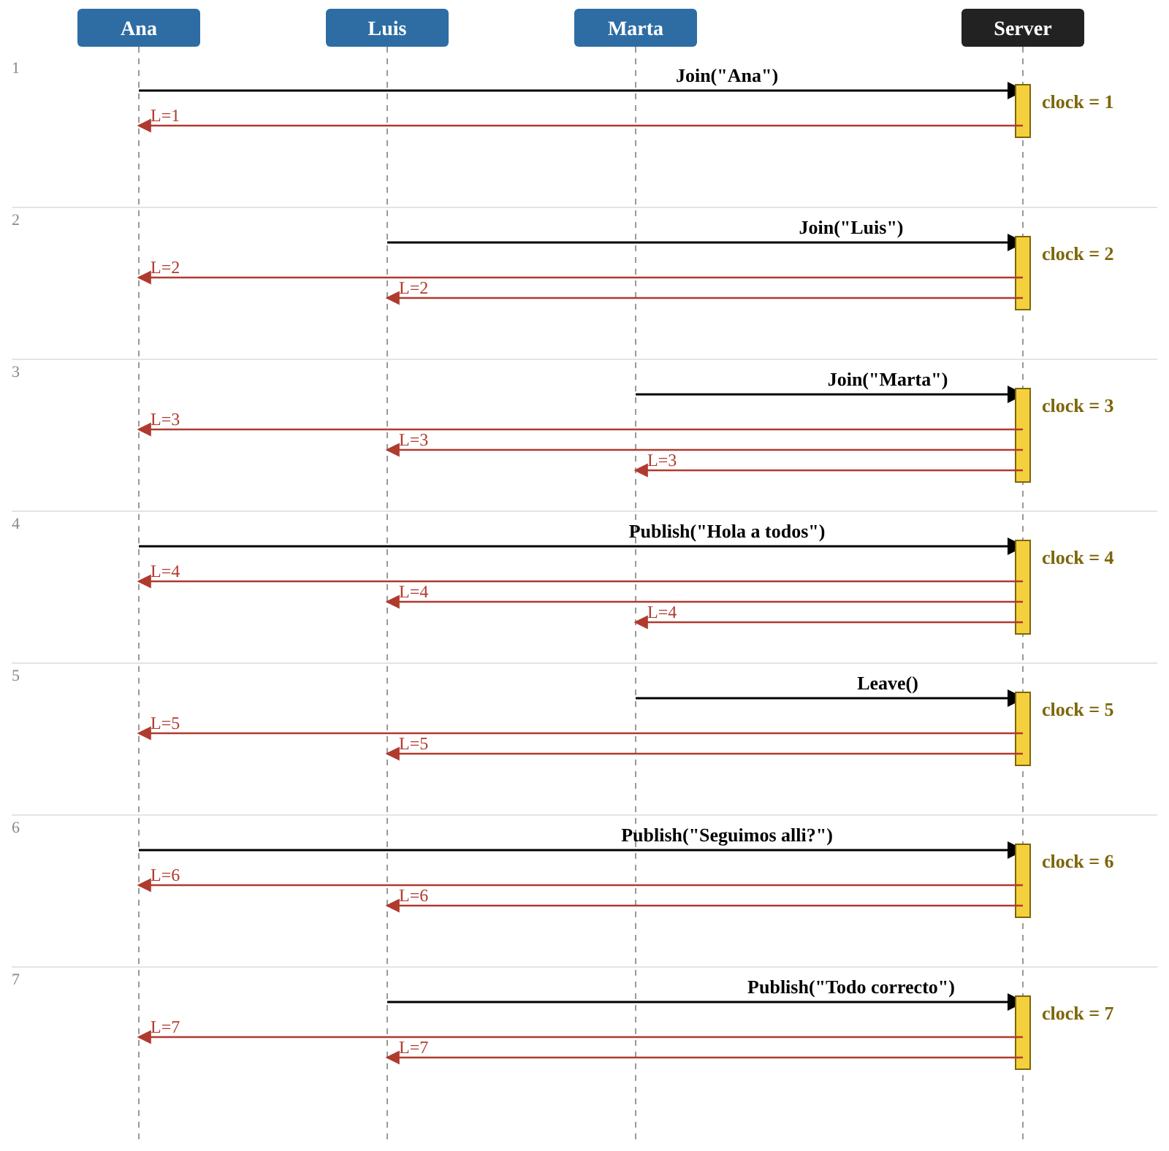
Figure 1. RPC calls and Lamport timestamps for the interaction in the test run.

7. Logging and message validation
Server and clients use Go's standard log package. Each line has the automatic timestamp followed by component= (Server or Client), event= and the relevant identifiers (client_id, name, logical_time).
Component | Events logged
Server | startup, shutdown, connection, join, publish, delivery (one line per participant per event), leave, disconnection; and error events (delivery_error, queue_closed, startup_error, serve_error)
Client | connection, received (every broadcast, with its logical time and content), disconnection

In a client's received line, client_id is the ID of the participant the event concerns (for example, the author of a message), not the ID of the receiving client.
A valid message is a non-empty UTF-8 string of at most 128 characters, counted in characters (runes), not bytes. The client ignores empty input and refuses longer messages with an explanatory text; the server checks the same rules again and rejects invalid messages with InvalidArgument.

8. How to run
From the project root, start the server with go run ./server and, in a separate terminal for each participant, start a client with go run ./client. Enter a name to join, type messages and press Enter to send them, and type /quit to leave. The readme.md in the repository gives the complete instructions, including how to regenerate the Go code from the .proto file.
Source code: GitHub repository, under the assignment/chitchat/ folder.

Appendix A – System logs
The logs below come from one run with a server and three concurrent clients (Ana, Luis and Marta) on 25/10/2026. Ana, Luis and Marta joined (L=1, 2, 3); Ana published (L=4); Marta left with /quit and the server notified the remaining clients (L=5); Ana (L=6) and Luis (L=7) published again. They show server startup, client connections and disconnections, the broadcast of the join and leave messages, and the delivery of every message.
Note: in the server log, the last event (L=7) shows a delivery line only for client-2; Ana's client log shows that she received it.

A.1 Server
go run ./server
2026/10/25 13:15:00 component=Server event=startup address=localhost:5050
2026/10/25 13:15:07 component=Server event=connection client_id=client-1 name="Ana"
2026/10/25 13:15:07 component=Server event=join client_id=client-1 name="Ana" logical_time=1
2026/10/25 13:15:07 component=Server event=delivery client_id=client-1 logical_time=1
2026/10/25 13:15:17 component=Server event=connection client_id=client-2 name="Luis"
2026/10/25 13:15:17 component=Server event=join client_id=client-2 name="Luis" logical_time=2
2026/10/25 13:15:17 component=Server event=delivery client_id=client-2 logical_time=2
2026/10/25 13:15:17 component=Server event=delivery client_id=client-1 logical_time=2
2026/10/25 13:15:26 component=Server event=connection client_id=client-3 name="Marta"
2026/10/25 13:15:26 component=Server event=join client_id=client-3 name="Marta" logical_time=3
2026/10/25 13:15:26 component=Server event=delivery client_id=client-3 logical_time=3
2026/10/25 13:15:26 component=Server event=delivery client_id=client-2 logical_time=3
2026/10/25 13:15:26 component=Server event=delivery client_id=client-1 logical_time=3
2026/10/25 13:15:36 component=Server event=publish client_id=client-1 logical_time=4
2026/10/25 13:15:36 component=Server event=delivery client_id=client-1 logical_time=4
2026/10/25 13:15:36 component=Server event=delivery client_id=client-2 logical_time=4
2026/10/25 13:15:36 component=Server event=delivery client_id=client-3 logical_time=4
2026/10/25 13:15:41 component=Server event=disconnection client_id=client-3 name="Marta"
2026/10/25 13:15:41 component=Server event=leave client_id=client-3 name="Marta" logical_time=5
2026/10/25 13:15:41 component=Server event=delivery client_id=client-2 logical_time=5
2026/10/25 13:15:41 component=Server event=delivery client_id=client-1 logical_time=5
2026/10/25 13:15:54 component=Server event=publish client_id=client-1 logical_time=6
2026/10/25 13:15:54 component=Server event=delivery client_id=client-2 logical_time=6
2026/10/25 13:15:54 component=Server event=delivery client_id=client-1 logical_time=6
2026/10/25 13:15:59 component=Server event=publish client_id=client-2 logical_time=7
2026/10/25 13:15:59 component=Server event=delivery client_id=client-2 logical_time=7

A.2 Client Ana
go run ./client
Your name: Ana
2026/10/25 13:15:07 component=Client event=connection client_id=client-1 name="Ana"
[1] Participant Ana joined Chit Chat at logical time 1
2026/10/25 13:15:07 component=Client event=received client_id=client-1 logical_time=1 content="Participant Ana joined Chit Chat at logical time 1"
You are in Chit Chat.
Type a message and press Enter to send it.
Type /quit to leave the chat.
> [2] Participant Luis joined Chit Chat at logical time 2
2026/10/25 13:15:17 component=Client event=received client_id=client-2 logical_time=2 content="Participant Luis joined Chit Chat at logical time 2"
[3] Participant Marta joined Chit Chat at logical time 3
2026/10/25 13:15:26 component=Client event=received client_id=client-3 logical_time=3 content="Participant Marta joined Chit Chat at logical time 3"
Hola a todos
[4] Ana: Hola a todos
2026/10/25 13:15:36 component=Client event=received client_id=client-1 logical_time=4 content="Ana: Hola a todos"
> [5] Participant Marta left Chit Chat at logical time 5
2026/10/25 13:15:41 component=Client event=received client_id=client-3 logical_time=5 content="Participant Marta left Chit Chat at logical time 5"
Seguimos alli?
[6] Ana: Seguimos alli?
2026/10/25 13:15:54 component=Client event=received client_id=client-1 logical_time=6 content="Ana: Seguimos alli?"
> [7] Luis: Todo correcto
2026/10/25 13:15:59 component=Client event=received client_id=client-2 logical_time=7 content="Luis: Todo correcto"

A.3 Client Luis
go run ./client
Your name: Luis
2026/10/25 13:15:17 component=Client event=connection client_id=client-2 name="Luis"
[2] Participant Luis joined Chit Chat at logical time 2
2026/10/25 13:15:17 component=Client event=received client_id=client-2 logical_time=2 content="Participant Luis joined Chit Chat at logical time 2"
You are in Chit Chat.
Type a message and press Enter to send it.
Type /quit to leave the chat.
> [3] Participant Marta joined Chit Chat at logical time 3
2026/10/25 13:15:26 component=Client event=received client_id=client-3 logical_time=3 content="Participant Marta joined Chit Chat at logical time 3"
[4] Ana: Hola a todos
2026/10/25 13:15:36 component=Client event=received client_id=client-1 logical_time=4 content="Ana: Hola a todos"
[5] Participant Marta left Chit Chat at logical time 5
2026/10/25 13:15:41 component=Client event=received client_id=client-3 logical_time=5 content="Participant Marta left Chit Chat at logical time 5"
[6] Ana: Seguimos alli?
2026/10/25 13:15:54 component=Client event=received client_id=client-1 logical_time=6 content="Ana: Seguimos alli?"
Todo correcto
[7] Luis: Todo correcto
2026/10/25 13:15:59 component=Client event=received client_id=client-2 logical_time=7 content="Luis: Todo correcto"

A.4 Client Marta
go run ./client
Your name: Marta
2026/10/25 13:15:26 component=Client event=connection client_id=client-3 name="Marta"
[3] Participant Marta joined Chit Chat at logical time 3
2026/10/25 13:15:26 component=Client event=received client_id=client-3 logical_time=3 content="Participant Marta joined Chit Chat at logical time 3"
You are in Chit Chat.
Type a message and press Enter to send it.
Type /quit to leave the chat.
/quit
2026/10/25 13:15:41 component=Client event=disconnection client_id=client-3 name="Marta"
You left Chit Chat.

