# SEO RECOMMENDATIONS

## www.mikedesigns.com

## Set relevant meta title

*Titles are critical to giving users a quick insight into the content of a result and why it’s relevant to their query. It's often the primary piece of information used to decide which result to click on, so it's important to use high-quality titles on your web pages.*

A title tag shouldn’t exceed the 50/60 characters.

*Reference: <https://support.google.com/webmasters/answer/35624?hl=en>*

In the audited website the titles aren’t relevant, as you can see in the image below:

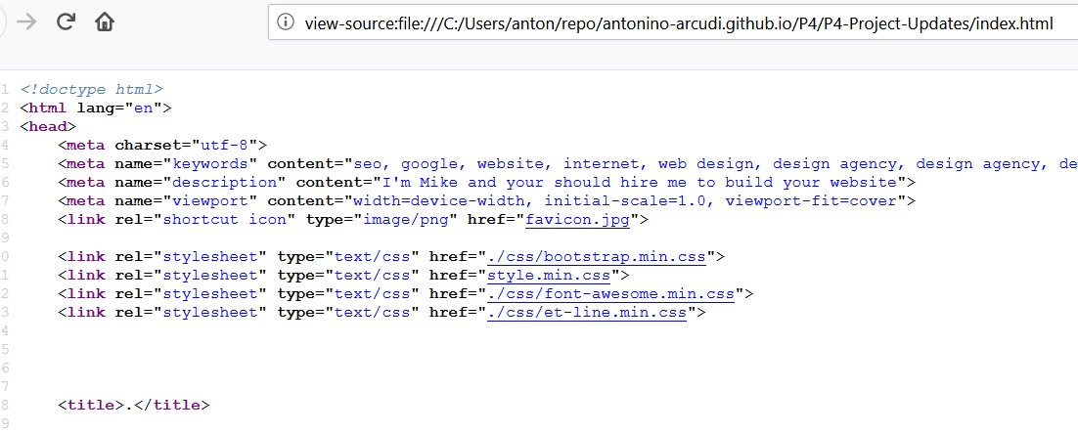

I have added relevant title to both pages bearing in mind that you would like to rank for freelance web designer Atlanta.

## Set relevant meta-description

Even if metadescription is not a direct ranking factor, it can affect the CTR in the SERP, which is one of the 200 and more ranking factors.

A meta description shouldn’t be longer than 150/160 characters.

*Reference: <https://support.google.com/webmasters/answer/35624?hl=en>*

In the contact page the meta description has no content, so we have written a metadescription.

## Removing meta keywords

The meta keyword isn’t used from Google. You can safetly remove this meta from your website: it gives clues to your competitors about your SEO strategy and it could be interpreted from search engines as a keyword stuffing signal.

*Reference: https://webmasters.googleblog.com/2009/09/google-does-not-use-keywords-meta-tag.html*

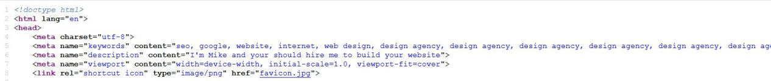

## Replace actual alt=”” text of images with a less spammy text

Image alternative text is meant to be as an indication of what and images represent. It is used by screen reader and browsers which are not able to render the images.

Reference: <https://support.google.com/webmasters/answer/114016?hl=en>

In the audited website I noticed that the alt text was used for keyword stuffing or provide no info about the image. You can insert some keywords only if they are relevant with the image content.

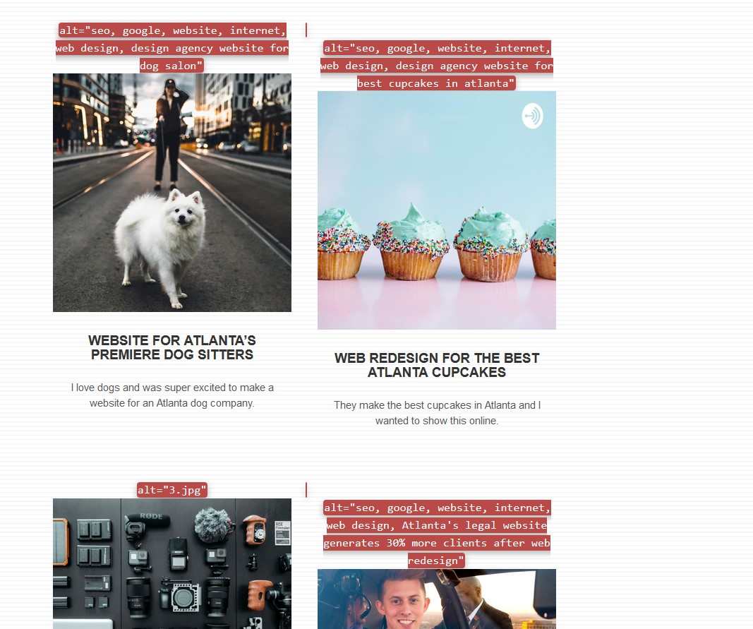

The alternative texts of the images have been changed.

## Optimize image size, weight and format

Pagespeed is a ranking factor for mobile websites. Using images that are too large for the viewports, too heavy, or in a non optimized format results in an increase of the website loading time.

As you can see in the following image:

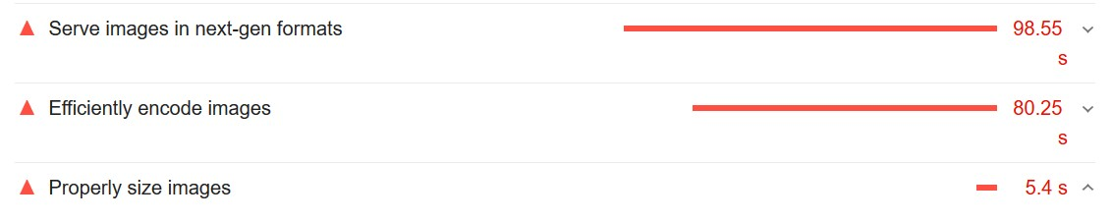

We have optimized the images size, weight and format in order to reduce the loading time of your website.

## Minify JS and CSS

Minifying CSS and JS files can improve your page load performance. CSS files are often larger than they need to be

According to Lightouse plugin, on your website JS files can be minified in order to achieve a better loading experience:

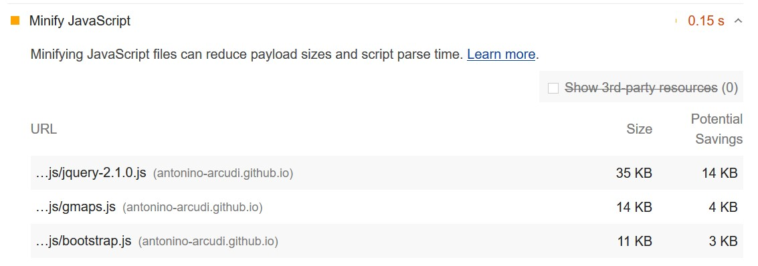

I have minified CSS and JS

#### Avoid to delay the first paint of the webpage

Resources are blocking the first paint of your page. Not every JS and CSS is really needed for the first paint of the page and for the content above the folder:

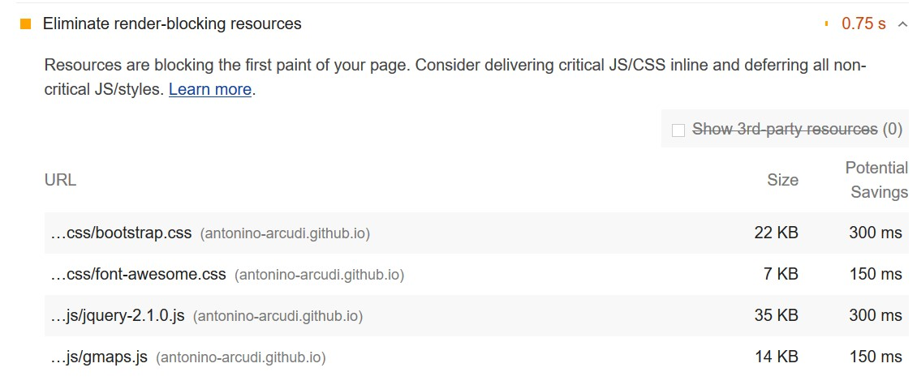

Since this webpage isn’t using JS for the above the fold content I have moved the scripts and the footer block.

## Avoid Cloaking

Presenting different information to users and crawlers is considered a violation of Google’s [Webmaster Guidelines](https://support.google.com/webmasters/answer/answer.py?answer=35769) because it provides our users with different results than they expected. Is a black-hat SEO practice that you should never used.

In your website I’ve found some white text over white background. The text is inside a div with a class=”keywords” and is not visible for normal users of your webpage:

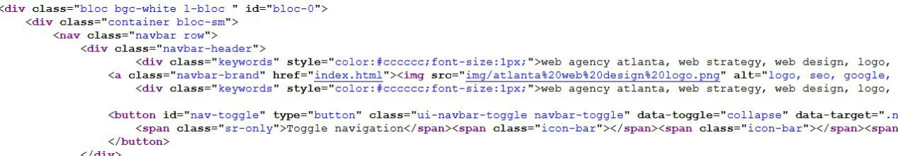

I have removed these divs from your website because they can only harm your rankings.

## Use the headings for structuring the content and not for style

The headings tags should be used to provide a logical structure of your content. Using the headings tags in a proper way helps the search engines to understand what your page contains.

In your website I noticed and incorrect use of headings tags that sometimes seems to be used for styling reasons:

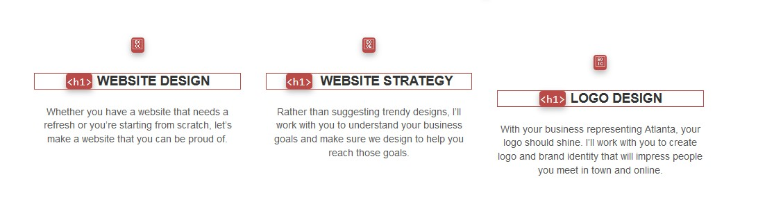

Also I would recommend the use of a unique H1 for page. If you are using HTML5,you can set an H1 for section.

I have changed the headings tags according to the recommendation and also changed the H1 text from “I’m Mike” to “I’m Mike, a freelance web designer in Atlanta”. In the contact page and h1 has been added.

## Don’t embed important text inside images

Avoid embedding text in images, especially important text elements like page headings and menu items, because not all users can access them (and page translation tools won't work on images). To ensure maximum accessibility of your content, keep text in HTML.

I noticed that in your website you are including important text inside images. Also this images are not responsive and break the content flow and appearance on mobile device, as you can see in the following image:

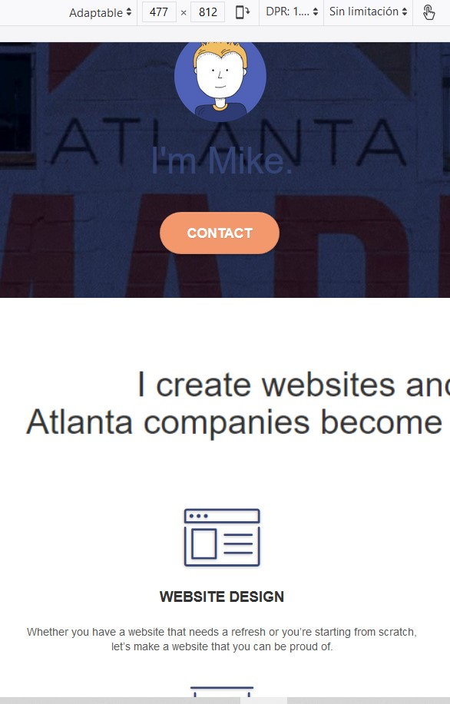

I have created a text in order to replace the images.

## Remove the links from the footer

According to Google guidelines, any links intended to manipulate PageRank or a site's ranking in Google search results may be considered part of a link scheme and a violation of Google’s Webmaster Guidelines. This includes any behavior that manipulates links to your site or outgoing links from your site.

In your footer you are linking some directories and this could be interpreted as an attempt to manipulate the pagerank.

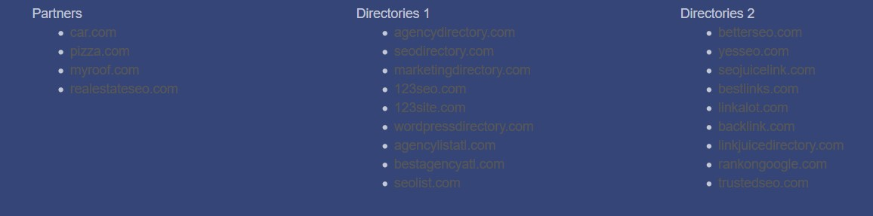

I have removed this links from the footer.