User Guide to the
Data anonymization procedure with the privacy filter by OpenAI
on Windows
Antonio Piemontese
June 2, 2026

The OpenAI Privacy Filter is an open-source tool (under the Apache 2.0 license) designed to intercept, recognize and redact personal or potentially sensitive information present in a text before it is used in an automated processing workflow, for example in a prompt intended for a language model, in an artificial intelligence pipeline, in a RAG system, in a training dataset, in an application log. Its main purpose is to reduce the risk that identifying data, such as names, addresses, emails, dates of birth, phone numbers or other personal references, are transmitted or stored unnecessarily. Internally, the filter does not merely perform a simple mechanical search for words or patterns, but analyzes the text in its context, identifies the portions that may represent personal data and replaces them with labels, masks or redacted forms. In this sense, the Privacy Filter belongs among the tools for preventive data protection: it does not change the logic of the document nor does it necessarily hide its general meaning, but it acts on the elements that could allow the identification of a person, possibly of a company, or the disclosure of confidential information. However, it should be regarded as a risk mitigation tool, not as an absolute guarantee of anonymization, because automatic recognition can always produce omissions or excessive redactions, especially when the personal data is implicit, ambiguous or context-dependent.
👉 The OpenAI privacy filter tool is technologically agnostic because it produces redacted files that can be given as input to any tool or chatbot (not just chatGPT).
The model has 1.5B total parameters but only 50M active, and a context window of 128,000 tokens that avoids chunking.
---
Legend
👉 key point, the "gist"
📌 note / start of a note
✅ resolved point, positive
❌ negative point, to be avoided
🛑 problem
⚠️ caution, warning, alarm
⟶ consequence, effect, next step

Required tools
- a Windows terminal (the Command Prompt)
- Python
- PyTorch (a Python package for handling neural networks)

Carry out the following steps:
---
0. IF the folder for testing the OpenAI privacy filter has already been created, it must be deleted beforehand in order to have a clean starting point, as follows:
- suppose the folder to be deleted is C:\Users\<User>\privacy-filter (or, instead of the generic <User>, your own specific user)
- move to the parent folder, for example with: cd C:\Users\<User>
- run the command:
rmdir /s /q privacy-filter
where:
- /s: tells Windows to remove the main folder and all the subfolders inside it.
- /q: runs the operation in "silent" (quiet) mode. It does not ask for confirmation for each individual file or folder.
⚠️ Warning:
Deleting a folder via the command line is permanent. Files removed this way do not go to the Windows Recycle Bin, so be very careful to be in the correct folder before pressing Enter.

---
1. open a Windows Command Prompt by typing "cmd" in the Windows search bar at the bottom left of the screen and then selecting the “Command Prompt” item

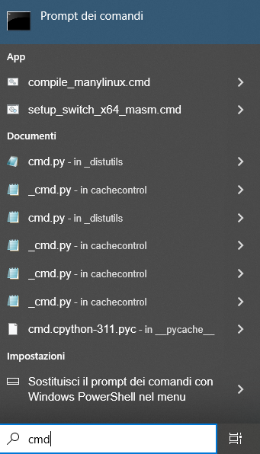
❷

❶

---
2. a black window titled "Command Prompt" opens, usually set to the folder C:\Users\<User> (where the generic <User> may have been replaced by your specific user, if previously created in Windows).
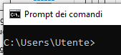
---
3. go to the website python.org and then click "Downloads" “All releases”
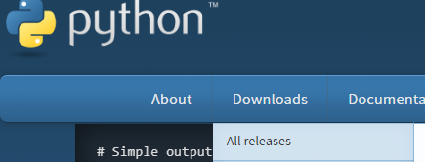
---
4. look at the center of the screen, below the big yellow button.
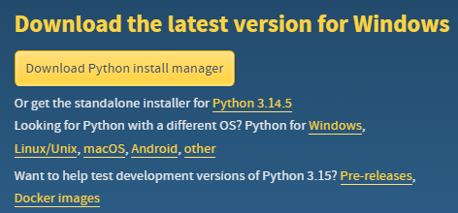
Find this line of text:
Looking for Python with a different OS? Python for Windows, Linux/Unix, macOS, Android, other.
Click on the yellow word Windows.
---
5. a page will open titled "Python Releases for Windows".
- scroll down until finding the version we want (as of today, Python 3.12.9).
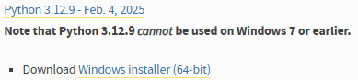
- under the title of the chosen version, click on the link Download Windows installer (64-bit).
This will directly start the download of the correct .exe file.
---
6. in the “Downloads” folder of your PC, double-click on the folder:
to launch the installer.
---
7. In the installer wizard, at this step:
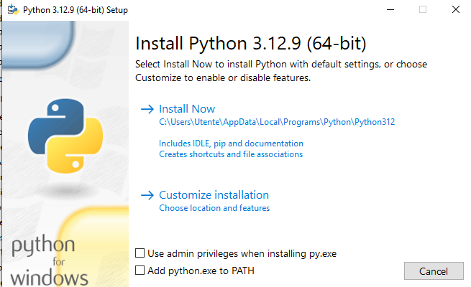
check “Add Python.exe to PATH” (important) and then choose the “Install Now” option
---
8. Once the installation has finished, close the terminal and reopen it. Then type “python”. A Python shell should open with version 3.12.9:
OK, we have installed python and it works.
We exit python with ctrl+Z.
---
9. Let’s go back to the terminal: under the folder C:\Users\<User> download the OpenAI software with the following command:
git clone https://github.com/openai/privacy-filter.git
where git is a (very good and widely used) piece of software for downloading and sharing software.
The result must be:
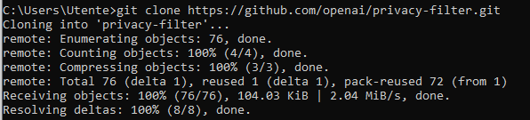
It is important that all the steps end with “done” and that there are no errors.
---
10. Move to the new folder created in step 9 with:
cd privacy-filter
This is the main project folder.
Run the command dir.
We should get something similar (dates aside):
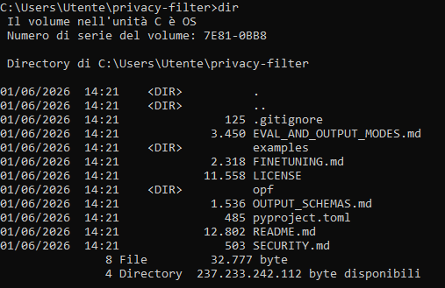
In particular, the following must exist in this folder:
- the file pyproject.toml
- the file README.md
- the subfolder opf
- the subfolder examples
---
11. From the project folder in the terminal, run:
pip install -e .

We should get an output of this kind:
…………..
NB. These two (similar) commands must not be confused:
pip install .
pip install -e .
The first command installs a “fixed” copy of the package, the second installs the package in development mode, linked to the local source files .
With the second command, pip creates an executable (a file.exe) called opf, for example in a folder such as:
C:\Users\Utente\AppData\Local\Programs\Python\Python312\Scripts\opf.exe
---
12. Verify that opf has been installed correctly, as follows:
python -m pip show opf
which should return something similar to:
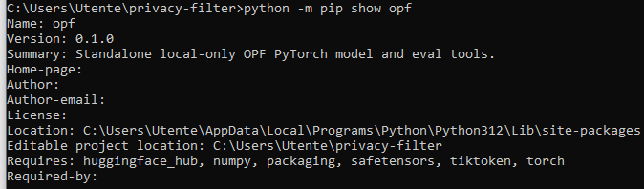

An output of this kind tells us 4 important things:
- The two lines:
Name: opf
Version: 0.1.0
confirm that Python sees the package opf.
- Summary: Standalone local-only OPF PyTorch model and eval tools. That is, what opf is!!
- The installation really is set to editable.
The line: Editable project location: C:\Users\Utente\privacy-filter
confirms that the command: python -m pip install -e .
worked and that the installed package points to the local project folder.
- We are using the official Python installed on Windows, as indicated by the line:
Location: C:\Users\Utente\AppData\Local\Programs\Python\Python312\Lib\site-packages
So the current situation is:
opf is installed
opf correctly points to the folder C:\Users\Utente\privacy-filter
opf is installed in the official Windows Python 3.12

---
13. Let’s (further) verify the availability of the help (and of opf!) with
python -m opf –help

---
14. At this point, we have a python script called opf that can be run via python -m opf

For a first anonymization (one-off) on CPU, i.e. a first use of the model, type:
python -m opf --device cpu "Alice was born on 1990-01-02."
We should get:
Alice was born on <PRIVATE_DATE>.
The model recognized a piece of sensitive data, Alice’s date of birth, and replaced it with a type label!
The following infographic describes all the components of the previous important command:
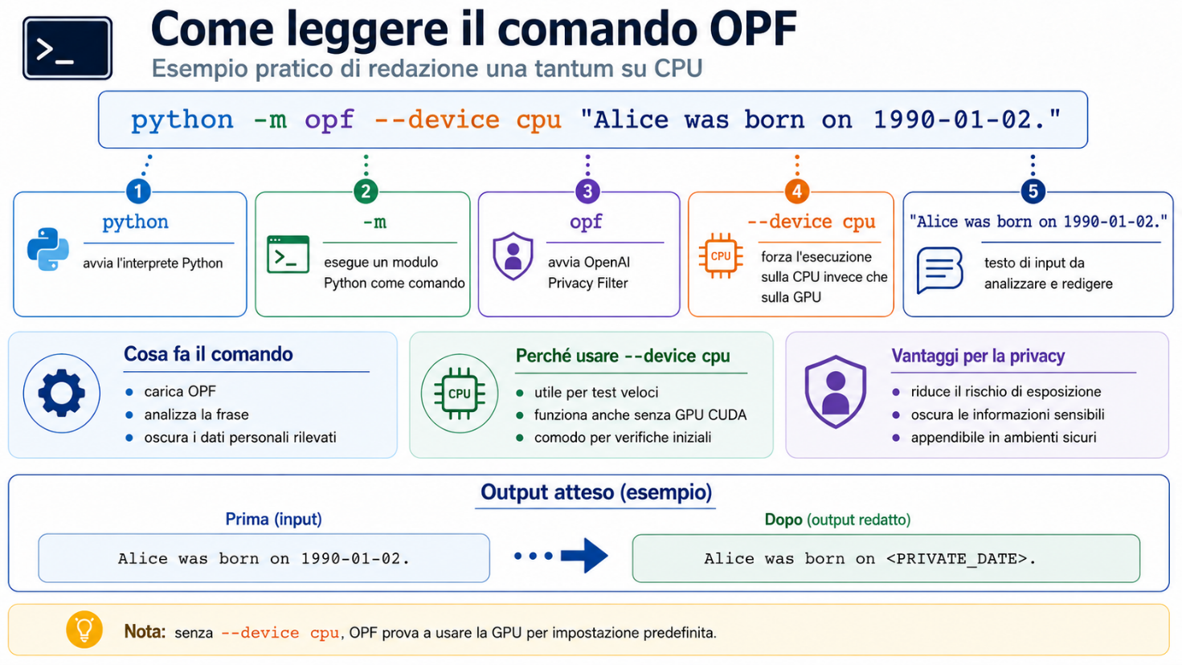
Why did opf not recognize Alice as <PRIVATE_PERSON>?

⚠ Note — why "Alice" is not redacted. It is not an error: the model leaves the standalone first name Alice in clear text, while it masks full names. Compare:
- Alice was born on 1990-01-02. → Alice was born on <PRIVATE_DATE>. (single name not redacted)
- Mario Rossi was born on 1980-06-01. → <PRIVATE_PERSON> was born on <PRIVATE_DATE>. (first name + surname redacted)
The behavior is consistent with the design: a first name alone does not uniquely identify anyone, so it is not treated as personal data.

---
15. It is possible to use opf directly (without python -m before it), as follows.
Check where opf is by typing, from the same terminal folder:
where opf
If everything is in order, something like this should appear:
C:\Users\Utente\AppData\Local\Programs\Python\Python312\Scripts\opf.exe
This means that this folder is in the PATH! (where searches in the PATH!)
We can then safely use the command directly
opf --device cpu "Alice was born on 1990-01-02."
to get the same result.
What matters, however, is that the command via python seen earlier works:
python -m opf --device cpu "Alice was born on 1990-01-02."
---
16. The basic installation of the OpenAI privacy filter works!
Now it is best to proceed in this order:
- find out where the model was downloaded;
- try anonymizing an entire file;
- possibly move to the GPU;
- then, only afterwards, look at eval and fine-tuning.

16.1 Check where the model is located
After the first successful run, opf should have created a folder under the user profile:
C:\Users\Utente\.opf\privacy_filter
Check with (from the terminal):
dir %USERPROFILE%\.opf\privacy_filter
If we see an output similar to the following:
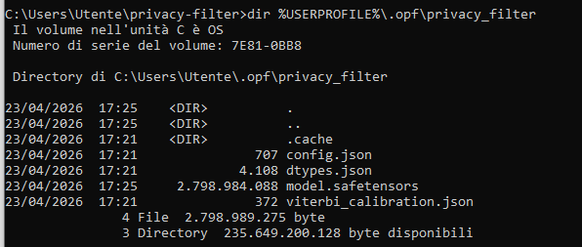
then the checkpoint has been downloaded correctly.
The most important file is: model.safetensors, which weighs about: 2,798,984,088 bytes, i.e. about 2.8 GB. That is the actual model.
So now the situation is:
opf = command/executable
C:\Users\Utente\.opf\privacy_filter = model/checkpoint folder
model.safetensors = main model file

We can also check whether an environment variable OPF_CHECKPOINT exists, with the command:
echo %OPF_CHECKPOINT%
If it simply prints:
%OPF_CHECKPOINT%
or an empty line, it means that the variable is not set. That is fine: in that case opf uses the default folder:
C:\Users\Utente\.opf\privacy_filter

16.2. Try with a text file
Create a small test file. For example, from cmd:
echo Alice was born on 1990-01-02. She lives in Rome in Via del Corso 120. > prova_privacy.txt
Check the content of the file by typing:
prova_privacy.txt
This should open notepad with the content.
Alternatively, it is also possible to check the content of the file with:
type prova_privacy.txt
Then run:
opf --device cpu -f prova_privacy.txt
We should get:
Both pieces of sensitive data were recognized, classified and redacted.
If the file is not in the current folder, use the full path, for example:
opf --device cpu -f C:\Users\Utente\.opf\privacy_filter\prova_privacy.txt
In this case too, we get:
NB. To save the results of this example to a file, do this:
opf --device cpu -f prova_privacy.txt > prova_privacy_redatto.txt
Then check its content with :
type prova_privacy_redatto.txt
This way we have verified the classic flow:
original file -> OPF -> redacted file
The original file is not modified.

16.3. Try with a more realistic example
Create a txt file:
notepad esempio_cliente.txt
Inside it, write several pieces of personal data, for example:
Mario Rossi was born on 1980-06-01.
He lives in Via Roma 25, Turin, Italy.
His email is mario.rossi@example.com.
His phone number is +39 333 1234567.
His bank account number is IT60X0542811101000000123456.
Save the file and then run:
opf --device cpu -f esempio_cliente.txt
We get this output:
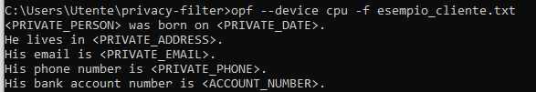
This example is useful because it tests several categories: person, date, address, email, phone, account.
As in the previous example, we can also save the result with:
opf --device cpu -f esempio_cliente.txt > esempio_cliente_redatto.txt
Then:
type esempio_cliente_redatto.txt
---
17. Try the GPU (if available on the PC)
We need to install pytorch, an open-source Python library developed by Meta, used to create and train artificial neural networks (artificial intelligence and deep learning).
For OPF / OpenAI Privacy Filter the important thing is:
torchaudio is not needed
torchvision is not needed
only torch is needed
And indeed, in the pyproject.toml of OPF the dependencies include torch, but they require neither torchvision nor torchaudio.
So type this command;
python -m pip install torch --index-url https://download.pytorch.org/whl/cu132
The following infographic describes the components of this important command:

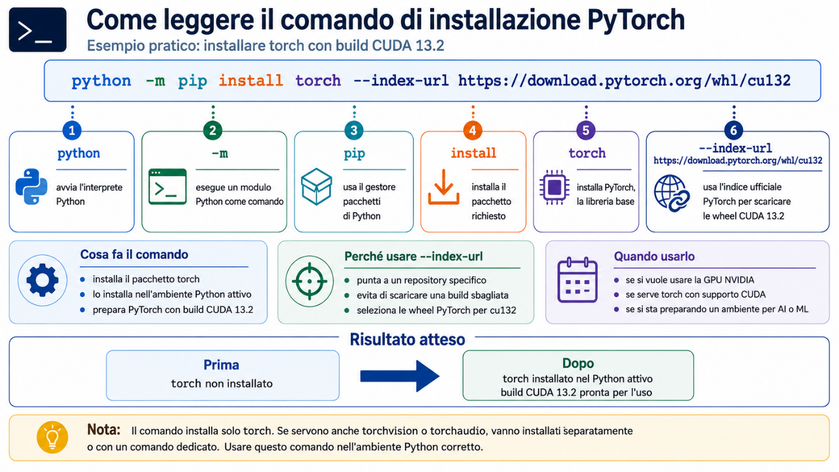
👉 The CUDA132 version is the best one for an RTX 5090 (as a fallback, 13.0), never 12.6. The reason is the compute capability.

Verify that torch is installed correctly with the following command:
python -c "import torch; print(torch.__version__); print(torch.version.cuda); print(torch.cuda.is_available()); print(torch.cuda.get_device_name(0) if torch.cuda.is_available() else 'NO CUDA')"
The goal is to see something like:
2.x.x+cu130
13.0
True
NVIDIA GeForce RTX 5090
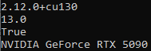
The NVIDIA GPU model depends on the individual PC. It is not necessary to have this particular model (RTX 5090, very powerful).
If instead cu130 does not find compatible packages, try the more traditional CUDA build:
python -m pip install torch --index-url https://download.pytorch.org/whl/cu128
Finally, we are ready for the GPU test.
First, we just need to reset a flag. In fact, when opf runs on GPU, it tries to use an accelerated component called Triton for the MoE kernels, i.e. Mixture-of-Experts .
In the code of opf, when the model is not running on CPU, the variable OPF_MOE_TRITON is considered active by default: default=not_running_on_cpu . If Triton is not installed and we run the next GPU test command, opf generates this message:
Install `triton` or unset OPF_MOE_TRITON.
The simplest way is to reset the flag, as follows:
set OPF_MOE_TRITON=0
And now the GPU test can work!!
opf -f esempio_cliente.txt > esempio_cliente_redatto.txt
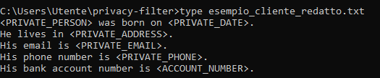
The GPU configuration worked correctly.
The final situation is this:
opf installed correctly
model downloaded to C:\Users\Utente\.opf\privacy_filter
PyTorch CUDA working
Triton disabled with OPF_MOE_TRITON=0
GPU anonymization working

At this point, let’s make permanent the variable OPF_MOE_TRITON.
set OPF_MOE_TRITON=0 in fact only applies to the current cmd window. When the terminal is closed, the setting is lost.
To make it permanent for the Windows user, run:
setx OPF_MOE_TRITON 0
It should return:
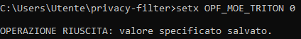
To further verify that the change to the variable is persistent, close and reopen the Command Prompt and check:
echo %OPF_MOE_TRITON%
It should return:
---
18. Benchmark CPU vs GPU
At what volumes of text to process does the difference between CPU and GPU become visible?
Let’s run a simple benchmark.
Let’s create a larger file, for example by duplicating the test text many times, for three separate files (of 1000, 10000 and 50000 test lines):
From the terminal cmd:
(for /L %i in (1,1,1000) do @echo Mario Rossi was born on 1980-06-01. He lives in Via Roma 25, Turin, Italy. His email is mario.rossi@example.com.) > test_1000.txt
(for /L %i in (1,1,10000) do @echo Mario Rossi was born on 1980-06-01. He lives in Via Roma 25, Turin, Italy. His email is mario.rossi@example.com.) > test_10000.txt
(for /L %i in (1,1,50000) do @echo Mario Rossi was born on 1980-06-01. He lives in Via Roma 25, Turin, Italy. His email is mario.rossi@example.com.) > test_50000.txt
Then, still from cmd, run these 3 commands, one at a time, noting down the output:
TEST CPU
python -c "import subprocess,time; t=time.perf_counter(); f=open('out_cpu_1000.txt','w',encoding='utf-8'); r=subprocess.run(['opf','--device','cpu','-f','test_1000.txt'],stdout=f,stderr=subprocess.PIPE,text=True); f.close(); print('CPU 1000 returncode =',r.returncode); print('CPU 1000 seconds =',round(time.perf_counter()-t,3)); print(r.stderr[-1000:])"

python -c "import subprocess,time; t=time.perf_counter(); f=open('out_cpu_10000.txt','w',encoding='utf-8'); r=subprocess.run(['opf','--device','cpu','-f','test_10000.txt'],stdout=f,stderr=subprocess.PIPE,text=True); f.close(); print('CPU 10000 returncode =',r.returncode); print('CPU 10000 seconds =',round(time.perf_counter()-t,3)); print(r.stderr[-1000:])"

python -c "import subprocess,time; t=time.perf_counter(); f=open('out_cpu_50000.txt','w',encoding='utf-8'); r=subprocess.run(['opf','--device','cpu','-f','test_50000.txt'],stdout=f,stderr=subprocess.PIPE,text=True); f.close(); print('CPU 50000 returncode =',r.returncode); print('CPU 50000 seconds =',round(time.perf_counter()-t,3)); print(r.stderr[-1000:])"

TEST GPU
And then the 3 commands for the GPU, also one at a time, noting down the output.
python -c "import subprocess,time; t=time.perf_counter(); f=open('out_gpu_1000.txt','w',encoding='utf-8'); r=subprocess.run(['opf','-f','test_1000.txt'],stdout=f,stderr=subprocess.PIPE,text=True); f.close(); print('GPU 1000 returncode =',r.returncode); print('GPU 1000 seconds =',round(time.perf_counter()-t,3)); print(r.stderr[-1000:])"

python -c "import subprocess,time; t=time.perf_counter(); f=open('out_gpu_10000.txt','w',encoding='utf-8'); r=subprocess.run(['opf','-f','test_10000.txt'],stdout=f,stderr=subprocess.PIPE,text=True); f.close(); print('GPU 10000 returncode =',r.returncode); print('GPU 10000 seconds =',round(time.perf_counter()-t,3)); print(r.stderr[-1000:])"

python -c "import subprocess,time; t=time.perf_counter(); f=open('out_gpu_50000.txt','w',encoding='utf-8'); r=subprocess.run(['opf','-f','test_50000.txt'],stdout=f,stderr=subprocess.PIPE,text=True); f.close(); print('GPU 50000 returncode =',r.returncode); print('GPU 50000 seconds =',round(time.perf_counter()-t,3)); print(r.stderr[-1000:])"

The value to note down, for each of these runs, is always
seconds = ...
and the test is valid only if:
returncode = 0
At the end we will have a table like this:
test_1000.txt CPU: ... sec GPU: ... sec
test_10000.txt CPU: ... sec GPU: ... sec
test_50000.txt CPU: ... sec GPU: ... sec
If the file test_50000.txt is very large, the CPU could take quite a long time. It is better to start with 1000 and 10000, and then move on to 50000 only after verifying that the first two tests complete correctly.

----
Note. The fact that the files of this stress test were built by repeating the same sentence does not invalidate the CPU/GPU performance comparison, as long as the goal is to measure the raw processing speed of OPF on increasing volumes.
For the performance benchmark we are running, the main point is to compare:
same input
same command
same model
same output
CPU vs GPU
So, if the file test_1000.txt is identical for CPU and GPU, the comparison remains valid.
However, repeating the same sentence can make the test less representative of a real case. In practice: it is fine for measuring pure throughput, but it is not ideal for simulating real documents, because a real text may contain:
- sentences of different lengths
- variable punctuation
- different names
- different addresses
- different emails
- dates in different formats
- empty lines
- non-sensitive text
- multilingual text
- messy layout from PDF/OCR
All of this can affect tokenization, span decoding and the amount of output produced.
So the three repetitive files should be used as a first technical benchmark, useful for understanding when the GPU starts to pull away from the CPU.
Then we can run a second, more realistic test with varied text.
For example, we can create a file with different sentences, again from cmd:
(
echo Mario Rossi was born on 1980-06-01 and lives at Via Roma 25, Turin.
echo Alice Smith was born on 1990-01-02 and her email is alice.smith@example.com.
echo Giuseppe Verdi has phone number +39 333 1234567.
echo The customer account number is IT60X0542811101000000123456.
echo Please contact Laura Bianchi at laura.bianchi@example.org.
echo John lives at 10 Downing Street, London.
echo This line contains no personal data.
echo Meeting scheduled for 2026-06-01 with Antonio Neri.
) > test_vario_base.txt
Then we duplicate it many times:
(for /L %i in (1,1,10000) do @type test_vario_base.txt) > test_vario_10000.txt
At that point we compare CPU and GPU on:
test_10000.txt
and on:
test_vario_10000.txt
This way we get two different measurements:
test_10000.txt regular synthetic benchmark
test_vario_10000.txt more realistic benchmark
In summary: the repeated-sentence test is valid for comparing computational performance. However, on its own it is not enough to estimate the behavior on real documents. Good practice is to do both: first a controlled synthetic test, then a realistic test with varied text.
---

19. Using Office and PDF files
So far we have used text files as input. If our data to be masked are in PDF or Office format, we first need to extract the text (e.g. with the packages pdftotext, python-docx) and then pipe it to the privacy-filter.
20. Custom types
It is possible to create “custom” types of sensitive data by fine-tuning the model.

Or by navigating with Explorer to C:\Users\<User>, then selecting the top bar with the full folder path  and then typing cmd + Enter. A cmd window will open, positioned right on C:\Users\<User>.
pip install -e . is a perfectly normal command in Python, even if at first glance it looks a bit strange. It means: - pip install = installs a Python package - . = the package to install is the current folder - -e = editable installation, i.e. “modifiable” or “in development” In practice, instead of copying the package into site-packages as a traditional installation does, pip creates a link to the local project folder. So, if we then modify the source code in that folder, Python sees the changes immediately without having to reinstall each time. This usage is consistent with the official repository openai/privacy-filter, which contains a Python project with pyproject.toml and package name opf, and can therefore be installed locally from the repo directory. In the specific case of OpenAI Privacy Filter, the command must be run after cloning the official GitHub repository and after moving into that folder. The repository is indeed public and very recent, and has no prepackaged GitHub release at the moment, so it makes sense for the guide to suggest installing from the local source instead of a simple pip install packagename.
This mode is widely used when we want to: - develop or inspect the code; - run tests by modifying the project; - avoid reinstalling after every small change. For simple “end-user” use, a non-editable installation is often preferred; for a project just published on GitHub, however, -e is quite common.
pip show opf and where opf answer two different questions. - pip show tells where the package is registered. The line Location: points to ...\Python312\Lib\site-packages, where the metadata are stored; with the editable installation, however, the actual source code stays in the project folder, as confirmed by the line Editable project location: C:\Users\Utente\privacy-filter. - where opf tells where the executable opf.exe is located, i.e. in ...\Python312\Scripts. This is the file that the PATH makes callable by typing opf. In short: Scripts hosts the command, site-packages the package registration, the project folder the source code.
Mixture of Experts (MoE) is a scalable machine learning technique in which a large artificial intelligence model is divided into smaller, specialized sub-networks called "experts".

