Plane Meta Splitter (by Delirio – November 1996)

Plane Meta Splitter (PMS) is a modeling utility that makes working with MetaNurbs simpler and faster. It can create a section (or, less precisely, a plane) of closed (e.g. a box) or open (e.g. planes) surfaces made of four-sided polygons.

Let us examine the PMS dialog box:

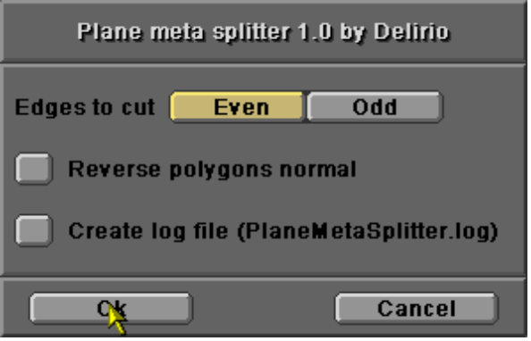

Parameters:

- “Edges to cut”: lets you choose the direction in which the adjacent polygons will be cut. “EVEN” and “ODD” are defined as follows. Suppose that the vertex order for a square polygon is as shown below:

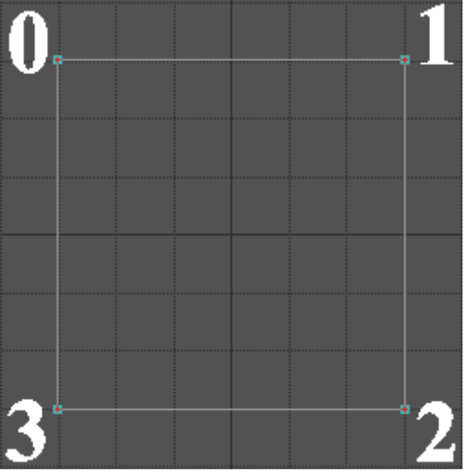

The EVEN edges are (0 ; 1) – (2 ; 3); the ODD edges are (0 ; 3) – (1 ; 2). The only way to discover this order is to make some tests. If you have a solution, please contact me!

- “Reverse polygons normal”: lets you flip the direction of the new polygons’ normals.
- “Create log file”: lets you store the execution flow in a log file named “PlaneMetaSplitter.log”, saved in the LightWave programs directory, which I used to debug this plug-in.

1) To start you must select ONLY ONE START POLYGON ;
2) The process terminates when it cannot found any other adjacent polygons to cut.

And now, a short PMS tutorial

Suppose you want to model a simple human head. These are the steps to follow:

Step 1: Create an approximate box.

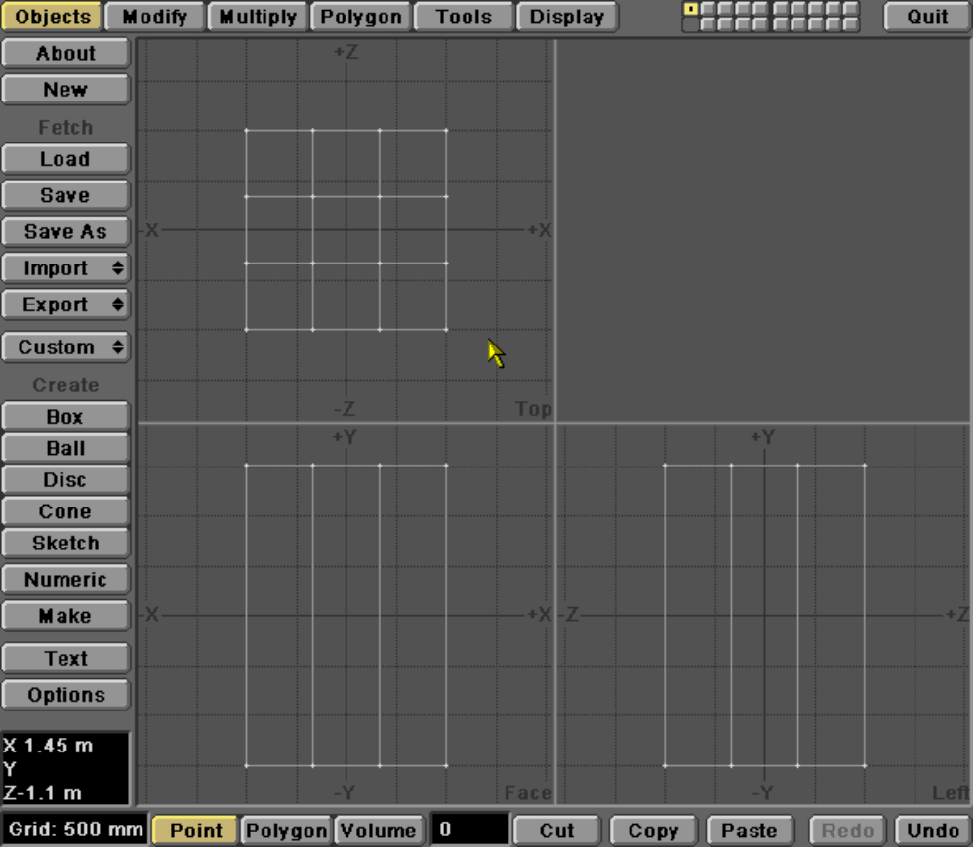

Step 2: Approximate a head profile and select one side polygon to refine with PMS.

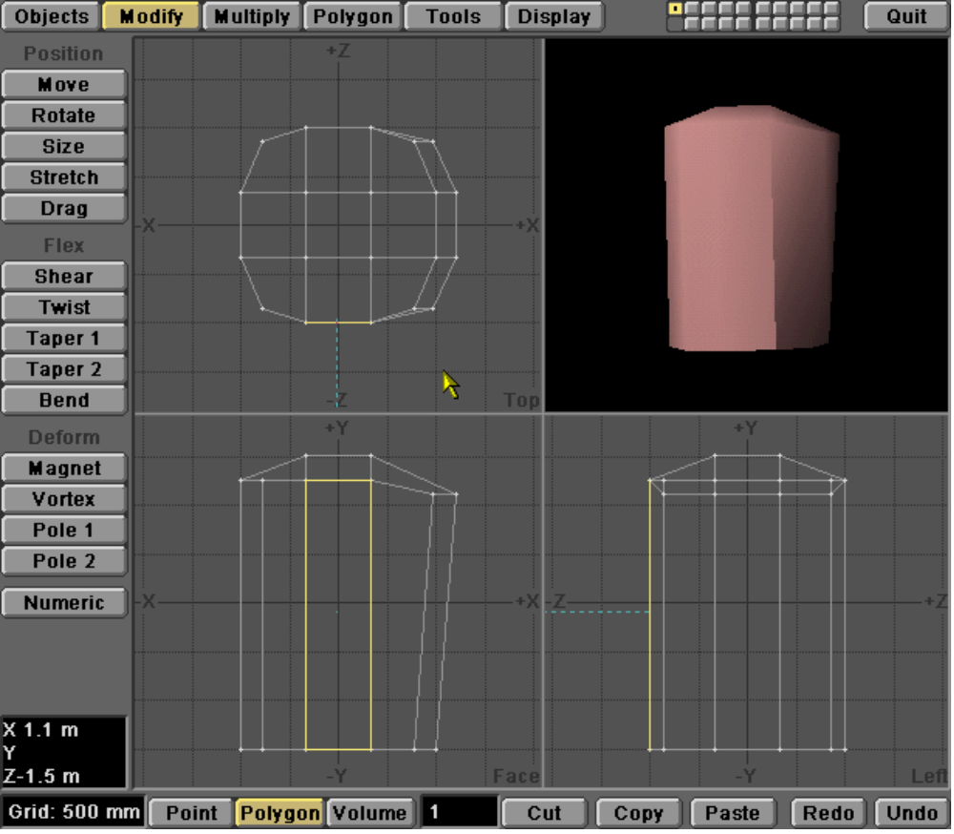

Step 3: Run PMS in ODD cut mode.

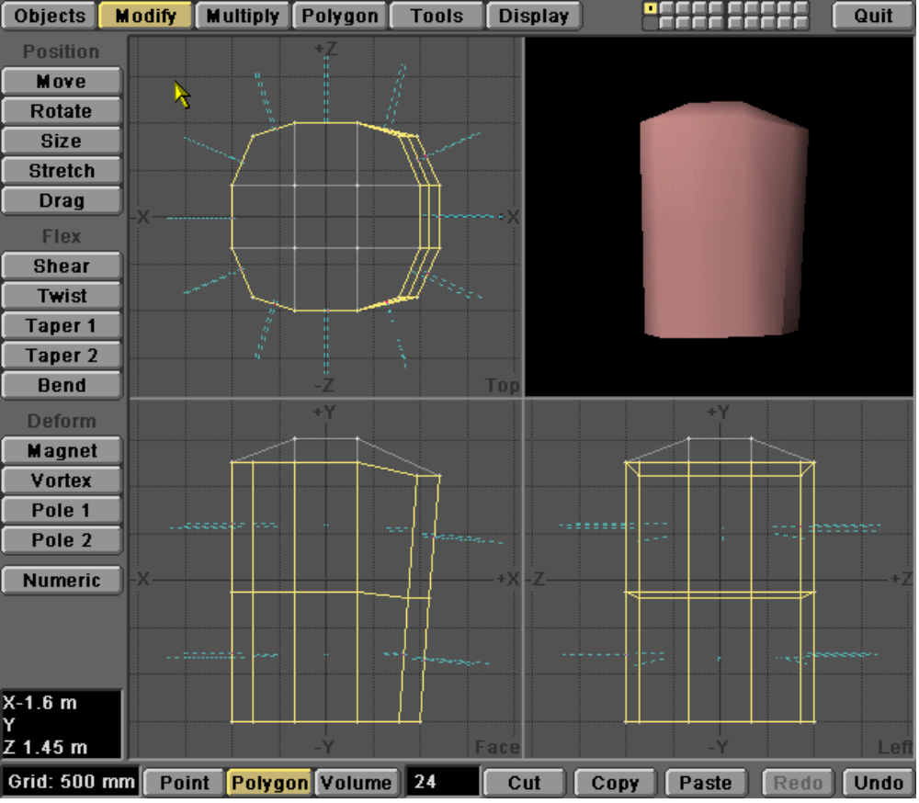

Step 4: Adjust some vertices, make another horizontal refinement with PMS, then continue adjusting the points.

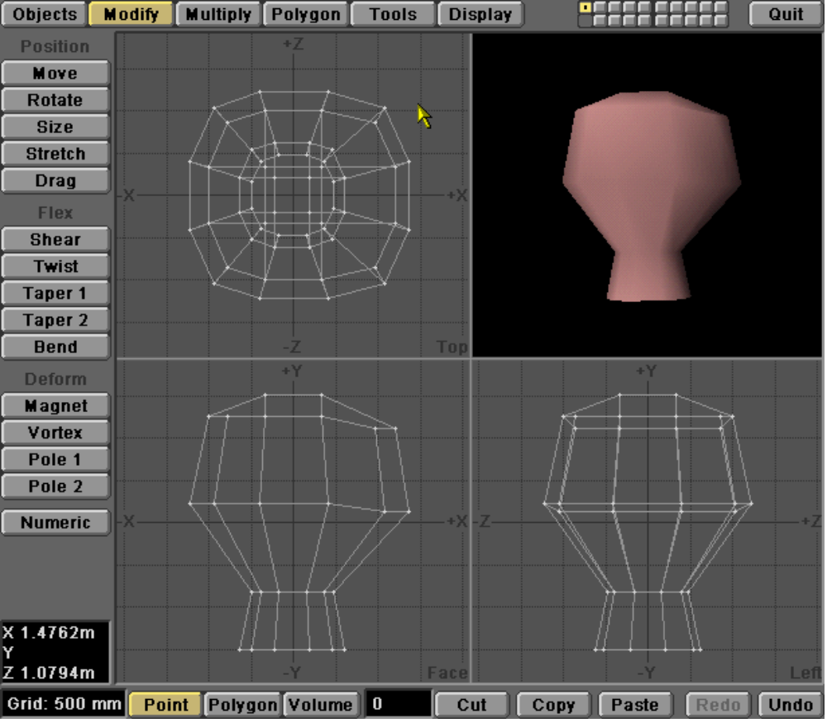

Step 5: Now refine a front polygon in the vertical direction to add details, e.g. to create the nose.

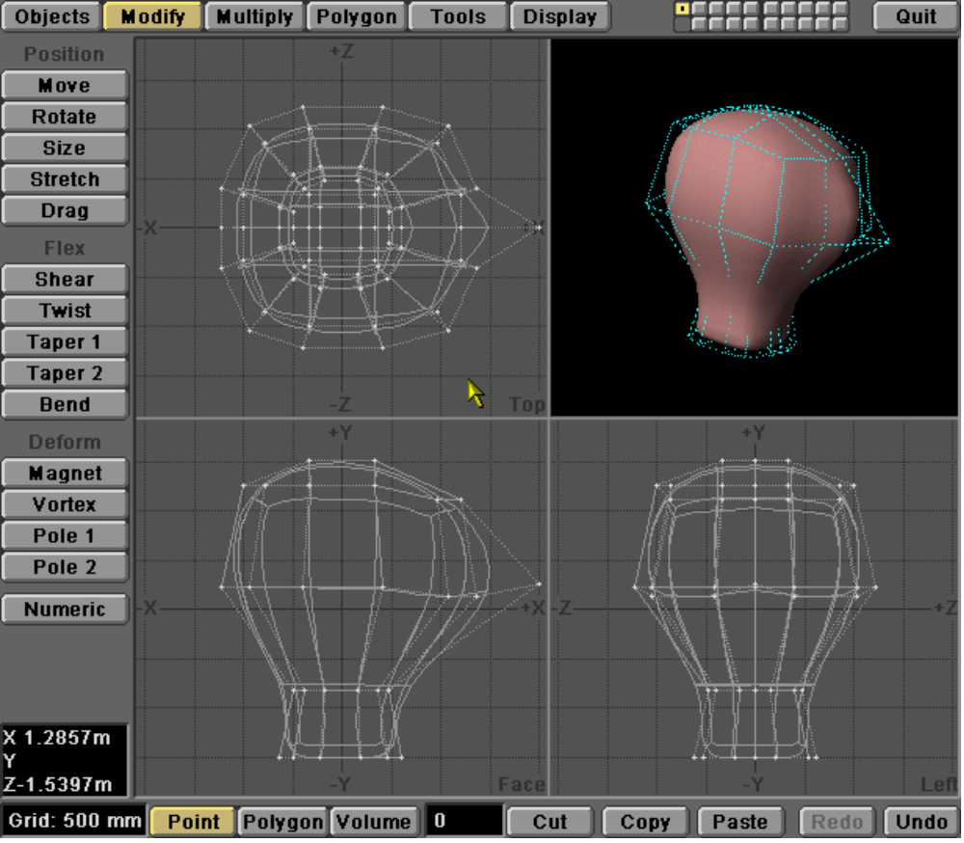

Step 6: Let your imagination run wild...

