Plane meta splitter (by Delirio - November 1996)

Plane meta splitter is a modeling utility that permit to work with MetaNurbs more simply and fast. It can create a section (or less precisely, plane) of closed (e.g. : box) or open (e.g. : planes) surfaces made of polygons with four vertexes.

We examine the PMS dialog box :

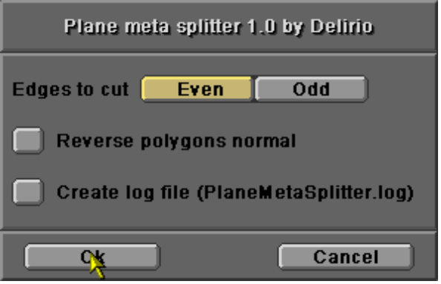

Parameters :

- “Edges to cut” : permits to choose the direction where the adjacent polygons will be cut. The meaning of “EVEN” and “ODD” is this : we suppose that the vertexes order for a square polygon is the following :

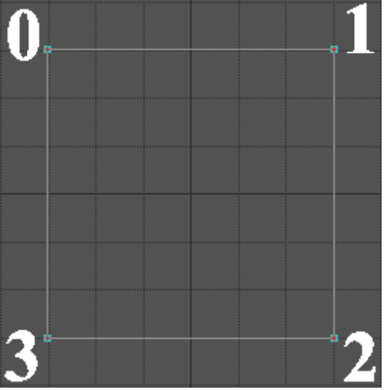

The EVEN edges are : (0 ; 1) - (2 ; 3), the ODD edges are (0 ; 3) - (1 ; 2). The only mode to discover this order is to make some tests . If you have a solution contact me ! J

- “Reverse polygons normal” : permits to revolve the direction of the new polygons normal.
- “Create log file” : permits to store the flow of execution in a log file named “PlaneMetaSplitter.log” and saved in lightwave programs directory, that I have used to debug this plug-in.

1) To start you must select ONLY ONE START POLYGON ;
2) The process terminates when it cannot found any other adjacent polygons to cut.

and now... a short PMS tutorial

We suppose to want to model a simple human head . These are the necessary steps to do this...

Step 1 : create an approximative box.

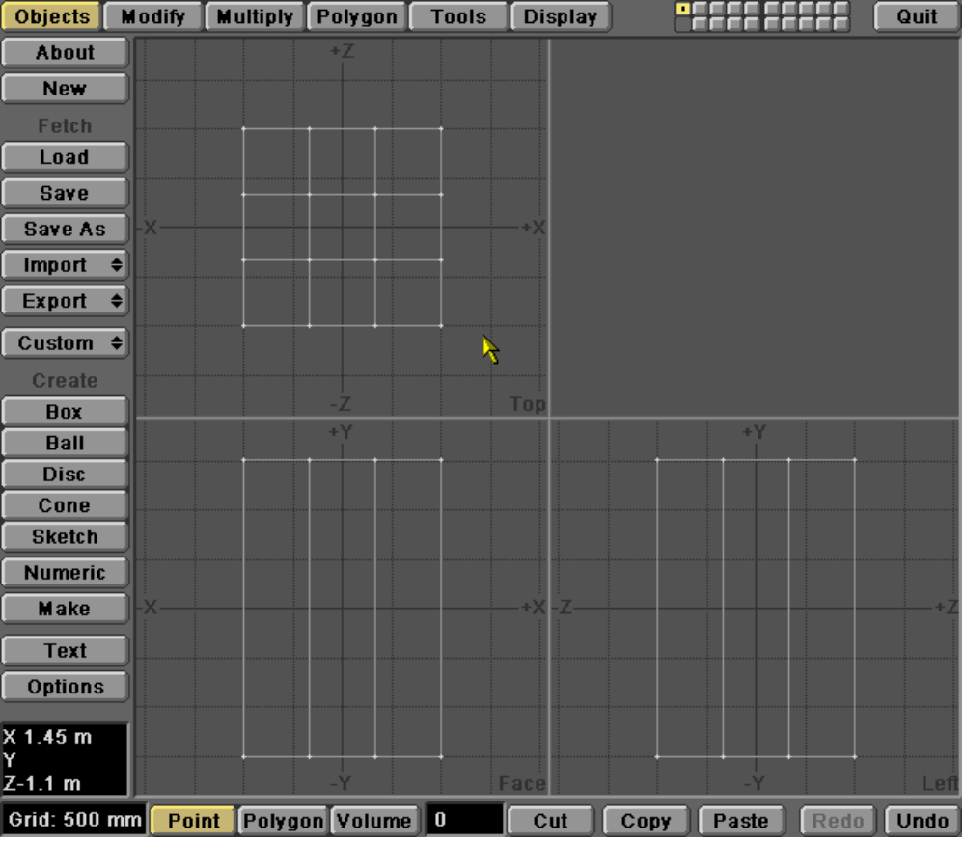

Step 2 : approximate a head profile, and select one side polygon for PMS refining.

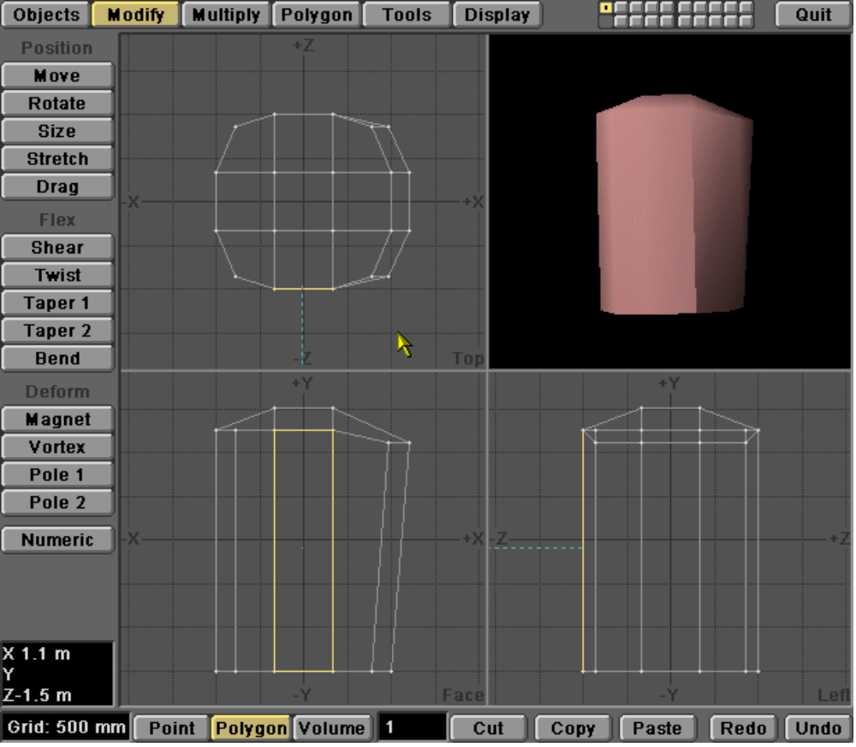

Pass 3 : run PMS in ODD cut mode.

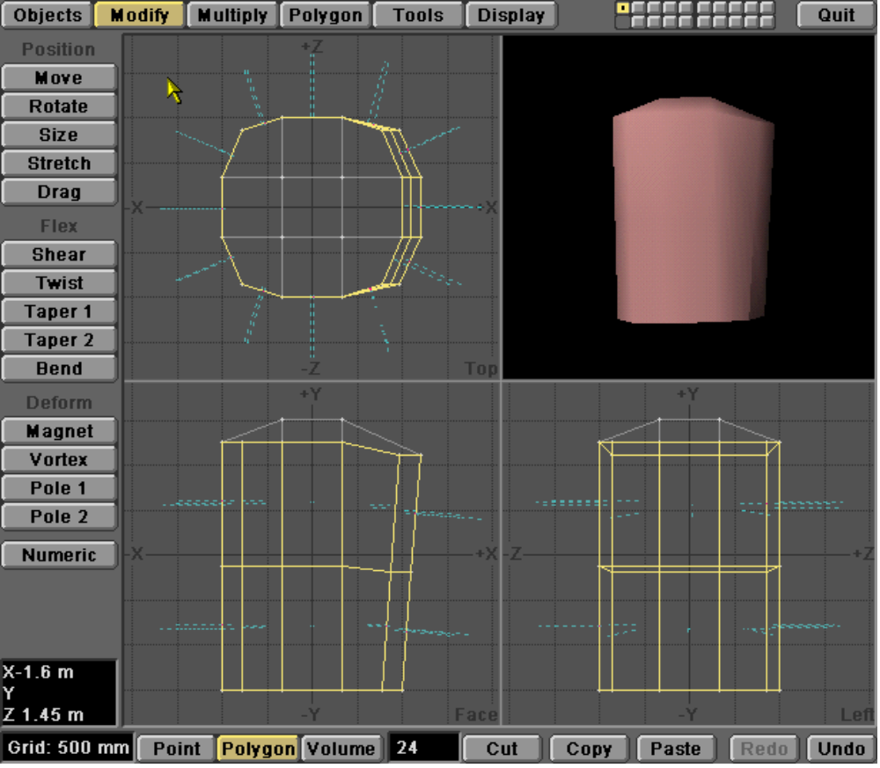

Pass 4 : adjust some vertexes, make another horizontal refine with PMS, then continue with point adjusting.

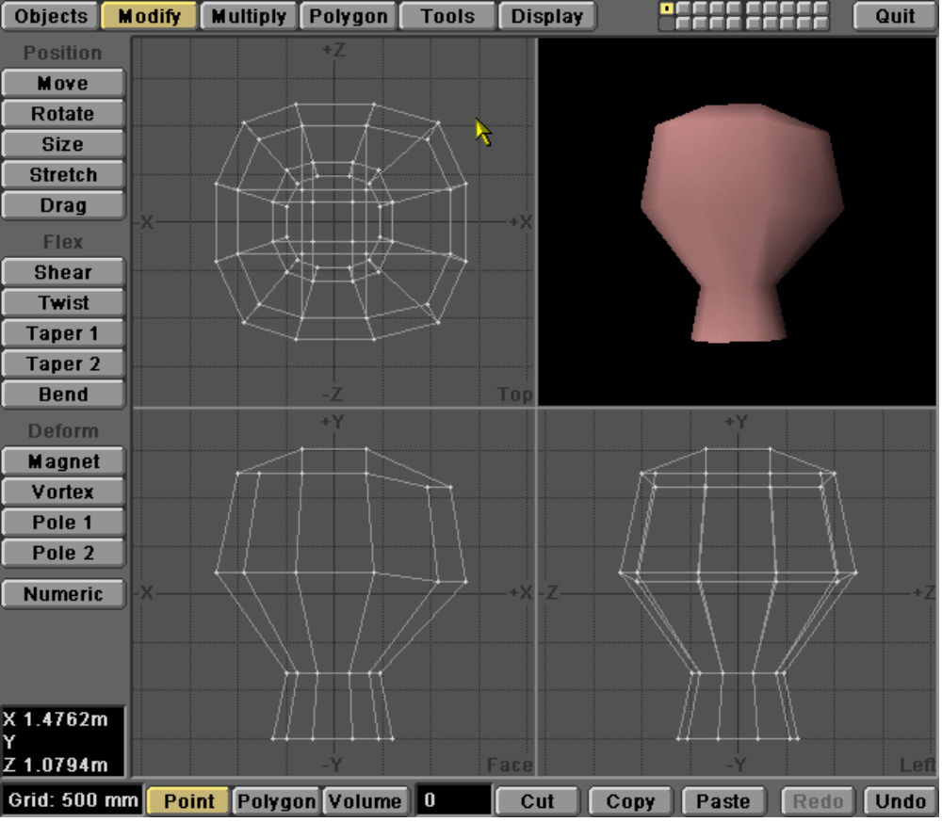

Pass 5 : now refine a front polygon in vertical direction to add particulars e.g. to create the nose.

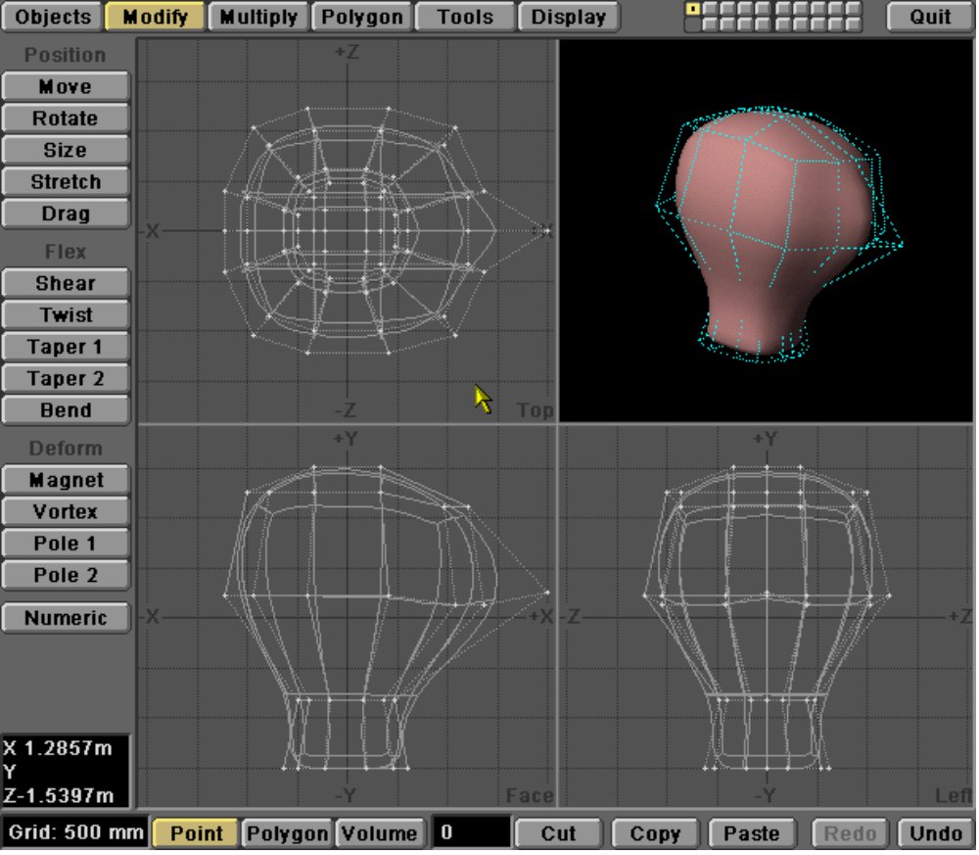

Pass 6 : go with your fantasy...

