Table of Contents
1.idChamp configuration for reading iClass card numbers 2
1.1.Switching to SPP mode 2
1.2.Configure reader 4
1.3.Switching reader back to HID Keyboard mode 6
2.Appendix: Configuration Listing 7

idChamp configuration for reading iClass card numbers
To setup idChamp HS3 HSE reader for reading card number from the HID Corporate 1000 (iClass) cards follow these instructions.
- Switch reader to Bluetooth interface to SPP mode
- Configure reader using serial terminal
- Switch reader Bluetooth interface back to HID Keyboard mode

Switching to SPP mode
Open the idChamp RS3 HSE Reader and make sure that the DIP switches match the pictures below.
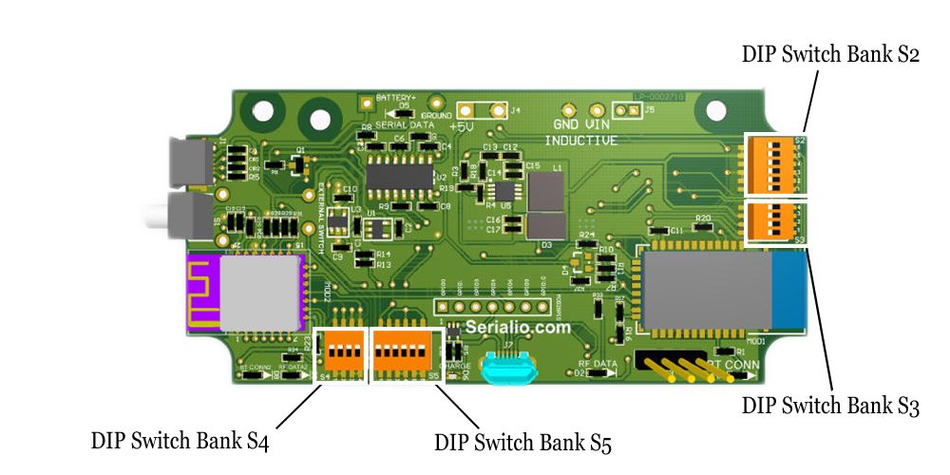Illustration 1: Reader bottom board layout
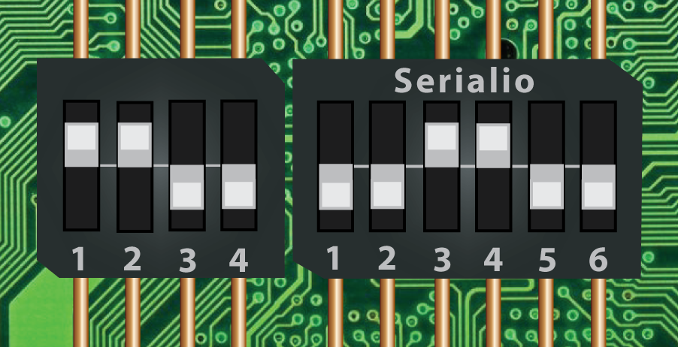Illustration 2: SPP mode: Positions for banks S2 and S3 (See diagram above).
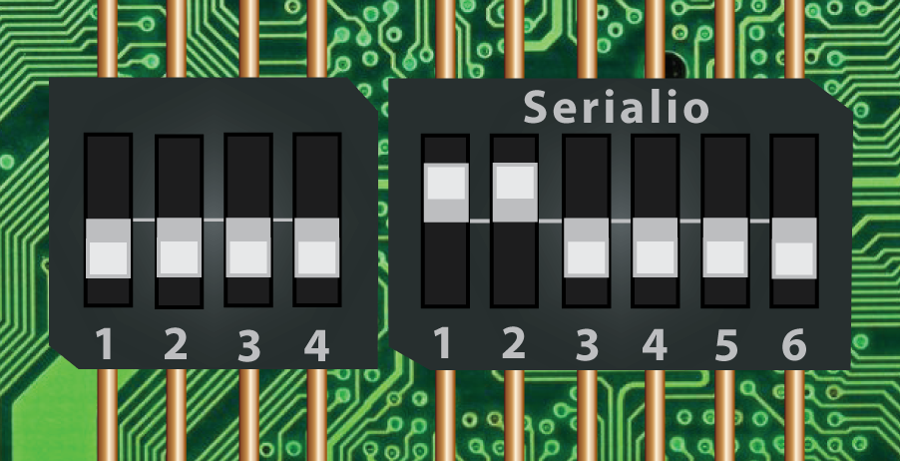Illustration 3: SPP mode: Positions for banks S4 and S5
Note: You will need to remove the idChamp RS3 HSE Reader from the case to access these banks - See diagram above).

Configure reader
- Power on the reader (do this using USB cable). Pair the reader with the computer, as usually do with Bluetooth devices.
- After connecting idChampRS3 reader to computer you have to identify reader serial port name. To do this open Device Manager and under Ports section search for COM port identifier. You will use this identifier in connecting terminal application to the reader.
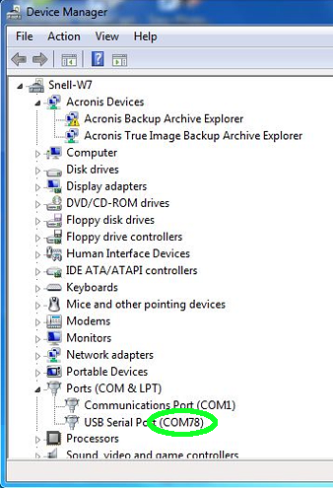Illustration 4: idChamp reader in this case have COM identifier COM78
- Now download PuTTY serial client from http://the.earth.li/~sgtatham/putty/latest/x86/putty.exe then open it and fill fill the fields as shown on image bellow and open terminal.
NOTE: Use serial line identifier that you found in your device manager instead of the one that is displayed here as an example.
- After opening a terminal you have to copy the listing shown in the Appendix of this document into terminal window.
- Close terminal and power off the reader.
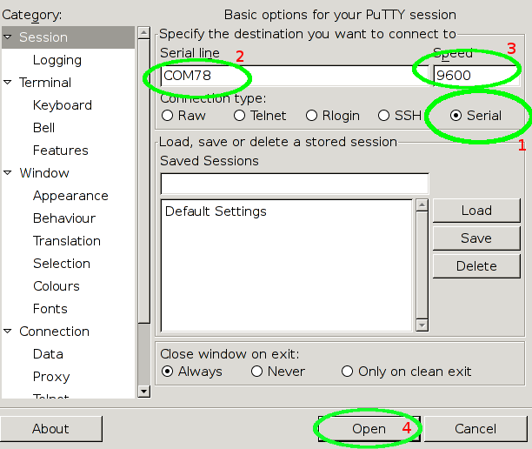Illustration 5: NOTE: Use serial line identifier that you found in your device manager instead of the one that is displayed here as an example.

Switching reader back to HID Keyboard mode
After configuring reader you have to switch device Bluetooth interface back to HID keyboard mode. To do this put DIP switches into position as shown on images bellow.
Illustration 6: Reader bottom board layout
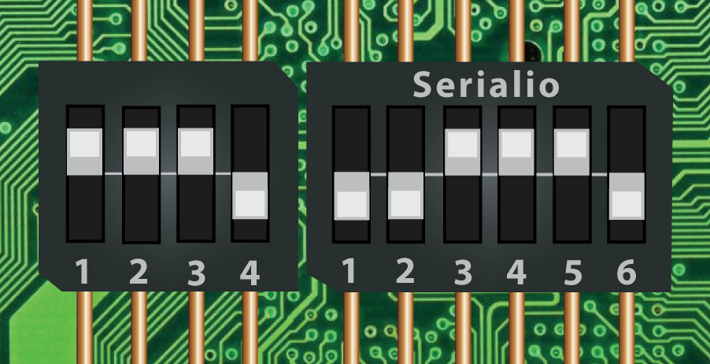Illustration 7: HID mode: Postions for banks S2 and S3 (See diagram above).
Illustration 8: HID mode: Positions for banks S4 and S5

Appendix: Configuration Listing
rfid:cfg=1
rfid:cfg.card.hipri=True
rfid:cfg.card.type=0xEF01
rfid:chr.1='\x00'
rfid:chr.2='\x00'
rfid:chr.3='\x00'
rfid:chr.count.lead=0
rfid:chr.count.trail=0
rfid:chr.eol='\x0D'
rfid:chr.fac=':'
rfid:chr.gone.1='\x00'
rfid:chr.gone.2='\x00'
rfid:cmd.echo=True
rfid:cmd.prompt=True
rfid:dev.luid=0x0000
rfid:disp.64bit=True
rfid:disp.fac.64bit=False
rfid:disp.fac.digits=0
rfid:disp.fac.hex=False
rfid:disp.fac.send=False
rfid:disp.fac.strip=False
rfid:disp.hex.lower=False
rfid:disp.id.digits=0
rfid:disp.id.hex=False
rfid:op.beep=True
rfid:op.cont=False
rfid:op.sdk=False
rfid:out.led=255
rfid:time.hold=20
rfid:wieg.id.bits=16
rfid:wieg.inv.bits=True
rfid:wieg.qual=False
rfid:wieg.qual.bits=93
rfid:wieg.rev.bits=False
rfid:wieg.rev.bytes=False
rfid:wieg.strip.lead.bits=0
rfid:wieg.strip.trail.bits=0
rfid:cfg.write
rfid:cfg=2
rfid:cfg.card.hipri=False
rfid:cfg.card.type=0x0000
rfid:chr.1='\x00'
rfid:chr.2='\x00'
rfid:chr.3='\x00'
rfid:chr.count.lead=0
rfid:chr.count.trail=0
rfid:chr.eol='\x8A'
rfid:chr.fac='\x00'
rfid:chr.gone.1='\x00'
rfid:chr.gone.2='\x00'
rfid:cmd.echo=True
rfid:cmd.prompt=True
rfid:dev.luid=0x0000
rfid:disp.64bit=False
rfid:disp.fac.64bit=False
rfid:disp.fac.digits=0
rfid:disp.fac.hex=False
rfid:disp.fac.send=False
rfid:disp.fac.strip=False
rfid:disp.hex.lower=False
rfid:disp.id.digits=0
rfid:disp.id.hex=False
rfid:op.beep=False
rfid:op.cont=False
rfid:op.sdk=False
rfid:out.led=3
rfid:time.hold=20
rfid:wieg.id.bits=0
rfid:wieg.inv.bits=False
rfid:wieg.qual=False
rfid:wieg.qual.bits=0
rfid:wieg.rev.bits=False
rfid:wieg.rev.bytes=False
rfid:wieg.strip.lead.bits=0
rfid:wieg.strip.trail.bits=0
rfid:cfg.write

Manual on how to connect Bluetooth device on computer with Windows 10 operating system can be found here http://windows.microsoft.com/en-us/windows-10/getstarted-connect-to-bluetooth-devices

