**Table of Contents**

**1. Introduction** 3

1.1. Purpose 3

1.2. Scope 3

1.3. Definitions, Acronyms, Abbreviations 4

1.3.1. Definitions 4

1.3.2. Acronyms 4

1.3.3. Abbreviations 4

1.4. Document Structure 4

**2. Architectural design** 6

2.1. Overview 6

2.2. High level architecture 6

2.3. Component view 6

2.4. Deployment view 6

2.5. Runtime view 6

2.6. Component interfaces 6

2.7. Selected architectural styles and patterns 7

**3. User interface design** 8

**4. Requirements traceability** 8

**5. Implementation, integration and test plan** 9

5.1. Implementation plan 9

**6. Effort Spent** 9

**7. References** 9

# **Introduction**

## **Purpose**

The purpose of this document is to give more technical details than the RASD about TrackMe system in order to provide an overall guidance to the architecture of the software product.

While the RASD presented a general view of the system and what functions the system is supposed to execute, this document aims to present the implementation of the system including main components and their interfaces, run-time behaviours, the high-level architectures and the corresponding deployment design. It also presents in more details the implementation and integration plan, as well as the testing plan.

## **Scope**

The project TrackMe, which is a service-based on mobile application and web application, has two different targets of Customers:

* Third-Parties
* Users

First of all, the system must provide the registration and login services.

To log into the system, both the Users and the Third-Parties will use their own credentials, such as username and the related password.

More precisely, the sign up and the sign in processes are carried out via:

* web app by Third Parties
* mobile application by the Users

Furthermore, the system allows Third Parties to require accessing to Users’ data via web app. More precisely, after choosing the type of request (single User data request or data w.r.t a specific group of anonymous Users) and filling out the corresponding fields, Third-Parties can make a data request.

On the other side the mobile app allows Users to see their own pending requests, to accept or reject a new single User data request or to withdraw a previously accepted request.

Group requests are, however, handled directly by the system in order to verify if it is able to properly anonymize the requested data.

The answer to a specific data request must be communicated on the corresponding Third-Party’s web app and for the accepted requests the system will provide a set of APIs in order to allow Third Parties to access data.

Through the mobile app, Users can also keep track of their health status by comparing them with the threshold values and update some fields of personal data (weight, height, etc.).

Finally, Users via mobile app can also subscribe to the AutomatedSOS service. For these Users the system must monitor constantly their health status in order to notify an external Ambulance Service in case of emergency.

## **Definitions, Acronyms, Abbreviations**

## **Definitions**

* **3-tier architecture:** acsbkcb
* Ascancja
* sacnla

## **Acronyms**

* **RASD:** Requirement Analysis and Specification Document
* **DD**: Design Document
* **MVC**: model view controller
* **REST**: REpresantional State Transfer
* **API:** Application Programming Interface
* **GPS:** Global Positioning System
* **Bpm:** Beats Per Minute
* **SSN:** Social Security Number

## **Abbreviations**

* **[Gn]:** n-th goal
* **[Rn]:** n-th functional requirement
* **Tp-a:** Third-Party administrator

## **Document Structure**

This document is divided into six sections:

* Section 1 gives an introduction of the design document. It contains the purpose and the scope of the document, as well as some abbreviation in order to provide a better understanding of the document to the reader.
* The second section deals with the architectural design of the application.   
  It gives an overview of the architecture and it also contains the most relevant architecture views: component view, class view, deployment view, runtime view and it shows the interaction of the component interfaces. Some of the used architectural designs and designs patterns are also presented here, with an explanation of each one of them and the purpose of their usage.
* Section 3 refers to the User Design Interface previously presented in the RASD document through some mock-ups w.r.t the Users and the Third Parties interfaces.
* The fourth section explains the mapping between the requirements previously defined in the RASD and the design elements that are defined in this document
* The fifth section provides the description of the implementation and testing strategy adopted in the whole project and of the order in which it is planned to integrate such subcomponents.
* Section 6 shows the effort spent by each group member while working on this project.
* Section 7 includes the reference documents

# **Architectural design**

## **Overview**

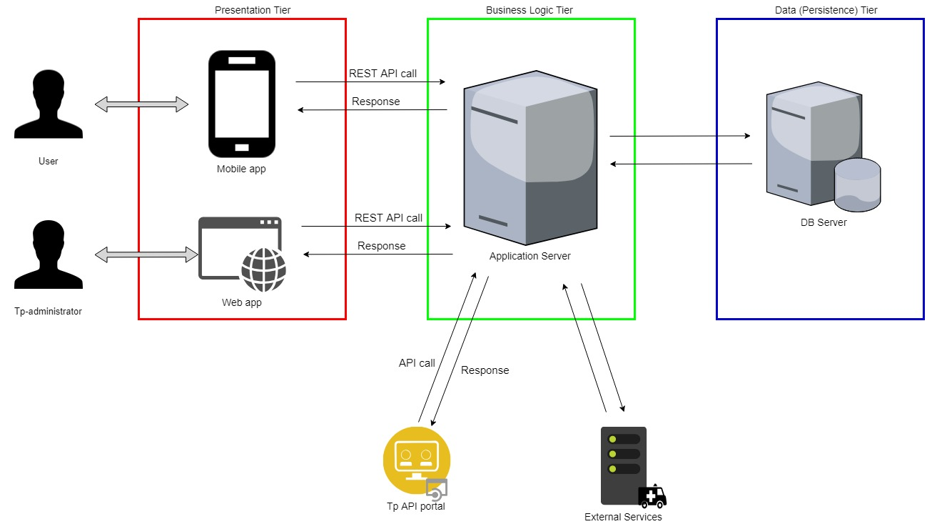The TrackMe system is based on a widely used 3-tier Architecture:

Where:

* **Presentation tier**: hgfg
* **Business Logic tier**: vhv
* **Data (Persistence) tier**: ygug

## **High level architecture**

Sasc

## **Component view**

saccas

## **Deployment view**

ascasc

## **Runtime view**

saccsa

## **Component interfaces**

ascaacs

## **Selected architectural styles and patterns**

Ascaasa

# **User interface design**

The mock-ups for this application were presented in the RASD Document in section “3.1.1. User Interfaces”.

At this point, there are no new functionalities that can be presented with new mock-ups for the application.

# **Requirements traceability**

The design of this application aims to meet all the goals and requirements that have been previously specified in RASD document.   
Below are listed the design components to which TrackMe requirements and goals are mapped:

* **[G1]**: Allow individuals to become registered users of Data4Help (requirements **[R1]**, **[R2]**, **[R3]**):
  + Scaac
* **[G2]**: Allow users to sign up for AutomatedSOS service (requirements **[R4]**, **[R5]**):
  + Asvasv
* **[G3]**: Provide the registration to third parties who want access to users’ data (requirements **[R6]**):
  + Ansicoas
* **[G4.1.]**: Give third parties access to data of a specific user (requirements **[R7]**, **[R8]**):
  + Csacshab
* **[G4.2]**: Give third parties access to anonymized data of group of users (requirements **[R9]**, **[R10]**):
  + Sjkabc
* **[G5]**: Allow users to accept or refuse the requests from third-parties to access their own data and their location (requirements **[R11]**):
  + Nacslicna
* **[G6]**: Allow third parties to subscribe to new data and to receive them as soon they are produced (requirements **[R12]**, **[R13]**):
  + AShcb
* **[G7]**: Allow customers to insert or update their own personal data and information about their body measurements (e.g. weight, height, etc.) (requirements **[R14]**):
  + AKJSbc
* **[G8]**: If some parameters of health status are below certain threshold, send an ambulance to the user location, with a reaction time less than 5 seconds (requirements **[R15]**, **[R16]**):
  + Sabcoas
* **[G9]**: Allow users to keep track of their health status at any time (requirements **[R17]**):
  + Shacicsih
* **[G10]**: Allow users to withdraw the authorisation to third parties to access their data (requirements **[R18]**, **[R19]**):
  + Ascvasc

# **Implementation, integration and test plan**

## **Implementation plan**

saicnsacnacs

# **Effort Spent**

Antonio: 6+ 6+

Enrico: 6 + ?+

# **References**

* Specification document *“A.Y. 2018-2019 Software Engineering 2 Mandatory Project: goal, schedule, and rules”*
* RASD document
* Old Design Documents: “*DD to be analysed*” and more previous documents.
* Slides provided on Beep channel
* Architecture styles: “<https://docs.microsoft.com/en-us/azure/architecture/guide/architecture-styles/>”