Experimental platform: MATLAB2018a+PlatEMOv2.8

1 Download PlatEMO <https://github.com/BIMK/PlatEMO>；

2 Download the MES-SVC compressed package and unzip it to the Algorithm module of PlatEMO;

3 Run the “main.m” in PlatEMO in Matlab to enter the graphical interface; as shown in the figure below:

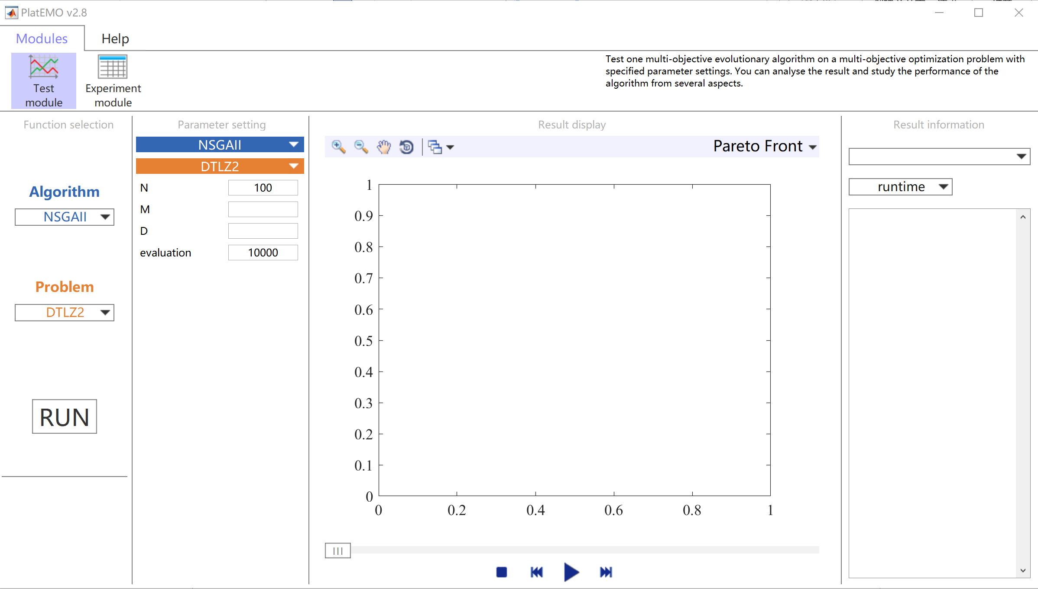

4 Running example: (LSMOP1, M=3, D=300);

