AEC MEDIA
Brogan Jordan
Website: broganjordan.com | Industry: Kitchen Design & Installation | Location: Dublin, Ireland
WHAT WE NOTICED

Brogan Jordan has a strong foundation of experience, quality project imagery and a clear range of kitchen, bedroom and commercial services. However, the current website experience does not fully showcase the quality of the work or make the journey from discovering the business to making an enquiry as clear and seamless as it could be.

● HIGH 01- THE HOMEPAGE DOESN'T GUIDE VISITORS TOWARDS AN ENQUIRY
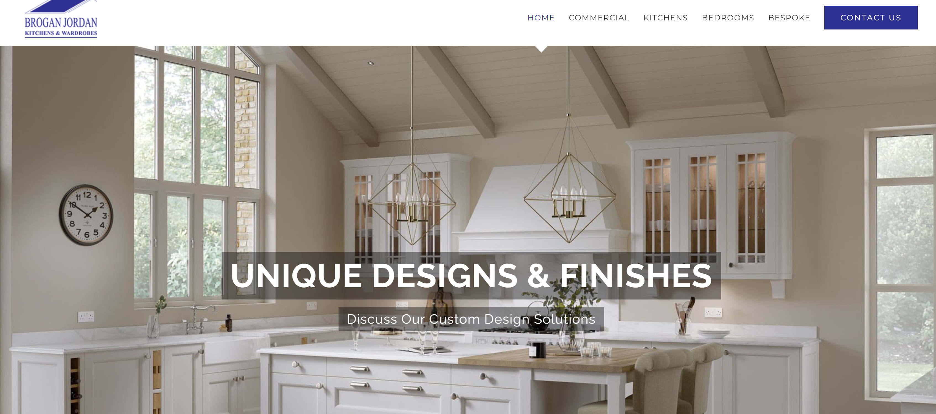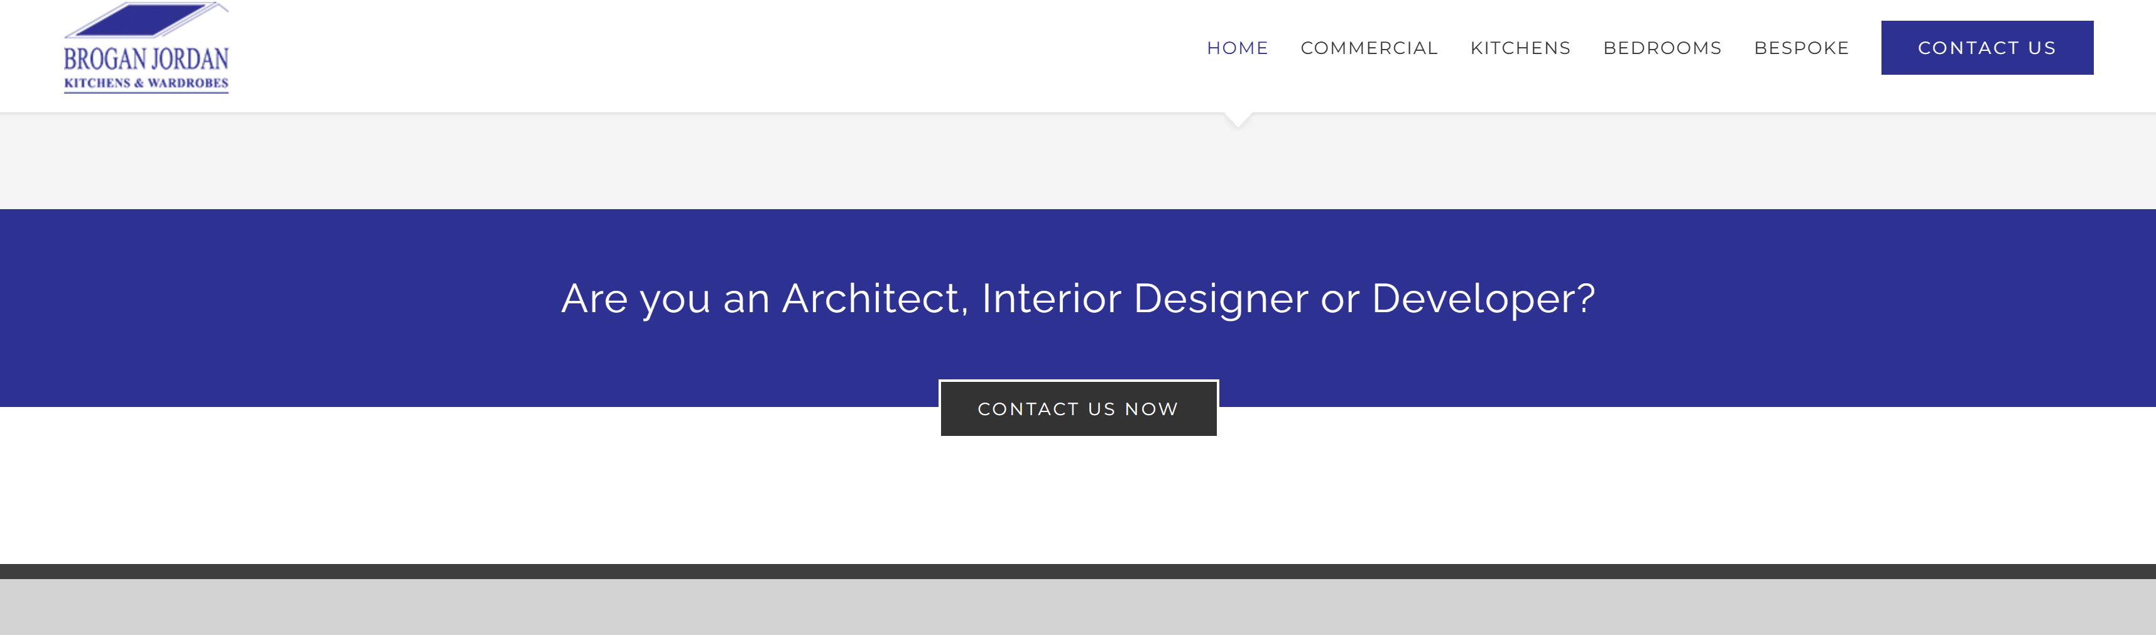

WHAT WE NOTICED
The homepage has a strong hero image and clear headline, but the main contact opportunity appears towards the bottom of the page, after visitors have already passed through the majority of the content.
WHY IT MATTERS
Visitors interested in a kitchen project should have an obvious next step as they explore the website. Relying mainly on the navigation to find the contact page can create unnecessary friction for potential enquiries.
WHAT WE'D CHANGE
Introduce clear “Get a Quote” or “Book a Design Consultation” CTAs throughout the homepage, particularly after key sections such as the project gallery and service information.
Priority: HIGH | Effort: LOW
● HIGH 02- THE WEBSITE UNDERSELLS THE QUALITY OF THE WORK
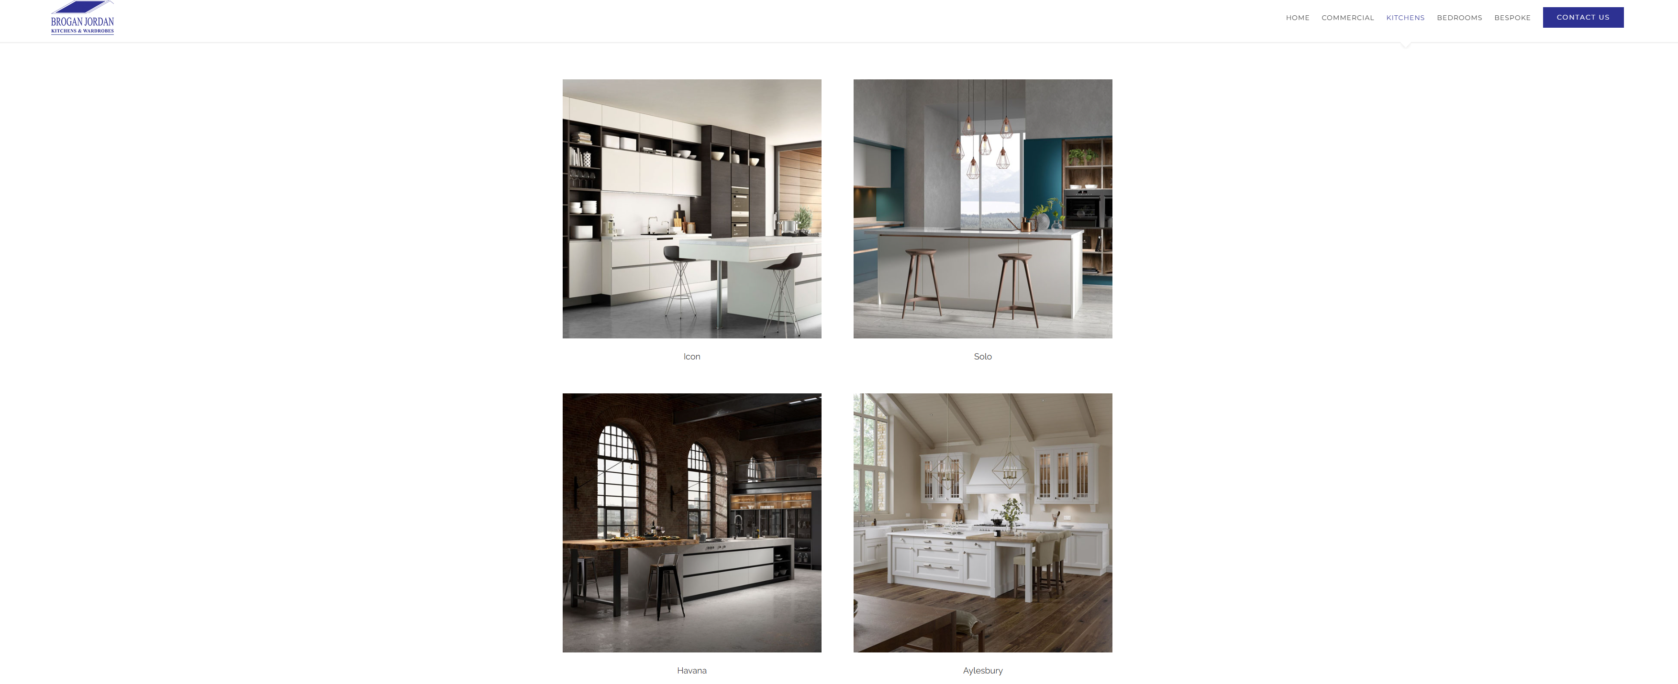

WHAT WE NOTICED
Brogan Jordan has strong kitchen imagery and a substantial portfolio, but much of the website presents this content through large areas of whitespace, small text and relatively simple page layouts.
WHY IT MATTERS
Kitchen design is a highly visual, high-value purchase. The website should make the quality of the work immediately obvious and create a premium experience that reflects the products and craftsmanship.
WHAT WE'D CHANGE
Rebuild key pages around larger project imagery, stronger visual hierarchy and concise supporting information, making completed projects and the quality of the work the centre of the experience.
Priority: HIGH | Effort: HIGH

THE OPPORTUNITY
CURRENT JOURNEY | RECOMMENDED JOURNEY
LAND  ↓  BROWSE  ↓  READ/EXPLORE  ↓  FIND CONTACT PAGE  ↓  COMPLETE FORM  ↓  CONTACT | LAND  ↓  UNDERSTAND THE OFFER  ↓  SEE THE WORK  ↓  BUILD TRUST  ↓  REQUEST QUOTE  ↓  BOOK DESIGN
● HIGH 03- THE ENQUIRY EXPERIENCE CREATES UNNECESSARY FRICTION
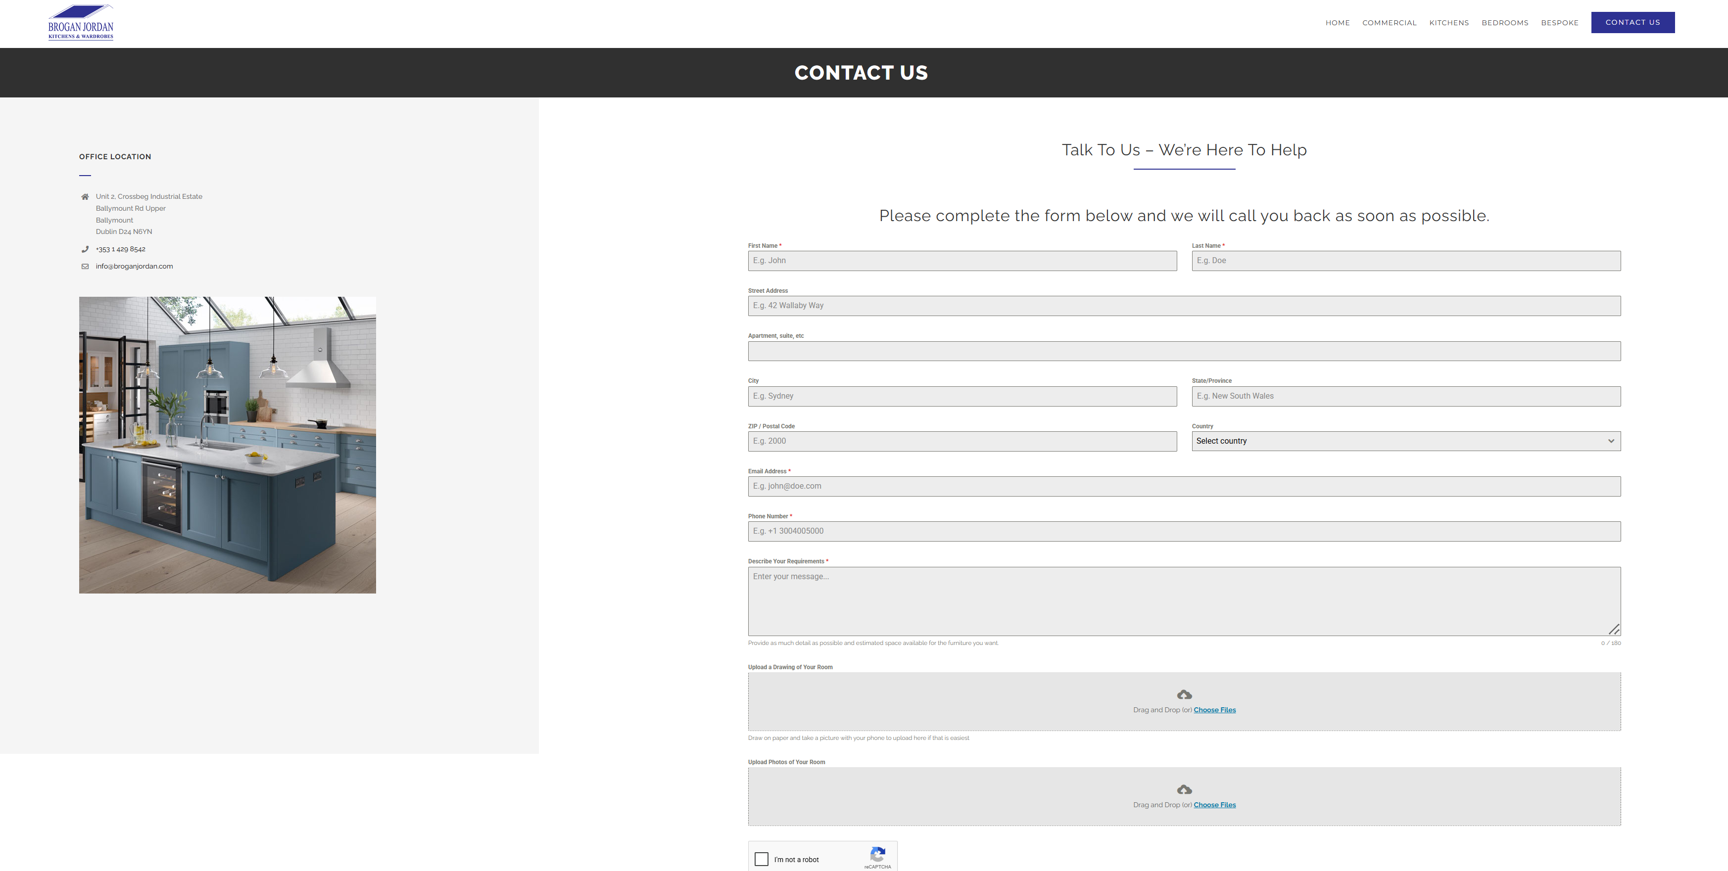

WHAT WE NOTICED
The contact page uses a lengthy form requiring personal details, address information, requirements and additional project uploads. The page also contains a Google Maps element that currently displays an error message.
WHY IT MATTERS
Visitors making an initial enquiry may not be ready to provide extensive information. At the same time, a broken map can reduce confidence and make the business appear less actively maintained.
WHAT WE'D CHANGE
Simplify the initial enquiry form around essential contact details and project requirements, with optional image uploads. Replace or correctly configure the Google Maps integration and make the primary enquiry CTA more prominent throughout the site.
Priority: HIGH | Effort: MEDIUM
OTHER OBSERVATIONS
OBSERVATION | OPPORTUNITY
Large areas of unused space | Create a more efficient page structure and bring key information into view sooner.
Strong project imagery | Give completed projects greater prominence and context.
Google Maps displays an error | Fix the map integration or replace it with a reliable location section.

WANT US TO TAKE A CLOSER LOOK?
This is a short preliminary review. A full AEC Media Growth Audit explores Conversion • UX • Messaging • Trust • SEO • Local Visibility • Competitors
Full Growth Audit — €79 introductory price • aecmedia.ie

Preliminary review based on the publicly visible website experience. Not a full technical SEO, analytics or accessibility audit. Recommendations are not guarantees of increased enquiries.

