AEC MEDIA
Custom Made
Website: custommade.ie | Industry: Bespoke Furniture / Cabinet Making | Location: Dublin, Ireland
WHAT WE NOTICED

Custom Made has a strong visual portfolio, clear service offerings and prominent enquiry opportunities. The website effectively showcases the quality and range of its bespoke work, but there are opportunities to make the value proposition clearer and create a more streamlined journey from viewing projects to making an enquiry.

● HIGH 01- THE VALUE PROPOSITION COULD BE COMMUNICATED MORE CLEARLY
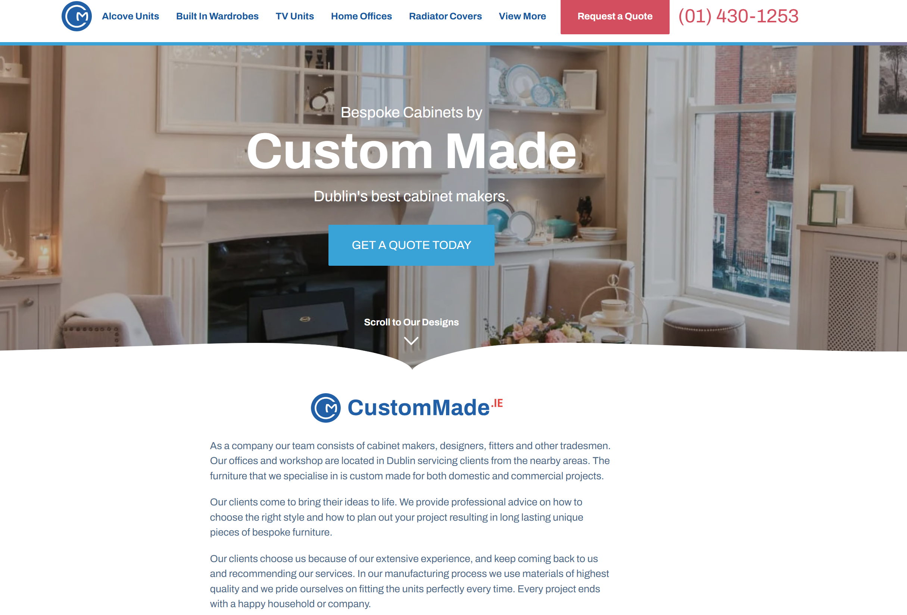

WHAT WE NOTICED
The homepage has strong imagery and clearly communicates bespoke furniture, but the messaging is relatively generic and does not immediately explain what makes Custom Made different.
WHY IT MATTERS
Visitors should quickly understand what the business offers, who it serves and why they should choose it before exploring the site.
WHAT WE'D CHANGE
Strengthen the above-the-fold messaging with a clearer value proposition focused on bespoke design, craftsmanship, experience and the range of services offered.
Priority: HIGH | Effort: LOW
● HIGH 02- PROJECT PRICING COULD BE USED MORE EFFECTIVELY
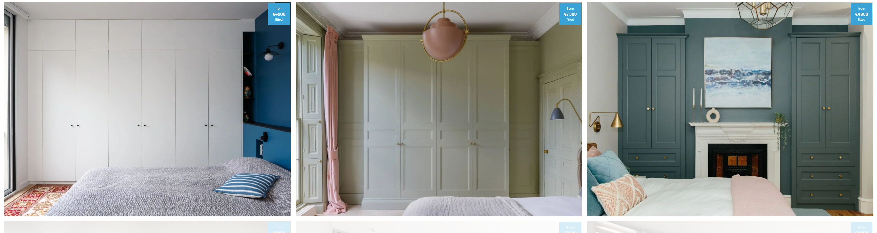

WHAT WE NOTICED
The project gallery shows starting prices such as €4,800, €8,000 and €5,400, but these prices are presented mainly as labels on the images with little supporting context.
WHY IT MATTERS
For a high-value purchase, pricing can help visitors understand the level of investment while also giving context to the quality and scope of each project.
WHAT WE'D CHANGE
Use the project cards to provide slightly more context around each example, such as project type, location, scope or “from” pricing, with a clear CTA leading visitors towards a quote.
Priority: MEDIUM | Effort: LOW

THE OPPORTUNITY
CURRENT JOURNEY | RECOMMENDED JOURNEY
LAND  ↓  BROWSE  ↓  READ/EXPLORE  ↓  FIND CONTACT PAGE  ↓  COMPLETE FORM  ↓  CONTACT | LAND  ↓  UNDERSTAND THE OFFER  ↓  SEE THE WORK  ↓  BUILD TRUST  ↓  REQUEST QUOTE  ↓  BOOK DESIGN
● HIGH 03- THE WEBSITE JOURNEY IS HEAVY AND CONTENT-LED
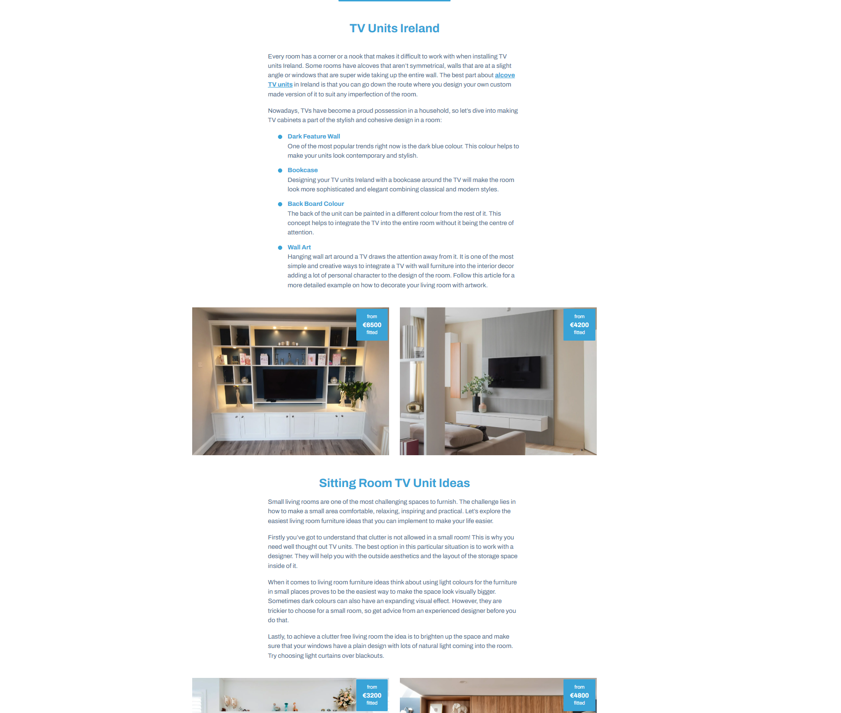

WHAT WE NOTICED
Several pages contain large sections of text, substantial whitespace and repeated information. The archived section also contains older content that may distract from the core offering.
WHY IT MATTERS
Customers are primarily looking to see the work, understand the service and decide whether to enquire. Excessive content can make this journey less direct.
WHAT WE'D CHANGE
Reduce repetitive copy and restructure key pages around service → projects → trust → enquiry, while reviewing older content that no longer supports the main offering.
Priority: HIGH | Effort: HIGH
OTHER OBSERVATIONS
OBSERVATION | OPPORTUNITY
Strong project imagery | Make completed work more prominent.
Multiple quote CTAs | Use more contextual CTAs.
Strong customer reviews | Place reviews closer to projects and CTAs.

WANT US TO TAKE A CLOSER LOOK?
This is a short preliminary review. A full AEC Media Growth Audit explores Conversion • UX • Messaging • Trust • SEO • Local Visibility • Competitors
Full Growth Audit — €79 introductory price • aecmedia.ie

Preliminary review based on the publicly visible website experience. Not a full technical SEO, analytics or accessibility audit. Recommendations are not guarantees of increased enquiries.

